CMOS D Flip Flop dflipflopx
D
CLK
Q
Q

Description:
This is an Extrinsic Super Element which models a Master-Slave Negative Edge Triggered D Flip-flop.

Form: dflipflopx:<instance name> n1 n2 n3 n4 n5 n6 <parameter list>

n1 is the high voltage source (Vdd) terminal,
n2 is D terminal
n3 is Clock terminal,
n4 is Q terminal,
n5 is Q terminal,
n6 is the ground or Vss terminal

Parameters:

Parameter | Type | Default Value | Required
ln: Channel Length of NMOS (m) | TR_DOUBLE | 1.0e-6 | No
wn: Channel Width of NMOS (m) | TR_DOUBLE | 1.0e-6 | No
lp: Channel Length of PMOS (m) | TR_DOUBLE | 1.0e-6 | No
wp: Channel Width of PMOS (m) | TR_DOUBLE | 1.0e-6 | No

Example:
dflipflopx: flop 1 2 3 4 5 0

Notes:
This implementation of D flip-flop is based on CMOS nand gate and inverter. This is master-slave negative edge triggered flip-flop.

Known Bugs:
No known bugs.

Truth Table
The D flip-flop is based on following truth table:

CLK | D | Q | Q | Operation
 | 1 | 1 | 0 | Set
 | 0 | 0 | 1 | Reset
 | 1 | Hold | Hold | Hold Previous Value
 | 0 | Hold | Hold | Hold Previous Value

Schematic
Following is the schematic of D Flip Flop

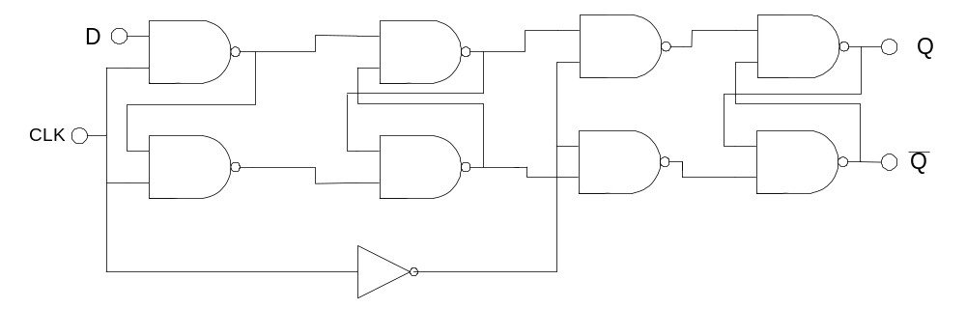

Sample Netlist:
*CMOS Master Slave Negative Edge Triggered D FLIP FLOP
* This netlist is for Transient analysis of D Flip Flop *
.tran2 tstop=12e-6 tstep=1e-9
*********** D and CLK inputs *************
vpulse:Vin2 2 0 v1=0 v2=5 td=0e-6 per=4e-6 pw=2e-6 tr=0.002e-6 tf=0.002e-6
vpulse:Vin3 3 0 v1=5 v2=0 td=0e-6 per=2e-6 pw=1e-6 tr=0.002e-6 tf=0.002e-6
***** Vdd Connection *****
vsource:Vdd 1 0 vdc=5
******* Instantiation*************
dflipflopx:flop 1 2 3 4 5 0
***********Load Resistances*******
r:R1 4 0 r=1000000
r:R2 5 0 r=1000000
*** Plot ******
.options gnuplot
.out plot term 2 vt in "d.out"
.out plot term 3 vt in "clk.out"
.out plot term 4 vt in "Q_output.out"
.out plot term 5 vt in "Qbar_output.out"
.end
Validation:
The output graph from the above netlist is shown below:
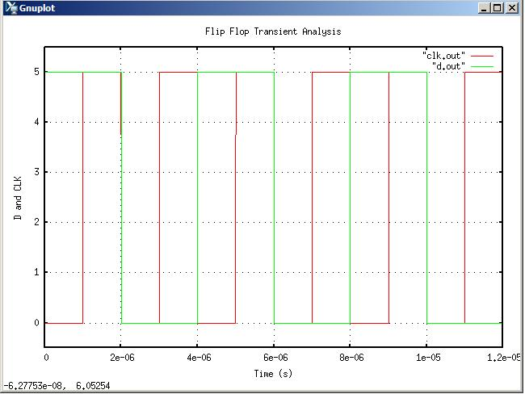
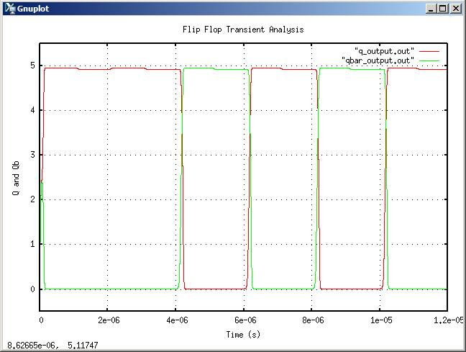

Version: 2009.04.30

Credits:
Name Affiliation Date Links
Shivam Priyadarshi NCSU April, 2009 http://www.ncsu.edu/
shivam.priyadarshi@gmail.com

Nikhil Kriplani NCSU April, 2009 http://www.ncsu.edu/
nkriplani@gmail.com

