Gyrator Element gyrator

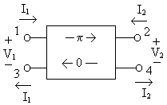

Description:
The gyrator shifts the input signal at port 1, terminal 1 with respect to terminal 3, by 180º (π) and transmits to the output, port 2, terminal 2 with respect to terminal 4. This transformation is done according to the following transimpedance relations: 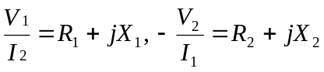.
A signal inserted to port 2 will not be shifted.

Form:
gyrator:<instance name> n₁ n₂ n₃ n₄ <parameter list>
n₁ is the port #1 signal input terminal
n₂ is the port #2 signal input terminal
n₃ is the port #1 reference terminal
n₄ is the port #2 reference terminal

Parameters:
Parameter | Type | Default Value | Required?
f: Center frequency (Hz) | DOUBLE | 1 GHz | no
r1: Resistance looking into port 1 (ohms) | DOUBLE | 0* | no
l1: Inductance looking into port 1 (henries) | DOUBLE | 0 | no
x1: Reactance looking into port 1 (ohms) | DOUBLE | 0 | no
r2: Resistance looking into port 2 (ohms) | DOUBLE | r1 | no
l2: Inductance looking into port 2 (henries) | DOUBLE | l1 | no
x2: Reactance looking into port 2 (ohms) | DOUBLE | x1 | no

* If no r, l, or x parameters are specified, r1 and r2 default to 50 ohms.

Example:
gyrator:gyrator1 1 2 3 4 r1=50 l1=1m
gyrator:gyr1 2 3 0 0 r1=25 x1=25 f=1e6

Model Documentation:
The gyrator is a device that shifts a signal by pi radians. The signal incident at port 1 is translated by pi radians at port 2 by the following transimpedance relations: 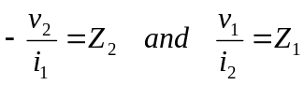, which are the gyrator ratios. Z₁ is the gyrator impedance ratio looking into port 1 and Z₂ is the impedance ratio looking into port 2. The gyrator was implemented based on these voltage and current equations found at Modelica.org. From these equations, we formulated admittance and impedance stamps for use in the model. Our final implementation of the gyrator was that of both an analog and microwave device. Because inductance is an important parameter in modeling the physical characteristics of a ferrite device, we included reactance, or inductance, as an optional parameter in the fREEDA gyrator model.

The gyrator transforms a waveform sent from port 1 to port 2 by 180 degrees, in accordance with the gyrator ratios. It does not transform a waveform sent from port 2 to port 1. This relationship is given by the following equations,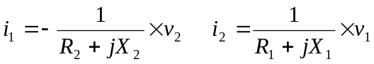 where R and X are the resistance and reactance looking into each port of the gyrator. From these equations, and the S parameter matrix the admittance stamp for the gyrator was derived.

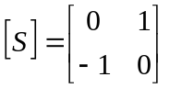 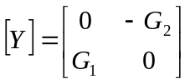.
The 4-terminal gyrator’s admittance matrix: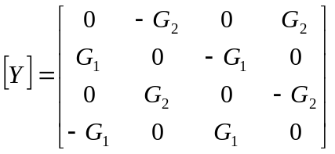.
The modified nodal admittance matrix is:
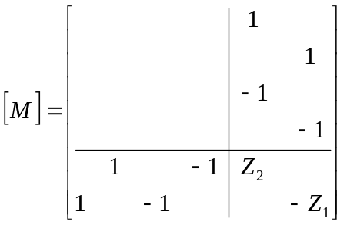 , the voltage and current vector: 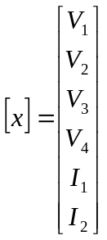.
This matrix was used to create the stamp for the gyrator.

The following is an example of the proper way to use this element in a fREEDA netlist:

gyrator:gyr1 2 3 0 0 r1=50 x1=50 f=1e6

Notice in this example first the declaration of the element used—gyrator:gyr1. gyrator is the element itself (similar to using R in SPICE) and gyr1 is simply the name assigned to the particular gyrator. The second thing to notice is that there are 4 terminals listed, corresponding to terminals 1, 2, 3, and 4 of the element. Remember the way the terminals are described in the gyrator model:

The numbers on the command line representing terminals (in this case, 2 3 0 0) are the numbers of the terminals in the whole circuit created inside the .net file. In this case, nodes 2 and 3 in the circuit are the terminals 1 and 2 of the gyrator. Terminals 3 and 4 of the gyrator are grounded, as indicated by the fact that they are both terminal 0 in the circuit.

The possible inputs on the command line for the gyrator are:
r1 – resistance looking into port 1
l1 – inductance looking into port 1
x1 – reactance looking into port 1
r2 – resistance looking into port 2
l2 – inductance looking into port 2
x2 – reactance looking into port 2
f – center frequency of the gyrator

If no parameters are specified, then the impedance looking into both ports defaults to 50 ohms (r1 and r2 become 50 ohms). If l and x are specified, x is ignored. If x is specified, the center frequency f should be specified or the default value of 1GHz is used. If the parameter value for one port is specified, but not the value for the other port, the other port automatically defaults to the value given for the first port.

References:
Adam, Davis, Dionne, Schloemann, Stitzer. “Ferrite Devices and Materials.” IEEE Transactions on Microwave Theory and Techniques vol. 50 (March 2002):721-736.
Carr, J. Elements of Microwave Electronics Technology. New York: Harcourt Brace Jovanovich, Inc., 1989.
Fay, C. and von Aulock, W. Linear Ferrite Devices For Microwave Applications. New York: Academic Press, Inc., 1968.
Microwave Harmonica. Gyrator Element, p 3-38.
Modelica. World Wide Web. http://www.modelica.org/library/Modelica/docu/Modelica_Electrical_Analog_Basic.html
Pozar, D. Microwave Engineering. New York: John Wiley & Sons, Inc., 1998.
Roberts, J. High Frequency Applications of Ferrites. Princeton, NJ: D. Van Nostrand Co., Inc., 1960.

Sample Netlist:
Gyrator Test 1 Netlist
*sending a signal forward through the gyrator

.tran2 tstart=0.1e-6 tstop=5e-6 tstep=.01e-6
*Transient analysis chosen.
vsource:vin 1 0 vac=2 f=1e6
*Voltage source at node 1
res:rin 1 2 r=50
*Input resistor between source and gyrator
gyrator:gyr1 2 3 0 0 r1=50 l1=8e-6
*Gyrator – input at node 2, output at node 3

res:rload 3 0 r=50
*Load resistor at output of gyrator
.out plot term 3 vt in "v3.out"
.out plot term 2 vt in "v2.out"
.out plot term 1 vt in "v1.out"
*Plot voltages at nodes 1, 2, and 3
.end

Validation:

The validation of the gyrator is a transient analysis of the model with real values for the input impedances.

The first test is to send a voltage signal forward through the gyrator—from port 1 to port 2.

Gyrator Transient Test 1 – Real Gyrator Ratio
*sending a signal forward through the gyrator
.tran2 tstart=0.1e-6 tstop=5e-6 tstep=.01e-6
vsource:vin 1 0 vac=2 f=1e6
res:rin 1 2 r=50
gyrator:gyr1 2 3 0 0 r1=50
res:rload 3 0 r=50
.out plot term 3 vt in "v3.out"
.out plot term 2 vt in "v2.out"
.out plot term 1 vt in "v1.out"
.end

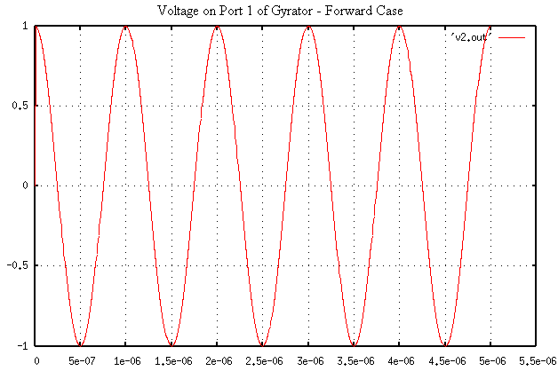
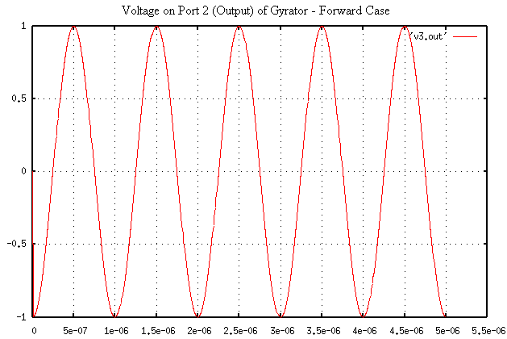

From the above plots, it is obvious that the phase angles with respect to the x=0 axis (considering the input to be a cosine) are:
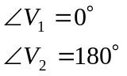
So the port 2 voltage is shifted from the port 1 voltage by 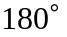!

As expected, the output (port 2) voltage signal is shifted by from the input (port 1) voltage signal. This verifies that there is a phase change with a signal traveling from port 1 to port 2.

The next validation test is to reverse the direction of the signal through the gyrator and check the output. In this test all real values for the gyrator impedances are used.

Gyrator Reverse Test 1
*sending a signal backward through the gyrator
.tran2 tstart=0.1e-6 tstop=5e-6 tstep=.01e-6
vsource:vin 1 0 vac=2 f=1e6
gyrator:gyr1 2 3 0 0 r1=50
res:rin 1 3 r=50
res:rload 2 0 r=50
.out plot term 3 vt in "v3.out"
.out plot term 2 vt in "v2.out"
.out plot term 1 vt in "v1.out"
.end

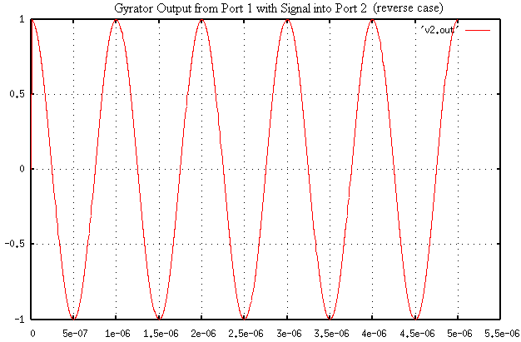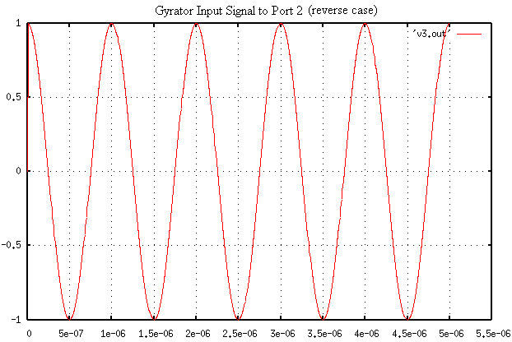

From the above plots, it is obvious that the phase angles with respect to the x=0 axis (considering the input waveform to be a cosine) are:
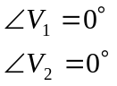

So the voltage at port 1 (output) is shifted by 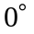 from the port 2 (input) voltage!

As expected, the output voltage signal is the same as the input voltage signal. This verifies that there is no phase change with a signal traveling from port 2 to port 1.

Known Bugs:
There is a problem when inputting a negative reactance. This corresponds to a capacitive gyrator ratio, which does not match any information found on the gyrator, so it is believed to be an unrealistic case.

Local reference terminals are implemented within the gyrator code, but have not yet been tested. Tying both reference terminals to terminal 0 (ground) works fine for now.

Notes:
The gyrator can be implemented as a two terminal or four terminal device. Set terminals 3 and 4 to the reference terminal to convert to a two terminal device.
The gyrator ratio can be calculated using a resistor and inductor or by using a resistance and reactance.

Version: 2003.05.15

Credits:
Names Affiliation Date Links
Isac Lima islima@ncsu.edu NC State University April 2003 www.ncsu.edu
Daryl Lindsey sdlindse@ncsu.edu
Don Widdows dwiddow@ncsu.edu

