Mutual Inductor K

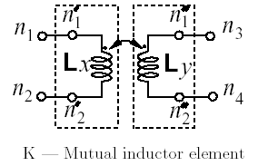

Description:
This element implements a mutual inductor model.

Form: k: <instance name> n_{r} <parameter list>
n_{r} is the reference terminal.
Parameters:

Parameter | Type | Default value | Required?
l1: name of first inductor | STRING | N/A | Yes
l2: name of second inductor | STRING | N/A | Yes
coupling: Couplingvalue | DOUBLE | N/A | Yes

Example:
k:k1 0 coupling=0.9 l1="ind:ind1" l2="ind:ind2"

Model Documentation:
The mutual coupled inductor model represents coupled inductors by self inductances Li and mutual inductances Mij. Here Li is the self inductance of the ith inductor element and Mij is the mutual inductance of the ith and jth inductor elements. The mathematical model of the coupled element consists of voltage sources controlled by the time derivatives of current.
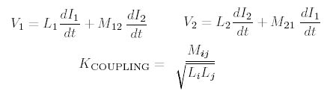

K_{COUPLING} may have any value between 0 and 1 including 1. Ferrite core provides almost ideal coupling 0.999 or higher.

References:
N/A

Sample Netlist:
**** Test netlist for K models ****
.options f0 = 5.1e9 method = 2 jupdm = 1
.tran2 tstop = 10e-3 tstep = .1e-3 nst=0 msv=0 deriv=0 im=1

ind:ind1 2 0 l=100u
ind:ind2 3 0 l=100u
k:k1 0 coupling=0.9 l1="ind:ind1" l2="ind:ind2"
vsource:vgs 1 0 vdc=2.5V vac=1V f=1e3
res:r0 1 2 r=10
res:r1 3 0 r=10

.out plot term 3 vt in "k.tran"
.out plot term 2 vt in "k.tran2"
.end

Validation:
Simulation Results for the sample netlist:
Voltage over inductor 1:
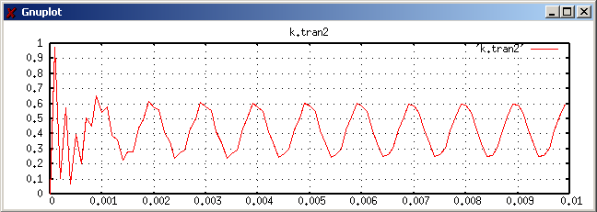

Voltage over inductor 2:
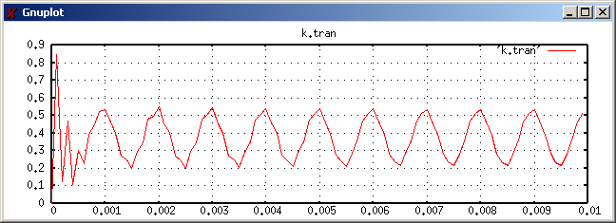

Known Bugs:
None.

Version: 2003.05.15
Credits:
Name Affiliation Date Links
Wei Zheng NC State University May 2003 www.ncsu.edu
weincsu@yahoo.com

