mos9 n-type mosn9

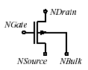

Description:

This element implements a Philips MOS9 (N – channel) Model.

Form:

mosn9:<instance name> n₁ n₂ n₃ n₄ <parameter list>
n₁ is the drain terminal,
n₂ is the gate terminal,
n₃ is the source terminal,
n₄ is the bulk terminal.

Parameters:

Parameters | Type | Default value | Required?
level: Level of this model. Must be set to 1 | Double | 3 | No
VT0:Threshold voltage at zero back-bias for the actual transistor at the actual temperature(volts) | Double | 7.099154e-1 | No
K0:low back-bias body factor for the actual transistor(V^1/2) | Double | 6.478116e-1 | no
K:high back-bias body factor for the actual transistor(V^1/2) | Double | 4.280174e-1 | no
PHIB: Surface potential at strong inversion for the actual transistor at the actual temperature(volts) | Double | 6.225999e-1 | no
VSBX:Transition voltage for the dual-k-factor model for the actual transistor(volts) | Double | 6.599578e-1 | no
BET:gain factor for the actual transistor at the actual temperature(A/V^2) | Double | 1.418789e-3 | no
THE1:coefficient of the mobility reduction due to the gate induced field for the actual transistor at the actual temperature(1/V) | Double | 1.923533e-1 | no
THE2:coefficient of the mobility reduction due to the back-biased for the actual transistor at the actual temperature(1/V^0.5) | Double | 1.144632e-2 | no
THE3:coefficient of the mobility reduction due to the lateral field for the actual transistor at the actual temperature(1/V) | Double | 1.381597e-1 | no
GAM1:coefficient for the drain induced threshold shift for large gate drive for the actual transistor (V^(1-ETADS)) | Double | 1.476930e-1 | no
ETADS: Exponent of the vds dependence of GAM1 for the actual transistor | Double | 0.6 | no
ALP: factor of the channel length modulation for the actual transistor | Double | 2.878165e-3 | no
VP: characteristic voltage of the channel length modulation for the actual transistor (V) | Double | 3.338182e-1 | no
GAM00: coefficient for the drain induced threshold shift at zero gate drive for the actual transistor | Double | 1.861785e-2 | no
ETAGAM: exponent of the back-bias dependence of gam0 for the actual transistor | Double | 2.0 | no
M0:factor of the subthreshold slope for the actual transistor at the actual temperature | Double | 5.024606e-1 | no
ETAM: exponent of the back-bias dependence of m for the actual transistor | Double | 2 | no
PHIT: thermal voltage at the actual temperature(volts | Double | 2.662680e-2 | no
ZET1: weak inversion correction factor for the actual transistor | Double | 4.074464e-1 | no
VSBT: limiting voltage of vsb dependence of m and gam0 for the actual transistor(volts) | Double | 2.025926 | no
A1: factor of the weak avalanche current for the actual transistor | Double | 6.022073 | no
A2: exponent of the weak avalanche current for the actual transistor(volts) | Double | 3.801696e+1 | no
A3: factor of the drain source voltage above which weak avalanche occurs for the actual transistor | Double | 6.407407e-1 | no
COX: gate to channel capacitance for the actual transistor(farads)", | Double | 2.979787e-14 | no
CGDO: gate drain overlap capacitance for the actual transistor(farads)" | Double | 6.392e-15 | no
CGSO: gate source overlap capacitance for the actual transistor(farads)", | Double | 6.392e-15 | no
Geometrical Parameters
TOX: thickness of gate oxide layer (meters)" | Double | 25e-9 | no
MULT: number of devices operating in parallel | Double | 1 | no
LER: Effective channel length of the reference transistor (m) | Double | 1.10e-6 | no
WER: Effective channel width of the reference transistor (m) | Double | 20e-6 | no
LVAR: Difference between the actual and the programmed poly-silicon gate length (m) | Double | -0.220e-6 | no
LAP: Effective channel length reduction per side due to the lateral diffusion of the source/drain dopant ions (m) | Double | 0.100e-6 | no
WVAR: Difference between the actual and the programmed field-oxide opening (m)", | Double | -0.025e-6 | no
WOT: Effective reduction of the channel width per side due to the lateral diffusion of the channel-stop dopant ions (m) | Double | 0.000e-6 | no
TR: Temperature at which the parameters for the reference transistor have been determined (0C) | Double | 21 | no
VT0R: Threshold voltage at zero back-bias for the reference transistor at the reference temperature (V) | Double | 0.73 | no
STVT0: Coefficient of the temperature dependence VT0 (VK-1) | Double | -1.20e-3 | no
SLVT0: Coefficient of the length dependence of VT0 (Vm) | Double | -0.135e-6 | no
SL2VT0: Second coefficient of the length dependence of VT0 (Vm2) | Double | 0.0 | no
SL3VT0: Third coefficient of the length dependence of VT0 (V) | Double | 0.0 | no
SWVT0: Coefficient of the width dependence of VT0 (Vm) | Double | 0.130e-6 | no
K0R: Low-backbias body factor for the reference transistor (V1/2) | Double | 0.65 | no
SLK0: Coefficient of the length dependence of K0 (V1/2m) | Double | -0.130e-6 | no
SL2K0: Second coefficient of the length dependence of K0 (V1/2m2) | Double | 0.0 | no
SWK0: Coefficient of the width dependence of K0 (V1/2m) | Double | 0.002e-6 | no
KR: High-backbias body factor for the reference transistor (V1/2) | Double | 0.11 | no
SLK: Coefficient of the length dependence of K (V1/2m) | Double | -0.280e-06 | no
SL2K: Second coefficient of the length dependence of K (V1/2m2) | Double | 0.0 | no
SWK: Coefficient of the width dependence of K (V1/2m) | Double | 0.275e-06 | no
PHIBR: Surface potential at strong inversion for the reference transistor at the reference temperature (V) | Double | 0.65 | no
VSBXR: Transition voltage for the dual-k-factor model for the reference transistor (V) | Double | 0.660 | no
SLVSBX: Coefficient of the length dependence of VSBX (Vm) | Double | 0.000e-06 | no
SWVSBX: Coefficient of the width dependence VSBX (Vm) | Double | -0.675e-06 | no
BETSQ: Gain factor for an infinite square transistor at the reference temperature (AV-2) | Double | 83e-06 | no
ETABET: Exponent of the temperature dependence of the gain factor (- | Double | 1.6 | no
LP1: Characteristic length of first profile (m) | Double | 1e-06 | no
FBET1: Relative mobility decrease due to first profile (-) | Double | 0.0 | no
LP2:Characteristic length of second profile (m) | Double | 1e-8 | no
FBET2: Relative mobility decrease due to second profile (-) | Double | 0.0 | no
THE1R: Coefficient of the mobility reduction due to the gate-induced field for the reference transistor at the reference temperature (V-1) | Double | 0.190 | no
STTHE1R: Coefficient of the temperature dependence of THE1 for the reference transistor (V-1K-1) | Double | 0.000e-3 | no
SLTHE1R: Coefficient of the length dependence of THE1 at the reference temperature (V-1m) | Double | 0.140e-6 | no
STLTHE1: Coefficient of the temperature dependence of the length dependence of THE 1 (V-1mK-1) | Double | 0.000e-3 | no
GTHE1: Parameter that selects either the old ( ) or the new ( ) scaling gTHE0 = gTHE1 = rule of THE 1 (-) | Double | 0.0 | no
SWTHE1: Coefficient of the width dependence of THE1 (V-1m) | Double | -0.058e-6 | no
WDOG: Characteristic drawn gate width, below which dogboning appears (m) | Double | 0.0 | no
FTHE1: Coefficient describing the geometry dependence of THE1 for W < WDOG (-) | Double | 0.0 | no
THE2R: Coefficient of the mobility reduction due to the back-bias for the reference transistor at the reference temperature (V-1/2) | Double | 0.012 | no
STTHE2R: Coefficient of the temperature dependence of THE2 for the reference transistor (V-1/2K-1) | Double | 0.000e-9 | no
SLTHE2R: Coefficient of the length dependence of THE2 at the reference temperature (V-1/2m) | Double | -0.033e-6 | no
STLTHE2: Coefficient of the temperature dependence of the length dependence of THE2 (V-1/2mK-1) | Double | 0.000e-3 | no
SWTHE2: Coefficient of the width dependence of THE2 (V-1/2m) | Double | 0.03e-6 | no
THE3R: Coefficient of the mobility reduction due to the lateral field for the reference transistor at the reference temperature (V-1) | Double | 0.145 | no
STTHE3R: Coefficient of the temperature dependence of THE3 for the reference temperature (V-1K-1 | Double | -0.660e-3 | no
SLTHE3R: Coefficient of the length dependence of THE3 at the reference temperature (V) | Double | 0.185e-6 | no
STLTHE3: Coefficient of the temperature dependence of the length dependence of THE3 (V-1mK-1) | Double | -0.620e-9 | no
SWTHE3: Coefficient of the width dependence of THE3 (V-1m) | Double | 0.02e-6 | no
GAM1R: Coefficient for the drain induced threshold shift for large gate drive for the reference transistor (V(1-ETADS)) | Double | 0.145 | no
SLGAM1: Coefficient of the length dependence of GAM1 (V(1 | Double | 0.16e-6 | no
SWGAM1: Coefficient of the width dependence of GAM1 (V(1-ETADS)m) | Double | -0.010e-6 | no
ETADSR: Exponent of the VDS dependence of GAM1 for the reference transistor | Double | 0.6 | no
ALPR: Factor of the channel-length modulation for the reference transistor (-) | Double | 0.003 | no
ETAALP: Exponent of the length dependence of ALP (-) | Double | 0.15 | no
SLALP: Coefficient of the length dependence of ALP (mETAALP) | Double | -5.65e-3 | no
SWALP: Coefficient of the width dependence of ALP (m) | Double | 1.67e-9 | no
VPR: Characteristic voltage of the channel length modulation for the reference transistor (V) | Double | 0.340 | no
GAM00R: Coefficient of the drain induced threshold shift at zero gate drive for the reference transistor (-) | Double | 0.018 | no
SLGAM00: Coefficient of the length dependence of GAM00 (m2) | Double | 20e-15 | no
SL2GAM00: Second coefficient of the length dependence of GAM00 (-) | Double | 0.0 | no
ETAGAMR: Exponent of the back-bias dependence of GAM0 for the reference transistor (-) | Double | 2.0 | no
M0R: Factor of the subthreshold slope for the reference transistor at the reference temperature (-) | Double | 0.50 | no
STM0: Coefficient of the temperature dependence of m0 (K-1) | Double | 0.000 | no
SLM0: Coefficient of the length dependence of m0 (m1/2) | Double | 0.280e-3 | no
ETAMR: Exponent of the back-bias dependence of m for the reference transistor (-) | Double | 2.0 | no
ZET1R: Weak-inversion correction factor for the reference transistor (-) | Double | 0.420 | no
ETAZET: Exponent of the length dependence of ZET1 (-) | Double | 0.17 | no
SLZET1: Coefficient of the length dependence of ZET1 (mETAZET) | Double | -0.390 | no
VSBTR: Limiting voltage of the VSB dependence of m and GAM0 for the reference transistor (V) | Double | 2.10 | no
SLVSBT: Coefficient of the length dependence of VSBT (Vm) | Double | -4.40e-6 | no
A1R: Factor of the weak-avalanche current for the reference transistor at the reference temperature (-) | Double | 6.00 | no
STA1: Coefficient of the temperature dependence of a1 (K-1) | Double | 0.000 | no
SLA1: Coefficient of the length dependence of a1 (m) | Double | 1.30e-6 | no
SWA1: Coefficient of the width dependence of a1 (m) | Double | 3.00e-6 | no
A2R: Exponent of the weak-avalanche current for the reference transistor (V) | Double | 38.0 | no
SLA2: Coefficient of the length dependence of a2 (Vm) | Double | 1.00e-6 | no
SWA2: Coefficient of the width dependence of a2 (Vm) | Double | 2.00e-6 | no
A3R: Factor of the drain-source voltage above which weak-avalanche occurs, for the reference transistor (-) | Double | 0.650 | no
SLA3: Coefficient of the length dependence of a3 (m) | Double | -0.550e-6 | no
SWA3: Coefficient of the width dependence of a3 (m) | Double | 0.000 | no
COL: Gate overlap capacitance per unit channel width (Fm-1) | Double | 0.320e-9 | no

Example:
mosn9: m1 1 2 3 4 l=1.5e-6 w=20e-6

Model Documentation:

The following equations have been obtained from original Philips MOS9 documentation.

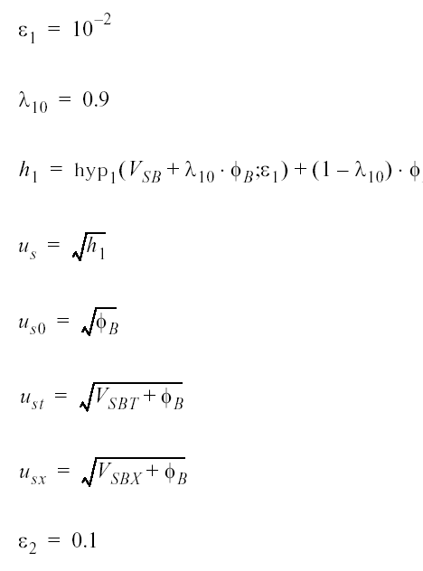

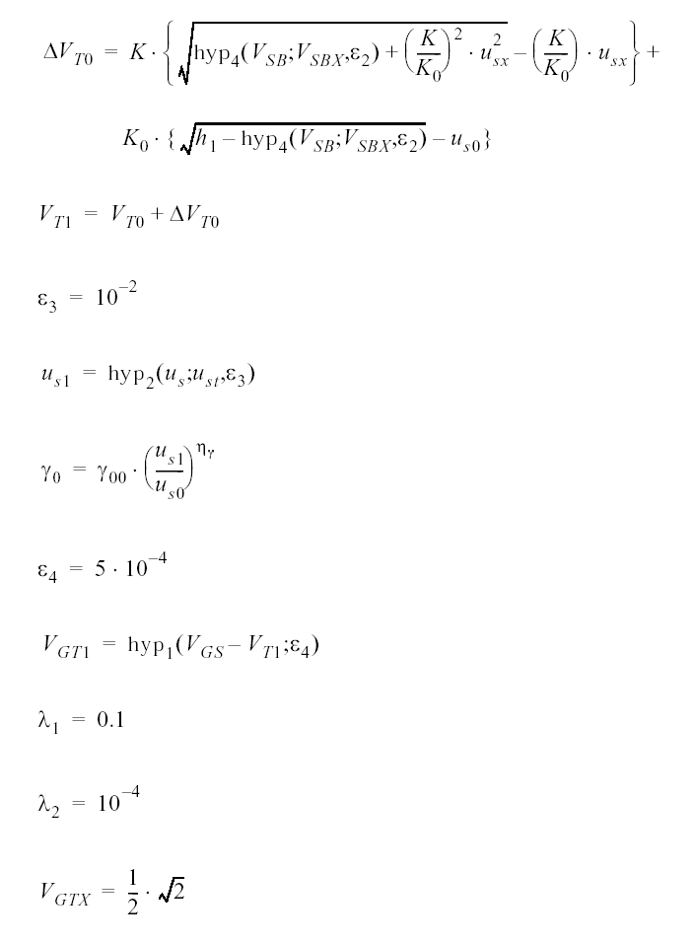
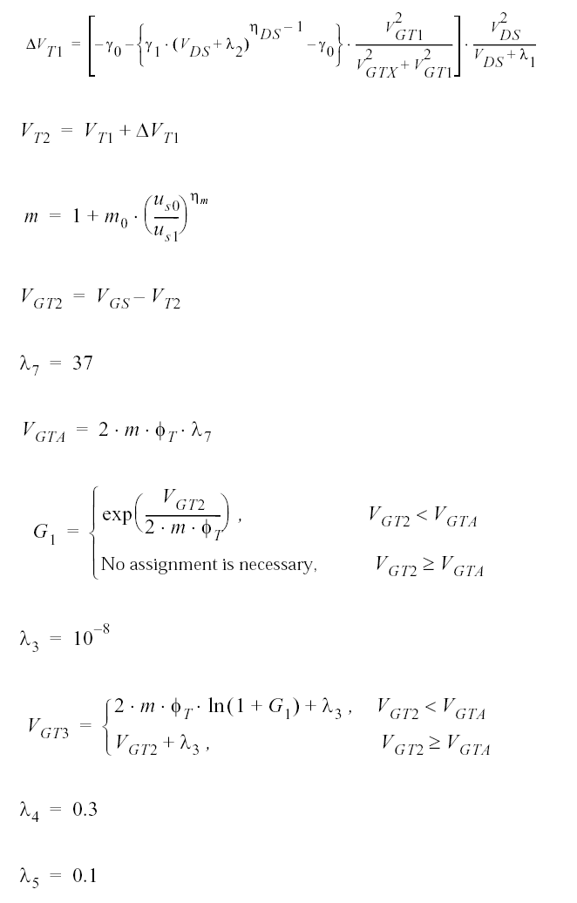

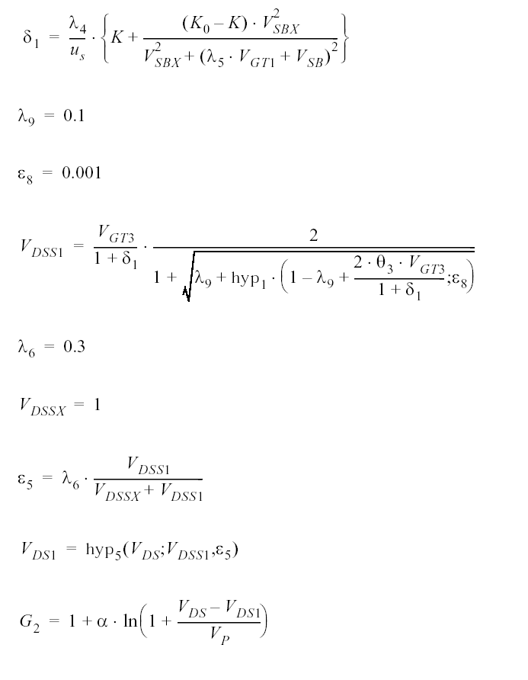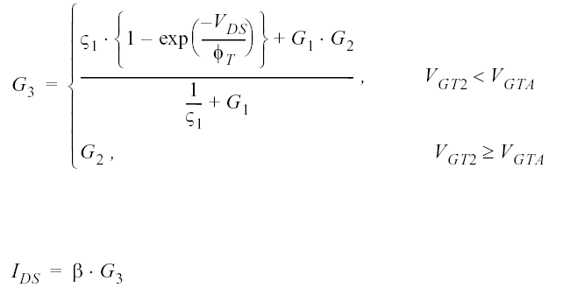
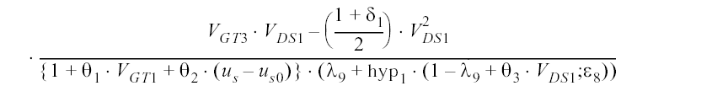

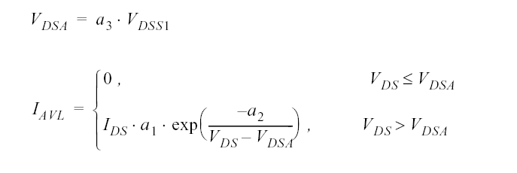
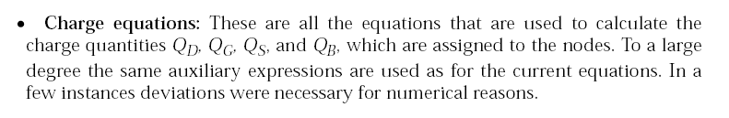

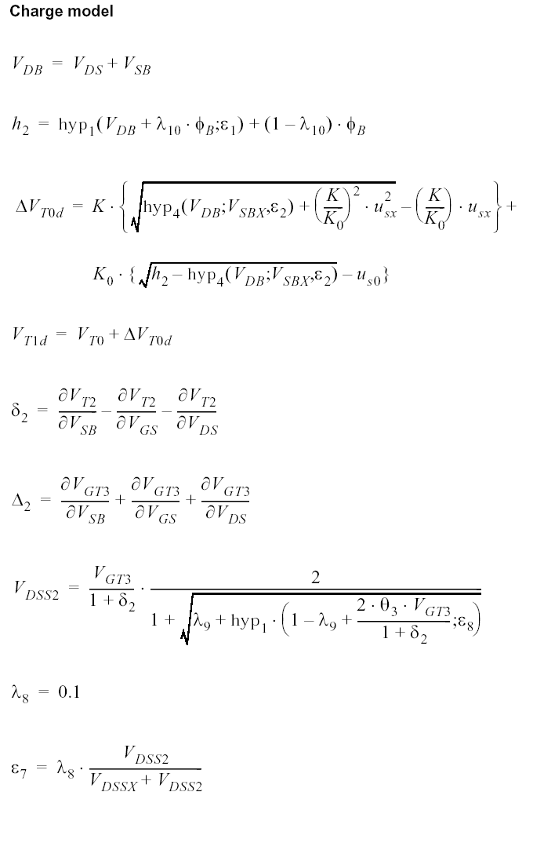
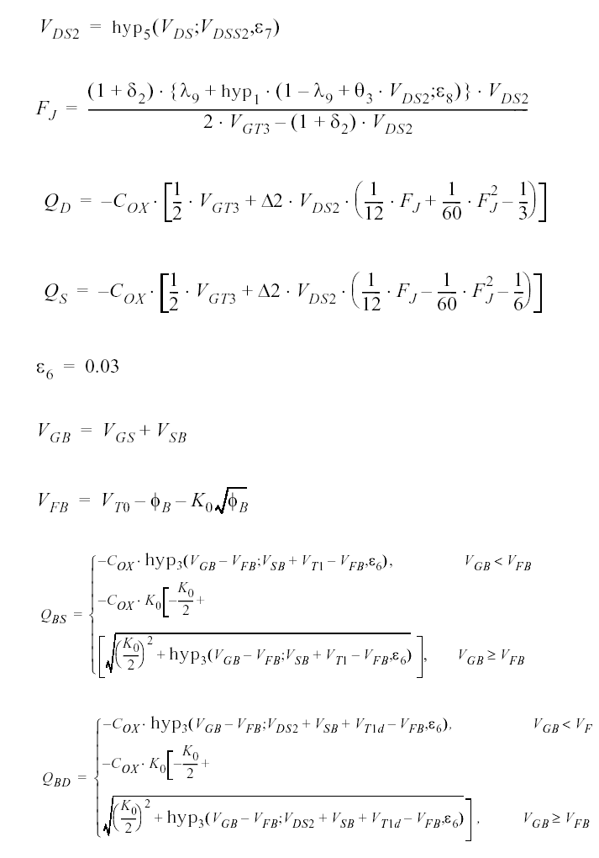

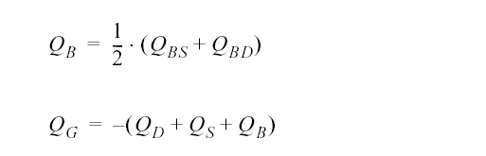

Several equations have to be adapted in order to obtain smooth transitions of the characteristics between adjacent regions of operation conditions and to prevent numerical problems during the iteration process for solving the network equations. In the following section a list of numerical adaptations and elucidations are given followed by the extended set of model equations. The definitions of the hyp functions are given at the end.

Hyp Function definitions:

hyp1(x) = 0.5*(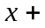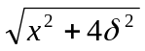)

hyp2(x) = x-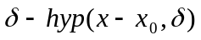

hyp3(x) = hyp2(x, x₀,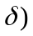-hyp2 (0, x₀,

hyp4(x) = hyp1(x-x₀,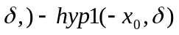

hyp5(x) = x₀ –hyp1 (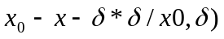

References:

- Philips document : http://www.semiconductors.philips.com/Philips_Models/mos_models/model9/index.html
- fREEDA Element Manual & Programmer’s manual :
http://freeda.org/
- “The operation and modeling of The MOS Transistor”, Yannis. P. Tsividis.

Sample Netlist:

*****Test netlist for Nmos9 level 903 model******
*****DC Analysis************

nmos9:m1 1 3 0 4

vsource:vds 1 0 vdc=0.1v

vsource:vsb 0 4 vdc=0

vsource:vgs 3 0

.dc sweep="vsource:vgs" start=0.6 stop=6.2 step=0.6

.out plot element "nmos9:m1" 0 it in "nmos9_id.dc"

.end

Validation:

- DC Analysis:

In order to show the accuracy of the model, we discuss here the simulated results and the results given in the Philips document. The size chosen for the reference transistor is W=20 micron and L=1.5 micron.

Fig 1 gives the drain current of the n-channel device as a function of the gate-bias voltage. The drain-bias voltage is fixed at 0.10 volts for n-channel device, the back bias and gate voltages have been varied as shown below.

Back-bias Vsb : 0➔4.5 volts for n channel at steps of 1.5 volts.

Gate Vgs : 0➔6 volts for n channel at steps of 0.6 volts.

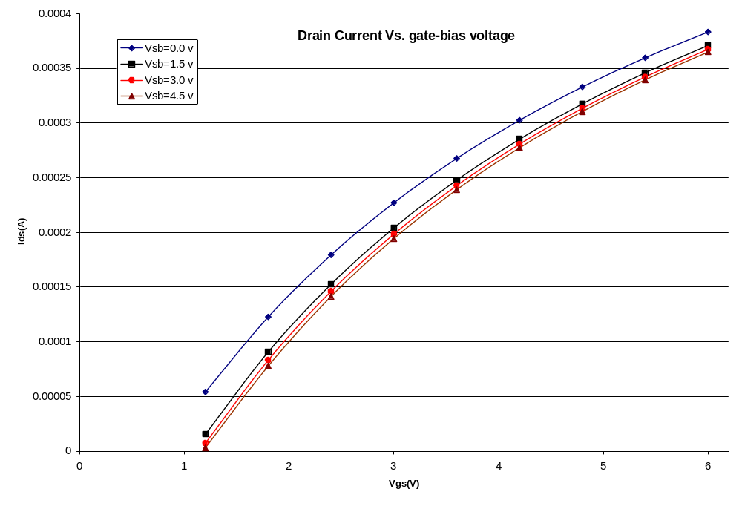
Figure 1: Drain Current Vs. gate-bias voltage for N-channel MOS

For Vgs < 2 Volts the average error is 1.5%.
For 2 < Vgs < 4 Volts the average error is 3.4%.
For Vgs > 4 Volts the average error is 2.4%.

Figure 2 gives Ids versus Vds for several values of Vgs. In addition for each Vgs three values of Vsb were taken (0, 2 and 5 volts).

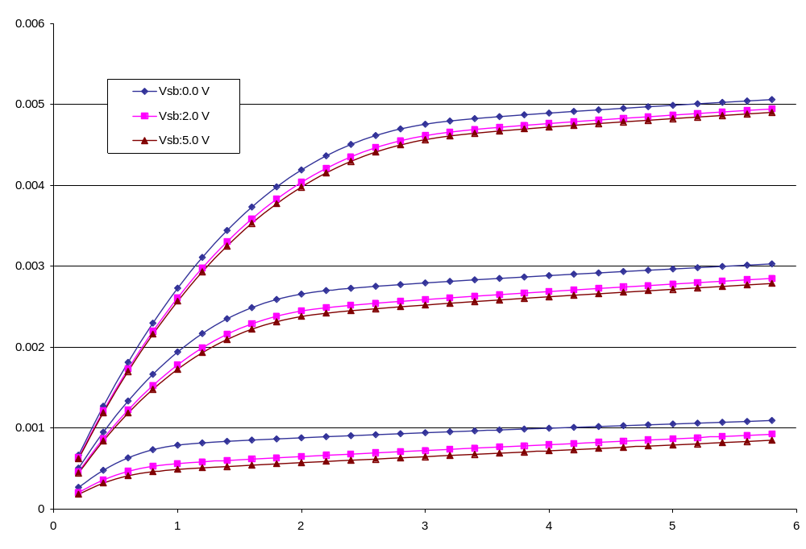
Figure 2: Ids vs. Vds for N-channel MOS

For Vds < 2 Volts the average error is 3.8%.
For 2 < Vds < 4 Volts the average error is 2.7%.
For Vds > 4 Volts the average error is 5.59%.

- Transient Analysis:

Transient analysis is done by giving pulse of 4.0 volt amplitude with rise time & fall time of 0.1 ns. The width and period of the pulse are 2 ns and 4 ns respectively. Figure 3 shows the .tran2 analysis of N-channel MOS.

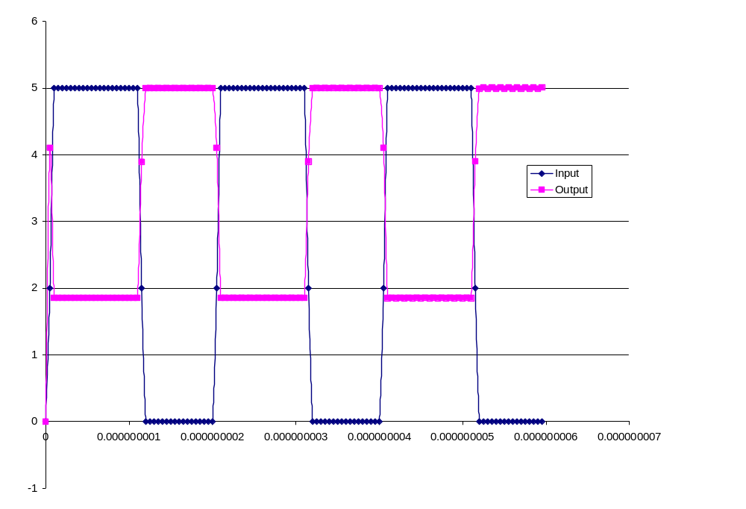
Figure 3: .tran2 analysis for N-channel MOS

Known Bugs:

Charge conservation problem is prominent when the time step in .tran2 analysis is too small (in the order of 1e-11).

Version: 2003.05.15

Notes:
Related models are juncap and mosp9.

Credits:

Name | Affiliation | Date | Links
Yogesh Ramdoss  (ytramdos@ncsu.edu)  Kuldip Gothi  (kuldipgothi@yahoo.com)  Ajit Rajagopalan  (ajit_r@softhome.net)  Xuemin Yang  (xyang@ncsu.edu)  Xin Cai  (xcai2@ncsu.edu)  Dapeng Ding  (dding@ncsu.edu) | NC State University | April 2003 | www.ncsu.edu

