Motorola’s Electro Thermal (MET) LDMOS Model MosnldMet
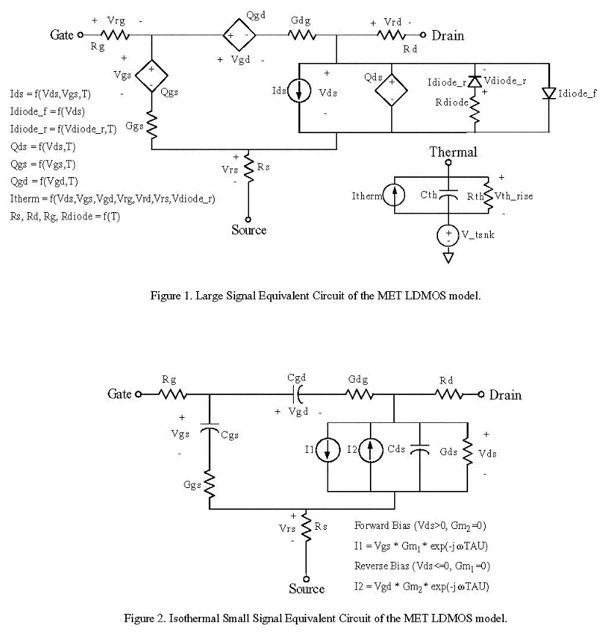

Description:
This element implements Motorola’s LDMOS. This is an electro thermal model that accounts for dynamic self-heating effects and was specifically tailored to model high power RF LDMOS transistors used in base station, digital broadcast, land mobile and subscriber applications.

Form: MosnldMet:<instance name> n1 n2 n3 n4 n5 <parameter list>
n1 is the gate terminal.
n2 is the drain terminal.
n3 is the source terminal.
n4 is the first thermal terminal.
n5 is the second thermal terminal.

Parameters:
Parameter | Type | Default value | Required?
RG_0 | Double | 1 ohm | Yes
RG_1 | Double | .0001 ohm/K | Yes
RS_0 | Double | .1 ohm | Yes
RS_1 | Double | .0001 ohm/K | Yes
RD_0 | Double | 1.5 ohm | Yes
RD_1 | Double | .0015 ohm/K | Yes
VTO_0 | Double | 3.5 V | Yes
VTO_I | Double | -.0001 V/K | Yes
Gamma | Double | -.02 | Yes
VST | Double | .15 V | Yes
BETA_0 | Double | .2 1/ohms | Yes
BETA_1 | Double | -.0002 1/(ohms*K) | Yes
LAMBDA | Double | -.00025 1/V | Yes
VGEXP | Double | 1.1 | Yes
ALPHA | Double | 1.5 | Yes
VK | Double | 7.0 V | Yes
DELTA | Double | .9 V | Yes
VBR_0 | Double | 75 V | Yes
VBR_1 | Double | .01 V/K | Yes
K1 | Double | 1.5 | Yes
K2 | Double | 1.15 1/V | Yes
M1 | Double | 9.5 | Yes
M2 | Double | 1.2 1/V | Yes
M3 | Double | .001 | Yes
BR | Double | .5 1/(V*ohms) | Yes
RDIODE_0 | Double | .5 ohm | Yes
RDIODE_1 | Double | .001 ohm/K | Yes
ISR | Double | 1e-13 A | Yes
NR | Double | 1.0 | Yes
VTO_R | Double | 3.0 V | Yes
RTH | Double | 10 degree C/watts | Yes
GGS | Double | 1e5 1/ohms | Yes
GGD | Double | 1e5 1/ohms | Yes
TAU | Double | 1e-12 seconds | Yes
TNOM | Double | 298 K | Yes
TSNK | Double | 25 degrees C | Yes
CGST | Double | .001 1/K | Yes
CDST | Double | .001 1/K | Yes
CGDT | Double | 0.0 1/K | No
CTH | Double | 0.0 J/ degrees C | No
KF | Double | 0.0 | No
AF | Double | 1.0 | Yes
FFE | Double | 1.0 | Yes
N | Double | 1.0 | Yes
ISS | Double | 1e-13 A | Yes
CGS1 | Double | 2e-12 F | Yes
CGS2 | Double | 1e-12 F | Yes
CGS3 | Double | -4.0 V | Yes
CGS4 | Double | 1e-12 | Yes
CGS5 | Double | .25 1/V | Yes
CGS6 | Double | 3.5 1/V | Yes
CGD1 | Double | 4e-13 F | Yes
CGD2 | Double | 1e-13 F | Yes
CGD3 | Double | .1 1/V^2 | Yes
CGD4 | Double | 4 V | Yes
CDS1 | Double | 1e-12 F | Yes
CDS2 | Double | 1.5e-12 F | Yes
CDS3 | Double | .1 1/V^2 | Yes
N_FING | Double | 1 | Yes
Area | Double | 1 | Yes

Example:
MosnldMet:ldmos1 3 2 1 1000 “tref”

Model Documentation:

The MET LDMOS model is an electro thermal model that can account for dynamic self-heating effects and was specifically tailored to model high power RF LDMOS transistors used in base station, digital broadcast, land mobile and subscriber applications.

The MET LDMOS is a large signal nonlinear model. It includes static and dynamic thermal dependencies. The model is now capable of accurately representing the current-voltage characteristics and their derivatives at any bias point and operating temperature. Motorola developed a model capable of modeling a single continuously differentiable drain current, which models the sub threshold, triode, high current saturation and drain to source breakdown regions of operation. These parameters were developed by measuring the nonlinear drain current under pulsed voltage conditions at different operation temperatures, ensuring an isothermal measurement environment.

The model has three voltage and temperature dependent nonlinear charges, Qgs, Qgd, and Qds. Ggs and Gdg are two internal gate conductances with three dependent parasitic resistances, Rg, Rd, and Rs. The power rise is calculated with the use of the thermal sub-circuit. Itherm is the total instantaneous power dissipated in the transistor, Rth is the thermal resistance, Cth is the thermal capacitance, and V_tsnk is the voltage source that represents the heat sink temperature of the system.

Scaling Rules
The model parameters are scaled by two different parameters, AREA, which is the ratio of the desired gate periphery to the gate periphery of the transistor used in the extraction of the model parameters, and N_FING, which is the ratio of the desired number of fingers to the number of fingers of the transistor used in the extraction of the model parameters.

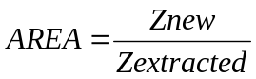

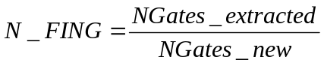

where Znew and Ngates_new are the gate periphery and number of gate fingers respectively of the desired transistor, and Zextracted and Ngates_extracted are the gate periphery and number of gate fingers of the extracted transistors.

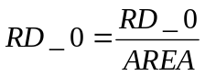

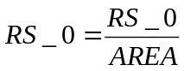

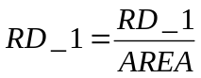

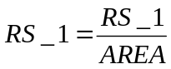

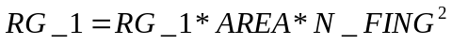

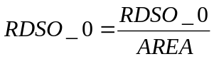

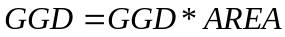

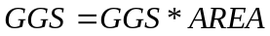

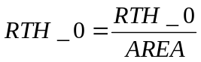

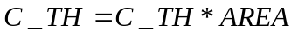

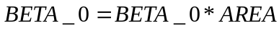

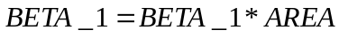

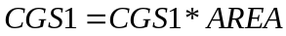

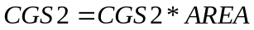

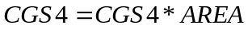

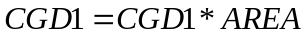

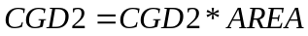

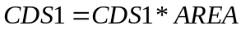

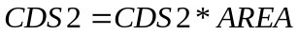

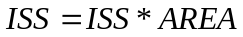

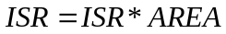

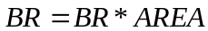

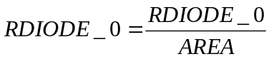

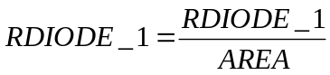

MET LDMOS Model Equations
The temperature dependency of parasitic resistances is given by:

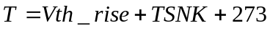

where T is the actual or total temperature (not the temperature rise) in K and TNOM is the temperature at which the parameters were extracted. The value of V_tsnk(℃)is numerically equal to the heat sink temperature TSNK(℃). Notice that even though RG_1, RD_1 and RS_1 have units of Ω/K, their numerical value will be the same if the units are Ω/℃.

The forward bias drain to source current equation is given by:

To maintain small signal to large signal model consistency, the gate to source voltage used in the calculation of the large signal drain to source current is delayed TAU seconds.

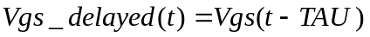

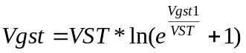

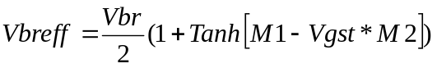

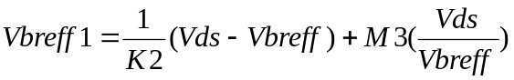

The forward bias drain to source diode is given by:

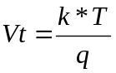

where k is the boltzmann’s constant(1.381e-23 J/K), T is the temperature in Kelvin, and q is the electron charge(1.602E-19C)

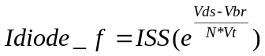

The reverse bias drain to source vurrent equation is given by:

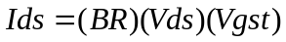

The reverse bias drain to source diode is given by

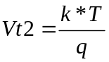

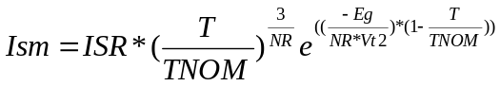

where Eg is the energy gap for silicon which is equal to 1.11 and T is the temperature in Kelvin.
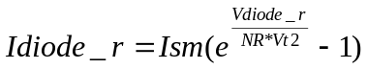

The reverse diode’s series resistances is given by:

The gate to source capacitance equation is given by:

The gate to drain capacitance equation is given by

The drain to source capacitance equation is given by

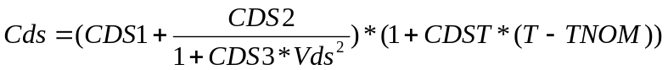

To avoid convergence problems the maximum tempereture rise, Vth_rise(℃) is limited to 300 ℃ using the following equation:

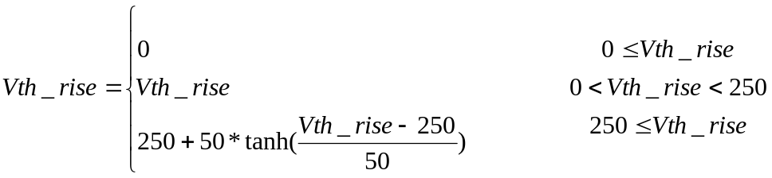

References:
[1] W. Curtice, J. Pla, D. Bridges, T. Liang & E. Shumate, A New Dynamic Electro-Thermal Nonlinear Model for Silicon RF LDMOS FETs, 1999 IEEE MTT-S International Microwave Symposium, Anaheim CA, pp. 419-422
[2] M. Golio, Microwave MESFETs and HEMTs, Arthec House, Boston, 1991, pp. 79-80
[3] P. Antognetti & G. Massobrio, Semiconductor Device Modeling with SPICE, McGraw Hill, New York, 1998.

Sample Netlist:
.options f0 = 1.0e7 jupdm=4 output=0 temp=298.
.tran2 tstep=0.1ns tstop=10ns
MosnldMet:m1 2 3 0 1000 "tref"
res:rd 1 3 r=50
vsource:vds 1 0 vdc=26v
vsource:vgs 2 0 vdc=5v vac=1v f=1e9
vsource:t1 1000 "tref" vdc=temp
.ref "tref"
.out plot term 2 vt in "ldmos_tr.vgs"
.out plot term 3 vt in "ldmos_tr.vds"
.end

Validation:
The Validation of the model was done with transient, DC and thermal wave forms compared to the wave forms located in the Motorola LDMOS paper.
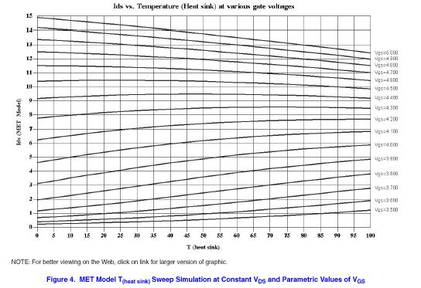
Figure 1: Ids vs. Temperature of the Motorola implemented LDMOS model

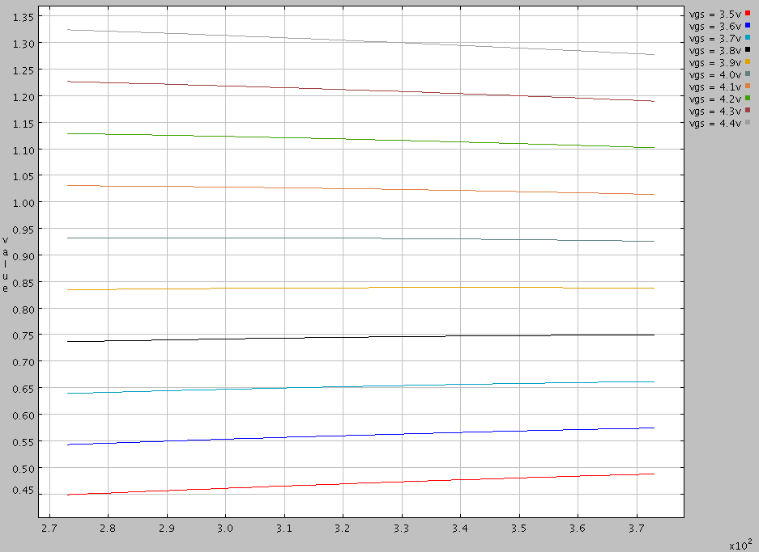
Figure 2: Ids vs. Temperature implemented in Freeda

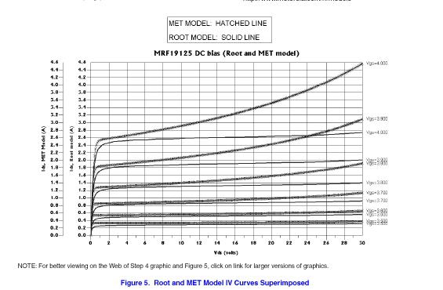
Figure 3: Ids vs. Vds for the Motorola model for spice

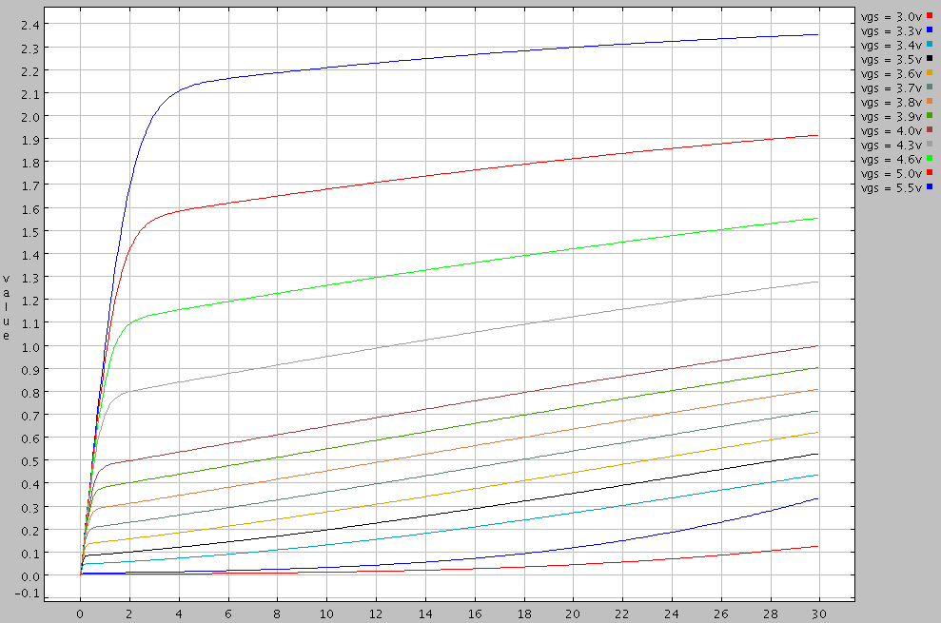
Figure 4: Ids vs. Vds for the LDMOS model in Freeda
Known Bugs:
The only difference between the Motorola model and this model is that in this model the Rdiode resistor has been left out. This is in series with the Idiode_r. It was seen to add to much complexity and after hand calculations did not cause much of a performance difference.

Version: 2003.05.15

Credits:
Name Affiliation Date Links
Jiankai Chang May 2003
Jason Thurston May 2003

