Philips MOS9 (P – channel) MOSFET model mosp9

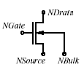

Description:

This element implements a Philips MOS9 (P – channel) Model.

Form:

mosp9 :( instance name) n₁ n₂ n₃ n₄ <parameter list>
Instance name is the model name,
n₁ is the drain node,
n₂ is the gate node,
n₃ is the source node,
n₄ is the bulk node.

Parameters:

Parameters | Type | Default value | Required?
level: Level of this model. Must be set to 1 | Double | 903 | no
VT0:Threshold voltage at zero back-bias for the actual transistor at the actual temperature(volts) | Double | 1.082125 | no
K0:low back-bias body factor for the actual transistor(V^1/2) | Double | 4.280174e-01 | no
K: high back-bias body factor for the actual transistor(V^1/2) | Double | 4.280174e-1 | no
PHIB: Surface potential at strong inversion for the actual transistor at the actual temperature(volts) | Double | 6.225999e-01 | no
VSBX: Transition voltage for the dual-k-factor model for the actual transistor(volts) | Double | 1.000000e-12 | no
BET: gain factor for the actual transistor at the actual temperature(A/V^2) | Double | 4.841498e-04 | no
THE1:coefficient of the mobility reduction due to the gate induced field for the actual transistor at the actual temperature(1/V) | Double | 2.046809e-01 | no
THE2:coefficient of the mobility reduction due to the back-biased for the actual transistor at the actual temperature(1/V^0.5) | Double | 1.492490e-01 | no
THE3:coefficient of the mobility reduction due to the lateral field for the actual transistor at the actual temperature(1/V) | Double | 3.267633e-02 | no
GAM1:coefficient for the drain induced threshold shift for large gate drive for the actual transistor (V^(1-ETADS)) | Double | 9.905701e-01 | no
ETADS: Exponent of the vds depedence of GAM1 for the actual transistor | Double | 6.000000e-01 | no
ALP: factor of the channel length modulation for the actual transistor | Double | 4.766925e-02 | no
VP: characteristic voltage of the channel length modulation for the actual transistor (V) | Double | 1.861200e-01 | no
GAM00: coefficient for the drain induced threshold shift at zero gate drive for the actual transistor | Double | 1.118334e-02 | no
ETAGAM: exponent of the back-bias dependence of gam0 for the actual transistor | Double | 1.0 | no
M0:factor of the subthreshold slope for the actual transistor at the actual temperature | Double | 3.801987e-01 | no
ETAM: exponent of the back-bias dependence of m for the actual transistor | Double | 1.0 | no
PHIT: thermal voltage at the actual temperature(volts | Double | 2.662680e-02 | no
ZET1: weak inversion correction factor for the actual transistor | Double | 1.270446 | no
VSBT: limiting voltage of vsb dependence of m and gam0 for the actual transistor(volts) | Double | 1.000000e02 | no
A1: factor of the weak avalanche current for the actual transistor | Double | 6.858299 | no
A2: exponent of the weak avalanche current for the actual transistor(volts) | Double | 5.732410e01 | no
A3: factor of the drain source voltage above which weak avalanche occurs for the actual transistor | Double | 4.254087e-01 | no
COX: gate to channel capacitance for the actual transistor(farads)", | Double | 2.717113e-014 | no
CGDO: gate drain overlap capacitance for the actual transistor(farads)" | Double | 6.358400e-15 | no
CGSO: gate source overlap capacitance for the actual transistor(farads)", | Double | 6.358400e-15 | no
Geometrical Parameters
TOX: thickness of gate oxide layer (meters)" | Double | 25e-9 | no
MULT: number of devices operating in parallel | Double | 1.0 | no
LER: Effective channel length of the reference transistor (m) | Double | 1.25e-6 | no
WER: Effective channel width of the reference transistor (m) | Double | 20e-6 | no
LVAR: Difference between the actual and the programmed poly-silicon gate length (m) | Double | -0.460e-6 | no
LAP: Effective channel length reduction per side due to the lateral diffusion of the source/drain dopant ions (m) | Double | 0.025e-6 | no
WVAR: Difference between the actual and the programmed field-oxide opening (m)", | Double | -0.130e-6 | no
WOT: Effective reduction of the channel width per side due to the lateral diffusion of the channel-stop dopant ions (m) | Double | 0.000e-6 | no
TR: Temperature at which the parameters for the reference transistor have been determined (0C) | Double | 21 | no
VT0R: Threshold voltage at zero back-bias for the reference transistor at the reference temperature (V) | Double | 1.1 | no
STVT0: Coefficient of the temperature dependence VT0 (VK-1) | Double | -1.70e-3 | no
SLVT0: Coefficient of the length dependence of VT0 (Vm) | Double | -0.035e-6 | no
SL2VT0: Second coefficient of the length dependence of VT0 (Vm2) | Double | 0.0 | no
SL3VT0: Third coefficient of the length dependence of VT0 (V) | Double | 0.0 | no
SWVT0: Coefficient of the width dependence of VT0 (Vm) | Double | 0.050e-6 | no
K0R: Low-backbias body factor for the reference transistor (V1/2) | Double | 0.47 | no
SLK0: Coefficient of the length dependence of K0 (V1/2m) | Double | -0.200e-6 | no
SL2K0: Second coefficient of the length dependence of K0 (V1/2m2) | Double | 0.0 | no
SWK0: Coefficient of the width dependence of K0 (V1/2m) | Double | 0.115e-6 | no
KR: High-backbias body factor for the reference transistor (V1/2) | Double | 0.47 | no
SLK: Coefficient of the length dependence of K (V1/2m) | Double | -0.200e-6 | no
SL2K: Second coefficient of the length dependence of K (V1/2m2) | Double | 0.0 | no
SWK: Coefficient of the width dependence of K (V1/2m) | Double | 0.115e-6 | no
PHIBR: Surface potential at strong inversion for the reference transistor at the reference temperature (V) | Double | 0.65 | no
VSBXR: Transition voltage for the dual-k-factor model for the reference transistor (V) | Double | 1.0e-12 | no
SLVSBX: Coefficient of the length dependence of VSBX (Vm) | Double | 0.0 | no
SWVSBX: Coefficient of the width dependence VSBX (Vm) | Double | 0.0 | no
BETSQ: Gain factor for an infinite square transistor at the reference temperature (AV-2) | Double | 26.1e-6 | no
ETABET: Exponent of the temperature dependence of the gain factor (- | Double | 1.6 | no
LP1: Characteristic length of first profile (m) | Double | 1e-06 | no
FBET1: Relative mobility decrease due to first profile (-) | Double | 0.0 | no
LP2:Characteristic length of second profile (m) | Double | 1e-8 | no
FBET2: Relative mobility decrease due to second profile (-) | Double | 0.0 | no
THE1R: Coefficient of the mobility reduction due to the gate-induced field for the reference transistor at the reference temperature (V-1) | Double | 0.190 | no
STTHE1R: Coefficient of the temperature dependence of THE1 for the reference transistor (V-1K-1) | Double | 0.000e-3 | no
SLTHE1R: Coefficient of the length dependence of THE1 at the reference temperature (V-1m) | Double | 0.45e-6 | no
STLTHE1: Coefficient of the temperature dependence of the length dependence of THE 1 (V-1mK-1) | Double | 0.000e-3 | no
GTHE1: Parameter that selects either the old ( ) or the new ( ) scaling gTHE0 = gTHE1 = rule of THE 1 (-) | Double | 0.0 | no
SWTHE1: Coefficient of the width dependence of THE1 (V-1m) | Double | -0.08e-6 | no
WDOG: Characteristic drawn gate width, below which dogboning appears (m) | Double | 0.0 | no
FTHE1: Coefficient describing the geometry dependence of THE1 for W < WDOG (-) | Double | 0.0 | no
THE2R: Coefficient of the mobility reduction due to the back-bias for the reference transistor at the reference temperature (V-1/2) | Double | 0.165 | no
STTHE2R: Coefficient of the temperature dependence of THE2 for the reference transistor (V-1/2K-1) | Double | 0.000e-9 | no
SLTHE2R: Coefficient of the length dependence of THE2 at the reference temperature (V-1/2m) | Double | -0.075e-6 | no
STLTHE2: Coefficent of the temperature dependence of the length dependence of THE2 (V-1/2mK-1) | Double | 0.000e-3 | no
SWTHE2: Coefficient of the width dependence of THE2 (V-1/2m) | Double | 0.020e-6 | no
THE3R: Coefficient of the mobility reduction due to the lateral field for the reference transistor at the reference temperature (V-1) | Double | 0.027 | no
STTHE3R: Coefficient of the temperature dependence of THE3 for the reference temperature (V-1K-1) | Double | 0.000e-9 | no
SLTHE3R: Coefficient of the length dependence of THE3 at the reference temperature (V) | Double | 0.027e-6 | no
STLTHE3: Coefficient of the temperature dependence of the length dependence of THE3 (V-1mK-1) | Double | 0.000e-3 | no
SWTHE3: Coefficient of the width dependence of THE3 (V-1m) | Double | 0.011e-6 | no
GAM1R: Coefficient for the drain induced threshold shift for large gate drive for the reference transistor (V(1-ETADS)) | Double | 0.12 | no
SLGAM1: Coefficient of the length dependence of GAM1 (V^1-ETADS)m | Double | 0.105e-6 | no
SWGAM1: Coefficient of the width dependence of GAM1 (V^1-ETADS)m) | Double | -0.011e-6 | no
ETADSR: Exponent of the VDS dependence of GAM1 for the reference transistor | Double | 0.6 | no
ALPR: Factor of the channel-length modulation for the reference transistor (-) | Double | 0.044 | no
ETAALP: Exponent of the length dependence of ALP (-) | Double | 0.17 | no
SLALP: Coefficient of the length dependence of ALP (mETAALP) | Double | 9e-3 | no
SWALP: Coefficient of the width dependence of ALP (m) | Double | 0.180e-9 | no
VPR: Characteristic voltage of the channellength modulation for the reference transistor (V) | Double | 0.235 | no
GAM00R: Coefficient of the drain induced threshold shift at zero gate drive for the reference transistor (-) | Double | 0.007 | no
SLGAM00: Coefficient of the length dependence of GAM00 (m2) | Double | 11e-15 | no
SL2GAM00: Second coefficient of the length dependence of GAM00 (-) | Double | 0.0 | no
ETAGAMR: Exponent of the back-bias dependence of GAM0 for the reference transistor (-) | Double | 1.0 | no
M0R: Factor of the subthreshold slope for the reference transistor at the reference temperature (-) | Double | 0.375 | no
STM0: Coefficient of the temperature dependence of m0 (K-1) | Double | 0.000 | no
SLM0: Coefficient of the length dependence of m0 (m1/2) | Double | 0.047e-3 | no
ETAMR: Exponent of the back-bias dependence of m for the reference transistor (-) | Double | 1.0 | no
ZET1R: Weak-inversion correction factor for the reference transistor (-) | Double | 1.3 | no
ETAZET: Exponent of the length dependence of ZET1 (-) | Double | 0.03 | no
SLZET1: Coefficient of the length dependence of ZET1 (mETAZET) | Double | -2.8 | no
VSBTR: Limiting voltage of the VSB dependence of m and GAM0 for the reference transistor (V) | Double | 100.0 | no
SLVSBT: Coefficient of the length dependence of VSBT (Vm) | Double | -0e-6 | no
A1R: Factor of the weak-avalanche current for the reference transistor at the reference temperature (-) | Double | 10.00 | no
STA1: Coefficient of the temperature dependence of a1 (K-1) | Double | 0.000 | no
SLA1: Coefficient of the length dependence of a1 (m) | Double | -15e-6 | no
SWA1: Coefficient of the width dependence of a1 (m) | Double | 30.00e-6 | no
A2R: Exponent of the weak-avalanche current for the reference transistor (V) | Double | 59.0 | no
SLA2: Coefficient of the length dependence of a2 (Vm) | Double | -8e-6 | no
SWA2: Coefficient of the width dependence of a2 (Vm) | Double | 15.00e-6 | no
A3R: Factor of the drain-source voltage above which weak-avalanche occurs, for the reference transistor (-) | Double | 0.52 | no
SLA3: Coefficient of the length dependence of a3 (m) | Double | -0.450e-6 | no
SWA3: Coefficient of the width dependence of a3 (m) | Double | -0.14e-6 | no
COL: Gate overlap capacitance per unit channel width (Fm-1) | Double | 0.320e-9 | no

Example:

mosp9: m1 1 2 3 4 l=1.5e-6 w=20e-6

Model Documentation:

Documentation is same as NMOS 9 model. Please refer to mosn9 model documentation.

References:

- Philips document : http://www.semiconductors.philips.com/Philips_Models/mos_models/model9/index.html
- fREEDA Element Manual & Programmer’s manual :
http://freeda.org/
- “The operation and modeling of The MOS Transistor”, Yannis. P. Tsividis.

Sample Netlist:

*****Test netlist for mosp9 level 903 model******
*****DC Analysis************

* D G S B

mosp9:m9 1 3 0 4
vsource:vds 1 0 vdc=-0.1v
vsource:vsb 0 4 vdc=0
vsource:vgs 3 0

.dc sweep="vsource:vgs" start=-0.6 stop=-6.2 step=-0.6
.out plot element "mosp9:m9" 0 it in "mosp9_id.dc"

.end

Validation:

- DC Analysis:

In order to show the accuracy of the model, we discuss here the simulated results and the results given in the Philips document. The size chosen for the reference transistor is W=20 micron and L=1.5 micron.

Fig 1 gives the drain current of the p-channel device as a function of the gate-bias voltage. The drain-bias voltage is fixed at -0.10 volts for p-channel devices, the back bias and gate voltages have been varied as shown below.

Back-bias Vsb : 0➔-4.5 volts for n channel at steps of -1.5 volts.

Gate Vgs : 0➔-6 volts for p channel at steps of -0.6 volts.

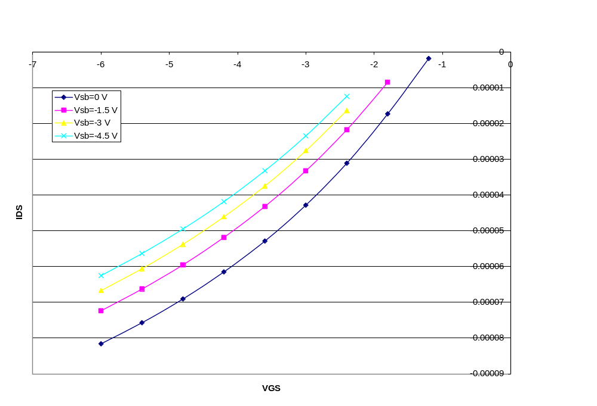
Figure 1 : Drain Current Vs. gate-bias voltage for P-channel MOS

Figure 2 gives Ids versus Vds for several values of Vgs. In addition for each Vgs three values of Vsb were taken (0, -2 and -5 volts).

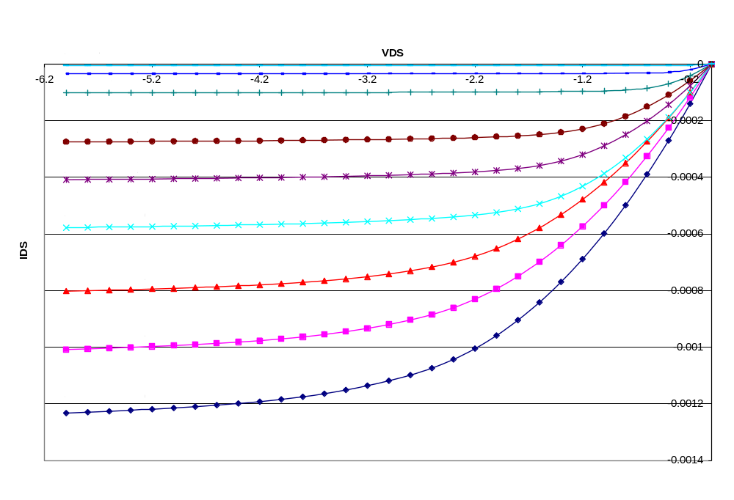
Figure 2: Ids vs. Vds for P-channel MOS

For Vds > - 2 Volts the average error is 7.2%.
For - 2 > Vds > - 4 Volts the average error is 9.2%.
For Vds < - 4 Volts the average error is 9.1%.

- Transient Analysis:

Transient analysis is done by giving pulse of 4.0 volt amplitude with rise time & fall time of 0.1 ns. The width and period of the pulse are 2 ns and 4 ns respectively. Figure 3 shows the .tran2 analysis of P- channel MOS.

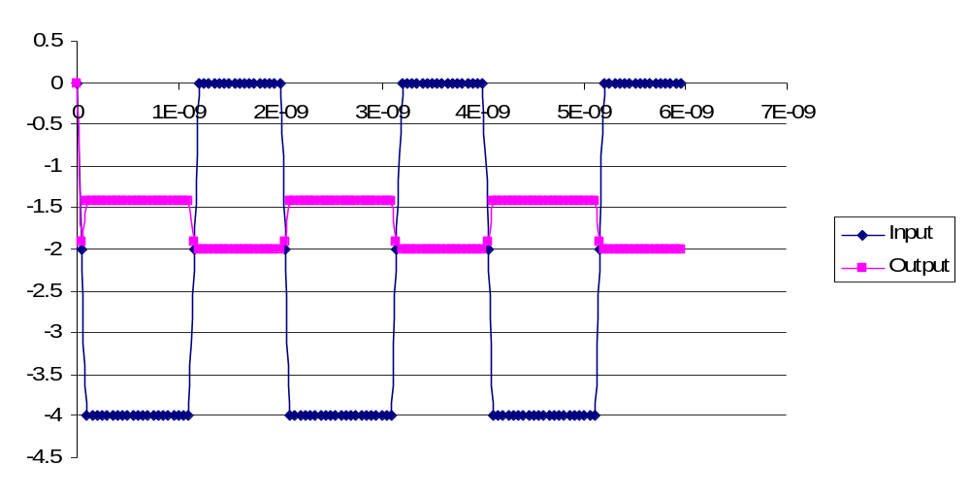
Figure 3: .tran2 analysis for P-channel MOS

Known Bugs:

None.

Credits:

Name | Affiliation | Date | Links
Yogesh Ramdoss  (ytramdos@ncsu.edu)  Kuldip Gothi  (kuldipgothi@yahoo.com)  Ajit Rajagopalan  (ajit_r@softhome.net)  Xuemin Yang  (xyang@ncsu.edu)  Xin Cai  (xcai2@ncsu.edu)  Dapeng Ding  (dding@ncsu.edu) | NC State University | April 2003 | www.ncsu.edu

