Ideal Transformer Transformer

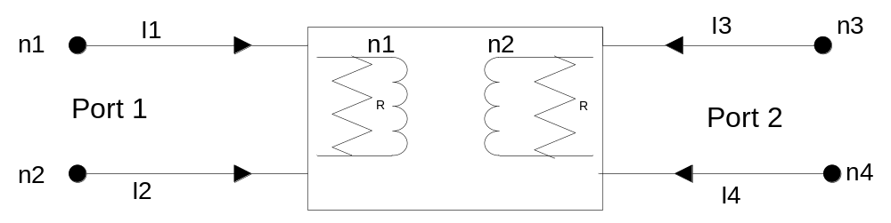

Description:
This element implements an ideal transformer model, for a given turns ratio, n1 (primary number of turns) and n2 (secondary number of turns), where R is leakage resistance.

Form: transformer: <instance name> n₁ n₂ n₃ n₄ <parameter list>
n₁ port #1 signal input terminal
n₂ port #1 reference terminal
n₃ port #2 signal output terminal
n₄ port #2 reference terminal

Parameters:

Parameter | Type | Default value | Required?
n1: number of turns in primary | DOUBLE | 1 | No
n2: number of turns in secondary | DOUBLE | 1 | No
R: Leakage resistance | DOUBLE | 1e10 | No

Examples:
// Vin GND Vout GND
transformer:trf 2 0 3 0
* Where ‘2 0’ input port & ‘3 0’ output port with ground as references.

// Example for Step-Down Voltage
transformer:trf 2 0 3 0 n1=10

// Example for Step-Up Voltage
transformer:trf 2 0 3 0 n2=10

Model Documentation:

An ideal transformer is represented by independent sides of primary and secondary wings. The mathematical model of the element consists of voltage ratio that depends on turns in primary to the secondary. The shunt leakage resistances were added to improve condition numbers for the simulator.

Let turn ratio be 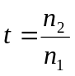 and g=1/R, then the following voltage relationship describes 2 sides of a transformer:

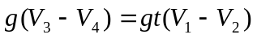 ➔ 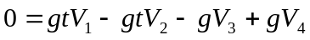

With introduction of the other state variable, I, relationship of currents as follow:

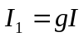
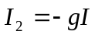
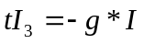 → 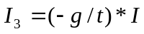
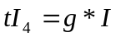 → 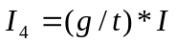

The ideal transformer does not have admittance matrix, thus modified nodal sparse technique was used to create matrix. The leakage resistance was entered into admittance matrix. Based on voltage and currents relationship the following stamp was developed.

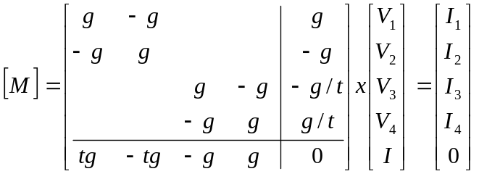

This matrix was used to code the stamp for an ideal transformer.

References:
“Illustrated Guide to PSPICE”, Robert Lamey, ISBN: 0827365241
“The Electrical Engineering Handbook”, Wai-Kai Chen, ISBN: 0121709604; pp55-56
“Fundamental Electrical Technology”, Marvin Klayton, ISBN: 0201038307
Professor: Michael Steer

Sample Netlist: Step up example
***** Ideal Transformer Test ************
***** transformer.net
***** transformer In LRT Out LRT n1=turns_primary n2=turns_second

.options gmin=0 ftol=1.e-10

.tran2 tstop = 50e-3 tstep = 10e-6 gcomp=0 im=2

***** print detailed info to .OUT file
.options verbose

**************** Circuit **************************
*++++++ source for transient analysis
vsource:v1 1 0 vac=10V f=60
r:rin 1 2 r=50

*+++++for turn ratio 1-to-10 -> Vin/t=Vout: 10V=100V
transformer:t1 2 0 3 0 n2=10

r:rload 3 0 r=1e6

***************** Simulation *******************************************
.options gnuplot

***************** Transient Simulation Results *************************
*++++++ set up plot preamble with font and label information
*.options plotVT1Preample="set term x11 font 'helvetica,18';
* set title 'Source Voltage';
* set xlabel 'Time (milliseconds)'; set ylabel 'Voltage *(V_ac)'"
*.out plot term 1 vt 1e3 scalex plotVT1Preample in "vsource.out"

.options plotVT1Preample="set term x11 font 'helvetica,18';
set title 'Voltage at Input Terminal';
set xlabel 'Time (milliseconds)'; set ylabel 'Voltage (V_ac)'"
.out plot term 2 vt 1e3 scalex plotVT1Preample in "vprimary.out"

.options plotVT1Preample="set term x11 font 'helvetica,18';
set title 'Voltage at Output Terminal';
set xlabel 'Time (milliseconds)'; set ylabel 'Voltage (V_ac)'"
.out plot term 3 vt 1e3 scalex plotVT1Preample in "vsecondary.out"

.end

Simulation Results: Below are results from above sample netlist. With input of 10 Volts the output was stepped-up by a factor of 10, which makes the output voltage equal to 100 Volts.

n2*Vin = n1*Vout, therefore Vout=Vin*(n2/n1)=10V*(10/1)=100V

Input Voltage:

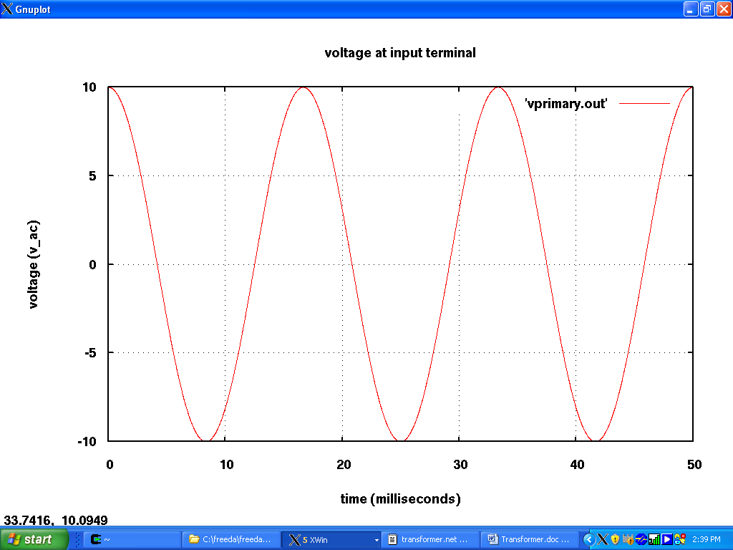

Output Voltage:
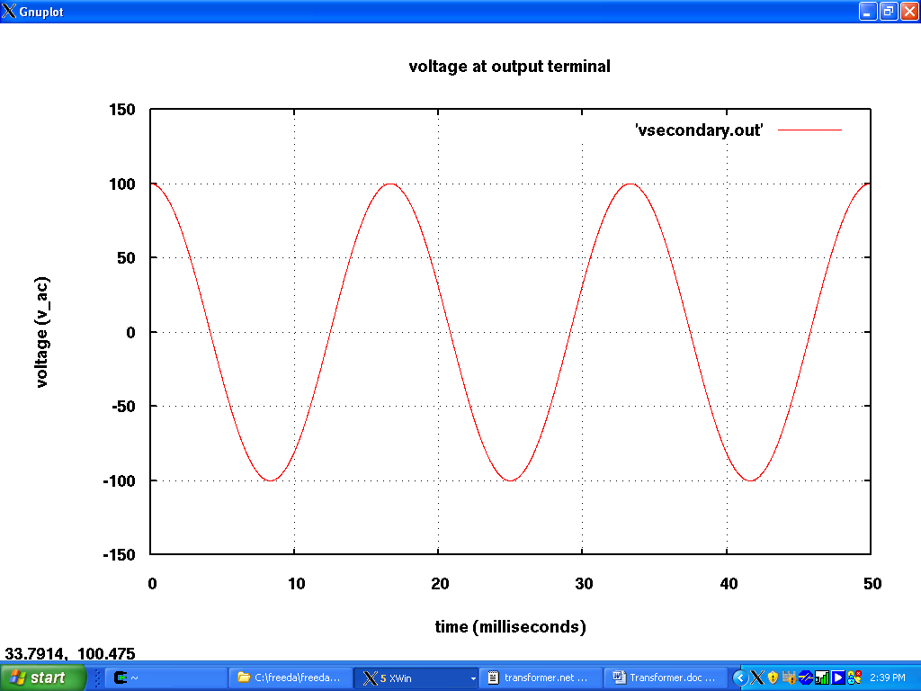

Sample Netlist: Step down example
***** Ideal Transformer Test ************
***** transformer.net
***** transformer In LRT Out LRT n1=turns_primary n2=turns_second

.options gmin=0 ftol=1.e-10
.tran2 tstop = 50e-3 tstep = 10e-6 gcomp=0 im=2

***** print detailed info to .OUT file
.options verbose

**************** Circuit **************************
*++++++ source for transient analysis
vsource:v1 1 0 vac=10V f=60
r:rin 1 2 r=50

*+++++for turn ratio 10-to-1 -> Vin/t=Vout: 10V=0.1V
transformer:t1 2 0 3 0 n1=10

r:rload 3 0 r=1e6

***************** Simulation *******************************************
.options gnuplot

***************** Transient Simulation Results *************************
*++++++ set up plot preamble with font and label information
*.options plotVT1Preample="set term x11 font 'helvetica,18';
* set title 'Source Voltage';
* set xlabel 'Time (milliseconds)'; set ylabel 'Voltage (V_ac)'"
*.out plot term 1 vt 1e3 scalex plotVT1Preample in "vsource.out"

.options plotVT1Preample="set term x11 font 'helvetica,18';
set title 'Voltage at Input Terminal';
set xlabel 'Time (milliseconds)'; set ylabel 'Voltage (V_ac)'"
.out plot term 2 vt 1e3 scalex plotVT1Preample in "vprimary.out"

.options plotVT1Preample="set term x11 font 'helvetica,18';
set title 'Voltage at Output Terminal';
set xlabel 'Time (milliseconds)'; set ylabel 'Voltage (V_ac)'"
.out plot term 3 vt 1e3 scalex plotVT1Preample in "vsecondary.out"

.end

Simulation Results: Below are results from above step-down sample netlist. With input of 10 Volts output was 1 Volt.

n2*Vin = n1*Vout, therefore Vout=Vin*(n2/n1)=10V*(1/10)=1V

Input Voltage:
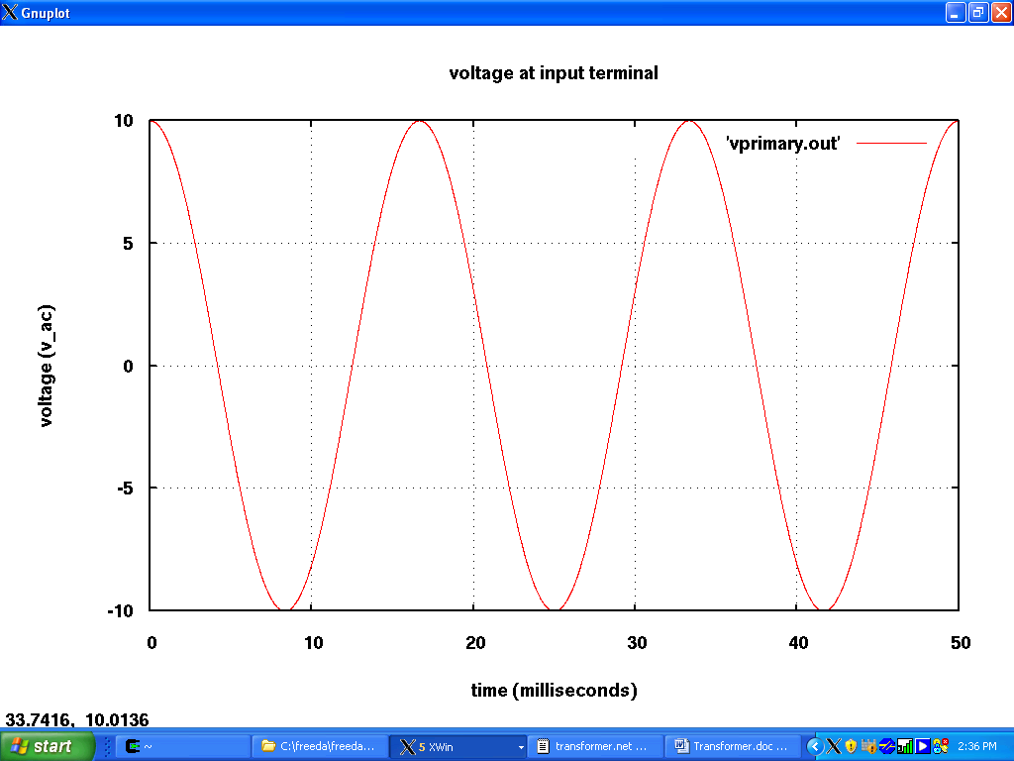

Output Voltage:
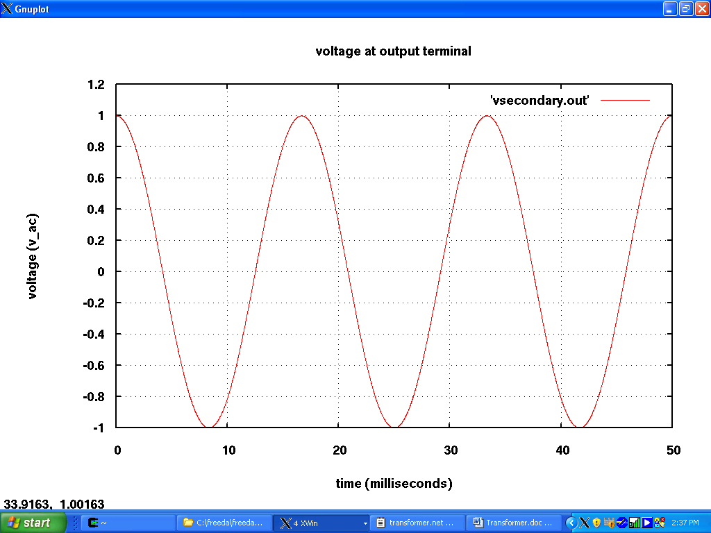

Sample Netlist: Example for using other reference point then ground
***** Ideal Transformer Test ************
***** transformer.net
***** transformer In LRT Out LRT n1=turns_primary n2=turns_second

.options gmin=0 ftol=1.e-10

.tran2 tstop = 50e-3 tstep = 10e-6 gcomp=0 im=2

***** print detailed info to .OUT file
.options verbose

**************** Circuit **************************
*++++++ source for transient analysis
vsource:v1 1 0 vac=10V f=60
r:rin 1 2 r=50

*+++++ for output reference other then Ground
*+++++ turn ratio=1-to-1 -> Vin=Vout
transformer:t1 2 0 3 4
*+++++ Define reference point for FREEDA
.ref 4
r:rload 3 4 r=1.e6

***************** Simulation *******************************************
.options gnuplot

***************** Transient Simulation Results *************************
*++++++ set up plot preamble with font and label information
*.options plotVT1Preample="set term x11 font 'helvetica,18';
* set title 'Source Voltage';
* set xlabel 'Time (milliseconds)'; set ylabel 'Voltage (V_ac)'"
*.out plot term 1 vt 1e3 scalex plotVT1Preample in "vsource.out"

.options plotVT1Preample="set term x11 font 'helvetica,18';
set title 'Voltage at Input Terminal';
set xlabel 'Time (milliseconds)'; set ylabel 'Voltage (V_ac)'"
.out plot term 2 vt 1e3 scalex plotVT1Preample in "vprimary.out"

.options plotVT1Preample="set term x11 font 'helvetica,18';
set title 'Voltage at Output Terminal';
set xlabel 'Time (milliseconds)'; set ylabel 'Voltage (V_ac)'"
.out plot term 3 vt 1e3 scalex plotVT1Preample in "vsecondary.out"

.end

Simulation Results: Below are results from above sample netlist. With input of 10 Volts output was 10 Volt, because default turn ratio is 1. In the simulator “.ref 4” defines reference point, other then ground. So here the circuit has two independent sides. This netlist also works as step-up and/or step-down voltage transformation for different n1 & n2 values.

Input Voltage:
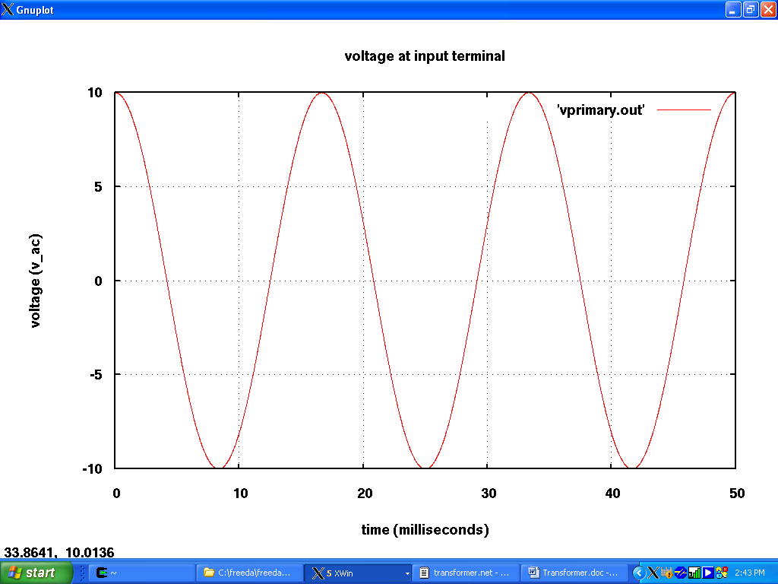

Output Voltage:
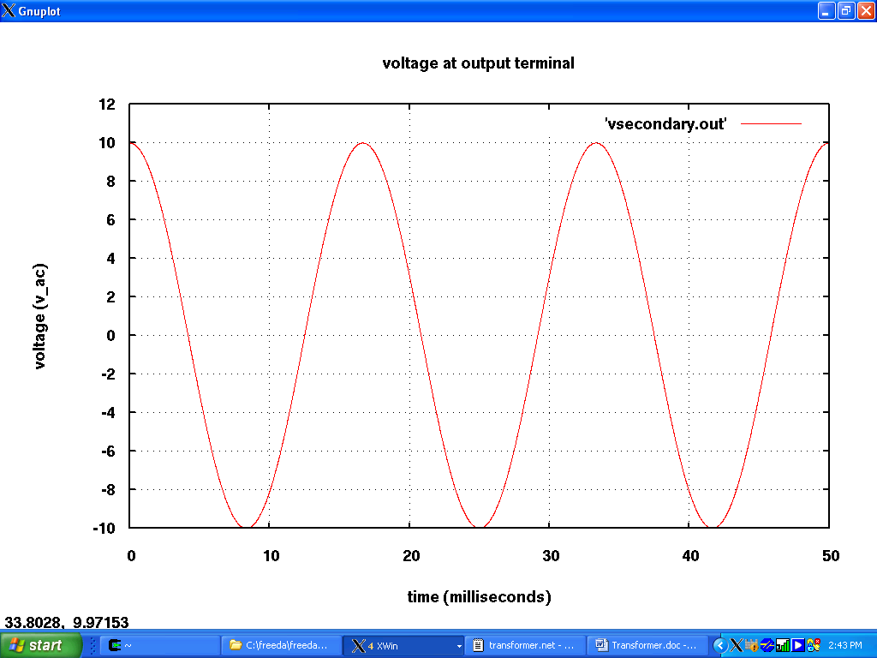

Sample Netlist: Example for using .AC analysis
***** Ideal Transformer Test ************
***** transformer.net
***** transformer In LRT Out LRT n1=turns_primary n2=turns_second

.options gmin=0 ftol=1.e-10

.ac start=1 stop = 100 n_freqs=10
***** print detailed info to .OUT file
.options verbose

**************** Circuit **************************
*++++++ source for ac analysis
vsource:v1 1 0 vac=10V

r:rin 1 2 r=50

*+++++for turn ratio 10-to-1 -> Vin/t=Vout: 10V=0.1V
transformer:t1 2 0 3 0 n1=10

r:rload 3 0 r=1e6

***************** Simulation *******************************************
.options gnuplot

****************** Frequency Simulation Results (.AC analysis)************
.options plotVT1Preample="set term x11 font 'helvetica,18';
set title 'Voltage at Input Terminal';
set xlabel 'Frequency (Hz)'; set ylabel 'Voltage (V_ac)'"
.out plot term 2 vf mag plotVT1Preample in "vprimary.out"

.options plotVT1Preample="set term x11 font 'helvetica,18';
set title 'Voltage at Output Terminal';
set xlabel 'Frequency (Hz)'; set ylabel 'Voltage (V_ac)'"
.out plot term 3 vf mag plotVT1Preample in "vsecondary.out"

.end

Simulation Results: Below are results from above sample netlist. With input of 10 Volts the output was 1 Volt, because turn ratio was 10-to-1. And as an ideal transformer output is flat across all frequency.

Input Voltage:
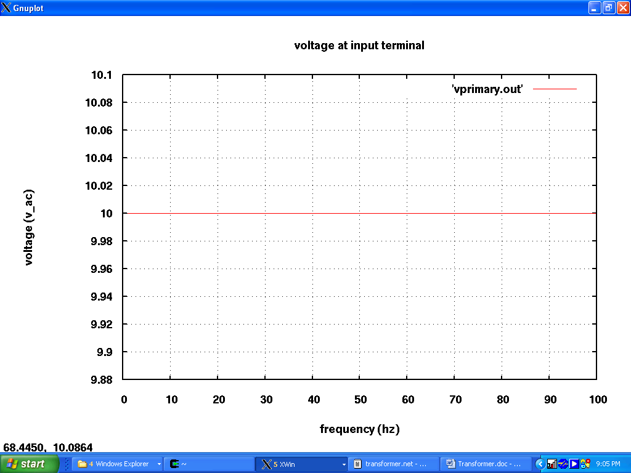

Output Voltage:
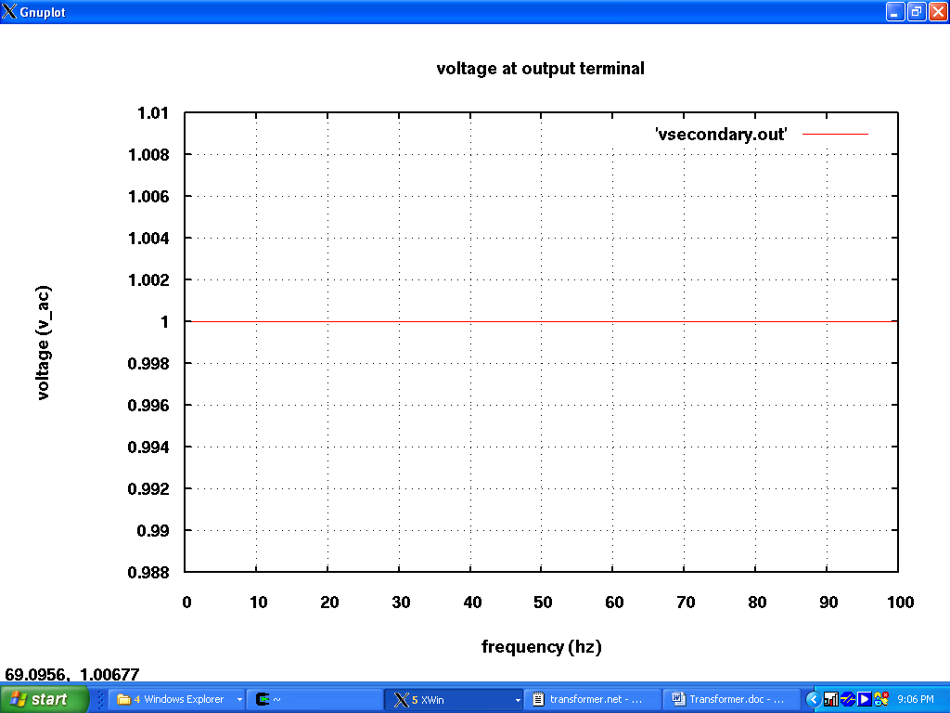

Known Bugs:
None found.

Version: 2008.04.15
Credits:
Name Affiliation Date Links
Olga Andreescu NC State University April 2008 www.ncsu.edu
oandree@ncsu.edu

