Center-Tap Transformer TransformerCT

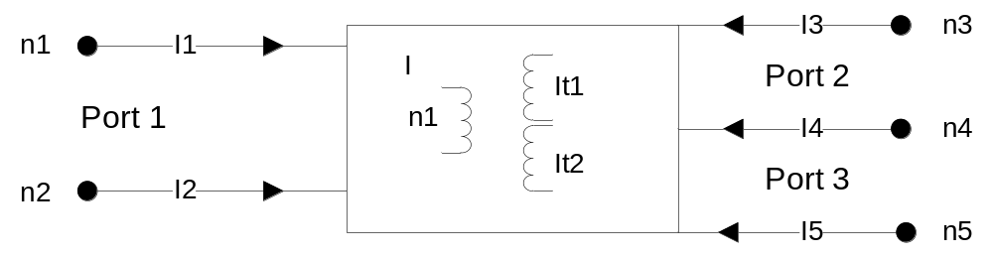

Description:

This element implements a center-tap transformer model. Coupling values and turn ratio are optional and can be used for step-up or step-down voltage transformations.

Form: transformerct: <instance name> n₁ n₂ n₃ n₄ n₅ <parameter list>
n₁ port #1 signal input terminal
n₂ port #1 reference terminal
n₃ port #2 signal input terminal
n₄ port #2 & port #3 reference terminal
n₅ port #3 signal input terminal

Parameters:
Parameter | Type | Default value | Required?
n1: number of turns in primary | DOUBLE | 1 | No
n2: number of turns in 1st secondary | DOUBLE | 1 | No
n3: number of turns in 2nd secondary | DOUBLE | 1 | No
k12: coupling between primary and 1st secondary | DOUBLE | 1 | No
k13: coupling between primary and 2nd secondary | DOUBLE | 1 | No
R: Leakage resistance | DOUBLE | 1e10 | No

There are the three equal value leakage resistances R, between the terminal pairs (n1,n2), (n3,n4) and (n4,n5). This is required for numerical conditioning.

Example:
// Vin GND Vout1 GND Vout2
transformerct:trf 2 0 3 0 5
* Where ‘2 0’ input port & ‘3 0’ and ‘5 0’ output ports with ground as references.

// Example for Step-Down Voltage
transformerct:trf 2 0 3 0 5 n1=10

// Example for Step-Up Voltage
transformerct:trf 2 0 3 0 5 n2=10 n3=10

Model Documentation:
The center-tap transformer is represented by symmetrically coupled 3 coils in primary and secondary wings. The shunt leakage resistances were added to improve condition numbers for the simulator.

Let turn ratios and coupling between coils be 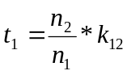 and 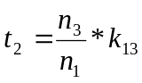, and let g=1/R, then the following mathematical formulation of the voltages relationship is

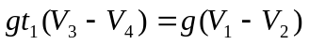 → 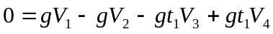
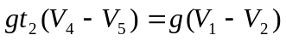 → 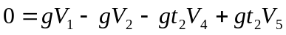

With introduction of the two unknown variables, Ia₁ and Ia₂, relationship of currents are found to be the following:
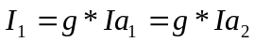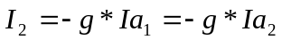
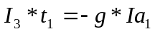
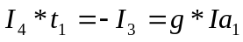
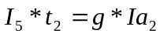
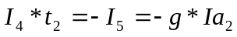

Ideal center-tap transformer do not have admittance, thus modified nodal sparse technique was used to create matrix. Based on voltage and current relationships the following stamp of modified nodal matrix was developed for 5 ports center-tap transformer model.

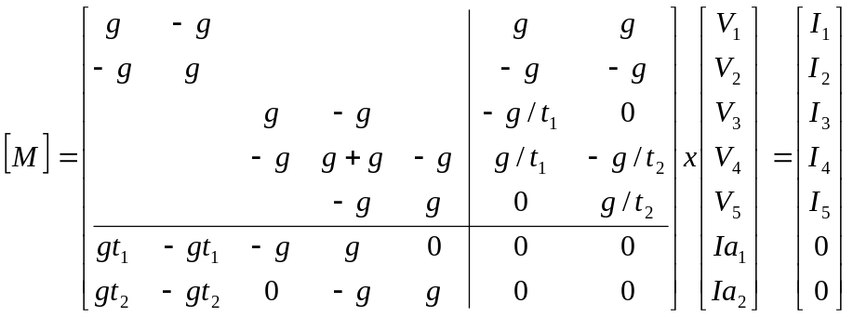

This modified nodal matrix was used to code the stamp for the ideal center-tap transformer. This stamp of symmetrical center tap transformer is allowed to use the different secondary coils turns numbers for none equal output voltages. The disadvantage of this stamp it is enlarges the modified nodal admittance matrix.

References:
“Illustrated Guide to PSPICE”, Robert Lamey, ISBN: 0827365241
“Fundamental Electrical Technology”, Marvin Klayton, ISBN: 0201038307

Sample Netlist: Step-up example
*++++++++++ Transformer Center-tap test +++++++++++++++++++++++++++++
*++++++++++ cttransformer.net
*+++++ transformerct:t1 in ref out1 ref out2
*+++++ print detailed info to .OUT file
.options verbose
.options gmin=0 ftol=1.e-10

*.ac start=1 stop = 10 n_freqs=10
.tran2 tstop = 50e-3 tstep = 10e-6 gcomp=0 im=2

*++++++++++++++++++ Circuit +++++++++++++++++++++++++++++++++++++++++
*++++++++++ source for ac analysis
*vsource:v1 1 0 vac=10V

*++++++++++ source for transient analysis
vsource:v1 1 0 vac=10V f=60

r:rin 1 2 r=50

*+++++for turn ratio 1-to-1 Vin=Vout: 10V=10V
*+++++for turn ratio 10-to-1 -> Vin(1/10)=Vout: 10V=0.1V make n1=10
*+++++for turn ratio 1-to-10 -> Vin(10/1)=Vout: 10V=100V make n2=10 n3=10
*&&&&&&&&&&&&&&&&&&&&&&&&&&&&&&&&&&&&&&&&&&&&&&&&&&&&&&&&&&&&&&&&&&
*+++++for turn ratio 1-to-10 and 1-to-2 ->
*+++++Vin(10/1)=1st Vout: n2=10 for Vout1=100V
*+++++Vin(2/1)=2nd Vout: n3=2 for Vout2=20V

transformerct:t1 2 0 3 0 4 n2=10 n3=2
r:rload1 4 0 r=1e6
r:rload2 3 0 r=1e6

*++++++++++++++++++++++++ Simulation +++++++++++++++++++++++++++++++++++
.options gnuplot

***************** Transient Simulation Results *************************
*++++++ set up plot preamble with font and label information
.options plotVT1Preample="set term x11 font 'helvetica,18';
set title 'Voltage at Input Terminal';
set xlabel 'Time (milliseconds)'; set ylabel 'Voltage (V_ac)'"
.out plot term 2 vt 1e3 scalex plotVT1Preample in "vprimary.out"

.options plotVT1Preample="set term x11 font 'helvetica,18';
set title 'Voltage at 1st Output Terminal';
set xlabel 'Time (milliseconds)'; set ylabel 'Voltage (V_ac)'"
.out plot term 3 vt 1e3 scalex plotVT1Preample in "vsecondary1.out"

.options plotVT1Preample="set term x11 font 'helvetica,18';
set title 'Voltage at 2nd Output Terminal';
set xlabel 'Time (milliseconds)'; set ylabel 'Voltage (V_ac)'"
.out plot term 4 vt 1e3 scalex plotVT1Preample in "vsecondary2.out"

****************** Frequency Simulation Results (.AC analysis)************
*.options plotVT1Preample="set term x11 font 'helvetica,18';
* set title 'Voltage at Input Terminal';
* set xlabel 'Frequency (Hz)'; set ylabel 'Voltage (V_ac)'"
*.out plot term 2 vf mag plotVT1Preample in "vprimary.out"

*.options plotVT1Preample="set term x11 font 'helvetica,18';
* set title 'Voltage at Output Terminal';
* set xlabel 'Frequency (Hz)'; set ylabel 'Voltage (V_ac)'"
*.out plot term 3 vf mag plotVT1Preample in "vsecondary1.out"

*.options plotVT1Preample="set term x11 font 'helvetica,18';
* set title 'Voltage at Output Terminal';
* set xlabel 'Frequency (Hz)'; set ylabel 'Voltage (V_ac)'"
*.out plot term 4 vf mag plotVT1Preample in "vsecondary2.out"

*.out plot term 1 vt in "source.out"
.end

Simulation Results: below are results from above sample netlist. On 10 volts input the outputs were 100 volts for 1st secondary and 20 volts for 2nd secondary outputs.
n2*Vin = n1*Vout1, therefore Vout1=Vin*(n2/n1)=10V*(10/1)=100V
n3*Vin = n1*Vout2, therefore Vout2=Vin*(n3/n1)=10V*(2/1)=20V

Input Voltage:
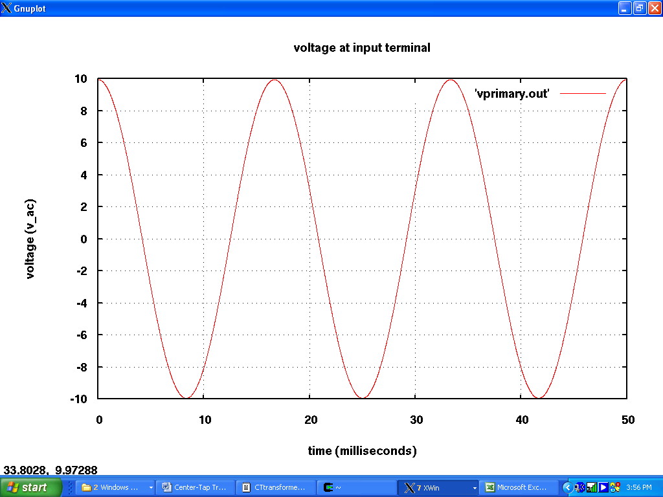

Output Voltages:
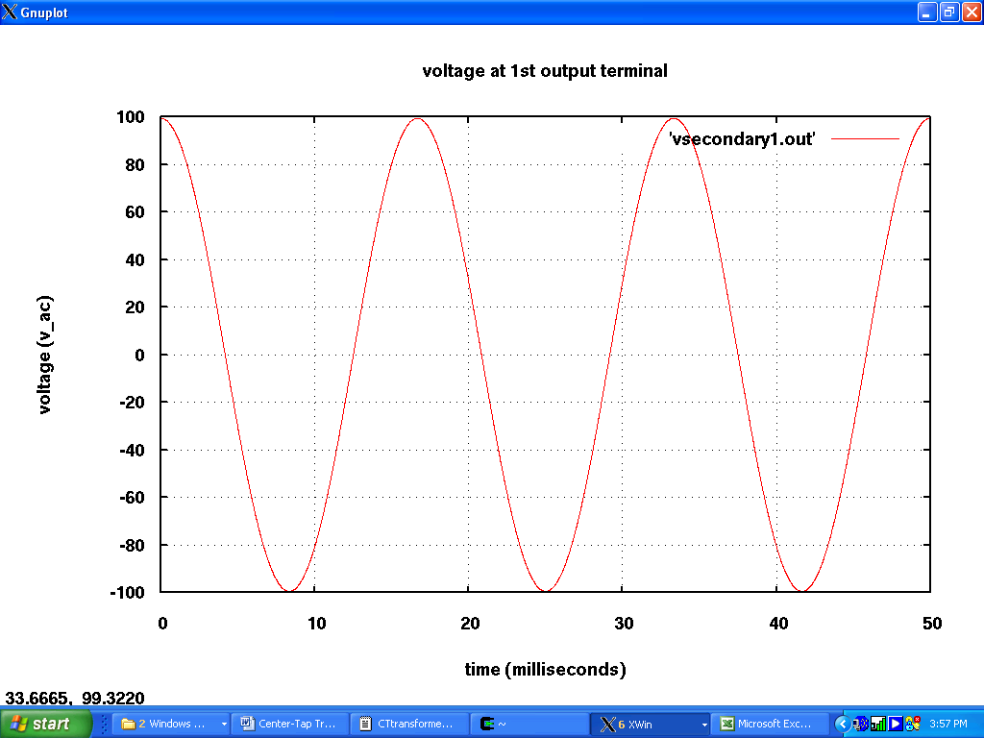
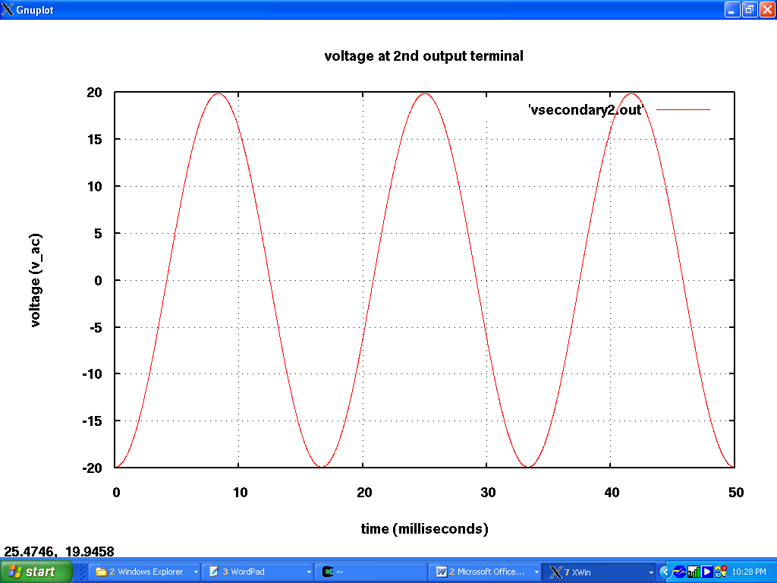

Sample Netlist: Step-Down example
*++++++++++ Transformer Center-tap test +++++++++++++++++++++++++++++
*++++++++++ cttransformer.net
*+++++ transformerct:t1 in ref out1 ref out2
*+++++ print detailed info to .OUT file
.options verbose
.options gmin=0 ftol=1.e-10

*.ac start=1 stop = 10 n_freqs=10
.tran2 tstop = 50e-3 tstep = 10e-6 gcomp=0 im=2

*++++++++++++++++++ Circuit +++++++++++++++++++++++++++++++++++++++++
*++++++++++ source for ac analysis
*vsource:v1 1 0 vac=10V

*++++++++++ source for transient analysis
vsource:v1 1 0 vac=10V f=60

r:rin 1 2 r=50

*+++++for turn ratio 1-to-1 Vin=Vout: 10V=10V
*+++++for turn ratio 10-to-1 -> Vin(1/10)=Vout: 10V=0.1V make n1=10
*+++++for turn ratio 1-to-10 -> Vin(10/1)=Vout: 10V=100V make n2=10 n3=10
*&&&&&&&&&&&&&&&&&&&&&&&&&&&&&&&&&&&&&&&&&&&&&&&&&&&&&&&&&&&&&&&&&&
*+++++for turn ratio 1-to-10 and 1-to-2 ->
*+++++Vin(10/1)=1st Vout: n2=10 for Vout1=100V
*+++++Vin(2/1)=2nd Vout: n3=2 for Vout2=20V

transformerctprof:t1 2 0 3 0 4 n1=10
r:rload1 4 0 r=1e6
r:rload2 3 0 r=1e6

*++++++++++++++++++++++++ Simulation +++++++++++++++++++++++++++++++++++
.options gnuplot

***************** Transient Simulation Results *************************
*++++++ set up plot preamble with font and label information
.options plotVT1Preample="set term x11 font 'helvetica,18';
set title 'Voltage at Input Terminal';
set xlabel 'Time (milliseconds)'; set ylabel 'Voltage (V_ac)'"
.out plot term 2 vt 1e3 scalex plotVT1Preample in "vprimary.out"

.options plotVT1Preample="set term x11 font 'helvetica,18';
set title 'Voltage at 1st Output Terminal';
set xlabel 'Time (milliseconds)'; set ylabel 'Voltage (V_ac)'"
.out plot term 3 vt 1e3 scalex plotVT1Preample in "vsecondary1.out"

.options plotVT1Preample="set term x11 font 'helvetica,18';
set title 'Voltage at 2nd Output Terminal';
set xlabel 'Time (milliseconds)'; set ylabel 'Voltage (V_ac)'"
.out plot term 4 vt 1e3 scalex plotVT1Preample in "vsecondary2.out"

****************** Frequency Simulation Results (.AC analysis)************
*.options plotVT1Preample="set term x11 font 'helvetica,18';
* set title 'Voltage at Input Terminal';
* set xlabel 'Frequency (Hz)'; set ylabel 'Voltage (V_ac)'"
*.out plot term 2 vf mag plotVT1Preample in "vprimary.out"

*.options plotVT1Preample="set term x11 font 'helvetica,18';
* set title 'Voltage at Output Terminal';
* set xlabel 'Frequency (Hz)'; set ylabel 'Voltage (V_ac)'"
*.out plot term 3 vf mag plotVT1Preample in "vsecondary1.out"

*.options plotVT1Preample="set term x11 font 'helvetica,18';
* set title 'Voltage at Output Terminal';
* set xlabel 'Frequency (Hz)'; set ylabel 'Voltage (V_ac)'"
*.out plot term 4 vf mag plotVT1Preample in "vsecondary2.out"

*.out plot term 1 vt in "source.out"
.end

Simulation Results: below are results from above sample netlist. On 10 volts input the outputs were 1 volt each.
n2*Vin = n1*Vout1, therefore Vout1=Vin*(n2/n1)=10V*(1/10)=1V
n3*Vin = n1*Vout2, therefore Vout2=Vin*(n3/n1)=10V*(1/10)=1V

Input Voltage:
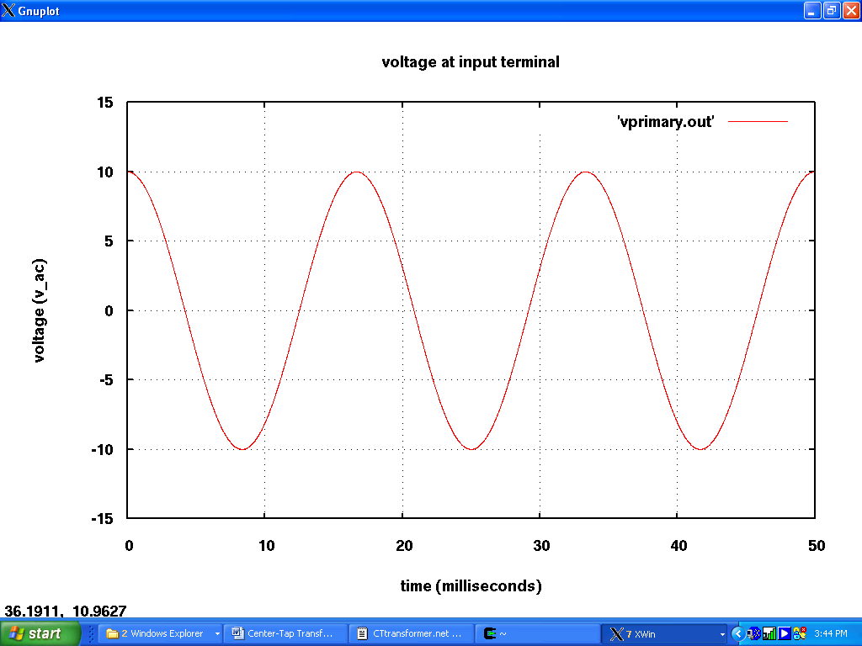

Output Voltages:
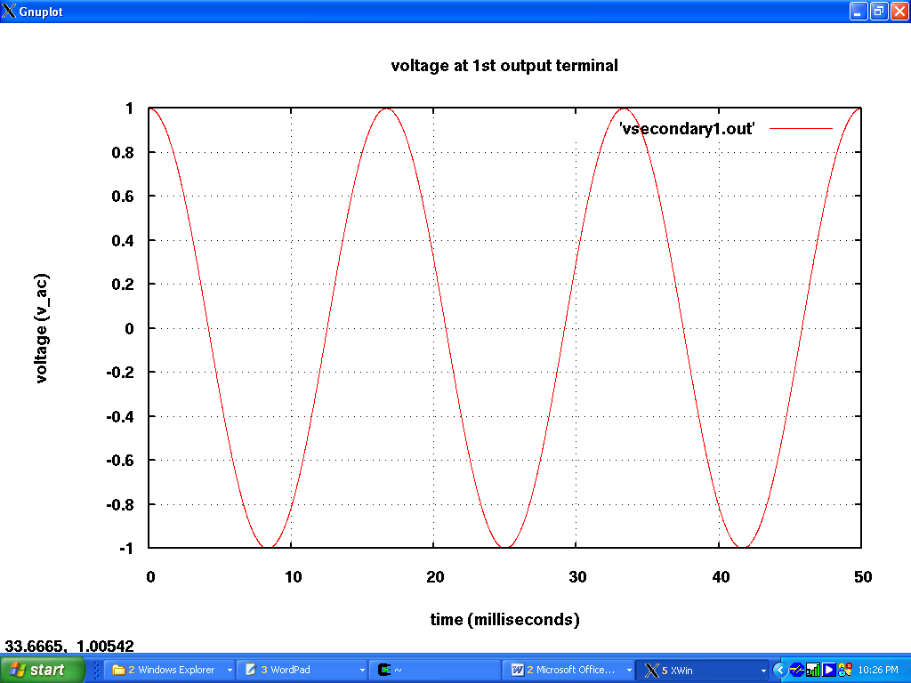
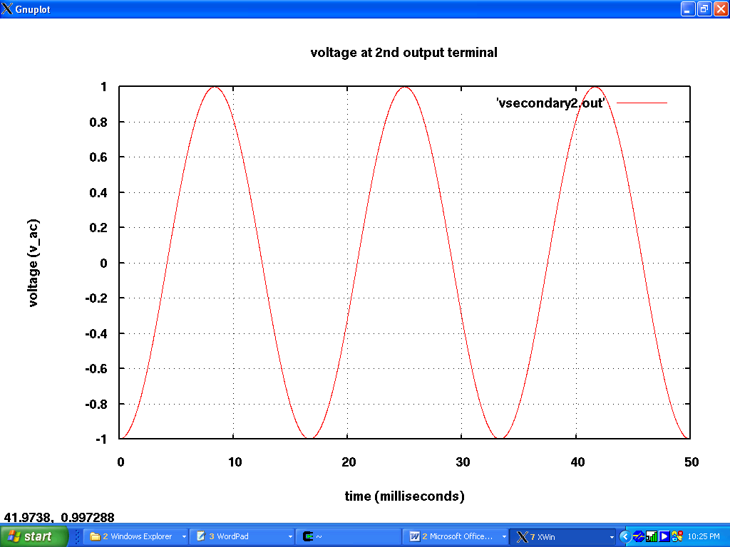

Sample Netlist: Example for using other reference point then ground
*++++++++++ Transformer Center-tap test +++++++++++++++++++++++++++++
*++++++++++ cttransformer.net
*+++++ transformerct:t1 in ref out1 ref out2
*+++++ print detailed info to .OUT file
.options verbose
.options gmin=0 ftol=1.e-10

*.ac start=1 stop = 10 n_freqs=10
.tran2 tstop = 50e-3 tstep = 10e-6 gcomp=0 im=2

*++++++++++++++++++ Circuit +++++++++++++++++++++++++++++++++++++++++
*++++++++++ source for ac analysis
*vsource:v1 1 0 vac=10V

*++++++++++ source for transient analysis
vsource:v1 1 0 vac=10V f=60

r:rin 1 2 r=50

*+++++for turn ratio 1-to-1 Vin=Vout: 10V=10V
*+++++for turn ratio 10-to-1 -> Vin(1/10)=Vout: 10V=0.1V make n1=10
*+++++for turn ratio 1-to-10 -> Vin(10/1)=Vout: 10V=100V make n2=10 n3=10
*&&&&&&&&&&&&&&&&&&&&&&&&&&&&&&&&&&&&&&&&&&&&&&&&&&&&&&&&&&&&&&&&&&
*+++++for turn ratio 1-to-10 and 1-to-2 ->
*+++++Vin(10/1)=1st Vout: n2=10 for Vout1=100V
*+++++Vin(2/1)=2nd Vout: n3=2 for Vout2=20V
*transformerct:t1 2 0 3 0 4 n2=10 n3=2

*&&&&&&&&&&&&&&&&&&&&&&&&&&&&&&&&&&&&&&&&&&&&&&&&&&&&&&&&&&&&&&&&&&
*&&& Configuration of transformer with reference point other then ground
*&&& This configuration make secondary winding independance from first
*&&& ".REF node#" defines reference point other then GROUND
*&&& Vin=10V, n1=n2=n3=1 by default
*&&& having k12=0.5 -> Vout1=10*0.5=5V
*&&& having k12=0.1 -> Vout2=10*0.1=1V
transformerct:t1 2 0 3 5 4 k12=0.5 k13=0.1
.ref 5
r:ref1 3 5 r=1e6
r:ref2 4 5 r=1e6
*&&&&&&&&&&&&&&&&&&&&&&&&&&&&&&&&&&&&&&&&&&&&&&&&&&&&&&&&&&&&&&&&&&&&

*r:rload1 4 0 r=1e6
*r:rload2 3 0 r=1e6

*++++++++++++++++++++++++ Simulation +++++++++++++++++++++++++++++++++++
.options gnuplot

***************** Transient Simulation Results *************************
*++++++ set up plot preamble with font and label information
.options plotVT1Preample="set term x11 font 'helvetica,18';
set title 'Voltage at Input Terminal';
set xlabel 'Time (milliseconds)'; set ylabel 'Voltage (V_ac)'"
.out plot term 2 vt 1e3 scalex plotVT1Preample in "vprimary.out"

.options plotVT1Preample="set term x11 font 'helvetica,18';
set title 'Voltage at 1st Output Terminal';
set xlabel 'Time (milliseconds)'; set ylabel 'Voltage (V_ac)'"
.out plot term 3 vt 1e3 scalex plotVT1Preample in "vsecondary1.out"

.options plotVT1Preample="set term x11 font 'helvetica,18';
set title 'Voltage at 2nd Output Terminal';
set xlabel 'Time (milliseconds)'; set ylabel 'Voltage (V_ac)'"
.out plot term 4 vt 1e3 scalex plotVT1Preample in "vsecondary2.out"

****************** Frequency Simulation Results (.AC analysis)************
*.options plotVT1Preample="set term x11 font 'helvetica,18';
* set title 'Voltage at Input Terminal';
* set xlabel 'Frequency (Hz)'; set ylabel 'Voltage (V_ac)'"
*.out plot term 2 vf mag plotVT1Preample in "vprimary.out"

*.options plotVT1Preample="set term x11 font 'helvetica,18';
* set title 'Voltage at Output Terminal';
* set xlabel 'Frequency (Hz)'; set ylabel 'Voltage (V_ac)'"
*.out plot term 3 vf mag plotVT1Preample in "vsecondary1.out"

*.options plotVT1Preample="set term x11 font 'helvetica,18';
* set title 'Voltage at Output Terminal';
* set xlabel 'Frequency (Hz)'; set ylabel 'Voltage (V_ac)'"
*.out plot term 4 vf mag plotVT1Preample in "vsecondary2.out"

*.out plot term 1 vt in "source.out"
.end

Simulation Results: Below are results from above sample netlist. With input of 10 Volts 1st and 2nd outputs were 5 and 1 Volts respectively, because I used different coupling values between coils. In the simulator “.ref 5” defines reference point, other then ground. So here the circuit has two independent sides. This netlist also works as step-up and/or step-down voltage transformation for different number of turn’s values.

Input Voltage:
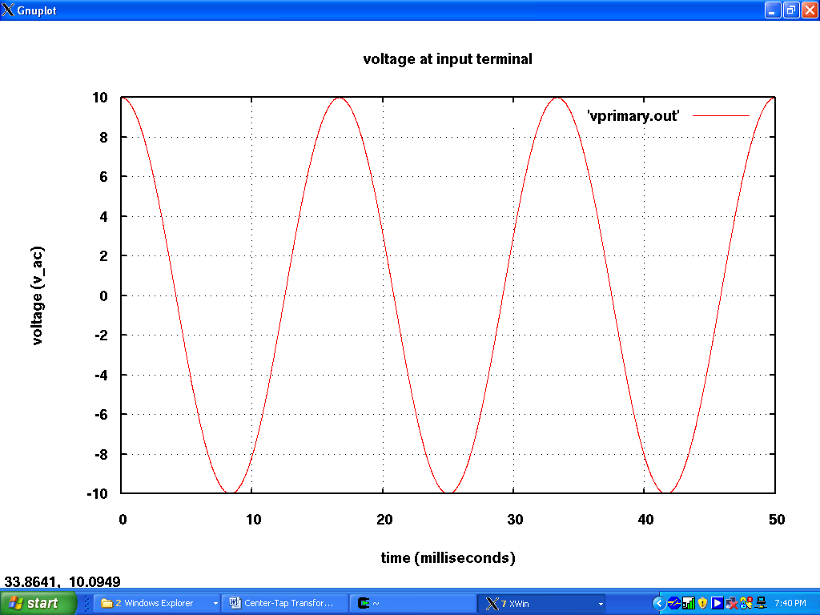

Output Voltages:
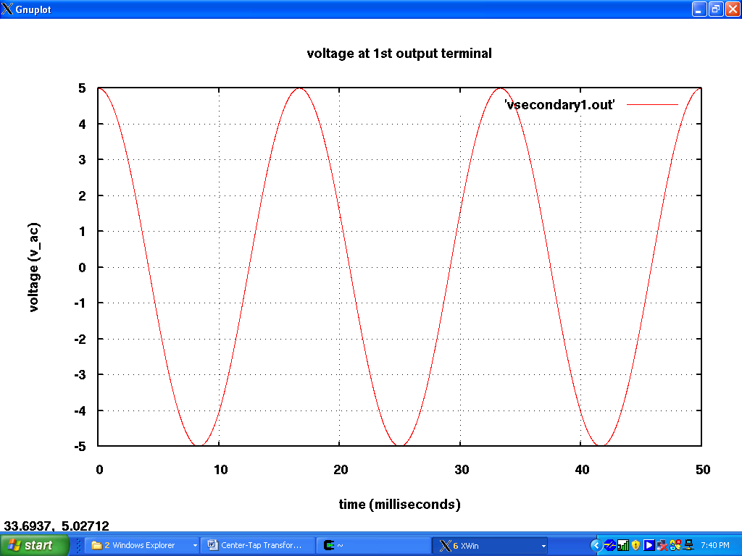
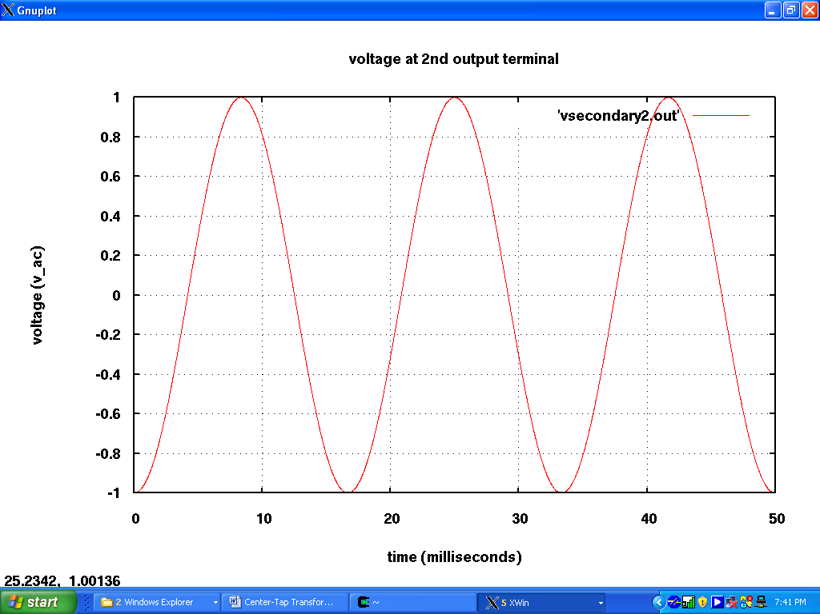

Sample Netlist: .AC analysis example
*++++++++++ Transformer Center-tap test +++++++++++++++++++++++++++++
*++++++++++ cttransformer.net
*+++++ transformerct:t1 in ref out1 ref out2
*+++++ print detailed info to .OUT file
.options verbose
.options gmin=0 ftol=1.e-10

.ac start=1 stop = 10 n_freqs=10
*.tran2 tstop = 50e-3 tstep = 10e-6 gcomp=0 im=2

*++++++++++++++++++ Circuit +++++++++++++++++++++++++++++++++++++++++
*++++++++++ source for ac analysis
vsource:v1 1 0 vac=10V

*++++++++++ source for transient analysis
*vsource:v1 1 0 vac=10V f=60

r:rin 1 2 r=50

*+++++for turn ratio 1-to-1 Vin=Vout: 10V=10V
*+++++for turn ratio 10-to-1 -> Vin(1/10)=Vout: 10V=0.1V make n1=10
*+++++for turn ratio 1-to-10 -> Vin(10/1)=Vout: 10V=100V make n2=10 n3=10
*&&&&&&&&&&&&&&&&&&&&&&&&&&&&&&&&&&&&&&&&&&&&&&&&&&&&&&&&&&&&&&&&&&
*+++++for turn ratio 1-to-10 and 1-to-2 ->
*+++++Vin(10/1)=1st Vout: n2=10 for Vout1=100V
*+++++Vin(2/1)=2nd Vout: n3=2 for Vout2=20V

transformerct:t1 2 0 3 0 4
r:rload1 4 0 r=1e6
r:rload2 3 0 r=1e6

*++++++++++++++++++++++++ Simulation +++++++++++++++++++++++++++++++++++
.options gnuplot

***************** Transient Simulation Results *************************
*++++++ set up plot preamble with font and label information
*.options plotVT1Preample="set term x11 font 'helvetica,18';
* set title 'Voltage at Input Terminal';
* set xlabel 'Time (milliseconds)'; set ylabel 'Voltage (V_ac)'"
*.out plot term 2 vt 1e3 scalex plotVT1Preample in "vprimary.out"

*.options plotVT1Preample="set term x11 font 'helvetica,18';
* set title 'Voltage at 1st Output Terminal';
* set xlabel 'Time (milliseconds)'; set ylabel 'Voltage (V_ac)'"
*.out plot term 3 vt 1e3 scalex plotVT1Preample in "vsecondary1.out"

*.options plotVT1Preample="set term x11 font 'helvetica,18';
* set title 'Voltage at 2nd Output Terminal';
* set xlabel 'Time (milliseconds)'; set ylabel 'Voltage (V_ac)'"
*.out plot term 4 vt 1e3 scalex plotVT1Preample in "vsecondary2.out"

****************** Frequency Simulation Results (.AC analysis)************
.options plotVT1Preample="set term x11 font 'helvetica,18';
set title 'Voltage at Input Terminal';
set xlabel 'Frequency (Hz)'; set ylabel 'Voltage (V_ac)'"
.out plot term 2 vf mag plotVT1Preample in "vprimary.out"

.options plotVT1Preample="set term x11 font 'helvetica,18';
set title 'Voltage at Output Terminal';
set xlabel 'Frequency (Hz)'; set ylabel 'Voltage (V_ac)'"
.out plot term 3 vf mag plotVT1Preample in "vsecondary1.out"

.options plotVT1Preample="set term x11 font 'helvetica,18';
set title 'Voltage at Output Terminal';
set xlabel 'Frequency (Hz)'; set ylabel 'Voltage (V_ac)'"
.out plot term 4 vf mag plotVT1Preample in "vsecondary2.out"

*.out plot term 1 vt in "source.out"
.end

Simulation Results: Below are results from above sample netlist. On 10 volts input the outputs were 10 volts each, because turns ratio was default and equal to 1 to 1. And as ideal transformer, the output is flat and none frequency dependent. Also, this transformer model works at DC as superconducting element (direct current).

Input Voltage:
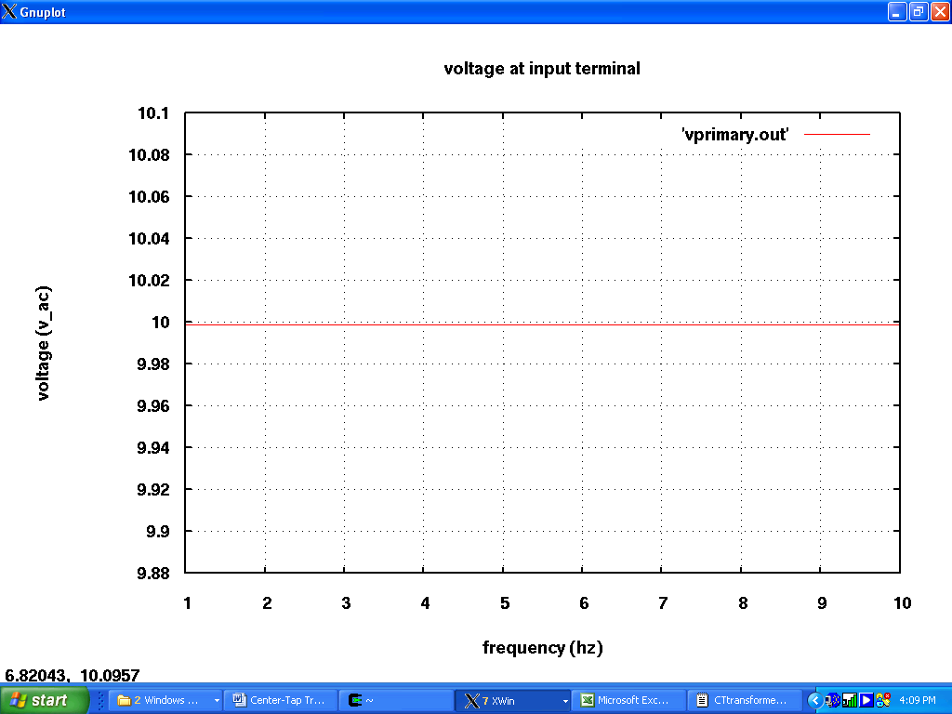

Output Voltages:
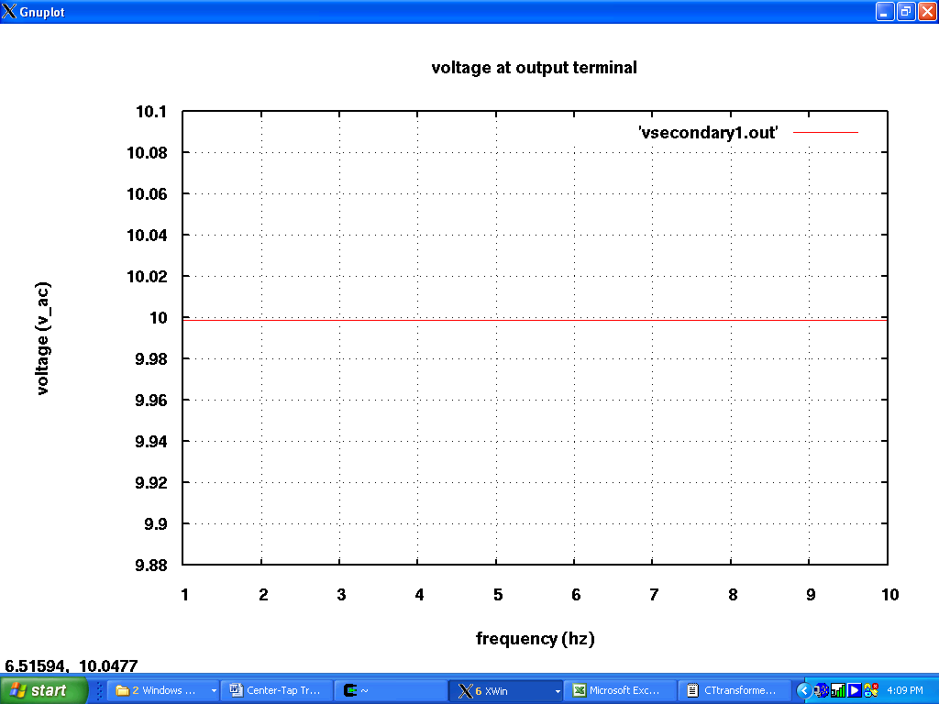
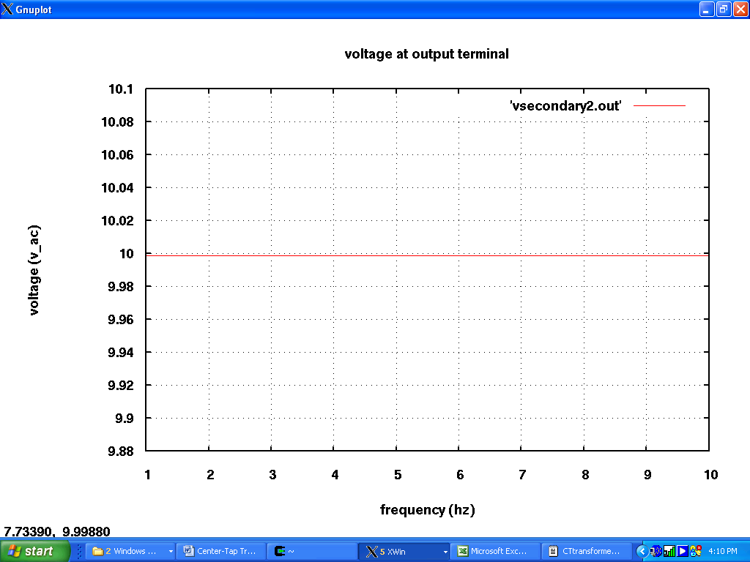

Sample Netlist: Ring-diode mixer example

Output File: ring_mixer_olga.net

********** fREEDA 1.3 running on Thu Apr 17 20:11:44 2008 **********

** Environment variables: **
FREEDA_HOME = /oandreescu/freeda
FREEDA_LIBRARY = /oandreescu/freeda/library
FREEDA_PROJECTS = /oandreescu/freeda/projects
FREEDA_PATH = /oandreescu/freeda/freeda
FREEDA_BIN = /oandreescu/freeda/freeda/bin
FREEDA_SIMULATOR = /oandreescu/freeda/freeda/simulator
FREEDA_ELEMENTS = /oandreescu/freeda/freeda/simulator/elements
FREEDA_DOCUMENTATION = /tmp
FREEDA_WEB_DOCUMENTATION = http://www.freeda.org/doc
FREEDA_BROWSER = cygstart

* Ring Diode Mixer With Olga's Center-Tap Transformer
* ring_mixer_olga.net
* Ring Diode Mixer With Olga's Center-Tap Transformer
* ring_mixer_olga.net
.options verbose

* Set tolerance in nonlinear iterations (ftol)
.options ftol=1e-10

* Jacobian update method (jupdm)
* 0 Jacbian updated every iteration
* 1 Use Broyden's quasi-Newton update method
* 2 Use Lee and Lee's quasi-Newton update method (default)
.options jupdm=0

.tran2 tstop=100ns tstep=2ps

*Behavioral model frequencies
* foin = center frequency of input signal
* fLO1 = Frequency of LO1
* fLO2 = Frequency of LO2
* fLO3 = Frequency of LO3
* fBPF1 = center frequency of BPF1
* fBPF2 = center frequency of BPF1
* fBPF3 = center frequency of BPF1
* tstep = maximum time step to capture waveforms

******************
* native frequencies (actual frequencies in ARC-210)
.options foin=300e6
.options flo1=1573.12e6 flo2=1162.56e6 flo3=90.42e6
.options fbpf1=20.14e6 fbpf2=1273.12e6 fbpf3=110.56e6

******************
* Input signal
* -40 dBm into 50 ohms corresponds to a peak voltage of 0.1 V
.options f1=299.4megahz
.options f2=299.5megahz
vsource:1 1 0 vac=0.1 f=f1 phase=90
vsource:2 2 1 vac=0.1 f=f2 phase=90
r:rf 2 rf1 r=50

******************************************************
* Ring Diode Mixer 1
* Local Oscillator
vsource:lo1 lo1internal 0 vac=2 f=flo1 phase=90
r:lo1 lo1internal lo1 r=50

c:l11 rf1 0 c=1pf
c:lo1 lo1 0 c=1f

transformerct:trf rf1 0 40 if1 20
* Center-tapped transformer with RF
*L:L11 RF1 0 L=10nH
*L:L12 40 IF1 L=10nH
*L:L13 IF1 20 L=10nH
*K:K11 coupling=0.999 L1="L:L11" L2="L:L12"
*K:K12 coupling=0.999 L1="L:L11" L2="L:L13"
*K:K13 coupling=0.999 L1="L:L12" L2="L:L13"

d:11 40 60 r0=2
c:11 40 60 c=1pf
d:12 50 40 r0=2
c:12 50 40 c=1pf
d:13 60 20 r0=2
c:13 60 20 c=1pf
d:14 20 50 r0=2
c:14 20 50 c=1pf

transformerct:tlo 0 lo1 60 0 50
* Center-tapped transformer with LO
*L:L14 50 0 L=10nH
*L:L15 0 60 L=10nH
*L:L16 0 LO1 L=10nH
*K:K14 coupling=0.999 L1="L:L14" L2="L:L15"
*K:K15 coupling=0.999 L1="L:L14" L2="L:L16"
*K:K16 coupling=0.999 L1="L:L15" L2="L:L16"

r:if11 if1 0 r=50
c:if11 if1 0 c=1pf

******************
*plot commands

* Use gnuplot assuming that X-Windows is available
.options gnuplot

* set up plot preamble with font and label information

* LO
set xlabel 'time (microseconds) (with center-tap transformer)'; set ylabel 'voltage' "
.out plot term "lo1" vt 1e6 scalex plotvt1preample in "out.vt.term.lo1"

* RF
set xlabel 'time (microseconds)'; set ylabel 'voltage' "
.out plot term "rf1" vt 1e6 scalex plotvt1preample in "out.vt.term.rf1"

* IF
set xlabel 'time (microseconds)'; set ylabel 'voltage' "
.out plot term "if1" vt 1e6 scalex plotvt1preample in "out.vt.term.if1"

* Diode
set xlabel 'time (microseconds)'; set ylabel 'voltage' "
.out plot term "40" vt term "60" vt -
+ 1e6 scalex plotvt1preample in "out.vt.term.d"

.end

************************************************************************

*** Network Dump:

*** Title:

* Ring Diode Mixer With Olga's Center-Tap Transformer

'OPTIONS' table, 33 entries
0: 'fbpf2' = 1.27312e+09 (double)
1: 'fbpf3' = 1.1056e+08 (double)
1: 'itl1' = 40 (int)
2: 'ftol' = 1e-10 (double)
2: 'itl2' = 20 (int)
3: 'chgtol' = 1e-14 (double)
4: 'verbose' = 1 (int)
4: 'itl4' = 10 (int)
4: 'cptime' = 1e+06 (double)
5: 'itl5' = 5000 (int)
5: 'defl' = 0.0001 (double)
6: 'f1' = 2.994e+08 (double)
7: 'f2' = 2.995e+08 (double)
7: 'abstol' = 1e-12 (double)
7: 'defad' = 0 (double)
11: 'tnom' = 27 (double)
12: 'vntol' = 1e-06 (double)
14: 'trtol' = 7 (double)
16: 'defw' = 0.0001 (double)
17: 'numdgt' = 4 (int)
18: 'plotvt1preample' = 'set term x11 font 'helvetica,13';
set title 'voltage across diode (with center-tap transformer)';
set xlabel 'time (microseconds)'; set ylabel 'voltage' ' (string)
20: 'pivrel' = 1e-13 (double)
20: 'reltol' = 0.001 (double)
21: 'gmin' = 1e-12 (double)
22: 'flo1' = 1.57312e+09 (double)
22: 'foin' = 3e+08 (double)
22: 'jupdm' = 0 (int)
22: 'defas' = 0 (double)
23: 'gnuplot' = 1 (int)
23: 'flo2' = 1.16256e+09 (double)
24: 'flo3' = 9.042e+07 (double)
27: 'limpts' = 201 (double)
28: 'fbpf1' = 2.014e+07 (double)

'OUTPUT' table, 4 entries
16: 'out1' (output request) =
type = 0 termination
type = 1 terminal id(val,type) = (10,1)
type = 101 operator
type = 202 double = 1e+06
type = 101 operator
type = 206 string = set term x11 font 'helvetica,13';
set title 'voltage at lo terminal';
set xlabel 'time (microseconds) (with center-tap transformer)'; set ylabel 'voltage'
type = 12 filename = out.vt.term.lo1
18: 'out3' (output request) =
type = 0 termination
type = 1 terminal id(val,type) = (6,1)
type = 101 operator
type = 202 double = 1e+06
type = 101 operator
type = 206 string = set term x11 font 'helvetica,13';
set title 'voltage at rf terminal (with center-tap transformer)';
set xlabel 'time (microseconds)'; set ylabel 'voltage'
type = 12 filename = out.vt.term.rf1
20: 'out5' (output request) =
type = 0 termination
type = 1 terminal id(val,type) = (15,1)
type = 101 operator
type = 202 double = 1e+06
type = 101 operator
type = 206 string = set term x11 font 'helvetica,13';
set title 'voltage at if terminal (with center-tap transformer)';
set xlabel 'time (microseconds)'; set ylabel 'voltage'
type = 12 filename = out.vt.term.if1
22: 'out7' (output request) =
type = 0 termination
type = 1 terminal id(val,type) = (14,1)
type = 101 operator
type = 1 terminal id(val,type) = (18,1)
type = 101 operator
type = 101 operator
type = 202 double = 1e+06
type = 101 operator
type = 206 string = set term x11 font 'helvetica,13';
set title 'voltage across diode (with center-tap transformer)';
set xlabel 'time (microseconds)'; set ylabel 'voltage'
type = 12 filename = out.vt.term.d
No expressions
***
No sweeps

*** Circuit "Main" listing:

vsource:1 - General DC and sinusoidal voltage source
1
0

vsource:2 - General DC and sinusoidal voltage source
2
1

r:rf - Resistor
2
rf1

vsource:lo1 - General DC and sinusoidal voltage source
lo1internal
0

r:lo1 - Resistor
lo1internal
lo1

c:l11 - Linear capacitor
rf1
0

c:lo1 - Linear capacitor
lo1
0

transformerct:trf - Center Tap Transformer
rf1
0
40
if1
20

d:11 - Microwave Diode
40
60

c:11 - Linear capacitor
40
60

d:12 - Microwave Diode
50
40

c:12 - Linear capacitor
50
40

d:13 - Microwave Diode
60
20

c:13 - Linear capacitor
60
20

d:14 - Microwave Diode
20
50

c:14 - Linear capacitor
20
50

transformerct:tlo - Center Tap Transformer
0
lo1
60
0
50

r:if11 - Resistor
if1
0

c:if11 - Linear capacitor
if1
0

************************************************************************

*** Starting analysis ...

-----------------------------------------------------------------------------
Matrix size = 17
Matrix nnz = 61
equed = 7.6735e-305
recip_pivot_growth = 0.5
1 / Condition number = 0.0034225
info = 0
ferr = 8.20191e-297
berr = 1
No of nonzeros in factor L = 72
No of nonzeros in factor U = 82
No of nonzeros in L+U = 137
L\U MB 0.002 total MB needed 0.005 expansions 0
Using line search method.
Nonlinear analysis tolerance (ftol) = 1e-10
Maximum number of nonlinear iterations per time-point (maxit) = 250
Jacobian evaluated at every iteration.
--- Starting transient simulation ...

Number of nonlinear state variables: 4
-----------------------------------------------------------------------------
| Step | Time (s) | Residual | Recent Max | Max |
-----------------------------------------------------------------------------
| 0 | 0.000000e+00 | 0.000000e+00 | 0.000000e+00 *| 0.000000e+00 |
| 200 | 4.000000e-10 | 7.633795e-13 | 6.821881e-07 | 6.821881e-07 |
| 400 | 8.000000e-10 | 1.109635e-11 | 1.006856e-07 | 6.821881e-07 |
| 600 | 1.200000e-09 | 3.344325e-12 | 1.484068e-07 | 6.821881e-07 |
| 800 | 1.600000e-09 | 1.944330e-13 | 1.291533e-07 | 6.821881e-07 |
| 1000 | 2.000000e-09 | 2.021039e-14 | 9.099046e-08 | 6.821881e-07 |
| 1200 | 2.400000e-09 | 3.531730e-12 | 8.377779e-08 | 6.821881e-07 |
| 1400 | 2.800000e-09 | 2.790134e-09 | 3.294403e-07 *| 6.821881e-07 |
| 1600 | 3.200000e-09 | 5.144240e-12 | 1.310371e-07 | 6.821881e-07 |
| 1800 | 3.600000e-09 | 4.292731e-16 | 1.437968e-07 | 6.821881e-07 |
| 2000 | 4.000000e-09 | 8.927213e-13 | 8.820259e-08 | 6.821881e-07 |
| 2200 | 4.400000e-09 | 1.240259e-08 | 3.144708e-07 *| 6.821881e-07 |
| 2400 | 4.800000e-09 | 7.270443e-11 | 1.493317e-07 | 6.821881e-07 |
| 2600 | 5.200000e-09 | 1.405019e-15 | 9.999921e-08 | 6.821881e-07 |
| 2800 | 5.600000e-09 | 4.483081e-13 | 1.541975e-07 | 6.821881e-07 |
| 3000 | 6.000000e-09 | 5.413917e-13 | 1.495760e-07 | 6.821881e-07 |
| 3200 | 6.400000e-09 | 1.110223e-16 | 1.401511e-07 | 6.821881e-07 |
| 3400 | 6.800000e-09 | 5.717822e-14 | 1.065512e-07 | 6.821881e-07 |
| 3600 | 7.200000e-09 | 9.351831e-08 | 1.993870e-07 *| 6.821881e-07 |
| 3800 | 7.600000e-09 | 3.893836e-11 | 1.551408e-07 | 6.821881e-07 |
| 4000 | 8.000000e-09 | 5.551115e-17 | 1.530015e-07 | 6.821881e-07 |
| 4200 | 8.400000e-09 | 4.492036e-12 | 1.160689e-07 | 6.821881e-07 |
| 4400 | 8.800000e-09 | 2.088992e-08 | 1.339039e-07 *| 6.821881e-07 |
| 4600 | 9.200000e-09 | 1.085030e-09 | 1.359117e-07 *| 6.821881e-07 |
| 4800 | 9.600000e-09 | 0.000000e+00 | 3.321039e-07 | 6.821881e-07 |
| 5000 | 1.000000e-08 | 0.000000e+00 | 1.384626e-07 | 6.821881e-07 |
| 5200 | 1.040000e-08 | 2.493905e-11 | 8.634293e-08 | 6.821881e-07 |
| 5400 | 1.080000e-08 | 4.110825e-15 | 1.334987e-07 | 6.821881e-07 |
| 5600 | 1.120000e-08 | 9.653667e-12 | 3.155971e-07 | 6.821881e-07 |
| 5800 | 1.160000e-08 | 9.539258e-12 | 1.332243e-07 | 6.821881e-07 |
| 6000 | 1.200000e-08 | 1.013358e-10 | 1.904097e-07 *| 6.821881e-07 |
| 6200 | 1.240000e-08 | 2.110542e-13 | 1.224493e-07 | 6.821881e-07 |
| 6400 | 1.280000e-08 | 4.989644e-13 | 1.568607e-07 | 6.821881e-07 |
| 6600 | 1.320000e-08 | 4.410805e-12 | 1.478744e-07 | 6.821881e-07 |
| 6800 | 1.360000e-08 | 1.808540e-09 | 1.383301e-07 *| 6.821881e-07 |
| 7000 | 1.400000e-08 | 4.452791e-12 | 1.369188e-07 | 6.821881e-07 |
| 7200 | 1.440000e-08 | 2.151878e-14 | 1.392326e-07 | 6.821881e-07 |
| 7400 | 1.480000e-08 | 3.179309e-12 | 1.358995e-07 | 6.821881e-07 |
| 7600 | 1.520000e-08 | 1.646118e-08 | 1.535211e-07 *| 6.821881e-07 |
| 7800 | 1.560000e-08 | 5.101831e-11 | 1.355649e-07 | 6.821881e-07 |
| 8000 | 1.600000e-08 | 6.317799e-14 | 1.416755e-07 | 6.821881e-07 |
| 8200 | 1.640000e-08 | 1.433187e-12 | 1.468184e-07 | 6.821881e-07 |
| 8400 | 1.680000e-08 | 7.834869e-08 | 1.443798e-07 *| 6.821881e-07 |
| 8600 | 1.720000e-08 | 1.110223e-16 | 1.154829e-07 | 6.821881e-07 |
| 8800 | 1.760000e-08 | 2.199994e-12 | 1.377829e-07 | 6.821881e-07 |
| 9000 | 1.800000e-08 | 1.278422e-12 | 3.176487e-07 | 6.821881e-07 |
| 9200 | 1.840000e-08 | 1.318105e-12 | 1.683818e-07 | 6.821881e-07 |
| 9400 | 1.880000e-08 | 5.551115e-17 | 8.471524e-08 | 6.821881e-07 |
| 9600 | 1.920000e-08 | 6.511952e-11 | 1.474664e-07 | 6.821881e-07 |
| 9800 | 1.960000e-08 | 1.312586e-07 | 1.401279e-07 *| 6.821881e-07 |
| 10000 | 2.000000e-08 | 3.477321e-11 | 1.186605e-07 | 6.821881e-07 |
| 10200 | 2.040000e-08 | 1.631555e-11 | 1.948206e-07 | 6.821881e-07 |
| 10400 | 2.080000e-08 | 4.124467e-11 | 1.728533e-07 | 6.821881e-07 |
| 10600 | 2.120000e-08 | 3.647104e-08 | 1.458184e-07 *| 6.821881e-07 |
| 10800 | 2.160000e-08 | 8.352527e-10 | 1.303843e-07 *| 6.821881e-07 |
| 11000 | 2.200000e-08 | 2.230649e-11 | 1.133136e-07 | 6.821881e-07 |
| 11200 | 2.240000e-08 | 2.696809e-11 | 1.707287e-07 | 6.821881e-07 |
| 11400 | 2.280000e-08 | 3.684845e-09 | 3.275581e-07 *| 6.821881e-07 |
| 11600 | 2.320000e-08 | 2.786638e-15 | 1.309088e-07 | 6.821881e-07 |
| 11800 | 2.360000e-08 | 6.974667e-13 | 1.851795e-07 | 6.821881e-07 |
| 12000 | 2.400000e-08 | 1.469280e-11 | 1.453674e-07 | 6.821881e-07 |
| 12200 | 2.440000e-08 | 3.225276e-11 | 3.115365e-07 | 6.821881e-07 |
| 12400 | 2.480000e-08 | 1.952070e-13 | 1.484800e-07 | 6.821881e-07 |
| 12600 | 2.520000e-08 | 1.756833e-14 | 1.004706e-07 | 6.821881e-07 |
| 12800 | 2.560000e-08 | 6.837386e-12 | 1.059572e-07 | 6.821881e-07 |
| 13000 | 2.600000e-08 | 8.915473e-09 | 1.472177e-07 *| 6.821881e-07 |
| 13200 | 2.640000e-08 | 5.353298e-12 | 1.387614e-07 | 6.821881e-07 |
| 13400 | 2.680000e-08 | 4.152227e-16 | 1.114956e-07 | 6.821881e-07 |
| 13600 | 2.720000e-08 | 1.795148e-12 | 1.808923e-07 | 6.821881e-07 |
| 13800 | 2.760000e-08 | 7.944184e-09 | 1.524088e-07 *| 6.821881e-07 |
| 14000 | 2.800000e-08 | 7.547447e-11 | 1.512423e-07 | 6.821881e-07 |
| 14200 | 2.840000e-08 | 2.420083e-15 | 1.227907e-07 | 6.821881e-07 |
| 14400 | 2.880000e-08 | 2.369142e-13 | 1.768504e-07 | 6.821881e-07 |
| 14600 | 2.920000e-08 | 3.030746e-13 | 1.528239e-07 | 6.821881e-07 |
| 14800 | 2.960000e-08 | 1.570092e-16 | 3.299428e-07 | 6.821881e-07 |
| 15000 | 3.000000e-08 | 2.049805e-13 | 1.383546e-07 | 6.821881e-07 |
| 15200 | 3.040000e-08 | 5.007130e-14 | 9.717592e-08 | 6.821881e-07 |
| 15400 | 3.080000e-08 | 2.030335e-11 | 1.818588e-07 | 6.821881e-07 |
| 15600 | 3.120000e-08 | 5.551115e-17 | 3.125464e-07 | 6.821881e-07 |
| 15800 | 3.160000e-08 | 1.580693e-11 | 1.322825e-07 | 6.821881e-07 |
| 16000 | 3.200000e-08 | 3.419644e-09 | 1.373177e-07 *| 6.821881e-07 |
| 16200 | 3.240000e-08 | 5.524609e-10 | 1.315893e-07 *| 6.821881e-07 |
| 16400 | 3.280000e-08 | 5.551115e-17 | 1.543955e-07 | 6.821881e-07 |
| 16600 | 3.320000e-08 | 2.074901e-11 | 1.464498e-07 | 6.821881e-07 |
| 16800 | 3.360000e-08 | 8.770585e-08 | 1.704380e-07 *| 6.821881e-07 |
| 17000 | 3.400000e-08 | 7.838557e-09 | 1.516126e-07 *| 6.821881e-07 |
| 17200 | 3.440000e-08 | 2.488924e-11 | 1.589667e-07 | 6.821881e-07 |
| 17400 | 3.480000e-08 | 1.244282e-11 | 1.591833e-07 | 6.821881e-07 |
| 17600 | 3.520000e-08 | 2.585271e-10 | 1.241454e-07 *| 6.821881e-07 |
| 17800 | 3.560000e-08 | 7.027808e-14 | 1.007989e-07 | 6.821881e-07 |
| 18000 | 3.600000e-08 | 1.219275e-12 | 1.387222e-07 | 6.821881e-07 |
| 18200 | 3.640000e-08 | 6.065037e-12 | 3.241740e-07 | 6.821881e-07 |
| 18400 | 3.680000e-08 | 9.369315e-10 | 1.529544e-07 *| 6.821881e-07 |
| 18600 | 3.720000e-08 | 1.658311e-12 | 1.054638e-07 | 6.821881e-07 |
| 18800 | 3.760000e-08 | 4.859895e-14 | 1.341398e-07 | 6.821881e-07 |
| 19000 | 3.800000e-08 | 1.333366e-12 | 3.144876e-07 | 6.821881e-07 |
| 19200 | 3.840000e-08 | 8.040935e-09 | 1.398190e-07 *| 6.821881e-07 |
| 19400 | 3.880000e-08 | 2.064114e-11 | 1.623018e-07 | 6.821881e-07 |
| 19600 | 3.920000e-08 | 1.830840e-14 | 1.202145e-07 | 6.821881e-07 |
| 19800 | 3.960000e-08 | 1.974032e-12 | 1.616331e-07 | 6.821881e-07 |
| 20000 | 4.000000e-08 | 4.585109e-08 | 1.543133e-07 *| 6.821881e-07 |
| 20200 | 4.040000e-08 | 1.922963e-16 | 1.398916e-07 | 6.821881e-07 |
| 20400 | 4.080000e-08 | 4.896034e-13 | 1.287040e-07 | 6.821881e-07 |
| 20600 | 4.120000e-08 | 1.700196e-12 | 1.432078e-07 | 6.821881e-07 |
| 20800 | 4.160000e-08 | 6.349636e-13 | 1.417354e-07 | 6.821881e-07 |
| 21000 | 4.200000e-08 | 5.551115e-17 | 1.496045e-07 | 6.821881e-07 |
| 21200 | 4.240000e-08 | 1.126191e-11 | 1.229709e-07 | 6.821881e-07 |
| 21400 | 4.280000e-08 | 1.525264e-07 | 3.255088e-07 *| 6.821881e-07 |
| 21600 | 4.320000e-08 | 2.499565e-11 | 1.306187e-07 | 6.821881e-07 |
| 21800 | 4.360000e-08 | 9.352061e-12 | 9.572069e-08 | 6.821881e-07 |
| 22000 | 4.400000e-08 | 3.925231e-17 | 1.014230e-07 | 6.821881e-07 |
| 22200 | 4.440000e-08 | 4.686063e-08 | 1.618872e-07 *| 6.821881e-07 |
| 22400 | 4.480000e-08 | 7.380722e-10 | 1.475129e-07 *| 6.821881e-07 |
| 22600 | 4.520000e-08 | 2.199203e-11 | 1.114347e-07 | 6.821881e-07 |
| 22800 | 4.560000e-08 | 3.227657e-11 | 1.988433e-07 | 6.821881e-07 |
| 23000 | 4.600000e-08 | 6.016016e-09 | 1.448517e-07 *| 6.821881e-07 |
| 23200 | 4.640000e-08 | 2.666847e-15 | 1.373149e-07 | 6.821881e-07 |
| 23400 | 4.680000e-08 | 8.320670e-13 | 1.377587e-07 | 6.821881e-07 |
| 23600 | 4.720000e-08 | 1.811418e-11 | 1.576740e-07 | 6.821881e-07 |
| 23800 | 4.760000e-08 | 5.513801e-11 | 1.626471e-07 | 6.821881e-07 |
| 24000 | 4.800000e-08 | 1.880891e-13 | 1.494452e-07 | 6.821881e-07 |
| 24200 | 4.840000e-08 | 3.492193e-14 | 1.469025e-07 | 6.821881e-07 |
| 24400 | 4.880000e-08 | 8.874481e-12 | 8.308049e-08 | 6.821881e-07 |
| 24600 | 4.920000e-08 | 6.371293e-09 | 1.551480e-07 *| 6.821881e-07 |
| 24800 | 4.960000e-08 | 5.057659e-12 | 3.276438e-07 | 6.821881e-07 |
| 25000 | 5.000000e-08 | 1.587787e-15 | 1.380769e-07 | 6.821881e-07 |
| 25200 | 5.040000e-08 | 3.144664e-12 | 1.256651e-07 | 6.821881e-07 |
| 25400 | 5.080000e-08 | 6.704906e-09 | 1.344435e-07 *| 6.821881e-07 |
| 25600 | 5.120000e-08 | 7.003853e-11 | 3.093253e-07 | 6.821881e-07 |
| 25800 | 5.160000e-08 | 7.622430e-15 | 1.312493e-07 | 6.821881e-07 |
| 26000 | 5.200000e-08 | 7.547964e-13 | 1.726087e-07 | 6.821881e-07 |
| 26200 | 5.240000e-08 | 1.846786e-13 | 1.139904e-07 | 6.821881e-07 |
| 26400 | 5.280000e-08 | 1.241267e-16 | 1.519194e-07 | 6.821881e-07 |
| 26600 | 5.320000e-08 | 5.757550e-13 | 1.449634e-07 | 6.821881e-07 |
| 26800 | 5.360000e-08 | 8.209775e-14 | 1.180316e-07 | 6.821881e-07 |
| 27000 | 5.400000e-08 | 8.837238e-12 | 2.195880e-07 | 6.821881e-07 |
| 27200 | 5.440000e-08 | 7.850462e-17 | 1.560720e-07 | 6.821881e-07 |
| 27400 | 5.480000e-08 | 3.829546e-11 | 1.573330e-07 | 6.821881e-07 |
| 27600 | 5.520000e-08 | 1.458964e-08 | 1.248370e-07 *| 6.821881e-07 |
| 27800 | 5.560000e-08 | 2.239397e-10 | 1.256367e-07 *| 6.821881e-07 |
| 28000 | 5.600000e-08 | 1.271920e-16 | 1.357432e-07 | 6.821881e-07 |
| 28200 | 5.640000e-08 | 2.594114e-11 | 3.221600e-07 | 6.821881e-07 |
| 28400 | 5.680000e-08 | 4.688099e-10 | 1.228480e-07 *| 6.821881e-07 |
| 28600 | 5.720000e-08 | 3.396927e-09 | 1.955596e-07 *| 6.821881e-07 |
| 28800 | 5.760000e-08 | 4.894472e-11 | 1.304547e-07 | 6.821881e-07 |
| 29000 | 5.800000e-08 | 1.637779e-11 | 3.111852e-07 | 6.821881e-07 |
| 29200 | 5.840000e-08 | 7.015500e-13 | 1.387629e-07 | 6.821881e-07 |
| 29400 | 5.880000e-08 | 1.621078e-14 | 1.120520e-07 | 6.821881e-07 |
| 29600 | 5.920000e-08 | 2.219581e-12 | 1.157692e-07 | 6.821881e-07 |
| 29800 | 5.960000e-08 | 8.411938e-12 | 1.590418e-07 | 6.821881e-07 |
| 30000 | 6.000000e-08 | 1.805792e-09 | 1.527919e-07 *| 6.821881e-07 |
| 30200 | 6.040000e-08 | 4.611503e-13 | 1.173031e-07 | 6.821881e-07 |
| 30400 | 6.080000e-08 | 7.981424e-14 | 9.403385e-08 | 6.821881e-07 |
| 30600 | 6.120000e-08 | 1.859068e-12 | 1.405841e-07 | 6.821881e-07 |
| 30800 | 6.160000e-08 | 3.189860e-09 | 1.399648e-07 *| 6.821881e-07 |
| 31000 | 6.200000e-08 | 6.693174e-12 | 1.957080e-07 | 6.821881e-07 |
| 31200 | 6.240000e-08 | 3.374936e-15 | 8.691441e-08 | 6.821881e-07 |
| 31400 | 6.280000e-08 | 1.980305e-12 | 3.232824e-07 | 6.821881e-07 |
| 31600 | 6.320000e-08 | 2.122838e-08 | 1.504692e-07 *| 6.821881e-07 |
| 31800 | 6.360000e-08 | 6.132974e-11 | 1.026928e-07 | 6.821881e-07 |
| 32000 | 6.400000e-08 | 5.972421e-14 | 1.993450e-07 | 6.821881e-07 |
| 32200 | 6.440000e-08 | 1.696754e-12 | 1.340051e-07 | 6.821881e-07 |
| 32400 | 6.480000e-08 | 3.220076e-13 | 1.595348e-07 | 6.821881e-07 |
| 32600 | 6.520000e-08 | 1.241267e-16 | 1.404829e-07 | 6.821881e-07 |
| 32800 | 6.560000e-08 | 1.119292e-12 | 1.366815e-07 | 6.821881e-07 |
| 33000 | 6.600000e-08 | 5.342393e-13 | 1.171732e-07 | 6.821881e-07 |
| 33200 | 6.640000e-08 | 1.853558e-11 | 1.424785e-07 | 6.821881e-07 |
| 33400 | 6.680000e-08 | 3.140487e-11 | 1.684660e-07 | 6.821881e-07 |
| 33600 | 6.720000e-08 | 1.824647e-11 | 1.727610e-07 | 6.821881e-07 |
| 33800 | 6.760000e-08 | 5.550179e-08 | 1.468950e-07 *| 6.821881e-07 |
| 34000 | 6.800000e-08 | 6.153716e-10 | 1.476153e-07 *| 6.821881e-07 |
| 34200 | 6.840000e-08 | 4.794954e-11 | 1.180799e-07 | 6.821881e-07 |
| 34400 | 6.880000e-08 | 5.551115e-17 | 1.047558e-07 | 6.821881e-07 |
| 34600 | 6.920000e-08 | 6.962452e-09 | 1.461638e-07 *| 6.821881e-07 |
| 34800 | 6.960000e-08 | 2.112343e-15 | 3.251960e-07 | 6.821881e-07 |
| 35000 | 7.000000e-08 | 2.936191e-12 | 1.508628e-07 | 6.821881e-07 |
| 35200 | 7.040000e-08 | 2.098605e-11 | 1.610254e-07 | 6.821881e-07 |
| 35400 | 7.080000e-08 | 2.233047e-11 | 1.372049e-07 | 6.821881e-07 |
| 35600 | 7.120000e-08 | 1.469940e-13 | 1.423888e-07 | 6.821881e-07 |
| 35800 | 7.160000e-08 | 1.610557e-13 | 1.301342e-07 | 6.821881e-07 |
| 36000 | 7.200000e-08 | 1.062192e-11 | 9.192485e-08 | 6.821881e-07 |
| 36200 | 7.240000e-08 | 7.786201e-10 | 1.670940e-07 *| 6.821881e-07 |
| 36400 | 7.280000e-08 | 3.979698e-12 | 1.494330e-07 | 6.821881e-07 |
| 36600 | 7.320000e-08 | 7.872833e-15 | 1.434224e-07 | 6.821881e-07 |
| 36800 | 7.360000e-08 | 3.973433e-12 | 1.201112e-07 | 6.821881e-07 |
| 37000 | 7.400000e-08 | 8.426662e-09 | 2.082908e-07 *| 6.821881e-07 |
| 37200 | 7.440000e-08 | 5.486668e-11 | 1.531562e-07 | 6.821881e-07 |
| 37400 | 7.480000e-08 | 1.621316e-14 | 1.554458e-07 | 6.821881e-07 |
| 37600 | 7.520000e-08 | 1.129391e-12 | 1.253097e-07 | 6.821881e-07 |
| 37800 | 7.560000e-08 | 9.099023e-08 | 1.643677e-07 *| 6.821881e-07 |
| 38000 | 7.600000e-08 | 1.570092e-16 | 1.327370e-07 | 6.821881e-07 |
| 38200 | 7.640000e-08 | 9.996850e-13 | 3.199377e-07 | 6.821881e-07 |
| 38400 | 7.680000e-08 | 3.366198e-13 | 1.452280e-07 | 6.821881e-07 |
| 38600 | 7.720000e-08 | 3.133931e-12 | 1.114920e-07 | 6.821881e-07 |
| 38800 | 7.760000e-08 | 8.986822e-11 | 1.361008e-07 | 6.821881e-07 |
| 39000 | 7.800000e-08 | 5.317335e-11 | 3.077466e-07 | 6.821881e-07 |
| 39200 | 7.840000e-08 | 9.404131e-08 | 1.376194e-07 *| 6.821881e-07 |
| 39400 | 7.880000e-08 | 7.339025e-11 | 1.137662e-07 | 6.821881e-07 |
| 39600 | 7.920000e-08 | 0.000000e+00 | 1.113087e-07 | 6.821881e-07 |
| 39800 | 7.960000e-08 | 3.247030e-11 | 1.564367e-07 | 6.821881e-07 |
| 40000 | 8.000000e-08 | 2.124523e-08 | 1.512107e-07 *| 6.821881e-07 |
| 40200 | 8.040000e-08 | 1.203297e-09 | 1.428223e-07 *| 6.821881e-07 |
| 40400 | 8.080000e-08 | 7.413813e-11 | 9.624701e-08 | 6.821881e-07 |
| 40600 | 8.120000e-08 | 2.144451e-11 | 1.379465e-07 | 6.821881e-07 |
| 40800 | 8.160000e-08 | 5.881791e-10 | 1.381691e-07 *| 6.821881e-07 |
| 41000 | 8.200000e-08 | 2.555925e-15 | 1.387770e-07 | 6.821881e-07 |
| 41200 | 8.240000e-08 | 3.069583e-12 | 1.756197e-07 | 6.821881e-07 |
| 41400 | 8.280000e-08 | 1.167832e-11 | 1.378541e-07 | 6.821881e-07 |
| 41600 | 8.320000e-08 | 1.156297e-12 | 3.208717e-07 | 6.821881e-07 |
| 41800 | 8.360000e-08 | 1.009281e-13 | 1.319241e-07 | 6.821881e-07 |
| 42000 | 8.400000e-08 | 9.878224e-14 | 1.397699e-07 | 6.821881e-07 |
| 42200 | 8.440000e-08 | 3.814171e-12 | 1.300565e-07 | 6.821881e-07 |
| 42400 | 8.480000e-08 | 2.114279e-09 | 1.571690e-07 *| 6.821881e-07 |
| 42600 | 8.520000e-08 | 2.070343e-12 | 1.753610e-07 | 6.821881e-07 |
| 42800 | 8.560000e-08 | 2.528637e-15 | 1.013459e-07 | 6.821881e-07 |
| 43000 | 8.600000e-08 | 1.553812e-12 | 1.125360e-07 | 6.821881e-07 |
| 43200 | 8.640000e-08 | 9.072026e-09 | 1.400985e-07 *| 6.821881e-07 |
| 43400 | 8.680000e-08 | 2.805059e-11 | 1.148788e-07 | 6.821881e-07 |
| 43600 | 8.720000e-08 | 4.607195e-15 | 1.070490e-07 | 6.821881e-07 |
| 43800 | 8.760000e-08 | 1.126543e-12 | 8.661054e-08 | 6.821881e-07 |
| 44000 | 8.800000e-08 | 1.192963e-13 | 1.457569e-07 | 6.821881e-07 |
| 44200 | 8.840000e-08 | 1.110223e-16 | 1.183362e-07 | 6.821881e-07 |
| 44400 | 8.880000e-08 | 7.563685e-14 | 1.371313e-07 | 6.821881e-07 |
| 44600 | 8.920000e-08 | 4.948264e-13 | 1.028430e-07 | 6.821881e-07 |
| 44800 | 8.960000e-08 | 1.170782e-11 | 3.225915e-07 | 6.821881e-07 |
| 45000 | 9.000000e-08 | 7.850462e-17 | 1.370687e-07 | 6.821881e-07 |
| 45200 | 9.040000e-08 | 1.127243e-12 | 8.743251e-08 | 6.821881e-07 |
| 45400 | 9.080000e-08 | 5.981189e-08 | 1.741058e-07 *| 6.821881e-07 |
| 45600 | 9.120000e-08 | 4.387880e-10 | 1.402047e-07 *| 6.821881e-07 |
| 45800 | 9.160000e-08 | 2.775558e-17 | 1.530954e-07 | 6.821881e-07 |
| 46000 | 9.200000e-08 | 2.037257e-11 | 9.241043e-08 | 6.821881e-07 |
| 46200 | 9.240000e-08 | 5.007155e-09 | 1.137081e-07 *| 6.821881e-07 |
| 46400 | 9.280000e-08 | 7.689369e-09 | 1.469369e-07 *| 6.821881e-07 |
| 46600 | 9.320000e-08 | 1.156869e-11 | 1.418332e-07 | 6.821881e-07 |
| 46800 | 9.360000e-08 | 1.029188e-11 | 1.219067e-07 | 6.821881e-07 |
| 47000 | 9.400000e-08 | 1.011857e-12 | 1.206912e-07 | 6.821881e-07 |
| 47200 | 9.440000e-08 | 8.859594e-14 | 1.502186e-07 | 6.821881e-07 |
| 47400 | 9.480000e-08 | 6.539693e-13 | 1.535263e-07 | 6.821881e-07 |
| 47600 | 9.520000e-08 | 1.211739e-11 | 1.255784e-07 | 6.821881e-07 |
| 47800 | 9.560000e-08 | 4.685763e-10 | 1.016299e-07 *| 6.821881e-07 |
| 48000 | 9.600000e-08 | 2.483482e-12 | 1.474715e-07 | 6.821881e-07 |
| 48200 | 9.640000e-08 | 3.173546e-14 | 3.253156e-07 | 6.821881e-07 |
| 48400 | 9.680000e-08 | 4.673372e-12 | 1.446614e-07 | 6.821881e-07 |
| 48600 | 9.720000e-08 | 9.563456e-09 | 1.075300e-07 *| 6.821881e-07 |
| 48800 | 9.760000e-08 | 3.469346e-11 | 1.229579e-07 | 6.821881e-07 |
| 49000 | 9.800000e-08 | 1.931617e-14 | 1.474413e-07 | 6.821881e-07 |
| 49200 | 9.840000e-08 | 1.406329e-12 | 1.363975e-07 | 6.821881e-07 |
| 49400 | 9.880000e-08 | 6.169520e-08 | 1.424197e-07 *| 6.821881e-07 |
| 49600 | 9.920000e-08 | 5.551115e-17 | 1.342743e-07 | 6.821881e-07 |
| 49800 | 9.960000e-08 | 9.220583e-13 | 1.538184e-07 | 6.821881e-07 |
| 50000 | 1.000000e-07 | 8.127943e-13 | 1.495766e-07 | 6.821881e-07 |
--- Maximum Residual: 6.82188e-07
-----------------------------------------------------------------------------

Plotting output file: out.vt.term.lo1.
Plotting output file: out.vt.term.rf1.
Plotting output file: out.vt.term.if1.
Plotting output file: out.vt.term.d.

************** fREEDA 1.3 stopping on Thu Apr 17 20:13:41 2008 ***********

Comparison Chart of Transformer vs Inductors and Couplings (RING_MIXER_OLGA.NET vs RING_MIXER.NET):
Using Center Tap Transformer | Using Inductors and Coupling
Matrix size = 17 | Matrix size = 19
Matrix nnz = 61 | Matrix nnz = 63
equed = 7.6735e-305 | equed = 7.6735e-305
recip_pivot_growth = 0.5 | recip_pivot_growth = 0.999902
1 / Condition number = 0.0034225 | 1 / Condition number = 1.74235e-05
info = 0 | info = 0
ferr = 8.20191e-297 | ferr = 4.5286e-303
berr = 1 | berr = 1
No of nonzeros in factor L = 72 | No of nonzeros in factor L = 73
No of nonzeros in factor U = 82 | No of nonzeros in factor U = 85
No of nonzeros in L+U = 137 | No of nonzeros in L+U = 139
Nonlinear analysis tolerance (ftol) = 1e-10 | Nonlinear analysis tolerance (ftol) = 1e-10
condition number: | condition number:
292.184076 | 57393.74982
stop: 20:13:41 | stop: 20:24:49
start: 20:11:44 | start: 20:22:44
run time : 00:01:57 | run time : 00:02:05
As it seen from about chart using center tap transformer have advantages:
- Run time is shorter by 8 seconds
- Condition number is smaller by almost 196 times
- Matrix size is smaller, lower count of component

Simulation Results: Below are results from above “Ring_Mixer_Olga.net”sample netlist. The netlist example, provided by professor as example, had inductors and coupling. Those inductors and couplings were replaced with center tap transformers. The simulation of netlist with transformer provided the same response as with using inductors and coupling between inductors.

RF Input Voltage at Transformer:
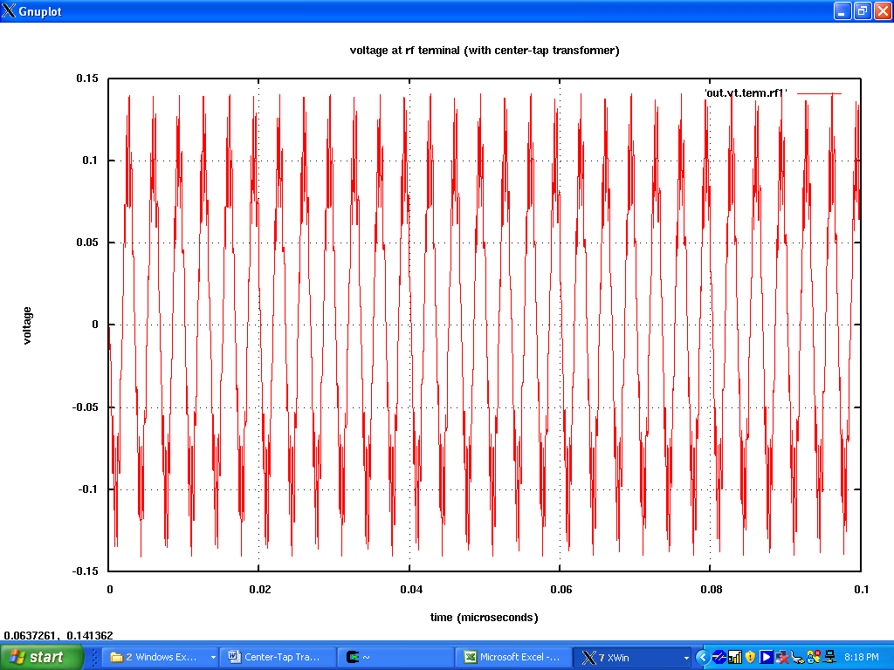

LO Input Voltage at Transformer:
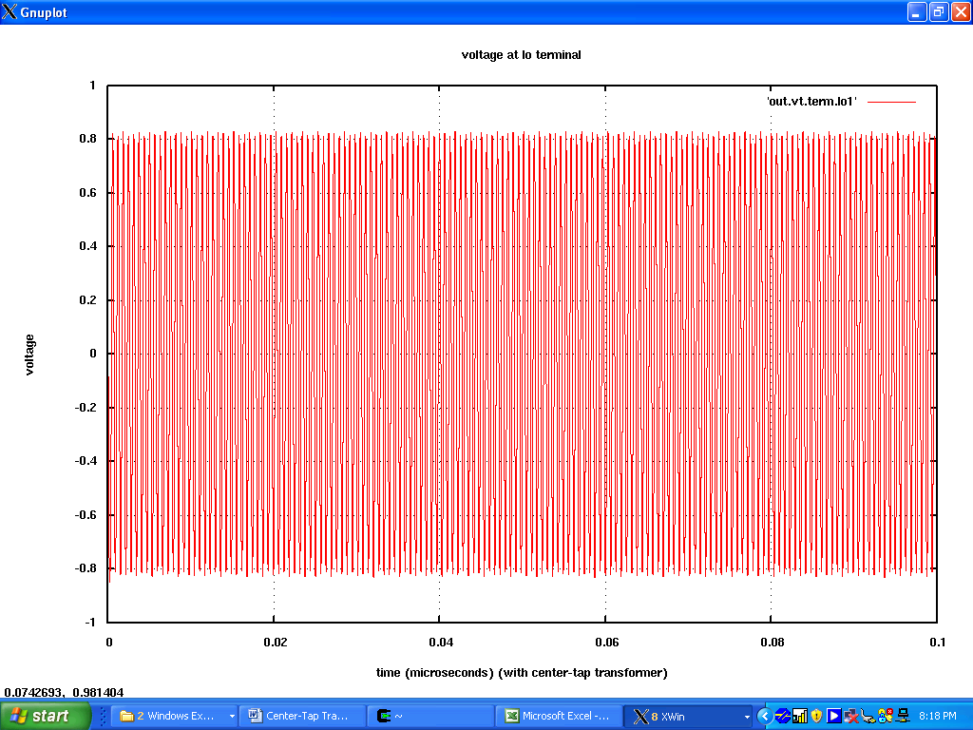

IF Output Voltage:
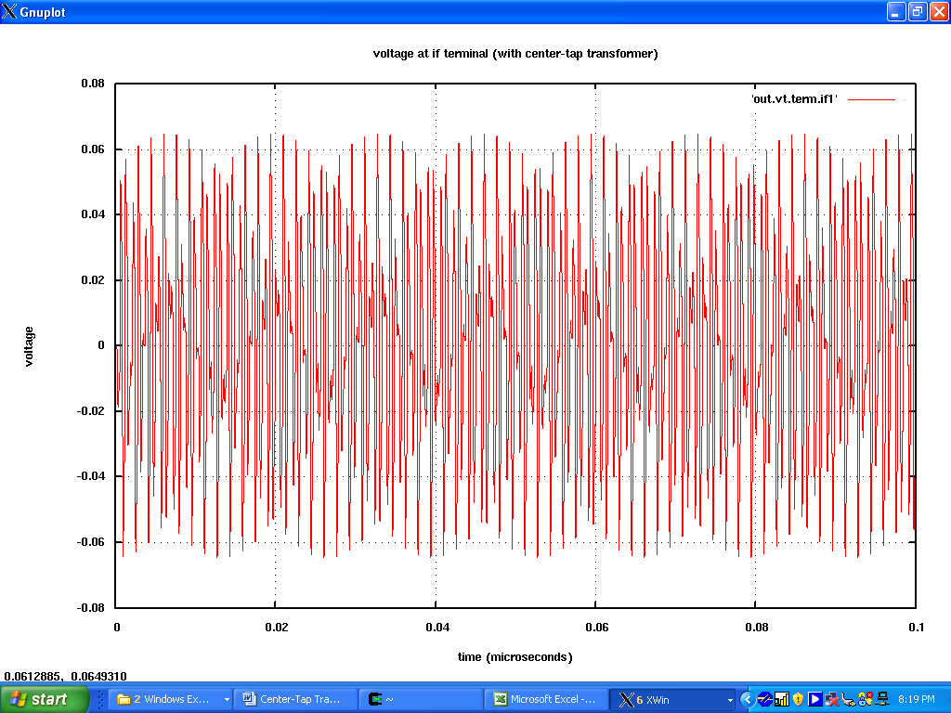

Known Bugs:
None found.

Version: 2008.04.17
Credits:
Name Affiliation Date Links
Olga Andreescu NC State University April 2008 www.ncsu.edu
oandree@ncsu.edu

