Analog N^{th}-Order Butterworth Bandpass Filter butterworthbpf

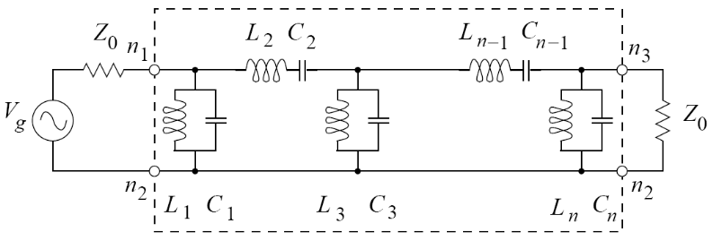

Figure 1: Butterworthbpf – N^{th} Order Butterworth Bandpass Filter Note that n_2 and n_3 are around the wrong way. Element needs to be updated. See Known Bugs.

Form: Butterworthbpf:<instance name> n1 n2 n3 <parameter list>
n1 is the input terminal
n2 is the output terminal
n3 is the reference terminal

Parameters:

Parameter | Type | Default Value | Required?
order: Filter order | INTEGER | N/A | yes
fc: Center Frequency of the filter (Hz) | DOUBLE | N/A | yes
bw: Bandwidth of the filter (Hz) | DOUBLE | N/A | yes
z0: Input/Output Impedance (ohms) | DOUBLE | N/A | yes

Example:
Butterworthbpf:b1 2 3 0 order=5 fc=1e6 bw=400e3 z0=50

Notes:
The filter has a maximum allowable order of 100. If an integer value larger then 100 is entered for the “order” parameter the model will not work correctly.

Details:
This model designs a type-2 Cauer topology butterworth bandpass filter, using parallel inductors and capacitors and series inductors and capacitors in a ladder structure. The filter can be of any order up to a maximum order of 100. The filter has a center frequency, fc, and a bandwidth, bw. The filter is designed so that the input and output impedance, z0, of the filter is the same.

Model Description:
The model actually works by creating individual “inductor” and “capacitor” elements and then connecting them together in the proper ladder structure to obtain the desired filter parameters. The model begins by calculating the coefficients of an n-order butterworth lowpass prototype filter normalized to a radian corner frequency of 1 radian/sec and a 1Ω system impedance. This is accomplished by using Equation 1 below.

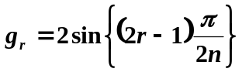 r = 1, 2, 3 ... n (Eq. 1)

The model then takes these coefficients and uses them to calculate the Inductor and Capacitor component values to build the type-2 Cauer ladder topology structure shown in Figure 2. These capacitor and inductor values are obtained from the butterworth lowpass prototype coefficients by using impedance transformation, frequency transformation, and lowpass-to-bandpass filter transformation methods.

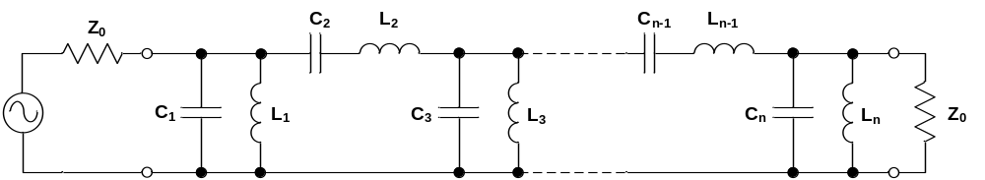

Figure 2: Type-2 Cauer Topology Butterworth Bandpass Filter

The L and C values in Figure 2 are calculated using the equations shown below. In Eq. 2 and 3: ω_{C} is the center frequency of the filter in rad/sec; ω_{BW} is the bandwidth of the filter in rad/sec; and Z₀ is the input/output impedance of the filter.
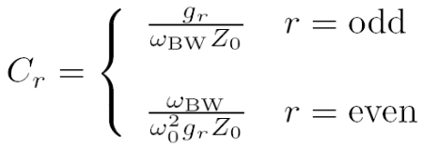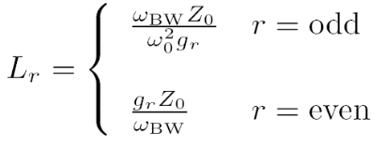

Once the inductor and capacitor component values are calculated the model then begins building up the filter by actually creating each element individually and connecting them together one-by-one. The inductors are created using the “inductor” element and the capacitors are created using the “capacitor” element. The odd numbered elements are connected in parallel, and the even numbered elements are connected in series, as shown in Figure 2.

Once all of the elements have been added and connected together the model is complete. This linear model is used for both the time domain and frequency domain

Sample Netlists:
Example of an AC Analysis of a 5th-order filter with a center frequency of 1MHz, a bandwidth of 400kHz, and a input/output impedance of 50Ω.
Netlist File: butterworthbpfactest.net

**** AC butterworthbpf test *****

.ac start=10e3 stop=100e6 n_freqs=4000

vsource:vin 1 0 vac=1.0

R:Rin1 1 2 r=50
Butterworthbpf:b1 2 3 0 order=5 fc=1e6 bw=400e3 z0=50
R:Rout1 3 0 r=50

.options gnuplot
.options preample1="set logscale x; set term x11 font 'helvetica,13';
set title 'Butterworth Filter Magnitude Response'; set xlabel 'FREQUENCY (MHz)';
set ylabel 'MAGNITUDE (dB)"
.out plot term 3 vf term 1 vf div mag db 1e-6 scalex preample1 in "butterworthbpf.ac.mag"

.options preample2="set logscale x; set term x11 font 'helvetica,13';
set title 'Butterworth Filter Phase Response'; set xlabel 'FREQUENCY (MHz)';
set ylabel 'phase (DEGREES)"
.out plot term 3 vf term 1 vf div prinphase 1e-6 scalex rad2deg preample2 in "butterworthbpf.ac.phase"

.end

The output log file is:

********** fREEDA 1.3 running on Thu Apr 17 19:28:02 2008 **********

** Environment variables: **
FREEDA_HOME = /sevans/freeda
FREEDA_LIBRARY = /sevans/freeda/library
FREEDA_PROJECTS = /sevans/freeda/projects
FREEDA_PATH = /sevans/freeda/freeda
FREEDA_BIN = /sevans/freeda/freeda/bin
FREEDA_SIMULATOR = /sevans/freeda/freeda/simulator
FREEDA_ELEMENTS = /sevans/freeda/freeda/simulator/elements
FREEDA_DOCUMENTATION = /tmp
FREEDA_WEB_DOCUMENTATION = http://www.freeda.org/doc
FREEDA_BROWSER = cygstart

**** AC butterworthbpf test *****

**** AC butterworthbpf test *****

.ac start=10e3 stop=100e6 n_freqs=4000

vsource:vin 1 0 vac=1.0

r:rin1 1 2 r=50
butterworthbpf:b1 2 3 0 order=5 fc=1e6 bw=400e3 z0=50
r:rout1 3 0 r=50

.options gnuplot
set ylabel 'magnitude (db)"
.out plot term 3 vf term 1 vf div mag db 1e-6 scalex preample1 in "butterworthbpf.ac.mag"

set ylabel 'phase (degrees)"
.out plot term 3 vf term 1 vf div prinphase 1e-6 scalex rad2deg preample2 in "butterworthbpf.ac.phase"

.end

*** Starting analysis ...

-----------------------------------------------------------------------------
*** AC Analysis ***
-----------------------------------------------------------------------------

Frequency step = 25003.8 Hz
--- Writing output vectors ...
Plotting output file: butterworthbpf.ac.mag.
Plotting output file: butterworthbpf.ac.phase.

************** fREEDA 1.3 stopping on Thu Apr 17 19:28:07 2008 ***********

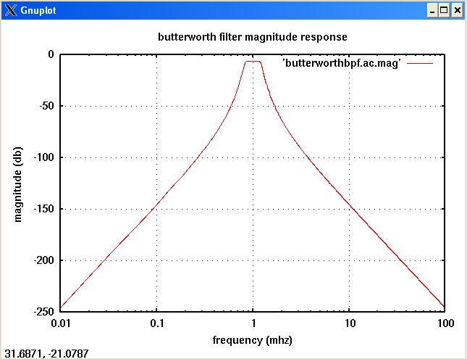

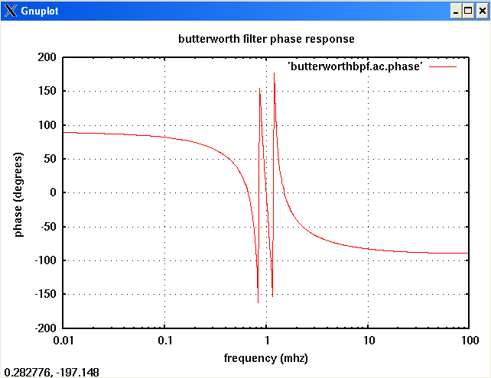
Example of a Transient Analysis (.TRAN2) of a 5th-order filter with a center frequency of 1MHz, a bandwidth of 400kHz, and a input/output impedance of 50Ω. The source frequency is set to the center frequency of 1MHz, with a 1V pk-to-pk amplitude.
Netlist File: butterworthbpftrantest1.net

**** tran2 butterworthbpf test #1 *****

.tran2 tstop=16us tstep=1ns out_steps=2000

vsource:vin 1 0 vac=1.0 f=1e6

R:Rin1 1 2 r=50
Butterworthbpf:b1 2 3 0 order=5 fc=1e6 bw=400e3 z0=50
R:Rout1 3 0 r=50

.options gnuplot
.options preample1="set term x11 font 'helvetica,13';
set title 'Butterworth Filter Transient Response'; set xlabel 'TIME (microseconds)';
set ylabel 'Voltage (V)"
.out plot term 3 vt 1e6 scalex preample1 in "butterworthbpf.tran.out1"

.end

The output log file is:

********** fREEDA 1.3 running on Thu Apr 17 19:28:24 2008 **********

** Environment variables: **
FREEDA_HOME = /sevans/freeda
FREEDA_LIBRARY = /sevans/freeda/library
FREEDA_PROJECTS = /sevans/freeda/projects
FREEDA_PATH = /sevans/freeda/freeda
FREEDA_BIN = /sevans/freeda/freeda/bin
FREEDA_SIMULATOR = /sevans/freeda/freeda/simulator
FREEDA_ELEMENTS = /sevans/freeda/freeda/simulator/elements
FREEDA_DOCUMENTATION = /tmp
FREEDA_WEB_DOCUMENTATION = http://www.freeda.org/doc
FREEDA_BROWSER = cygstart

**** tran2 butterworthbpf test #1 *****

**** tran2 butterworthbpf test #1 *****

.tran2 tstop=16us tstep=1ns out_steps=2000

vsource:vin 1 0 vac=1.0 f=1e6

r:rin1 1 2 r=50
butterworthbpf:b1 2 3 0 order=5 fc=1e6 bw=400e3 z0=50
r:rout1 3 0 r=50

.options gnuplot
set ylabel 'voltage (v)"
.out plot term 3 vt 1e6 scalex preample1 in "butterworthbpf.tran.out1"

.end

*** Starting analysis ...

-----------------------------------------------------------------------------
Matrix size = 12
Matrix nnz = 33
equed = 7.66303e-305
recip_pivot_growth = 0.999989
1 / Condition number = 0.215533
info = 0
ferr = 9.13374e-307
berr = 1
No of nonzeros in factor L = 44
No of nonzeros in factor U = 44
No of nonzeros in L+U = 76
L\U MB 0.001 total MB needed 0.003 expansions 0
Using line search method.
Nonlinear analysis tolerance (ftol) = 6.12865e-06
Maximum number of nonlinear iterations per time-point (maxit) = 250
Using Lee and Lee's quasi-Newton updates.
--- Starting transient simulation ...

Number of nonlinear state variables: 0
-----------------------------------------------------------------------------
| Step | Time (s) | Residual | Recent Max | Max |
-----------------------------------------------------------------------------
| 0 | 0.000000e+00 | 0.000000e+00 | 0.000000e+00 | 0.000000e+00 |
| 2000 | 2.000000e-06 | 0.000000e+00 | 0.000000e+00 | 0.000000e+00 |
| 4000 | 4.000000e-06 | 0.000000e+00 | 0.000000e+00 | 0.000000e+00 |
| 6000 | 6.000000e-06 | 0.000000e+00 | 0.000000e+00 | 0.000000e+00 |
| 8000 | 8.000000e-06 | 0.000000e+00 | 0.000000e+00 | 0.000000e+00 |
| 10000 | 1.000000e-05 | 0.000000e+00 | 0.000000e+00 | 0.000000e+00 |
| 12000 | 1.200000e-05 | 0.000000e+00 | 0.000000e+00 | 0.000000e+00 |
| 14000 | 1.400000e-05 | 0.000000e+00 | 0.000000e+00 | 0.000000e+00 |
| 16000 | 1.600000e-05 | 0.000000e+00 | 0.000000e+00 | 0.000000e+00 |
--- Maximum Residual: 0
-----------------------------------------------------------------------------

Plotting output file: butterworthbpf.tran.out1.

************** fREEDA 1.3 stopping on Thu Apr 17 19:28:30 2008 ***********

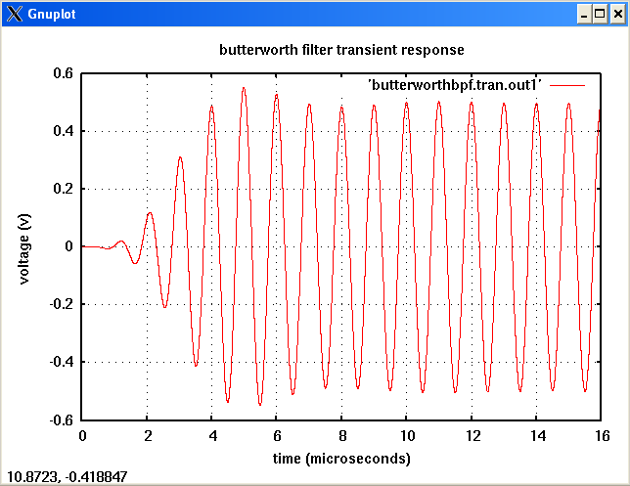
Example of a Transient Analysis (.TRAN2) of a 5th-order filter with a center frequency of 1MHz, a bandwidth of 400kHz, and a input/output impedance of 50Ω. The source frequency is set outside of the bandwidth of the filter at 1.5MHz, with a 1V pk-to-pk amplitude.
Netlist File: butterworthbpftrantest1.net

**** tran2 butterworthbpf test #2 *****

.tran2 tstop=16us tstep=1ns out_steps=2000

vsource:vin 1 0 vac=1.0 f=1.5e6

R:Rin1 1 2 r=50
Butterworthbpf:b1 2 3 0 order=5 fc=1e6 bw=400e3 z0=50
R:Rout1 3 0 r=50

.options gnuplot
.options preample1="set term x11 font 'helvetica,13';
set title 'Butterworth Filter Transient Response'; set xlabel 'TIME (microseconds)';
set ylabel 'Voltage (V)"
.out plot term 3 vt 1e6 scalex preample1 in "butterworthbpf.tran.out2"

.end

The output log file is:

********** fREEDA 1.3 running on Thu Apr 17 19:28:42 2008 **********

** Environment variables: **
FREEDA_HOME = /sevans/freeda
FREEDA_LIBRARY = /sevans/freeda/library
FREEDA_PROJECTS = /sevans/freeda/projects
FREEDA_PATH = /sevans/freeda/freeda
FREEDA_BIN = /sevans/freeda/freeda/bin
FREEDA_SIMULATOR = /sevans/freeda/freeda/simulator
FREEDA_ELEMENTS = /sevans/freeda/freeda/simulator/elements
FREEDA_DOCUMENTATION = /tmp
FREEDA_WEB_DOCUMENTATION = http://www.freeda.org/doc
FREEDA_BROWSER = cygstart

**** tran2 butterworthbpf test #2 *****

**** tran2 butterworthbpf test #2 *****

.tran2 tstop=16us tstep=1ns out_steps=2000

vsource:vin 1 0 vac=1.0 f=1.5e6

r:rin1 1 2 r=50
butterworthbpf:b1 2 3 0 order=5 fc=1e6 bw=400e3 z0=50
r:rout1 3 0 r=50

.options gnuplot
set ylabel 'voltage (v)"
.out plot term 3 vt 1e6 scalex preample1 in "butterworthbpf.tran.out2"

.end

*** Starting analysis ...

-----------------------------------------------------------------------------
Matrix size = 12
Matrix nnz = 33
equed = 7.66303e-305
recip_pivot_growth = 0.999989
1 / Condition number = 0.215533
info = 0
ferr = 9.13374e-307
berr = 1
No of nonzeros in factor L = 44
No of nonzeros in factor U = 44
No of nonzeros in L+U = 76
L\U MB 0.001 total MB needed 0.003 expansions 0
Using line search method.
Nonlinear analysis tolerance (ftol) = 6.12865e-06
Maximum number of nonlinear iterations per time-point (maxit) = 250
Using Lee and Lee's quasi-Newton updates.
--- Starting transient simulation ...

Number of nonlinear state variables: 0
-----------------------------------------------------------------------------
| Step | Time (s) | Residual | Recent Max | Max |
-----------------------------------------------------------------------------
| 0 | 0.000000e+00 | 0.000000e+00 | 0.000000e+00 | 0.000000e+00 |
| 2000 | 2.000000e-06 | 0.000000e+00 | 0.000000e+00 | 0.000000e+00 |
| 4000 | 4.000000e-06 | 0.000000e+00 | 0.000000e+00 | 0.000000e+00 |
| 6000 | 6.000000e-06 | 0.000000e+00 | 0.000000e+00 | 0.000000e+00 |
| 8000 | 8.000000e-06 | 0.000000e+00 | 0.000000e+00 | 0.000000e+00 |
| 10000 | 1.000000e-05 | 0.000000e+00 | 0.000000e+00 | 0.000000e+00 |
| 12000 | 1.200000e-05 | 0.000000e+00 | 0.000000e+00 | 0.000000e+00 |
| 14000 | 1.400000e-05 | 0.000000e+00 | 0.000000e+00 | 0.000000e+00 |
| 16000 | 1.600000e-05 | 0.000000e+00 | 0.000000e+00 | 0.000000e+00 |
--- Maximum Residual: 0
-----------------------------------------------------------------------------

Plotting output file: butterworthbpf.tran.out2.

************** fREEDA 1.3 stopping on Thu Apr 17 19:28:48 2008 ***********

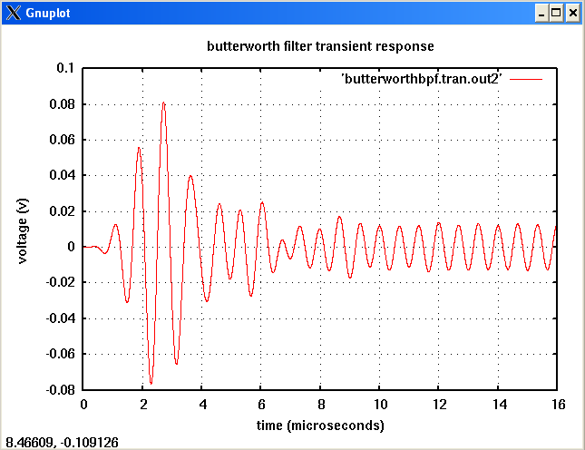

References:
Fathelbab, Wael. Microwave and RF Design. pg444-473.

Version:
2008.04.21 (2008 April 21)

Known Bugs:
Q needs to be added as a parameter
Change parameters and reorganize terminals to be consistent with ChebyshevBPF

Credits:
Name: Affiliation Date Links
Shawn Evans NC State University April 2008
sdevans@ncsu.edu www.ncsu.edu

