JUNCAP model (Philips JUNCAP Device) capacitorJn

0
Anode
1
Cathode
Figure 1: capacitorJn —— Juncap Element

Description:

This element implements a junction capacitor model that is used to model the source-bulk and drain-bulk junction diode behavior of the Philips MOS Model 9 model..

Form:

capacitorJn :(instance name) n₁ n₂ <parameter list>
n₁ is the positive(anode) diode voltage.
n₂ is the negative(cathode) diode voltage.

Parameters:

Parameters | Type | Default value | Required?
level: Level of this model. Must be set to 1 | Double | 1 | no
ab: Diffusion area(m^2) | Double | 1e-12 | no
ls: Length of side-wall of diffusion area AB which is not under gate(m) | Double | 1.0e-6 | no
lg: Length of side-wall of diffusion area AB which is under gate(m) | Double | 1.0e-6 | no
dta: Temperature offset of capjn element with respect to TA(C) | Double | 0.0 | no
tr: Temperature at which parameters have been determined(C) | Double | 25 | no
vr: Voltage at which parameters have been determined(V) | Double | 0.0 | no
jsgbr: Bottom saturation-current density due to electron-hole gene ration at V=VR(Am-2) | Double | 1.0E-3 | no
jsdbr: Bottom saturation-current density due to diffusion from back contact(Am-2) | Double | 1.0E-3 | no
jsgsr: Sidewall saturation-current density due to electron-hole generation at V=VR(Am-1) | Double | 1.0E-3 | no
jsdsr: Sidewall saturation-current density due to diffusion from back contact(Am-1) | Double | 1.0E-3 | no
jsggr: Gate edge saturation current density due to electron-hole generation at V=VR(Am-1) | Double | 1.0E-3 | no
jsdgr: Gate edge saturation current density due to diffusion from back contact(Am-1) | Double | 1.0E-3 | no
jsggr: Gate edge saturation current density due to electron-hole generation at V=VR(Am-1) | Double | 1.0E-3 | no
jsdgr: Gate edge saturation current density due to diffusion from back contact(Am-1) | Double | 1.0E-3 | no
nb: Emission coefficient of the bottom forward current | Double | 1.0 | no
ns: Emission coefficient of the sidewall forward current | Double | 1.0 | no
ng: Emission coefficient of the gate edge forward current | Double | 1.0 | no
vb: Reverse breakdown voltage(V) | Double | 0.9 | no
cjbr: Bottom junction capacitance at V=VR(Fm-2) | Double | 1.0E-12 | no
cjsr: Sidewall junction capacitance at V=VR(Fm-1) | Double | 1.0E-12 | no
cjgr: Gate edge junction capacitance at V=VR(Fm-1) | Double | 1.0E-12 | no
vdbr: Diffusion voltage of the bottom junction at T=TR(V) | Double | 1.00 | no
vdsr: Diffusion voltage of the sidewall junction at T=TR(V) | Double | 1.00 | no
vdgr: Diffusion voltage of the gate edge junction(V) | Double | 1.00 | no
pb: Bottom junction grading coefficient | Double | 0.40 | no
ps: Sidewall junction grading coefficient | Double | 0.40 | no
pg: Gate edge junction grading coefficient | Double | 0.40 | no

Example:
capacitorJn: j1 0 0.07 level=1 jsggr=1e-9

Model Documentation:
Theory
This section summarizes the elementary physics of a junction diode. Refer to semiconductor textbooks for additional information.Generally, the current voltage characteristics can be represented as follows:
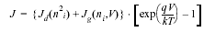
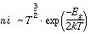
Table 1-1: Current Voltage Characteristics
Quantity | Units | Description
J | Am -2 | Total reverse current density
Jd | Am -2 | Diffusion saturation current density
Jg | Am -2 | Generation current density
ni | m -3 | Intrinsic carrier concentration
V | V | Voltage across the diode
Eg | J | Energy gap
k | JK -1 | Boltzmann constant
T | K | Temperature

For V<V_{D} , the charge of the junction capacitance is described by:
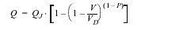
Table 1-2: Junction Capacitance Charge
Quantity | Units | Description
Q | C | Total diode junction charge
Q j | C | Junction charge at built-in voltage
V | V | Voltage across the diode
Vd | V | Junction diffusion voltage
P |  | Junction grading coefficient

CAPJN Model

The CAPJN model is intended to describe formed by the source, drain or well-to-bulk junction devices, limited to the case of reverse biasing of these junctions. Similar to the MOS model, the current equations are formulated and AC effects are modeled via charge equations using the quasi-static approximation. In order to include the effects from differences in the sidewall, bottom, and gate-edge junction profiles, these three contributions are calculated separately in the CAPJN model. Both the diffusion and the generation currents are treated in the model, each with individual temperature and voltage dependence.
In the CAPJN model, a part of the total charge comes from the gate-edge junction very close to the surface. This charge is also included in the MOS model charge equations and is counted twice. However, this results in only a very minor error.
In the next section, the model equations are presented. Correct operation of the model in a circuit simulator environment requires some numerical additions, which are described in the section on implementation. Any fixed capacitance that is present on a node (e.g., metal-1-to-substrate capacitance) must appear in a fixed capacitor statement or must be included in INTCAP. They no longer form the CAPJN model in contrast to the old NODCAP model.

Nomenclature
Table 1-3: List of Electrical Variable Parameters
No | Variable | Programming Name | Units | Description
1 | Va | VA | V | Potential applied to the anode
2 | Vk | VK | V | Potential applied to the cathode
3 | Ia | IA | A | DC current into the anode
4 | Ik | IK | A | DC current into the cathode
5 | Qa | QA | C | Charge in the device attributed to the anode
6 | Qk | QK | C | Charge in the device attributed to the cathode

List of Internal Variables and Parameters
Table 1-4: Internal Variables and Parameters
No | Parameter | Programming Name | Units | Description
1 | Vdb | VDB | V | Diffusion voltage of bottom area AB
2 | Vds | VDS | V | Diffusion voltage of Locos-edge LS
3 | Vdg | VDG | V | Diffusion voltage of gate-edge LG
4 | Cjb | CJB | F | Capacitance of bottom area AB
5 | Cjs | CJS | F | Capacitance of Locos-edge LS
6 | Cjg | CJG | F | Capacitance of gate-edge LG
7 | Isdb | ISDB | A | Diffusion saturation current of bottom area AB
8 | Isds | ISDS | A | Diffusion saturation current of Locos-edge LS
9 | Isdg | ISDG | A | Diffusion saturation current of gate-edge LG
10 | Isgb | ISGB | A | Generation saturation current of bottom area AB
11 | Isgs | ISGS | A | Generation saturation current of Locos-edge LS
12 | Isgg | ISGG | A | Generation saturation current of gate-edge LG
13 | Ta | TA | C | Ambient circuit temperature
14 | Tkd | TKD | K | Absolute temperature of the junction/device
15 | V | V | V | Diode bias voltage (V=VA - VK)
16 | I | I | A | Total DC current from anode to cathode (I = IA = -IK)
17 | Q | Q | C | Total junction charge(Q = QA = - QK)

ON/OFF Condition
The solution of a circuit involves a process of successive calculations. The calculations are started from a set of "initial guesses" for the electrical quantities of the non-linear elements. The devices start in the default state.
JUNCAP | Default | ON | OFF
V_{D} | -0.1 | 0.7 | -0.1

Numerical Adaptation
To implement the model in a circuit simulator, care must be taken of the numerical stability of the simulation program. A small non-physical conductance, Gmin, is connectedvalue of the conductance Gmin is 10⁻¹⁵[1/].
Remark: The conductance G min is connected in parallel to the conductance G. This conductance influences the DC operating output.

DC Operating Point Output
The DC operating point output facility gives information on the state of a device at its operation point.

CAPJN Model Equations
Temperature, Geometry and Voltage Dependence
The general scaling rules, which apply to all three components of the CAPJN model, are:

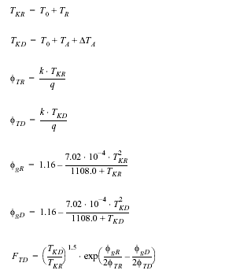
The internal reference parameters for the bottom component are specified by:
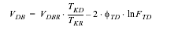
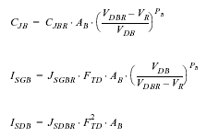
Similar formulations hold for the locos-edge and the gate-edge components. Replace the index B by S and G , and the area AB by LS and LG
In subsequent sections, we will show the equations only for the bottom component.

CAPJN Capacitor and Leakage Current Model
Charge
In the charge description, the following internal parameter is defined:
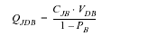
In order to prevent an unlimited increase of the voltage derivative of the charge, the charge description is in two parts: the original power function and a supplemented quadratic function. At the cross-over point between these regions, indicated by V_{L}, the following parameters are defined:
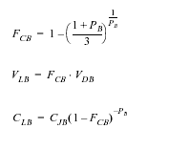
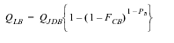
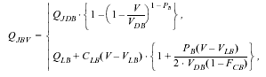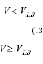
Similar expressions exist for the locos-edge and gate-edge charges, Qjsv and Qjgv .
The total charge characteristic can be described by:
Capacitance
Using elementary mathematics, simple equations for the capacitance of the bottom area:
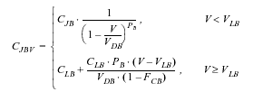
and similar expressions exist for Cjsv and Cjgv .
The total capacitance can be described by:
Current
With the scaled parameters of the preceding section, the diffusion and generation current components can be expressed as:
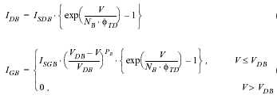
The first relation concerning the diffusion component is valid over the whole operating range. The second relation, describing the generation current, shows an unlimited increase in the derivative of this function at V=V DB . Therefore, the power function is merged at V=0.0 with a hyperbolic function in the forward bias range. The exponential part is divided by . This enables a gradual decrease in the generation current component.
The hyperbolic function is used. The parameter B controls the decrease of the current for voltages V>0.0 for all generation components. The value of B is fixed and set to 2 in the model. The continuity constraints of function and derivative in the merge point lead to the following relations for Fsb and Vab :
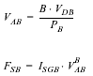
The generation current voltage characteristic in the forward region becomes:
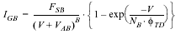
The final model equations for the currents of the bottom area are:
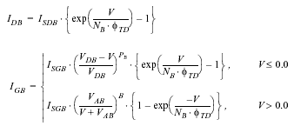

Similar expressions exist for the locos-edge and gate-edge components.
The total junction current can be expressed as:
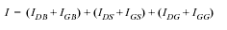

References:
http://www.semiconductors.philips.com/Philips_Models/additional/juncap/

Sample Netlist:

*****Test netlist for capacitoJn(mos9)mosfet model*****
*.dc sweep="vsource:v1" start=-5 stop=-0.1 step=0.1
*.dc sweep="vsource:v1" start=-1 stop=-0.01 step=0.01
.dc sweep="vsource:v1" start=-1 stop=0.1 step=0.01
capacitorJn:j1 1 0

vsource:v1 1 0
*res:rd 1 0 r=1e15

*.out plot element "capacitorjn:j1" 0 it in "capjn_1.dc"
*.out plot element " capacitorjn:j1" 0 it in "capjn_2.dc"
.out plot element " capacitorjn:j1" 0 it in "capjn_3.dc"
.end

Validation:

The results of runs.
1. capjn_1.dc
Juncap I-V curve1
-7
-6
-5
-4
-3
-2
-1
0
V(-5v~-0.1v)
I:
(e-9A)

2. capjn_2.dc
Juncap I-V curve2
-5
-4
-3
-2
-1
0
V(-5v~-0.01v)
I:
(e-9A)

3. capjn_3.dc
Juncap I-V curve3
-1.00E+04
0.00E+00
1.00E+04
2.00E+04
3.00E+04
4.00E+04
5.00E+04
6.00E+04
7.00E+04
8.00E+04
V(-1v~1v) 0.7v
I

Known Bugs:

When the input voltage is zero, the derivative of zero turn out to be extremely small but not zero.

Credits:

Name | Affiliation | Date | Links
Yogesh Ramdoss  ytramdos@ncsu.edu  Kuldip Gothi  kuldipgothi@yahoo.com  Xuemin Yang  xyang@ncsu.edu  Ajit Rajagopalan  ajit_r@softhome.net  Dapeng Ding  dding@ncsu.edu  Xin Cai  xcai2@ncsu.edu | NC State University | April 2003 | www.ncsu.edu

