Chebyshev Lumped Lowpass/Highpass Filter chebyshevLPF

/chebyshevf
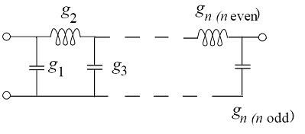
Figure 1: Lowpass filter element (highpass filter swaps L and C elements)

Form: cheyshevLPF:(instance name) n1 n2 n3 (parameter list)
n1, n2 and n3 are the element terminals. Terminal n2 is the element reference terminal, n1 is the input terminal and n3 is the output terminal.

_______________________________________________________

Parameters:
Parameter | Type | Default Value | Required?
n: Filter Order (no limit) | Integer | 3 | No
f0: Corner Frequency | Double | None | Yes
z0: Characteristic Impedance | Double | None | Yes
type: Type of filter, lowpass(0) or highpass(1) | Integer | None | Yes
ripple: Filter ripple (in dB) | Double | 1 | No

Details:
This is a linear element, comprised of ideal inductors and capacitors. Chebyshev filters of odd order are usually used. If an even order is specified, the element includes a resistor in parallel with the output to control the ripple.

chebyshevLPF:f1 2 0 3 n=21 f0=300e6 z0=50 type=1 ripple=1
Here, node 2 is the input, node 0 is the local reference, and node 3 is the output. This is a 21st-order highpass filter with 1 dB of ripple, 50 ohm impedance, and a 300 MHz corner frequency.

Example of Transient Analysis (.TRAN2) Fixed times steps, time-stepping nonlinear analysis.
netlist: chebyshevLPF.net:

* Transient chebyshevLPF test
.options verbose

.tran2 tstop=80ns tstep=0.1ns out_steps=1

vsource:1 1 0 vac=1 f=300e6 phase=90
R:Rin 1 2 r=10
chebyshevLPF:f1 2 0 3 n=11 f0=300e6 z0=10 type=0 ripple=0.1
R:Ro 3 0 r=10
.options gnuplot
.options plotVT1Preamble="set xlabel 'Time (s)'; set ylabel 'Magnitude (V)"
.out plot term 3 vt plotVT1Preamble in "out.tran.value"

.end

The output log file is:
********** fREEDA 1.3 running on Sun Apr 20 14:07:01 2008 **********

* Transient chebyshevLPF test
.options verbose

.tran2 tstop=80ns tstep=0.1ns out_steps=1

vsource:1 1 0 vac=1 f=300e6 phase=90
r:rin 1 2 r=10
chebyshevLPF:f1 2 0 3 n=11 f0=300e6 z0=10 type=0 ripple=0.1
r:ro 3 0 r=10
.options gnuplot
.options plotvt1preamble="set xlabel 'time (s)'; set ylabel 'magnitude (v)"
.out plot term 3 vt plotvt1preamble in "out.vsource.value"

************************************************************************

*** Network Dump:

*** Title:

* Transient chebyshevLPF test

'OPTIONS' table, 22 entries
1: 'itl1' = 40 (int)
2: 'itl2' = 20 (int)
3: 'chgtol' = 1e-14 (double)
4: 'plotvt1preamble' = 'set xlabel 'time (s)'; set ylabel 'magnitude (v)' (string)
4: 'verbose' = 1 (int)
4: 'itl4' = 10 (int)
4: 'cptime' = 1e+06 (double)
5: 'itl5' = 5000 (int)
5: 'defl' = 0.0001 (double)
7: 'abstol' = 1e-12 (double)
7: 'defad' = 0 (double)
11: 'tnom' = 27 (double)
12: 'vntol' = 1e-06 (double)
14: 'trtol' = 7 (double)
16: 'defw' = 0.0001 (double)
17: 'numdgt' = 4 (int)
20: 'pivrel' = 1e-13 (double)
20: 'reltol' = 0.001 (double)
21: 'gmin' = 1e-12 (double)
22: 'defas' = 0 (double)
23: 'gnuplot' = 1 (int)
27: 'limpts' = 201 (double)

'OUTPUT' table, 1 entries
16: 'out1' (output request) =
type = 0 termination
type = 1 terminal id(val,type) = (6,1)
type = 101 operator
type = 206 string = set xlabel 'time (s)'; set ylabel 'magnitude (v)
type = 12 filename = out.vsource.value
No expressions
***
No sweeps

*** Circuit "Main" listing:
vsource:1 - General DC and sinusoidal voltage source
1
0

r:rin - Resistor
1
2

chebyshevLPF:f1 - 3 terminal Chebyshev Filter
2
0
3

r:ro - Resistor
3
0

************************************************************************

*** Starting analysis ...

-----------------------------------------------------------------------------
Matrix size = 13
Matrix nnz = 36
equed = 7.66328e-305
recip_pivot_growth = 0.994658
1 / Condition number = 0.207838
info = 0
ferr = 5.36751e-307
berr = 1
No of nonzeros in factor L = 52
No of nonzeros in factor U = 53
No of nonzeros in L+U = 92
L\U MB 0.001 total MB needed 0.004 expansions 0
Using line search method.
Nonlinear analysis tolerance (ftol) = 6.12865e-06
Maximum number of nonlinear iterations per time-point (maxit) = 250
Using Lee and Lee's quasi-Newton updates.
--- Starting transient simulation ...

Number of nonlinear state variables: 0
-----------------------------------------------------------------------------
| Step | Time (s) | Residual | Recent Max | Max |
-----------------------------------------------------------------------------
| 0 | 0.000000e+00 | 0.000000e+00 | 0.000000e+00 | 0.000000e+00 |
| 1 | 1.000000e-10 | 0.000000e+00 | 0.000000e+00 | 0.000000e+00 |
| 2 | 2.000000e-10 | 0.000000e+00 | 0.000000e+00 | 0.000000e+00 |
| 3 | 3.000000e-10 | 0.000000e+00 | 0.000000e+00 | 0.000000e+00 |
| 4 | 4.000000e-10 | 0.000000e+00 | 0.000000e+00 | 0.000000e+00 |
| 5 | 5.000000e-10 | 0.000000e+00 | 0.000000e+00 | 0.000000e+00 |
.
.
.
| 800 | 8.000000e-08 | 0.000000e+00 | 0.000000e+00 | 0.000000e+00 |
--- Maximum Residual: 0
-----------------------------------------------------------------------------

Plotting output file: out.vsource.value.

************** fREEDA 1.3 stopping on Sun Apr 20 14:07:03 2008 ***********
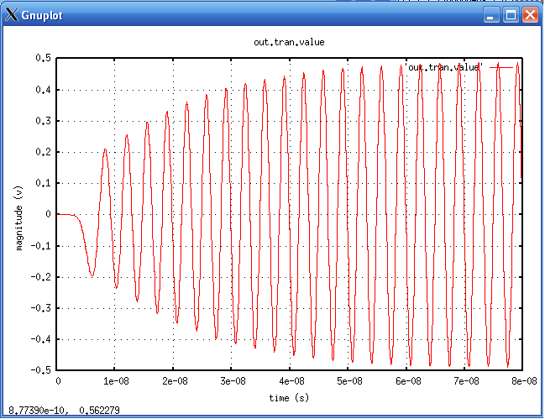

Example of AC analysis
Netlist file: chebyshevLPFAC.net:

* AC Analysis
.ac start = 1e6 stop = 1GHz n_freqs=100
vsource:v1 1 0 vac= 5
resistor:rs1 1 2 r=50
chebyshevLPF:f1 2 0 3 n=21 f0=300e6 z0=50 type=0 ripple=1
resistor:rl1 3 0 r=50

vsource:v2 4 0 vac= 5
resistor:rs2 4 5 r=50
chebyshevLPF:f2 5 0 6 n=21 f0=300e6 z0=50 type=1 ripple=1
resistor:rl2 6 0 r=50

.options gnuplot
.options plotVF1Preamble="set logscale x; set xlabel 'FREQUENCY (Hz)'; set ylabel 'Magnitude (dB)"
.out plot term 3 vf term 2 vf div mag db plotVF1Preamble in "out.ac1.value"
.out plot term 6 vf term 5 vf div mag db plotVF1Preamble in "out.ac2.value"

.end

Output log file:
********** fREEDA 1.3 running on Sun Apr 20 14:36:04 2008 **********

* AC Analysis
.ac start = 1e6 stop = 1GHz n_freqs=100
* AC Analysis
.ac start = 1e6 stop = 1ghz n_freqs=100
vsource:v1 1 0 vac= 5
resistor:rs1 1 2 r=50
chebyshevLPF:f1 2 0 3 n=21 f0=300e6 z0=50 type=0 ripple=1
resistor:rl1 3 0 r=50

vsource:v2 4 0 vac= 5
resistor:rs2 4 5 r=50
chebyshevLPF:f2 5 0 6 n=21 f0=300e6 z0=50 type=1 ripple=1
resistor:rl2 6 0 r=50

.options gnuplot
.options plotvf1preamble="set logscale x; set xlabel 'frequency (hz)'; set ylabel 'magnitude (db)"
.out plot term 3 vf term 2 vf div mag db plotvf1preamble in "out.ac1.value"
.out plot term 6 vf term 5 vf div mag db plotvf1preamble in "out.ac2.value"

.end

*** Starting analysis ...

-----------------------------------------------------------------------------
*** AC Analysis ***
-----------------------------------------------------------------------------

Frequency step = 1.00909e+07 Hz
--- Writing output vectors ...
Plotting output file: out.ac1.value.
Plotting output file: out.ac2.value.

************** fREEDA 1.3 stopping on Sun Apr 20 14:36:06 2008 ***********

Results are:

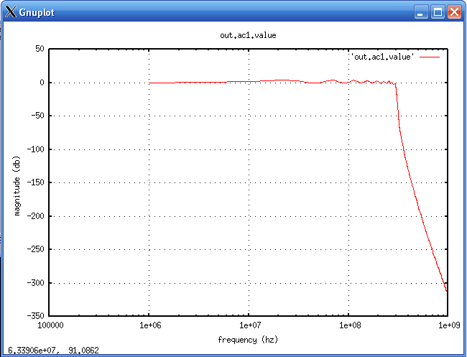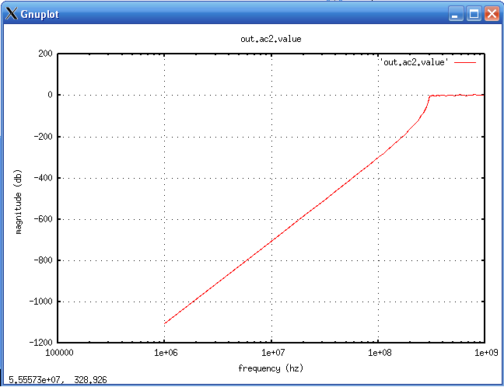

_______________________________________________________
Version:
2008.04.21 (2008 April 21)

_______________________________________________________
Credits:
Name Affiliation Date Links
Michael Bucher NC State University April 2008 
mdbucher@gmail.com www.ncsu.edu

