CMOS Inverter cmosinv
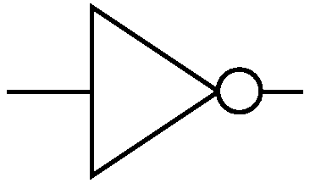
IN
OUTT

Description:
This is an Intrinsic Super Element which models a CMOS inverter utilizing the EKV 2.6 model.

Form: cmosinv:<instance name> n1 n2 n3 n4 <parameter list>

n1 is the high voltage source (Vdd) terminal,
n2 is the input terminal,
n3 is the output terminal,
n4 is the ground or Vss terminal.

Parameters:
Parameter | Type | Default Value | Required
ln: Channel Length of NMOS (m) | TR_DOUBLE | 1.0e-6 | No
wn: Channel Width of NMOS (m) | TR_DOUBLE | 1.0e-6 | No
lp: Channel Length of PMOS (m) | TR_DOUBLE | 1.0e-6 | No
wp: Channel Width of PMOS (m) | TR_DOUBLE | 1.0e-6 | No
np_n: Parallel multiple device number of NMOS | TR_DOUBLE | 1.0 | No
np_p: Parallel multiple device number of PMOS | TR_DOUBLE | 1.0 | No
ns_n: Serial multiple device number of NMOS | TR_DOUBLE | 1.0 | No
ns_p: Serial multiple device number of PMOS | TR_DOUBLE | 1.0 | No
cox_n: Gate oxide capacitance per area of NMOS (F/m^2) | TR_DOUBLE | 0.0 | No
cox_p: Gate oxide capacitance per area of PMOS (F/m^2) | TR_DOUBLE | 0.0 | No
xj_n: Junction depth of NMOS (m) | TR_DOUBLE | 1.0e-7 | No
xj_p: Junction depth of PMOS (m) | TR_DOUBLE | 1.0e-7 | No
dw_n: Channel width correction of NMOS (m) | TR_DOUBLE | 0.0 | No
dw_p: Channel width correction of PMOS (m) | TR_DOUBLE | 0.0 | No
dl_n: Channel length correction of NMOS (m) | TR_DOUBLE | 0.0 | No
dl_p: Channel length correction of PMOS (m) | TR_DOUBLE | 0.0 | No
vto_n: Long_channel threshold voltage of NMOS (V) | TR_DOUBLE | 0.0 | No
vto_p: Long_channel threshold voltage of PMOS (V) | TR_DOUBLE | 0.0 | No
gamma_n: Body effect parameter of NMOS (V^1/2) | TR_DOUBLE | 0.0 | No
gamma_p: Body effect parameter of PMOS (V^1/2) | TR_DOUBLE | 0.0 | No
phi_n: Bulk Fermi potential of NMOS (V) | TR_DOUBLE | 0.0 | No
phi_p: Bulk Fermi potential of PMOS (V) | TR_DOUBLE | 0.0 | No
kp_n: Transconductance parameter of NMOS (A/V^2) | TR_DOUBLE | 0.0 | No
kp_p: Transconductance parameter of PMOS (A/V^2) | TR_DOUBLE | 0.0 | No
eo_n: Mobility reduction coefficient of NMOS (V/m) | TR_DOUBLE | 0.0 | No
eo_p: Mobility reduction coefficient of PMOS (V/m) | TR_DOUBLE | 0.0 | No
ucrit_n: Longitudinal critical field of NMOS (V/m) | TR_DOUBLE | 0.0 | No
ucrit_p: Longitudinal critical field of PMOS (V/m) | TR_DOUBLE | 0.0 | No
tox_n: Oxide thickness of NMOS (m) | TR_DOUBLE | 0.0 | No
tox_p: Oxide thickness of PMOS (m) | TR_DOUBLE | 0.0 | No
nsub: Channel doping of NMOS (1/cm^3) | TR_DOUBLE | 0.0 | No
psub: Channel doping of PMOS (1/cm^3) | TR_DOUBLE | 0.0 | No
vfb_n: Flat-band voltage of NMOS (V) | TR_DOUBLE | -2003.0 | No
vfb_p: Flat-band voltage of PMOS (V) | TR_DOUBLE | -2003.0 | No
uo_n: Low-field mobility of NMOS(cm^2/(V.s)) | TR_DOUBLE | 500 | No
uo_p: Low-field mobility of PMOS(cm^2/(V.s)) | TR_DOUBLE | 200 | No
vmax_n : Saturation velocity of NMOS (m/s) | TR_DOUBLE | 0.0 | No
vmax_p: Saturation velocity of PMOS (m/s) | TR_DOUBLE | 0.0 | No
lambda_n: Channel-length modulation of NMOS | TR_DOUBLE | 0.5 | No
lambda_p: Channel-length modulation of PMOS | TR_DOUBLE | 0.5 | No
weta_n: Narrow-channel effect coefficient of NMOS | TR_DOUBLE | 0.25 | No
weta_p: Narrow-channel effect coefficient of PMOS | TR_DOUBLE | 0.25 | No
leta_n: Short-channel effect coefficient of NMOS | TR_DOUBLE | 0.1 | No
leta_p: Short-channel effect coefficient of PMOS | TR_DOUBLE | 0.1 | No
qo_n: Reverse short channel effect peak charge density of NMOS (A.s/m^2) | TR_DOUBLE | 0.0 | No
qo_p: Reverse short channel effect peak charge density of PMOS (A.s/m^2) | TR_DOUBLE | 0.0 | No
lk_n: Reverse short channel effect characteristic length of NMOS (m) | TR_DOUBLE | 2.9e-7 | No
lk_p: Reverse short channel effect characteristic length of PMOS (m) | TR_DOUBLE | 2.9e-7 | No
iba_n: First impact ionization coefficient of NMOS (1/m) | TR_DOUBLE | 0.0 | No
iba_p: First impact ionization coefficient of PMOS (1/m) | TR_DOUBLE | 0.0 | No
ibb_n: Second impact ionization coefficient of NMOS (V/m) | TR_DOUBLE | 3.0e8 | No
ibb_p: Second impact ionization coefficient of PMOS (V/m) | TR_DOUBLE | 3.0e8 | No
ibn_n: Saturation voltage factor for impact ionization of NMOS | TR_DOUBLE | 1.0 | No
ibn_p: Saturation voltage factor for impact ionization of PMOS | TR_DOUBLE | 1.0 | No
tcv_n: Threshold voltage temperature coefficient of NMOS (V/K) | TR_DOUBLE | 1.0e-3 | No
tcv_p: Threshold voltage temperature coefficient of PMOS (V/K) | TR_DOUBLE | 1.0e-3 | No
bex_n: Mobility temperature exponent of NMOS | TR_DOUBLE | -1.5 | No
bex_p: Mobility temperature exponent of PMOS | TR_DOUBLE | -1.5 | No
ucex_n: Longitudinal critical field temperature exponent of NMOS | TR_DOUBLE | 0.8 | No
ucex_p: Longitudinal critical field temperature exponent of PMOS | TR_DOUBLE | 0.8 | No
ibbt_n: Temperature coefficient for IBB of NMOS (1/K) | TR_DOUBLE | 9.0e-4 | No
ibbt_p: Temperature coefficient for IBB of PMOS (1/K) | TR_DOUBLE | 9.0e-4 | No
avto_n: Area related threshold voltage mismatch parameter of NMOS (Vm) | TR_DOUBLE | 0.0 | No
avto_p: Area related threshold voltage mismatch parameter of PMOS (Vm) | TR_DOUBLE | 0.0 | No
akp_n: Area related gain mismatch parameter of NMOS (m) | TR_DOUBLE | 0.0 | No
akp_p: Area related gain mismatch parameter of PMOS (m) | TR_DOUBLE | 0.0 | No
agamma_n: Area related body effect mismatch parameter of NMOS (V^(1/2)m) | TR_DOUBLE | 0.0 | No
agamma_p: Area related body effect mismatch parameter of PMOS (V^(1/2)m) | TR_DOUBLE | 0.0 | No
scale: Scale parameter | TR_DOUBLE | 1.0 | No
tnom: Nominal temperature of model parameters (K) | TR_DOUBLE | 300.15 | No
tmp: Model simulation temperature (K) | TR_DOUBLE | 300.15 | No

Example:
cmosinv:inverter 1 2 3 0

Notes:
This implementation of cmos inverter is based on EKV 2.6 [1] mosfet model.

Known Bugs:
No known bugs.

Implementation Details:

This element is implemented as a fREEDA Intrinsic Super Element based on EKV 2.6 MOSFET model [1]. The element has 3 state variables: Input Voltage (VIN), Output Voltage (VOUT) and Power Supply Voltage (VDD). Following is the schematic of Inverter:
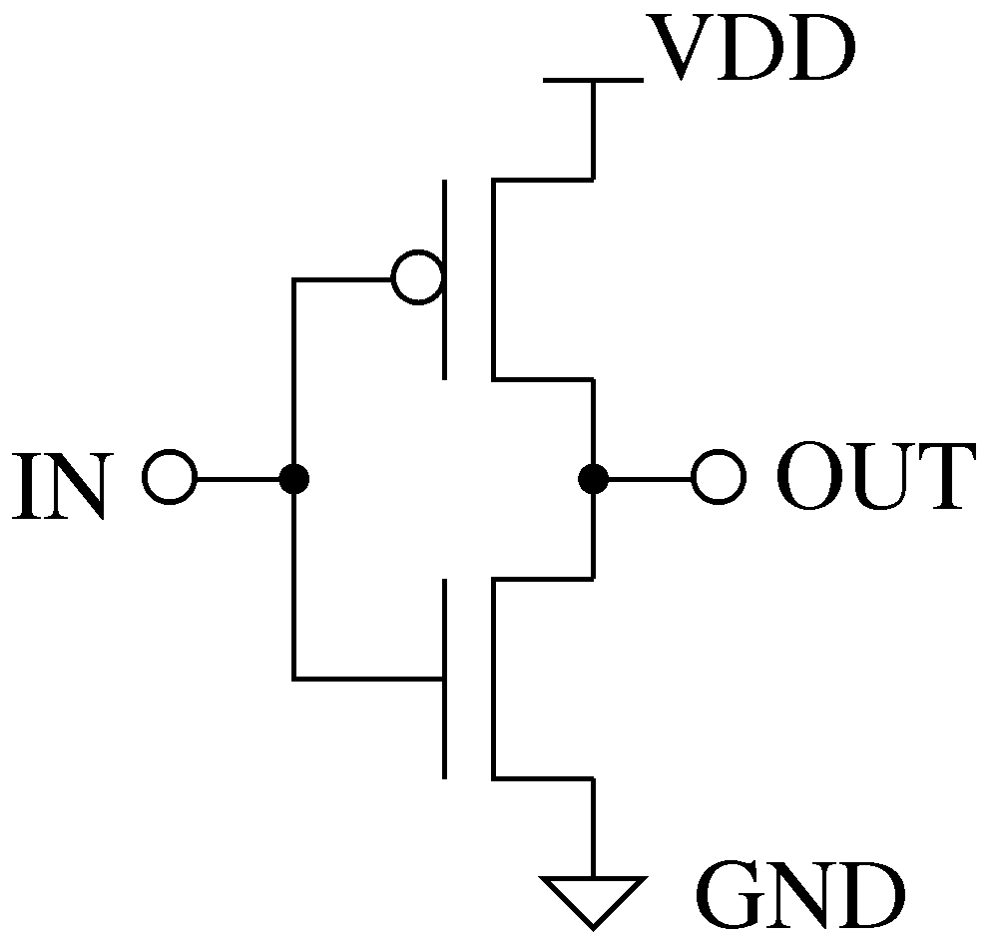

If it would have been implemented as Extrinsic Super Element, then there would have been 6 state variables (3 corresponding to each transistor). Intrinsic implementation has reduced the state variables by factor of two which will lead to faster run time of simulation.

State Variables of Intrinsic Super Element:

State variables of EKV PMOS and NMOS have been represented in terms of these variables. This is charged based model. The current entering in each terminal is sum of corresponding AC and DC current.

In equation (1), Q_{in} indicates charge at gate. The derivative of this charge will give AC current entering in gate. DC current entering in gate is zero.

I_{N} and I_{P} is DC current through nmos and pmos. Q_{out} is charge stored at output node.

are functions of state variables of Intrinsic Super Element.

[1]

References:
[1] The EKV 2.6 Documentation: http://legwww.epfl.ch/ekv/pdf/ekv_v262.pdf

Sample Netlist:
- DC Analysis
The following netlist plots the output voltage of the CMOS Inverter for an input voltage range of 0 ~ 5V.
* CMOS Inverter DC Analysis
** This netlist is for Cmos Inverter DC Analysis. It is based on EKV 2.6 **MOSFET model
.dc sweep="vsource:Vin" start=0 stop=5 step=0.01
*** Vdd connection
vsource:Vdd 1 0 vdc=5
**** Input DC source
vsource:Vin 2 0
***** Instantiation of Inverter
cmosinv:inv 1 2 3 0
**** Load Resistance
r:Rout 3 0 r=1000000
* Load Capacitance
c:Cout 3 0 c=1e-12
***Plot
.options gnuplot
.out plot term 3 vt in "vout.out"
.out plot term 2 vt in "vin.out"
.end

Validation:
The output graph from the above netlist is shown below:
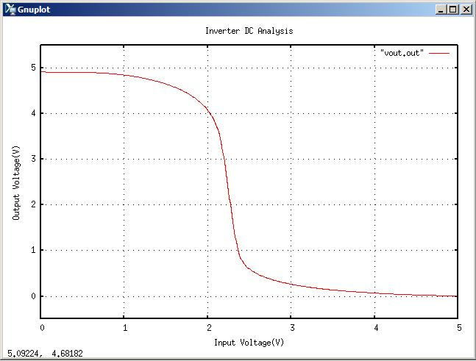

- Transient Analysis
* CMOS Inverter Transient Analysis
*This netlist is for Transient Analysis of Cmos Inverter. It is based on EKV **MOSFET model.
.tran2 tstop=4e-6 tstep=1e-10
*** Input Pulse
vpulse:Vin2 22 0 v1=0 v2=5 per=2e-6 pw=1e-6 tr=0.002e-6 tf=0.002e-6
**** Vdd connection
vsource:Vdd 1 0 vdc=5
*** Instantiation of Inverter
cmosinv:inv 1 2 3 0

* Load Resistance
r:Rout 3 0 r=1000000
* Load Capacitance
c:Cout 3 0 c=1e-12
* Source Resistance
r:Rsource 22 2 r=10
* Source Capacitance
c:Csource 2 0 c=1e-12
*****Plot
.options gnuplot
.out plot term 3 vt in "vout.out"
.out plot term 22 vt in "vin.out"
.end

Validation:
The output graph from the above netlist is shown below:
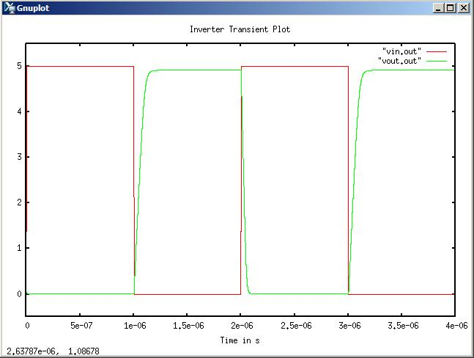

Version: 2009.04.27

Credits:
Name Affiliation Date Links
Shivam Priyadarshi NCSU April, 2009 http://www.ncsu.edu/
Shivam.priyadarshi@gmail.com

Nikhil Kriplani NCSU April, 2009 http://www.ncsu.edu/
nkriplani@gmail.com

