CMOS NAND Gate cmosnand

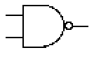
In1
Out
In2

Description:
This element models a CMOS NAND gate.

Form: cmosnand:<instance name> n1 n2 n3 n4 n5 <parameter list>

n1 is the high voltage source (Vdd) terminal,
n2 is the first input terminal,
n3 is the second input terminal,
n4 is the output terminal,
n5 is the ground or Vss terminal

Parameters:

Parameter | Type | Default Value | Required
vtn: NMOS Threshold Voltage (V) | TR_DOUBLE | 1 | No
vtp: PMOS Threshold Voltage (V) | TR_DOUBLE | -1 | No
un: Effective Mobility of Electrons in NMOS ((cm^2)/(V-sec)) | TR_DOUBLE | 500 | No
up: Effective Mobility of Electrons in PMOS ((cm^2)/(V-sec)) | TR_DOUBLE | 200 | No
en: Permittivity of the Gate Insultor in NMOS (F/cm) | TR_DOUBLE | 34.515e-14 | No
ep: Permittivity of the Gate Insultor in PMOS (F/cm) | TR_DOUBLE | 34.515e-14 | No
tox: Thickness of the Gate Insulator (cm) | TR_DOUBLE | 2.0e-6 | No
wn: Channel Width of NMOS (cm) | TR_DOUBLE | 50e-6 | No
ln: Channel Length of NMOS (cm) | TR_DOUBLE | 2.0e-6 | No
wp: Channel Width of PMOS (cm) | TR_DOUBLE | 50e-6 | No
lp: Channel Length of PMOS (cm) | TR_DOUBLE | 2.0e-6 | No
td: Response Delay Time (sec) | TR_DOUBLE | 0 | No

Example:
cmosnand:nand1 1 2 3 4 0 td=0.1e-6

Notes:
This is an analog implementation of a digital NAND gate.

Known Bugs:
No known bugs.

Model documentation:

ßn = (un)(en)(wn)/(tox)(ln)
ßp = (up)(ep)(wp)/(tox)(lp)

The operation of the CMOS NAND gate can be divided into five regions:
V_{in} is considered to be the dominant input of V_{in1} and V_{in2}

Region A: 0 < Vin < V_{Tn}
PMOS: nonsaturated; NMOS cutoff
V_{out} = V_{DD}
I_{DSn} = I_{DSp} = 0

Region B: V_{Tn} < Vin < V_{DD}/2
PMOS: nonsaturated; NMOS saturated
I_{DSp} = - ßp [(V_{DD} - Vin - |V_{Tp}|)(V_{DD} - Vout) – (0.5)(VDD - Vout)²]
I_{DSn} = - I_{DSp}
V_{out} = (V_{in} – V_{Tp}) + sqrt[(V_{in} – V_{Tp})² – 2 V_{DD} (V_{in} – 0.5V_{DD} - V_{Tp})
- (ßn/ ßp) [(V_{in} – V_{Tp})²]

Region C: Vin = V_{DD}/2
PMOS: saturated; NMOS saturated
I_{DSp} = - 0.5ßp [(Vin - V_{DD} - |V_{Tp}|)²]
I_{DSn} = - I_{DSp}
V_{in} – V_{Tn} < V_{out} < V_{in} – V_{Tp}

Region D: V_{DD}/2 < Vin < V_{DD} + V_{Tp}
PMOS: saturated; NMOS nonsaturated
I_{DSp} = - 0.5ßp [(Vin - V_{DD} - |V_{Tp}|)²]
I_{DSn} = - I_{DSp}
V_{out} = (V_{in} – V_{Tn}) + sqrt[(V_{in} – V_{Tn})² – (ßp/ ßn) [(V_{in} – V_{DD} - V_{Tp})²]

Region E: Vin > V_{DD} + V_{Tp}
PMOS: cutoff; NMOS nonsaturated
V_{out =} Vss

References:

Weste and Eshraghian, Principles of CMOS VLSI Design, Addison-Wesley, 1994
G.M. Glasford, Digital Electronic Circuits, Prentice-Hall, 1988

Sample Netlist:

The following netlist plots the output voltage of the CMOS gate for an input voltage range of 0 ~ 5V for V_{in1} and constant V_{in2} = 5V.

* CMOS NAND Gate Test
.dc sweep="vsource:Vin2" start=0 stop=5 step=0.1
vsource:Vdd 1 0 vdc=5
vsource:Vin1 2 0 vdc=5
vsource:Vin2 3 0
cmosnand:nand 1 2 3 4 0
res:R 4 0 r=1000000
.out plot term 4 vt in "plot_cmos_nand_in1_high.out"
.end

Validation:
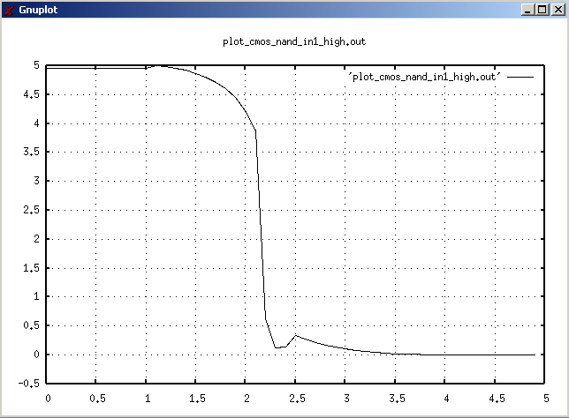
The output graph from the above netlist is shown below:

Version: 2003.05.15

Credits:
Name Affiliation Date Links
Mazen M Kharbutli NCSU April, 2003 http://www4.ncsu.edu/~mmkharbu
mazen_kharbutli@yahoo.com

