Quick Diode diodeqk

Description:
Fast-calculating diode with series resistance. Several calculation steps have been left out and the i-v characteristic is approximate. No capacitance. Tests indicate a speed up of 20% compared to the full diode (model d).

Form: diodeqk: <instance name> n₁ n₂ <parameter list>
n₁ is the cathode terminal
n₂ is the anode terminal

Parameters:

Parameter | Type | Default value | Required?
js: saturation current density (A/cm^2) | TR_DOUBLE | 10e-12 | No
r0: series resistance | TR_DOUBLE | 2 | No
alfa: alpha variable | TR_DOUBLE | 38.696 | No
Area: area (cm^2) | TR_DOUBLE | 1 | No

Example:
diodeqk:d1 1 2 js=10e-12 rs=10 alfa=39 area=1e-4

Description:
Shockley model:
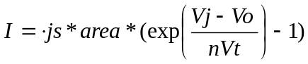
where:
Vj: junction voltage
Vo: log(5e8/alfa)/alfa (.612V default)
nVt=1/alfa (~.025V default)

V=I*Rs + Vj

Sample Netlist: (diodeqk.net)

.options verbose
.options ftol=1e-10
.options jupdm=0
.tran2 tstop=1ms tstep=1us
.ref 0
vsource:v1 1 0 vdc=2 tr=1ms
diodeqk:d1 1 0
.options gnuplot
.out plot element "diodeqk:d1" 0 it "set title 'Current across diode'" in "diodeqki.out"
.out plot term 1 vt "set title 'Voltage across Diode'" in "diodeqkv.out"
.out plot element "diodeqk:d1" 0 it db "set title 'Log of Current'" in "diodeqkilog.out"
.end

Validation:
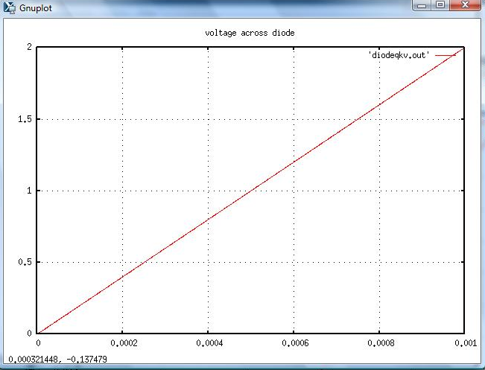
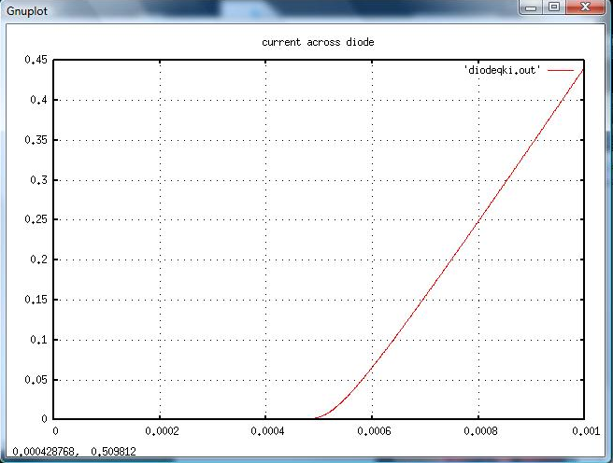
Figure 1: Results from a tran2 run on the default model showing the current as voltage is raised linearly.

Known Bugs:
No known bugs.

Credits:
Name Affiliation Date Links
Murray, James NC State University April 2008 www.ece.ncsu.edu
jpmurray@ncsu.edu

*Modified from the d.cc model made by Carlos Cristofferson

