Electro-Thermal NPN UCSD HBT Model HBTnpnxT

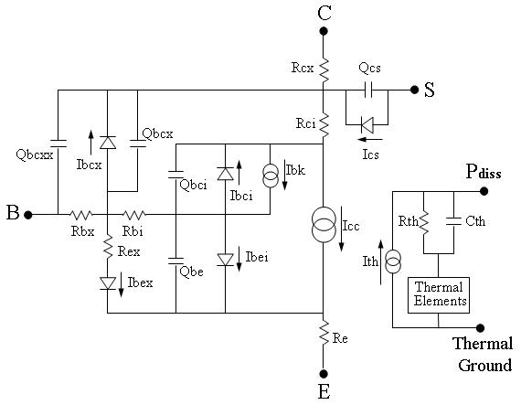

Description:
This is a large signal HBT model based on the UCSD HBT model with extra thermal terminals for dynamic electro-thermal simulations. An npn transistor is assumed. There are up to 6 terminals in the model: Base (B), Collector (C), Emitter (E), Substrate (S), Power dissipation (P_{diss}) and Thermal Ground.

Form:
hbtnpnxt:<instance name> n₁ n₂ n₃ n₄ n₅ n₆ <parameter list>
n₁ is the Collector terminal
n₂ is the Base terminal
n₃ is the Emitter terminal
n₄ is the Substrate terminal
n₅ is the Power Dissipation terminal
n₆ is the Thermal Ground terminal

Parameters:
Parameter | Type | Default Value | Required?
type: only NPN currently | DOUBLE | 1 | no
afn: Flicker noise exponent for current | DOUBLE | 1.5 | no
bf: Forward ideal current gain | DOUBLE | 200000 | no
bfn: BE flicker noise exponent for frequency | DOUBLE | 1 | no
bkdn: Flag denoting that BC breakdown should be included | BOOLEAN | false | no
br: Reverse ideal current gain | DOUBLE | 1000 | no
bvc: Collector-base breakdown voltage | DOUBLE | 28 | no
ccmin: Minimum value of intrinsic BC C_{j} | DOUBLE | 9.89E-15 | no
cemin: Minimum BE capacitance | DOUBLE | 1.09E-14 | no
cjc: Intrinsic BC depletion capacitance at zero bias | DOUBLE | 1.4E-14 | no
cjcx: Extrinsic BC depletion capacitance at zero bias | DOUBLE | 1.6E-14 | no
cje: BE depletion capacitance at zero bias | DOUBLE | 1.88E-14 | no
cjs: Collector-substrate depletion capacitance | DOUBLE | 0 | no
cth: Thermal capacitance of device | DOUBLE | 3E-10 | no
cxmin: Minimum extrinsic C_{bc} | DOUBLE | 3.6E-14 | no
dtmax: Maximum expected temperature rise above heatsink | DOUBLE | 1000 | no
eaa: Added activation energy for I_{SE} temp dependence | DOUBLE | 0.105 | no
eab: Added activation energy for I_{SC} temp dependence | DOUBLE | 0 | no
eac: Activation energy for I_{SB} temperature dependence | DOUBLE | -0.1 | no
eae: Activation energy for I_{SA} temperature dependence | DOUBLE | -0.495 | no
eax: Added activation energy for I_{SEX} temp dependence | DOUBLE | 0 | no
eg: Activation energy for I_{S} temperature dependence | DOUBLE | 0.271 | no
fa: Factor for specification of avalanche voltage | DOUBLE | 0.995 | no
fc: Factor for start of high bias BC C_{j} approximation | DOUBLE | 0.8 | no
fce: Factor for start of high bias BE C_{j} approximation | DOUBLE | 0.9 | no
fex: Factor to determine excess phase | DOUBLE | 1 | no
icrit0: Critical current for intrinsic C_{j} variation | DOUBLE | 0.035 | no
ics: Saturation value for collector-substrate current | DOUBLE | 0 | no
ik: Knee current for dc high injection effect | DOUBLE | 2 | no
ikrk: Characteristic current for Kirk effect | DOUBLE | 0.023 | no
is: Saturation value for forward collector current | DOUBLE | 5E-16 | no
isa: Collector current EB barrier limiting current | DOUBLE | 1E10 | no
isb: Collector current BC barrier limiting current | DOUBLE | 2E-13 | no
isc: Saturation value for intrinsic bc junction current | DOUBLE | 2.16E-15 | no
iscx: Saturation value for extrinsic bc junction current | DOUBLE | 3E-9 | no
ise: Saturation value for nonideal base current | DOUBLE | 1.05E-17 | no
isex: Saturation value for emitter leakage diode | DOUBLE | 3E-9 | no
itc: Characteristic current for TFC | DOUBLE | 0.06 | no
itc2: Characteristic current for TFC | DOUBLE | 0.04 | no
kfn: BE flicker noise constant | DOUBLE | 0 | no
mjc: Exponent for voltage variation of Intrinsic BC C_{j} | DOUBLE | 0.5 | no
mjcx: Exponent for voltage variation of Extrinsic BC C_{j} | DOUBLE | 0.3 | no
mje: Exponent for voltage variation of BE C_{j} | DOUBLE | 0.507 | no
mjs: Exponent for voltage variation of CS C_{j} | DOUBLE | 0.01 | no
na: Collector current EB barrier ideality factor | DOUBLE | 10 | no
nb: Collector current BC barrier ideality factor | DOUBLE | 3 | no
nbc: Exponent for BC multiplication factor vs voltage | DOUBLE | 6 | no
nc: Ideality factor for intrinsic bc junction current | DOUBLE | 1 | no
ncs: Ideality factor for collector-substrate current | DOUBLE | 2 | no
ncx: Ideality factor for extrinsic bc junction current | DOUBLE | 22 | no
ne: Ideality factor for nonideal forward base current | DOUBLE | 1.15 | no
nex: Ideality factor for emitter leakage diode | DOUBLE | 22 | no
nf: Forward collector current ideality factor | DOUBLE | 1.15 | no
nr: Reverse current ideality factor | DOUBLE | 1.03 | no
rbi: Intrinsic base resistance | DOUBLE | 10.5 | no
rbx: Extrinsic base resistance | DOUBLE | 0 | no
rci: Intrinsic collector resistance | DOUBLE | 0 | no
rcx: Extrinsic collector resistance | DOUBLE | 1 | no
re: Emitter resistance | DOUBLE | 2.5 | no
rex: Extrinsic emitter leakage diode series resistance | DOUBLE | 0 | no
rth: Thermal resistance from device to thermal ground | DOUBLE | 2200 | no
tbcxs: Excess BC heterojunction transit time | DOUBLE | 0 | no
tbexs: Excess BE heterojunction transit time | DOUBLE | 0 | no
tfb: Base transit time | DOUBLE | 2.5E-13 | no
tfc0: Collector forward transit time | DOUBLE | 0 | no
tkrk: Forward transit time for Kirk effect | DOUBLE | 5.5E-14 | no
tnc: Coefficient for NC temperature dependence | DOUBLE | 0 | no
tne: Coefficient for NE temperature dependence | DOUBLE | 0 | no
tnex: Coefficient for NEX temperature dependence | DOUBLE | 0 | no
tnom: Temperature at which model parameters are given | DOUBLE | 300 | no
tr: Reverse charge storage time for intrinsic BC diode | DOUBLE | 3.5E-10 | no
trx: Charge storage time for extrinsic BC diode | DOUBLE | 3.5E-10 | no
tre: Charge storage time | DOUBLE | 3.5E-10 | no
tvjc: Coefficient for V_{JC} temperature dependence | DOUBLE | -0.0015 | no
tvjci: Coefficient for V_{JCI} temperature dependence | DOUBLE | -0.0015 | no
tvjcx: Coefficient for V_{JCX} temperature dependence | DOUBLE | -0.0015 | no
tvje: Coefficient for V_{JE} temperature dependence | DOUBLE | -0.0015 | no
tvjs: Coefficient for V_{JS} temperature dependence | DOUBLE | -0.0015 | no
vaf: Forward Early voltage | DOUBLE | 300 | no
var: Reverse Early voltage | DOUBLE | 100 | no
vjc: ntrinsic BC diode builtin potential for C_{j} estimation | DOUBLE | 0.242 | no
vjci: V_{jci} | DOUBLE | 0.242 | no
vjcx: Extrinsic BC diode builtin potential for C_{j} estimation | DOUBLE | 0.35 | no
vje: BE diode builtin potential for C_{j} estimation | DOUBLE | 1 | no
vjs: CS diode builtin potential for C_{j} estimation | DOUBLE | 1.4 | no
vkrk: Characteristic Voltage for Kirk effect | DOUBLE | 0.25 | no
vtc: Characteristic voltage for TFC | DOUBLE | 0.5 | no
xcjc: Factor for partitioning extrinsic BC C_{j} | DOUBLE | 1 | no
xrb: Exponent for R_{B} temperature dependence | DOUBLE | 0.5 | no
xrc: Exponent for R_{C} temperature dependence | DOUBLE | 0.5 | no
xre: Exponent for R_{E} temperature dependence | DOUBLE | 0.5 | no
xrex: Exponent for R_{EX} temperature dependence | DOUBLE | 0.5 | no
xrt: Exponent for R_{TH} temperature dependence | DOUBLE | 1.2 | no
xtb: Exponent for beta temperature dependence | DOUBLE | -2.8 | no
xti: Exponent for I_{S} temperature dependence | DOUBLE | 2 | no
xtikrk: Exponent for IKRK temperature dependence | DOUBLE | 0.6 | no
xtitc: Exponent for ITC temperature dependence | DOUBLE | 0 | no
xtitc2: Exponent for ITC2 temperature dependence | DOUBLE | 0 | no
xttf: Exponent for TF temperature dependence | DOUBLE | 0.75 | no
xttkrk: Exponent for TKRK temperature dependence | DOUBLE | 0.6 | no
xtvkrk: Exponent for VKRK temperature dependence | DOUBLE | 0.6 | no
kirchhoff: Use Kirchhoff transformation flag | BOOLEAN | false | no
b: Thermal conductivity temperature exponent | DOUBLE | 1.22 | no
ts: Kirchhoff transformation temperature | DOUBLE | 300 | no

Example:
hbtnpnxt:h1 1 2 0 0 100 "tref" type=1 afn=1.5 fc=0.8 rth=2200 xti=2 b=1.22

Model Documentation:

This model is based on the UCSD HBT model. All the model equations except the thermal part can be found on the website: http://hbt.ucsd.edu. All the first and higher derivatives of parameters and vector functions in the model are obtained from calling ADOL-C library. There are over all 104 parameters in this model. The thermal calculations are based on the electro-thermal iterations for the values of 25 temperature dependent parameters of the model and the following expression of the power dissipation:

This HBT model has 2 thermal terminals instead of just one in the conventional UCSD model. The extra port is the Thermal Ground which is the thermal local reference of the HBT model. Electro-thermal simulations can be carried out by coupling other thermal elements which represent packaging or heat sink conditions. The junction temperature obtained from the thermal circuit will update the temperature dependent parameters of the electrical part of the model during simulations.

Sample Netlist:
**** Test netlist for hbtnpnxt model, DC simulation****

.dc sweep="vsource:vc" start=0 stop=3 step=0.05

hbtnpnxt:h1 1 2 0 0 100 "tref"

vsource:vc 1 0 vdc = 3
isource:vb 2 0 idc = 1e-3

res:rth 100 101 r = 2200
cap:cth 100 101 c = 3e-10
vsource:t1 101 "tref" vdc=300

.ref "tref"

.out plot element "hbtnpnxt:h1" 0 it in "hbtdc.1"
.end

Validation:
DC and transient simulations were performed using this model. Results were compared with the isothermal UCSD HBT model simulation results using ADS™. These simulations are just for demonstration and only a thermal resistance and a thermal capacitance were used to compose the thermal network. Thermal models of the device substrates or heat sinks should be developed and employed for a specific simulation.

**** Test netlist for hbtnpnxt model, DC simulation****

.dc sweep="vsource:vc" start=0 stop=3 step=0.05

hbtnpnxt:h1 1 2 0 0 100 "tref"

vsource:vc 1 0 vdc = 3
isource:vb 2 0 idc = 1e-3

res:rth 100 101 r = 2200
cap:cth 100 101 c = 3e-10
vsource:t1 101 "tref" vdc=300

.ref "tref"

.out plot element "hbtnpnxt:h1" 0 it in "hbtdc.1"
.end

**** Test netlist for hbtnpnxt model, transient simulation ****

.options f0 = 20e9

.tran2 tstop = 6e-9 tstep = 0.002e-9

hbtnpnxt:h1 1 2 0 0 100 "tref"

vsource:vc 6 0 vdc = 2
isource:ib 7 0 idc = 1e-3
vsource:v1 9 0 f = f0 vac = 0.05 delay = 1ns phase = 265

res:r1 9 8 r = 50
*res:r3 1 4 r = 1
res:r5 5 0 r = 50
*res:r6 3 0 r = 2.5

cap:c1 8 2 c = 1e-12
cap:c2 1 5 c = 1e-12
ind:l1 2 7 l = 1e-9
ind:l2 1 6 l = 1e-9

res:rth 100 101 r = 2200
cap:cth 100 101 c = 3e-10
vsource:t1 101 "tref" vdc=300
.ref "tref"

.out plot element "hbtnpnxt:h1" 0 ut in "hbt.vc"
.out plot element "hbtnpnxt:h1" 1 ut in "hbt.vb"
.out plot element "hbtnpnxt:h1" 1 it in "hbt.ib"
.out plot element "hbtnpnxt:h1" 0 it in "hbt.ic"
.out plot term 9 vt in "hbt.in"
.out plot term 5 vt in "hbt.out"

.end

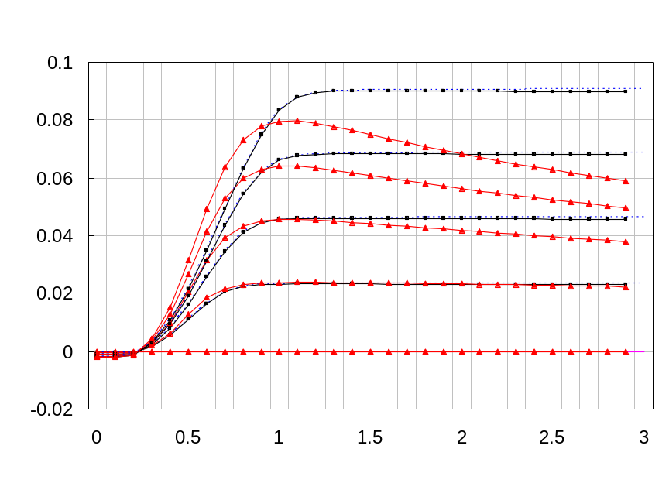

ADS
fREEDA
fREEDA thermal
Vce (V)
Ic (A)

Figure 1 DC simulation of OMMIC™ InP HBT T10RA20 (I_{b} = 0.5mA/step from 0mA to 2mA, ambient temperature = 300K) using ADS™ and fREEDA™ UCSD model and fREEDA™ UCSD thermal model [5]

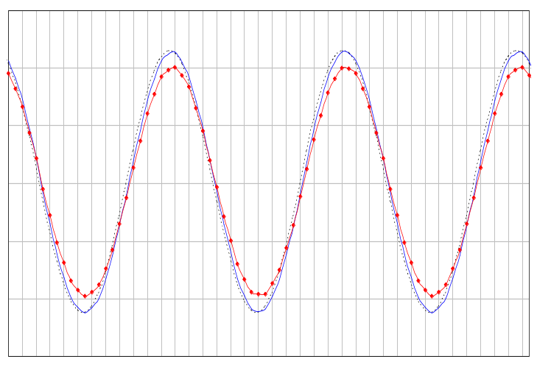
60.00 60.05 60.10 60.15
Time (ns)
0.15
0.1
0.05
0
- 0.05
- 0.1
- 0.15
Voltage (V)

ADS UCSD
fREEDA UCSD
fREEDA UCSD thermal

Figure 2 Output Signal from Transient Simulation of OMMIC™ T10RA20 InP HBT Based Amplifier Using ADS™ UCSD Model, fREEDA™ UCSD Model and fREEDA™ UCSD Thermal Model [5]

References:
[1]UCSD HBT Model, http://hbt.ucsd.edu
[2]ADOL-C Library, www.math.tu-dresden.de/~adol-c/
[3]OMMIC™ DH15IB Design Manual, www.ommic.com
[4]W. Batty, C.E. Christoffersen, A.J. Panks, S. David, C.M. Snowden, and M.B. Steer, “Electro-thermal CAD of power devices and circuits with fully physical time-dependent compact thermal modeling of complex nonlinear 3-D systems”, IEEE Trans. on Components and Packaging Technologies, Vol.24, pp.566-590, Dec. 2001

Publication:
[5]J. Ding, D. Linton, D. Smith and M. Steer, “Compact Electro-thermal Modelling and Simulation of InP HBT Based on the Local Reference Concept”, Proc. of 1st European Microwave Integrated Circuits Conference, European Microwave Week 2006, pp.383-386, September 2006

Version: 2005.12.20

Credits:
Names Affiliation Date
Jian Ding j.ding@ecit.qub.ac.uk Queen’s University Belfast July 2007
Sonali Luniya srluniya@ncsu.edu North Carolina State University

