Isolator isolator

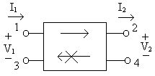

Description:
The isolator passes a signal from port 1, terminals 1 and 3, to port 2, terminals 2 and 4, but blocks a signal inserted into port 2 from getting to port 1. Port 1 is the input to the isolator and port 2 is the output.

Form:
isolator:<instance name> n₁ n₂ n₃ n₄ <parameter list>
n₁ is the port #1 signal input terminal
n₂ is the port #2 signal output terminal
n₃ is the port #1 reference terminal
n₄ is the port #2 reference terminal

Parameters:
Parameter | Type | Default Value | Required?
r: Resistance looking into port 1 (ohms) | DOUBLE | 0* | no
g: Conductance looking into port 1 (siemens) | DOUBLE | 0* | no

*The default value is zero if the other parameter is listed. If neither parameter is listed, then the default conductance value is 0.02 siemens, which is equivalent to a 50 ohm resistance value.

Example:
isolator:isolator1 1 2 3 4 r=50
isolator:i1 2 3 0 0 g=0.02

Model Documentation:
The isolator model is based on the S matrix of an ideal isolator, which was converted to a Y matrix. This admittance matrix was used for the stamp for this element.
The s-parameter matrix of an ideal isolator is: 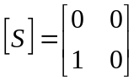.

The admittance matrix of an ideal isolator is: 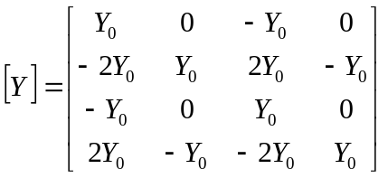

The following is an example of the proper way to use this element in a fREEDA netlist:

isolator:iso1 2 3 0 0 r=50

Notice in this example first the declaration of the element used—iso:iso1. iso is the element itself (similar to using R in SPICE) and iso1 is simply the name assigned to the particular isolator. The second thing to notice is that there are 4 terminals listed, corresponding to terminals 1, 2, 3, and 4 of the element. Remember the way the terminals are described in the isolator model:

The numbers on the command line representing terminals (in this case, 2 3 0 0 ) are the numbers of the terminals in the whole circuit created inside the .net file. In this case, nodes 2 and 3 in the circuit are the terminals 1 and 2 of the isolator. Terminals 3 and 4 of the isolator are grounded, as indicated by the fact that they are both terminal 0 in the circuit.

The possible inputs on the command line for the isolator are:
r – resistance looking into both ports
g – conductance looking into both ports

If no parameters are specified, then the conductance looking into both ports defaults to .02 siemens, which equals 50 ohms resistance. Otherwise, the user has the option of specifying either a conductance or a resistance.

References:
Adam, Davis, Dionne, Schloemann, Stitzer. “Ferrite Devices and Materials.” IEEE Transactions on Microwave Theory and Techniques vol. 50 (March 2002):721-736.
Carr, J. Elements of Microwave Electronics Technology. New York: Harcourt Brace Jovanovich, Inc., 1989.
Fay, C. and von Aulock, W. Linear Ferrite Devices For Microwave Applications. New York: Academic Press, Inc., 1968.
Pozar, D. Microwave Engineering. New York: John Wiley & Sons, Inc., 1998.
Roberts, J. High Frequency Applications of Ferrites. Princeton, NJ: D. Van Nostrand Co., Inc., 1960.

Sample Netlist:
Isolator Test 1 Netlist
*sending a signal forward through the isolator

.tran2 tstart=0.1e-6 tstop=5e-6 tstep=.01e-6

vsource:vin 1 0 vac=2 f=1e6
isolator:iso1 2 3 0 0 r=50
res:rin 1 2 r=50
res:rload 3 0 r=50

.out plot term 3 vt in "v3.out"
.out plot term 2 vt in "v2.out"
.out plot term 1 vt in "v1.out"
.end

Validation:
The isolator is validated in forward mode by inputting a signal into port 1 and measuring the same signal at the output port 2. It is then validated in reverse mode by inputting a signal into port 2, the output port, and measuring port 1 to verify that no signal is present. Two netlists were run with the signal applied to each isolator port.

Isolator Test 1 Netlist
*sending a signal forward through the isolator

.tran2 tstart=0.1e-6 tstop=5e-6 tstep=.01e-6

vsource:vin 1 0 vac=2 f=1e6
isolator:iso1 2 3 0 0 r=50
res:rin 1 2 r=50
res:rload 3 0 r=50

.out plot term 3 vt in "v3.out"
.out plot term 2 vt in "v2.out"
.out plot term 1 vt in "v1.out"
.end

Isolator Test 2 Netlist
*sending a signal backward through the isolator

.tran2 tstart=0.1e-6 tstop=5e-6 tstep=.01e-6

vsource:vin 1 0 vac=2 f=1e6
isolator:iso1 3 2 0 0 r=50
res:rin 1 2 r=50
res:rload 3 0 r=50

.out plot term 3 vt in "v3.out"
.out plot term 2 vt in "v2.out"
.out plot term 1 vt in "v1.out"
.end

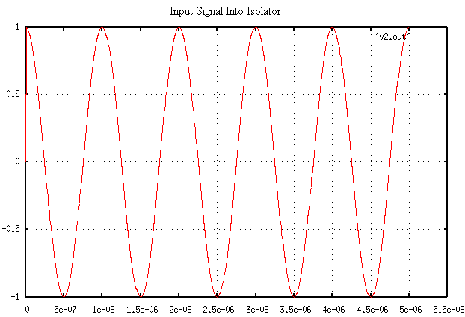
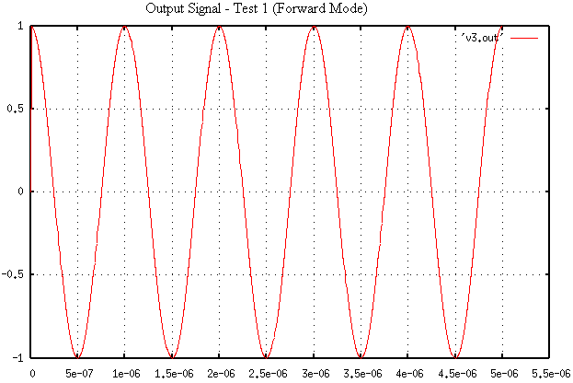
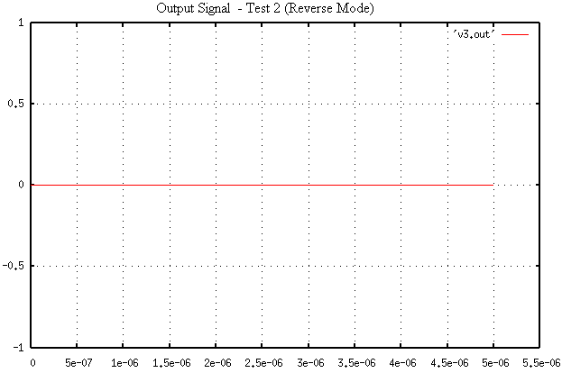

Known Bugs:
Ideal isolator only.

Local reference terminals are implemented within the isolator code, but have not yet been tested. Tying both reference terminals to terminal 0 (ground) works fine for now.

Notes:
The isolator can be implemented as a two terminal or four terminal device. Set terminals 3 and 4 to the reference terminal to convert to a two terminal device.
The isolator model is ideal. Both ports have the same input impedance. This impedance is real with no reactive component.

Version: 2003.05.15

Credits:
Names Affiliation Date Links
Isac Lima islima@ncsu.edu NC State University April 2003 www.ncsu.edu
Daryl Lindsey sdlindse@ncsu.edu
Don Widdows dwiddow@ncsu.edu

