General Purpose Operational Amplifier (Electro-Thermal) opampT
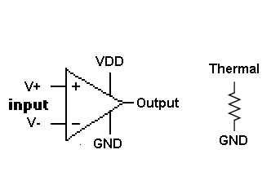

Description:
This element implements a general-purpose operational-amplifier with thermal properties.
Form: opampt: <instance name> 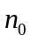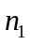 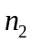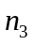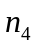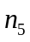 <parameter list>
instance name is the model name
is the Vdd Source Node,
is the Non-Inverting Input,
is the Inverting Input,
is the Op-Amp Output,
is the Thermal Source (not present in Ideal Mode),
is the Ground Terminal.
Trans-Conductance | 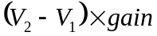
Thermal Resistance*
Slew Bounding | 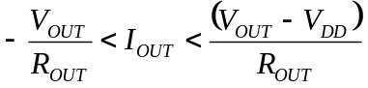
Heat Flux
* Same equation used for 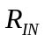, 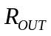, and 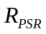

Parameters:

Parameter | Default value | Required?
gain: Transconductance Gain (Amps/Volt) | 1.0 | No
rin: Input Resistance (ohm) | 2 Mohm | No
rint: Input Thermal Effect (ohm/deg) | 12500 ohm/deg | No
rout: Output Resistance (ohm) | 80 ohm | No
routt: Output Thermal Effect (ohm/deg) | -0.4 ohm/deg | No
psr: Vdd to gnd Resistance (ohm) | 11 kohm | No
psrt: Vdd to gnd Thermal Effect (ohm/deg) | -27 ohm/deg | No
cin: Input Capacitance (F) | 50 nF | No
cout: Output Capacitance (F) | 5 uF | No
nomt: Nominal Temperature (K) | 25°K | No
pdr: Thermal Dependance (bool) | FALSE | No

Example:
opampt:u1 1 2 3 4 100 0 gain=0.2 pdr=1
Model Documentation:
This model implements a laundry list of features:
- Slew-Limiting behavior through the use of the rout parameter
- Leakage current behavior through the use of rin (Input pins resistance to gnd) and psr (power source resistance to gnd)
- Individual pin to body effect behavior through cin (input pin capacitance) and cout (output pin capacitance)
- Thermal effects through rint, routt, and psrt, which dictate the size of the effect
- T_{NOM} used to identify the measurement temperature of the various thermal denominators

Default Element Characteristics at 25 degrees Celsius (298 Kelvin)
Derived from the LM741 Data-Sheet from Fairchild Semiconductor
Input Resistance: 2Mohm
Power Supply Current: 2.8mA
Power Supply Resistance: 11 kohm
Output Resistance: 80 ohms
Default Straight-Line Temperature Response, origin at 25C
Power Supply Current: -0.0025 per degree -27 ohm per degree
Output Resistance: -0.0050 per degree -0.4 ohm per degree
Input Resistance: 0.00625 per degree 12.5kohm per degree

Model calculates the current on the output pin in three stages:
Calculate the maximum current sink or source using the output resistance
Calculate the amount of current dictated by the input difference amplifier
Use the first set of results as bounds for the second result to calculate the real current draw.
References:
LM741 Data-Sheet, Fairchild Semiconductor, www.fairchildsemi.com/pf/LM/LM741.html

Sample Netlist:
* General Purpose Operational Amplifier
* Basic Linear Amplifier: Gain = -r1/r2
.tran2 tstop=1e-2 tstep=1e-5
.ref 0
vsource:vs 6 0 vdc=5 vac=2 f=200
vsource:vdd 1 0 vdc=10
vsource:gnd 2 0 vdc=5

r:r1 3 4 r=1000
r:r2 6 3 r=500
r:rl 4 2 r=1000
r:rt 101 0 r=100

* name Vdd V+ V- Vout Temp gnd
opampT:u1 1 2 3 4 101 0 gain=0.2 pdr=1 nomt=25
+ rin=2000000 rout=80 psr=1000 cin=0.00000005 cout=0.000001
+ rint=12500 routt=-1 psrt=-27
+

.out plot term 6 vt in "input.out"
.out plot term 4 vt in "output.out"
.out plot term 101 vt in "temp.out"
.end

Validation:
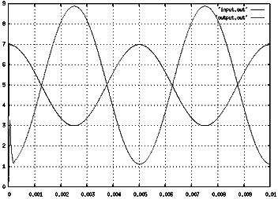
Known Bugs:
If the op-amp gain is set too high then fREEDA might not generate a useful solution, therefore:
Note: Trans-conductance Gain defaults to a low value of 1.0 Amps per Volt when it should be much higher. I did not have time to experiment with this bug, nevertheless, I suspect that it can be minimized by reducing the time-step.
Credits:
Name Affiliation Date Links
Gregory Parsons NC State University April 2004 www.ncsu.edu gsparson@ncsu.edu

Introduction
My motivation for this project was the lack of an op-amp model in fREEDA. First, an analog circuit simulator devoid of perhaps the most popular analog IC on the market seemed like a niche I could fill. Second, of all the possible elements I could have worked on, an op-amp seemed like the one I would most likely use in my research on embedded systems. Therefore, my ultimate goal in this project was to make an op-amp that I would want to use in my circuit simulations. I felt it would need to simulate the behavior as closely as possible while maintaining analytical expediency. Ultimately, a single op-amp model completes simulating nearly instantly regardless of how many features are enabled. The average commercial op-amp has upwards of twenty-four transistors, each one requiring more execution overhead than a single op-amp macro-model (See Figure 1). I will not speculate as to how many times faster this macro-model is when compared to a net-listed op-amp circuit.

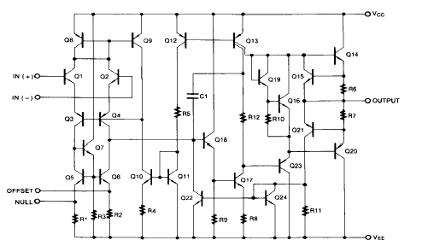
Figure 1: Op-Amp Internals
LM741 Data-Sheet, Fairchild Semiconductor

Design Features
Slew-Rate: The op-amp chosen as the design base for this implementation had conflicting reports as to the devices slew-rate. I estimated the best means of simulating slew-rate was with a resistor-capacitor relationship on the output pin. As such, reducing the output resistance, R_{OUT}, or the output capacitance, C_{OUT}, can increase the slew-rate, or the rate of transition.

Delay Effect: It was concluded that the propagation delay of the op-amp would be sufficiently simulated by the slew-rate limiting feature for high-frequency applications and totally negligible for low-frequency applications. As such, it was left out of this model for expediency. However, adding such a feature when necessary should be of minimal difficulty.

Linear Resistive Coupling: After perusing op-amp datasheets, particularly the LM741, it was noticed that most pin-couplings could easily be simulated using a linear gradient (see Figure 2).

Capacitive Coupling: Every pin has a primary capacitive coupling with the ground rail, but not to every other pin because this secondary effect could be matched by simply increasing the magnitude of the primary effect while at the same time avoiding quadrupling of the computations necessary to manage capacitance. Product data-sheets did not hint at any heat effects on coupling capacitances, which seems a reasonable simplification.

Thermal Effect: When enabled, this feature allows for most internal variables to be varied along a linear gradient using a fifth state-variable for the current ambient temperature. See documentation for an explanation of the various parameters that can be used to alter the models thermal response. The model also generates instantaneous power dissipation data, treated as a point source, which simulates the creation and sourcing of heat-flux. It is incumbent upon the user to provide a thermal path to ground in the net-list.

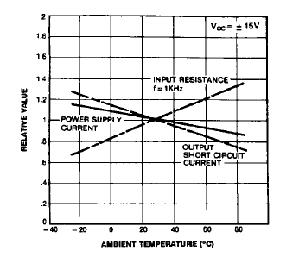
Figure 2: Normalized DC Parameters vs. Ambient Temperature
LM741 Data-Sheet, Fairchild Semiconductor

