Strain Gauge StrainGauge cir

Description:
A mechanical straoin gauge.

Form:
straingauge:<instance name> n₁ n₂ n₃ <parameter list>
instance name is the model name
n₁ is the mechanical terminal
n₂ is the electrical terminal
n₃ is the common reference terminal

At n1 the flux is strain, potential is force.
At n2 the flux is electrical current, potential is voltage.

There should be separate electrical and mechanical reference terminals. This model will only work correctly if the n3 is system ground (zero potential).

Parameters:
Parameter | Type | Default Value | Required?
h1: length in y-direction (m) | DOUBLE | - | yes
h2: length in x-direction (m) | DOUBLE | - | yes
h3: length in z-direction (m) | DOUBLE | - | yes
c: elastic constant | DOUBLE | - | yes
e: piezoelectric constant (C/m^2) | DOUBLE | - | yes
eps: dielectric constant (F/m) | DOUBLE | - | yes

Model Documentation:
The piezo-electric crystal is a non-linear device that varies with the amount of mechanical strain placed on it. This force is directly related to the voltage and current outputs through a system of non-linear equations. When a force is applied to the piezo in a strain gauge, (Refer to fFigure 2) a voltage is generated across the two parallel plates in the x-plane. This voltage is proportional to the amount of stress applied but is only present until the piezo is compressed to its minimum length for the given force. Because of this characteristic, the voltage across the piezo is a function of the change in length of the device compared to its original length from a given fixed point. As shown in the diagram above, the side of the device at the origin is fixed so that when a force is applied in the negative x-direction, the device begins to compress and generate a voltage output.

Strain is defined as a unitless quantity representing the difference between the original length of an object and its current length. Strain does not need to be conserved and can be represented by the following:

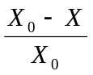

Where X₀ is the original length and X represents the length at any given time. S will be used to represent strain in the circuit model, as S is used as a state variable. Stress (T) is defined as an expression of a force applied over a given area. Units can be expressed as N/m² or Pascals.

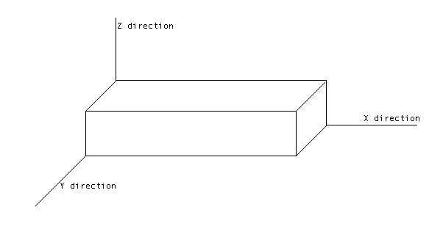

Figure 2 Physical dimensions of a piezoelectric device.

Concepts Behind Formulation

There are many complex properties of a piezo electrical crystal that relate its mechanical-electrical inputs and outputs. The device is shown in Figure 2. The y and z directions are fixed so that movement only occurs in the x-direction.
The main ideas drawn upon for the analysis of this device are based upon the relationships between stress, strain, charge, electric field, and ultimately the electrical voltage and current output from the device.

The following constants are used to describe the device and are set as parameters for the circuit model:

C: Piezoelectric elastic constant
Can be viewed as mechanical resistance.
ε : Dielectric constant
Represents the capacitive properties of the crystal material.
e: Piezoelectric coupling constant
h1: length of device in the y-direction
h2: length of device in the x-direction
h3: length of device in the z-direction

Charge is conserved and can be represented by the following integral involving D3, the electric displacement in the z-direction. (Montgomery, 5)

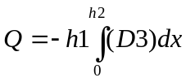
This integral estimates the area of the device in the x-plane and creates a “box” of charge using the value for the electric displacement.
Because Transim uses a quasi-Newton iteration to determine the values of the state variables, the charge can be estimated using the following discredited version of the above equation:

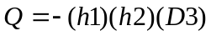 ⁽¹⁾

Using the relationship of D3 to the strain, S and the z-component of the electric field (Montgomery, 2),

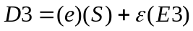 ⁽²⁾

Charge can be represented as the following by substituting into equation (1):

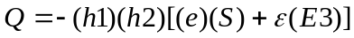 ⁽³⁾

As was stated before, the device conserves charge, so the current through the device can be represented as follows:

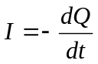

Integrating both sides with respect to time yields:

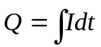 ⁽⁴⁾
Substituting equation (4) into (3) yields the following:

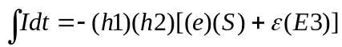 ⁽⁵⁾
Differentiation of both sides with respect to time yields the following equation that can be easily computed in Transim:

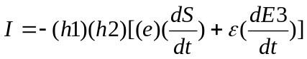 ⁽⁶⁾
Equation (6) makes the choice of S and E3 as state variables obvious because Transim can use automatic differentiation to calculate the time derivatives of the state variables using Adol-C.
The voltage across the parallel plates (which are equipotential surfaces) in the x-plane is given by:

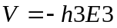

The equation relating force to the state variables is derived from the following equation for stress:

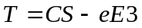

Solving for force yields:

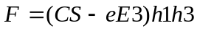

Implementation

As we have now determined that the input forces should be modeled as a flux, it will take on the identity of current in our circuit representation. As with any other circuit element input currents and voltages determine the devices output. Subsequently there are many tools that allow us to analyze the circuit when using voltages and currents as inputs. Since our force is a flux, we subsequently choose to model the mechanical input as a force. Since displacement can be seen as a potential we will model that as a potential.
Ostensibly one would think that a force would naturally be assumed to be a potential difference. This however is a counter-intuitive concept. In actuality force more closely approximates the flux. This can be demonstrated through a simple example.
Take for example a system of pylons supporting a structure, in this case a bridge. The three pylons hold up the weight of the structure.(see Figure 1) If we sum the forces in the y direction we see that the force through the first pylon is twice that of the force through the other two members. This is very similar to current. For this reason, the force input to the strain gauge was determined to be the flux value.
The implementation of the circuit involving the strain gauge includes one current source and two resistors.(see figure 3) The input resistor r1 is placed in the circuit to stabilize the current source input and r2 serves as a load resistor to measure output.
The current source on the input of the device serves as the time-varying force input. As described above, the force is modeled as a flux value in the circuit simulator, even though it is treated as a mechanical value by the actual model equations for the device.
The parameters chosen were assumed values for a typical piezoelectric crystal that may be use in a strain gauge. (Measurement, 4)
Appendix A.1 and Appendix A.2 contain the source code for the header and .cc files respectively (StrainG.h and StrainG.cc). In Transim the following netlist was run to test the model:

*** Strain gauge test netlist ***
.OPTIONS FREQ = 1000Hz ftol=1e-8
.svhb n_freqs = 8 fundamental = freq
isource:fin 1 0 idc=100

straingauge:sg1 1 2 0 h1=0.01 h2=0.02 h3=0.002 C=126r9
+ e=6.5 eps=1.3e-8

res:r3 2 3 r=.001
res:r2 1 0 r=1e6
res:r1 3 0 r=100

.out plot term 3 vf invfft 2 repeat in "res.vout"
.out plot term 2 vf invfft 2 repeat in "sg.vout"
.out plot term 1 vf invfft 2 repeat in "sg.x"

.end

References

P.J. Chen and S.T. Montgomery, “Normal mode Responses of Linear Piezoelectric materials with hexagonal Symmetry,” Int. J. Solids Struct.. 13 pp. 947-955, 1977.

R. J. Lawrence and L.W. Davison, “Analysis of nonlinear Plane-Wave Propagation in Piezoelectric Solids,“ Proceedings of the Symposium on Applications of Computer Models in Engineering, Los Angeles, CA, August 23-26, 1977, pp. 941-950

Measurement Specialists, “Piezo Film Sensors Technical Manual: Internet Version”, Valley Forge, PA, August 1998.

Montgomery, Steven T., “Numerical integration of the equations governing a normal mode linear piezoelectric transducer with an inductive-resistive load”, United States. Dept. of Energy. Sandia Laboratories, Feb. 1979.

Known Bugs:
Not implemented correctly, a common reference terminal is used rather than one for electrical and one for mechanical. Basic equations are there but needs to be reexamined.

Version: 2002.01.01

Credits:
Names Affiliation Date
Jonathan Cantor NC State University April 2002
Richard McMunn NC State University April 2002

