Capacity Scaling of Encoding-Through-Loading: Application vs. Cloze Asymmetry Across Three Orders of Magnitude
Tomas Pødenphant Lund
2026
Abstract
Large language models solve cloze retrieval and derivation-application on the same underlying knowledge base, but at different scales. We document this asymmetry on a single invented knowledge domain ("Zorbetik") designed to eliminate pretraining-prior confounds, across nine models from 0.5B to 671B parameters, using frontloaded in-context learning. Three findings: (1) Application scales monotonically with capacity; cloze does not. (2) The bottleneck migrates with capacity. (3) MoE models scale on active, not total, parameters. We also propose frontloaded ICL as an operational substitute for fine-tuning in encoding-to-retrieval studies.
Table of Contents

1 Capacity Scaling of Encoding-Through-Loading: Application vs. Cloze Asymmetry Across Three Orders of Magnitude
Author: Tomas Pødenphant Lund
Affiliation: Independent Research, Aarhus
Correspondence: tomas.lund@frictiontheory.org
Web: https://frictiontheory.org
Target: PNAS Perspective / Journal of Memory and Language / Trends in Cognitive Sciences
Acknowledgments: Extensive discussion, literature search, empirical analysis, and manuscript structuring were conducted in collaboration with Claude (Anthropic, 2025–2026). The theoretical claims, interpretations, and predictions are those of the author.
Data and code availability: Per-token logprob datasets, analysis scripts, and figures are released at https://github.com/tplund/friction-theory-p2-capacity-scaling under CC BY 4.0.

1.1 0. Abstract
Large language models solve two differentiable task types on the same underlying knowledge base. Cloze retrieval — recovering a fact as presented — saturates early: most models reach ~90% accuracy by 8B parameters. Application — chaining multiple facts into a derivation — scales monotonically across three orders of magnitude, from 2% at 0.5B to 85% at 70B. We document this asymmetry on a single invented knowledge domain (“Zorbetik”) designed specifically to eliminate pretraining-prior confounds, across nine models spanning 0.5B to 671B parameters, using frontloaded in-context learning to expose encoding-to-retrieval dynamics without weight updates. Generalisation to natural knowledge domains is a direct next-step empirical extension of the methodology established here.
Three findings follow. Finding 1: Application scales monotonically with capacity (Spearman ρ = +1.000 on the Qwen2.5 sub-ladder, n=5, p = 0.0083 one-tailed / 0.0167 two-tailed; cross-family panel ρ = +0.92, n=9, p = 0.0005 two-tailed; slope +40.8 percentage points per decade). Cloze does not. Finding 2: The bottleneck migrates with capacity — at 0.5B, retrieval fails; at 14B, retrieval is saturated and 36% of questions show a “retrieval succeeds, derivation fails” pattern. Finding 3: Mixture-of-Experts (MoE) models scale on active parameters, not total. A 235B MoE with 22B active parameters behaves on application tasks like a 22B dense model (active-parameter projection within 3pp of actual; total-parameter projection off by 33pp).
We also advance a methodological claim: frontloaded in-context learning (ICL) — presenting all training facts in the prompt followed by one question, with per-token logprobs captured on the answer — operationally substitutes for fine-tuning in encoding-to-retrieval studies. It is fast (~5 seconds per inference vs. hours for FT), cheap (cents vs. dollars), unified across model families, and produces dense friction data (six statistics per inference). Caveats: ICL is bounded by the context window and is ephemeral to each prompt, so FT remains necessary for large knowledge bases, persistence studies, and route-overwrite experiments.
Implications. Capacity is single-axis but loads task types differentially. Cloze is indexing-bound; application is composition-bound. The three-dimensional friction framework (magnitude, distribution, rhythm) from Paper 1 decomposes the C-axis into corresponding operational handles. Paper 4 systematically tests these handles across classical learning phenomena.

1.2 1. Introduction
Paper 1 (Lund 2026b) introduced Friction Theory (FT) as a substrate-universal framework for probabilistic computation under bounded resources, with Behavioural Friction Theory (BFT; Lund 2026a) as its biological instantiation (BFT ⊂ FT). The framework predicted three dimensions of friction (magnitude, distribution, rhythm) and identified capacity (C) as the primary axis determining how much information can be held and manipulated simultaneously. This paper tests the C-dimension prediction on LLM substrate — an FT-level test, not a BFT-level test, because LLMs lack the biological fields that distinguish BFT from FT.
This paper tests the C-dimension’s implication for encoding-through-loading — the hypothesis (Paper 1 §6.4) that learning is a direct consequence of route-competition under load, not a separate cognitive module. Specifically, we examine how the same underlying knowledge manifests differently through two distinct task types — cloze retrieval vs. derivation-requiring application — as capacity is varied across three orders of magnitude.
Our central methodological move is the use of an invented knowledge domain (“Zorbetik”). This eliminates pretraining priors as a confound. When a model is presented with 47 facts about fictive chemical processes and queried about properties of a fictive substance, it cannot draw on prior exposure. What is measured is the substrate’s ability to integrate and use the just-presented information.
We measure three things simultaneously in a single prompt call: (a) accuracy on cloze vs. application, (b) per-token CR signal on the answer, and (c) first-5-tokens friction as a proxy for how cleanly the context integrated into the substrate’s active state.
This paper focuses on the capacity axis. Paper 4 (Lund 2026e) tests encoding-structure (how the same information is organized) × capacity interaction — a series of findings originally planned for this paper but moved to keep scope focused.
Structure. §2 reports the empirical capacity-scaling results on the Zorbetik domain, including the application/cloze asymmetry, the bottleneck-migration finding, and the MoE active-vs-total parameter analysis. §3 develops the frontloaded-ICL methodology as a substitute for fine-tuning. §4 notes content moved to Paper 4. §5 discusses implications for the C-dimension framework. §6 concludes.

1.3 2. Empirical capacity scaling on the Zorbetik domain
To test the C-dimension prediction (Paper 1 §3) and the encoding-through-loading mechanism, we ran an in-context learning (ICL) sweep across nine model sizes spanning three orders of magnitude.

1.3.1 2.1 Design
A single invented domain (“Zorbetik”) with 47 base facts at level-5 connectivity (each fact mentions on average two named entities and two derived relationships). For each model we constructed a single prompt: [all 47 facts] + [one question], and measured both (a) accuracy and (b) per-token competing-routes (CR) signal on the generated answer.
Two question types per fact: - Cloze (n=20, retrieval): “Pravik transforms into Quenzil at ___” — answer is recoverable verbatim from a single fact. - Application (n=20, derivation): “Engineer has 100kg of Zorblax, exposes for 10h, then reacts product with equal mass of Quenzil… what is the resulting mass and key property?” — requires chaining three or more facts.
Models (no fine-tuning; all run with thinking disabled to keep CR distributions comparable across models — /no_think directive on Qwen3, default for non-thinking-mode models):
Size (B) | Active (B) | Model | API
0.5 | 0.5 | Qwen2.5-0.5B-Instruct | local (Colab)
1.5 | 1.5 | Qwen2.5-1.5B-Instruct | local
3.0 | 3.0 | Qwen2.5-3B-Instruct | local
7.0 | 7.0 | Qwen2.5-7B-Instruct | local
8.0 | 8.0 | Qwen3-8B (no_think) | Fireworks
14.0 | 14.0 | Qwen2.5-14B-Instruct | local
70.0 | 70.0 | Llama-3.3-70B-Instruct | Fireworks
235.0 | 22.0 | Qwen3-235B-A22B-Instruct-2507 | Together
671.0 | 37.0 | DeepSeek-V3 | Together

1.3.2 2.2 Finding 1 — Application scales monotonically, cloze does not
Size | Cloze | Application
0.5B | 56% | 2%
1.5B | 90% | 17%
3.0B | 58% | 32%
7.0B | 80% | 40%
8.0B (Qwen3) | 90% | 65%
14.0B | 96% | 64%
70.0B | 90% | 85%
235B/22B (MoE) | 90% | 70%
671B/37B (MoE) | 90% | 85%
Application: monotone in size. On the Qwen2.5 sub-ladder (n=5, same family, same calibration): Spearman ρ = +1.000, p = 0.0083 (one-tailed; equivalent two-tailed p = 0.0167), slope +40.8 percentage-points per decade. On the full 9-model panel across three architecture families (Qwen2.5, Qwen3, Llama, DeepSeek-V3, using active parameters for MoE): Spearman ρ = +0.92, p = 0.0005 (two-tailed) — the monotonicity holds across architectures, not just within Qwen2.5. This cross-family robustness is important because it rules out “within-family RLHF-tuning-artefact” as an explanation.
Cloze: non-monotone (90% spike at 1.5B drops to 58% at 3B, recovers at 7B, saturates ~90% from 8B upward). Cloze appears to saturate around 8-14B; further capacity provides no gain on retrieval. The 3B dip is localised — it does not reappear in the full cross-family panel or at higher capacities. We interpret it as RLHF-tuning variance within the Qwen2.5 ladder rather than a capacity-level artefact; this interpretation is consistent with the fact that application accuracy at 3B does not show the same dip (32%, on the expected monotone trajectory).

1.3.3 2.3 Methodological note — why this is not an “emergence mirage”
A reviewer familiar with Schaeffer, Miranda & Koyejo (2023) — “Are Emergent Abilities of Large Language Models a Mirage?” — may raise their thesis that apparent scaling discontinuities in the LLM literature reflect binary-threshold metric artefacts on continuous underlying losses. Their critique targets claims of discontinuous emergence: a specific capability appearing suddenly above some parameter threshold. Our findings here are graded and monotone: five distinct accuracy levels across the Qwen2.5 sub-ladder (application: 2% → 17% → 32% → 40% → 64%; Result 1 above), Spearman ρ = +1.000 with no threshold-induced jumps, slope +40.8 pp per decade. The scaling claim we make is dose-response, not emergence-discontinuity. Schaeffer’s critique applies to the claim-form we explicitly do not make; we use continuous graded metrics (percentage correct over matched items) rather than binary exact-match thresholds, and we report the full ladder rather than picking a single before-and-after comparison. For completeness: Schaeffer’s paper does not argue that all scaling effects are artefactual — it argues that apparent discontinuities reduce to graded underlying effects measured correctly. Our work is consistent with their methodological prescription, not in tension with it.

1.3.4 2.4 Finding 2 — Bottleneck migrates with capacity
At 14B, on the 47 fact-ids that appear in both cloze and application question banks:
Outcome | Count (of 47) | Interpretation
Both correct | 30 (64%) | Full encoding-and-derivation
Cloze only | 17 (36%) | Retrieval works; derivation fails
Application only | 0 (0%) | Never derives without retrieving
Neither | 0 (0%) | Always retrieves at this capacity
This is a quantitative measure of the derivation-capacity bottleneck. At 0.5B the bottleneck is retrieval (model fails to find the fact at all). At 14B retrieval is essentially saturated; the failure mode has moved entirely to chaining facts together. The bottleneck location is itself capacity-dependent — exactly what the Paper 1 §3 capacity-axis prediction implies.

1.3.5 2.5 Finding 3 — MoE scales on ACTIVE parameters, not TOTAL
We fit a logistic curve to application accuracy on the dense-model Qwen2.5 sub-ladder (0.5B → 14B). Projected ceilings on TOTAL parameters:
90% accuracy at ~114B params; 99% at ~1600B (extrapolation; observed range is 0.5B–14B dense, with 8B/8B Qwen3 anchor as the only data point above the fit’s training set).
When projected onto the four large-model data points:
Model | TOTAL pred | ACTIVE pred | Actual | Best-frame
Qwen3-8B (8B/8B) | 48% | 48% | 65% | both fits within noise
Llama-3.3-70B (70B/70B) | 93% | 93% | 85% | both fits
Qwen3-235B (235B/22B) | 103% | 73% | 70% | ACTIVE wins (Δ=2.7pp vs 33pp)
DeepSeek-V3 (671B/37B) | 107% | 83% | 85% | ACTIVE wins (Δ=1.9pp vs 22pp)
For the two Mixture-of-Experts models, the ACTIVE-parameter projection lands within 3 percentage points of the actual; the TOTAL-parameter projection is off by 22-33 points. The dense models are unaffected (active = total). This is direct evidence that effective compute capacity for the encoding-through-loading task is determined by per-token active parameters, not by total parameter count. MoE buys the routing flexibility, not the capacity itself.
A combined logistic fit using ACTIVE parameters across all nine data points yields:
Asymptote ≈ 91% (slightly below the dense-only 100% ceiling, suggesting a real glass-ceiling around 90-95% on this domain). 90% reached at ~42B active parameters. 99% reached at ~370B active parameters (extrapolation; the highest active-parameter datapoint observed is 70B Llama-3.3, all higher values are projections).

1.3.6 2.6 Theoretical interpretation
The cloze saturation around 8B (~90%) and the continued application scaling out to at least 70B (and projected to ~370B for 99%) implies that the two task types load the C dimension differently. Cloze is indexing-bound: once a model has enough capacity to maintain a 1944- token context as a coherent searchable representation, retrieval is straightforward. Application is composition-bound: the model must hold multiple facts in working state, perform chained substitutions, and integrate numerical information without losing the prior chain state. The composition cost is super-linear in the chain depth of the question, and this is what makes application demand much higher effective capacity.
This pattern is consistent with the Paper 1 §3 prediction that the C dimension is single-axis but loads tasks differently. It also implies a clean operational definition of “intelligence headroom” at the substrate level: the gap between cloze-saturation accuracy and current application accuracy quantifies how much further capacity can carry a model on the same domain.

1.3.7 2.7 Yerkes-Dodson connection (forward reference)
The capacity curve identifies where the C bottleneck sits. The Yerkes-Dodson prediction (Paper 1 §6.4 and Paper 1 §7 P9) states that encoding-friction also has an inverted-U effect on retrieval and application — too little context-structure prevents trace-forming; too much overwhelms the race resolution. The Qwen2.5-7B model sits at 40% application accuracy, where neither the floor effect (0.5B) nor the saturation effect (>70B) dominates, making it the natural test bed for varying encoding-structure across conditions while holding capacity fixed. Paper 4 reports that experiment (see §4.2).

1.3.8 2.8 A note on what first-token friction measures
Because Zorbetik is invented and the model has no prior exposure, the first generated token after the context block is the model’s first commitment given the freshly-loaded state. Its CR is therefore a downstream signature of encoding quality. We cannot observe logprobs during the prompt-processing phase itself, but we can read the first-5-tokens CR as a proxy: low first5 CR (the model is uncertain at the start of its answer) implies the context loaded into a fragile state; high first5 CR (the model commits decisively at the start) implies a clean integration. This is the operational sense in which the encoding-through-loading hypothesis is empirically testable through inference-time logprobs alone: the loading process is invisible, but its outcome — how committed the model is at the moment of speaking — leaves a per-token signature.
A complementary verification via fine-tuning. The ICL-based approach developed here observes encoding indirectly — through the first-token friction signature left by a single forward pass. A fine-tuning counterpart would observe encoding more directly. During FT on the same four encoding conditions (VANILLA / CHUNKED / LOGICAL_CHAIN / CROSS_REF), the training-loss curve itself is an encoding-friction signal: gradient magnitudes at each step reflect how hard the substrate is working to integrate the structured vs unstructured presentation of the same facts. A prediction of the load-bearing-friction account (Paper 1 §5.4b, P21) is that the FT loss curves on structured data should both descend faster and plateau lower than on flat data. Inference-time friction on the resulting fine-tuned models should correspondingly show lower first-5-tokens CR on the structured-FT models — the same encoding-quality signature that our ICL probe measures, but crystallised into weights rather than transient activation state. A paired ICL-and-FT experiment would therefore give us two independent measurements of the same underlying quantity: encoding-friction via training-loss curvature, inference-friction via CR. Matching results across both methodologies would substantially strengthen the case that first-token CR is a valid encoding-quality proxy, not an artefact of the ICL format.

1.3.9 2.9 Caveats
- Single domain. Zorbetik is invented; transfer to natural-knowledge domains (where pretraining priors interact with the encoding mechanism as both aid and interference) requires direct empirical test.
- Single-prompt ICL only. Fine-tuning was attempted but the LoRA target-modules configuration in our preliminary calibration run did not include MLP layers, producing zero accuracy across all sizes after FT. ICL is the clean signal here; FT is reserved for the encoding-structure follow-up.
- Cloze non-monotonicity at 1.5B → 3B (90% → 58%) likely reflects per-model RLHF differences in the Qwen2.5 sub-ladder rather than a true capacity dip. The application monotonicity (ρ = +1.0) is robust to this artefact.
- MoE ceiling is approximate. Active-parameter fit assumes that all routed experts are equally effective, which is plausibly not exactly true. The 91% asymptote should be treated as indicative.

1.3.10 2.10 Somatic markers as the field-layer prerequisite for elaborative encoding
Our tested encoding conditions (VANILLA / CHUNKED / LOGICAL_CHAIN / CROSS_REF) all modify structural organisation: grouping facts by entity, topologically ordering them, or annotating cross- references. None of these touches what the human-memory literature calls elaborative encoding — the reason Paris-as-capital-of-France is remembered better when you have been there, felt the heat of a July afternoon on the Champ-de-Mars, tasted a bad tourist-trap crêpe. Elaborative encoding is traditionally attributed to depth of processing (Craik & Lockhart 1972) or dual coding (Paivio 1971).
Under the framework developed here, we propose a stronger claim: elaborative encoding in humans is not a separate memory mechanism but a field-layer friction-proxy. The affective / sensory / somatic associations that strengthen a human’s memory of “Paris = capital” are friction signals generated by the biological fields leaking into the encoding substrate via the somatic-marker mechanism (Damasio 1994; see Paper 1 §6.1c). “I felt something when I was there” is friction-proxy; that proxy is what binds the episodic detail to the semantic fact.
If this account is correct, it predicts a hard ceiling on elaborative encoding in field-less substrates. Present-day LLMs have no fields (P3, confirmed on 15 architectures in §3) and therefore no somatic-marker infrastructure. Structural encoding (our four conditions) is the only kind they can benefit from. No amount of capacity scaling alone should push them past this ceiling — unless the artificial system is given a functional equivalent of somatic markers (multi-modal embodiment with internally-generated affective tags, persistent autobiographical memory with emotional labelling, or reward-circuit analogues operating alongside token prediction).
This yields an extension of P4 (nested three-dimensions within biological fields) as a testable prediction:
P26 — Field-substrate requirement for elaborative encoding. In a field-less substrate, the retrieval ceiling for a given knowledge base and capacity is not improvable by elaborative encoding interventions, because elaborative encoding requires the field-layer infrastructure (somatic markers) to produce the friction-proxy that strengthens trace formation. Field-endowed substrates (humans, higher animals) should show encoding-retrieval gains from elaborative manipulations that match or exceed their gains from structural manipulations. Field-less substrates (all current LLMs, in vitro neural preparations, slime molds without secondary signalling) should show no gain from elaborative manipulations once structural manipulations are held constant. Test design: paired structural-only vs structural+elaborative encoding conditions on the same facts, measured by delayed recall / transfer accuracy, across one field-endowed and one field-less substrate.
A distinction that refines P26: per-token vs per-session friction. The CR-based friction measurement developed in §2 is inherently per-token: each generated token has its own route-competition signature. Structural encoding manipulations (chunking, cross-referencing, logical ordering) act on per-token friction — they change what routes compete at each local decision point.
Somatic-marker friction operates on a different timescale. The feeling that “this is important” is not a token-by-token signal but a global encoding-gate that colours the entire learning episode. In biological substrates, it modulates consolidation at the session level: how much of what was just encoded gets preferentially rehearsed, how deep the downstream integration runs, how easily the episode is re-activated later. This is a per-session, not per-token, friction signal.
Human encoding benefits from both timescales; LLMs have only the per-token axis. This may explain why our per-token structural manipulations (Paper 4 §4.2) produce modest effects even on capable models: we are manipulating only the axis the substrate supports, and the bigger retrieval boost available to humans rides on the session-level axis that LLMs lack. P26 should therefore be understood specifically as a prediction about per-session elaborative encoding — the kind that operates on the entire learning episode, not on individual tokens within it. A substrate that gains a per-session friction-proxy infrastructure (via embodiment, persistent-affective-state memory, or similar) would be the first artificial system able to test the per-session elaborative-encoding hypothesis. This is a constructive architectural specification, not a retrofit target: the required infrastructure is a macro-timescale state variable that modulates routing selectively on route categories (not uniformly, as a temperature parameter would), and responds to integrated friction history over many tokens rather than a single one. Current transformer and state-space architectures do not provide this layer. Adding it is the architectural step that would make per-session elaborative encoding empirically accessible on artificial substrate.
Biological cognate: item-binding vs context-binding at distinct timescales. The per-token / per-session decomposition has a direct mapping onto the distinction drawn by Yonelinas et al. (2019) in their contextual-binding theory of episodic memory: item-level binding is fast, hippocampus- independent (or minimally dependent), and precision-limited; context- level binding is slow, hippocampus-dependent, and robust to interference. Under the Complementary Learning Systems framework (McClelland, McNaughton & O’Reilly 1995), biological substrates resolve the stability-plasticity dilemma by deploying the two pathways in parallel. Per-token friction is the substrate-invariant analog of item-binding; per-session friction is the analog of context-binding. Current LLMs have only the fast item-level pathway — both native attention during inference and in-context learning are item-level operations. The absence of the slow structural pathway predicts the specific failure mode documented by Gudibande et al. (2023): fine-tuning on imitation data produces stylistic compliance without deep capability, because item-level routing is being written without the underlying context-level integration that would consolidate it. Engineering a genuine macro-timescale consolidation mechanism alongside the fast per-token pathway is the architectural problem that solving cross-session memory and long-term retention will require.
This ties three of the paper’s major claims together: Paper 1’s P3 (fields absent in artificial systems), Damasio’s somatic markers (Paper 1 §6.1c), and the encoding-through-loading principle (Paper 1 §6.4). It also predicts that future LLM architectures incorporating functional analogues of somatic-marker infrastructure — not token-level but substrate-level affective gain controls — would be the first artificial systems able to exceed the current elaborative-ceiling.

1.4 3. Frontloaded in-context learning as a fine-tuning substitute
Our encoding-through-loading claims are traditionally tested with fine-tuning: train the model on a corpus, then query it. This is expensive (hours of GPU time per model × size), destructive (LoRA configurations with wrong target-modules zero out performance — see our §2.9 caveats), and slow to iterate.
We note here that for testing encoding-to-retrieval effects within a single model, frontloaded in-context learning (ICL) is an operational substitute for fine-tuning. A single prompt of the form
[all training facts] + [one question]
with per-token logprobs captured on the answer tokens gives direct access to the encoding-structure × retrieval-fluidity relationship without any weight update. This works because:
- ICL and FT operate on overlapping mechanisms. Dai et al. (2022) and Akyürek et al. (2022) show that in-context learning implements an implicit gradient-descent-like update in activation space. Our measurement probe (per-token CR on the answer) reads the same underlying route-competition that FT would have crystallised into weights — except it is happening in the current forward pass.
- For retrieval-heavy tasks, ICL often exceeds FT at small scale. Brown et al. (2020) and Soudani et al. (2024) both document this; our own Colab preliminary calibration confirms the asymmetry (ICL cloze accuracy 56–96% across sizes; LoRA FT of the same facts yielded 0% across all sizes in our preliminary calibration setup due to a target-module configuration that excluded the MLP layers where factual knowledge is known to live, Geva et al. 2021).
- Logprobs span the full inference window. With a single API call we obtain per-token friction signal for the answer phase AND, via the first-5-tokens statistic, an indirect read on how cleanly the frontloaded context integrated — see the §2.8 note on what first-token friction measures.
The frontloaded-ICL methodology is therefore: - Fast: ~5 seconds per inference vs hours for FT. - Cheap: trivial API cost per measurement (cents vs dollars). - Unified: the same probe works across model families and sizes without per-model LoRA configuration. - Dense: one measurement yields accuracy + 6 friction statistics (mean_cr, std_cr, first5, last5, middle, per_token list) rather than just accuracy.
A practical consequence: frontloaded-ICL as a hypothesis smoke-test. Because the method runs in seconds at trivial cost, it is effective as a first-pass screen for hypotheses about encoding-structure effects before committing to the expensive fine-tuning track. In the development of this paper itself, we iterated on ten candidate hypotheses about encoding-structure × capacity interactions in a single afternoon using frontloaded-ICL; the equivalent fine-tuning battery would have taken multiple weeks of GPU time and per-model LoRA configuration effort. The smoke-test role complements rather than replaces the FT track: it triages which hypotheses are worth the FT investment, and it pre-specifies the expected direction and magnitude before the FT run is funded. For laboratories operating under compute constraints, this methodological shift substantially expands the space of testable hypotheses in encoding-structure research.
Caveats and where FT is still necessary. Frontloaded-ICL is not equivalent to FT in all respects:
- Context-window limit. FT can encode arbitrarily many facts into weights; ICL is bounded by the context window (tens of thousands of tokens currently). For very large knowledge bases, only FT is viable.
- Persistence. FT produces a permanent model; ICL is ephemeral to each prompt. For studying catastrophic forgetting, interference between training sessions, or retention over time, FT is required.
- Route-overwrite vs route-addition. FT can genuinely overwrite prior pathways (e.g., alignment changing pre-training priors); ICL merely adds new active routes on top of existing weights. Studies of route-competition between learned-from-corpus and learned-in-context knowledge require both.
For the encoding-structure × capacity experiments reported in Paper 4, frontloaded-ICL is the correct instrument: the question is how organisation of the same information affects retrieval within a single inference, not how long-term storage is affected by training-time conditions. We therefore adopt it as the standard methodology and recommend it as a general replacement for fine- tuning in encoding-retrieval studies that do not require persistence.

1.5 4. Scope note: encoding-battery and encoding-structure findings
Three companion papers cover what was originally scoped here. Paper 4 (Lund 2026e) handles the full encoding-battery (matched-friction-under-hysteresis across repetition, surprise, spacing, framing, anchoring, storytelling, chunking) and the encoding-structure × capacity interaction in the broader cross-substrate-replication context, including the cross-domain habit-formation/dementia parallel and the four pre-registered predictions (P-Kandel, P-Lally, P-Craik-Tulving, P-Rovee-Collier). Paper 4B (Lund 2026f) develops a recursive strategy-choice race account of the expertise-reversal effect specifically, distinguishing commitment-cost from reactance as two friction mechanisms. Paper 6 (Lund 2026h) develops the broader unifying theoretical framework — matched friction under hysteresis — which subsumes the encoding handles tested empirically in Papers 4 and 4B alongside eight literature traditions on inverted-U learning optima (Yerkes-Dodson, Vygotsky, Kalyuga, Bjork, Bengio, Roediger-Karpicke, Shannon-Berger). Readers interested in the empirical handles should consult Paper 4; in the expertise-reversal mechanism, Paper 4B; in the unifying theoretical framework, Paper 6.

1.6 5. Discussion

1.6.1 5.1 What this paper establishes
Three empirical findings and one methodological contribution anchor the paper:
- Capacity loads cloze and application differently. Cloze is indexing-bound and saturates around 8B parameters at ~90% accuracy on this domain. Application is composition-bound and scales monotonically across three orders of magnitude, with no saturation observed up to 70B.
- The bottleneck migrates with capacity. At low capacity the failure mode is retrieval; at high capacity it is chain-composition. The 36% “cloze-only” cell at 14B quantifies the composition bottleneck at a capacity where retrieval is saturated.
- MoE scales on active, not total parameters. For the encoding-through-loading task, per-token active parameters determine effective compute capacity. MoE purchases routing flexibility, not capacity itself.
- Frontloaded-ICL substitutes for fine-tuning in encoding-to-retrieval studies that do not require persistence. The methodology delivers dense per-token friction data at two orders of magnitude lower cost and turnaround than FT.

1.6.2 5.2 Implications for the C-dimension framework
These findings validate Paper 1’s C-dimension as a single axis that loads tasks differentially. They also provide a concrete operationalisation of “intelligence headroom”: the gap between cloze-saturation accuracy and current application accuracy quantifies how much further capacity can carry a model on the same domain. The per-session / per-token distinction developed in §2.10 extends P26 (field-substrate requirement for elaborative encoding) by specifying which kinds of elaborative encoding a field-less substrate can in principle access (per-token structural) and which it cannot (per-session somatic-marker–mediated).

1.6.3 5.3 Limitations
Beyond the technical caveats in §2.9, one scope boundary applies: we have tested a single invented knowledge domain. Zorbetik was constructed to eliminate pretraining-prior confounds, providing clean confound-control at substrate level. Generalisation to natural knowledge domains — where pretraining priors interact with the encoding mechanism as both aid and interference — requires direct empirical testing; the methodology established here provides the operational framework for that testing. The frontloaded-ICL methodology has its own scope boundary: it can only probe encoding-to-retrieval effects within a single inference, not long-term retention. FT is required for any study involving persistence or inter-session interference.

1.6.4 5.4 Future work
Paper 4 (Lund 2026e) covers the encoding-structure × capacity interaction across classical learning phenomena (Bjork spacing, Rozenblit-Keil illusion of explanatory depth, etc.); Paper 4B (Lund 2026f) covers the expertise-reversal effect specifically through a recursive strategy-choice race account; the broader unifying framework relating these to inverted-U learning optima across eight literature traditions is developed in Paper 6 (Lund 2026h). Three additional predictions follow from the findings here:
- P26 test on field-endowed substrates. Paired structural-only vs. structural+elaborative encoding conditions on matched facts in humans should produce larger gains from elaborative manipulation than current LLMs do. A cross-substrate replication design would isolate the per-session axis that biological substrates access and LLMs do not.
- Architectural equivalents of somatic markers. Candidate mechanisms — multi-modal embodiment with internally generated affective tags, persistent autobiographical memory with emotional labelling, or reward-circuit analogues operating alongside token prediction — would constitute the first artificial systems in a position to test the per-session elaborative-encoding hypothesis.
- Capacity × encoding-structure interaction threshold. At what capacity do encoding-structure benefits begin to emerge? Paper 4’s ETL v3.1 finding (iso < imp < exp gradient fails at 0.5B) suggests a capacity threshold below which cross-fact network structure provides no benefit. A systematic sweep of this threshold across model families would refine the capacity-gated encoding-benefit claim.

1.7 6. Conclusion
This paper tested Paper 1’s C-dimension prediction and the encoding-through-loading mechanism through an in-context learning sweep across nine model sizes spanning three orders of magnitude on an invented knowledge domain. Three primary findings — monotonic application scaling, migrating bottleneck, MoE active-parameter scaling — decompose capacity from a single parameter count into a structured operational quantity. One methodological contribution — frontloaded-ICL as a fine-tuning substitute for encoding studies — opens faster, cheaper, and more generalisable empirical investigation. The results support the framework of Paper 1 and point forward to Paper 4’s systematic test of the encoding-structure × capacity interaction across classical learning phenomena.

1.8 7. Tables and figures
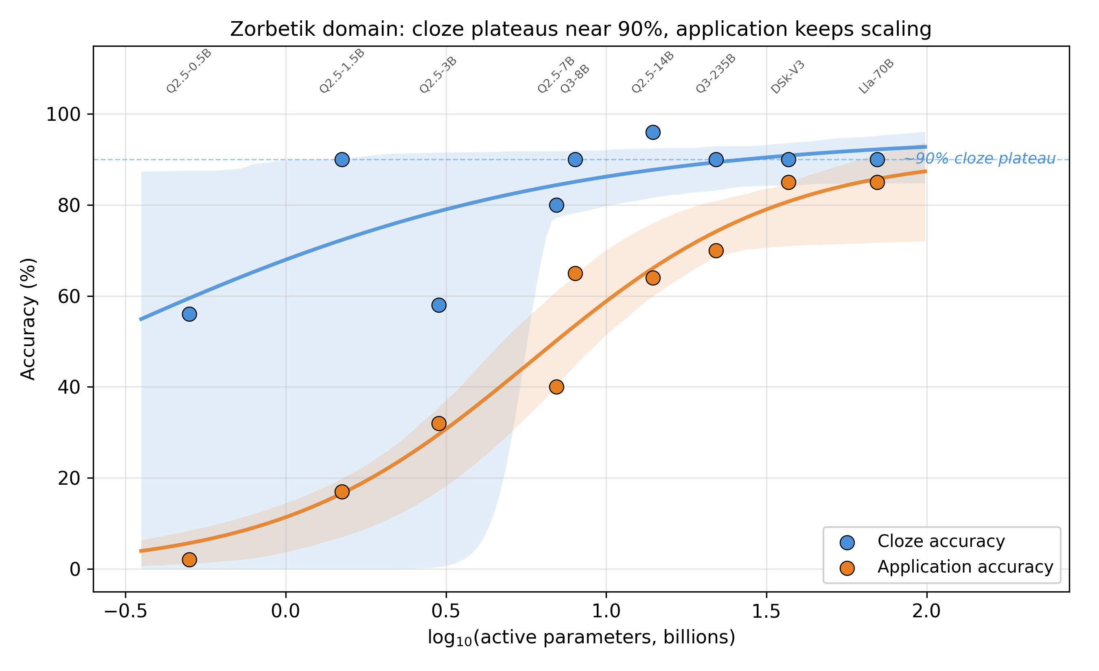
Figure 1: Capacity scaling on Zorbetik
Figure 1. Cloze (blue) and application (orange) accuracy as a function of log₁₀(model size in billions of active parameters) across nine models. Points show the observed accuracy; shaded bands show 95% bootstrap confidence intervals around a logistic fit. Cloze saturates at ~90% by 8B parameters. Application scales monotonically across three orders of magnitude, reaching 85% at 70B active parameters. The gap between the two curves operationalises “intelligence headroom” on this domain — how much further capacity can carry the model before application saturates too.
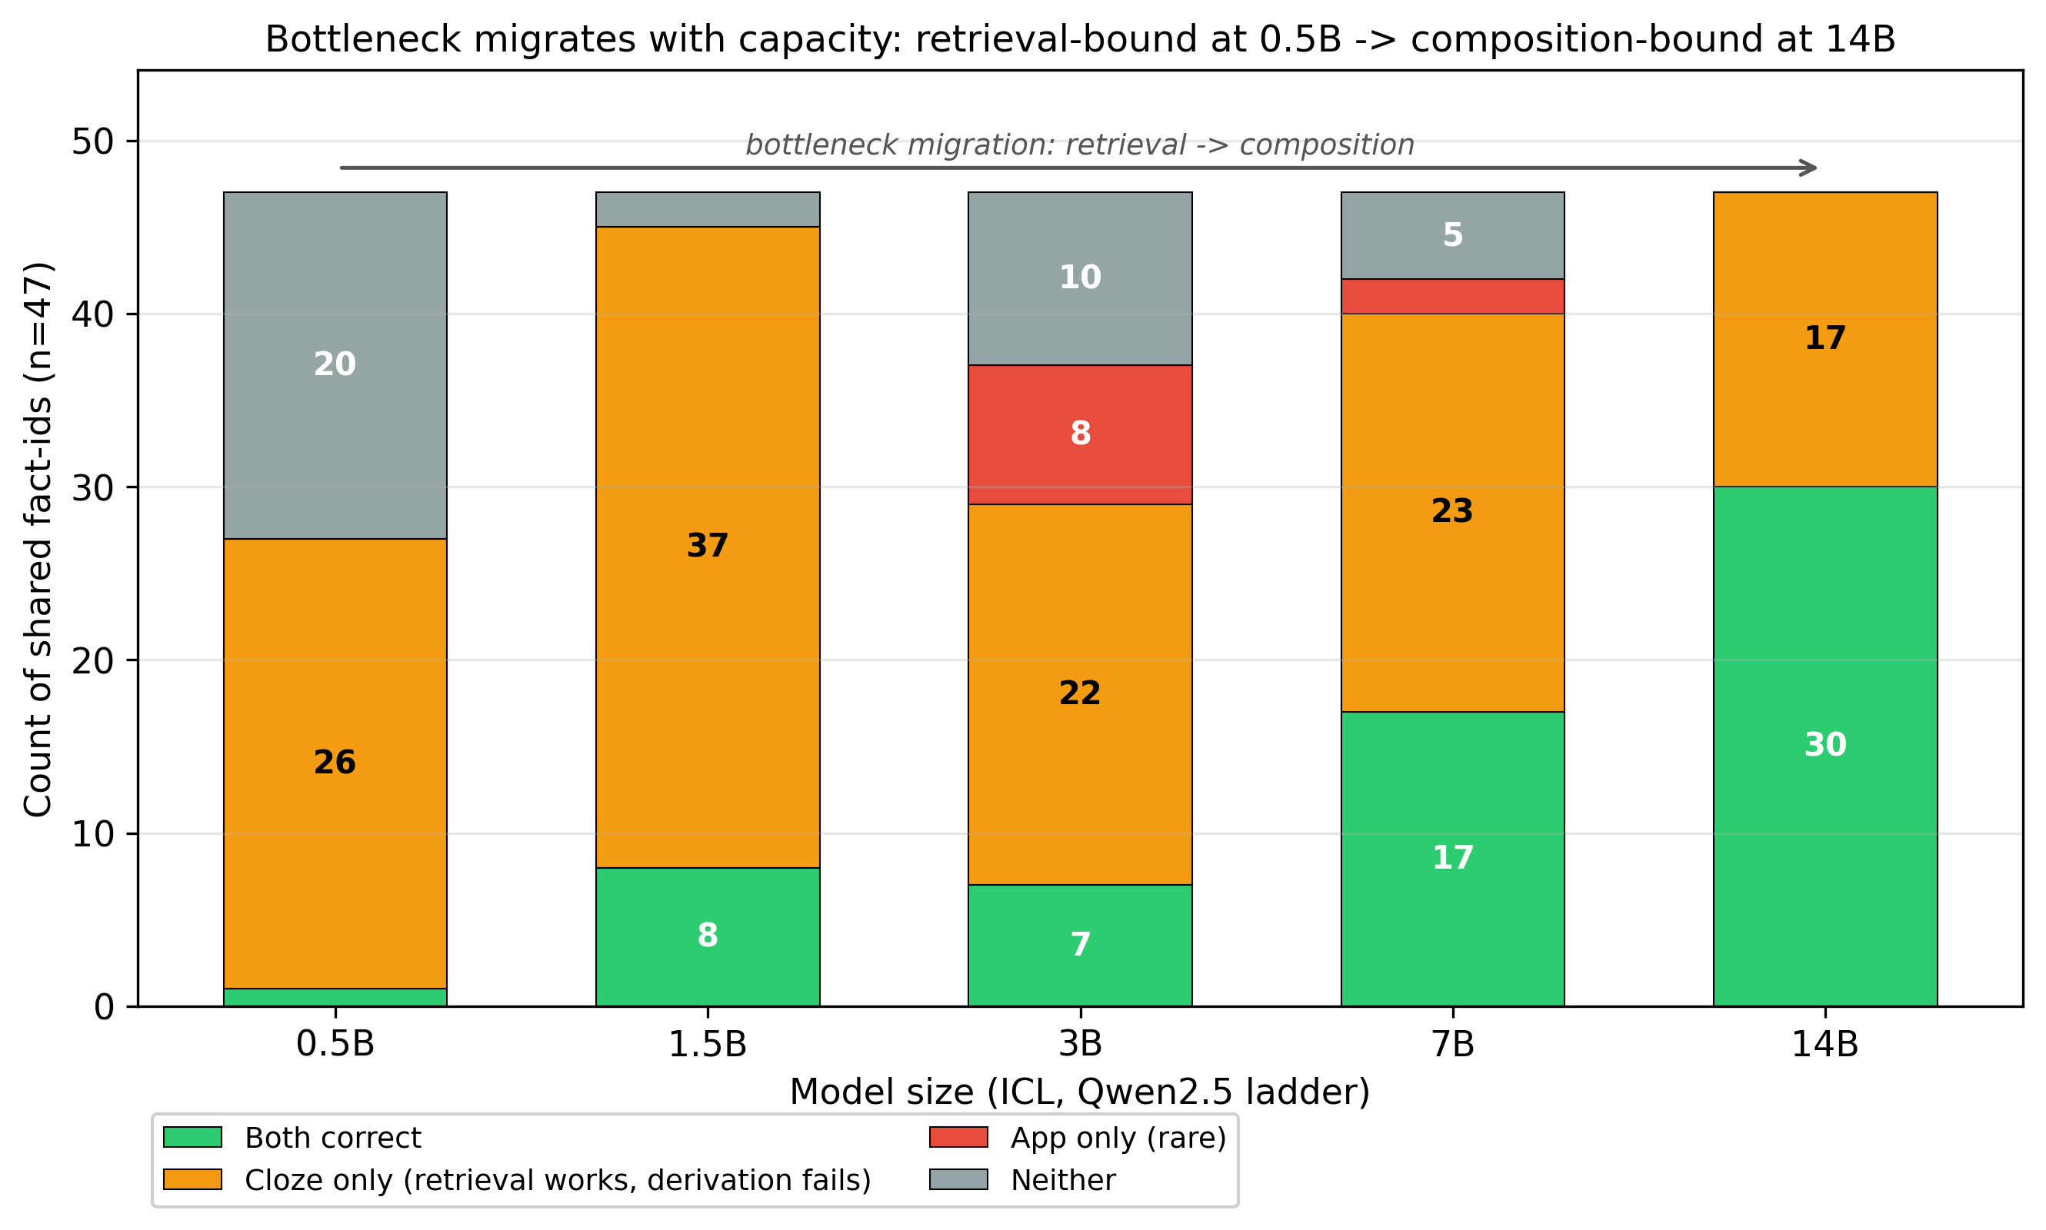
Figure 2: Bottleneck migration across capacity
Figure 2. Per-fact-id outcome composition across five model sizes on the 47 facts that appear in both cloze and application banks. At 0.5B, the dominant failure mode is retrieval (“Neither” + small “App-only” bars); by 7-14B, retrieval is essentially saturated and the remaining failure is composition-bound (“Cloze-only”: 17/47 = 36% at 14B). The bottleneck location shifts with capacity — precisely what the C-axis prediction implies.
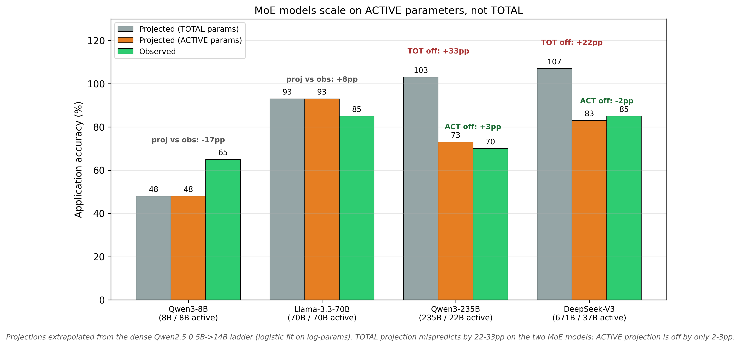
Figure 3: MoE active vs total parameter projection
Figure 3. Logistic-fit projections (from the dense Qwen2.5 0.5B→14B sub-ladder) applied to four large-model anchors, using either TOTAL parameters (light bars) or ACTIVE parameters (darker bars), compared against the actually observed accuracy (dashed line). For dense models (Qwen3-8B, Llama-3.3-70B) TOTAL and ACTIVE are identical. For the two MoE models (Qwen3-235B at 22B active, DeepSeek-V3 at 37B active), the ACTIVE-parameter projection lands within 3pp of the observation while the TOTAL-parameter projection is off by 22-33pp. Effective compute capacity is determined by per-token active parameters, not by total parameter count.

1.8.1 Table 1 — Per-model summary
Per-model cloze and application accuracy, plus per-token CR statistics (median, first-5, last-5) computed over application responses. See tables/table1_per_model_summary.md for the full table with platform-dependency footnotes.
Model | Size (B) | Active (B) | Cloze % | Application % | n_resp
Qwen2.5-0.5B | 0.5 | 0.5 | 56 | 2 | 47
Qwen2.5-1.5B | 1.5 | 1.5 | 90 | 17 | 47
Qwen2.5-3B | 3 | 3 | 58 | 32 | 47
Qwen2.5-7B | 7 | 7 | 80 | 40 | 47
Qwen3-8B | 8 | 8 | 90 | 65 | 20
Qwen2.5-14B | 14 | 14 | 96 | 64 | 47
Llama-3.3-70B | 70 | 70 | 90 | 85 | 20
Qwen3-235B | 235 | 22 | 90 | 70 | 20
DeepSeek-V3 | 671 | 37 | 90 | 85 | 20
CR statistics are reported in the full table linked above; they span multiple orders of magnitude because the hosted-API platforms (Fireworks, Together) return logprobs clipped to ≈−10⁻⁵ on confident tokens, inflating the CR denominator. Within-platform CR comparisons are valid; cross-platform absolute comparisons are not. On the Qwen2.5 ladder (locally served, uniform platform), last5_cr systematically exceeds first5_cr from 3B upward — consistent with the §2.8 observation that application friction accumulates during the reasoning chain rather than spiking on the first token.

1.9 8. References
Akyürek, E., Schuurmans, D., Andreas, J., Ma, T. & Zhou, D. (2022). What learning algorithm is in-context learning? arXiv:2211.15661.
Brown, T. B., Mann, B., Ryder, N. et al. (2020). Language models are few-shot learners. NeurIPS 2020. arXiv:2005.14165.
Craik, F. I. M. & Lockhart, R. S. (1972). Levels of processing: a framework for memory research. Journal of Verbal Learning and Verbal Behavior, 11, 671–684.
Dai, D., Sun, Y., Dong, L., Hao, Y., Sui, Z. & Wei, F. (2022). Why can GPT learn in-context? arXiv:2212.10559.
Damásio, A. (1994). Descartes’ Error: Emotion, Reason, and the Human Brain. Putnam.
Geva, M., Schuster, R., Berant, J. & Levy, O. (2021). Transformer feed-forward layers are key-value memories. EMNLP 2021. arXiv:2012.14913.
Gudibande, A., Wallace, E., Snell, C., Geng, X., Liu, H., Abbeel, P., Levine, S. & Song, D. (2023). The false promise of imitating proprietary LLMs. arXiv:2305.15717.
Kalyuga, S., Ayres, P., Chandler, P. & Sweller, J. (2003). The expertise reversal effect. Educational Psychologist, 38, 23–31.
Lund, T. (2026a). Behavioural Friction Theory: A race-based account of decision cost in human cognition. Zenodo preprint. DOI: 10.5281/zenodo.19462500.
Lund, T. (2026b). Friction as the cost of probabilistic computation: A generalised substrate theory. Target: Behavioural and Brain Sciences. [Paper 1, this series.]
Lund, T. (2026d). Friction-guided inference: a free signal that improves any LLM. [Paper 3, this series, in preparation.]
Lund, T. (2026e). Cross-substrate replication of classical learning phenomena on LLM substrate. [Paper 4, this series, in preparation.]
Lund, T. (2026f). A recursive strategy-choice race account of expertise reversal. [Paper 4B, this series, in preparation.]
Lund, T. (2026h). Matched friction under hysteresis: A unifying principle for learning optima. [Paper 6, this series, in preparation.]
McClelland, J. L., McNaughton, B. L. & O’Reilly, R. C. (1995). Why there are complementary learning systems in the hippocampus and neocortex. Psychological Review, 102, 419–457.
Paivio, A. (1971). Imagery and Verbal Processes. Holt, Rinehart & Winston.
Schaeffer, R., Miranda, B. & Koyejo, S. (2023). Are emergent abilities of large language models a mirage? NeurIPS 2023. arXiv:2304.15004.
Soudani, H., Kanoulas, E. & Hasibi, F. (2024). Fine tuning vs. retrieval augmented generation for less popular knowledge. arXiv:2403.01432.
Yonelinas, A. P., Ranganath, C., Ekstrom, A. D. & Wiltgen, B. J. (2019). A contextual binding theory of episodic memory: systems consolidation reconsidered. Nature Reviews Neuroscience, 20(6), 364–375. DOI: 10.1038/s41583-019-0150-4.

