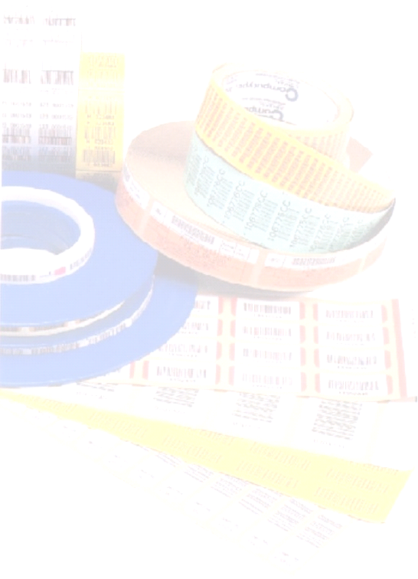
Meridian Rail

Axle Tracker
Manual
Version A

Revision Information
Revision | Description | Date
A | Initial Draft Release (Tucson – Jan Havlix) | 12/2906

Associated Documents
File Name | Title
Meridian Rail DD v1 02.doc
AxleTracker.doc
Computype, Inc.
2285 West County Road C
Saint Paul, Minnesota 55113
(800) 328-0852
(651) 633-0633

Table of Contents

Introduction 4

General Description 4

Purpose and Scope 4

Definitions 4

References 4

Components 4

System Verification and Testing 5

Constraints 5

Performance Requirements 5

Hazard Analysis 5

System description 6

Attributes 6

Functional Requirements 6

Process 6

System Management 6

User Management function 6

Customer Management 7

Process Tracking 7

General 7

Functional Decomposition 9

Operator Login 11

Operator Account(s) 12

Access Profiles 12

Process Tracking Stations 15

Receiving Of Wheel Sets 18

Receiving Axle Screen 18

Receiving Wheel Screen 20

Receiving Bearing Screen 21

Bearing Demount 24

Wheel Demount (New Mount Track Only) 24

Axle Operation 29

Magna Flux 33

Wheel Mount (New Mount track only) 33

Bearing Mount 36

Wheel Lathe (Turned Tread track only) 36

Axle Scrap (To be determined) 37

Outbound 37

Data Dictionary 38

Axle 38

Axle Operation 39

Axle QA 40

Axle Scrap 41

Axle Type 41

Axle UT 42

Bearing Demount Operation 42

Bearing Mount Operation 43

Bearing Scrap 43

Bearing Type 43

Customers 44

Customer Bearing Reference 44

Machines 44

Magna Flux NM Operation 45

Magna Flux TT Operation 45

Operators 46

Plant 46

Wheel Demount Operation 47

Wheel Lathe 48

Wheel Mount Operation 49

Wheel Scrap 50

Wheel Type 50

Wheel UT 50

Work Center 51

Customer Specification Review and Sign-Off 52

Specification Review and Sign-Off 53

Summary of Revisions 53

IntroductION
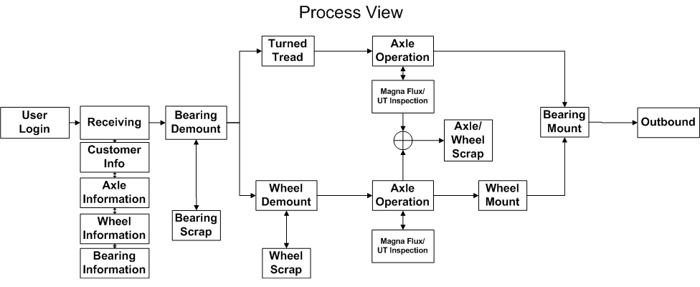
Figure 1

The Axle Tracking System (ATS) is a web based application server that runs on a Microsoft IIS 5.0+ intranet server. Operators are required to log onto the system. Axle sets are processed and tracked in loads. Individual load assets are tracked by attaching a barcode tag ID at the beginning of the production process. As axles are moved through the production plant, the operator will scan the tag ids and enter information into either a handheld portable terminal or a desktop computer. Transactional records are entered via a set of user input screens.
Table 1
User Input  Modules | Comments
Login Screen
Receiving
Bearing Demount
Wheel Demount
Bearing Mount
Axle Production
Wheel Mount
Turned Tread
Magnaflux NM
Magnaflux TT
Wheel UT
Axle UT
Outbound

Operator Login
Access to the different user input modules is password controlled.

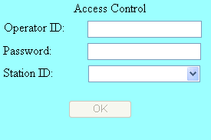
Figure 2 Operator Login Screen

Only when an operator has successfully supplied a user ID and password will the station ID combo box be populated.

Each operator account is assigned an “Access Profile” that defines which stations/work centers are allowed.

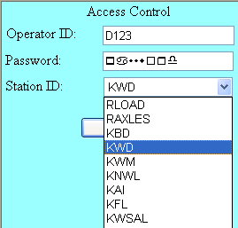
Figure 3 Station ID’s Listed for Access Profile

Operator Account(s)
Each operator account has
- operator id
- password
- Plant ID
- Access Profile
- User Name
- DefaultWS (Default Work Station)
- LoginStatus

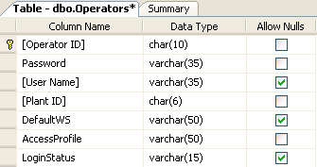

Operator ID’s

Operator ID’s are unique and only support alpha-numeric characters.

Password(s)

Passwords are case sensitive, alpha-numeric strings.

Plant ID
Plant ID’s defined where the operator is based. It is not an entered value.

Access Profiles
Access to the different user input screens is controlled by assigning a profile value to an operator account e.g. Figure 4.
In Figure 4, three different access profiles are displayed. An operators assigned “Profile 1” is allowed to access work center’s “A”, “B”, “C”, and “D”. An operator assigned “Profile 2” is allowed access to work center’s “B” and “D”. And, an operator assigned “Profile 3” is allowed accessed to work centers “A” and “C”.
Access profile definitions are defined in the RFDB database’s “AccessProfiles” table.

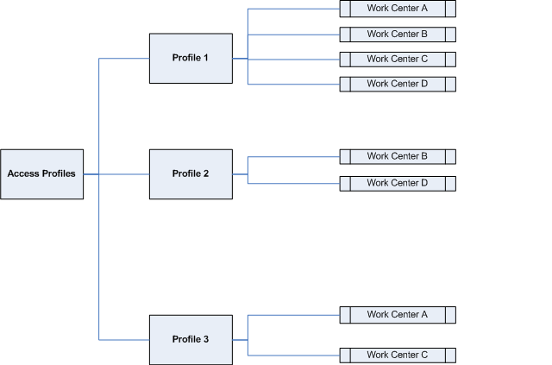
Figure 4 Access Profiles Top Down View
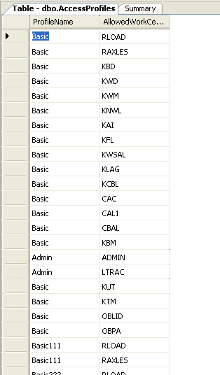
Figure 5 “AccessProfiles” Table

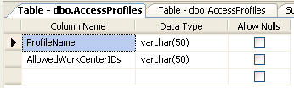
Figure 6 “AccessProfiles” Table Structure

User Name,Default WS, Login Status
User Name is optionally and Default WS, Login Status are not implemented.

Receive Load
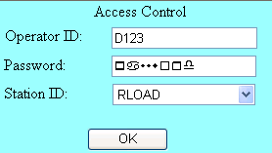
Figure 7 RLOAD Access
The receive load function is available when an operator’s access profile includes “RLOAD”. From the “Access Control” input screen, select “RLOAD” from the station ID combo box shown in Figure 7.

Receive Load - Customer
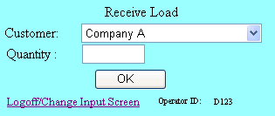
Figure 8 Scanned Customer Name
Customer name’s are displayed when the operator either scan, types or selects the customer name.

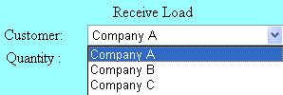
Figure 9 Selected Customer Name

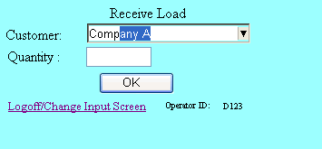
Figure 10 Typed Customer Name

Receive Load – Quantity

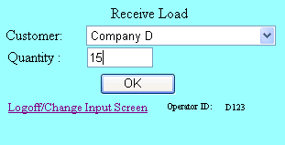
Figure 11 Load Quantity
Quantity defines the number of axles that are belong to a load. When the “OK” command button is pressed, a load id number is displayed for the operator to record.

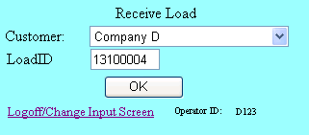
Figure 12 Load ID
The first two characters of the load id is the plant number associated with the operator ID. The last six digits represent the current count of load id’s that have been assigned – 100000. For example, a load id of 13100500 indicates that the load id was generated for an operator assigned to plant 13 and that it is the 500th assigned value (100500 – 100000)
Pressing the “OK” command button returns the RLOAD screen to its original state where the operator can enter information for the next load of axles.
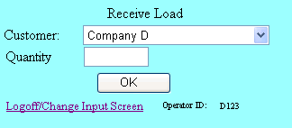
Figure 13 New Receive Load

Receiving Of Wheel Sets
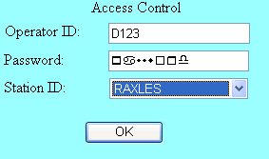
Figure 14
Select “RAXLES” to enter axle/wheel sets.
Receiving a wheel set is done in four steps.

Step 1: Receive Axle
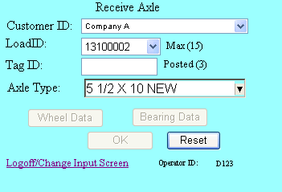

Table 2 Receive Axle Details
Item | Screen Capture | Description
 | 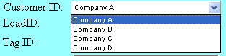 | Scan, type, select the name of the company that represents the source of the inbound axles.
 | 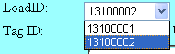 | When the customer name is entered, a list of all pending loads id is displayed. Select the load id recorded during the “RLOAD” session.
 |  | Record the tag id attached to the axle.
 | 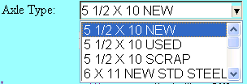 | Record the axle type.
 |  | “Max” indicates the entered number of axles expected when the load id was created.
 |  | “Posted” reports the number of tag id’s that have been assigned to the current load id.
 |  | The Wheel Data command button is dimmed until a tag id has been entered.
 |  | The Bearing Data command button is dimmed until a tag id has been entered.
 |  | The “Reset” command button purges the current transaction record being entered.
 |  | The “OK” button is dimmed until all the axles, wheel and bearing data has been entered.
 |  | Returns the operator to the access control screen.
 |  | Reports the operator ID.
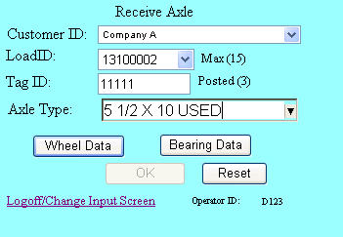
Figure 15 Wheel/Bearing Command Buttons Enabled
After selecting the customer ID, load ID and entering a tag id, the “Wheel Data” and “Bearing Data” command buttons are enabled.

Step2: Receiving Wheel(s)
When the “Wheel Data” command button is pressed, the “Receive Wheel Set” input screen appears see Figure 16 Receive Wheel Set Input Screen.
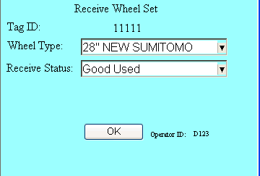
Figure 16 Receive Wheel Set Input Screen
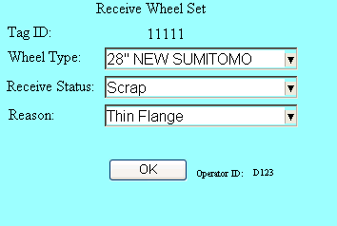
Figure 17 Scrap Wheel Set
If the wheel status is declared as scrap, the operator will be prompted to give a reason, see Figure 17 .

Step 3: Receiving Bearing Screen
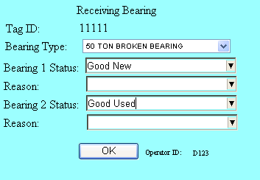
Figure 18 Receiving Bearings
Enter the bearing type and status condition for both bearings. If any of the bearings are declared as “scrap”, enter the reason, see Figure 19.
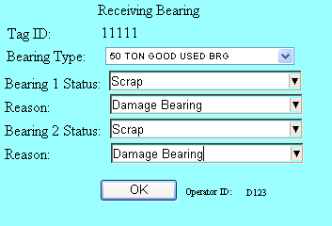
Figure 19 Scrap Bearings

Step 4: Post Information
Wheel the axle information, wheel and bearing data have been entered the “OK” command button will become enabled. The wheel set data is posted to the Axle Tracking system database when the OK command button is pressed. After the data is successfully posted, the input screen’s “Posted” count will be incremented, see Figure 21.
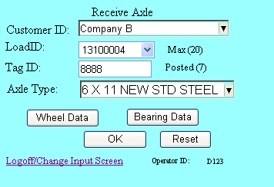
Figure 20 Before Posting Wheel Set
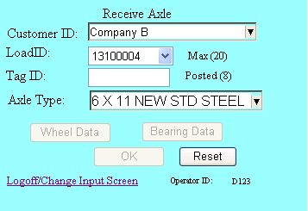
Figure 21 After Posting Wheel Set

Bearing Demount

Accessing Bearing Demount Input Screen
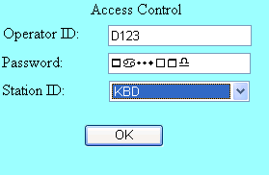
Figure 22 Station ID for Bearing Demount

Bearing Demount Data Entry
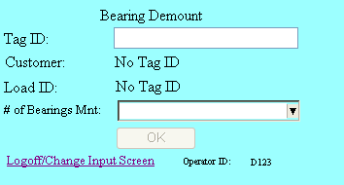
Figure 23 Bearing Demount Data Entry Screen

Step 1: Scan/Enter Tag ID

When the tag id is entered, it searches the ATS’s database for an axle that has a matching tag id and belongs to the same plant id as the operator’s account.

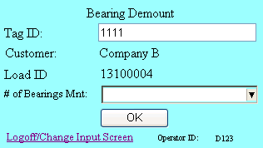
Figure 24

Step 2: Define Number Of Bearings Mounted

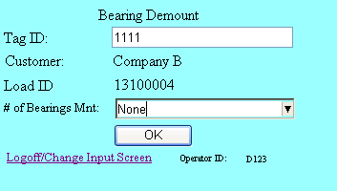
Figure 25
The operator has 3 choices;

- Mounted
- One
- None

Mounted indicates that both bearings are mounted. “One” indicates that one bearing has been removed, and “None” means both bearings have been removed.

The ATS will checked the bearing status for the tag id for the downstream work stations, and will not process an axle that does not have a bearing status of “none”.

Step 3: Press “OK”

When the “OK” the bearing status for the tag id is updated and the input fields are cleared as shown in
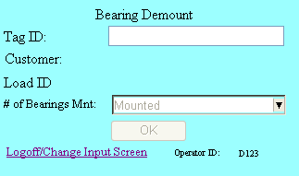
Figure 26 Completed BD Entry

Wheel Demount (WD)

Accessing Wheel Demount Input Screen
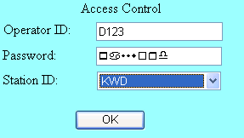
Figure 27 Accessing Wheel Demount
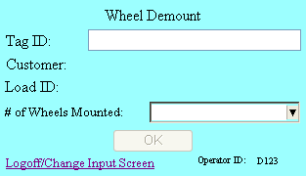
Figure 28 Blank WD Input Screen

Bearing Demount Data Entry

Step 1: Enter Valid Tag ID

Table 3
Invalid Tag IDs | Valid Tag ID
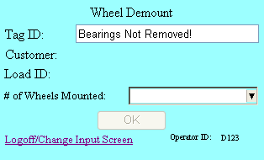 | 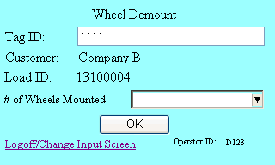
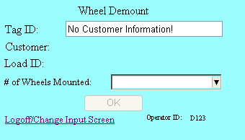

When a tag ID is entered, the ATS will determine if the tag id exists in the system database and has been assigned, then verify that the bearing status for the axle is equal to “none”.

Step 2: Define Number Of Wheels Mounted

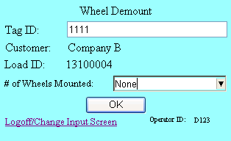
Figure 29

Step 4: Press “OK”
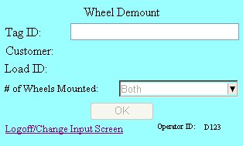
Figure 30
Pressing the “OK” command button will update the wheel status for the axle record defined by the tag id.

Axle Operation
There are number of axle operations that are accepted by the ATS provided their process is identified as a process work station with an ID of “LOOSE AXLES”.
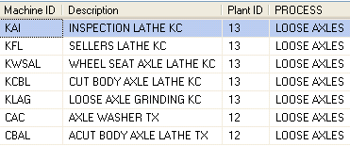
Figure 31 Sample Records From RFDB.Machines Table
Item | Access Control | Input Screen
1 | 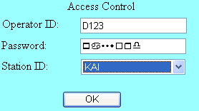 | 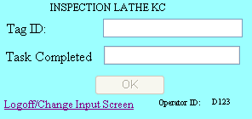
2 | 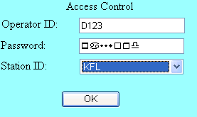 | 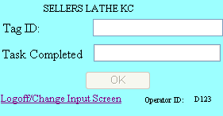
3 | 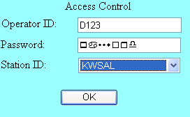 | 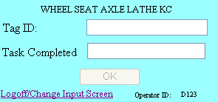
4 | 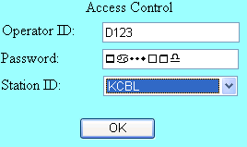 | 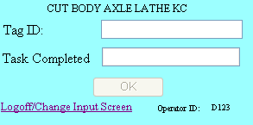
5 | 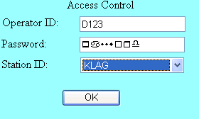 | 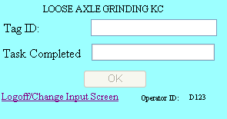
6 | 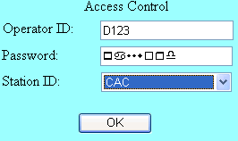 | 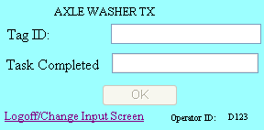
7 | 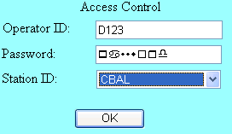 | 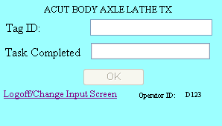

Step 1: Enter Valid Tag ID
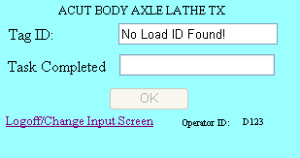
Figure 32 Invalid Tag ID Entered
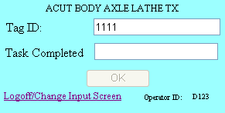
Figure 33 Valid Tag ID Entered
When a recognized tag id is entered, the input screen focus shifts to the task completed textbox.

When an invalid tag id is entered, the input screen reports an error as shown in Figure 32.

Step 3: Enter Task Completed
Scan or type information about the task completed and then press enter.
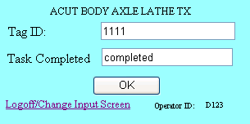
Figure 34

Step 4: Press “OK” to Post Completed Task
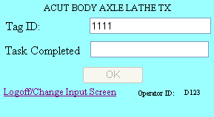
Figure 35
Tasks completed and posted are stored in the ATS database in the “AP Operation”’s table.

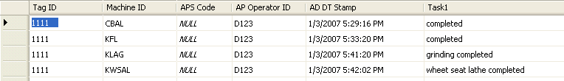
Figure 36 AP Operation Table
Items posted are timestamp along with the operator ID and machine ID used to complete the task.

Magna Flux
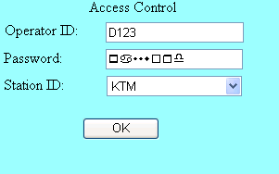
Figure 37

Step 1: Enter Valid Tag ID
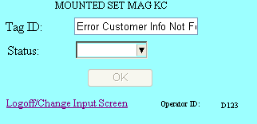
Figure 38 Invalid Tag ID

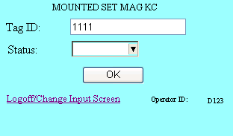
Figure 39

Step 2: Select Status
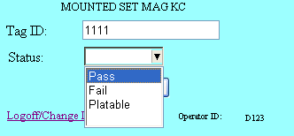
Figure 40

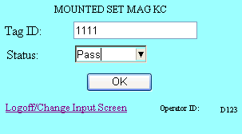
Figure 41

Step 3: Press “OK”
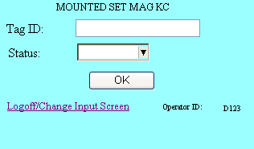
Figure 42

Wheel Mount (New Mount track only)
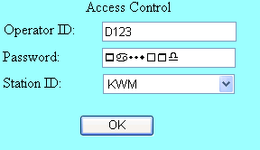
Figure 43 Accessing Wheel Mount

Wheel mount operation is only allowed when the bearing and wheel status are none for the entered tag ID and the inbound wheel state was defined as “Scrap”
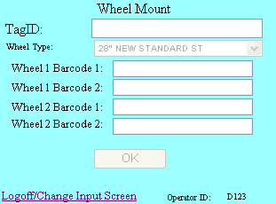
Figure 44
The business rule that define what tag ids are allowed are defined in the system table, RFDB.Business Rules (see Figure 45

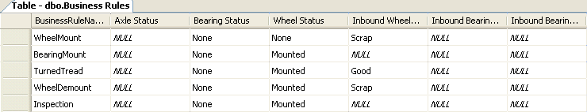
Figure 45 Business Rules
Business rules can be assigned to an input screen through the RFDB.Machines table (see Figure 46 )

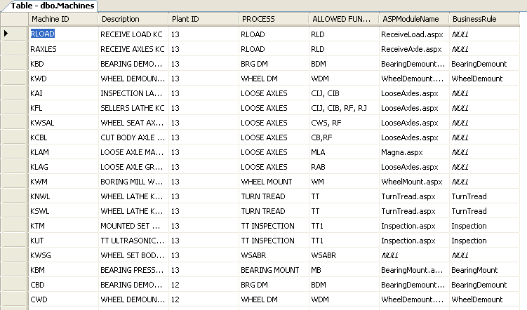
Figure 46 Sample Machine Table Showing How Business Rules Are Assigned

Step 1: Enter Valid Tag ID
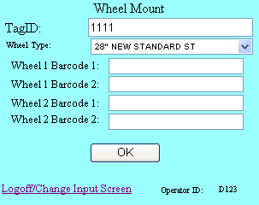
Figure 47

Step 2: Scan/Select Wheel Type
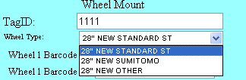
Figure 48

Step 3: Enter Serial Number(s)
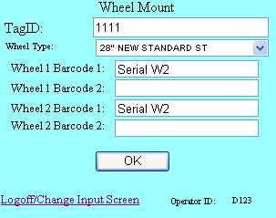
Figure 49

Step 4: Press “OK”
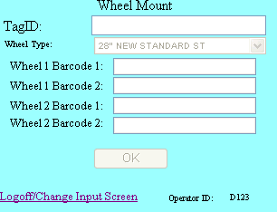
Figure 50

Bearing Mount

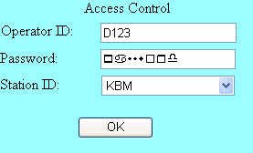
Figure 51 Accessing Bearing Mount
Bearing mount operation is only allowed when the bearing status is “None”, the wheel mount status is “Mounted” for the entered tag ID and plant ID (implicit from the operator ID log in).

The business rule that define what tag ids are allowed are defined in the system table, RFDB.Business Rules (see Figure 45 )

Step 1: Enter Valid Tag ID
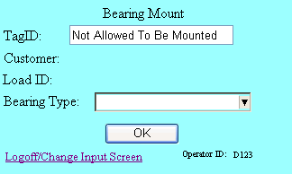
Figure 52 Invalid Tag ID

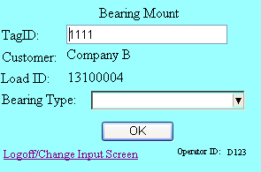
Figure 53 Valid Tag ID

Step 2: Scan/Select Bearing Type
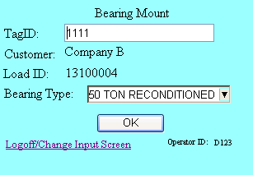
Figure 54

Step 3: Press “OK”
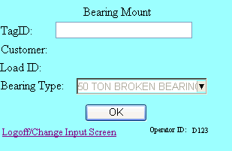
Figure 55

Turned Tread
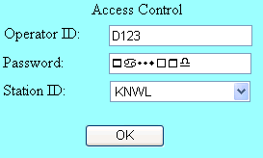
Figure 56

Step 1: Enter Valid Tag ID

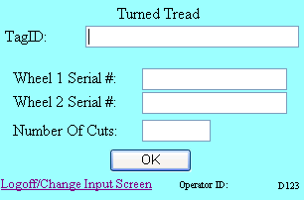
Figure 57
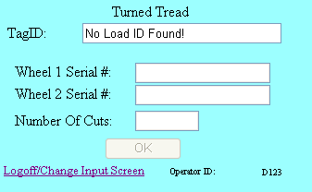
Figure 58

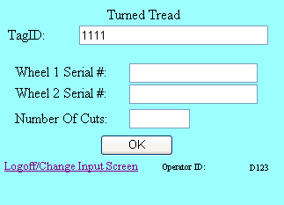
Figure 59 Valid Tag ID

Step 2: Enter Wheel Serial Numbers
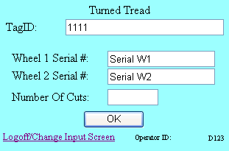
Figure 60

Step 3: Enter Wheel Cuts

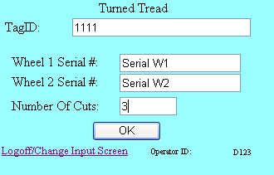
Figure 61

Step 4: Press OK
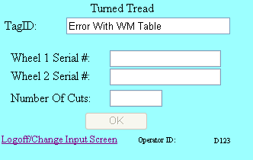

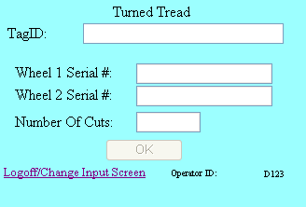
Figure 62

Axle Scrap (To be determined)

Outbound

Step 1: Create Outbound ID
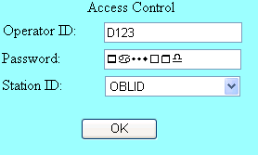
Figure 63

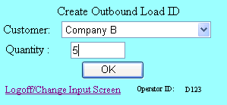
Figure 64

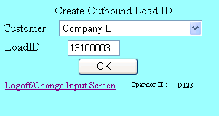
Figure 65

Step 2: Link Tag IDs to Outbound Load ID

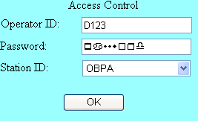
Figure 66

Step 2: Select Customer, Out Bound Load ID

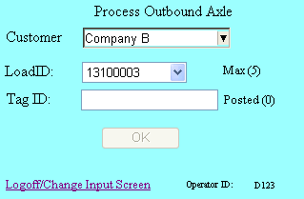
Figure 67

Step 4: Enter Valid Tag ID

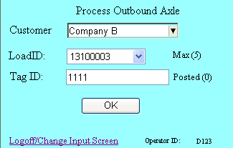
Figure 68
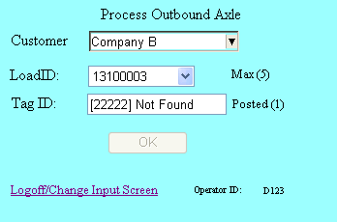
Figure 69 Invalid Tag ID

Step 3: Press “OK”
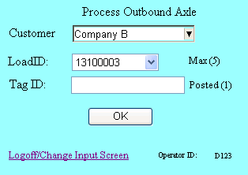
Figure 70

Data Dictionary

Axle
Table 4 Axle Table Definition
Table Name | Field Name | Format | Index | Validation W/Syspro | Comments
Axle
 | Tag ID | INT(6) |  | na | serial number assigned to axle body with barcode
 | Created By | VARCHAR (25) |  | na | user ID field
 | Created On | DATETIME |  | na | yyyymmddhhmmss
 | Plant ID | INT(2) |  | na
 | Inbound Customer | VARCHAR (50) |  |  | Inbound from Customer
 | Inbound Customer Location | VARCHAR (50) |  |  | Inbound from Customer location
 | Inbound Axle Type | VARCHAR (6) |  |  | inbound axle type
 | Inbound Wheel Type | VARCHAR (2) |  |  | inbound wheel size
 | Inbound Bearing Type | VARCHAR (10) |  |  | inbound bearing type
 | Axle Scrap Code | VARCHAR (4) |  |  | inbound axle scrap code
 | Wheel Scrap Code | VARCHAR (4) |  |  | inbound wheel scrap code
 | Bearing Scrap Code 1 | VARCHAR (4) |  |  | inbound bearing scrap code 1
 | Bearing Scrap Code 2 | VARCHAR (4) |  |  | inbound bearing scrap code 2
 | Outbound Customer | VARCHAR (50) |  |  | Outbound to Customer
 | Outbound Sales Order | VARCHAR (20)
 | Shipped By | VARCHAR (50) |  | na | user ID field
 | Shipped On | DATETIME |  | na | yyyymmddhhmmss
 | Axle Size | ?????? |  |  | Needed to calculate FG stock code to backflush
 | Outbound Wheel Type | VARCHAR (2) |  |  | Needed to calculate FG stock code to backflush
 | Outbound Bearing Type | VARCHAR (10) |  |  | Needed to calculate FG stock code to backflush
 | Status Code | VARCHAR (25) |  |  | Is this axle currently in the shop? Needed since tracking numbers will be reused.

Axle Operation
Table 5 Axle Operation Table Definition
Table Name | Field Name | Format | Length | Validation W/Syspro | Comments
AP Operation
 | Tag ID | Numeric | 6 | na | serial number assigned to axle body with barcode
 | Machine ID | alpha/numeric | 10 |  | Machine Number ID
 | APS Code | alpha/numeric | 4 |  | Axle Production Scrap Code
 | AP User ID | alpha/numeric | 10 |  | Axle Production user ID
 | AP DT Stamp | alpha/numeric | 10 |  | Axle Production Date and Time Stamp
 | Task1 | alpha/numeric | 4 |  | indicates work performed during process
 | Task2 | alpha/numeric | 4 |  | indicates work performed during process
 | Task3 | alpha/numeric | 4 |  | indicates work performed during process
 | Task4 | alpha/numeric | 4 |  | indicates work performed during process
 | Task5 | alpha/numeric | 4 |  | indicates work performed during process
 | Task6 | alpha/numeric | 4 |  | indicates work performed during process
 | Task7 | alpha/numeric | 4 |  | indicates work performed during process
 | Task8 | alpha/numeric | 4 |  | indicates work performed during process
 | Task9 | alpha/numeric | 4 |  | indicates work performed during process
 | Task10 | alpha/numeric | 4 |  | indicates work performed during process
 | Task11 | alpha/numeric | 4 |  | indicates work performed during process
 | Task12 | alpha/numeric | 4 |  | indicates work performed during process
 | Task13 | alpha/numeric | 4 |  | indicates work performed during process
 | Task14 | alpha/numeric | 4 |  | indicates work performed during process
 | Task15 | alpha/numeric | 4 |  | indicates work performed during process
 | Task16 | alpha/numeric | 4 |  | indicates work performed during process
 | Task17 | alpha/numeric | 4 |  | indicates work performed during process
 | Task18 | alpha/numeric | 4 |  | indicates work performed during process
 | Task19 | alpha/numeric | 4 |  | indicates work performed during process
 | Task20 | alpha/numeric | 4 |  | indicates work performed during process

Axle QA
Table 6 Axle QA Definition
Table Name | Field Name | Format | Length | Validation W/Syspro | Comments
Axle QA
 | Tag ID | Numeric | 6 | na | serial number assigned to axle body with barcode
 | Created By | alpha/numeric | 10 | na | user ID field
 | Created On | date/time stamp | 14 | na | yyyymmddhhmmss
 | Closed By | alpha/numeric | 10 | na | user ID field
 | Closed On | date/time stamp | 14 | na | yyyymmddhhmmss
 | Axle Scrap Code | alpha/numeric | 4 |  | Inbound axle scrap code
 | Axle Produciton Scrap Code | alpha/numeric | 4 |  | Axle Production scrap code
 | Wheel Scrap Code | alpha/numeric | 4 |  | Inbound wheel scrap code
 | Bearing Scrap Code 1 | alpha/numeric | 4 |  | Inbound bearing scrap code
 | Bearing Scrap Code 2 | alpha/numeric | 4 |  | Inbound bearing scrap code
 | BD issue | alpha/numeric | 4 |  | issue code
 | BD resolution | alpha/numeric | 4 |  | resolution code
 | MG NM Required | Integer | 1 |  | 0 = NA, 1 = Required, 2 = Completed
 | MG TT Required | Integer | 1 |  | 1 = NA, 1 = Required, 2 = Completed
 | Wheel UT Required | Integer | 1 |  | 2 = NA, 1 = Required, 2 = Completed
 | Axle UT Required | Integer | 1 |  | 3 = NA, 1 = Required, 2 = Completed
 | MG NM Scrap Code | alpha/numeric | 4 |  | required work for future operation
 | MG TT Scrap Code | alpha/numeric | 4 |  | required work for future operation
 | Wheel UT Scrap Code | alpha/numeric | 4 |  | required work for future operation
 | Axle UT Scrap Code | alpha/numeric | 4 |  | required work for future operation

Axle Scrap
Table 7
Table Name | Field Name | Format | Length | Validation W/Syspro | Comments
Axle Scrap
 | Scrap # | Numeric | 6 |  | Numeric Scrap Code
 | Description | alpha/numeric | 20 |  | Scrap Code Description
 | AxleID |  |  |  | Which axle did this come from?
 | DateTimeStamp

Axle Type
Table 8 Axle Type
Table Name | Field Name | Format | Length | Validation W/Syspro | Comments
Axle Type
 | Axle Type ID | Numeric | 6 |  | Axle Type #
 | Description | alpha/numeric | 20 |  | Axle Type Description
 | Size | alpha/numeric | 10 |  | 70T, 100T, 100TK, 125T etc.
 | Type | alpha/numeric | 10 |  | Used, New, Cut Body
 | MFGR | alpha/numeric | 10 |  | for new

Axle UT
Table 9
Table Name | Field Name | Format | Length | Validation W/Syspro | Comments
Axle UT
 | Tracking# | Numeric | 6 |  | serial number assigned to axle body with barcode
 | Axle UT Operation | Numeric | 1 |  | Axle UT Operation (default = 0 indicating not complete / '1' defines action complete)
 | Axle UT Scrap | Numeric | 1 |  | Axle UT Scrap code
 | Axle UT DT Stamp | date/time stamp | 14 |  | Axle UT Date/Time Stamp
 | Axle UT User | alpha/numeric | 10 |  | user ID field

Bearing Demount Operation
Table 10 Bearing Demount Operation Table Definition
Table Name | Field Name | Format | Length | Validation W/Syspro | Comments
BD Operation
 | Tag ID | Numeric | 6 |  | serial number assigned to axle body with barcode
 | BD Operation | Numeric | 1 |  | Bearing Demount Operation (default = 0 indicating not complete / '1' defines action complete)
 | BD Result | Numeric | 1 |  | Bearing Demount Result code / There are 2 possible result codes / '2' indicates that two bearing were successfully removed / '1' indicates < two bearings were removed
 | BD DT Stamp | date/time stamp | 14 |  | Bearing Demount Date/Time Stamp
 | BD User | alpha/numeric | 10 |  | user ID field
 | GoodBearingsRemoved | Numeric | 2 |  | Number of good bearings removed
 | BadBearingsRemoved | Numeric | 2 |  | Number of bad bearings removed

Bearing Mount Operation
Table 11 Bearing Mount Table Definition
Table Name | Field Name |  | Format | Length | Validation W/Syspro | Comments
Bearing Mount Operation
 |  | Tag ID | Numeric | 6 | na | serial number assigned to axle body with barcode
 |  | Machine ID | alpha/numeric | 10 |  | Machine Number ID
 |  | BM User ID | alpha/numeric | 10 |  | Wheel Mount user ID
 |  | BM DT stamp | alpha/numeric | 10 |  | Wheel Mount Date and Time Stamp
 |  | Bearing Type | alpha/numeric | 10 |  | Wheel Serial # ??????
 |  | Customer ID | alpha/numeric | 20 |  | intended customer

Bearing Scrap
Table 12
Table Name | Field Name | Format | Length | Validation W/Syspro | Comments
Bearing Scrap
 | Scrap # | Numeric | 6 |  | Numeric Scrap Code
 | Description | alpha/numeric | 20 |  | Scrap Code Description
 | AxleID |  |  |  | Which axle did this come from?
 | DateTimeStamp

Bearing Type
Table 13 Bearing Type
Table Name | Field Name | Format | Length | Validation W/Syspro | Comments
Bearing Type
 | Bearing Type ID | Numeric | 6 |  | Bearing Type #
 | Description | alpha/numeric | 20 |  | Bearing Type Description
 | Mfgr | alpha/numeric | 20 |  | RBS, QBS, Prec, Brenco, Timkin
 | Size | alpha/numeric | 20 |  | 70T, 100T, 100TK, 125T etc.
 | Type | alpha/numeric | 20 |  | AAR, Prem, UP, TTX, etc.

Customers
Table 14 Customers
Table Name | Field Name | Format | Length | Validation W/Syspro | Comments
Customer
 | CustomerName | alpha/numeric | 50 |  | Customer Name
 | CustomerLocation | alpha/numeric | 50 |  | Customer Location

Customer Bearing Reference
Table 15 Customer Bearing Reference
Table Name | Field Name | Format | Length | Validation W/Syspro | Comments
Customer Bearing Reference
 | Customer Name | alpha/numeric | 20 |  | User Name
 | Axle Type | alpha/numeric | 2 |  | Axle Type
 | Bearing Type | alpha/numeric | 10 |  | Bearing type

Machines
Table 16 Machines
Table Name | Field Name | Format | Length | Validation W/Syspro | Comments
Machine
 | Machine # | alpha/numeric | 6 |  | Machine #
 | Machine Description | alpha/numeric | 20 |  | Description
 | Work Center # | Numeric | 6 |  | Work Center #

Magna Flux NM Operation
Table 17 Magna Flux NM Operation Table
Table Name | Field Name | Format | Length | Validation W/Syspro | Comments
Magna Flux NM Operation
 | Tag ID | Numeric | 6 |  | serial number assigned to axle body with barcode
 | MG NM Scrap | Numeric | 4 |  | MG Scrap code
 | MG NM DT Stamp | date/time stamp | 14 |  | Magna Flux NM Date/Time Stamp
 | MG NM Operator | alpha/numeric | 10 |  | user ID field

Magna Flux TT Operation
Table 18 Magna Flux TT Operation Table
Table Name | Field Name | Format | Length | Validation W/Syspro | Comments
Magna Flux TT Operation
 | Tag ID | Numeric | 6 |  | serial number assigned to axle body with barcode
 | MG TT Operation | Numeric | 1 |  | Magna Flux TT Operation (default = 0 indicating not complete / '1' defines action complete)
 | MG TT Scrap | Numeric | 1 |  | MG Scrap code
 | MG TT DT Stamp | date/time stamp | 14 |  | Magna Flux TT Date/Time Stamp
 | MG TT User | alpha/numeric | 10 |  | user ID field

Operators
Table 19 Operators Table Definition
Table Name | Field Name | Format | Length | Validation W/Syspro | Comments
Operators | Operator ID | alpha/numeric | 10
 | User Name | alpha/numeric | 35 |  | User Name
 | Plant ID | integer | 6 |  | Plant #

Plant
Table 20 Plant Table Definition
Table Name | Field Name | Format | Length | Validation W/Syspro | Comments
Plant
 | Plant # | Numeric | 6 |  | Plant #
 | Description | alpha/numeric | 20 |  | Plant Description

Wheel Demount Operation
Table 21 Wheel Demount Definition Table
Table Name | Field Name | Format | Length | Validation W/Syspro | Comments
WD Operation
 | Tag ID | Numeric | 6 | na | serial number assigned to axle body with barcode
 | WD Operation | Numeric | 1 |  | Bearing Demount Operation (default = 0 indicating not complete / '1' defines action complete)
 | WD Results | Numeric | 1
 | WD DT Stamp | date/time stamp | 14 |  | Wheel Demount date and time stamp
 | WD User | alpha/numeric | 10 |  | Wheel demount user ID
 | Good Wheels Removed | Numeric | 2 |  | Number of good wheels removed
 | Bad Wheels Removed | Numeric | 2 |  | Number of bad wheels removed

Wheel Lathe
Table 22 Wheel Lathe Table Definition
Table Name | Field Name | Format | Length | Validation W/Syspro | Comments
Wheel Lathe
 | Tag ID | Numeric | 6 | na | serial number assigned to axle body with barcode
 | Machine ID | alpha/numeric | 10 |  | Machine Number ID
 | WLS Code | alpha/numeric | 4 |  | Wheel Lathe Scrap Code
 | WL User ID | alpha/numeric | 10 |  | Wheel Lathe user ID
 | WL DT Stamp | alpha/numeric | 10 |  | Wheel Lathe Date and Time Stamp
 | Wheel Data 1 | alpha/numeric | 10 |  | Misc
 | Wheel Data 2 | alpha/numeric | 10 |  | Misc
 | Wheel Data 3 | alpha/numeric | 10 |  | Misc
 | Wheel Data 4 | alpha/numeric | 10 |  | Misc
 | Wheel Data 5 | alpha/numeric | 10 |  | Misc
 | Wheel Data 6 | alpha/numeric | 10 |  | Misc
 | Wheel Data 7 | alpha/numeric | 10 |  | Misc
 | Wheel Data 8 | alpha/numeric | 10 |  | Misc
 | Wheel Data 9 | alpha/numeric | 10 |  | Misc
 | Wheel Data 10 | alpha/numeric | 10 |  | Misc

Wheel Mount Operation
Table 23 Wheel Mount Table Definition
Table Name | Field Name | Format | Length | Validation W/Syspro | Comments
WM Operation
 | Tag ID | Numeric | 6 | na | serial number assigned to axle body with barcode
 | Machine ID | alpha/numeric | 10 |  | Machine Number ID
 | WM Operator ID | alpha/numeric | 10 |  | Wheel Mount user ID
 | WM DT stamp | alpha/numeric | 10 |  | Wheel Mount Date and Time Stamp
 | Wheel 1 Serial 1 a | alpha/numeric | 10 |  | Wheel Serial #
 | Wheel 1 Serial 1 b | alpha/numeric | 10 |  | Wheel Serial #
 | Wheel 2 Serial 2 a | alpha/numeric | 10 |  | Wheel Serial #
 | Wheel 2 Serial 2 b | alpha/numeric | 10 |  | Wheel Serial #
 | Wheel Type ID | alpha/numeric | 6
 | Misfits | alpha/numeric | 2
 | Remounts | alpha/numeric | 2

Wheel Scrap
Table 24
Table Name | Field Name | Format | Length | Validation W/Syspro | Comments
Wheel Scrap
 | Scrap ID | Numeric | 6 |  | Numeric Scrap Code
 | Description | alpha/numeric | 20 |  | Scrap Code Description
 | Tag ID | Numeric | 6 |  | Which axle did this come from?
 | DT Stamp

Wheel Type
Table 25
Table Name | Field Name | Format | Length | Validation W/Syspro | Comments
Wheel Type
 | Wheel Type | Numeric | 6 |  | Wheel Type #
 | Description | alpha/numeric | 20 |  | Wheel Type Description
 | Size | alpha/numeric | 2 |  | 28, 33, 36, 38
 | Type | alpha/numeric | 10 |  | Used, New
 | MFGR | alpha/numeric | 10 |  | SS, Grif. Sum

Wheel UT
Table 26
Table Name | Field Name | Format | Length | Validation W/Syspro | Comments
Wheel UT
 | Tag ID | Numeric | 6 |  | serial number assigned to axle body with barcode
 | Wheel UT Operation | Numeric | 1 |  | Wheel UT Operation (default = 0 indicating not complete / '1' defines action complete)
 | Wheel UT Scrap | Numeric | 1 |  | Wheel UT Scrap code
 | Wheel UT DT Stamp | date/time stamp | 14 |  | Wheel UT Date/Time Stamp
 | Wheel UT user | alpha/numeric | 10 |  | user ID field

Work Center
Table 27 Work Center
Table Name | Field Name | Format | Length | Validation W/Syspro | Comments
Work Center
 | Work Center # | Numeric | 6 |  | Work Center #
 | Description | alpha/numeric | 20 |  | WC Description
 | Plant # | Numeric | 6 |  | Plant #

Customer Specification Review and Sign-Off
Function | Date | Name | Signature | Comments

Specification Review and Sign-Off

Function | Date | Name | Signature | Comments
Development
Technical Support
Customer

Additional Comments:

Revisions:
Requested By | Date | Summary of Revisions | Date Incorporated

