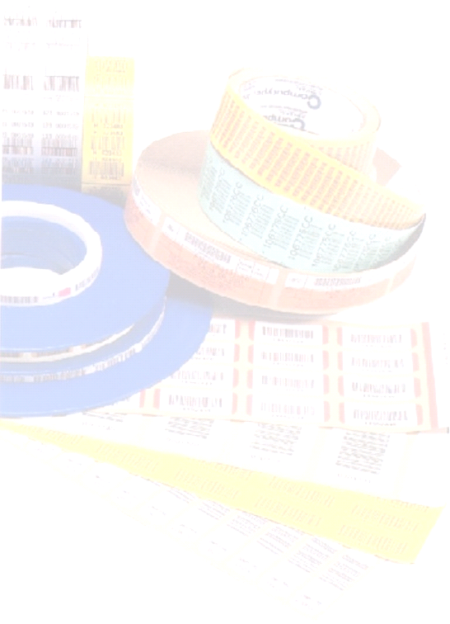
Meridian Rail

Axle Tracker
Manual
Version A

Revision Information
Revision | Description | Date
A | Initial Draft Release (Tucson – Jan Havlix) | 12/2906

Associated Documents
File Name | Title
Meridian Rail DD v1 02.doc
AxleTracker.doc
Computype, Inc.
2285 West County Road C
Saint Paul, Minnesota 55113
(800) 328-0852
(651) 633-0633

Table of Contents

IntroductION 4

Operator Login 6

Operator Account(s) 7

Receive Load 10

Receive Load - Customer 10

Receive Load – Quantity 11

Receiving Of Wheel Sets 13

Step 1: Receive Axle 13

Step2: Receiving Wheel(s) 15

Step 3: Receiving Bearing Screen 16

Step 4: Post Information 17

Limiting Axles Assigned to a Load ID 18

Bearing Demount 20

Accessing Bearing Demount Input Screen 20

Bearing Demount Data Entry 20

Bearing Scrap Operation 22

Wheel Demount (WD) 23

Accessing Wheel Demount Input Screen 23

Wheel Demount Data Entry 24

Wheel Scrap Operation 25

Axle Operation 26

Step 1: Enter Valid Tag ID 28

Step 3: Enter Task Completed 28

Step 4: Press “OK” to Post Completed Task 29

Magna Flux 30

Step 1: Enter Valid Tag ID 30

Step 2: Select Status 31

Step 3: Press “OK” 31

Wheel Mount (New Mount track only) 32

Step 1: Enter Valid Tag ID 34

Step 2: Scan/Select Wheel Type 34

Step 3: Enter Serial Number(s) 34

Step 4: Press “OK” 35

Bearing Mount 35

Step 1: Enter Valid Tag ID 36

Step 2: Scan/Select Bearing Type 36

Step 3: Press “OK” 37

Turned Tread 37

Step 1: Enter Valid Tag ID 37

Step 2: Enter Wheel Serial Numbers 39

Step 3: Enter Wheel Cuts 39

Step 4: Press OK 39

Axle Scrap (To be determined) 40

Outbound 41

Step 1: Create Outbound ID 41

Step 2: Link Tag IDs to Outbound Load ID 41

Step 2: Select Customer, Out Bound Load ID 42

Step 4: Enter Valid Tag ID 42

Step 3: Press “OK” 43

Post Shipping 44

Business Rules 45

Data Dictionary 47

Axle 47

Axle Operation 48

Axle QA 49

Axle Scrap 50

Axle Type 50

Axle UT 51

Bearing Demount Operation 51

Bearing Mount Operation 52

Bearing Scrap 52

Bearing Type 52

Customers 53

Customer Bearing Reference 53

Machines 53

Magna Flux NM Operation 54

Magna Flux TT Operation 54

Operators 55

Plant 55

Wheel Demount Operation 56

Wheel Lathe 57

Wheel Mount Operation 58

Wheel Scrap 59

Wheel Type 59

Wheel UT 59

Work Center 60

IntroductION
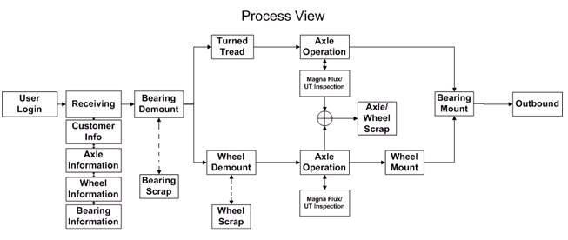
Figure 1
The Axle Tracking System (ATS) is a web based application server that runs on a Microsoft IIS 5.0+ intranet server. Operators are required to log onto the system. Axle sets are processed and tracked in loads. Individual load assets are tracked by attaching a barcode tag ID at the beginning of the production process. As axles are moved through the production plant, the operator will scan the tag ids and enter information into either a handheld portable terminal or a desktop computer. Transactional records are entered via a set of user input screens.

After an axle has been entered into the system, whenever its tag id is scanned or entered the ATS verifies that it has been assigned and that the axle meets certain prerequisites, henceforth referred to as business rules (see Business Rules) ,that are defined for each machine..

The tag id is used to identify an axle until it is processed/assigned at the outbound station. After a tag is removed from an axle it may be reused at receiving station.

Statistics are scrap parts are kept when items are demounted or fail inspection. Scrap items are monitored for each load id, and a summary of the reasons for the scrapping an item is kept when a tag id is released at the outbound workstation.

Table 1
User Input  Modules | Comments
Login Screen | Where users log into system and select work station.
Receiving | Work station for receiving inbound axles
Bearing Demount | Workstation for removing bearings.
Wheel Demount | Workstation for removing wheels.
Bearing Mount | Workstation for mounting bearings.
Axle Production | Generic workstation used to track activities at different machines.
Wheel Mount | Work station for mounting wheels.
Turned Tread | Workstation for working on repairing wheels
Magnaflux NM | Workstation for testing new mount wheels.
Magnaflux TT | Workstation for testing reconditioned wheels.
Wheel UT | Work station for ultrasonic testing of wheels.
Axle UT | Work station for ultrasonic testing of axles.
Outbound | Workstation where axles are assembled for shipping.

Operator Login
Access to the different user input modules is password controlled.

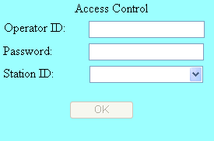
Figure 2 Operator Login Screen

Only when an operator has successfully supplied a user ID and password will the station ID combo box be populated.

Each operator account is assigned an “Access Profile” that defines which stations/work centers are allowed.

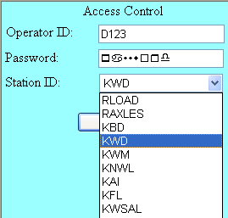
Figure 3 Station ID’s Listed for Access Profile

Operator Account(s)
Each operator account has
- operator id
- password
- Plant ID
- Access Profile
- User Name
- DefaultWS (Default Work Station)
- LoginStatus

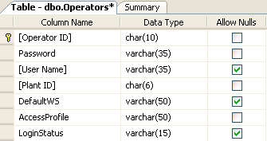

Operator ID’s

Operator ID’s are unique and only support alpha-numeric characters.

Password(s)

Passwords are case sensitive, alpha-numeric strings.

Plant ID
Plant ID’s defined where the operator is based. It is not an entered value.

Access Profiles
Access to the different user input screens is controlled by assigning a profile value to an operator account e.g. Figure 4.
In Figure 4, three different access profiles are displayed. An operators assigned “Profile 1” is allowed to access work center’s “A”, “B”, “C”, and “D”. An operator assigned “Profile 2” is allowed access to work center’s “B” and “D”. And, an operator assigned “Profile 3” is allowed accessed to work centers “A” and “C”.
Access profile definitions are defined in the RFDB database’s “AccessProfiles” table.

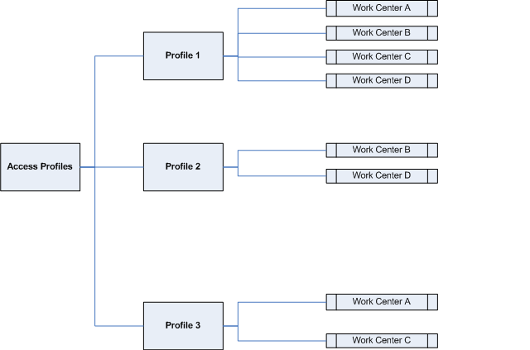
Figure 4 Access Profiles Top Down View
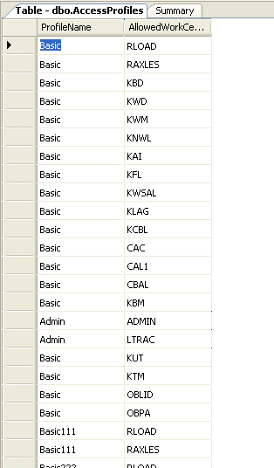
Figure 5 “AccessProfiles” Table

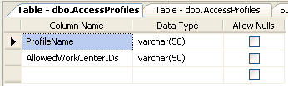
Figure 6 “AccessProfiles” Table Structure

User Name,Default WS, Login Status
User Name is optionally and Default WS, Login Status are not implemented.

Receive Load
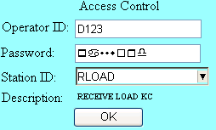
Figure 7 RLOAD Access
The receive load function is available when an operator’s access profile includes “RLOAD”. From the “Access Control” input screen, select “RLOAD” from the station ID combo box shown in Figure 7.

Receive Load - Customer
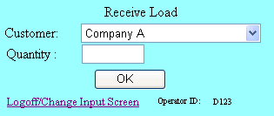
Figure 8 Scanned Customer Name
Customer name’s are displayed when the operator either scan, types or selects the customer name.

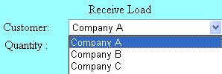
Figure 9 Selected Customer Name

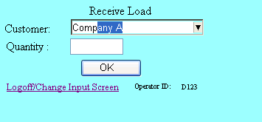
Figure 10 Typed Customer Name

Receive Load – Quantity

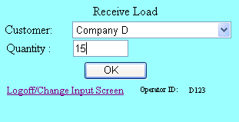
Figure 11 Load Quantity
Quantity defines the number of axles that are belong to a load. When the “OK” command button is pressed, a load id number is displayed for the operator to record.

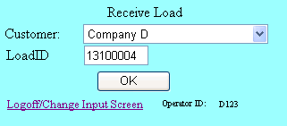
Figure 12 Load ID
The first two characters of the load id is the plant number associated with the operator ID. The last six digits represent the current count of load id’s that have been assigned – 100000. For example, a load id of 13100500 indicates that the load id was generated for an operator assigned to plant 13 and that it is the 500th assigned value (100500 – 100000)
Pressing the “OK” command button returns the RLOAD screen to its original state where the operator can enter information for the next load of axles.
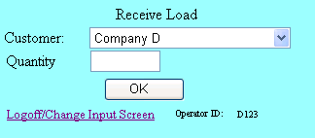
Figure 13 New Receive Load

Receiving Of Wheel Sets
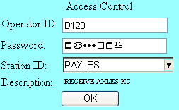
Figure 14
Select for the station id “RAXLES” to enter axle/wheel sets.
Receiving a wheel set is done in four steps.

Step 1: Receive Axle
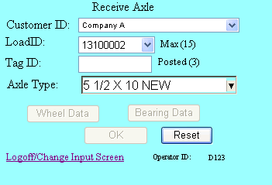

Table 2 Receive Axle Details
Item | Screen Capture | Description
 | 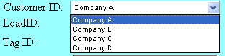 | Scan, type, select the name of the company that represents the source of the inbound axles.
 | 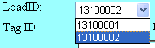 | When the customer name is entered, a list of all pending loads id is displayed. Select the load id recorded during the “RLOAD” session.
 |  | Record the tag id attached to the axle.
 | 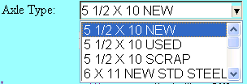 | Record the axle type.
 |  | “Max” indicates the entered number of axles expected when the load id was created.
 |  | “Posted” reports the number of tag id’s that have been assigned to the current load id.
 |  | The Wheel Data command button is dimmed until a tag id has been entered.
 |  | The Bearing Data command button is dimmed until a tag id has been entered.
 |  | The “Reset” command button purges the current transaction record being entered.
 |  | The “OK” button is dimmed until all the axles, wheel and bearing data has been entered.
 |  | Returns the operator to the access control screen.
 |  | Reports the operator ID.
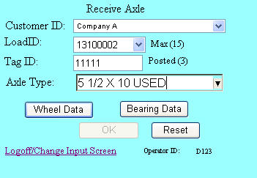
Figure 15 Wheel/Bearing Command Buttons Enabled
After selecting the customer ID, load ID and entering a tag id, the “Wheel Data” and “Bearing Data” command buttons are enabled.

Step2: Receiving Wheel(s)
When the “Wheel Data” command button is pressed, the “Receive Wheel Set” input screen appears see Figure 16 Receive Wheel Set Input Screen.
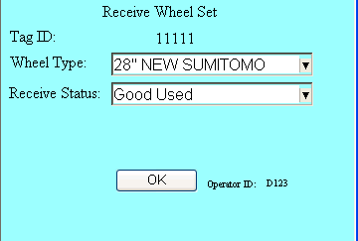
Figure 16 Receive Wheel Set Input Screen
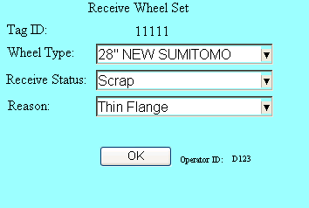
Figure 17 Scrap Wheel Set
If the wheel status is declared as scrap, the operator will be prompted to give a reason, see Figure 17 .

Step 3: Receiving Bearing Screen
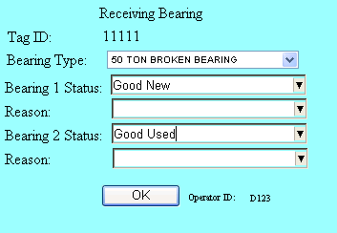
Figure 18 Receiving Bearings
Enter the bearing type and status condition for both bearings. If any of the bearings are declared as “scrap”, enter the reason, see Figure 19.
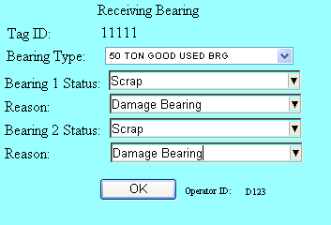
Figure 19 Scrap Bearings

Step 4: Post Information
Wheel the axle information, wheel and bearing data have been entered the “OK” command button will become enabled. The wheel set data is posted to the Axle Tracking system database when the OK command button is pressed. After the data is successfully posted, the input screen’s “Posted” count will be incremented, see Figure 21.
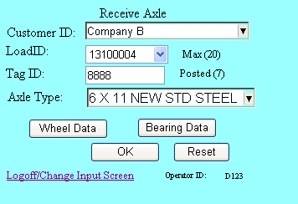
Figure 20 Before Posting Wheel Set
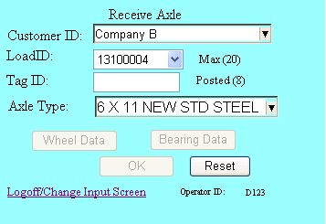
Figure 21 After Posting Wheel Set

Limiting Axles Assigned to a Load ID
When a load id is created, a quantity figure is assigned to it. The quantity figure defines how many axles may be received and grouped with the load id.
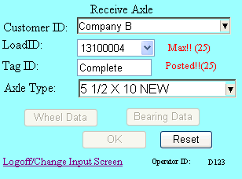
Figure 22 Max Axles Received
There is a global over-ride that can be set in the RFDB table, “ATSSiteTable”.
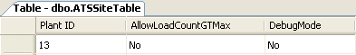
Figure 23 Site Table Config Used For Figure 22
If the “AllowLoadCountGTMax” value is set to “Yes”, operators will be allowed to increase the max count. As shown in Figure 24 a “LoadID command button will be displayed that when pressed will display the load id editor (see Figure 25)

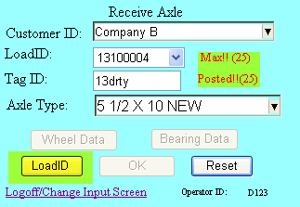
Figure 24

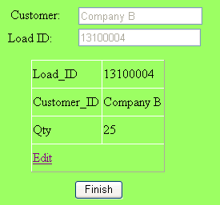
Figure 25 Load ID Editor

Bearing Demount

Accessing Bearing Demount Input Screen
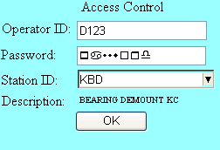
Figure 26 Station ID for Bearing Demount

Bearing Demount Data Entry
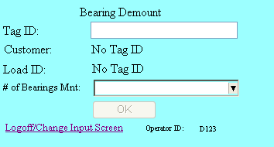
Figure 27 Bearing Demount Data Entry Screen

Step 1: Scan/Enter Tag ID

When the tag id is entered, it searches the ATS’s database for an axle that has a matching tag id and belongs to the same plant id as the operator’s account.

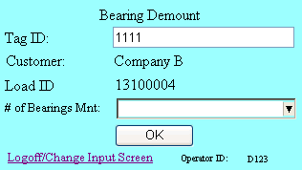
Figure 28

Step 2: Define Number Of Bearings Mounted

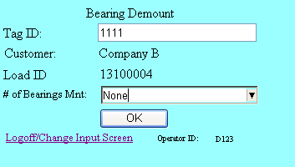
Figure 29
The operator has 3 choices;

- Mounted
- One
- None

Mounted indicates that both bearings are mounted. “One” indicates that one bearing has been removed, and “None” means both bearings have been removed.

The ATS will checked the bearing status for the tag id for the downstream work stations, and will not process an axle that does not have a bearing status of “none”.

Step 3: Press “OK”

When the “OK” the bearing status for the tag id is updated and the input fields are cleared as shown in
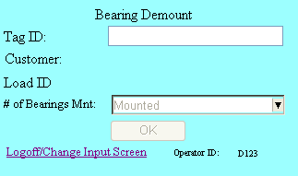
Figure 30 Completed BD Entry

Bearing Scrap Operation
If either or both of the bearings were tagged as scrap, and when the when the number of bearings is equal to none (dismounted) statistics are record for the load id.
Figure 31 Scrap Statistics Table
In the example given in Figure 31, both of the bearings at receiving were classed as “scrap”.

Wheel Demount (WD)

Accessing Wheel Demount Input Screen
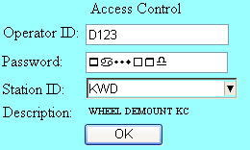
Figure 32 Accessing Wheel Demount
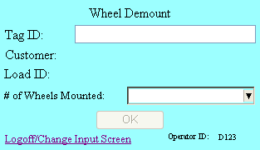
Figure 33 Blank WD Input Screen

Wheel Demount Data Entry

Step 1: Enter Valid Tag ID

Table 3
Invalid Tag IDs | Valid Tag ID
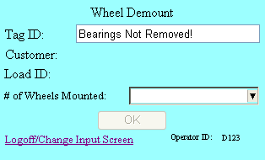 | 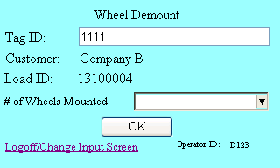
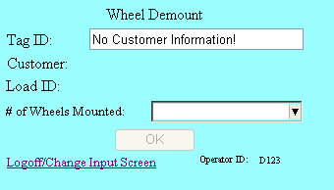

When a tag ID is entered, the ATS will determine if the tag id exists in the system database and has been assigned, then verify that the bearing status for the axle is equal to “none”.

Step 2: Define Number Of Wheels Mounted

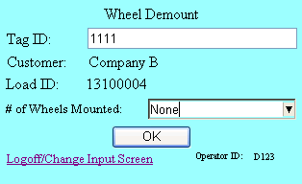
Figure 34

Step 4: Press “OK”
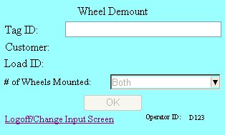
Figure 35
Pressing the “OK” command button will update the wheel status for the axle record defined by the tag id.

Wheel Scrap Operation
If the wheels at receiving were tagged as scrap, and when the when the number of wheels is equal to none (dismounted) statistics are recorded for the load id in a table called ScrapStatistics.
Figure 36

Axle Operation
There are number of axle operations that are accepted by the ATS provided their process is identified as a process work station with an ID of “LOOSE AXLES”.
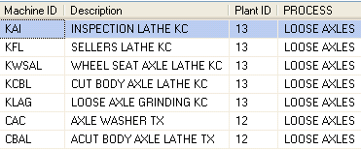
Figure 37 Sample Records From RFDB.Machines Table
Item | Access Control | Input Screen
1 | 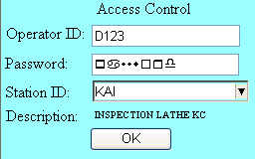 | 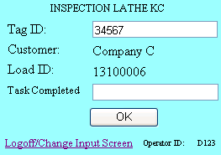
2 | 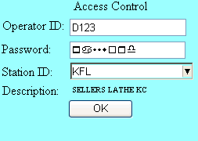 | 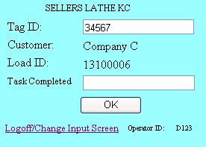
3 | 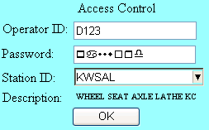 | 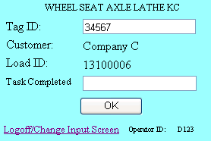
4 | 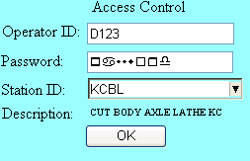 | 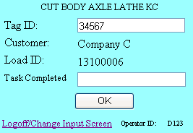
5 | 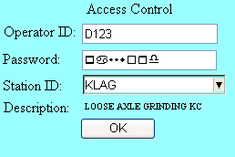 | 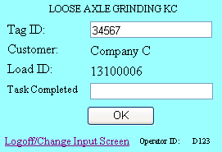
6 | 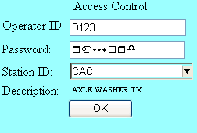 | 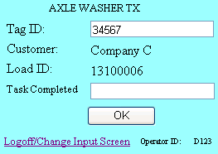
7 | 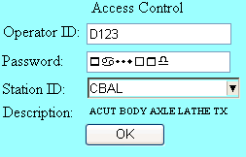 | 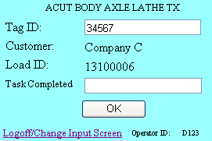

Step 1: Enter Valid Tag ID
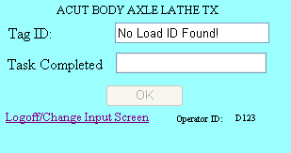
Figure 38 Invalid Tag ID Entered
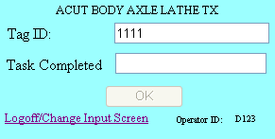
Figure 39 Valid Tag ID Entered
When a recognized tag id is entered, the input screen focus shifts to the task completed textbox.

When an invalid tag id is entered, the input screen reports an error as shown in Figure 38.

Step 3: Enter Task Completed
Scan or type information about the task completed and then press enter.
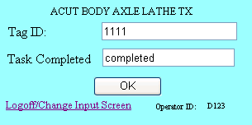
Figure 40

Step 4: Press “OK” to Post Completed Task
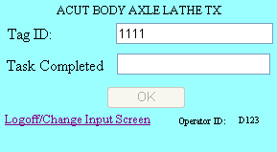
Figure 41
Tasks completed and posted are stored in the ATS database in the “AP Operation”’s table.

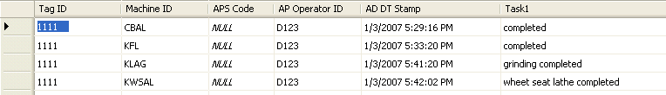
Figure 42 AP Operation Table
Items posted are timestamp along with the operator ID and machine ID used to complete the task.

Magna Flux
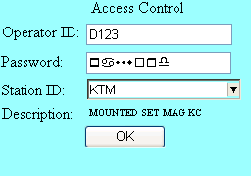
Figure 43

Step 1: Enter Valid Tag ID
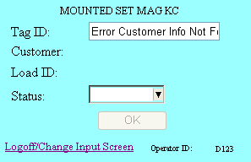
Figure 44 Invalid Tag ID

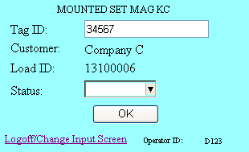
Figure 45

Step 2: Select Status
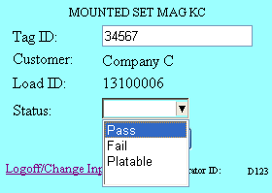
Figure 46

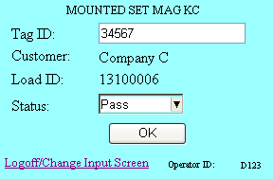
Figure 47

Step 3: Press “OK”
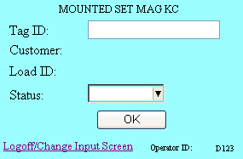
Figure 48

Wheel Mount (New Mount track only)
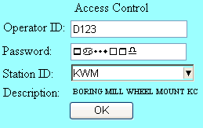
Figure 49 Accessing Wheel Mount

Wheel mount operation is only allowed when the bearing and wheel status are none for the entered tag ID and the inbound wheel state was defined as “Scrap”
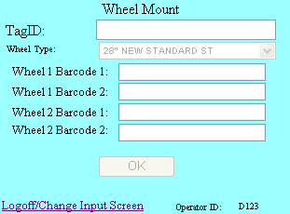
Figure 50
The business rule that define what tag ids are allowed are defined in the system table, RFDB.Business Rules (see Figure 51

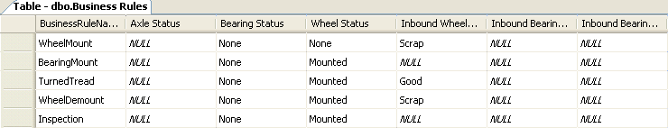
Figure 51 Business Rules
Business rules can be assigned to an input screen through the RFDB.Machines table (see Figure 52 ). A more detailed explanation of how ATS business rules work is provided in the “Business Rules” chapter.

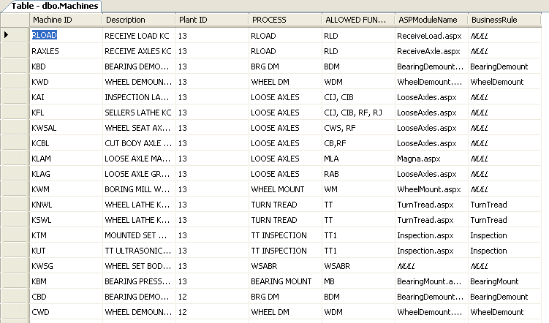
Figure 52 Sample Machine Table Showing How Business Rules Are Assigned

Step 1: Enter Valid Tag ID
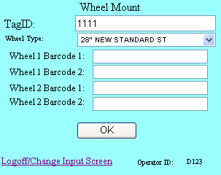
Figure 53

Step 2: Scan/Select Wheel Type
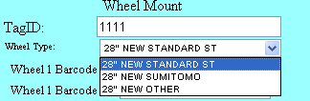
Figure 54

Step 3: Enter Serial Number(s)
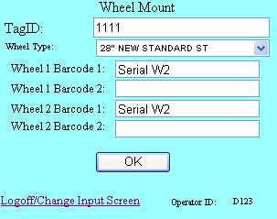
Figure 55

Step 4: Press “OK”
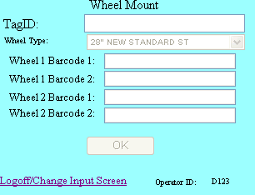
Figure 56

Bearing Mount
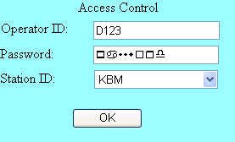
Figure 57 Accessing Bearing Mount
Bearing mount operation is only allowed when the bearing status is “None”, the wheel mount status is “Mounted” for the entered tag ID and plant ID (implicit from the operator ID log in).

The business rule that define what tag ids are allowed are defined in the system table, RFDB.Business Rules (see Figure 51 )

Step 1: Enter Valid Tag ID
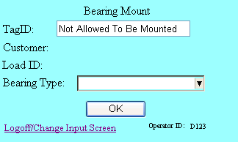
Figure 58 Invalid Tag ID

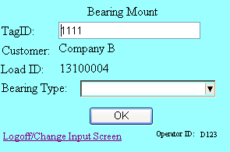
Figure 59 Valid Tag ID

Step 2: Scan/Select Bearing Type
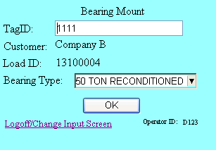
Figure 60

Step 3: Press “OK”
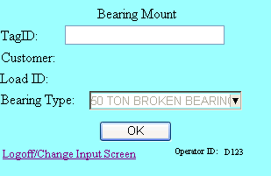
Figure 61

Turned Tread
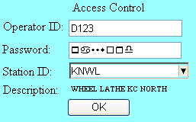
Figure 62

Step 1: Enter Valid Tag ID

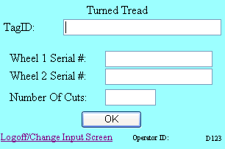
Figure 63
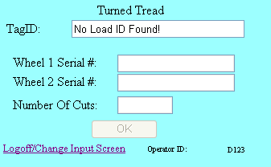
Figure 64

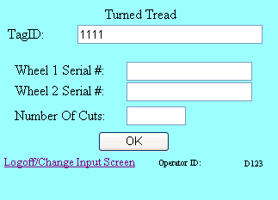
Figure 65 Valid Tag ID

Step 2: Enter Wheel Serial Numbers
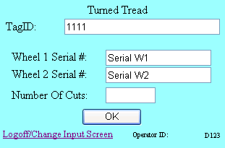
Figure 66

Step 3: Enter Wheel Cuts

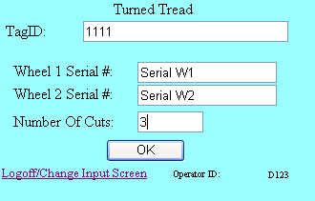
Figure 67

Step 4: Press OK
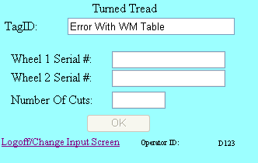

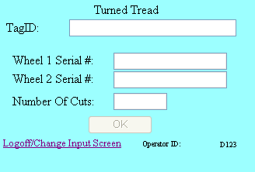
Figure 68

Axle Scrap (To be determined)

Outbound

Step 1: Create Outbound ID
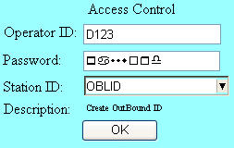
Figure 69

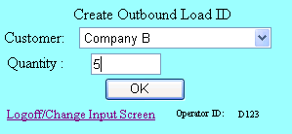
Figure 70

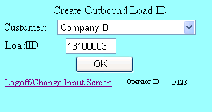
Figure 71

Step 2: Link Tag IDs to Outbound Load ID

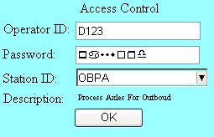
Figure 72

Step 2: Select Customer, Out Bound Load ID

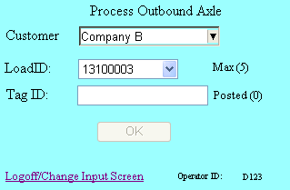
Figure 73

Step 4: Enter Valid Tag ID

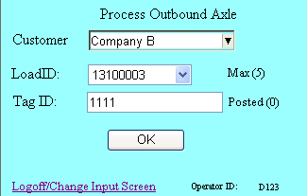
Figure 74
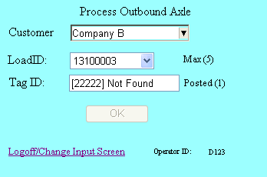
Figure 75 Invalid Tag ID

Step 3: Press “OK”
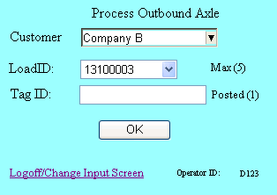
Figure 76

Post Shipping
When a tag id is attached to an outbound id, it is free to be used again and all data that had been associated with it prior to shipping is purged from the production tables.

Productions tables are as defined in Table 4.

Table 4 ATS Production Tables
Item # | Table Name | Description
1 | Axle | Main table for tracking tag ids from station to station.
2 | Axle Production | Records operations associated with axle production activities.
3 | WM Operation | Records wheel serial numbers

Business Rules
A business rule in ATS defines a set of prerequisite conditions that must be met before a user input module is allowed to process (receive) a scanned or entered tag id.
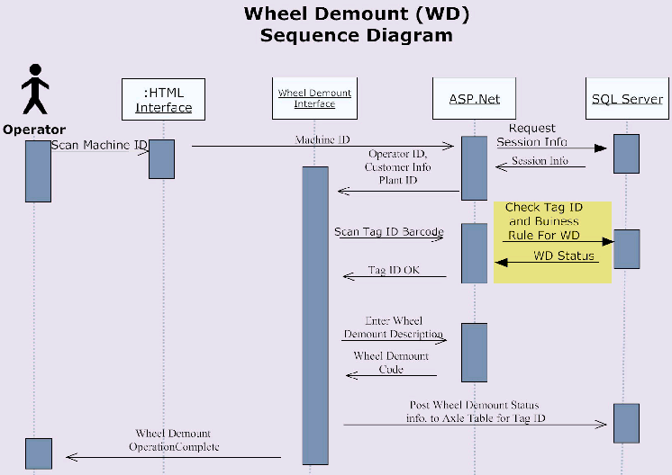
Figure 77 Sequence Diagram for Bearing Demount

In the sequence timing shown in Figure 77 for the “Wheel Demount” station, when the tag id is scanned the ATS reads the axle production table and determines if the business rule for the wheel demount operations has been met.

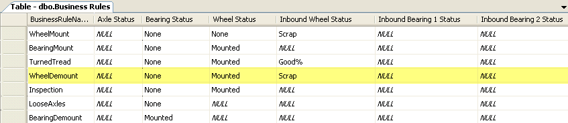
Figure 78 ATS Business Rules

For the wheel demount operation to be entered, the tag id for the axle must have set

- Bearing Status = None
- Wheel Status = Mounted
- Inbound Wheel Status = Scrap

The status values, “None”, and “Mounted” are values defined in the system demount status tables, e.g. “BearingDemountStatusCodes”, “Scrap” is a system reserved word.

Note, when an axle is received, the wheel and bearing status values are automatically posted as “Mounted” in the RFDB.Axle table. Also, at receiving if the wheels or any of the bearings are declared as “scrap” their state is recorded in their associated inbound state fields.

Inbound status vales can not be changed.

The axle, bearing and wheel status fields in the Axle table change as the axle is being tracked through the system.

Data Dictionary

Axle
Table 5 Axle Table Definition
Table Name | Field Name | Format | Index | Validation W/Syspro | Comments
Axle
 | Tag ID | INT(6) |  | na | serial number assigned to axle body with barcode
 | Created By | VARCHAR (25) |  | na | user ID field
 | Created On | DATETIME |  | na | yyyymmddhhmmss
 | Plant ID | INT(2) |  | na
 | Inbound Customer | VARCHAR (50) |  |  | Inbound from Customer
 | Inbound Customer Location | VARCHAR (50) |  |  | Inbound from Customer location
 | Inbound Axle Type | VARCHAR (6) |  |  | inbound axle type
 | Inbound Wheel Type | VARCHAR (2) |  |  | inbound wheel size
 | Inbound Bearing Type | VARCHAR (10) |  |  | inbound bearing type
 | Axle Scrap Code | VARCHAR (4) |  |  | inbound axle scrap code
 | Wheel Scrap Code | VARCHAR (4) |  |  | inbound wheel scrap code
 | Bearing Scrap Code 1 | VARCHAR (4) |  |  | inbound bearing scrap code 1
 | Bearing Scrap Code 2 | VARCHAR (4) |  |  | inbound bearing scrap code 2
 | Outbound Customer | VARCHAR (50) |  |  | Outbound to Customer
 | Outbound Sales Order | VARCHAR (20)
 | Shipped By | VARCHAR (50) |  | na | user ID field
 | Shipped On | DATETIME |  | na | yyyymmddhhmmss
 | Axle Size | ?????? |  |  | Needed to calculate FG stock code to backflush
 | Outbound Wheel Type | VARCHAR (2) |  |  | Needed to calculate FG stock code to backflush
 | Outbound Bearing Type | VARCHAR (10) |  |  | Needed to calculate FG stock code to backflush
 | Status Code | VARCHAR (25) |  |  | Is this axle currently in the shop? Needed since tracking numbers will be reused.

Axle Operation
Table 6 Axle Operation Table Definition
Table Name | Field Name | Format | Length | Validation W/Syspro | Comments
AP Operation
 | Tag ID | Numeric | 6 | na | serial number assigned to axle body with barcode
 | Machine ID | alpha/numeric | 10 |  | Machine Number ID
 | APS Code | alpha/numeric | 4 |  | Axle Production Scrap Code
 | AP User ID | alpha/numeric | 10 |  | Axle Production user ID
 | AP DT Stamp | alpha/numeric | 10 |  | Axle Production Date and Time Stamp
 | Task1 | alpha/numeric | 4 |  | indicates work performed during process
 | Task2 | alpha/numeric | 4 |  | indicates work performed during process
 | Task3 | alpha/numeric | 4 |  | indicates work performed during process
 | Task4 | alpha/numeric | 4 |  | indicates work performed during process
 | Task5 | alpha/numeric | 4 |  | indicates work performed during process
 | Task6 | alpha/numeric | 4 |  | indicates work performed during process
 | Task7 | alpha/numeric | 4 |  | indicates work performed during process
 | Task8 | alpha/numeric | 4 |  | indicates work performed during process
 | Task9 | alpha/numeric | 4 |  | indicates work performed during process
 | Task10 | alpha/numeric | 4 |  | indicates work performed during process
 | Task11 | alpha/numeric | 4 |  | indicates work performed during process
 | Task12 | alpha/numeric | 4 |  | indicates work performed during process
 | Task13 | alpha/numeric | 4 |  | indicates work performed during process
 | Task14 | alpha/numeric | 4 |  | indicates work performed during process
 | Task15 | alpha/numeric | 4 |  | indicates work performed during process
 | Task16 | alpha/numeric | 4 |  | indicates work performed during process
 | Task17 | alpha/numeric | 4 |  | indicates work performed during process
 | Task18 | alpha/numeric | 4 |  | indicates work performed during process
 | Task19 | alpha/numeric | 4 |  | indicates work performed during process
 | Task20 | alpha/numeric | 4 |  | indicates work performed during process

Axle QA
Table 7 Axle QA Definition
Table Name | Field Name | Format | Length | Validation W/Syspro | Comments
Axle QA
 | Tag ID | Numeric | 6 | na | serial number assigned to axle body with barcode
 | Created By | alpha/numeric | 10 | na | user ID field
 | Created On | date/time stamp | 14 | na | yyyymmddhhmmss
 | Closed By | alpha/numeric | 10 | na | user ID field
 | Closed On | date/time stamp | 14 | na | yyyymmddhhmmss
 | Axle Scrap Code | alpha/numeric | 4 |  | Inbound axle scrap code
 | Axle Produciton Scrap Code | alpha/numeric | 4 |  | Axle Production scrap code
 | Wheel Scrap Code | alpha/numeric | 4 |  | Inbound wheel scrap code
 | Bearing Scrap Code 1 | alpha/numeric | 4 |  | Inbound bearing scrap code
 | Bearing Scrap Code 2 | alpha/numeric | 4 |  | Inbound bearing scrap code
 | BD issue | alpha/numeric | 4 |  | issue code
 | BD resolution | alpha/numeric | 4 |  | resolution code
 | MG NM Required | Integer | 1 |  | 0 = NA, 1 = Required, 2 = Completed
 | MG TT Required | Integer | 1 |  | 1 = NA, 1 = Required, 2 = Completed
 | Wheel UT Required | Integer | 1 |  | 2 = NA, 1 = Required, 2 = Completed
 | Axle UT Required | Integer | 1 |  | 3 = NA, 1 = Required, 2 = Completed
 | MG NM Scrap Code | alpha/numeric | 4 |  | required work for future operation
 | MG TT Scrap Code | alpha/numeric | 4 |  | required work for future operation
 | Wheel UT Scrap Code | alpha/numeric | 4 |  | required work for future operation
 | Axle UT Scrap Code | alpha/numeric | 4 |  | required work for future operation

Axle Scrap
Table 8
Table Name | Field Name | Format | Length | Validation W/Syspro | Comments
Axle Scrap
 | Scrap # | Numeric | 6 |  | Numeric Scrap Code
 | Description | alpha/numeric | 20 |  | Scrap Code Description
 | AxleID |  |  |  | Which axle did this come from?
 | DateTimeStamp

Axle Type
Table 9 Axle Type
Table Name | Field Name | Format | Length | Validation W/Syspro | Comments
Axle Type
 | Axle Type ID | Numeric | 6 |  | Axle Type #
 | Description | alpha/numeric | 20 |  | Axle Type Description
 | Size | alpha/numeric | 10 |  | 70T, 100T, 100TK, 125T etc.
 | Type | alpha/numeric | 10 |  | Used, New, Cut Body
 | MFGR | alpha/numeric | 10 |  | for new

Axle UT
Table 10
Table Name | Field Name | Format | Length | Validation W/Syspro | Comments
Axle UT
 | Tracking# | Numeric | 6 |  | serial number assigned to axle body with barcode
 | Axle UT Operation | Numeric | 1 |  | Axle UT Operation (default = 0 indicating not complete / '1' defines action complete)
 | Axle UT Scrap | Numeric | 1 |  | Axle UT Scrap code
 | Axle UT DT Stamp | date/time stamp | 14 |  | Axle UT Date/Time Stamp
 | Axle UT User | alpha/numeric | 10 |  | user ID field

Bearing Demount Operation
Table 11 Bearing Demount Operation Table Definition
Table Name | Field Name | Format | Length | Validation W/Syspro | Comments
BD Operation
 | Tag ID | Numeric | 6 |  | serial number assigned to axle body with barcode
 | BD Operation | Numeric | 1 |  | Bearing Demount Operation (default = 0 indicating not complete / '1' defines action complete)
 | BD Result | Numeric | 1 |  | Bearing Demount Result code / There are 2 possible result codes / '2' indicates that two bearing were successfully removed / '1' indicates < two bearings were removed
 | BD DT Stamp | date/time stamp | 14 |  | Bearing Demount Date/Time Stamp
 | BD User | alpha/numeric | 10 |  | user ID field
 | GoodBearingsRemoved | Numeric | 2 |  | Number of good bearings removed
 | BadBearingsRemoved | Numeric | 2 |  | Number of bad bearings removed

Bearing Mount Operation
Table 12 Bearing Mount Table Definition
Table Name | Field Name |  | Format | Length | Validation W/Syspro | Comments
Bearing Mount Operation
 |  | Tag ID | Numeric | 6 | na | serial number assigned to axle body with barcode
 |  | Machine ID | alpha/numeric | 10 |  | Machine Number ID
 |  | BM User ID | alpha/numeric | 10 |  | Wheel Mount user ID
 |  | BM DT stamp | alpha/numeric | 10 |  | Wheel Mount Date and Time Stamp
 |  | Bearing Type | alpha/numeric | 10 |  | Wheel Serial # ??????
 |  | Customer ID | alpha/numeric | 20 |  | intended customer

Bearing Scrap
Table 13
Table Name | Field Name | Format | Length | Validation W/Syspro | Comments
Bearing Scrap
 | Scrap # | Numeric | 6 |  | Numeric Scrap Code
 | Description | alpha/numeric | 20 |  | Scrap Code Description
 | AxleID |  |  |  | Which axle did this come from?
 | DateTimeStamp

Bearing Type
Table 14 Bearing Type
Table Name | Field Name | Format | Length | Validation W/Syspro | Comments
Bearing Type
 | Bearing Type ID | Numeric | 6 |  | Bearing Type #
 | Description | alpha/numeric | 20 |  | Bearing Type Description
 | Mfgr | alpha/numeric | 20 |  | RBS, QBS, Prec, Brenco, Timkin
 | Size | alpha/numeric | 20 |  | 70T, 100T, 100TK, 125T etc.
 | Type | alpha/numeric | 20 |  | AAR, Prem, UP, TTX, etc.

Customers
Table 15 Customers
Table Name | Field Name | Format | Length | Validation W/Syspro | Comments
Customer
 | CustomerName | alpha/numeric | 50 |  | Customer Name
 | CustomerLocation | alpha/numeric | 50 |  | Customer Location

Customer Bearing Reference
Table 16 Customer Bearing Reference
Table Name | Field Name | Format | Length | Validation W/Syspro | Comments
Customer Bearing Reference
 | Customer Name | alpha/numeric | 20 |  | User Name
 | Axle Type | alpha/numeric | 2 |  | Axle Type
 | Bearing Type | alpha/numeric | 10 |  | Bearing type

Machines
Table 17 Machines
Table Name | Field Name | Format | Length | Validation W/Syspro | Comments
Machine
 | Machine # | alpha/numeric | 6 |  | Machine #
 | Machine Description | alpha/numeric | 20 |  | Description
 | Work Center # | Numeric | 6 |  | Work Center #

Magna Flux NM Operation
Table 18 Magna Flux NM Operation Table
Table Name | Field Name | Format | Length | Validation W/Syspro | Comments
Magna Flux NM Operation
 | Tag ID | Numeric | 6 |  | serial number assigned to axle body with barcode
 | MG NM Scrap | Numeric | 4 |  | MG Scrap code
 | MG NM DT Stamp | date/time stamp | 14 |  | Magna Flux NM Date/Time Stamp
 | MG NM Operator | alpha/numeric | 10 |  | user ID field

Magna Flux TT Operation
Table 19 Magna Flux TT Operation Table
Table Name | Field Name | Format | Length | Validation W/Syspro | Comments
Magna Flux TT Operation
 | Tag ID | Numeric | 6 |  | serial number assigned to axle body with barcode
 | MG TT Operation | Numeric | 1 |  | Magna Flux TT Operation (default = 0 indicating not complete / '1' defines action complete)
 | MG TT Scrap | Numeric | 1 |  | MG Scrap code
 | MG TT DT Stamp | date/time stamp | 14 |  | Magna Flux TT Date/Time Stamp
 | MG TT User | alpha/numeric | 10 |  | user ID field

Operators
Table 20 Operators Table Definition
Table Name | Field Name | Format | Length | Validation W/Syspro | Comments
Operators | Operator ID | alpha/numeric | 10
 | User Name | alpha/numeric | 35 |  | User Name
 | Plant ID | integer | 6 |  | Plant #

Plant
Table 21 Plant Table Definition
Table Name | Field Name | Format | Length | Validation W/Syspro | Comments
Plant
 | Plant # | Numeric | 6 |  | Plant #
 | Description | alpha/numeric | 20 |  | Plant Description

Wheel Demount Operation
Table 22 Wheel Demount Definition Table
Table Name | Field Name | Format | Length | Validation W/Syspro | Comments
WD Operation
 | Tag ID | Numeric | 6 | na | serial number assigned to axle body with barcode
 | WD Operation | Numeric | 1 |  | Bearing Demount Operation (default = 0 indicating not complete / '1' defines action complete)
 | WD Results | Numeric | 1
 | WD DT Stamp | date/time stamp | 14 |  | Wheel Demount date and time stamp
 | WD User | alpha/numeric | 10 |  | Wheel demount user ID
 | Good Wheels Removed | Numeric | 2 |  | Number of good wheels removed
 | Bad Wheels Removed | Numeric | 2 |  | Number of bad wheels removed

Wheel Lathe
Table 23 Wheel Lathe Table Definition
Table Name | Field Name | Format | Length | Validation W/Syspro | Comments
Wheel Lathe
 | Tag ID | Numeric | 6 | na | serial number assigned to axle body with barcode
 | Machine ID | alpha/numeric | 10 |  | Machine Number ID
 | WLS Code | alpha/numeric | 4 |  | Wheel Lathe Scrap Code
 | WL User ID | alpha/numeric | 10 |  | Wheel Lathe user ID
 | WL DT Stamp | alpha/numeric | 10 |  | Wheel Lathe Date and Time Stamp
 | Wheel Data 1 | alpha/numeric | 10 |  | Misc
 | Wheel Data 2 | alpha/numeric | 10 |  | Misc
 | Wheel Data 3 | alpha/numeric | 10 |  | Misc
 | Wheel Data 4 | alpha/numeric | 10 |  | Misc
 | Wheel Data 5 | alpha/numeric | 10 |  | Misc
 | Wheel Data 6 | alpha/numeric | 10 |  | Misc
 | Wheel Data 7 | alpha/numeric | 10 |  | Misc
 | Wheel Data 8 | alpha/numeric | 10 |  | Misc
 | Wheel Data 9 | alpha/numeric | 10 |  | Misc
 | Wheel Data 10 | alpha/numeric | 10 |  | Misc

Wheel Mount Operation
Table 24 Wheel Mount Table Definition
Table Name | Field Name | Format | Length | Validation W/Syspro | Comments
WM Operation
 | Tag ID | Numeric | 6 | na | serial number assigned to axle body with barcode
 | Machine ID | alpha/numeric | 10 |  | Machine Number ID
 | WM Operator ID | alpha/numeric | 10 |  | Wheel Mount user ID
 | WM DT stamp | alpha/numeric | 10 |  | Wheel Mount Date and Time Stamp
 | Wheel 1 Serial 1 a | alpha/numeric | 10 |  | Wheel Serial #
 | Wheel 1 Serial 1 b | alpha/numeric | 10 |  | Wheel Serial #
 | Wheel 2 Serial 2 a | alpha/numeric | 10 |  | Wheel Serial #
 | Wheel 2 Serial 2 b | alpha/numeric | 10 |  | Wheel Serial #
 | Wheel Type ID | alpha/numeric | 6
 | Misfits | alpha/numeric | 2
 | Remounts | alpha/numeric | 2

Wheel Scrap
Table 25
Table Name | Field Name | Format | Length | Validation W/Syspro | Comments
Wheel Scrap
 | Scrap ID | Numeric | 6 |  | Numeric Scrap Code
 | Description | alpha/numeric | 20 |  | Scrap Code Description
 | Tag ID | Numeric | 6 |  | Which axle did this come from?
 | DT Stamp

Wheel Type
Table 26
Table Name | Field Name | Format | Length | Validation W/Syspro | Comments
Wheel Type
 | Wheel Type | Numeric | 6 |  | Wheel Type #
 | Description | alpha/numeric | 20 |  | Wheel Type Description
 | Size | alpha/numeric | 2 |  | 28, 33, 36, 38
 | Type | alpha/numeric | 10 |  | Used, New
 | MFGR | alpha/numeric | 10 |  | SS, Grif. Sum

Wheel UT
Table 27
Table Name | Field Name | Format | Length | Validation W/Syspro | Comments
Wheel UT
 | Tag ID | Numeric | 6 |  | serial number assigned to axle body with barcode
 | Wheel UT Operation | Numeric | 1 |  | Wheel UT Operation (default = 0 indicating not complete / '1' defines action complete)
 | Wheel UT Scrap | Numeric | 1 |  | Wheel UT Scrap code
 | Wheel UT DT Stamp | date/time stamp | 14 |  | Wheel UT Date/Time Stamp
 | Wheel UT user | alpha/numeric | 10 |  | user ID field

Work Center
Table 28 Work Center
Table Name | Field Name | Format | Length | Validation W/Syspro | Comments
Work Center
 | Work Center # | Numeric | 6 |  | Work Center #
 | Description | alpha/numeric | 20 |  | WC Description
 | Plant # | Numeric | 6 |  | Plant #

