Seminar 3: Solutions

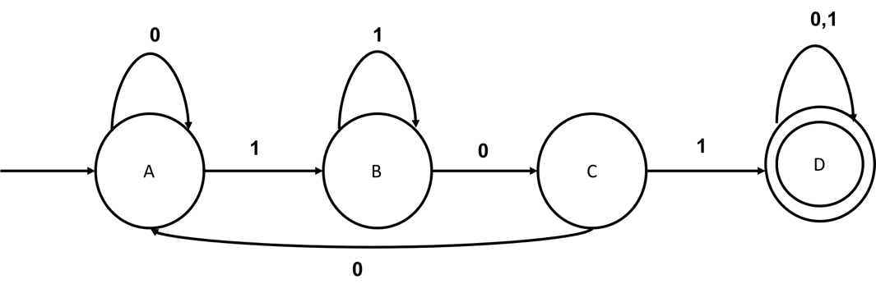

1. Name three strings accepted and three strings that are rejected by this automaton.

101, 1101,1111010 are accepted,

000, 110, 0100 are rejected

1. What is the language of this automaton?

All binary strings of containing 101

1. Design an automaton that accept the language of all binary strings not containing 001.

