Successful Optimisation Strategies
Stage 2: Required Capstone Component 25.2 | Section B
13-week black-box optimisation challenge | Eight functions | 104 prospective queries

Entering unfamiliar territory
I came to this capstone as a consultant neurologist, well outside my usual field. Black-box optimisation was new to me, although uncertainty, incomplete evidence and difficult decisions were not. Those are part of everyday clinical neurology. I had to find out whether the same habits would work in a numerical challenge: examine the evidence, question assumptions, change course when results disagree with expectations and keep going when the route is unclear. I was thrown into unfamiliar territory, yet I found my way and remained among the leaders. Just as importantly, I could explain how I got there.
Over 13 rounds, I submitted one prospective query for each of eight unknown functions, giving 104 portal evaluations. Every input had to be chosen before its output was known. My best results came when I stopped looking for one universal optimiser and treated each function on its own evidence. At different points this meant exploring, refining locally, moving towards a boundary, recovering an earlier winner, repeating a measurement or stopping altogether.
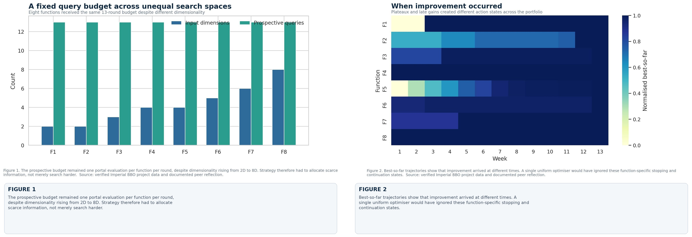
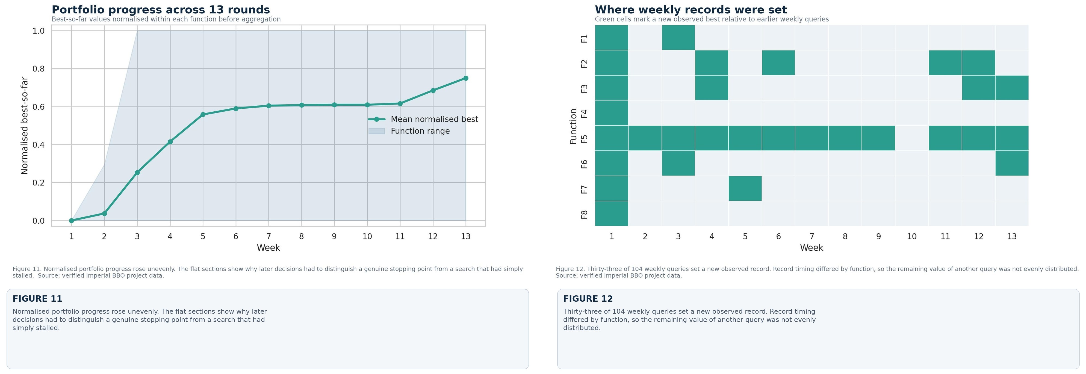
Additional visual analysis checks this account against the full dataset. It shows record timing, query movement, gains, reversals, replication, clustering, principal component findings and surrogate error. The response maps project observed data rather than reconstructing hidden equations, making available evidence and the limits of sparse sampling explicit.

Strategies that produced the strongest results
The most efficient move was often to identify what kind of problem I was facing before trying to optimise it. F1, F7 and F8 repeatedly returned the same best value at the same coordinate. Once that repeatability was clear, further movement offered little likely benefit. Keeping those winners protected the score and left more attention for unresolved functions. F4 needed a related recovery strategy. Broad exploration gave markedly poorer outputs, whereas returning to the Week 1 coordinate in Weeks 12 and 13 reproduced the best result exactly. Recovery was not a retreat. It was a sensible decision to stop spending queries in a weaker region.
F5 gave the clearest example of controlled exploitation. Its output rose as the search moved towards a boundary. The final input changed by an L1 distance of only 0.011001, while the output increased from 4427.343996 to 4440.957217. The direction had worked repeatedly, the movement was small and the feasible boundary was known. Even so, it would have been wrong to carry that rule across to every function. The boundary relationship belonged to F5 and did not generalise to the rest.
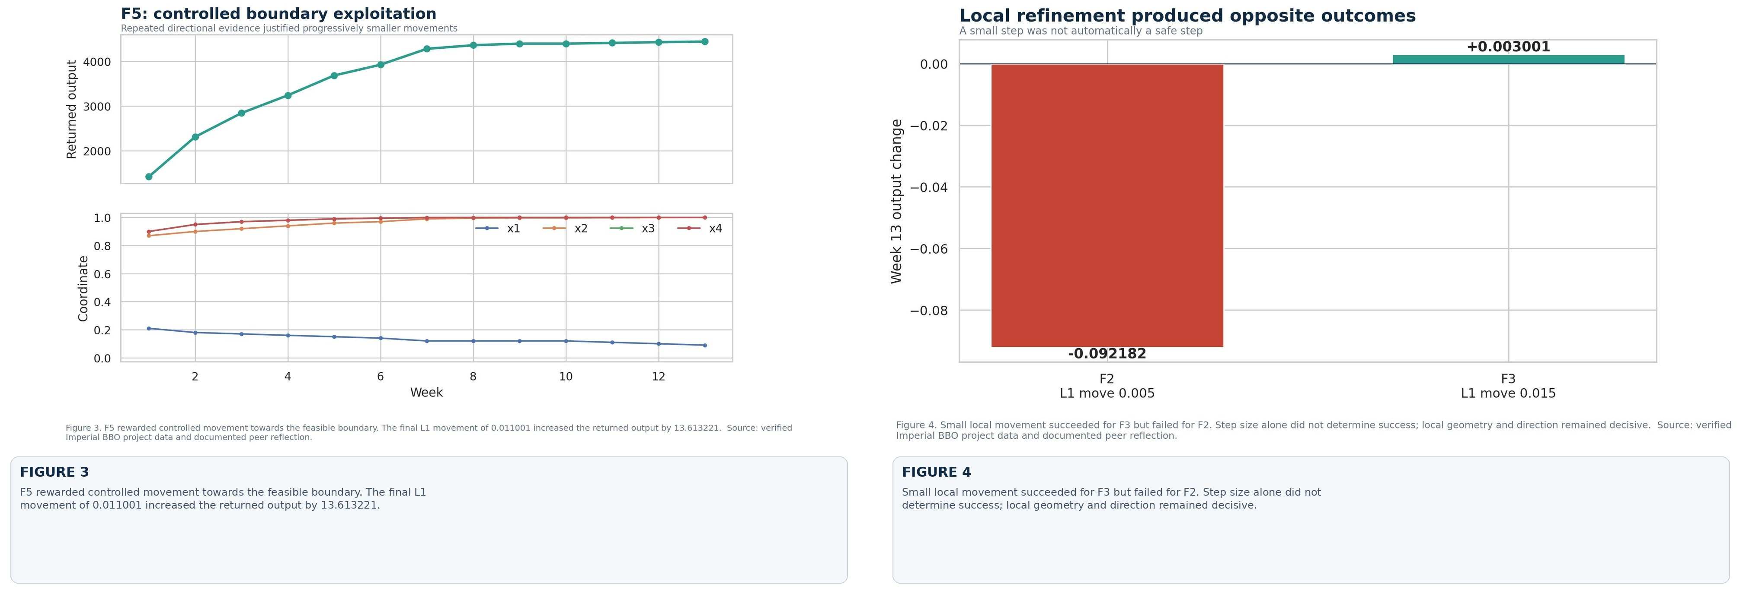
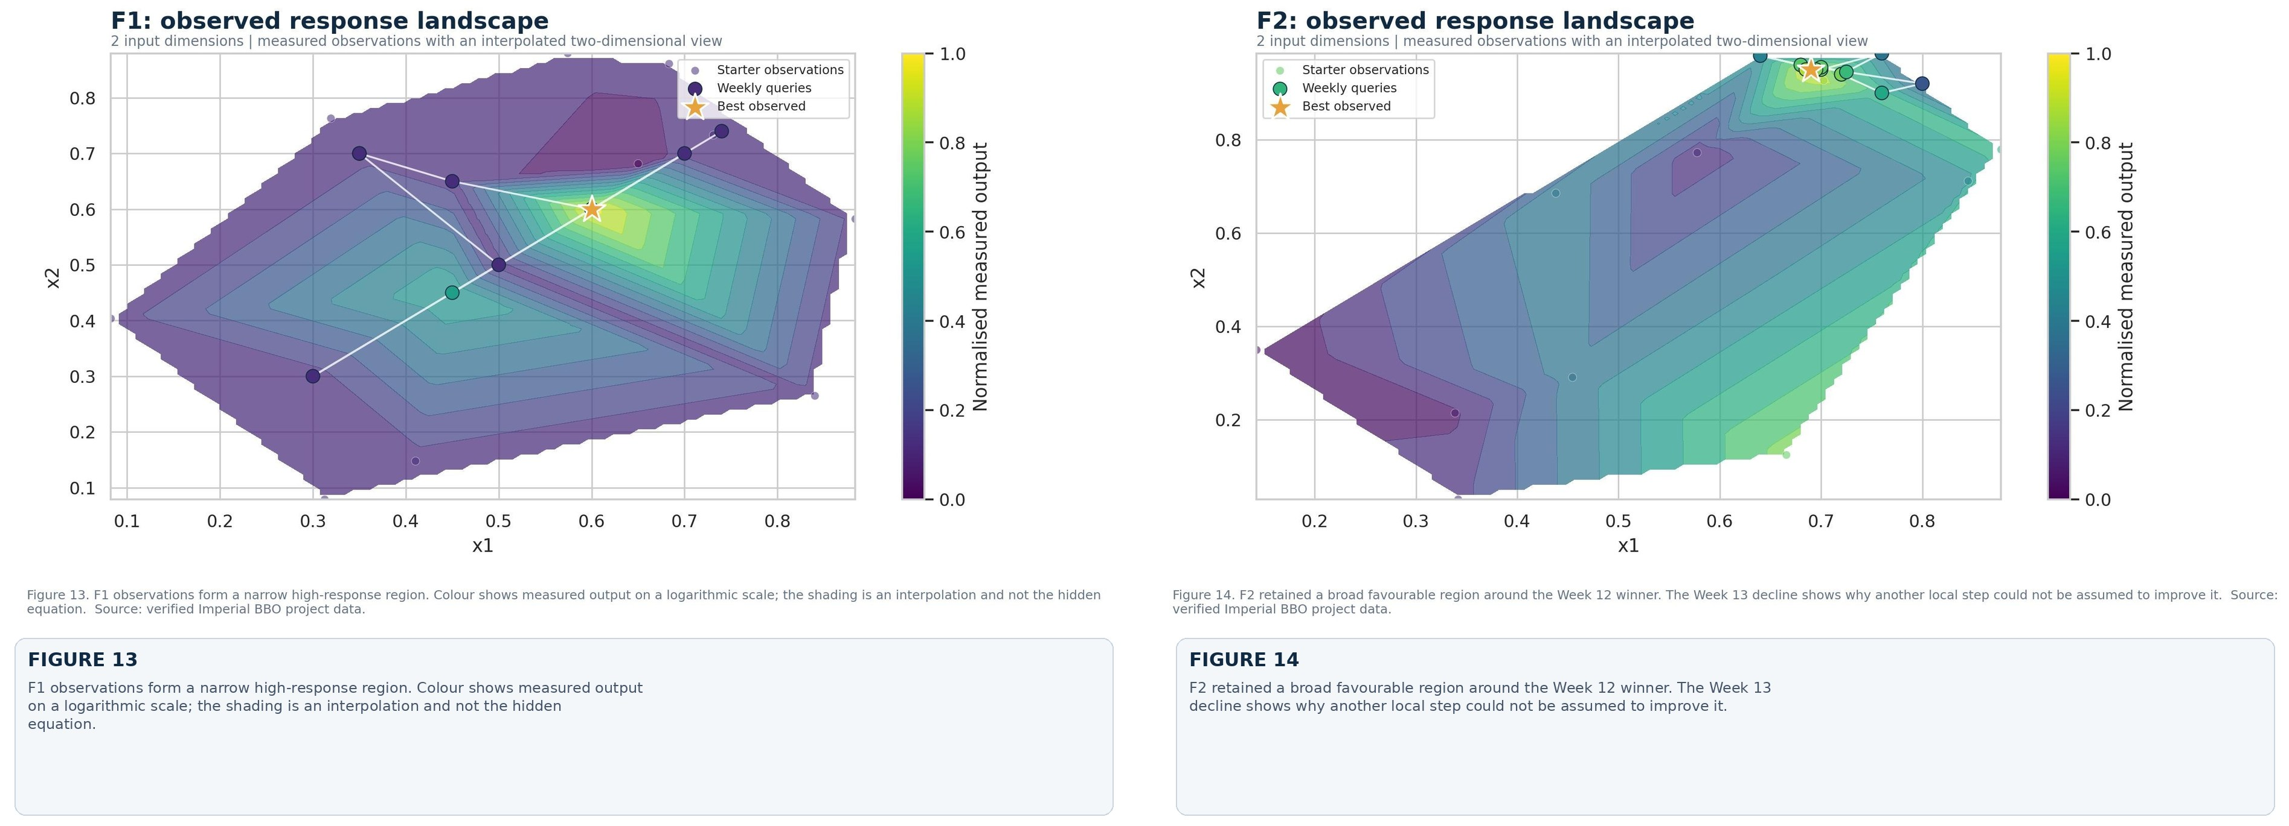
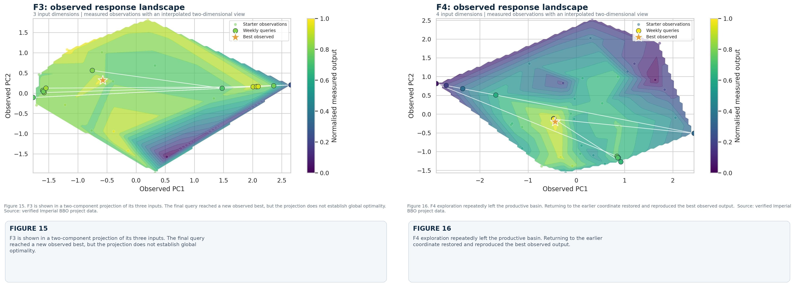
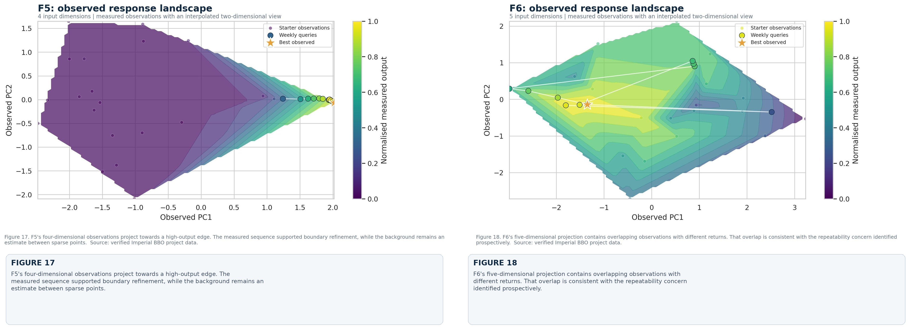
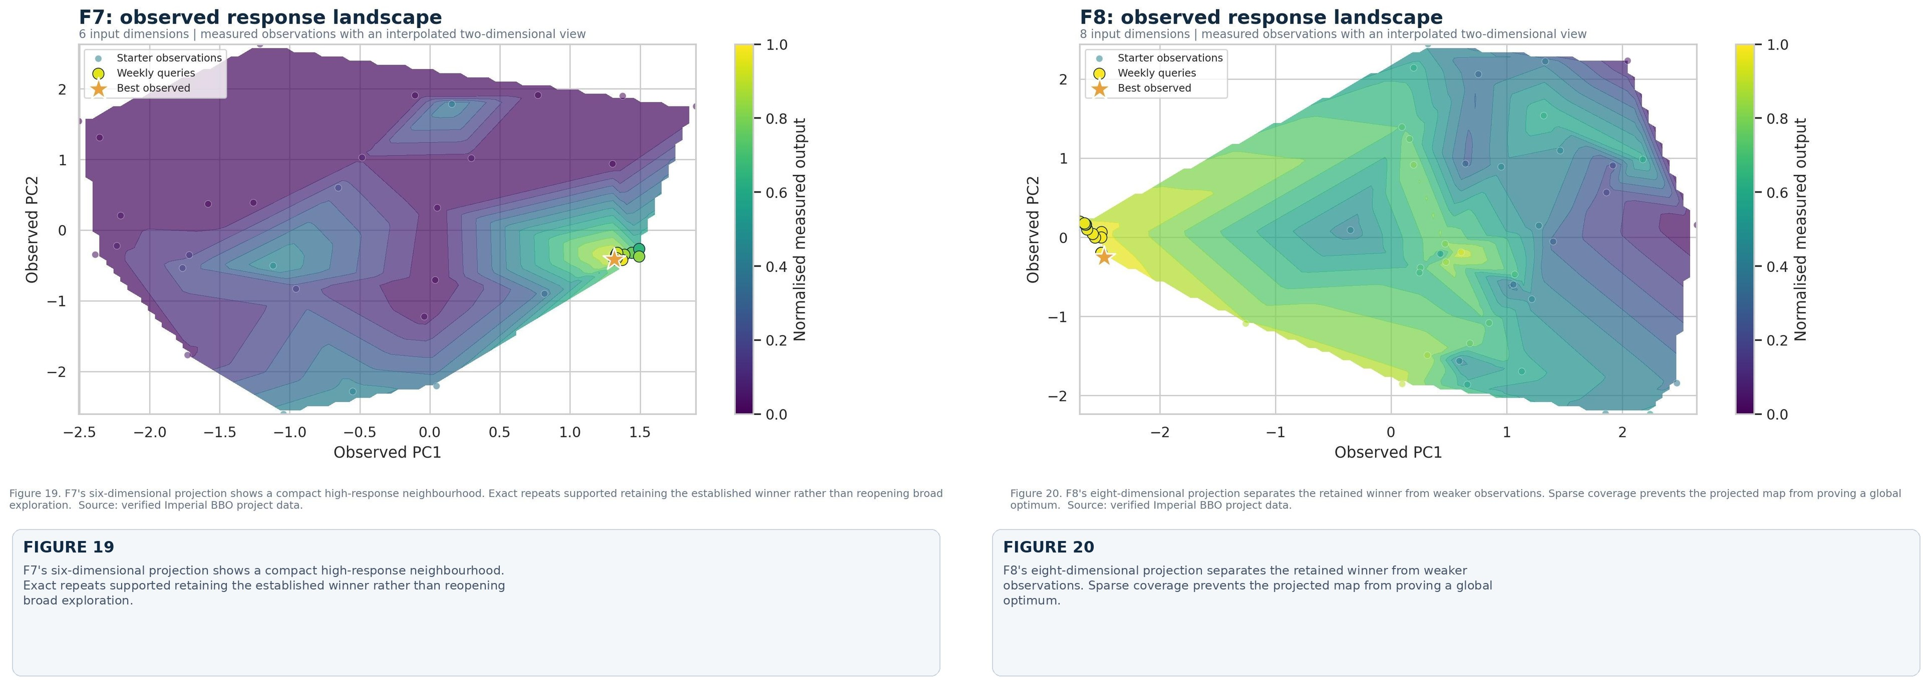
Local refinement worked for F3. A final movement of 0.015000 produced a new best of -0.056851. F2 showed where the same idea could fail. Week 12 reached 0.733525, but another movement of only 0.005000 reduced the Week 13 result to 0.641343. That contrast changed how I viewed a promising local trend. It may justify another test, but it does not prove that improvement will continue. With one more round, I would test both sides of the F2 Week 12 coordinate instead of continuing in the same direction.
Repeating measurements proved especially useful for F6. The Week 13 input was identical to Week 12, yet the result changed from -0.707832 to -0.607156 and became a new observed best. Earlier repeats at the same coordinate had also varied. I could not reasonably claim that the coordinate itself had improved. The important finding was that the response was not fully repeatable. This kept a favourable return from being mistaken for a stable optimum.
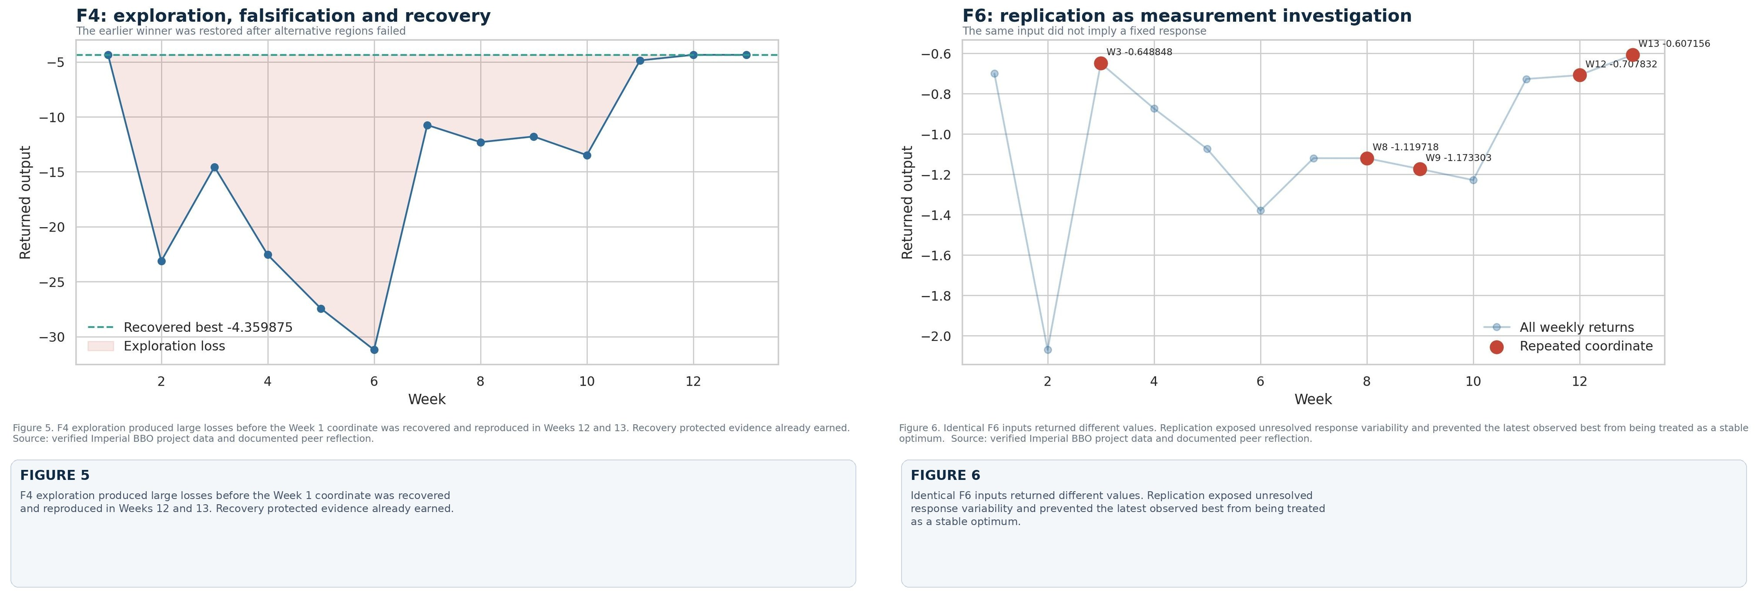
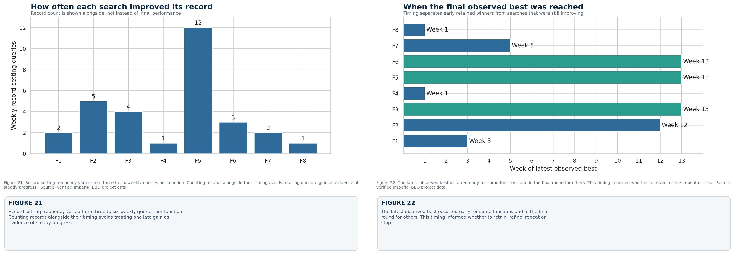
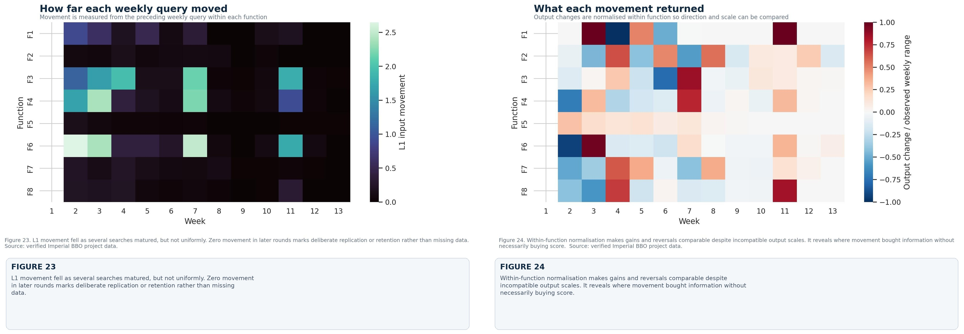
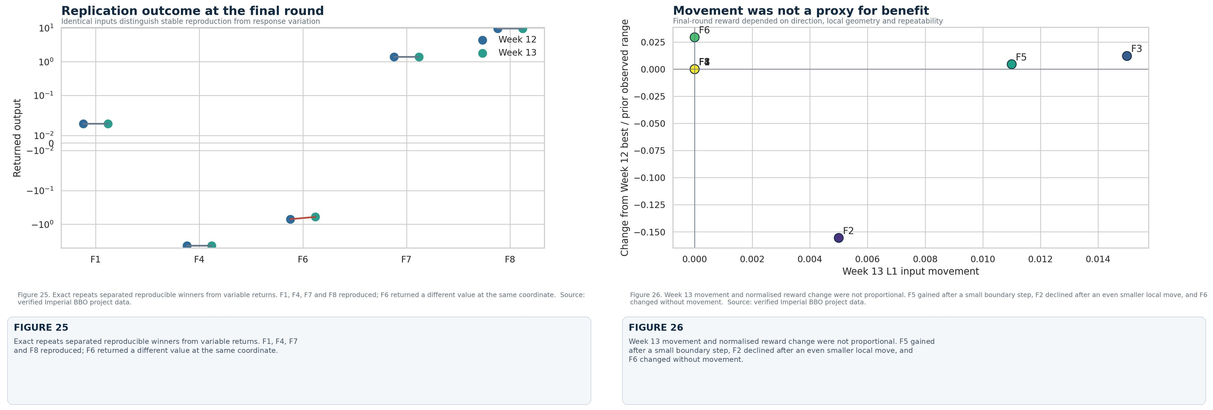
Clustering, principal component analysis, surrogate hyperparameter comparison and the Week 13 policy experiment helped me make these decisions, but none replaced judgement. Clustering organised recurring regions and remained descriptive because the samples were sparse. Principal component analysis summarised coordinated movement and redundancy rather than claiming causal influence. I compared surrogate settings in chronological order so that later observations could not leak into earlier decisions. The policy experiment then assigned retain, local refinement, boundary refinement or repeat actions using only Weeks 1 to 12. Week 13 remained unseen until the actions had been chosen, which allowed a genuinely prospective test.
The balance shifted as the challenge progressed. Early rounds needed broader exploration because the local geometry was unknown. Later, repeated gains supported tighter movements for F3 and F5, while repeated failures made further movement less attractive for F4. Week 10 clustering helped separate recurring regions from isolated points. Week 11 principal component analysis showed where several coordinates were moving together, so visible movement was not confused with new information. By Weeks 12 and 13, the problem was mainly one of allocating a limited budget. Four functions received exact repeats, three received small directed changes and F6 was repeated to investigate uncertainty. The last round retained four winners, found new observed bests for F3, F5 and F6, and rejected the continued F2 step. The method had changed with the evidence rather than remaining fixed for all 13 rounds.
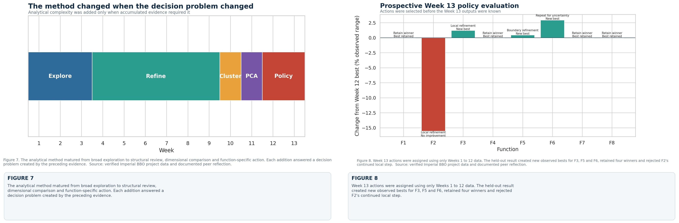
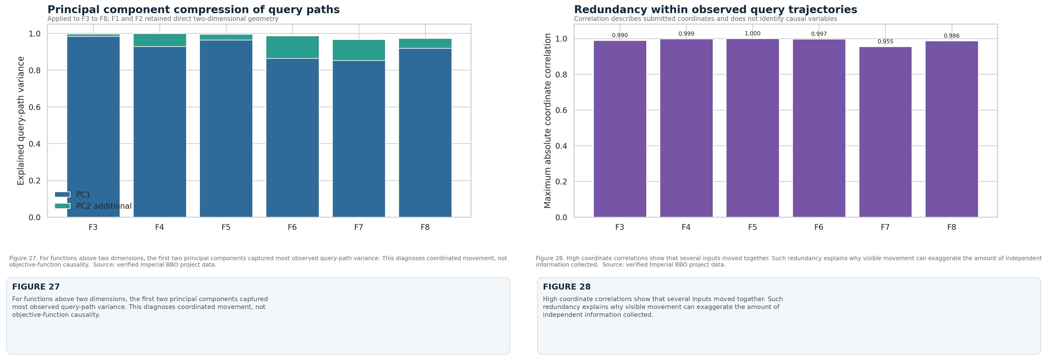
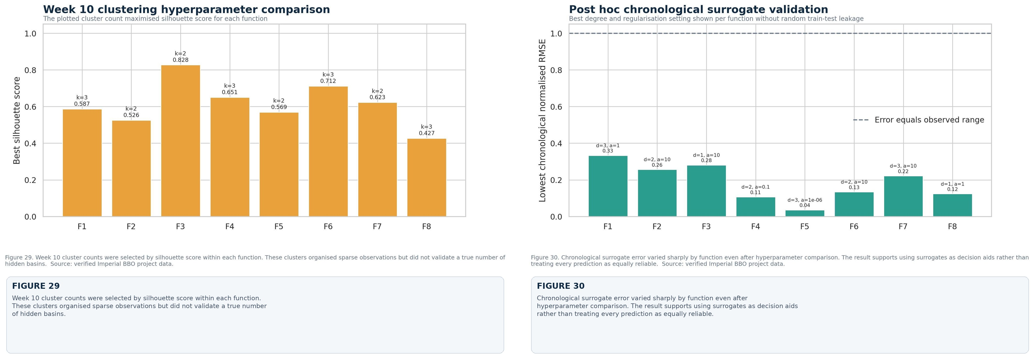

What made a strategy successful
The score mattered, but it could not define success on its own. A sound strategy should improve or preserve the objective, respond when new evidence challenges the working explanation, state what finding would make us stop or reverse, and use the limited query budget carefully. These qualities belong together. A high result is less convincing when it cannot be reproduced or explained.
An unsuccessful query could therefore still earn its place. F2's decline argued against further movement in one direction. F4's poor exploratory results supported recovery, and the changing F6 repeats exposed measurement uncertainty. None set a record, yet each removed a less credible option. The reverse was also true: one high return carried limited weight if it could not be reproduced. With only 13 evaluations per function, a well-placed query could succeed partly through chance. Confidence had to come from repeatability, neighbourhood testing and an honest account of uncertainty.
Stopping became an active decision rather than the absence of one. By the end, F1, F4, F7 and F8 had reproducible winners and no persuasive alternative direction. Continuing them in the same way as F2, F3, F5 and F6 would have confused activity with progress. The next query belonged where useful improvement or useful information was still plausible.
The final results still require caution. We observed only the submitted path through each search space. The true equations remained hidden, and no retained point could be proved globally optimal. Dimensionality rose from two variables in F1 and F2 to eight in F8, but the prospective budget stayed at 13 queries per function. Exhaustive coverage was impossible, and chance affected whether an exploratory point reached a productive region. I would therefore place more trust in a reproducible near-best result reached through a defensible sequence than in an isolated extreme value with no local confirmation. Good performance should come with a credible account of its uncertainty.

Relevance to professional decision-making
These principles are familiar in clinical neurology, although the capstone policy itself cannot be transferred without external validation. Referral thresholds, urgent-recall rules and investigation pathways are all adjusted from limited observations where the consequences are unequal. A pathway may improve average performance and still be unsafe if it misses high-risk patients. The clinical equivalent of a high black-box score is not enough. We also need sensitivity for serious disease, sound calibration, reproducible results, subgroup assessment and prospective safety monitoring.
In practice, identification before optimisation means defining the clinical problem and outcome before choosing a method. Structural probing means testing assumptions about referral categories, missing data and threshold behaviour instead of accepting them because a fitted model appears stable. Replication would use a later cohort, another site or a changed referral population before deployment. Safety signals that would pause or withdraw the change should also be agreed in advance.
The wider lesson is one of economical reasoning. When evaluations are expensive, choosing what to measure may matter more than adding a more elaborate model. Human review should remain visible where evidence is sparse or consequences are unequal. For that reason, the repository keeps the inputs, returned outputs, analytical additions, negative results and the reason for each change of direction. It records the decision process, not merely the final score.

Learning from Eduardo's strategy
Eduardo's was the only peer submission available when I completed this assignment, so the comparison is necessarily based on his account. What interested me most was his separation of diagnosis from optimisation. He described identifying the problem before choosing a method, probing assumed parameters, using parametric modelling when the black box appeared partly recognisable, repeating measurements deliberately and setting failure criteria in advance. The clearest overlap with my own work was the belief that analysis should change the next decision. We also agreed that a negative result can still be useful and that replication should be planned rather than added afterwards.
Our emphasis was not identical. Eduardo placed more weight on recognising benchmark structure and deriving a closed-form or parametric representation where possible. My approach stayed more function-specific and sequential, with clustering, principal component analysis, chronological surrogate validation and the held-out Week 13 policy experiment used as decision aids. I also divided the functions into those worth continuing and those ready to stop, rather than spreading the remaining budget evenly.
Neither approach is universally better. Recognising structure can save many queries when the identification is correct, but it can also close the search too early if a familiar pattern is imposed on sparse observations. A flexible sequential method avoids that early commitment, although it may spend too many queries approximating a relationship that could have been tested algebraically. The best combination would test any recognisable structure early, keep a flexible alternative available and agree beforehand what observation would overturn either explanation.
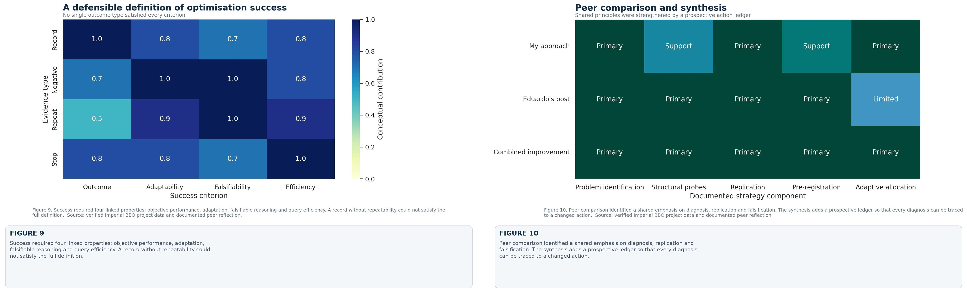
His analysis made falsifiability much more explicit in my own definition of success. A strategy becomes more convincing when the result that would defeat it is stated before the query. It also clarified the difference between recognising a problem and acting on that recognition. Correctly identifying a failure mode achieves little if the next action still follows the assumption that has just failed. The same weakness can occur in optimisation and in clinical decision support.

Constructive suggestions and final perspective
I would strengthen Eduardo's framework by linking each named strategy to a short prospective ledger. It could record the hypothesis, chosen coordinate, expected direction, failure criterion, returned value and next action. That would show whether the diagnosis genuinely changed behaviour. I would also reserve an early structural probe for extreme points, since a local surrogate may appear settled while an untested boundary contains the main opportunity. Repeated measurements should report both the retained record and the spread of repeat values, so that an exceptional return is not mistaken for stable performance.
In return, I would adopt his clearer language for stating failure criteria in advance and his separation of problem identification from method selection. The comparison showed me that successful optimisation is neither blind search nor intuition alone. It depends on recognising the problem, choosing an action before the result is known, learning from the return and changing direction when the evidence requires it.
The capstone confirmed something familiar from neurology. Uncertainty does not prevent a defensible decision, but it raises the standard of evidence needed to support it. I entered a field outside my established expertise and remained among the leaders because I could diagnose the problem, keep contradictory evidence and change course. The position mattered, but the more lasting achievement was a transparent method that shows why a move was made, what could disprove it and when it was sensible to stop.
For me, that mattered beyond the leaderboard: a neurologist placed outside familiar practice could still lead by combining disciplined observation, technical curiosity, transparent reasoning and the confidence to revise assumptions.
Black Box Resolution is the structured investigation of a hidden function using its recorded inputs and outputs. It compares competing explanations, tests their chronological predictive performance and rejects explanations that fail. BBR may identify a best-supported local structure without claiming recovery of the original hidden equation or its global optimum.
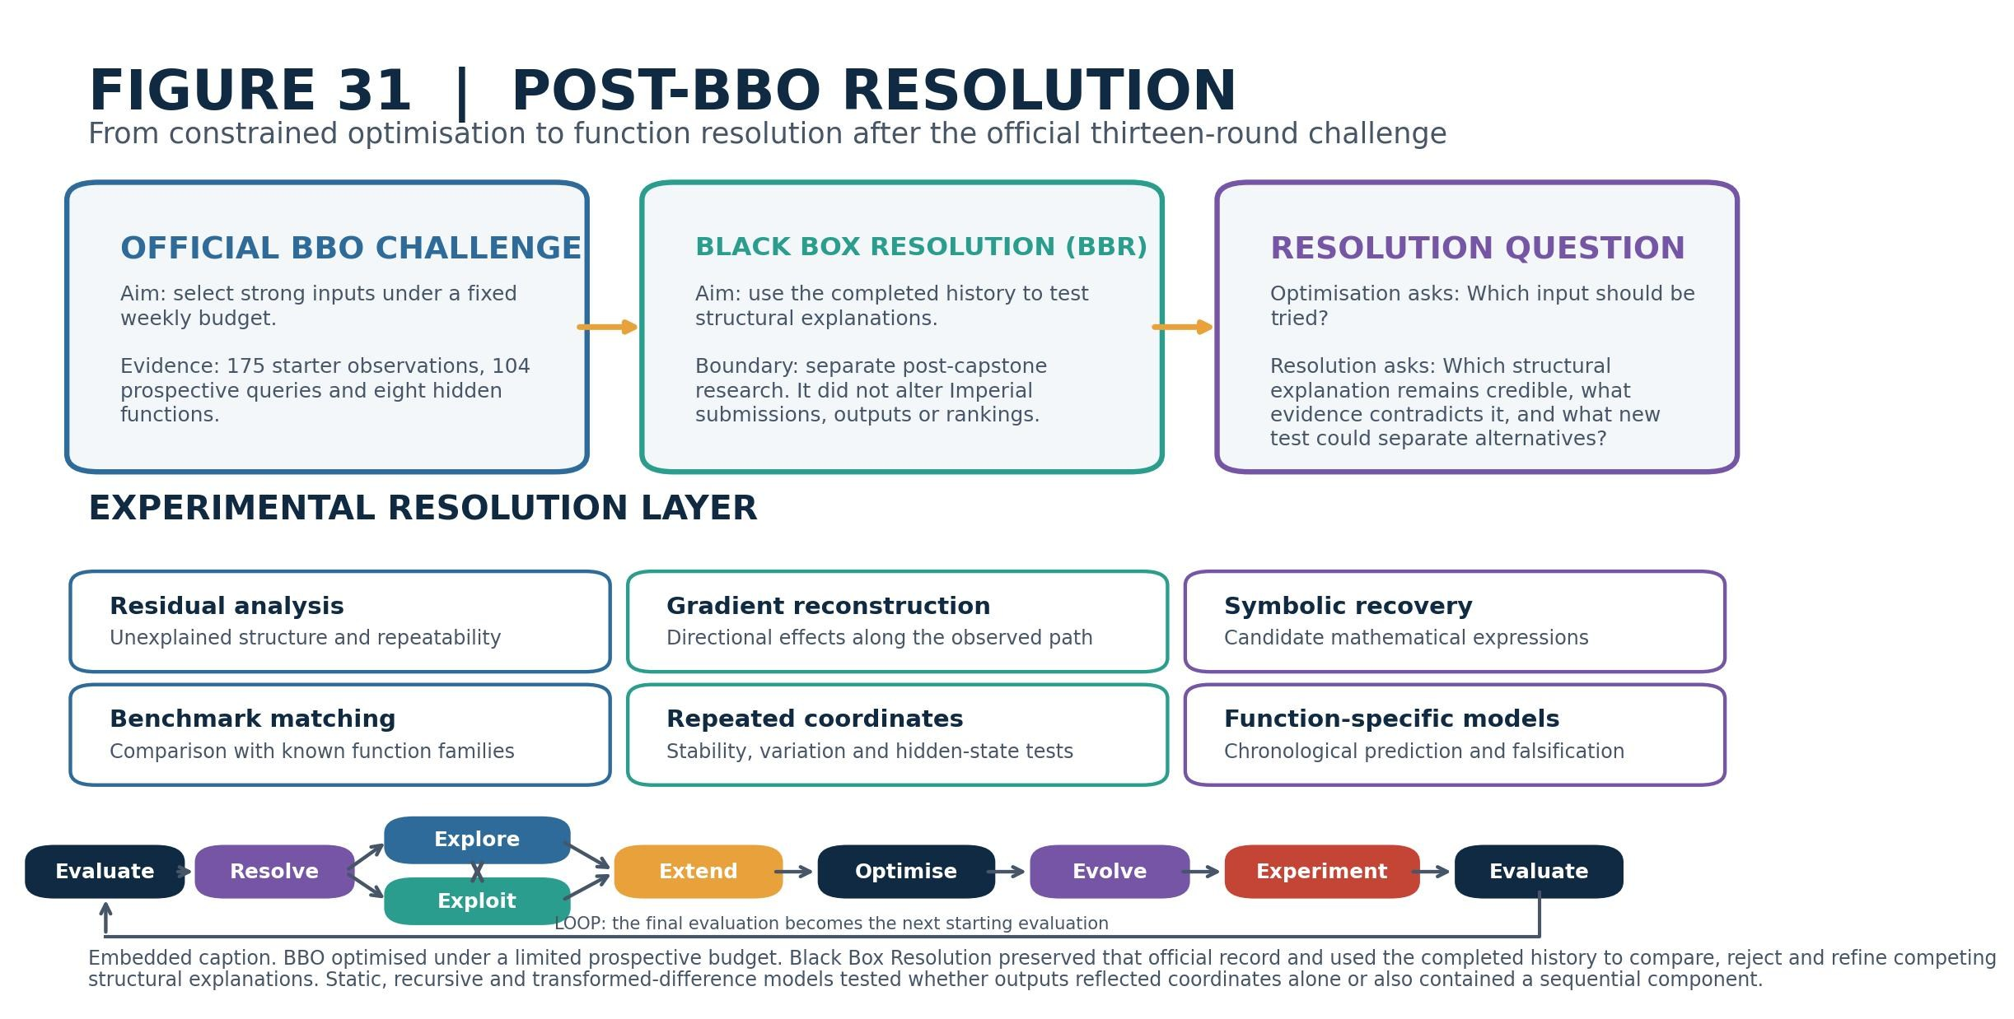

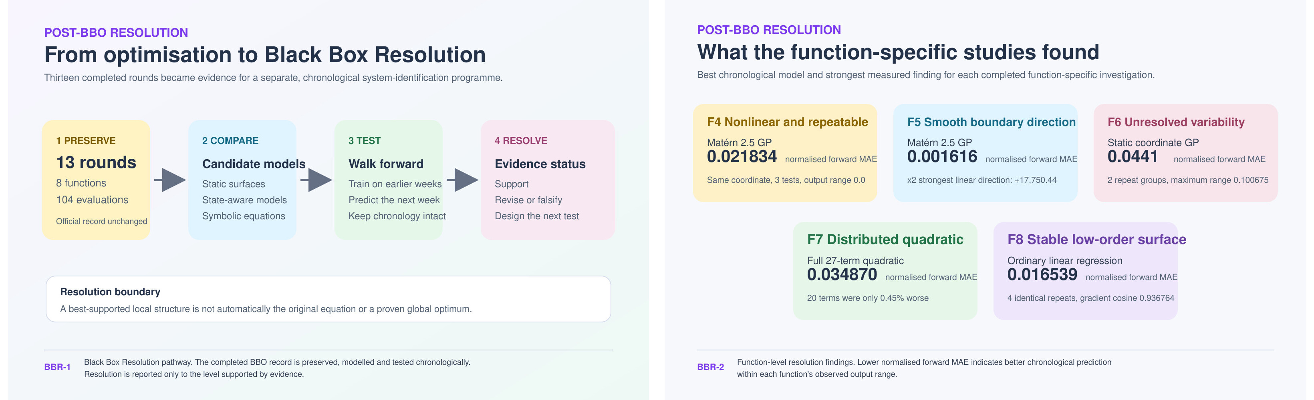
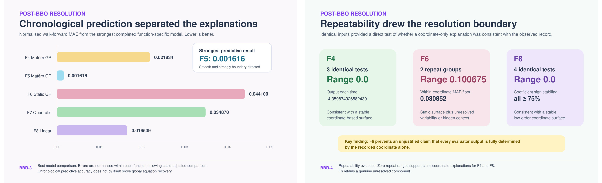
Repository: https://github.com/tpnandakumar/Imperial_BBO_Capstone

