Retrospective on the BBO Capstone Project
Stage 2: Required Capstone Component 25.1 | Section B
Dr Nandakumar Theekkootu Pisharam | 13-week BBO challenge

1. Initial codebase, data and experimental design
The capstone comprised eight unknown objective functions with input dimensions of 2, 2, 3, 4, 4, 5, 6 and 8. The course supplied 175 starter observations, not a starting codebase: 10 points for F1 and F2, 15 for F3, 30 for F4, 20 each for F5 and F6, 30 for F7 and 40 for F8. Each coordinate was bounded within [0,1]. The equations, gradients, noise processes and optima were hidden. During each of 13 rounds, I submitted one coordinate per function through the BBO portal and received one corresponding output. The experimental budget was therefore 104 black-box evaluations.
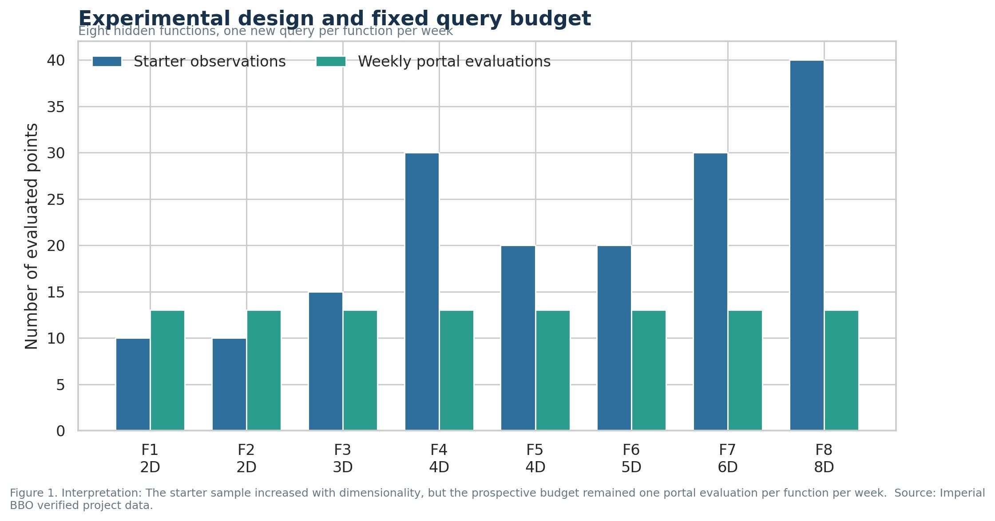
Figure 1
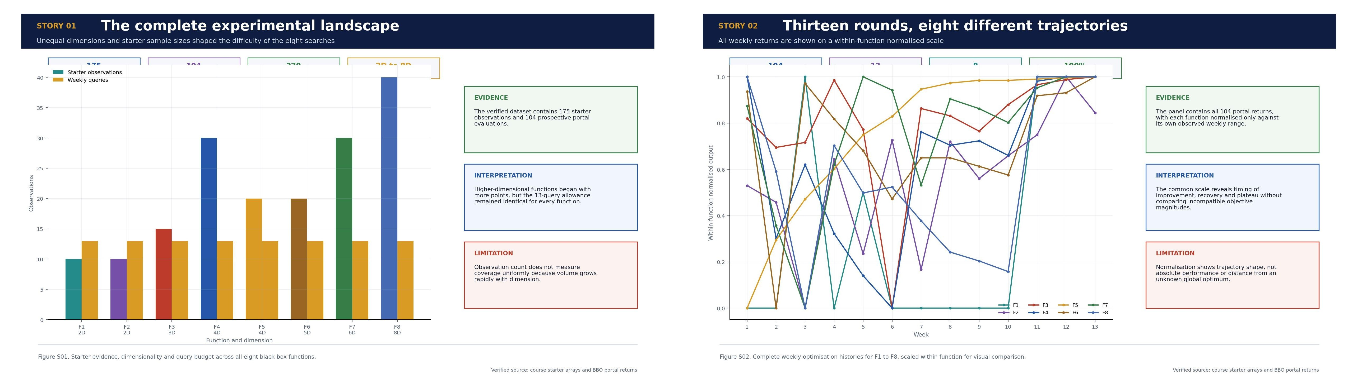
Scientific story infographics S01 and S02
I built the repository code specifically for this project rather than copying a previous optimisation repository. I chose this approach because the eight functions differed in dimensionality, scale and observed behaviour, while the weekly portal cycle required exact provenance and incremental updating. Standard Python libraries provided array handling, numerical optimisation, visualisation, clustering, PCA and Gaussian process components, but the data pipeline, weekly comparison logic, candidate rules, validation checks and decision records were developed for these eight functions. The public Imperial BBO Capstone repository preserves the starter arrays, submitted inputs, returned outputs, unsuccessful trials, analytical code and figures.
The portal output was treated as the authoritative observation. Predicted values were candidate-selection evidence, not achieved results. After each round, I appended the eight returned values, verified dimensions and bounds, calculated exact changes and input movement, then reconsidered the strategy for each function. This prevented model forecasts, rounded reconstructions or later estimates from entering the verified performance record.
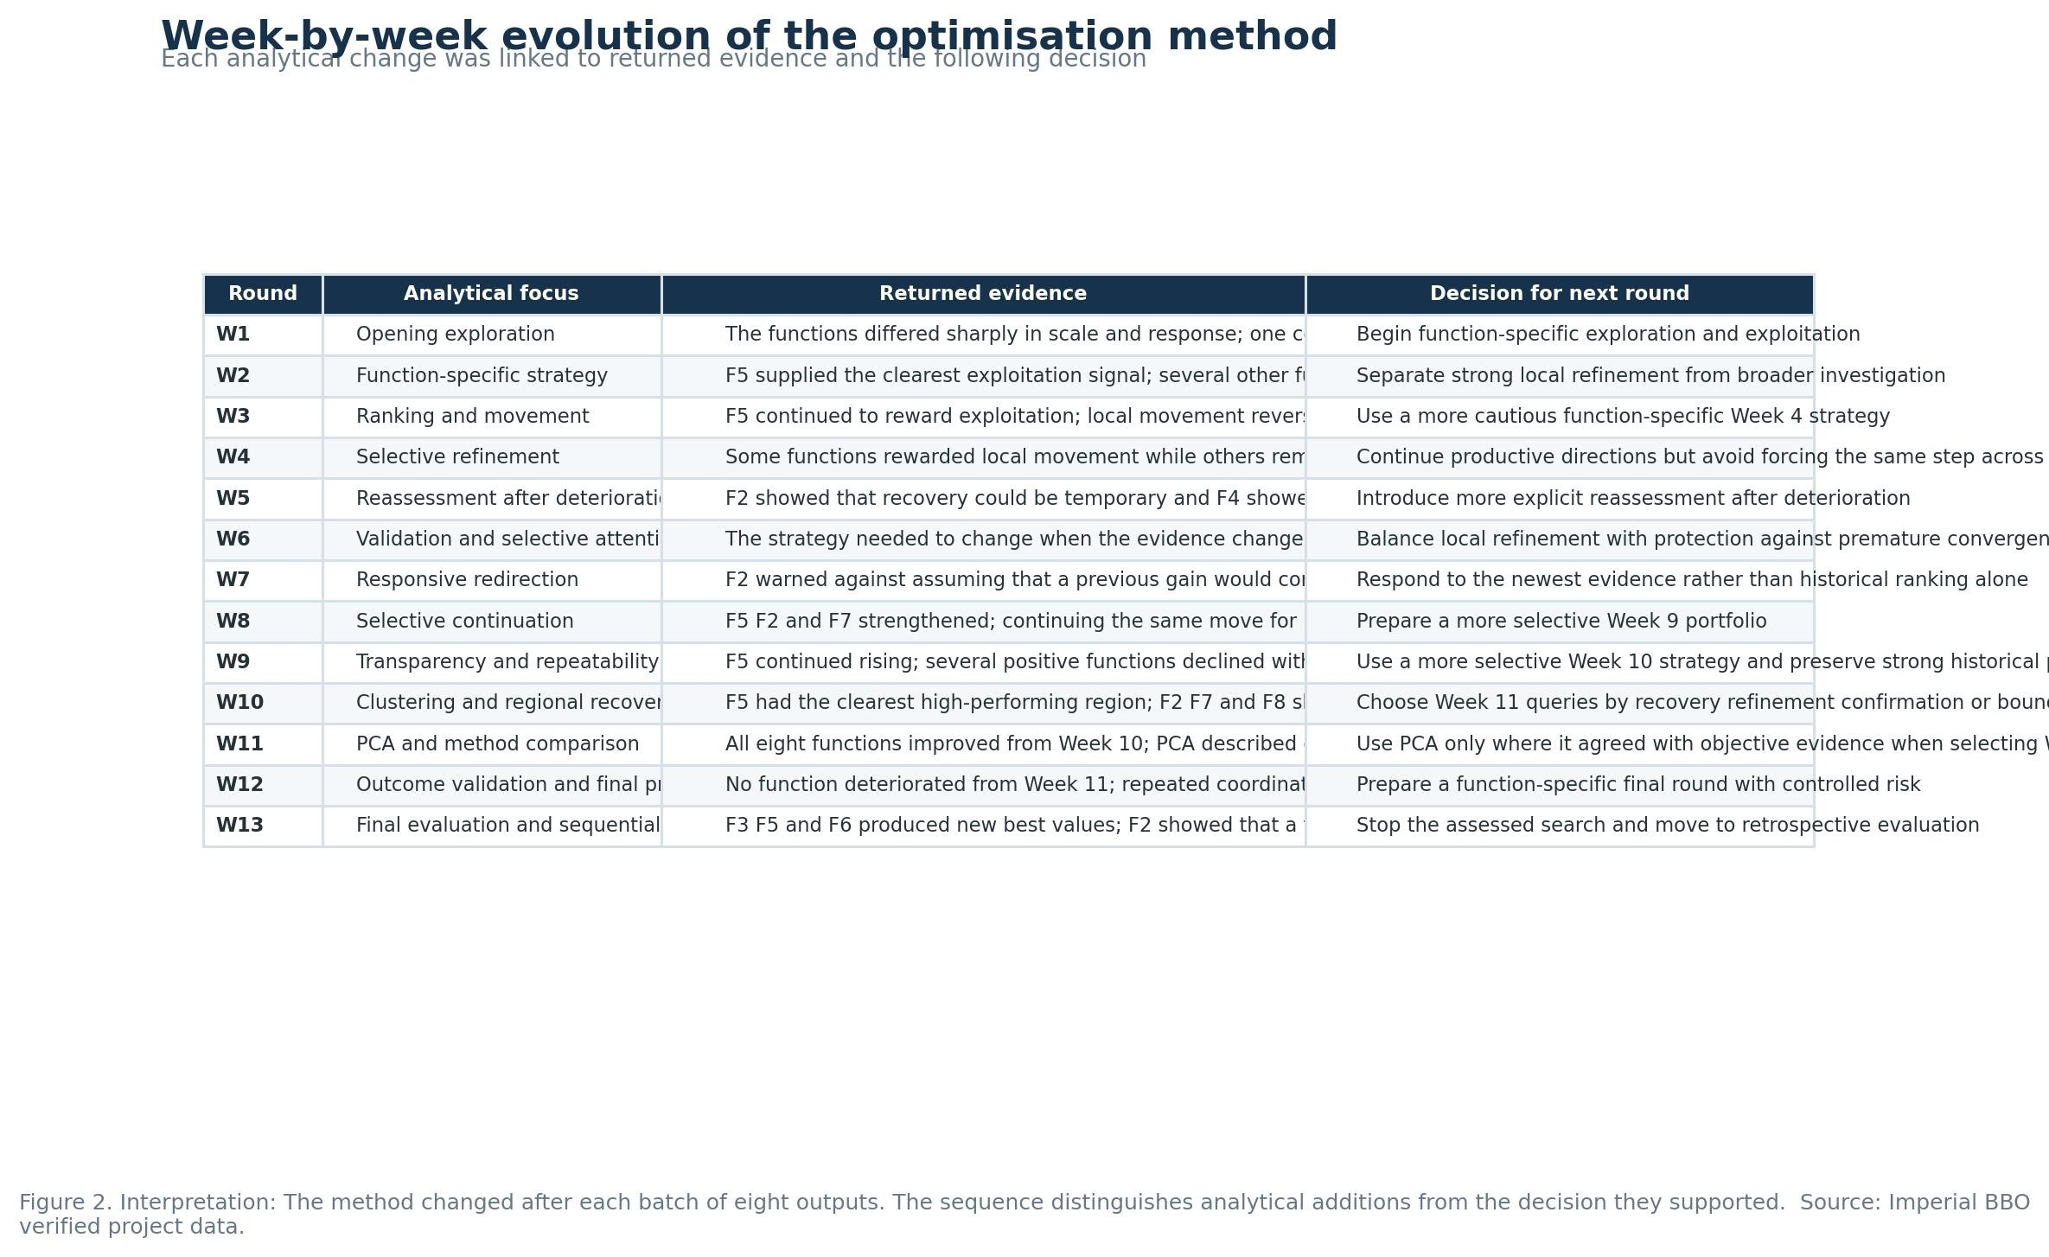
Figure 2
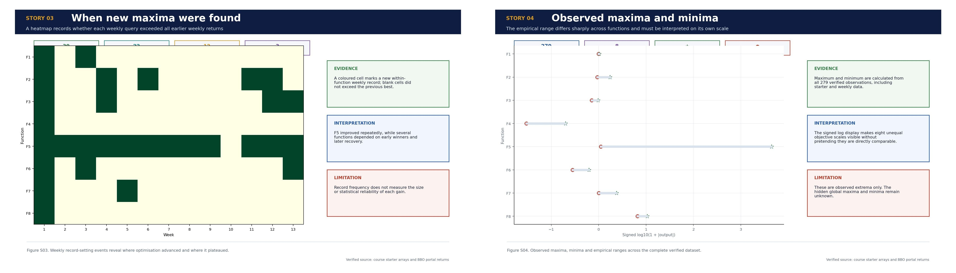
Scientific story infographics S03 and S04

2. How the approach developed over 13 rounds
Week 1 established a baseline by making small local movements around the strongest supplied points. Week 2 separated functions showing a useful direction from those needing wider exploration. Week 3 confirmed that one rule was unsuitable for all eight functions: F1 produced its first clear positive result, F5 continued to improve, and F2, F7 and F8 reacted poorly to apparently reasonable directional moves.
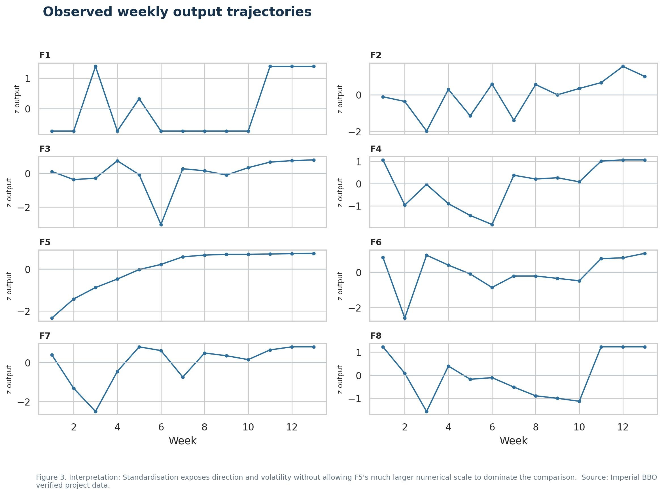
Figure 3
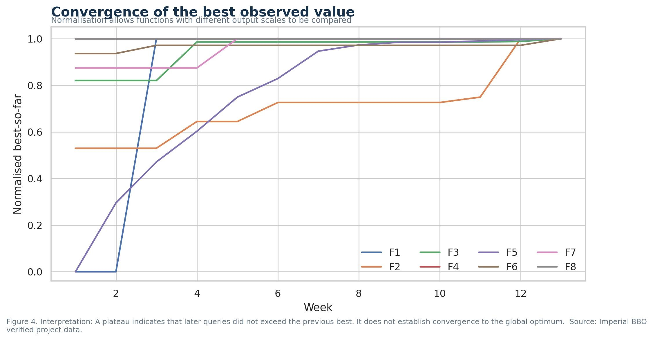
Figure 4
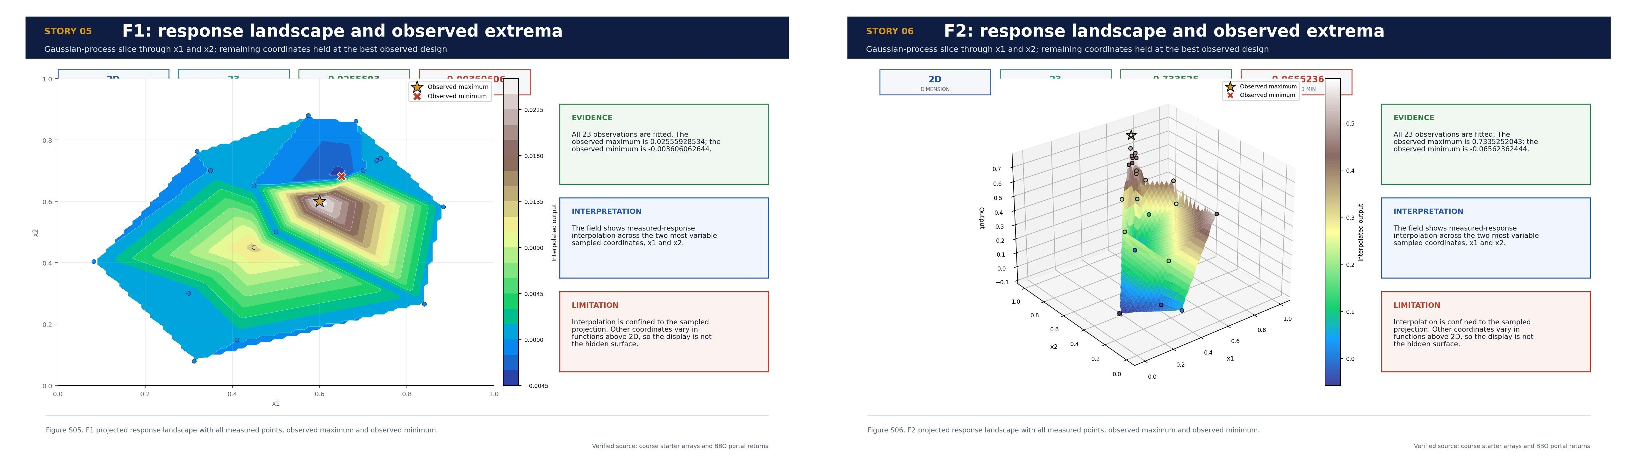
Scientific story infographics S05 and S06
Week 4 tested reversals after weak responses. Week 5 adjusted movement size rather than merely repeating direction. Week 6 confirmed that F2 and F3 could recover after changing direction, whereas larger moves reduced F4 and F6. F5 improved as x1 decreased and x2 to x4 approached the upper boundary. I therefore added L1 movement, output change and boundary-distance measures. These showed that coordinate interaction and response direction mattered more than movement magnitude alone.
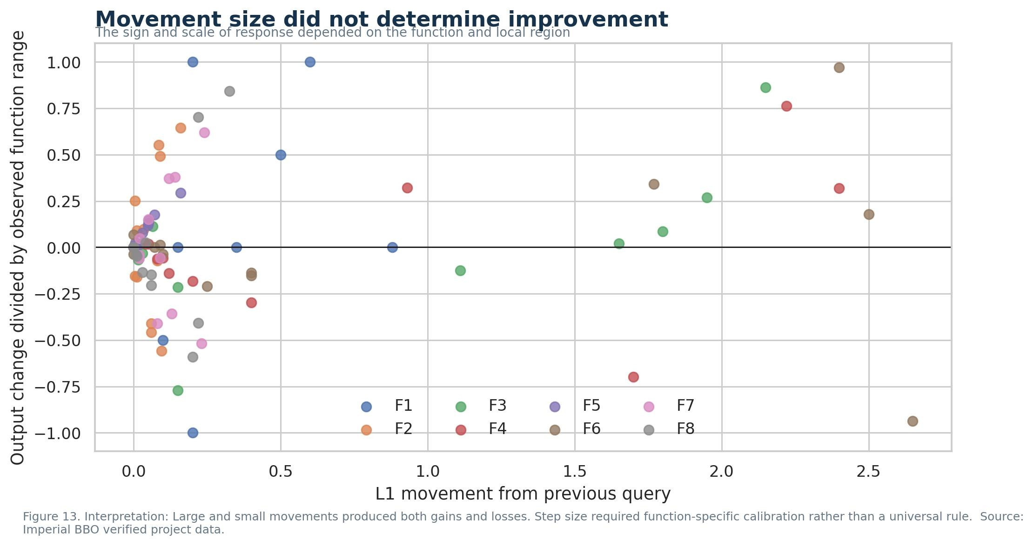
Figure 13
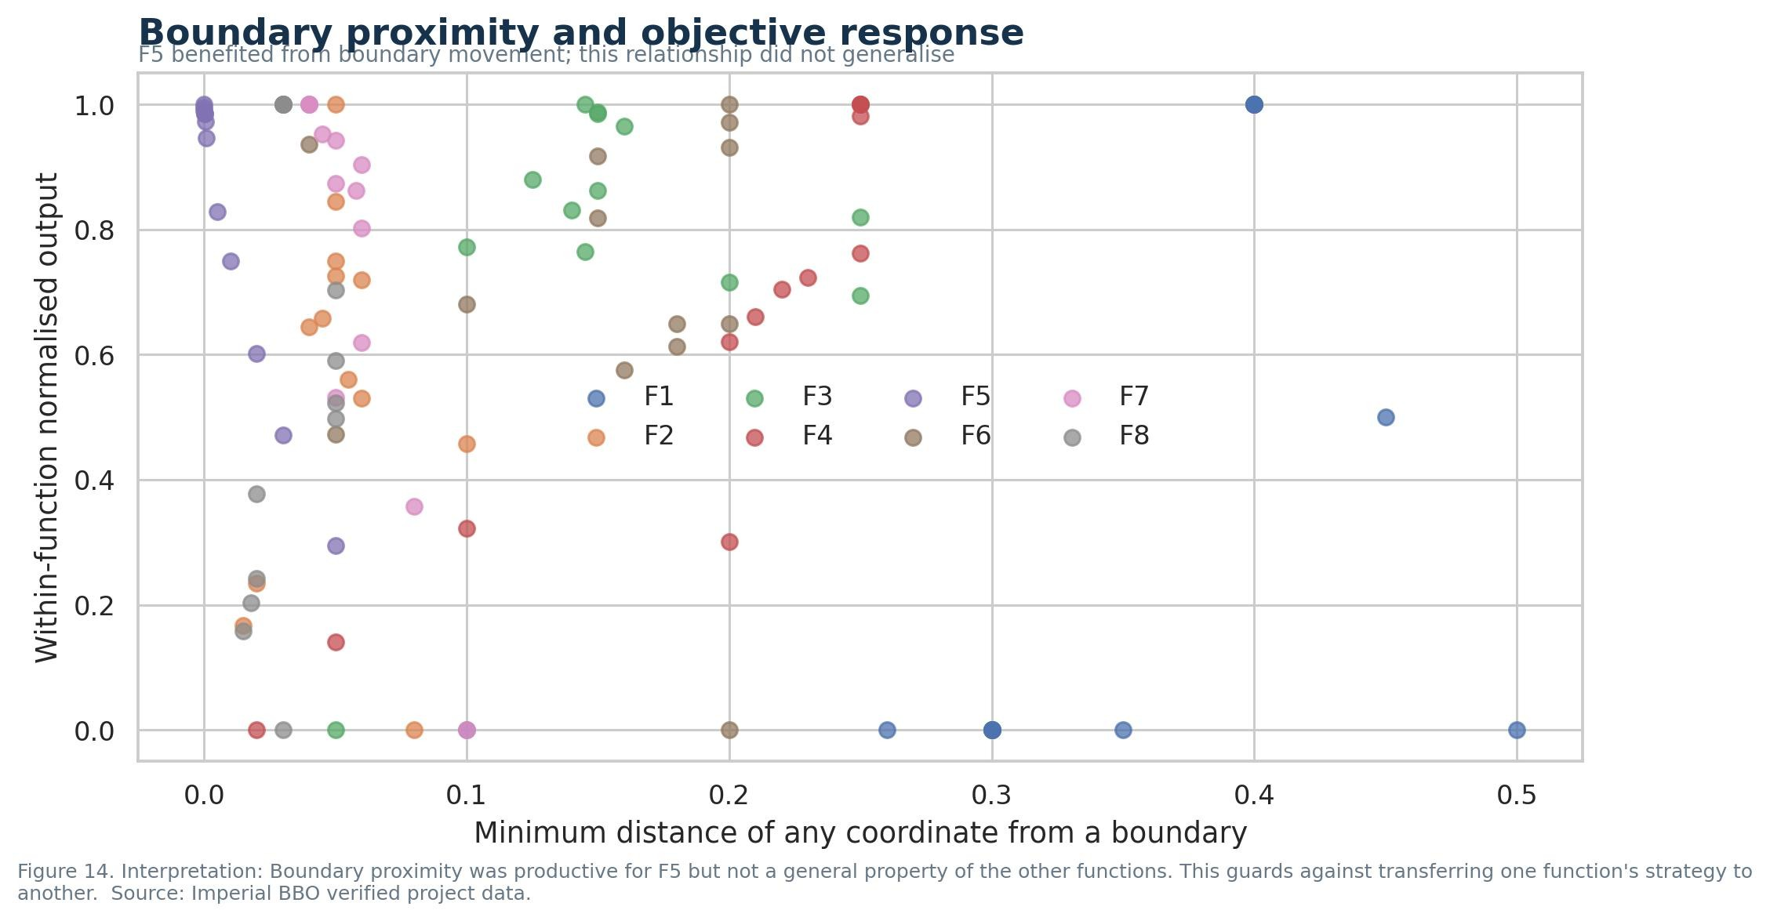
Figure 14
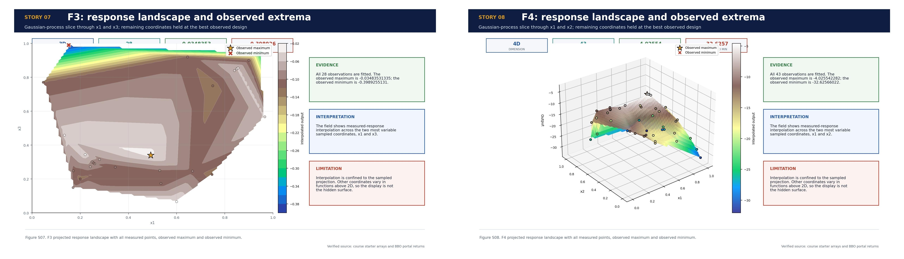
Scientific story infographics S07 and S08
Week 7 continued the supported F5 path while using recovery probes elsewhere. Week 8 introduced smaller local refinements where recent evidence was consistent. Week 9 compared improvement, deterioration and plateau states separately rather than treating every unchanged result as failure. Across these rounds, F5 rose from 4278.817 to 4394.868. I also added automatic dimension and bound validation, exact comparison files, reproducible figure data, datasheets, model cards and decision records. The repository became an auditable sequential experiment rather than a collection of weekly scripts.
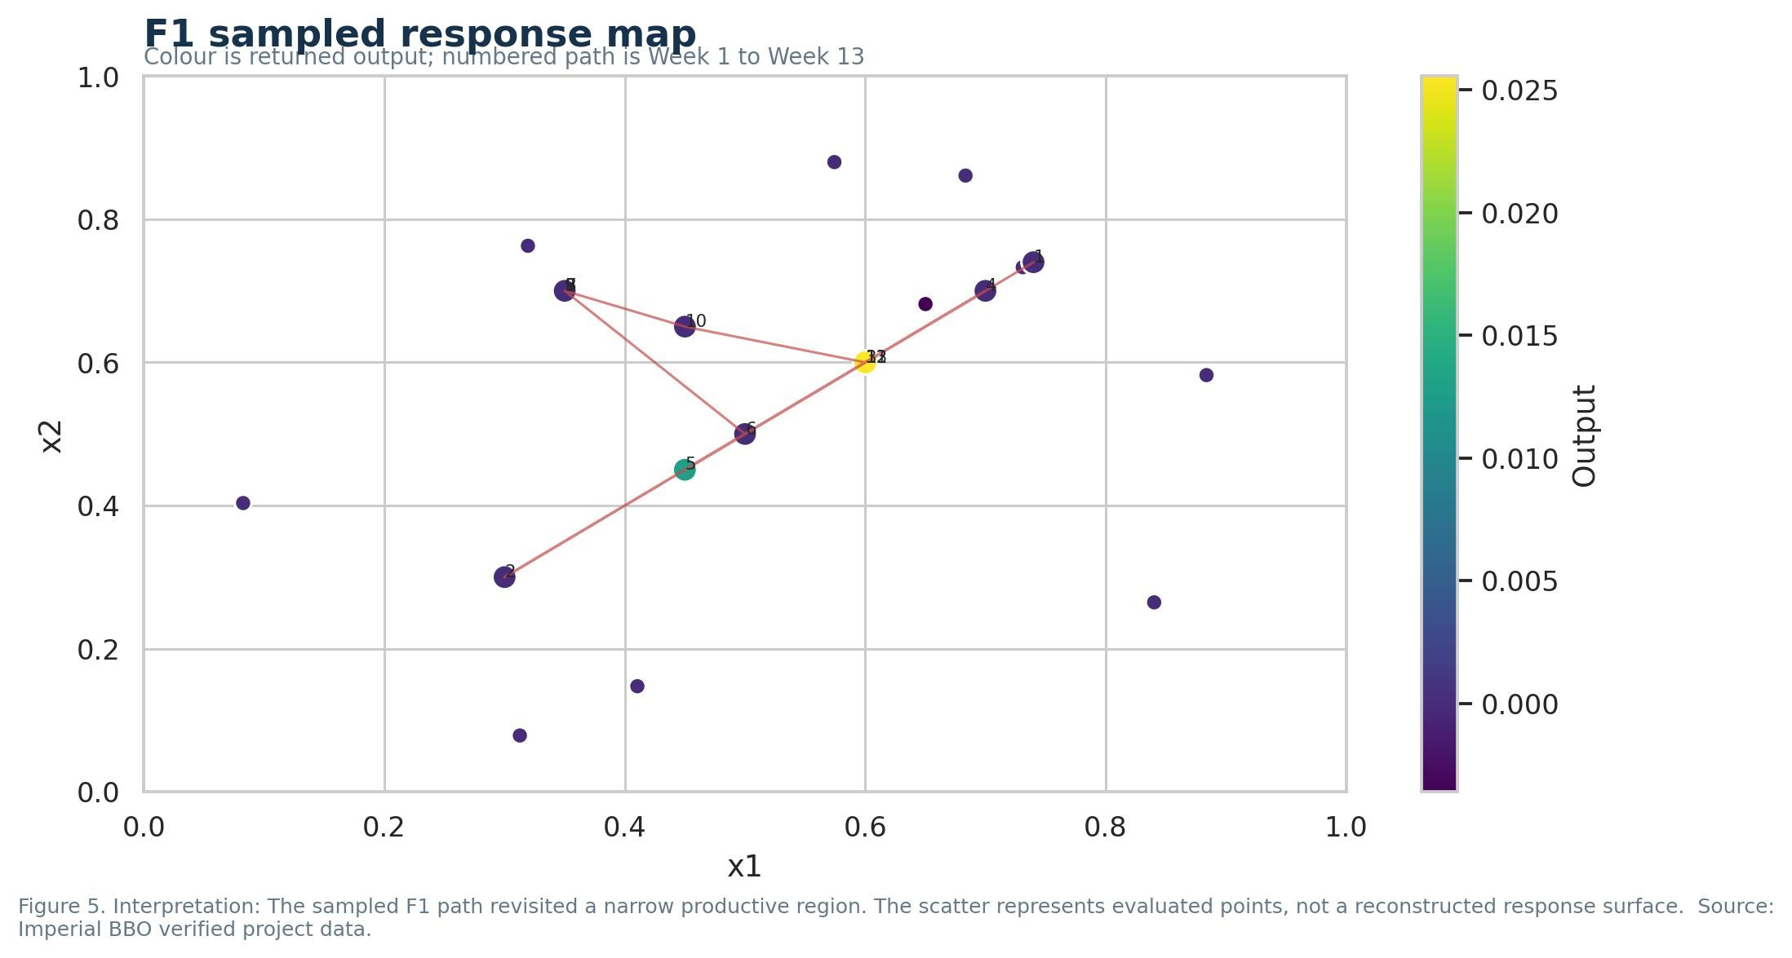
Figure 5
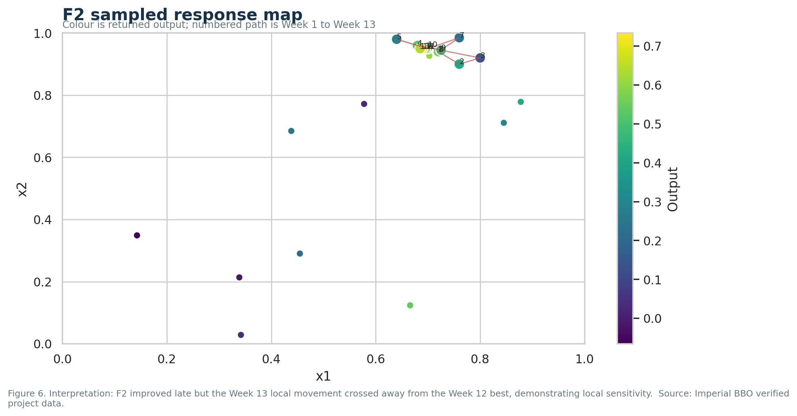
Figure 6
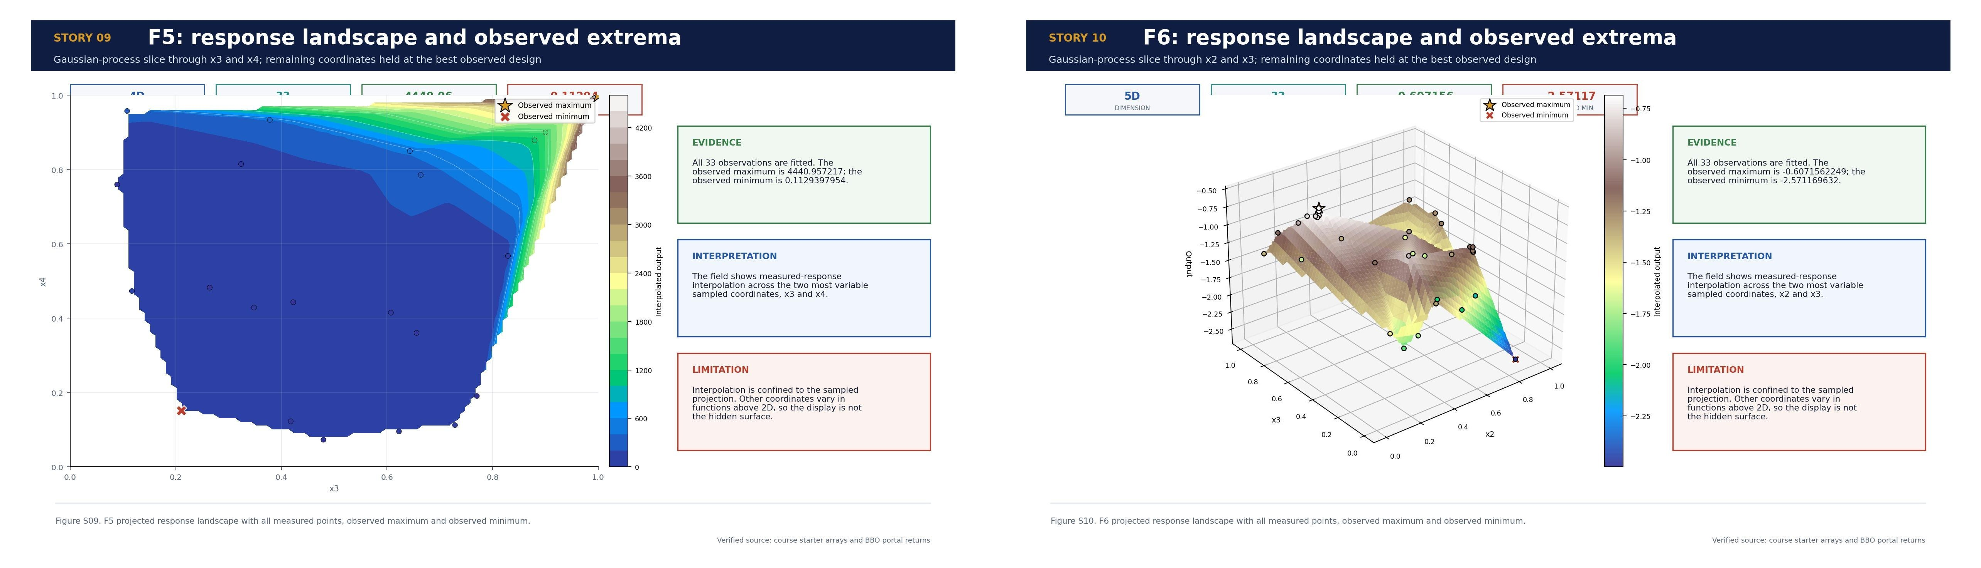
Scientific story infographics S09 and S10
Week 10 introduced clustering as an exploratory diagnostic. Candidate k values were compared using silhouette score, with inertia, repeated initialisations and a fixed random seed used to check stability. Clustering was not assumed to reveal the hidden objective surface. It tested whether evaluated coordinates formed recurring regions associated with productive, weak or plateauing outputs. The small, path-dependent samples limited the reliability of cluster labels.
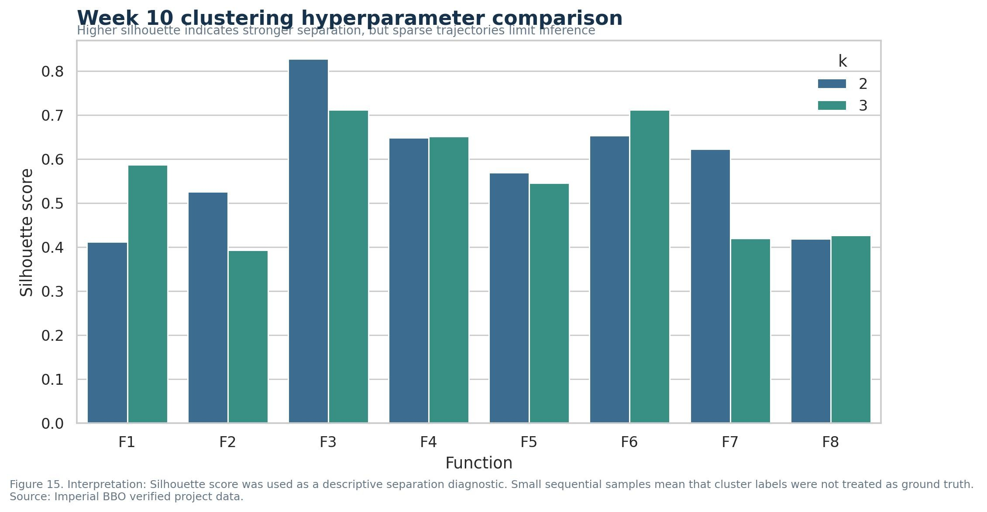
Figure 15
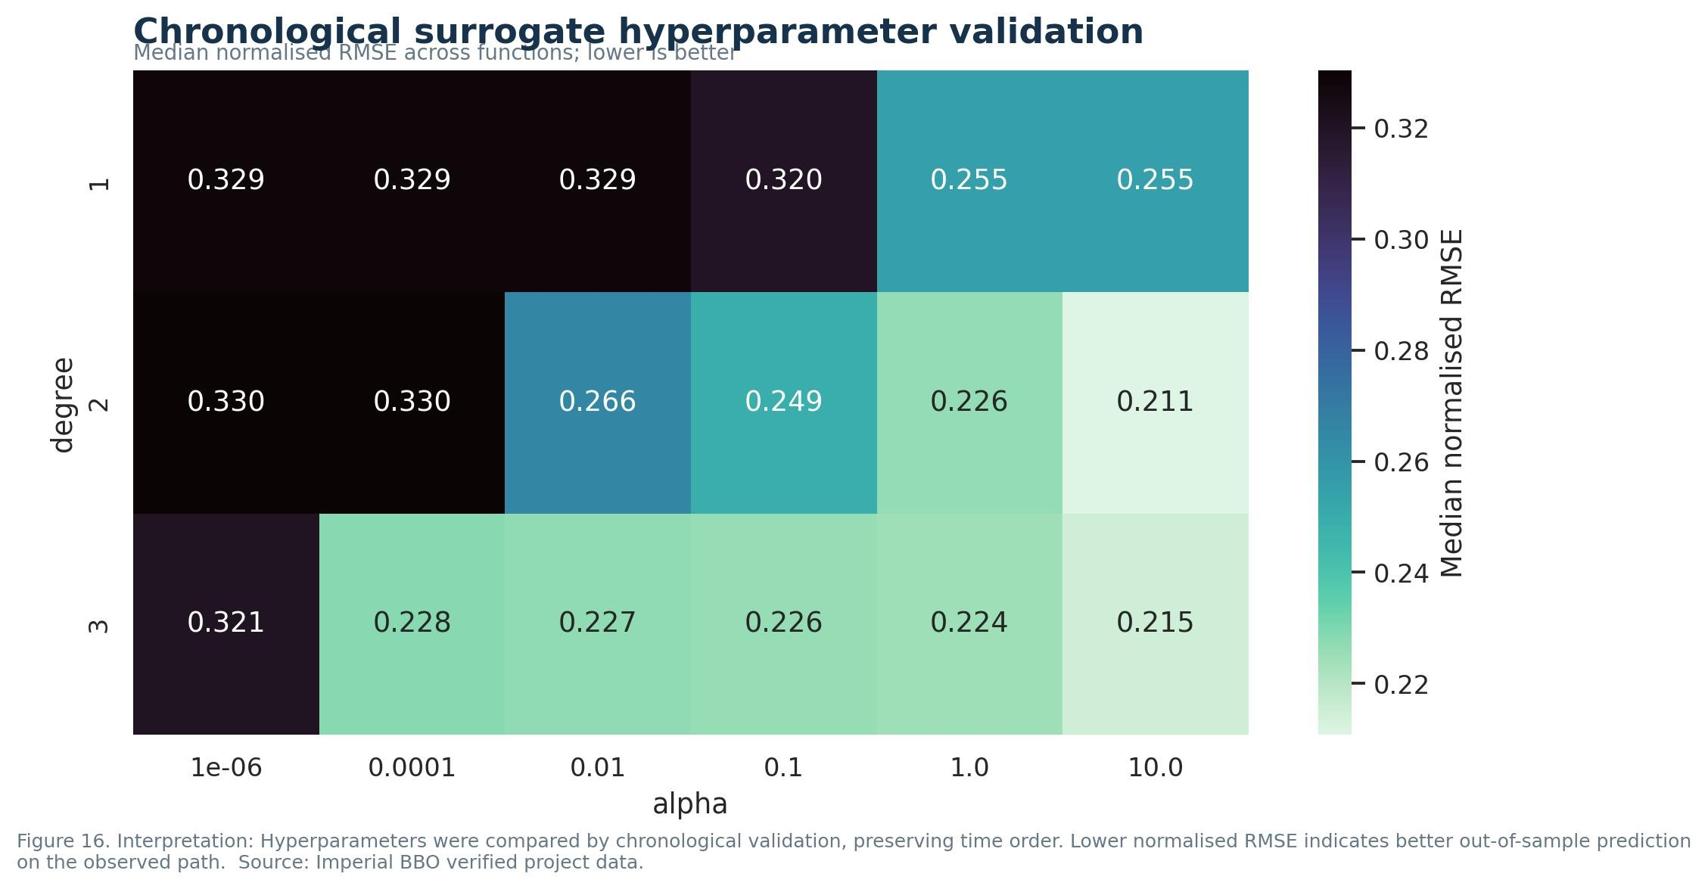
Figure 16
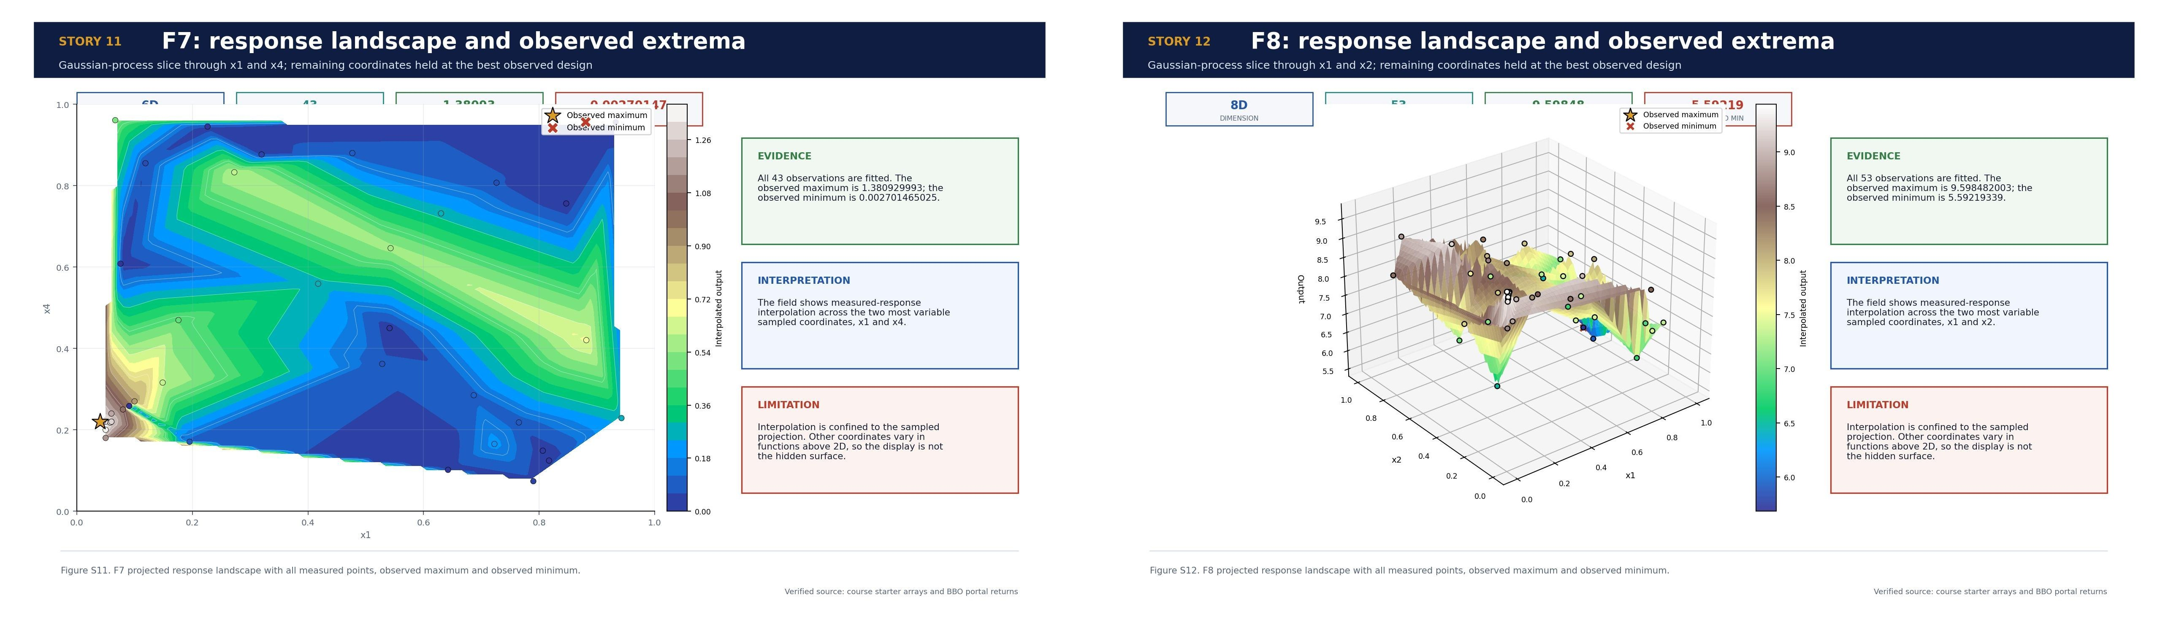
Scientific story infographics S11 and S12
Week 11 added PCA for the accumulated coordinate paths, particularly in higher dimensions. Explained variance measured whether movement was concentrated into a few directions, while PC1 loadings identified the dominant coordinates. PCA described the sampled path, not the unknown function. I accepted its interpretation only when the returned objectives agreed. Chronological surrogate validation was also introduced so that polynomial degree and regularisation strength were compared without training on future observations.
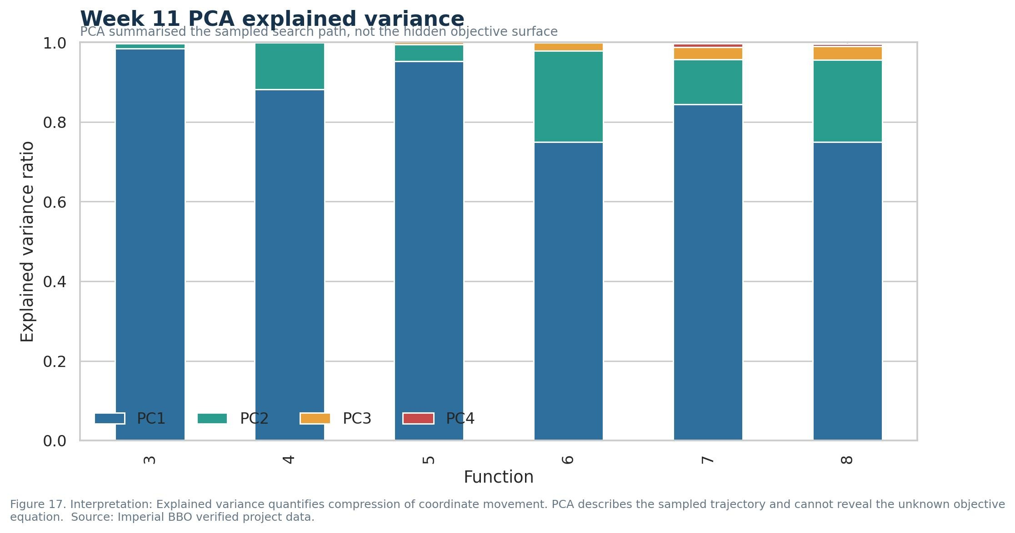
Figure 17
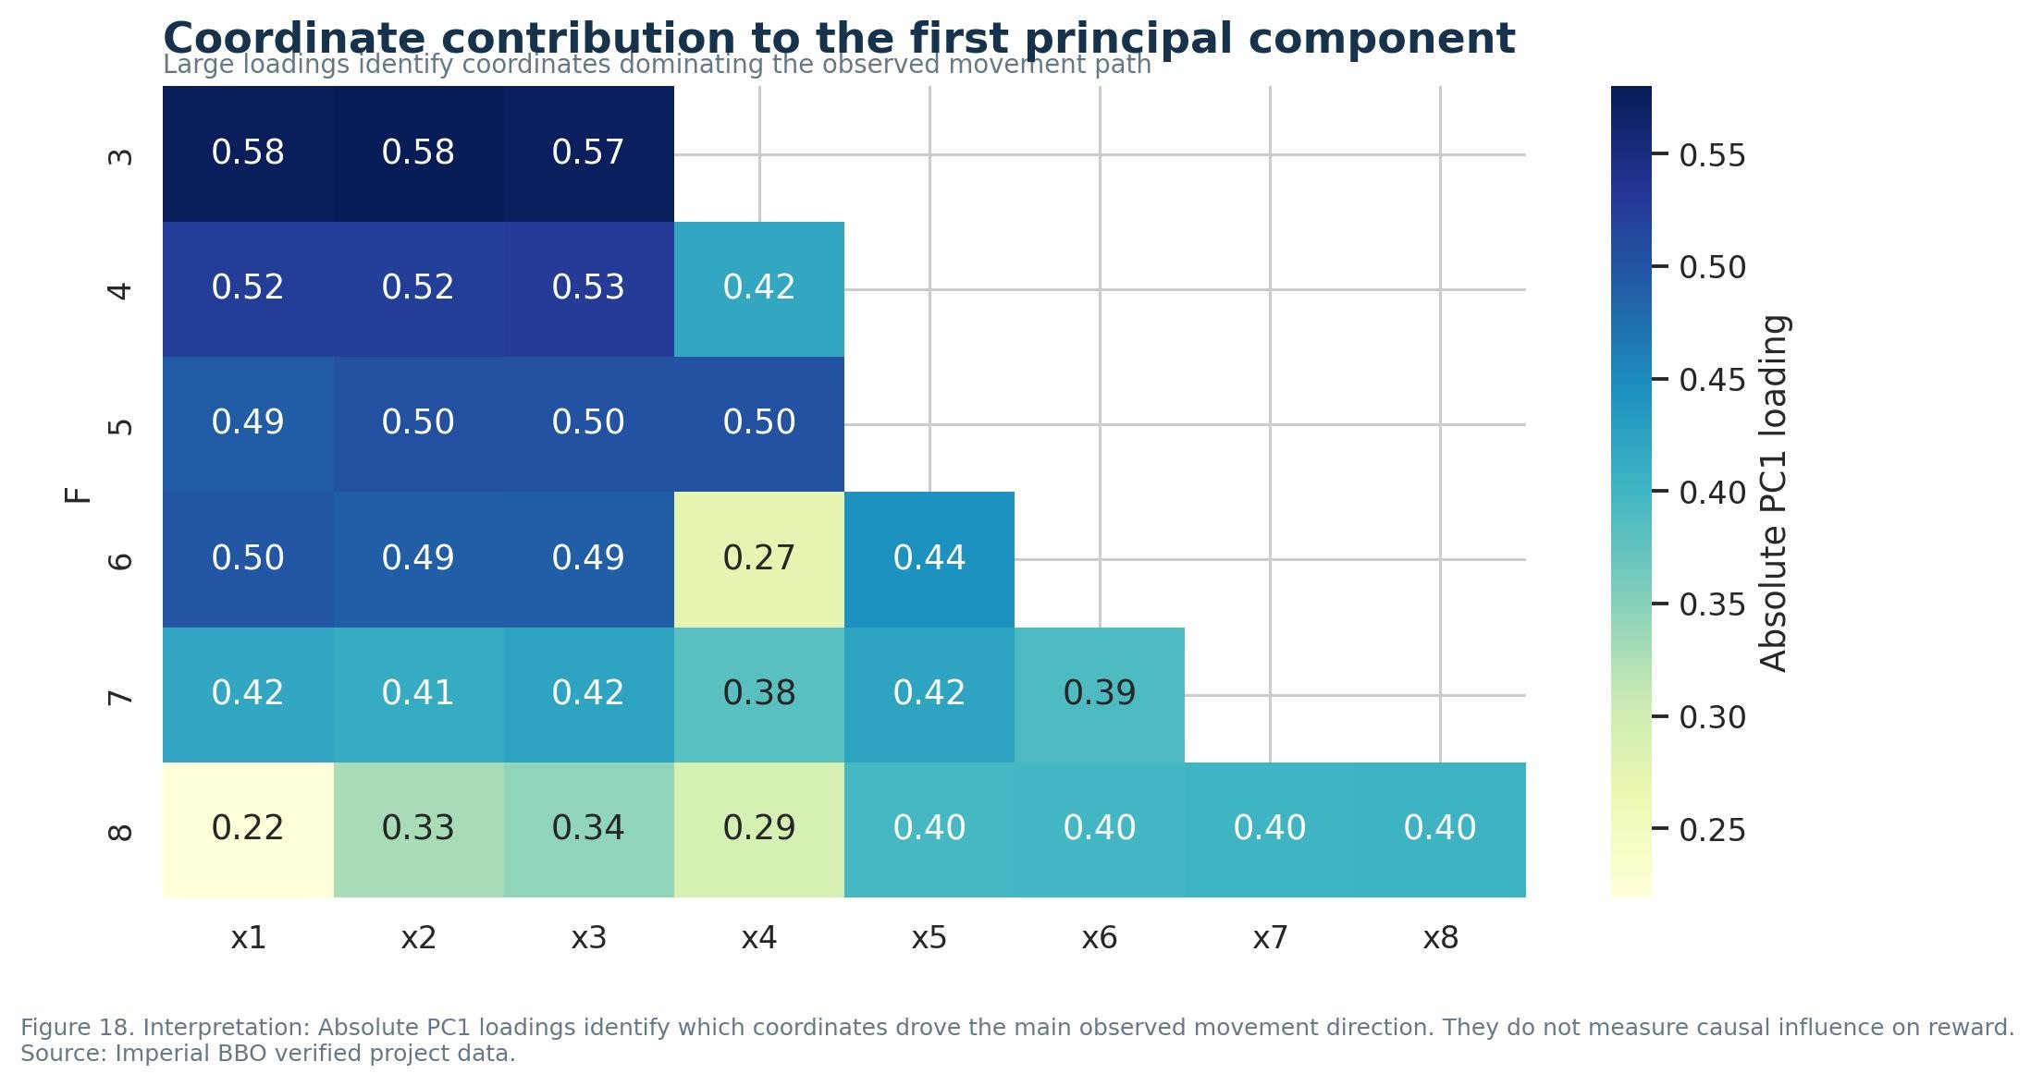
Figure 18
Week 12 combined current-best status, recent change, movement size, repeated-coordinate evidence and the multivariate diagnostics. F2, F3 and F5 produced new best values. F1, F4, F7 and F8 exactly reproduced earlier winners. F6 did not reproduce its previous output at an identical coordinate, raising a repeatability question. These different states required different final actions.
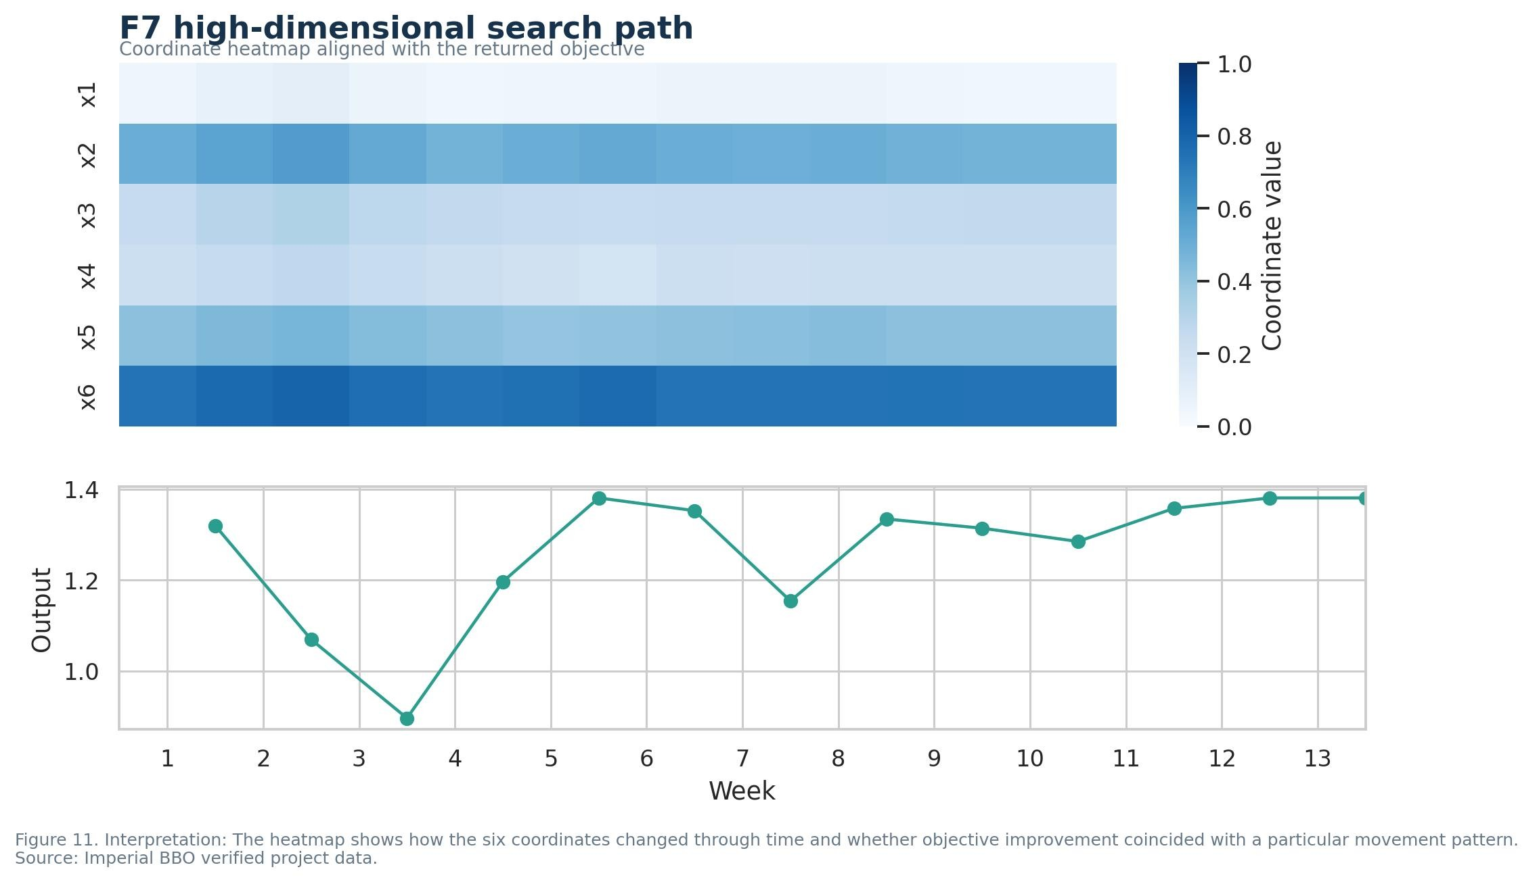
Figure 11
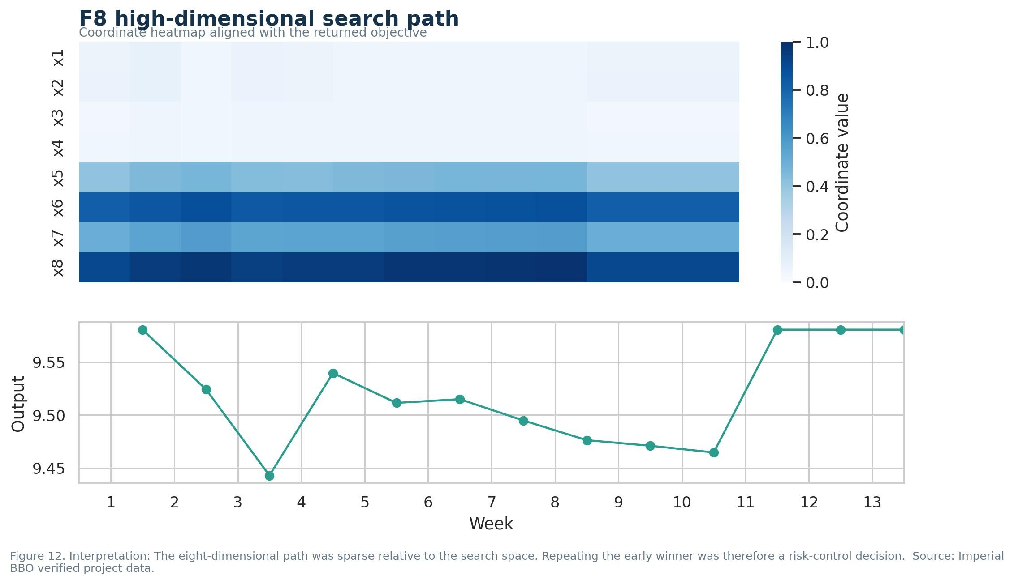
Figure 12
Before Week 13, I formalised selection as a state, action and reward experiment. The state contained the verified Week 1 to Week 12 history. Actions were exploration, local refinement, boundary refinement, recovery, retention and repeat evaluation. The returned output was the reward. Multi-armed bandit reasoning informed the balance between uncertain and productive functions, while sequential updating reflected an MDP interpretation. I did not claim a stable tabular Q-function because the action space was continuous and the dataset was small. The final policy retained F1, F4, F7 and F8, locally refined F2 and F3, continued the F5 boundary direction and repeated F6.
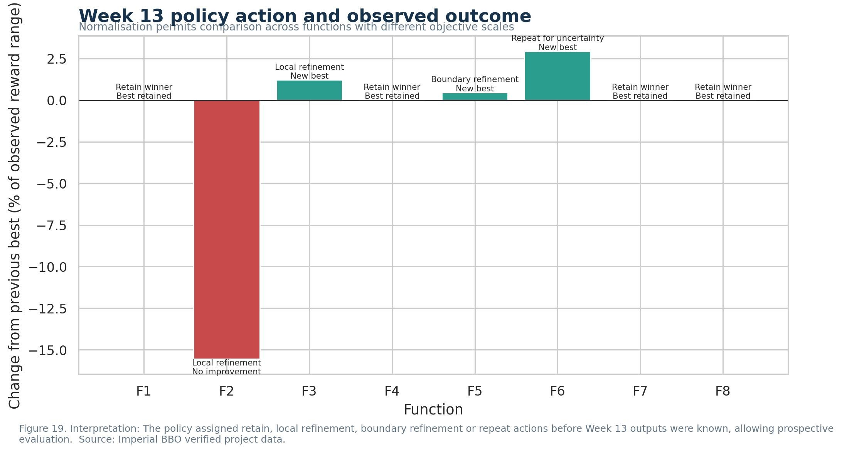
Figure 19
The most consequential modification was abandoning a shared search rule in favour of function-specific policies. It allowed sustained exploitation of the empirically supported F5 direction, recovery of earlier winners for F4, F7 and F8, and cautious late refinement of F2 and F3. The second major improvement was the validated evidence pipeline, because it prevented candidate predictions or rounded values from being mistaken for portal-confirmed performance. Clustering, PCA and reinforcement learning concepts improved interpretation, but neither changed results as directly as these two modifications.

3. Final results and function-specific interpretation
Week 13 produced new overall best outputs for F3, F5 and F6. F1, F4, F7 and F8 retained their verified winners, while F2 declined from its Week 12 best. The strongest observed values were F1 0.0255592853, F2 0.7335252043, F3 -0.0568506160, F4 -4.3598749266, F5 4440.9572166, F6 -0.6071562249, F7 1.3809299934 and F8 9.58024. These are maxima within the evaluated points and authorised query budget. They do not establish that the global optima were found.
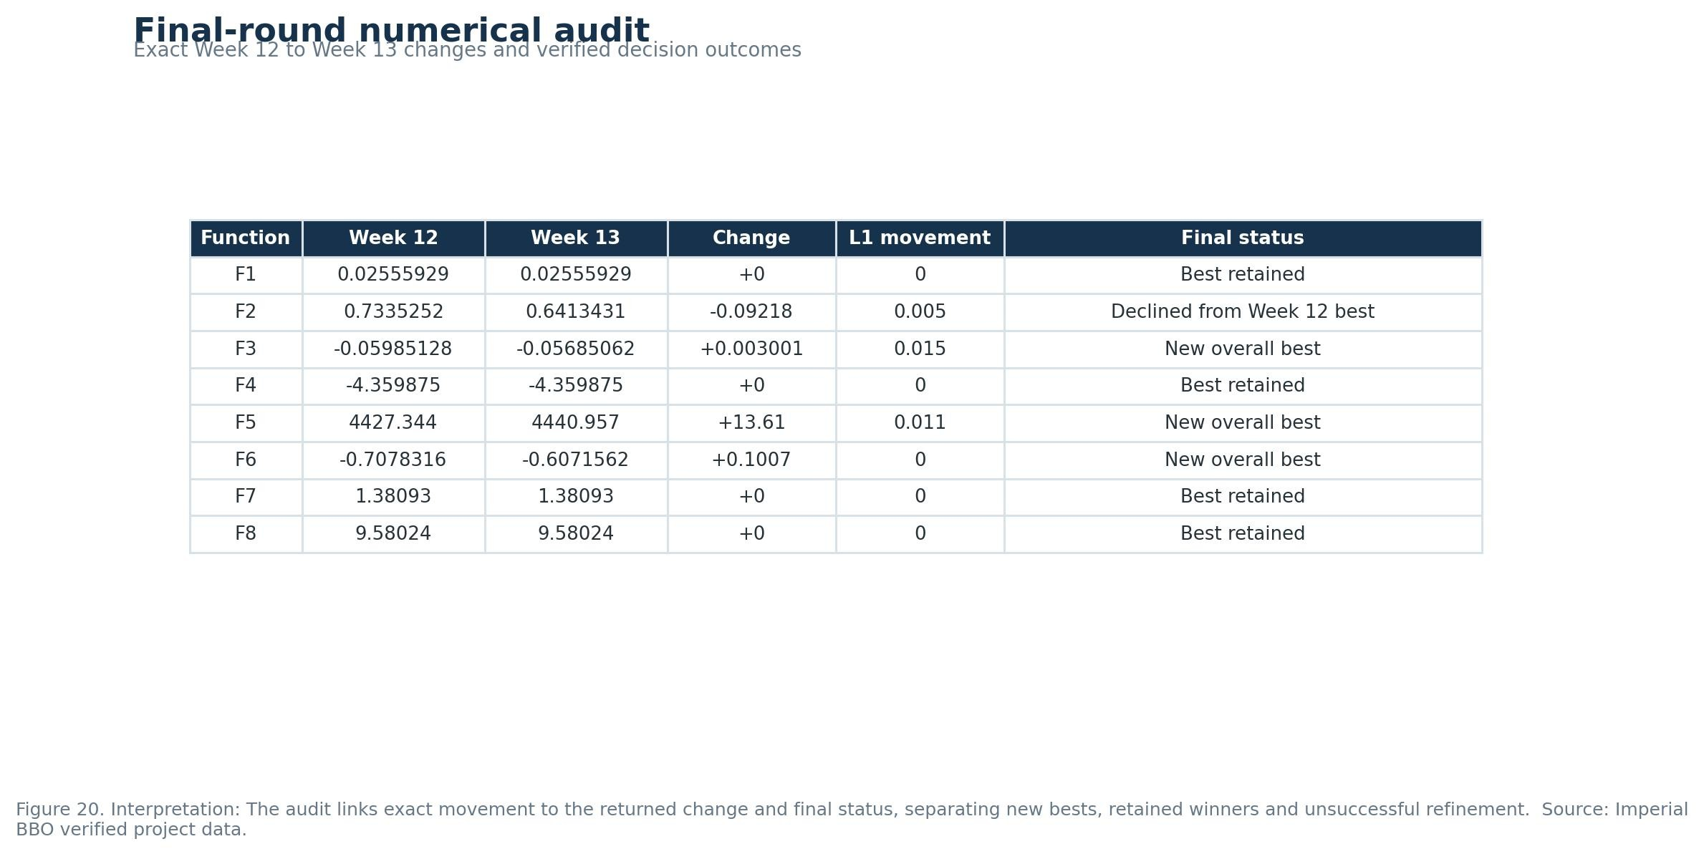
Figure 20
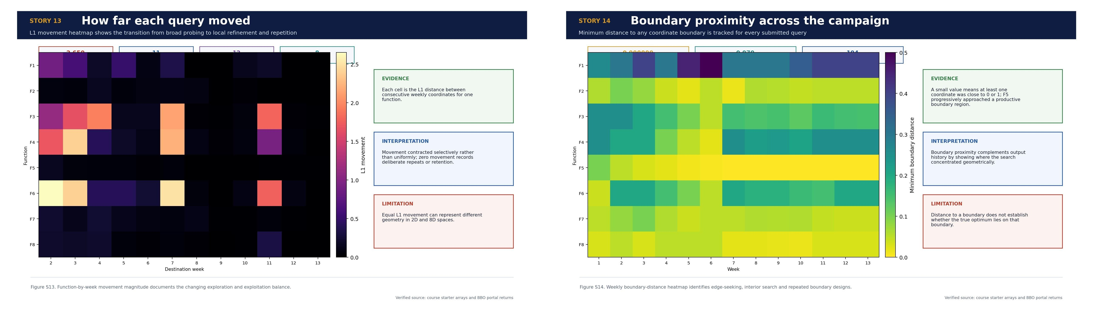
Scientific story infographics S13 and S14
Performance in the final two rounds was mixed rather than uniformly increasing. Week 12 created new bests for F2, F3 and F5 and restored or confirmed the best coordinates for F1, F4, F7 and F8. Week 13 then improved F3 by 0.00300065931115935, F5 by 13.613220792305 and F6 by 0.1006753882307160, while F2 fell by 0.0921821158135095. The remaining four outputs were unchanged because their coordinates were deliberately retained. This distinction is important: an unchanged final output represented successful confirmation for those functions, whereas a numerical increase was the intended outcome for the active continuation targets.
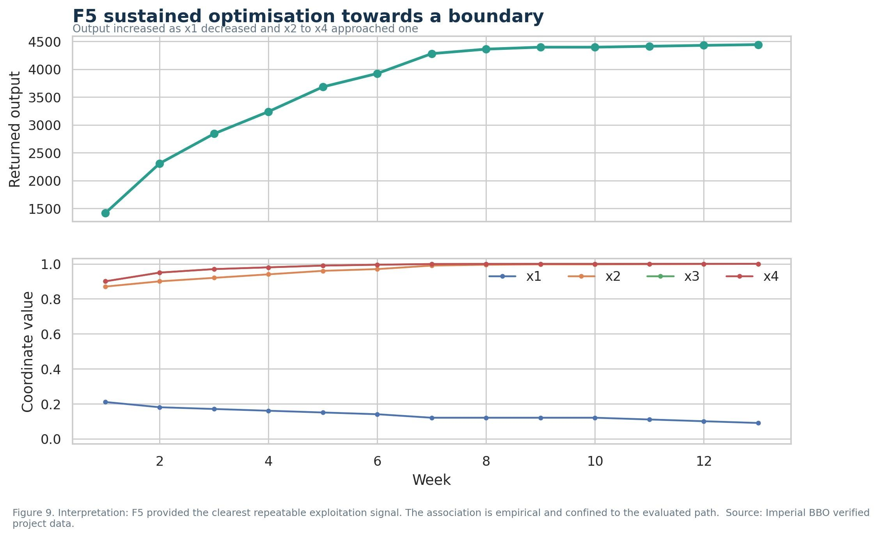
Figure 9
F5 provided the strongest optimisation trajectory. Its output increased from 1415.8763939603884 in Week 1 to 4440.957216598753 in Week 13, an absolute gain of 3025.0808226383646. The improvement arose through repeated controlled movement rather than one isolated jump. This was the clearest evidence for continued exploitation. By contrast, F4 and F8 had strong early observations, deteriorated during exploration and were recovered by returning to the earlier coordinates.
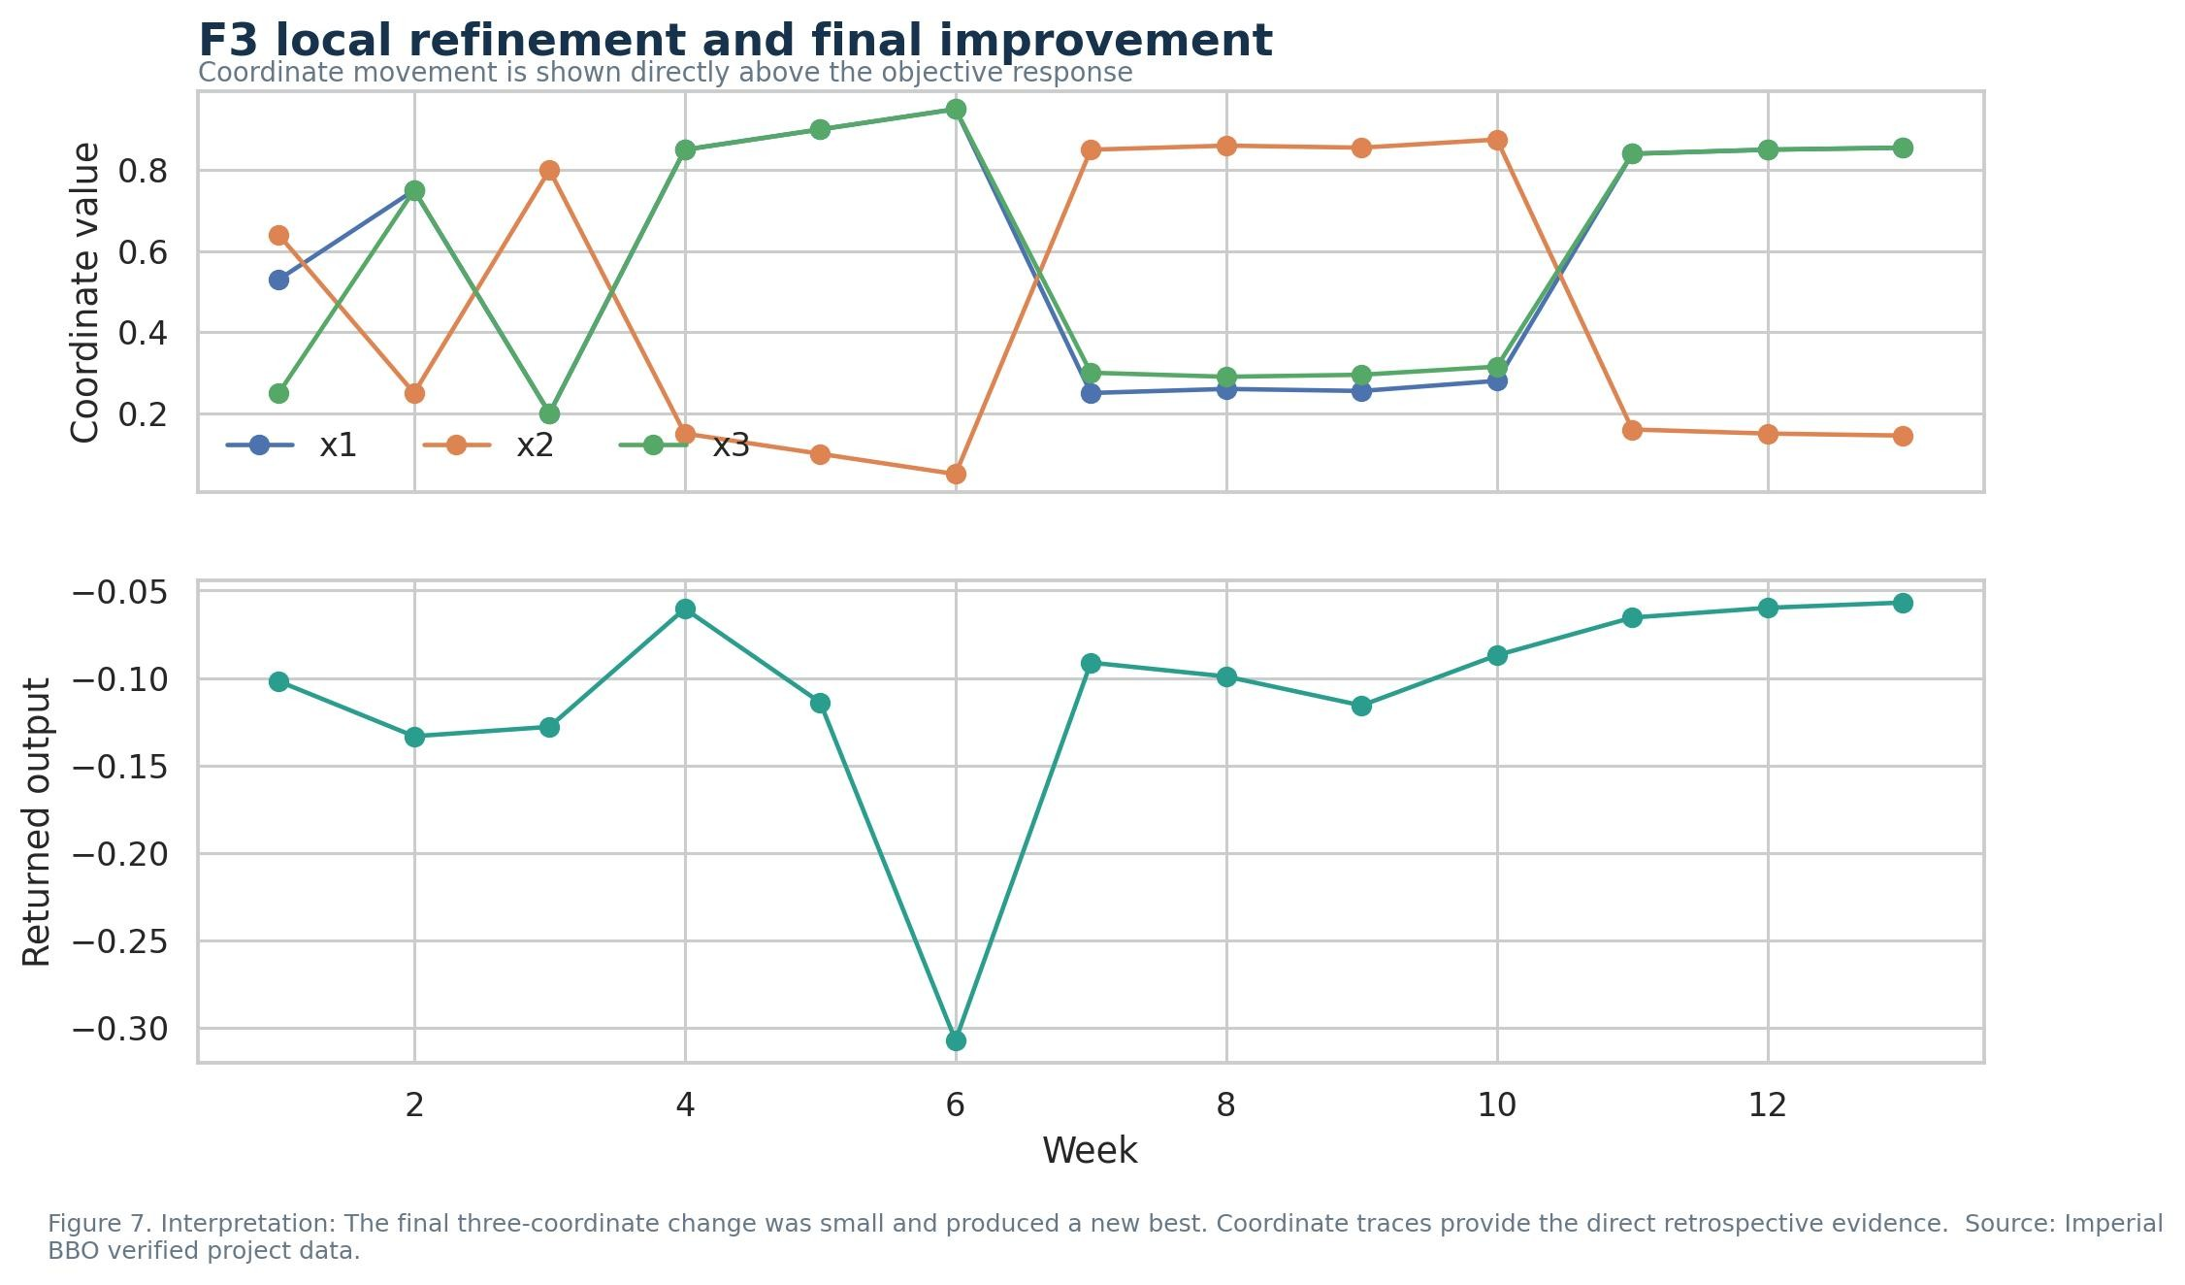
Figure 7
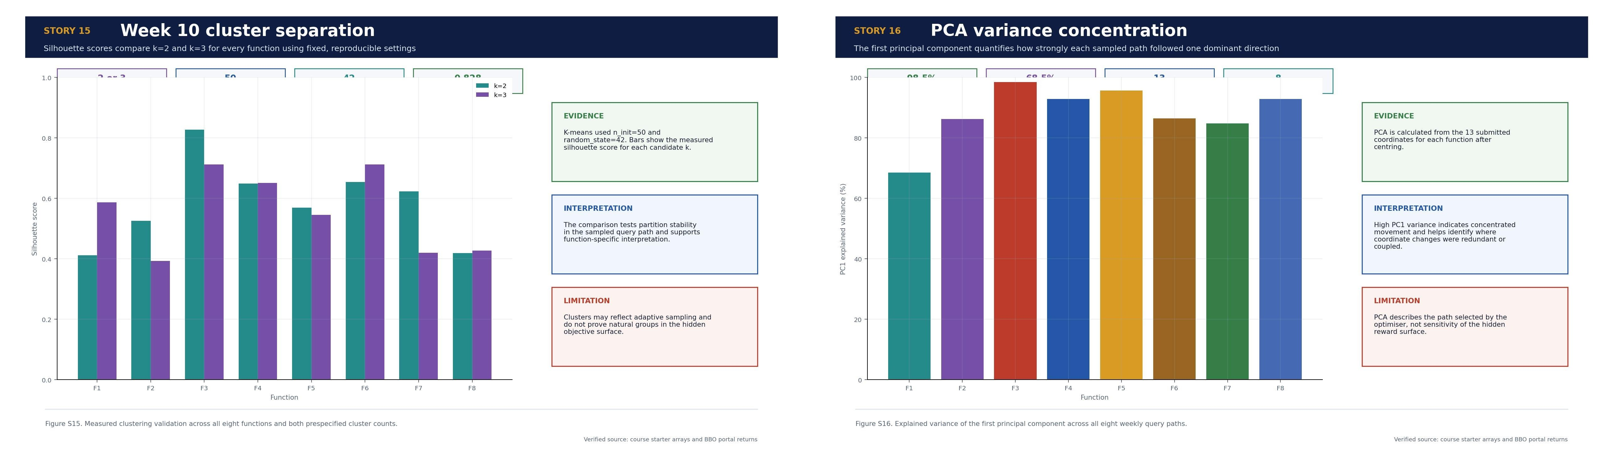
Scientific story infographics S15 and S16
F2 and F3 demonstrated the importance of local geometry. F2 reached 0.7335252043269003 at [0.690000, 0.950000] in Week 12. Changing x1 by only 0.005 reduced the Week 13 output by 0.0921821158135095, suggesting a narrow productive region or steep local response. F3 moved by an L1 distance of 0.015 and improved by 0.003000659, producing a new best. The same action label, local refinement, therefore concealed opposite outcomes.
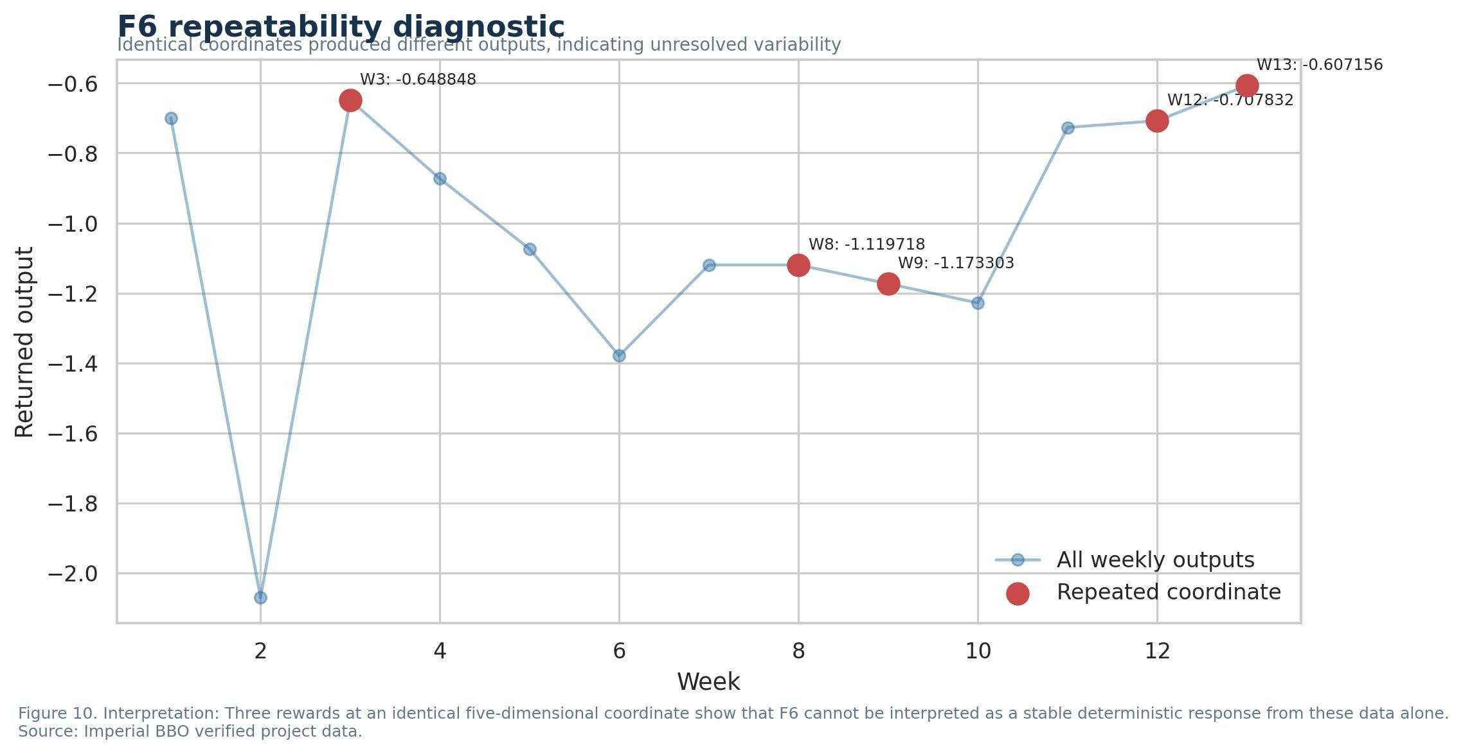
Figure 10
F6 supplied the main repeatability warning. The coordinate [0.700, 0.200, 0.700, 0.700, 0.200] returned different outputs in Weeks 3, 12 and 13. The Week 13 value was the best observed, but the variation prevents a simple deterministic interpretation. Possible explanations include stochasticity, an unobserved process or an evaluation inconsistency. The available evidence cannot distinguish these mechanisms. F1, F4, F7 and F8 provided a useful contrast because their repeated winning coordinates reproduced identical outputs.

4. Trade-offs, decision quality and stopping
The central trade-off was information gain against immediate performance. Early exploratory queries could locate a new region but also consumed one of only 13 opportunities. Late exploration had a higher opportunity cost because there was little time to recover. I therefore shifted from broader investigation towards function-specific refinement, recovery or retention. The movement-versus-change analysis confirmed that a universal step-size schedule would have been inappropriate.
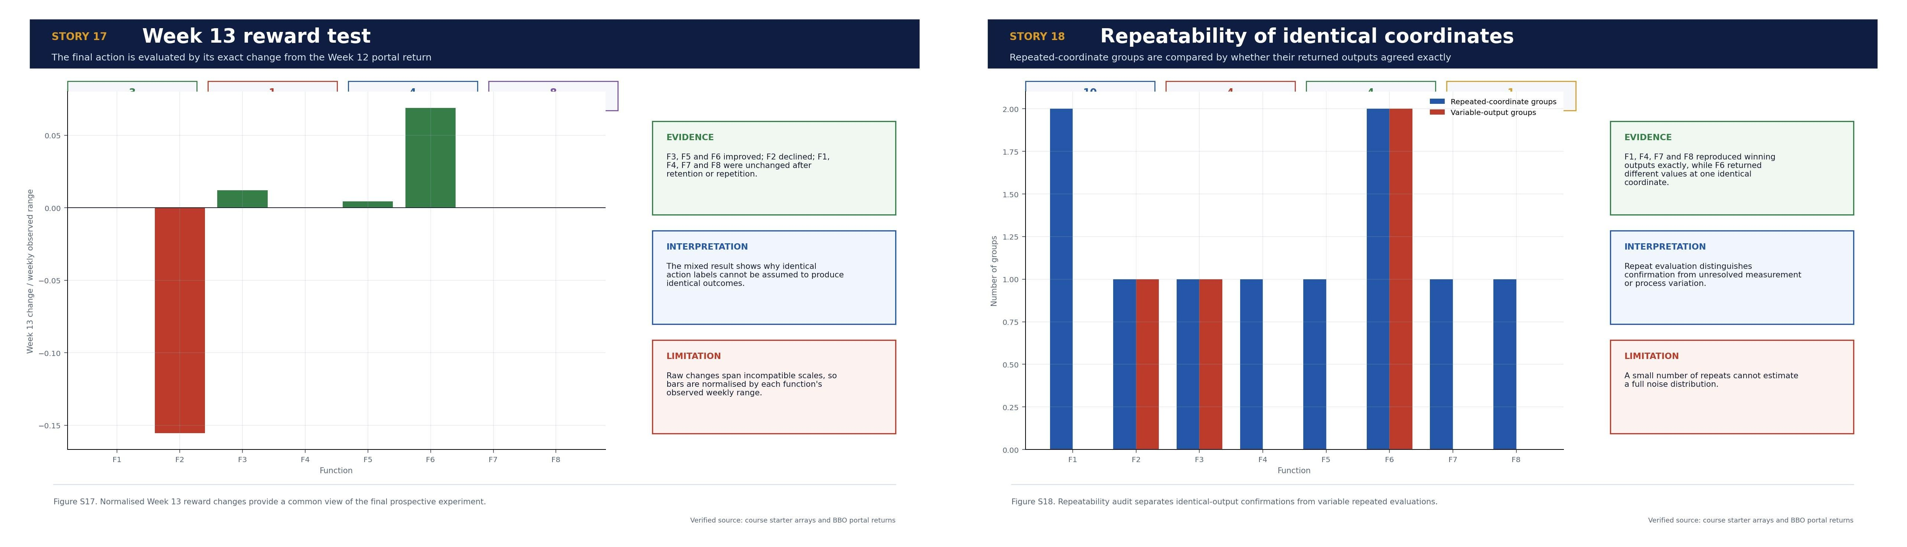
Scientific story infographics S17 and S18
Clustering, PCA and surrogate models improved organisation of the evidence, but each had a defined limitation. Clustering was sensitive to sparse, path-dependent sampling. PCA captured coordinate variance rather than reward sensitivity. Surrogate validation assessed prediction along the observed chronological path and could not guarantee extrapolation into unobserved regions. These methods were decision aids and were checked against the complete returned-output history before submission.
Stopping was function-specific. Routine movement should stop for F1, F4, F7 and F8 because their winners had been recovered and repeatedly confirmed. Further work on F2 should return to the Week 12 neighbourhood and estimate local sensitivity on both sides. F3 and F5 remained continuation targets because their final movements still improved the objective. F6 required a designed repeatability experiment before further optimisation. Continuing all eight functions equally would waste queries and mix optimisation with unresolved measurement uncertainty.
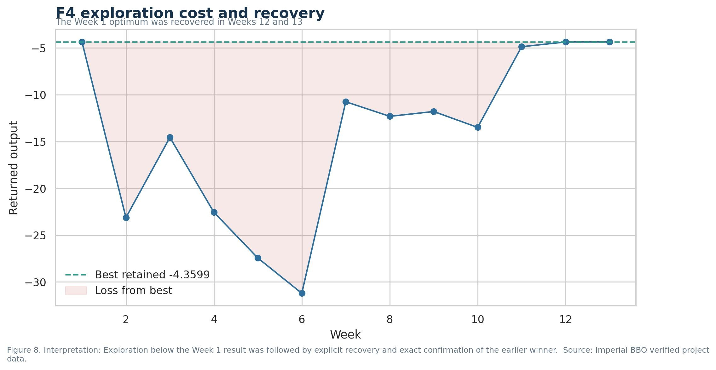
Figure 8

5. Retrospective learning and clinical application
With only 13 evaluations per function, chance remained substantial. One well-positioned exploratory query could reveal a productive region that a reasoned search might miss. After finding a promising point, too few rounds often remained to test competing regions and characterise its neighbourhood. If restarting, I would use broader space-filling exploration initially, followed by symmetric local tests. F2 would have benefited from testing both sides of 0.690000 before moving in one direction. I would establish the validated pipeline and experiment register in Week 1, label each query by purpose and uncertainty, reserve planned repeats, compare acquisition functions by walk-forward validation and define stopping criteria in advance.
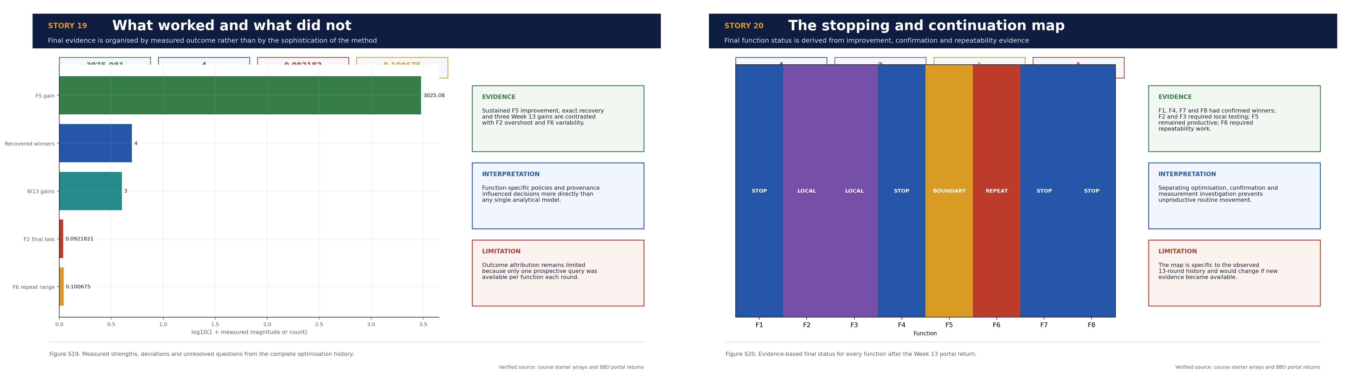
Scientific story infographics S19 and S20
The limited budget also changed how I interpret success: a strong result may reflect a productive strategy, favourable sampling, or both. Confidence therefore depends on reproducibility, local testing and transparent uncertainty, not on the highest observed value alone.
With additional evaluation rounds, I would not simply continue the Week 13 direction for every function. F2 would receive symmetric probes around its Week 12 optimum to estimate local curvature. F3 would receive one smaller step along the successful final direction and one orthogonal check. F5 would require boundary-aware refinement because three coordinates were already close to their upper limits. F6 would receive repeated evaluations at the same coordinate and at a nearby control point before further optimisation. F1, F4, F7 and F8 would remain stopped unless new evidence justified reopening them. This plan separates optimisation, confirmation and measurement investigation.
The main learning was that black-box optimisation is an evidence-management problem as well as a modelling problem. Dimensionality, response scale, local sensitivity, repeatability and query cost differed across the functions. The best decisions came from matching the method to observed behaviour, preserving negative evidence and stating when the data did not support a conclusion. More sophisticated analysis was useful only when its assumptions and validation boundary were explicit. The most surprising result was the contrast between exact repeatability in F1, F4, F7 and F8 and three different F6 outputs at one identical coordinate. I was also surprised that recovery and stopping decisions were sometimes more valuable than another model-driven move.
One further lesson was the value of distinguishing a poor decision from an informative negative result. Several queries reduced the objective, but they still narrowed the plausible search region, exposed unstable directions or justified returning to an earlier winner. Judging each round only by whether it set a new record would therefore miss much of the experimental value. In future work, I would record the intended hypothesis before every query and assess the result against that hypothesis afterwards. This would make unsuccessful evaluations more useful, reduce retrospective rationalisation and provide a clearer basis for deciding whether to explore, refine, repeat or stop.
This has direct relevance to clinical neurology service improvement. Referral thresholds, urgent-recall rules and investigation pathways are also adjusted using limited observations with unequal consequences. A higher average performance measure is insufficient if high-risk patients are missed or an apparent gain reflects random variation. The transferable approach is to preserve provenance, evaluate changes prospectively, monitor subgroup and safety outcomes, repeat uncertain measurements and apply stopping rules. Clinical adoption would require external validation, governance review and continued surveillance rather than direct transfer of the numerical capstone strategy.

