When is cophylogeny evidence of coevolution? The evolutionary ecology of co-speciation.

Timothée Poisot

Apr. 2013

**Conceptual advances in the field of antagonistic coevolution resulted in an increased understanding of how hosts and parasites have a reciprocal impact on their ecology and evolution. While it is known that coevolution can trigger diversification in both the host and its parasite, it is not clear under which set of conditions coevolution will result in mirorring phylogenies. By reviewing the literature related to host-parasite diversification and antagonistic coevolution, I highlight that coevolution is neither necessary nor sufficient in order to establish a co-phylogenetic pattern. The consequences of this fact for the interpretation of the presence or absence of a co-phylogenetic pattern are discussed.**

# Introduction

Since the idea of coevolution as a relevant concept for the study of evolutionary ecology of communities was introduced by Ehrlich and Raven (1964), there has been a vast literature around this concept. The first formal definition of coevolution can be attributed to Janzen (1980): coevolution is a change of traits in a first population as a response to the trait of a second population, *followed by* a change of trait in the second population in response to the new trait in the first (different trait dynamics have been described since then, Gandon et al. 2008). Much emphasis is put on the fact that the existence of an interaction *is not* indicative that the species have coevolved (it can reflect a recent host acquisition, for example). Based on this, Janzen recommends a lot of cautiousness when using the word *coevolution*, and it is worth asking if more than 45 years later, we are being cautious enough.

It is a widely appreciated fact that some symbiontic or interacting systems display a co-phylogenetic pattern. In these situation, (1) the phylogeny of one group of species mirrors the phylogeny of the other group, and (2) species from one group tend to interact with species occupying a position similar to their own on the opposite tree (Fahrenholz 1913). Although exemples of pairs of trees conforming exactly to this rule are scarce, a significant cophylogenetic structure was reported for a variety of systems (some of which are revied by Nieberding, Jousselin, and Desdevises 2010), including monogeneans parasites of Mediterranean sparids (Desdevises et al. 2002) and African cichlids (Mendlova et al. 2012), aphids and their bacteria (Jousselin, Desdevises, and Coeur d’acier 2009), algae and prasinoviridae (Clerissi, Desdevises, and Grimsley 2012), and mimetic heliconid butterflies (Hoyal Cuthill and Charleston 2012). In other instances, phylogenetic analysis failed to demonstrate congruence of the two trees, such as in millipedes and mites (Swafford and Bond 2010). The accumulating evidences that species interactions (notably antagonistic ones, such as hosts-parasites) often resulted in partners sharing a phylogenetic structure was instrumental in developing the notion of *tangled trees* [@Page1994;@Page2003]. It posits that because hosts and parasites species are engaged in intimate interactions with one another, and often have a reciprocal effect on one another fitnesses, we expect that their evolutionary history will show some degree of similarity. A the macro-evolutionary scale, this can result in the host phylogeny and the parasite phylogeny looking alike. In a significant number of these studies, the significance of the cophylogenetic pattern is equated to the likelihood that the host-symbiont system considered is coevolved. Indeed, this trend is clear when looking at the bibliometry (Fig. **xx**).

Historically, looking for correspondences in the phylogenetic history of hosts and parasites to infer a coevolutionary history stems from two central ideas:

1. Both partners represent a strong selective force for one another, given that their interaction has important consequences for their fitness and life-traits. They should hence influence each other evolutionary histories (Crofton 1971), to the point where evolutionary events in one of the partners (the host or the parasite) should trigger an evolutionary event in the other one.
2. One of the species is using the other as its environment, and as such, we should expect it to track this environment in the phylogenetic space, much in the same way that plants and animals track their environmental niche in space. A consequence of this would be that the phylogenetic tree of the exploiting species will mimic its of the exploited species, if only because host speciation will result in "allopatric" speciation in the parasite (Le Gac and Giraud 2004).

The current theoretical framework surrounding the notion of coevolution (Thompson 1994; Thompson 2005) relies on correlation between coevolved traits (Nuismer, Gomulkiewicz, and Ridenhour 2010), and correlations between traits values and fitness (Gomulkiewicz et al. 2000; Gomulkiewicz et al. 2007), which results in reciprocal selection. Although it makes predictions on the diversification of coevolving lineages (Yoder and Nuismer 2010), it is an inherently micro-evolutionary phenomenon. Yet, Thompson (1999) states that coevolution can bridge the gap between micro and macro-evolutionary scales, specifically by focusing on the relationships between traits values and diversification patterns. Phylogenetic tracking (parasites speciate in response to host speciation) can happen without reciprocal selection (several exemples are given in the second part). On the contrary, novel hosts with trait values allowing them to escape their parasites should be advantaged. In this situation, there will be no co-diversification, and we predict a loss of the phylogenetic similarity between hosts and parasites. In this perspective, there are a large number of situations in which (i) co-phylogenetic structure can happen without coevolutionary dynamics (*i.e.* no reciprocal selection), and (ii) reciprocal selection will result in the loss of the co-phylogenetic structure.

More recently, the interactions between coevolutionary processes and phylogenetic structre (including trait conservatism and the phylogenetic determinism of species interactions) received an increased amount of attention in teh emerging field of community phylogenetics. Cavender-Bares et al. (2009) showed that the phylogenetic structure of victims species can be significantly altered by enemies. Specifically, two factors are important in determining the shape of the current victim phylogenetic structure: the conservation (or convergence) of defenses, and the generality of enemies. Combination of these two factors can alter both the structure of the victim phylogeny, and the extent to which (defense) traits are conserved through it. @mouquet_ecophylogenetics_2012 emphasized that phylogenetic information is critical to understand the current structure of interaction networks, as long as we are able to understand (i) the current structure and evolutionary history of traits, and (ii) how this trait structure relates to species interaction.

With these elements in hand, it appears that understanding the relationship between the co-evolutionary process and the phylogenetic structure of host-parasite assemblages is an important research perspective. The litterature mentionned in this introduction suggest that (i) a co-phylogenetic structure can emerge without co-evolutionary dynamics, and (ii) coevolutionary dyanmics can impede the establishment of a co-phylogenetic structure. In this contribution, I review empirical and theoretical studies to further clarify the interactions between the two. I challenge the idea that detecting a co-phylogenetic structure allows concluding that coevolution is occuring. I do so by showing that coevolution is neither necessary (co-phylogenetic structure can emerge outside of coevolving interactions), nor sufficient (coevolution can lead to non-matching phylogenies), to establish a cophylogenetic pattern. I briefly discuss the consequences of these facts for the methodology on co-phylogenies. Finally, I explore the role of several coevolutionary scenarios in preventing the establishment of a co-phylogenetic structure, and show that they have predictible consequences on the observed co-phylogeny. I conclude by recommending that we do away with the idea that co-phylogeny implies coevolution (and that conversely, the lack of a co-phylogeny implies no co-evolution), as it can severely undermine our ability to understand the evolution of defense mechanisms in coevolved interactions.

# Coevolution is neither necessary nor sufficient

In this part, I propose that cospeciation and coevolution should be considered as two distinct processes. One (cospeciation) can arise as a consequence of the other, but neither is coevolution necessary, nor sufficient, in triggering the establishment of a co-phylogenetic pattern. I illustrate these aspects through various empirical examples.

What I would like to achieve with this part is to show that there are times when coevolution will lead to no phylogenetic pattern, or when phylogenetic pattern can appear in coevolutionary coldspots. This will establish that coevolution != codivergence, and begs the question of when the cophylogenetic pattern should emerge through coevolution.

## Coevolution is not necessary: cospeciation without coevolution

The importance of spatial processes in the establishment of a co-phylogenetic pattern has been recognized for a long time. Phylogenetic reconstruction of amphibians and their parasites from the genus *Polystoma* (Bentz et al. 2006) established that co-speciation events were for a vast majority well explained by the acquisition of new host habitats at a large (continental) biogeographic scale. A similar situation was reported in a variety of other systems. The highly significant cophylogenetic structure of toucans and chewing lices is explained by biogeographic events (Weckstein 2004). Peterson, Pfister, and Bell (2010) show that fungal parasites of the southern beech from the genus *Cyttaria* show some degree of cophylenetic structure with their host, despite having a wide host range. However, most of the clear co-divergence events can be attributed to biogeographic events, most notably the breakup of Gondwana. In these examples, the host and parasite phylogeny display a good level of congruence, but the mechanism through which this congruence emerges has nothing to do with the coevolutionary process.

Looking into more details into the biology of these systems, it is possible to better understand the properties of host-parasites associations having or not a cophylogenetic structure. Dispersal-limited parasites with a narrow host-range should be expected to display a better phylogenetic congruence with their hosts. Generalists parasites, or those able to disperse over long distances, should have a distinct phylogeny from their hosts. This is particularly striking in the analyses of Jackson and Charleston (2004): viruses with (mostly) vertical transmission are more phylogenetically congruent with their hosts than are viruses with (mostly) horizontal transmission. It must also be noted that higher dispersal can allow the evolution of a wider host range, as a more heterogeneous population of hosts is encountered (Poisot et al. 2011), which will (as illustrated later on) decrease the likelihood that a cophylogenetic signal is detected.

In the most extreme case, a perfect co-phylogenetic pattern is expected when host speciation events are completely independent of the parasites. Each time two host populations speciate because of distance separation, if parasite dispersal is low, a parasite speciation event is expected to occur. Note that this makes no assumption about trait matching between the host and the parasite, and can occur even if the parasite has almost no fitness effect on its host. In this case, concluding that the perfect co-phylogenetic pattern indicates coevolution is deeply misleading. Note that this can also arise in environments wherein the reciprocal selection is weak (the so-called "coevolutionary cold-spots"); in these environments, there is no correlation between traits values and fitness, and even though the two species can co-evolve, no coevolutionary dynamics is established (*i.e.* the direction of trait change is random). In these environments, parasites can co-speciate with these hosts, but coevolution is not the mechanism driving the co-speciation.

## Coevolution is not sufficient: coevolving without cospeciating

speciation is driven by non-interactive constraints

Diffuse coevolution, dispersal, high degree of generality

(Jackson and Charleston 2004) some RNA viruses are congruent, others are not: viruses with wide host ranges and horizontal transmission due to high virulence show *less* congruence than specialized benign viruses

More than two-ways symbioses with generalist species

# Methodological consequences

In the previous part, I **what?**

This view bears important methodological consequences, as I show that (i) the detection of a co-phylogenetic structure is not a good indicator of wether coevolution occured or not, and (ii) some of these tests may furthermore be biased by some situations which are likely to arise in coevolutionary systems.

There has been a number of methodological developments surrounding the significance of a co-phylogenetic pattern. SHORT REVIEW.

A good number of these methods have strong underlying assumptions, some of which may make little ecological sense. Looking at the method behind *ParaFit* (Legendre, Desdevises, and Bazin 2002)], it is clear that the emergence of generalist parasites will result in a loss of statistical power. This test works on the assumption that most of the parasitic lineages are highly specialized, which was the dominant opinion in systematic parasitology at some point REF, and may hold true for broad taxonomical scales REF. Should generalists parasites appears at several places in the tree, even after a perfect series of cospeciation, they would prevent the detection of the cospeciation events.

PROBLEM WITH THIS – if coevo leads to more generalism, even after cospe, then viewing these as evidences of coevo will tell no coevo !!!

* Assumptions behind tests of cospeciation (Parafit and subsequent methods), and how they relate to the biological reality

Some interesting recent proposals have been made to better integrate evolutionary and ecological mechanisms in the study of host-parasites community phylogenetics, starting with a replacement of the world co-phylogeny by co-phylogeography (Nieberding, Jousselin, and Desdevises 2010). This step is extremely important, as it explicitely accounts for the spatial signal in the … **more**

# Should coevolution result in cospeciation ?

In this part, I propose scenarios under which we can assume the coevolutionary process to result in a cophylogenetic pattern. **more**

As mentionned in the introduction, coevolution requires correlations between the traits of one partner and both its fitness and the fitness of the other partner [@Nuismer2010], though correlation itself do not necessarily result in coevolution **ref**. Co-speciation, which can be revealed by the existence of a co-phylogenetic pattern, emerges when an evolutionary event (i.e. speciation) in one partner results in speciation in the other partner. The initial speciation even can be induced spatial constraints, niche differentiation, or can be triggered by the interaction with the parasite.

As we show in the previous part, this event can occur with no associated change in fitness. Yet, this do not preclude the fact that under some conditions, coevolution can be the triggering factor in a co-speciation event.

Reformulate this argument : Coevolution: evolutionary changes in Partner X leads to differential fitness among individuals of Partner Y. The latter then evolves in response to the selection force imposed by the former, and vice versa.

Co-speciation: evolutionary changes (e.g., measured by genetic divergence) in Partner X is induced by the evolutionary changes in Partner Y, with the consequent correlated changes leading to phylogenetic concordance between the two partners. It is better to illustrate this with an example of chewing lice-pocket gopher co-speciation. When gopher populations become fragmented and genetically diverged, the chewing lice carried on them become fragmented and genetically diverged as well, leading to phylogenetic concordance between the lice and the gopher. The population fragmentation of chewing lice is induced by the population fragmentation of the gophers, but not vice versa.

YES but gradual changes early in the coevolutionary process can, during sympatric speciation, lead to fitness changes if the parasite is specialist

## The co-phylogeny scenarios

The emergence of perfectly matching phylogenies requires that each host speciation event is matched by a parasite speciation event (and reciprocally), while no other evolutionary events happen [@Page1994]. Any deviation from this situation will result in a decrease of the matching between the host and parasite phylogenies. Broadly speaking, one can describe four categories of evolutionary events decreasing the matching between phylogenies: intra-host speciation (independant speciation of the parasite), failure to cospeciate (independant speciation of the host, with one incipient species non infected by the parasite), host acquisition and host switch, and finaly parasite extinction.

All of these events have been well described in a variety of empirical systems.

host-switch can give congruent phylo, see De Vienne 2007

(Jackson and Charleston 2004) and [@DeVienne20070]: host-siwtch towrads phylo related hosts can give congruent phylogenies if the pathogen evolves faster than the host

## Coevolutionary mechanisms behind the lack of cophylogenetic signal

In this part, I show how coevolution can, and under some circumstances, is expected to, result in the four previously described events, thus preventing the establishment of a cophylogenetic structure.

**Coevolution can trigger intra-host speciation.**

# Conclusions

assuming that cophylo = coevo can hinder our understanding of how defense evolve: janzen (evolved IN THE PAST), cavender-bares

need to better integrate the spatial/temporal turnover (Alvarez et al. 2010)

# Figures

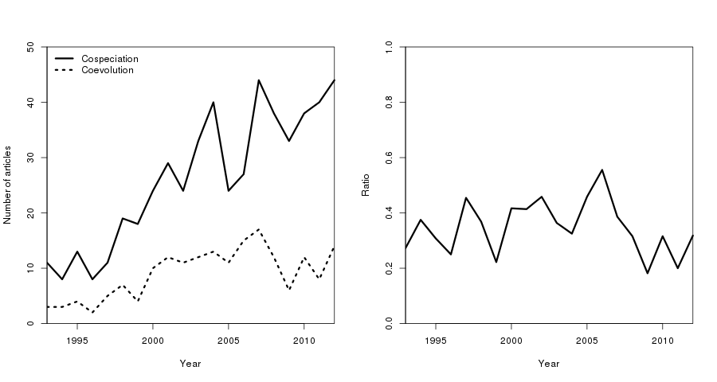

Bibliometric analysis of the cophylogeny-coevolution association. Left: Number of articles published each year (data from Web of Knowledge) with cospeciation, codivergence, or cophylogeny in the text (plain line), and subset of these articles also mentioning coevolution (dashed line). Right: proportion of the papers about cophylogeny, cospeciation or codivergence mentioning coevolution. This ratio has been stable (around 0.34) since the 1990s.

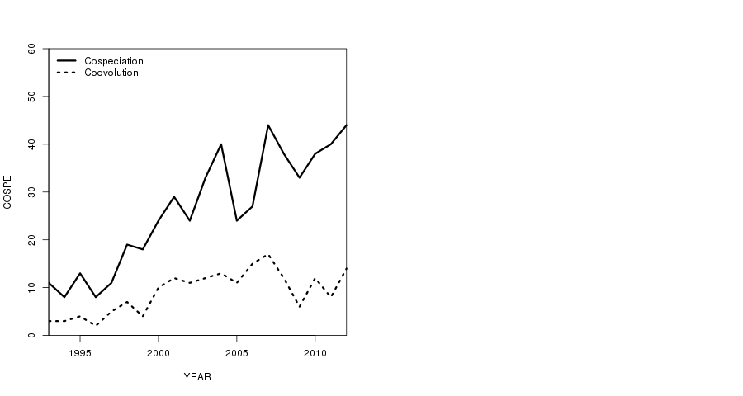

Effect of adding interactions in a host-parasite interaction matrix on the results of *ParaFit*. The data used come from **ttt**. Left panel: value of the parafit global statistic (lower value inidicate high support for coevolution). Right panel: p-value of the parafit test. In both panels, the outcome of 100 simulations (mean plus/minus one standard deviation) are ploted. The solid line is the value on the original dataset. In the right panel, the dashed line represents *p = 0.05*.

# References

Alvarez, Nadir, F. Kjellberg, D. McKey, and Martine Hossaert-McKey. 2010. “Phylogeography and historical biogeography of obligate specific mutualisms.” In *The Biogeography of Host–Parasite Interactions*, ed. Serge Morand and Boris R. Krasnov, 31–39. Oxford University Press. <http://118.97.161.124/perpus-fkip/Perpustakaan/Geography/Biogeography/Biogeography%20of%20Host%20Parasite%20Interaction.pdf page=42>.

Bentz, Sophie, N. D. Sinnappah-Kang, L. H. S. Lim, B. Lebedev, Claude Combes, and Olivier Verneau. 2006. “Historical biogeography of amphibian parasites, genus Polystoma (Monogenea: Polystomatidae).” *Journal of Biogeography* 33 (4): 742–749.

Cavender-Bares, Jeannine, Kenneth H. Kozak, Paul V. A. Fine, and Steven W. Kembel. 2009. “The merging of community ecology and phylogenetic biology.” *Ecology Letters* 12 (7) (jul): 693–715. doi:10.1111/j.1461-0248.2009.01314.x. <http://www.ncbi.nlm.nih.gov/pubmed/19473217>.

Clerissi, Camille, Yves Desdevises, and Nigel Grimsley. 2012. “Prasinoviruses of the marine green alga Ostreococcus tauri are mainly species specific.” *Journal of virology* 86 (8) (apr): 4611–9. doi:10.1128/JVI.07221-11. <http://www.ncbi.nlm.nih.gov/pubmed/22318150>.

Crofton, H. D. 1971. “A quantitative approach to parasitism.” *Parasitology* 62: 179–193.

Desdevises, Yves, Serge Morand, Olivier Jousson, and Pierre Legendre. 2002. “Coevolution between Lamellodiscus (Monogenea: Diplectanidae) and Sparidae (Teleostei): the study of a complex host-parasite system.” *Evolution* 56 (12): 2459–2471.

Ehrlich, P. R., and P. H. Raven. 1964. “Butterflies and plants: a study in coevolution.” *Evolution* 18 (4): 586–608.

Fahrenholz, H. 1913. “Ectoparasiten und abstammungslehre.” *Zoologischer Anzeiger* 41: 371–374.

Gandon, Sylvain, Angus Buckling, Ellen Decaestecker, and Troy Day. 2008. “Host-parasite coevolution and patterns of adaptation across time and space.” *Journal of Evolutionary Biology* 21 (6): 1861–1866.

Gomulkiewicz, Richard, D. M. Drown, Mark F. Dybdahl, W. Godsoe, Scott L. Nuismer, K. M. Pepin, Benjamin J. Ridenhour, C. I. Smith, and Jeremy B. Yoder. 2007. “Dos and don’ts of testing the geographic mosaic theory of coevolution.” *Heredity* 98 (5): 249–258.

Gomulkiewicz, Richard, John N. Thompson, Robert D. Holt, Scott L. Nuismer, and Michael E. Hochberg. 2000. “Hot spots, cold spots, and the geographic mosaic theory of coevolution.” *The American Naturalist* 156: 156–174.

Hoyal Cuthill, Jennifer, and Michael Charleston. 2012. “Phylogenetic Codivergence Supports Coevolution of Mimetic Heliconius Butterflies.” Ed. Corrie S. Moreau. *PLoS ONE* 7 (5) (may): e36464. doi:10.1371/journal.pone.0036464. <http://dx.plos.org/10.1371/journal.pone.0036464>.

Jackson, Andrew P., and Michael A. Charleston. 2004. “A cophylogenetic perspective of RNA–virus evolution.” *Molecular biology and evolution* 21 (1): 45–57. <http://mbe.oxfordjournals.org/content/21/1/45.short>.

Janzen, Daniel H. 1980. “When is it coevolution?.” *Evolution* 34 (3): 611–612.

Jousselin, Emmanuelle, Yves Desdevises, and Armelle Coeur d’acier. 2009. “Fine-scale cospeciation between Brachycaudus and Buchnera aphidicola: bacterial genome helps define species and evolutionary relationships in aphids.” *Proceedings of the Royal Society B: Biological Sciences* 276 (1654) (jan): 187–196. doi:10.1098/rspb.2008.0679. <http://www.pubmedcentral.nih.gov/articlerender.fcgi?artid=2614242&tool=pmcentrez&rendertype=abstract>.

Le Gac, M., and T. Giraud. 2004. “What is sympatric speciation in parasites?.” *Trends in Parasitology* 3 (5) (may): 404–411. doi:10.1016/j.pt.2004.02.003. <http://scholar.google.com/scholar?hl=en&btnG=Search&q=intitle:What+is+sympatric+speciation+in+parasites? 0>.

Legendre, Pierre, Yves Desdevises, and Eric Bazin. 2002. “A statistical test for host-parasite coevolution.” *Systematic Biology* 51 (2): 217–234.

Mendlova, Monika, Yves Desdevises, Kristina Civanova, Antoine Pariselle, and Andrea Simková. 2012. “Monogeneans of West African Cichlid Fish : Evolution and Cophylogenetic Interactions.” *PLoS One* 7 (5): e37268. doi:10.1371/journal.pone.0037268.

Nieberding, Caroline, Emmanuelle Jousselin, and Yves Desdevises. 2010. “The use of co-phylogeographic patterns to predict the nature of host-parasite interactions, and vice versa.” In *Biogreography of host-parasite interactions*, ed. Serge Morand and Boris Krasnov. Oxford: Oxford University Press.

Nuismer, Scott L., Richard Gomulkiewicz, and Benjamin J. Ridenhour. 2010. “When Is Correlation Coevolution?.” *The American Naturalist* 175 (5): 525–537.

Peterson, Kristin R., Donald H. Pfister, and Charles D. Bell. 2010. “Cophylogeny and biogeography of the fungal parasite Cyttaria and its host Nothofagus, southern beech.” *Mycologia* 102 (6): 1417–1425. <http://www.mycologia.org/content/102/6/1417.short>.

Poisot, Timothée, James D. Bever, Adnane Nemri, Peter H. Thrall, and Michael E. Hochberg. 2011. “A conceptual framework for the evolution of ecological specialisation.” *Ecology Letters* 14 (9) (jun): 841–851. doi:10.1111/j.1461-0248.2011.01645.x. <http://www.ncbi.nlm.nih.gov/pubmed/21699641>.

Swafford, L., and J. E. Bond. 2010. “Failure to cospeciate: an unsorted tale of millipedes and mites.” *Biological Journal of the Linnean Society* 101 (2): 272–287. doi:10.1111/j.1095-8312.2010.01499.x. <http://dx.doi.org/10.1111/j.1095-8312.2010.01499.x>.

Thompson, John N. 1994. *The Coevolutionary Process*. Chicago: University of Chicago Press.

———. 1999. “The raw material for coevolution.” *Oikos* 84 (1): 5–16.

———. 2005. *The Geographic Mosaic of Coevolution*. University Of Chicago Press.

Weckstein, Jason D. 2004. “Biogeography explains cophylogenetic patterns in toucan chewing lice.” *Systematic Biology* 53 (1): 154–164. <http://sysbio.oxfordjournals.org/content/53/1/154.short>.

Yoder, Jeremy B., and Scott L. Nuismer. 2010. “When does coevolution promote diversification?.” *The American Naturalist* 176 (6) (dec): 802–817. doi:10.1086/657048. <http://www.ncbi.nlm.nih.gov/pubmed/20950142>.