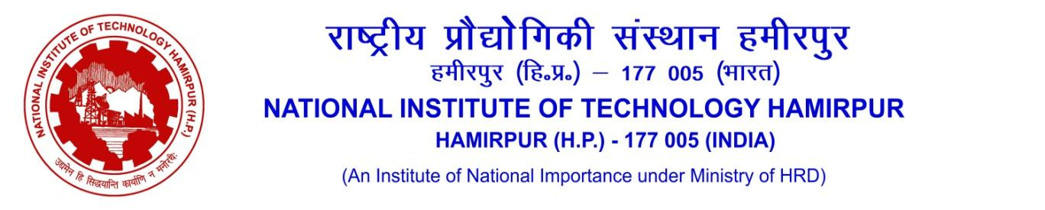
OFFICE OF TRAINING & PLACEMENT
------------------------------------------------------------------------------------------------------------------------------------------------
Job Notification Form/Internship Form
Name of Organization - ________________________________________

Sr. No. | Nature of Drive | Eligible Batches | Specify | No. of likely Vacancies | Remarks
1 | Placement Drive | (UG, PG & PhD) |  |  | Tentative Date of Joining: _______
2 | Internship Drive | - Current (Final Year) Batch B.Tech Students are available for both full time on-line/off-line mode internship up to six months between Jan-June in final semester.  - Current (Final Year) Batch Dual Degree students are available for both full time on-line/off-line mode internship upto six months between Jan-June in final semester.  - Current (Final Year) Batch M.Tech 2nd year students are available for both full time on-line/off-line mode internship initially upto six months, extendable upto 12 months. |  |  | Duration of Internship :  Tentative Start Date:
3 | Both (As mentioned above) | Internship+PPO |  |  | Duration of Internship :  Tentative Start Date:
Note: - Any other internship with or without PPO for B.Tech, Dual Degree, MBA, MSc. students shall only be allowed in online (part time) mode, beyond the routine academic activity hours. No relaxation in academic requirements will be allowed to such students.

1 | Gross Emoluments/ CTC/Pay Package (per annum inclusive of all bonuses) | Placement (Package/PPO): |  |  |  | Internship Stipend:
2 | Job Profile
3 | Eligibility Criteria for students*(For Placement)
4 | Eligibility Criteria for students*(For Internship)
5 | Recruitment Process
 | Mode of Hiring Process | Virtual |  | Onsite
 | Pre-Placement Talk | Yes/No:
 | Written Test | Aptitude |  | Technical
 | Group Discussion | Yes/No
 | Personal Interview | Yes / No
 | Tentative date for conducting Placement/Internship drive | :
 | Tentative date for sharing list of selected candidates | :
6 | No. of persons visiting NIT Hamirpur (If placement drive is to be conducted in onsite mode)
7 | Job Location (Tentative)
8 | Any other specific information:
9 | Contact details of HR | Primary |  |  | Secondary
 | Name
 | Mobile Number
 | Email
*Grading is done on a 10-point scale. NIT Hamirpur has not evolved any formula to convert the CGPI into percentage. However, the CGPI may be notionally converted to percentage by multiplying the CGPI with 10.
Please select (Yes/No) the eligible Programs/Specializations for drive as mentioned below
Sr. No. | Programs Offered | Specializations |  |  | Yes/No
 | B.Tech. disciplines to be considered (4-year course)  (please tick or write yes/no ) | CIRCUITAL BRANCHES
 |  | Computer Science & Engineering
 |  | Mathematics & Computing Engineering (Software Oriented)
 |  | Electronics & Communication Engineering
 |  | Electrical Engineering
 |  | Engineering Physics
 |  | CORE (NON-CIRCUITAL) BRANCHES
 |  | Mechanical Engineering
 |  | Chemical Engineering
 |  | Civil Engineering
 |  | Material Science & Engineering (Metallurgical Engineering)
 | Dual Degree (5-year Course: B.Tech. +M.Tech.) | Computer Science & Engineering
 |  | Electronics & Communication Engineering
 | B.Arch. (5-year Course) | Architecture
 | M. Arch. (2-year Course) | Sustainable Architecture
 | M.Tech. (2-year Course)  (please tick or write yes/no) | Civil Engineering
 |  |  |  | Environment
 |  |  |  | Geotechnical
 |  |  |  | Structures
 |  |  |  | Transportation
 |  |  |  | Water Resources
 |  | Computer Science & Engineering
 |  |  |  | Computer Science & Engineering (Artificial Intelligence)
 |  |  |  | Computer Science & Engineering
 |  | Centre for Energy Studies
 |  | (a) | Energy Technology
 |  | Chemical Engineering
 |  | (a) |  | Chemical Engineering
 |  | Electrical Engineering
 |  |  |  | Condition Monitoring of Power Apparatus
 |  |  |  | Power System
 |  |  |  | Signal Processing & Control
 |  | Electronics & Communication Engineering
 |  |  |  | Communication Systems & Networks
 |  |  |  | VLSI Design
 |  | Material Science & Engineering
 |  | (a) |  | Material Science & Engineering
 |  | Mechanical Engineering
 |  |  |  | Design
 |  |  |  | Manufacturing
 |  |  |  | Thermal
 | Master of Business Administration | MBA
 |  | (Marketing Mgmt.|Operations Mgmt.| Financial Mgmt.|HR Mgmt.)
 | M. Sc. Programs  (2-year course) | Chemistry
 |  | Mathematics & Computing
 |  | Physics & Photonics Science

