|  |
| --- |
| **Dynamic Terrain:**  **Documentation and step-by-step instructions for modelling turbulence wind flow and wind induced loads in the ABL** |
| Theodore Potsis* and Ted Stathopoulos  Department of Building, Civil and Environmental Engineering, Concordia University, Montreal, Quebec, Canada  *theodore.potsis@concordia.ca |

**1. Introduction**

This report aims to document the Dynamic Terrain (DT) methodology implemented in OpenFOAM/v2012 for modeling turbulence wind flow and wind induced loads. The methodology will be detailed and demonstrated through a step-by-step case study focusing on wind flow and wind induced loads on roofs of a low-rise building. Through these procedural steps, the objective is to model the atmospheric boundary layer (ABL) with a suburban exposure (Type B based on ASCE 49-21) at the incident flow that will interact with a low-rise building, with the ultimate goal of extracting pressure time series from selected locations. These time series will subsequently undergo Extreme Value Analysis (EVA) to estimate the peak local pressures on the roof of the low-rise building. The code is publicly accessible in gitHub/Dynamic_Terrain and utilizes C++ v11.

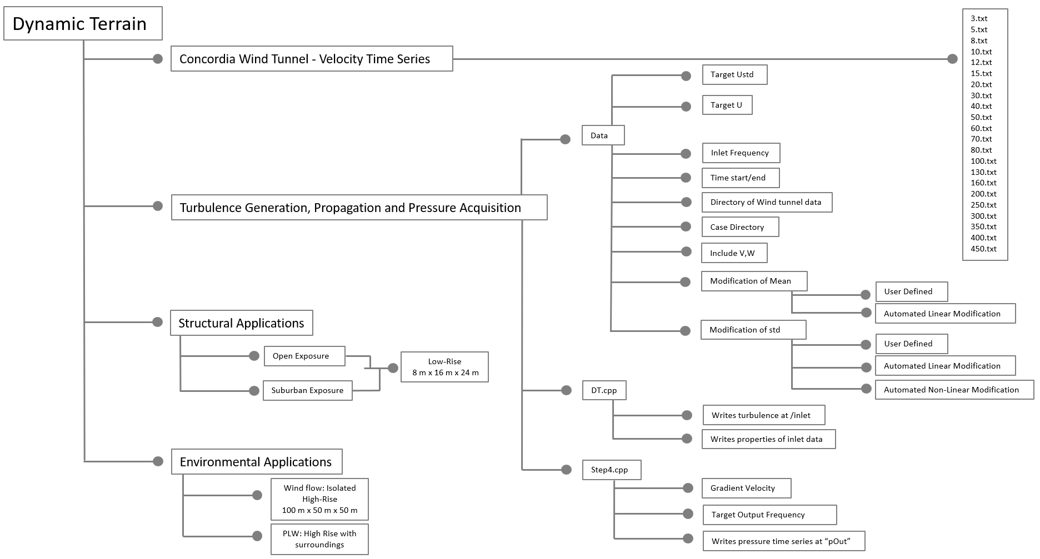

**Figure 1.** Structure of directories found in the database

In Figure 1, the structure of the database is presented that regards all the directories and files that are publicly accessible. In the first branch the wind tunnel database is presented with the velocity time series. The second branch relates with the DT steps that are explained in Section 3 of the document. Finally, some case studies of structural and environmental application are presented that have been used in Potsis and Stathopoulos, 2024 and Potsis et. al., 2024.

**2. Computational domain and case study**

To facilitate this case study and accurately model the incident flow, it is imperative to create an Empty Computational Domain (ECD) devoid of any buildings. In this documentation, a computational domain with dimensions outlined in Figure 1 has been established. It is strongly advised to maintain a height of 0.5 meters for the ECD, as this aligns with the maximum height tested in the DT methodology data thus far. While the lateral dimensions of the ECD can be adjusted to suit other applications, the specified height is recommended for consistency. The streamwise direction of the domain may vary depending on the specific application, with no imposed restrictions. OpenFOAM offers various meshing techniques, such as blockMesh, for generating the ECD. The domain was divided in 150 elements in x-direction, 95 in the y-direction and 98 in the z-direction. Further inflation of the mesh near the ground is selected with an aspect ratio of 1.08. For comprehensive guidance on ECD generation, refer to the example script labeled ~/setECD, which contains essential details.

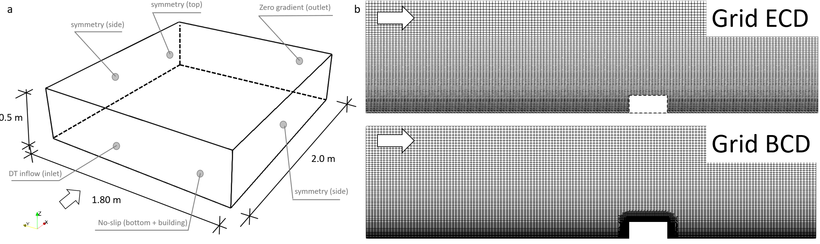

**Figure 2.** Computational domain (a) and grids of ECD and BCD that were utilized for the case study (b)

The case study serving as an illustration for applying the DT method involves a suburban exposure (Type B) on a low-rise building with full-scale dimensions of H x B x D = 8 m x 16 m x 24 m. A scaling of 1:100 was selected for this study. The Empty Computational Domain (ECD) depicted in Figure 2b is utilized for the first three steps of the methodology, while the Building Computational Domain (BCD), including the building, is employed for the final step. To construct the BCD, the ECD is inflated near the building in three distinct regions. Within a region of H/2 around the building, the mesh size is set to H/32, whereas in a region extending to H/4, the mesh size is reduced to H/64. Lastly, the mesh near the building within a region of H/16 features a mesh size of H/128. The total mesh count is 1.2 x 106 cells for the ECD and 3.8 x 106 cells for the BCD. Details regarding the selection of numerical parameters and solution properties can be found in the corresponding files within the database.

**3. Dynamic terrain steps**

*3.1. Dynamic Terrain Step 1: Wind tunnel Velocity Time series Database*

The DT methodology involves generating and propagating turbulence wind flow representative of the Atmospheric Boundary Layer (ABL) using time series data extracted from the Concordia Wind Tunnel (Stathopoulos, 1984). These data are located within the "Wind Tunnel – Velocity Time Series" directory. Each file within this directory is named according to the height of the probe in millimeters, with a data output frequency of 1000 Hz and a duration of 23.12 seconds for each of the four experimental data sets. In total, there are 92,480 data for the three wind directions, comprising 4 sets of 23,120 data from each experiment. Figure 3 illustrates the mean, turbulence intensity, and integral length scale profiles of these data. The mean velocity at z=10 m is U=8.6 m/s. The wind profile corresponds to exposure type B as defined in ASCE 49-21. During the first step, these velocity time series are used as inflow conditions with the same inlet frequency as they were extracted from the wind tunnel.

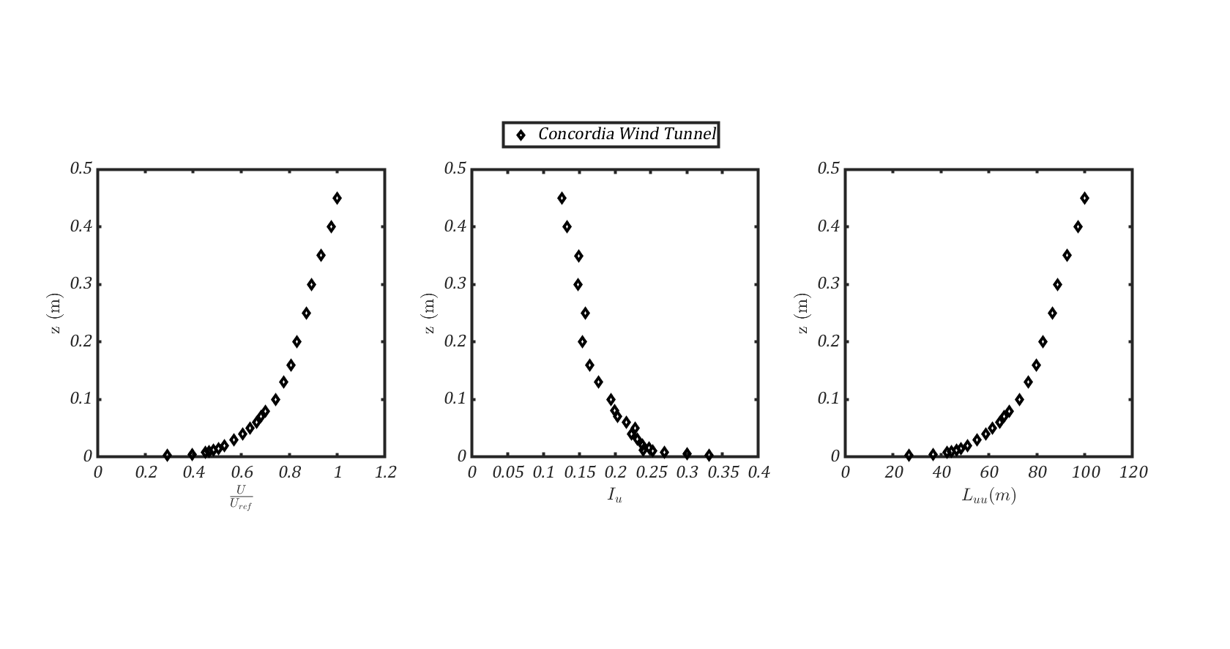

**Figure 3.** Mean (a), turbulence intensity (b) and integral length scale (c) of Concordia wind tunnel data in the database

The computational inlet condition utilized for the DT method in OpenFOAM/v2012 is the "timeVarryingMappedFixedValue" (OpenFOAM, 2024). The mode is set to the default with linear interpolation. To apply this condition, specific files must be created within the directory ~/constant/boundaryData/inlet/<time>/U. Here, <time> refers to the time of analysis when the velocity data in U will be imposed on the boundary named "inlet". A very important aspect is that the velocity time series should imposed in a quasi-steady manner at the inlet plane. This means that the profiles should be kept constant during a specific period. This period is related with the inverse of the inlet frequency (IF-1) that is selected in Step 2 (Section 3.2). To achieve this, the code in L.5, creates two directories with name <time> and <time>+IF-1-e, where e is a very small value (10^-10), where the same inlet conditions are included in files U.

Additionally, a file named "points" must exist within the directory ~/constant/boundaryData/inlet/, specifying the location of each control point at the inlet boundary for each <time> that the data in file U will be imposed. For DT purposes, 22 vertical points are selected, uniformly distributed across the entire inlet plane. This distribution is achieved by selecting 11 vertical lines of control points, one at the plane's symmetry and five on each side with equal spacing. While various distribution methods are possible, this approach was chosen to ensure consistent results.

*3.2. Dynamic Terrain Step 2: Inlet frequency (I.F.)*

The next crucial step involves tuning the inlet velocity time series to select the appropriate Inlet Frequency (IF), aiming to enhance the energy of small-scale turbulence fluctuations within the computational domain. These fluctuations typically occur at lengths beyond the cut-off length of Large Eddy Simulation (LES). As discussed in Potsis and Stathopoulos (2024), the inlet frequency should be set to 50 to 100 times greater than the cut-off frequency of LES. This process requires iteration to ensure that the chosen inlet frequency aligns with the selected mesh and computational setup.

In the current setup detailed in Section 2, the inlet frequency of Step 1 (IF =1000 Hz) and Step 2 (IF= 5000 Hz), are illustrated in Figure 4. These results are depicted at a height of 0.08 meters (or 8 meters at full-scale), but similar comparisons can be made across the entire Atmospheric Boundary Layer (ABL). Consistency in the qualitative outcome of the tuning process should be maintained across different setups. For instance, the increase in energy beyond the cut-off frequency of LES (fc = 66.29 or nc = 0.56) should be verified to match the distribution of wind tunnel data from CWT. The target inlet frequency can be adjusted in the Data file at line 5.

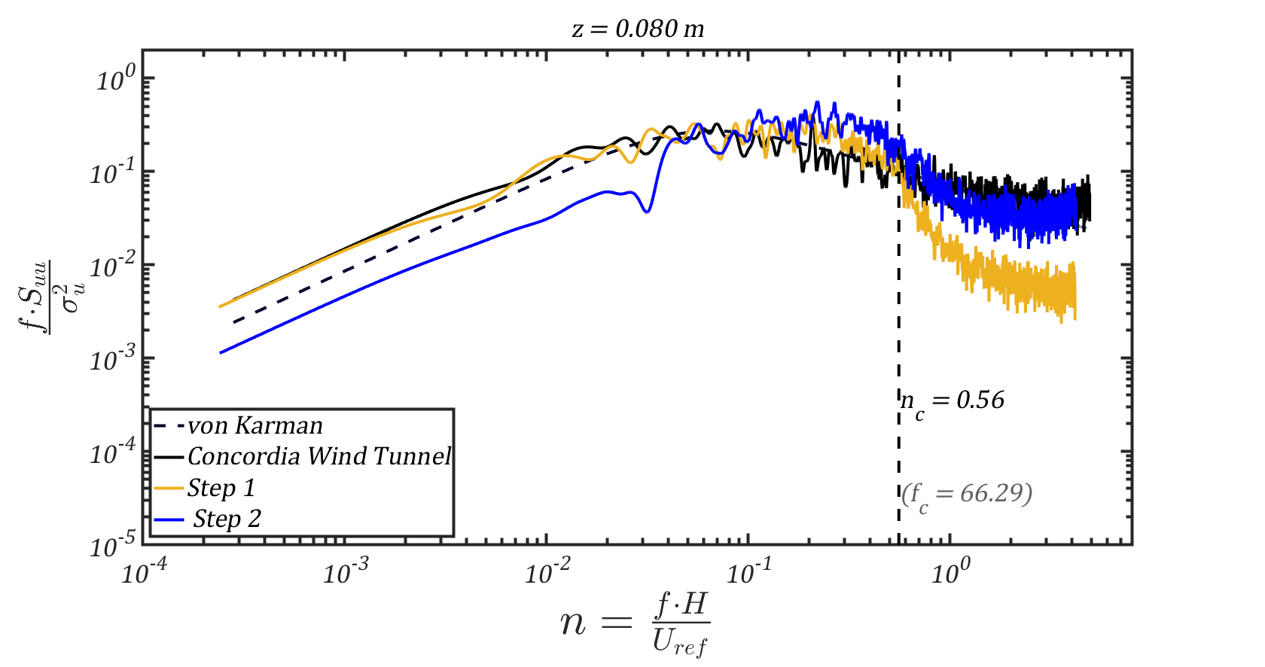

**Figure 4.** Normalized spectrum of longitudinal velocity of the incident flow at roof height from Steps 1 and 2 compared with Concordia Wind Tunnel data and theoretical von Karman spectrum

*3.3. Dynamic Terrain Step 3: Inflow modification*

Step 3 is further divided into two procedures: the adjustment of inflow data concerning the mean (Step 3a) and standard deviation (Step 3b) to compensate for turbulence losses within the computational domain, from the inlet to the building's location. This step is highly sensitive to the computational setup (mesh, numerical settings) and the desired exposure. For visualization, refer to Figure 5a: modifying the mean profile of the time series at the inlet (from green to mauve) enables the alternation of the mean profile at the incident flow (from blue to red). A similar approach is adopted for the standard deviation profile, to achieve the target exposure in terms of mean and turbulence intensity profiles at the incident flow.

The modification of the mean profile (Step 3a) can be accomplished in two ways. Firstly, through a user-defined modification matrix of the data that linearly scales up (or down) the mean values of the inflow. This matrix should correspond to the number of control points (22) and written in a file that is read from the Data file at Line 62. Secondly, by providing the target mean profile at the incident flow and the velocity time series for each control point at the incident flow as extracted from Step 1. This information is read by the DT.cpp from the Data file at Lines 66. The algorithm calculates the mean profile at the incident flow and the corresponding linear modification matrix, automatically generating the new set of inlet data. The mean profile should be verified before proceeding.

Once the mean profile of the incident flow matches the target profile, the modification of the standard deviation (std) profile takes place. There are two methods to achieve the correct std profile. Firstly, by providing the algorithm with a modification matrix located for all control points. An example, of this is presented in the database, with name LMMU and utilized in L. of Data file. Secondly, by providing the algorithm with the time series data at the 22 control points from Step 3a and the target exposure. The user can choose to modify the inflow std profile based on linear and non-linear assumptions. Typically, linear modification is suitable for exposures B and A, while non-linear modification is preferable for exposures C and D, as defined in ASCE 49-12. However, an iterative process may be necessary to ensure the turbulence intensity profile is correctly expressed at the incident flow. It should be verified that the it corresponds well with the target profile before proceeding.

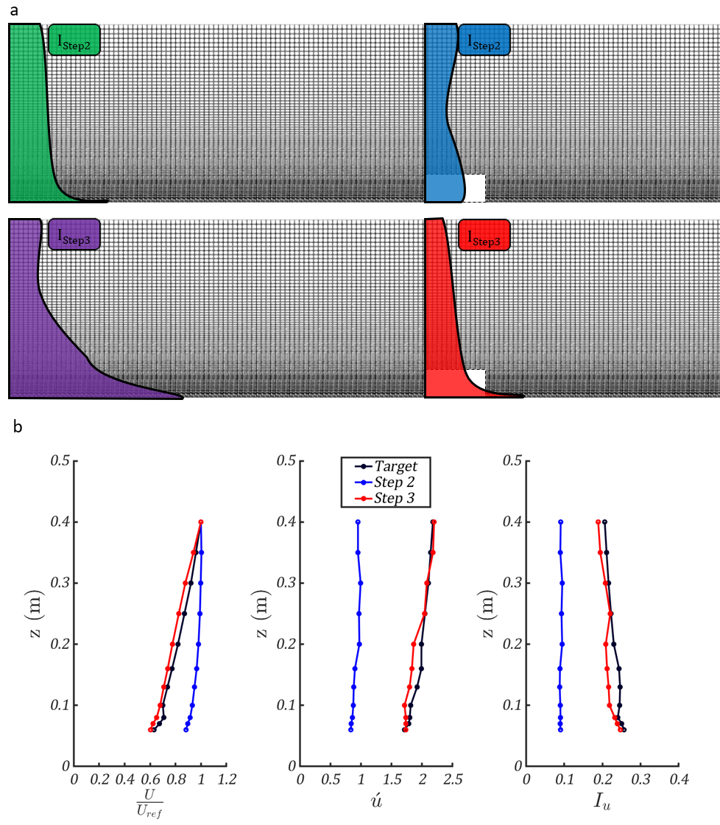

**Figure 5.** Propagation of turbulence in the computational domain (a) mean, std and turbulence intensity of Step 2 and Step 3 compared with target values (b)

In the current setup, after the inlet frequency of 5000 Hz was selected from step 2, the target profile of exposure Type B (ASCE 49-21) was included at the files TargetU for the mean and TargetUstd for the std. Step3a and Step3b were executed based on the automated procedure with linear modification. Finally, the mean, std and turbulence intensity profiles are presented in Figure 5b. It is important to mention that the normalized spectrum of the longitudinal velocity is not sensitive to Step 3, thus the same accuracy can be achieved as the previous step, presented in Figure 4.

*3.4. Dynamic Terrain Step 4: Pressure time series acquisition*

The first three steps of the methodology are applied in ECD, as to properly model the incident flow. The final step is to create an equivalent computational domain, but with the building (CDB) at the incident flow location. In this way, the pressure time series in specific locations on the building envelope can be extracted, for each time step of the computational analysis. One demerit of using this seemingly straightforward and simple approach to model turbulence in the ABL, is that due to the sudden changes of the velocity at the inlet, a flux is created that the pressure needs to compensate in the Navier – Stokes Equations. Consequently, during the transitions of the inlet profile, the pressure inside the computational domain may not converge for a couple of time steps.

This phenomenon is illustrated in Figure 6 in terms of the convergence factor Φ. The time series was extracted for every time step of the analysis, at height of z = 0.08 m, at the incident flow. As depicted, during a period of dynamic terrain, the initial pressure values exhibit non-convergence (red dots), while subsequent values converge (blue). Consequently, the non-converged red values are excluded from the final time series. This task is carried out using the Step3.cpp code, where all pressure values exceeding the dynamic pressure at the top of the Atmospheric Boundary Layer (ABL) are eliminated. The dynamic pressure can be calculated as 0.5·ρ·Ug2, and it serves as an input to the code. Additionally, another necessary input for this code is the output frequency of the time series, enabling the algorithm to perform an averaging process.

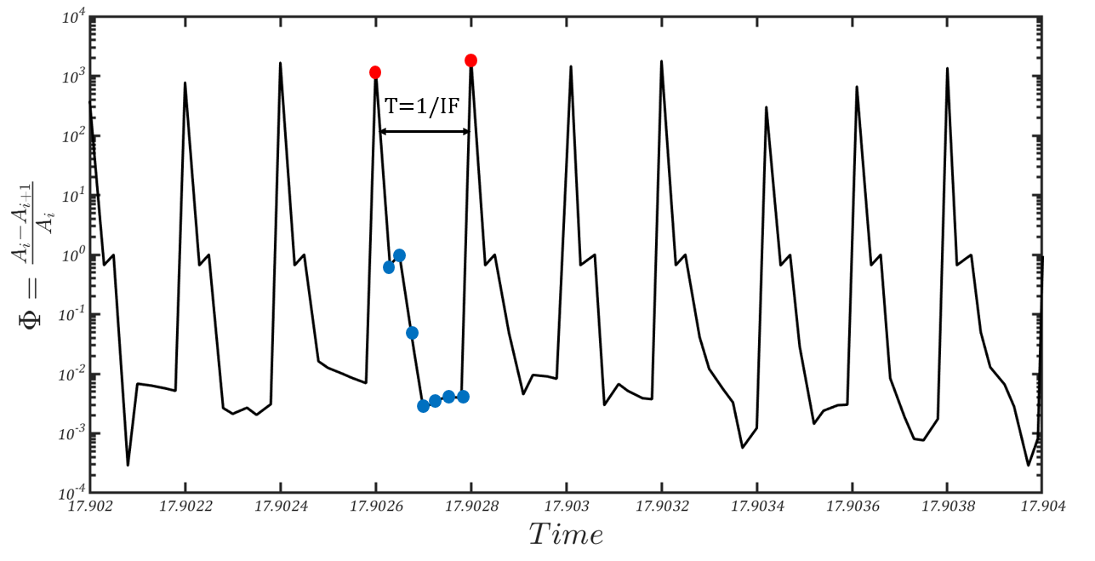

**Figure 6.** Convergence of pressure for a representative time window

The resulting time series is written to a file named "pOut," as defined in Line 139 of the code. The format of this file consists of the first column containing the time for which the pressures are extracted, while the subsequent columns represent the pressures from each selected probe. The probes themselves can be specified in the /system/probes file and referenced in the controlDict file, following the example provided in the /Case directory. It is crucial to configure the extraction for every time step to ensure the accurate repetition of this procedure under various conditions. This relates with the need to iterate around 10 times for each period of the DT method, creating the need for a proper CFL number, during the analysis.

In the current configuration, a minimum CFL (Courant-Friedrichs-Lewy) number of 0.4 was employed, resulting in approximately 8 to 10 iterations for each period of the DT method. Figure 7a and 7b illustrate the outcomes of the mean and peak pressure coefficients observed on the building envelope of the selected building. Additionally, the locations of the pressure taps are denoted with dots for reference. Lastly, Figure 7c displays the time series of the pressure coefficient for a specific location on the roof, near the windward side.

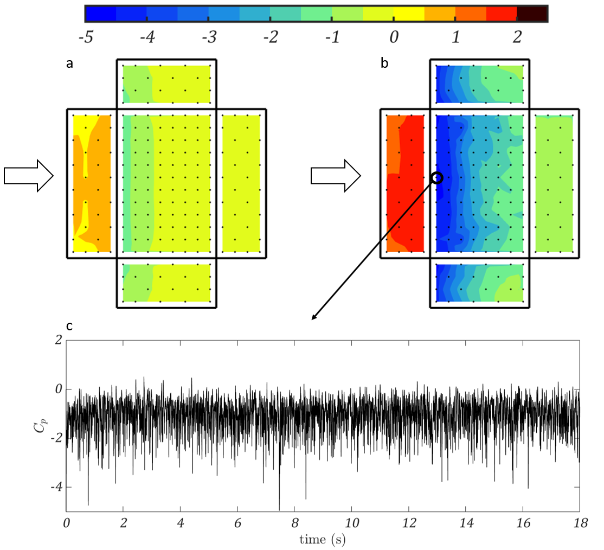

**Figure 7.** Mean (a) peak (b) pressure coefficients at the envelope of the building for perpendicular wind flow. Time series of pressure coefficient (c) location indicated with a circle.

**4. Conclusion**

This report presents the documentation of the DT methodology through a case study example. The case study involves modeling exposure Type B and wind-induced loads on the envelope of a low-rise building with dimensions of 8 m x 16 m x 24 m. The structure of the database is discussed, and the four steps of the DT method are thoroughly explained.

In Step 1, wind tunnel velocity time series serve as inlet conditions. Step 2 involves tuning the spectral content, while Step 3 focuses on modifying the mean and standard deviation profiles of the inflow to model the incident flow according to the target exposure. Finally, in Step 4, the pressure time series from the analysis are filtered accordingly, and peak pressures are estimated.

Validation studies have been conducted for this methodology, including oblique wind directions, open exposure, and wind flow around isolated and clusters of buildings, demonstrating the accuracy of the DT method (Potsis and Stathopoulos, 2024; Potsis et al., 2024).

**References**

ASCE/SEI 49-21, 2022. Wind Tunnel Testing for Buildings and Other Structures, American Society of Civil Engineers. <https://doi.org/10.1061/9780784415740>.

Potsis, T., & Stathopoulos, T. (2024). Wind induced peak pressures on low-rise building roofs via dynamic terrain computational methodology. Journal of Wind Engineering and Industrial Aerodynamics, 245, 105630. <https://doi.org/10.1016/J.JWEIA.2023.105630>

Stathopoulos, T. (1984). Design and fabrication of a wind tunnel for building aerodynamics. Journal of Wind Engineering and Industrial Aerodynamics, 16(2–3), 361–376. <https://doi.org/10.1016/0167-6105(84)90018-7>

Potsis, T., Ricci, A., & Stathopoulos, T. (2024). On the reliability of the dynamic terrain method to generate ABL winds for environmental applications. *Meccanica*. <https://doi.org/10.1007/s11012-024-01810-5>

OpenFOAM (2024), timeVaryingMappedFixedValue, https://www.openfoam.com/documentation/guides/latest/api/classFoam_1_1timeVaryingMappedFixedValueFvPatchField.html (retrieved 02.12.2024)