Tanner Poulton
June 14, 2026
Professor Martinez
CS-499
Enhancement Three: Databases

Artifact Description
The artifact selected for this enhancement is my Flask-based professional portfolio website. The project was originally created as a personal resume and portfolio site to showcase my skills, projects, and technical experience as a Computer Science student. Throughout CS 499, I have continued to improve the application by implementing enhancements that demonstrate software engineering, algorithmic design, and database skills. For this milestone, I focused on improving the database functionality of the application by integrating a SQLite database into the project.
Justification for Inclusion and Enhancement
I selected this artifact because it represents a project that I created and actively developed throughout my Computer Science program. The website demonstrates skills in web development, backend programming, software design, and user interface development. It also serves as a professional portfolio that can be shared with potential employers.
For the database enhancement, I redesigned portions of the application to retrieve information from a SQLite database instead of relying on hardcoded content. I created database tables to store project information and algorithm metadata. I then implemented database access functions and modified the Flask routes to retrieve records from the database and dynamically display them within the application. The Projects section of the website and the algorithm selection options in the Algorithm Visualizer are now generated from database records rather than static HTML content.
This enhancement demonstrates my ability to design database schemas, work with relational data, execute database queries, and integrate a database into a functioning web application.
Course Outcomes
This enhancement supports the outcome of demonstrating the ability to use well-founded techniques, skills, and tools in computing practices to implement computer solutions that deliver value and accomplish industry-specific goals. Through the implementation of SQLite, database schema design, and dynamic data retrieval, I demonstrated practical database development skills commonly used in professional software applications.
The enhancement also supports communication and software development outcomes by improving the maintainability and scalability of the application. By separating application data from presentation logic, the website is easier to update and extend in the future.
Reflection
This enhancement helped me gain a deeper understanding of how databases interact with web applications. Before making these changes, much of the site's content was hardcoded directly into the HTML templates. Through the enhancement process, I learned how to design tables, seed a database with data, query records through Python, and dynamically render database content using Flask and Jinja templates.
One challenge was restructuring the application so that existing content could be retrieved from the database while preserving the site's functionality. This required careful planning of the database schema and updates to the application routes and templates. Another challenge was ensuring that the new database-driven implementation produced the same user experience as the original version.
Overall, this enhancement strengthened my understanding of database integration, data management, and web application architecture while demonstrating meaningful growth in my software development skills.
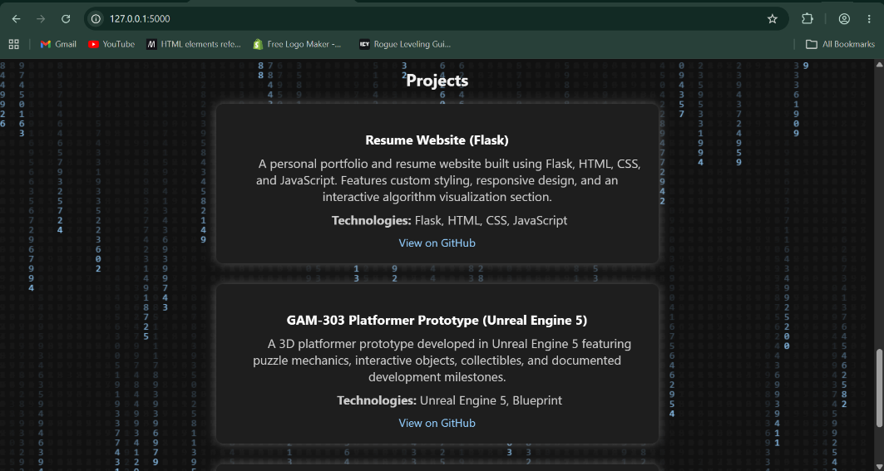
Projects section displaying project information retrieved from the SQLite database.
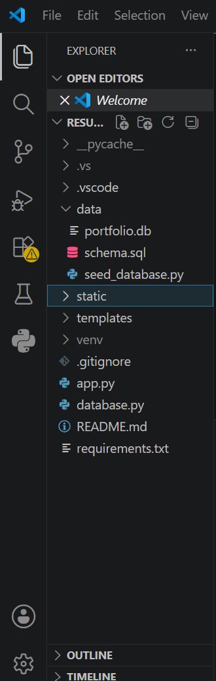
Project structure showing database files including schema, seed script, database file, and database access layer.
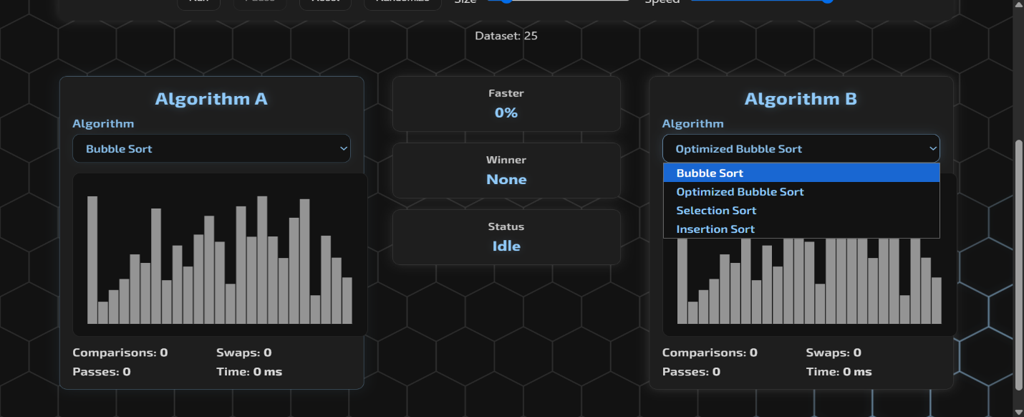
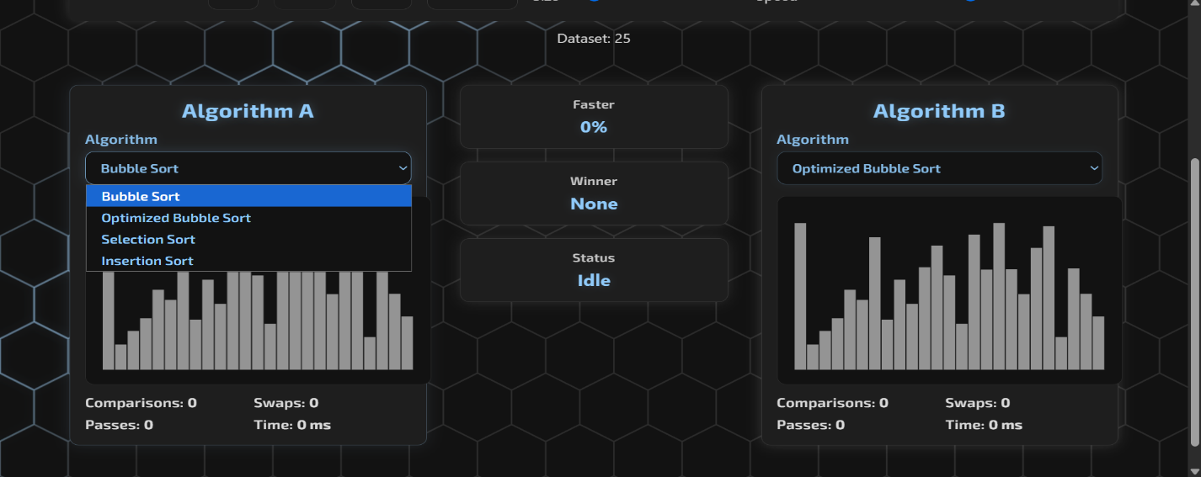
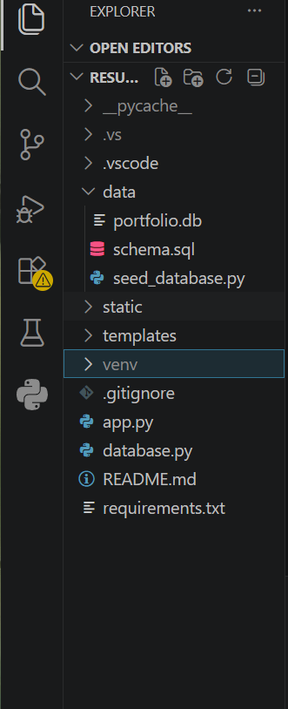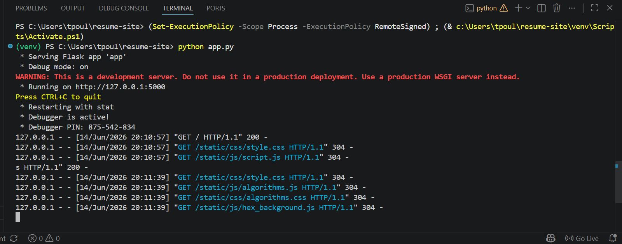
Flask application running successfully with database integration and HTTP requests.

