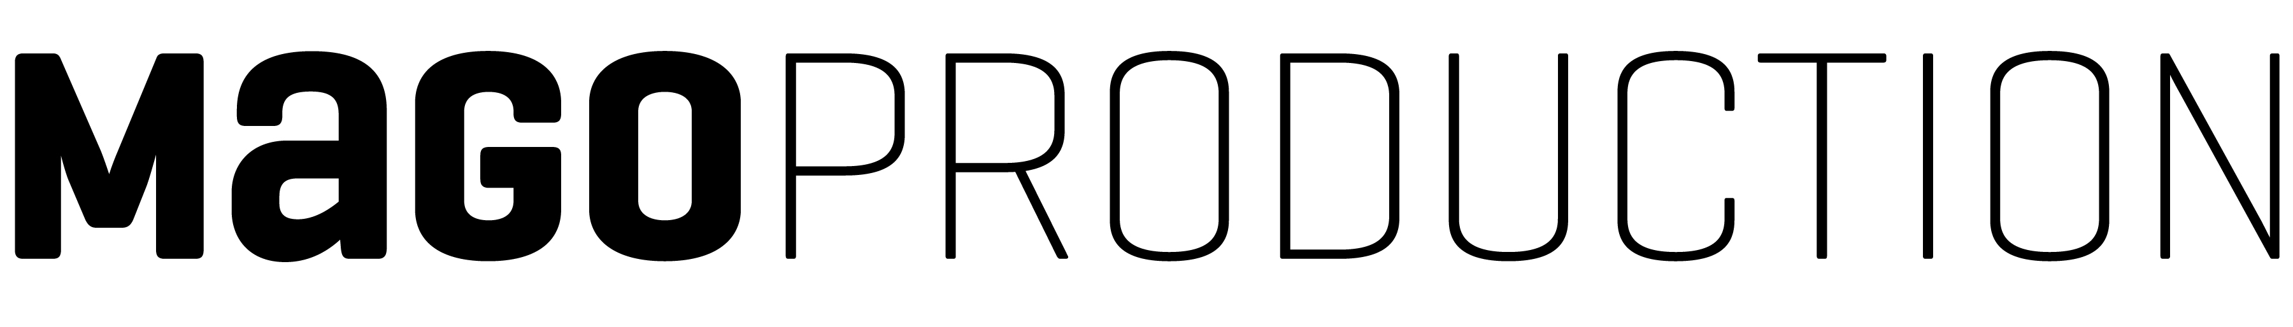
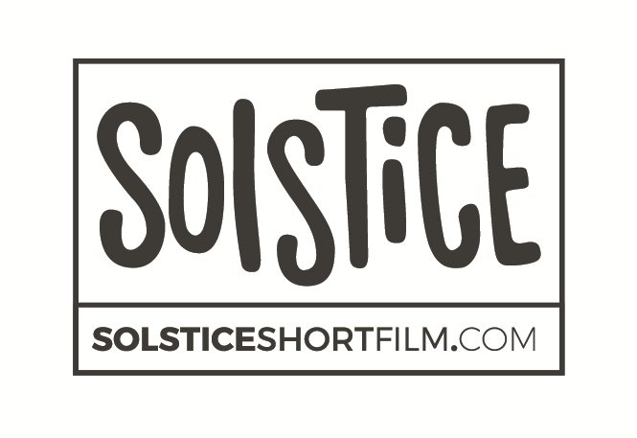
Mago Audiovisual Production SL
NIF: B 62903885
C/ Secretari Coloma, 2
08025 Barcelona
t: +34 93 207 08 34
www.magoproduction.com

CONFIDENTIALITY COMMITMENT
SOLSTICE SHORT FILM

I, the undersigned, hereby declare that I agree to undertake the tasks assigned to me.

I undertake to perform my duties honestly and fairly. My contribution to the activities in which I will be involved will be objective and will fully respect the principles of fairness and impartiality.

I undertake to hold in trust and confidence any SOLSTICE SHORT FILM related information or documents. I undertake to use them only for the purposes of executing the tasks assigned to me and not to disclose them to any third party.

I will endeavour to avoid any conflict of interest situation, either direct or indirect. Should any such situation arise, I will promptly inform the relevant supervisor or the production manager.

I understand that I will be held personally responsible for maintaining the confidentiality of any documents or electronic files received and for returning, erasing or destroying all confidential documents or files upon completing the tasks, unless otherwise instructed.

On conclusion of my assignment I will remain obligated to preserve the confidentiality.

Name:

Signature:

Date:

