Effect of ambient-temperature on the PSS FPGA hardware

Contents
Effect of ambient-temperature on the PSS FPGA hardware 2
Introduction 2
Thermal Model 3
Parameters of Interest 3
Cases considered for the analysis 7
Thermal resistance calculation 8
Results 9
References 11

Figure 1 Thermal Circuit Model 3
Figure 2 An example for the power estimate - PSS FDAS module 4
Figure 3 A10PL4 Heatsink 5
Figure 4 Round-pin heatsink performed better than a plate-fin heatsink 7
Figure 5 Thermal resistance for the heatsink variant-c.[5] 8
Figure 6 Effect of ambient temperature on junction temperature 9

Table 1 Temperature resistance properties of 1517-pin FBGA 4
Table 2 Lenovo server airflow options 6
Table 3 Three variants of heatsink considered for the analysis 7

Effect of ambient-temperature on the PSS FPGA hardware

Introduction
We have analyzed the effect of variations to the ambient-temperature on the PSS FPGA hardware and present here the details of the analysis.

We understand from literature and from our discussions with Altera/intel that [1]
- Ambient temperature alters the junction temperature of the FPGAs.
- Nominal junction temperature for the Arria 10 FPGA is 100 ºC (T_{JMAX})
- Reliability is improved if junction temperature is maintained lower than 100 ºC
- Reliability reduces if the nominal junction temperature increases.
- As a rule of thumb, the lifetime of the FPGA is reduced by half at a junction temperature of 110 ºC
- Within an operating temperature of 100 ºC, the Altera FPGAs are expected to perform for about 10 years
- If the cooling fails then the chip can damage itself within few seconds
- The larger the package the better the heat dissipation therefore better the reliability

Hence the primary questions that we intend addressing in the analysis are:
- Could we be able to maintain a safe limit (T_{JMAX} ≤ 100 ºC ) to the junction temperature for the FPGAs?
- What is the tradeoff to maintain this safe junction temperature?

Thermal Model
A junction temperature in a semiconductor such as the FPGA can be calculated using a thermal circuit model as shown in Figure 1. In the figure, T_{J} , T_{C} , T_{S} and T_{A} are the junction temperature, device-case temperature, heat-sink temperature and ambient temperature respectively. The quantities θ_{JC} , θ_{CS} and θ_{SA} are the junction-to-case, case-to-heatsink and heatsink-to-ambient thermal resistances. The value P is the total power expected to be dissipated in the FPGA while running the PSS modules.

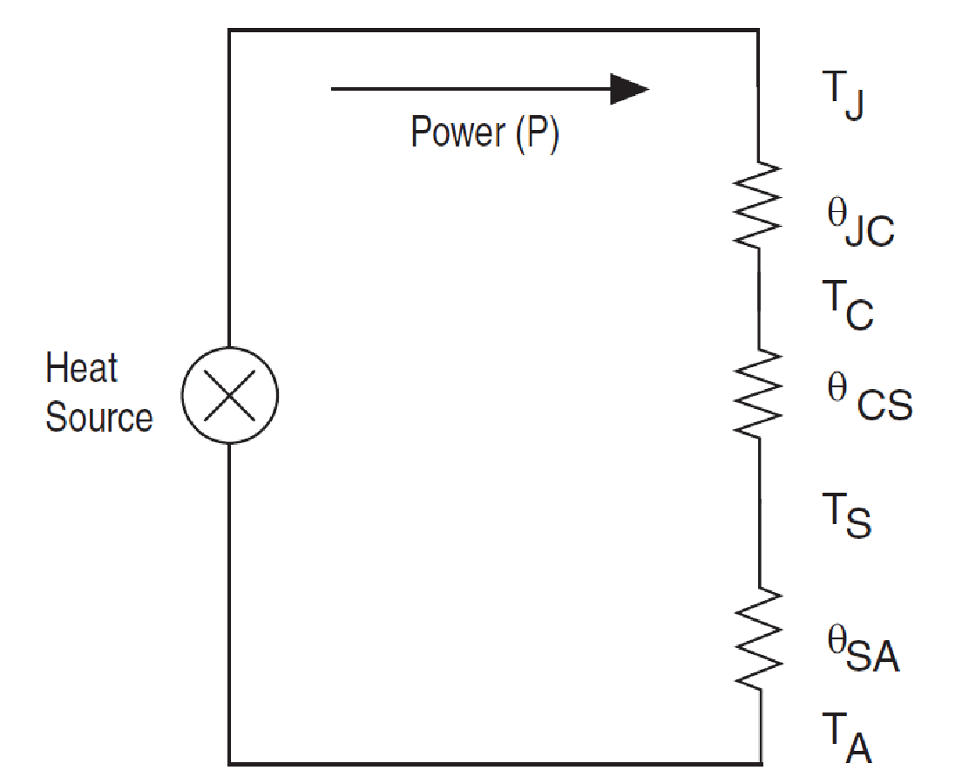
Figure 1 Thermal Circuit Model
If the FPGA is dissipating P Watts of power and operating in an ambient temperature of T_{A} , then the junction temperature T_{J} can be calculated using the relation:

 | T_{J} = T_{A} + ( θ_{JC} + θ_{CS} + θ_{SA} ) * P | ()

Parameters of Interest

This analysis depends on:
- Ambient temperature
- FPGA power dissipation
- FPGA package characteristics
- Heatsink bonding characteristics
- Heatsink configuration
- Airflow
- Junction temperature

Here, items 1 to 6 are the input parameters that can vary over a range. Item 7, the junction temperature is derived from the input parameters. We present below details of these parameters.

Ambient temperature
A limit to the ambient temperature for the FPGA hardware comes from the various constraints of the infrastructure that are under discussion at the moment [2]. We observe that 15-32.5 ºC is a reasonable ambient temperature range for the purpose of this analysis.

FPGA power dissipation
In this analysis we consider a power range from P=10 W to about 40 W, as this range reasonably covers the power expected to accelerate different PSS modules in an Arria 10 FPGA. An example for the power estimate available for this work from a PSS module namely FDAS is shown in Figure 2. Later we will see, how to handle the power dissipation for the future FPGA devices such as the Stratix 10.

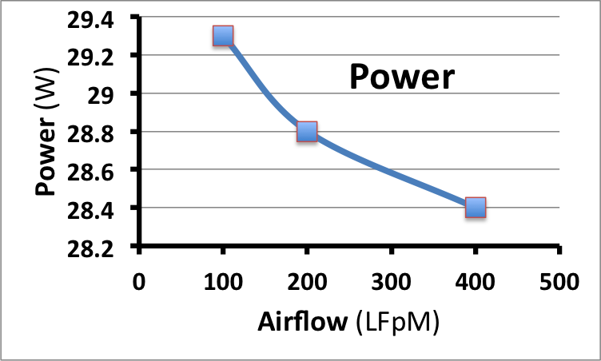
Figure 2 An example for the power estimate - PSS FDAS module

FPGA package
The part number of the Arria 10 FPGA chip that we use in the Bittware accelerator card is 10AX115N3F40E2SG. This chip comes in a 1517-pin FBGA package and its temperature resistance property from [3] is given in Table 2.

Table 1 Temperature resistance properties of 1517-pin FBGA
Device | Package Type | Pins | θ_{JA}  (° C/W) Still Air | θ_{JA} (° C/W) 100 ft./min. | θ_{JA} (° C/W) 200 ft./min. | θ_{JA} (° C/W) 400 ft./min. | θ_{JC}  (° C/W) | θ_{JB}  (°C/W)
10AX115N | FBGA | 1517 | 6.6 | 6.6 | 5.3 | 4.3 | 0.14 | 1.8

The table lists a variety of temperature resistances: junction-to-ambient θ_{JA}, junction–to-case θ_{JC} and junction-to-board θ_{JB}, of which we use only the junction–to-case temperature resistance θ_{JC} for the analysis.

 | θ_{JC} = 0.14 °C/W | ()

Heatsink bond
The case-to-heatsink thermal resistance θ_{CS} considered for this study is:

 | θ_{CS} = 0.035 ºC/W | ()

Heatsink configuration
The A10PL4 FPGA card has a heatsink configuration as shown in the Fig. 3. It can be observed that the heatsink is covering the entire base of the FPGA and is fitted with a fan to improve the heat dissipation [4].

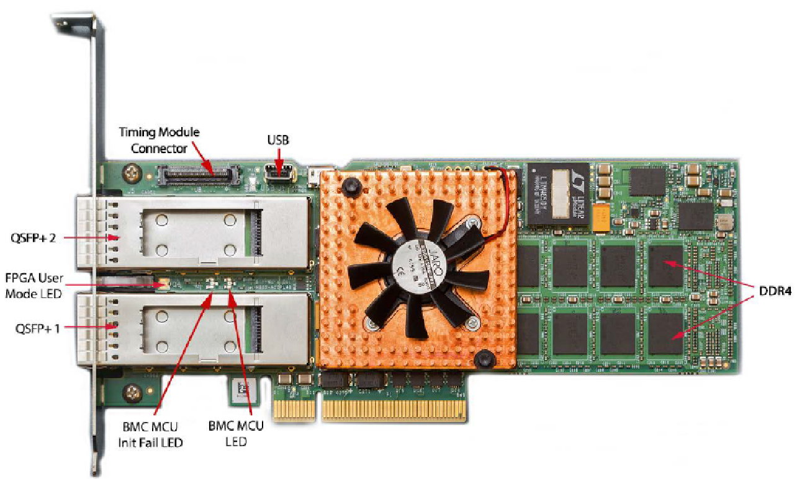
Figure 3 A10PL4 Heatsink

Airflow
For the analysis, we consider 100, 200 and 300 LFMs airflow conditions inside a typical server environment. For the prototype system we use the Lenovo server X3650 M5 and its airflow options are given in Table 1.

Table 2 Lenovo server airflow options
X3650 M5 Broadwell |  | LFM
Riser 1 | PCI-1 flow speed | 347.76
Riser 1 | PCI-2 flow speed | 339.73
Riser 1 | PCI-3 flow speed | 283.42
Vertical | PCI-4 flow speed | 177.69
Vertical | PCI-5 flow speed | 198.54
Riser 2 | PCI-6 flow speed | 328.32
Riser 2 | PCI-7 flow speed | 199.18
Riser 2 | PCI-8 flow speed | 169.53

Cases considered for the analysis
The heatsink-to-ambient thermal resistances θ_{SA} of the heatsink varies with the type of the heatsink and with the amount of airflow available. The dimension for the heatsink width and length is primarily constrained by the case dimension of the FPGA package. Normally the performance of a round-pin heatsink shown in , is less affected by the airflow direction when compared to the fin-type heatsinks. The fin type heatsinks can form hot packets if the airflow is not aligned with the fin arrangement. Round-pin heatsinks also performed much better in the analysis when compared with a fin type ones. Also in the analysis, a copper heatsink performed only marginally better than an aluminum heatsink.

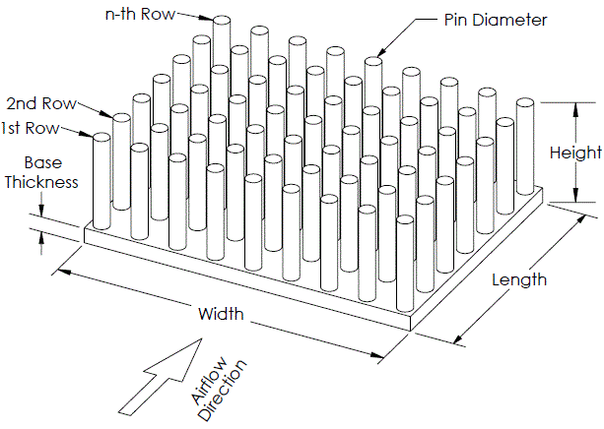 | 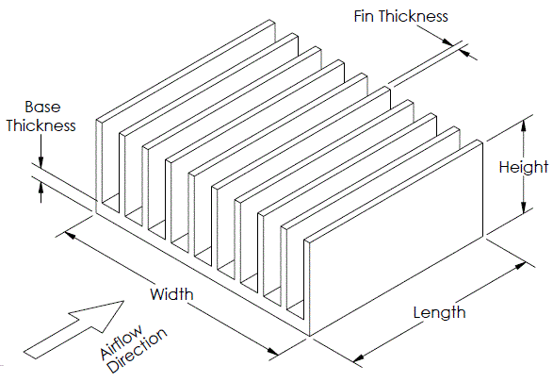
Round-pin Heatsink | Flat-fin heatsink
Figure 4 Round-pin heatsink performed better than a plate-fin heatsink
For the purpose of analysis, we considered round-pin heatsinks made of aluminum with length and width of 40 mm each and a base thickness of 3 mm. We fixed the diameter of the pins used in the heatsink as 2 mm but varied the number of pin rows, number of pins-per-row, the overall height for the heatsink and the airflow to effectively get three different variants of the heatsink as shown in Table 3 for the analysis.

Table 3 Three variants of heatsink considered for the analysis
 | Heatsink height of 10 mm,  number of rows 10, pins per row 10,  under 200 LFM airflow | (a)
 | same as (a), but under 300 LFM airflow and | (b)
 | Heatsink base height of 12 mm  number of rows 13, pins per row 13  under 100 LFM airflow | (c)

Thermal resistance calculation
Then the thermal resistance (θ_{SA}) of the heatsink for the three variants a, b and c are calculated using an online software tool “myheatsinks”, available in a vendor website [5]. The myheatsinks tool, accepts the heatsink configuration and outputs the thermal resistance θ_{SA} for a variety of practical airflow settings as listed in the table below.

Input parameters for the heatsink variant-c are:
Make is Aluminum, Width: 40 mm, Length: 40 mm, Height: 12 mm, Base Thickness: 3 mm
Pin Diameter: 2 mm, Number of Rows: 13, Pins Per Row: 13
Airflow rate | Thermal Resistance
0.5 m/s (~100 LFM) | 0.88 °C/W
1.0 m/s (~200 LFM) | 0.63 °C/W
1.5 m/s (~300 LFM) | 0.52 °C/W

Figure 5 Thermal resistance for the heatsink variant-c.[5]
In equations (4), (5) and (6) we present only the thermal resistance θ_{SA} corresponding to the three heatsink variations a, b, and c that is considered in the analysis:

 | θ_{SA} at 200 LFM = 1.60 °C/W | ()
 | θ_{SA} at 300 LFM = 1.31 °C/W | ()
 | θ_{SA} at 100 LFM = 0.88 °C/W | ()

Results
The thermal resistance θ_{SA} thus obtained from (4), (5) and (6) are substituted in equation (1) along with the junction-to-case resistance θ_{JC} available from (2) and case-to-heatsink resistance θ_{CS} available from (3), in order to obtain the junction temperature T_{J} expected over an ambient temperature range of 15-32.5 ºC. These measurements are repeated for the different FPGA power dissipations starting from P = 10 W to 41 W.

The plots 1 to 3 of Fig. 4 show the effects of ambient temperature on junction temperature for each of the three heatsink variants a, b and c that we considered for the analysis. It can be clearly seen that in all three cases:
- increasing the ambient temperature results in increasing the junction temperature
- increasing the power dissipation of the FPGA also increases the junction temperature
- different heatsink variants affects the junction temperature but with a noticeable difference

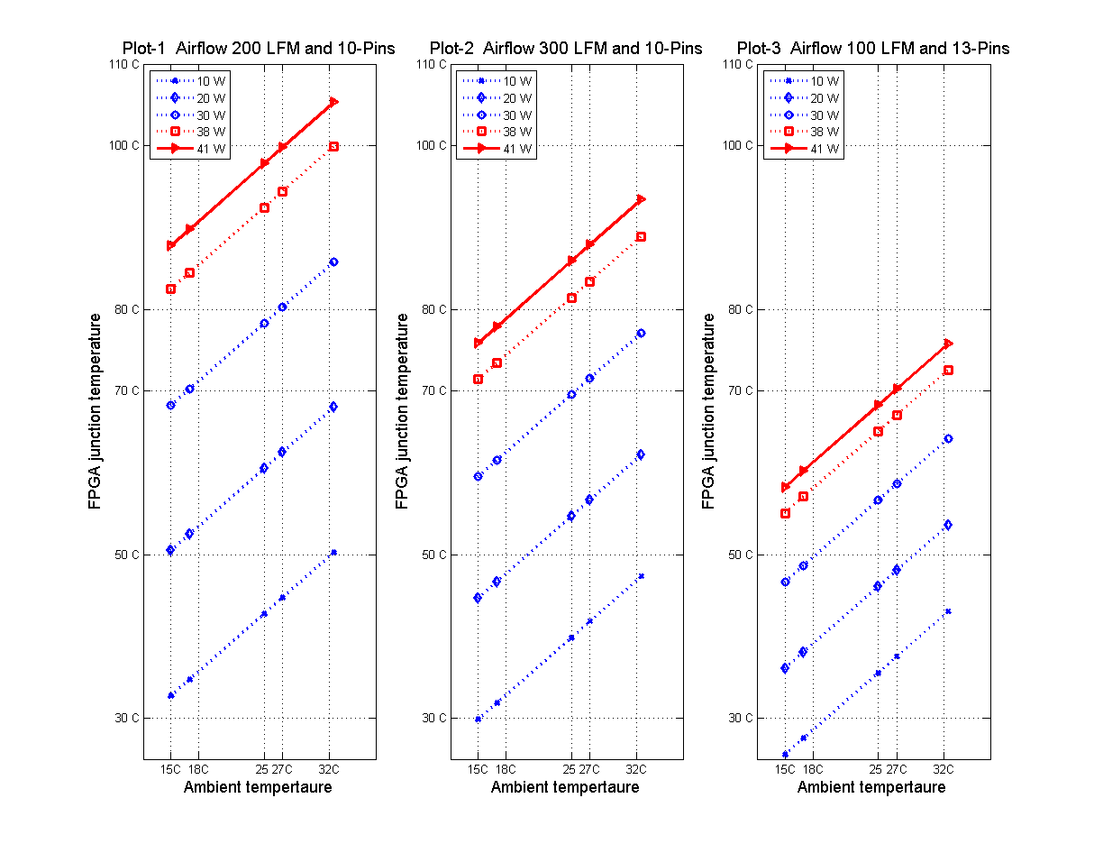
Figure 6 Effect of ambient temperature on junction temperature

The plot-1 in Figure 6 corresponds to the heatsink variant-a, where the FPGA is fitted with a 10-pin heatsink and is under 200 LFM of airflow. In this configuration, when the ambient is 32.5 ºC a power dissipation of up to P = 38 W in the FPGA is fine because the junction temperature T_{J} is still below 100 ºC, ie., T_{J} ≤ T_{JMAX}, where T_{JMAX} = 100 ºC. It can also be observed from plot-1 that T_{J} ≤ T_{JMAX} can be maintained at ambient of T_{A} = 27 ºC, for P ≤ 41 W. This means, for this configuration of heatsink (a), an ambient of 27 ºC instead of 32.5 ºC allows an additional power dissipation of 3 W in the FPGA. In other words, in this configuration, moving the ambient from T_{A} = 27 ºC to 32 ºC, limits the processing power by about 3 W.

We also show in plot-2 of Figure 6, a result from using heatsink variant-b across the same range of ambient T_{A} and power P. The only change in this configuration is that the air-flow rate used now is higher, i.e., 300 LFM instead of 200 LFM. In can be observed that significant performance is achieved by just using higher airflow rate and T_{J} ≤ T_{JMAX} condition is well met even at the ambient T_{A} = 32.5 ºC, for P ≤ 41 W. The FPGA has higher headroom for power dissipation.

In plot-3 of Figure 6 we show results correspond to the third variant (c) of the heatsink arrangements where we use 12 mm height instead of 10 mm height, 13-pins per row and 13 rows of pins for the heatsink instead of 10-pins per row and 10 row of pins, and we also use only a lower airflow rate of 100 LFM. It can be observed that a significant performance is achieved just by changing total number of pins even at a lower airflow rate and T_{J} ≤ T_{JMAX} condition is more than adequately met at the ambient T_{A} = 32.5 ºC, for P ≤ 41 W. In other words, the FPGA has much higher headroom now for power dissipation.

In summary, moving the higher end of the operating ambient T_{A} from 27 ºC to 35 ºC marginally affects the FPGA hardware by limiting the maximum usable computational power. The low-end for the ambient at T_{A} = 15 ºC seems to be fine and has no significant effect on the hardware as seen from this analysis.

References

- Internal e-mails dated 23/08/2017/Prabu-MikeM
- Based on discussions with Altera/intel on 06/07/2016/Prabu-Mike Pearson and from the data sheets
- https://www.altera.com/support/literature/lit-index/lit-pkg/thermal.html?type=thermal&family=Arria_10
- A10PL4 Arria 10 GX Low Profile PCIe Board User’s Guide, BittWare, Inc 1/18/2017 Edition
- Thermal Resistance Calculator
http://www.myheatsinks.com/calculate/thermal-resistance-round-pin/# .
- AN-368-4.0 Thermal management for FPGAs, March 2012, Altera
- http://www.zseries.in/electronics%20lab/heat%20sinks/#.WaWPdfMjF0s
- Thermal resistivity of copper is only marginally lower than aluminum
https://heatsinks.files.wordpress.com/2010/10/heat_sink_thermal_resistance_as_a_function_of_velocity.png
- https://www.qats.com/cms/2010/10/04/copper-heat-sinks-aluminum-heat-sinks-does-it-matter-what-you-make-a-heat-sink-from/
- https://www.altera.com/content/dam/altera-www/global/en_US/pdfs/literature/packaging/04r00461-04.pdf
- https://www.altera.com/support/literature/lit-index/lit-pkg/thermal.html?type=thermal&family=Arria_10
- E-mail summary after discussions with Altera dated 07/07/2016/

