INCOME PLAN — TWO-PATTERN DISPLAY REQUIREMENTS
Pattern A account rollup + position grid | Pattern B week drill-down
Status: DRAFT FOR OWNER LOCK | Revised 8 September 2026 (corrected table split + visualization appendix)

0. Visualization companion — not a runtime requirement
A clickable HTML mock lives next to this document: Income_Plan_Pattern_A_B_Simulation.html. Screenshots from that mock are embedded below.
Purpose of the HTML and screenshots: show the expected layout, row order, column split, color states, and A↔B navigation so development can match the picture without inventing a third layout.
The new system MUST NOT be required to use, embed, ship, or execute that HTML. FinOS remains Tauri + React + Rust as locked in the system architecture. The mock is a visualization aid only. Any stack that produces the same information architecture and behaviors is acceptable.
Live-sheet dollars in the mock are rounded household-shaped samples for layout. Production uses PlanHistory, lots, and the Activity Ledger.

1. Purpose and relationship to locked architecture
This document specifies how Income Plan is displayed. It does not reopen Calculator ownership, Sat–Fri week definition, Plan-vs-Declaration-vs-Actual separation, or Dashboard burndown ownership. Those remain locked in Income_Plan_Target_Architecture_v1.0_2026-08-13.docx.

2. Two display patterns
Income Plan has exactly two primary views. A persistent control switches between them.
Pattern A — Weekly summary (two stacked tables, never merged). Table 1 is account-level rollup. Table 2 is the position plan grid.
Pattern B — One Sat–Fri week drill-down: Plan vs declaration vs actual by position, exceptions, locked Plan amount for that week.
Navigation: click a week header (or a week $ cell) on Pattern A → Pattern B for that week. Pattern B has a week strip to change weeks without leaving B, and Back returns to Pattern A with that week still selected.

3. Pattern A Table 1 — account rollup ONLY
This table is account-level detail for the selected accounts and the visible week window. It has no symbols, no frequency groups, no quantity, no annual %, and no Last Update / collector column. Those fields belong only in Table 2 or Pattern B.
Columns, left to right:
1. Row label.
2. Current-year summary (live sheet column E, header is the plan year). Totals on Total Plan / Total Actual / Total Difference / Delta. Weekly averages on the account detail rows (live: Income Plan average $808.31 vs Total Plan year $42,306.26).
3+. One column per displayed week, labeled by Friday week-ending date (and any extra live columns such as 5-Sep if the owner keeps them).
Rows, in this order:
• Delta to plan % — (Actual − Plan) / Plan. Blank on weeks with no actual.
• Total Plan — sum of planned dividend $ across selected accounts.
• Plan by account — Income, Health, Roth (FI Roth), 9, CAR. Show only accounts in the current selector. Live-sheet names may be used.
• Total Actual — ledger dividend + cash interest in that Sat–Fri week. Blank, not zero, when the week has no actual yet. Green fill on the Total Actual week cells as in the live sheet.
• Actual by the same accounts.
• Total Difference — Actual − Plan. Blank on future weeks.
Green fill on Total Plan week $ and Total Actual week $ matches the live sheet. Do not add collector or symbol fields to this table if the position grid later changes.
Account selector (top left of the page, shared by both tables and Pattern B): multi-select one / several / all. Default on = Income, Car, Health, FI Roth, 9. Speculation, Energy, Robinhood available but default off.
Expected visualization — Pattern A (Table 1 on top, Table 2 below):
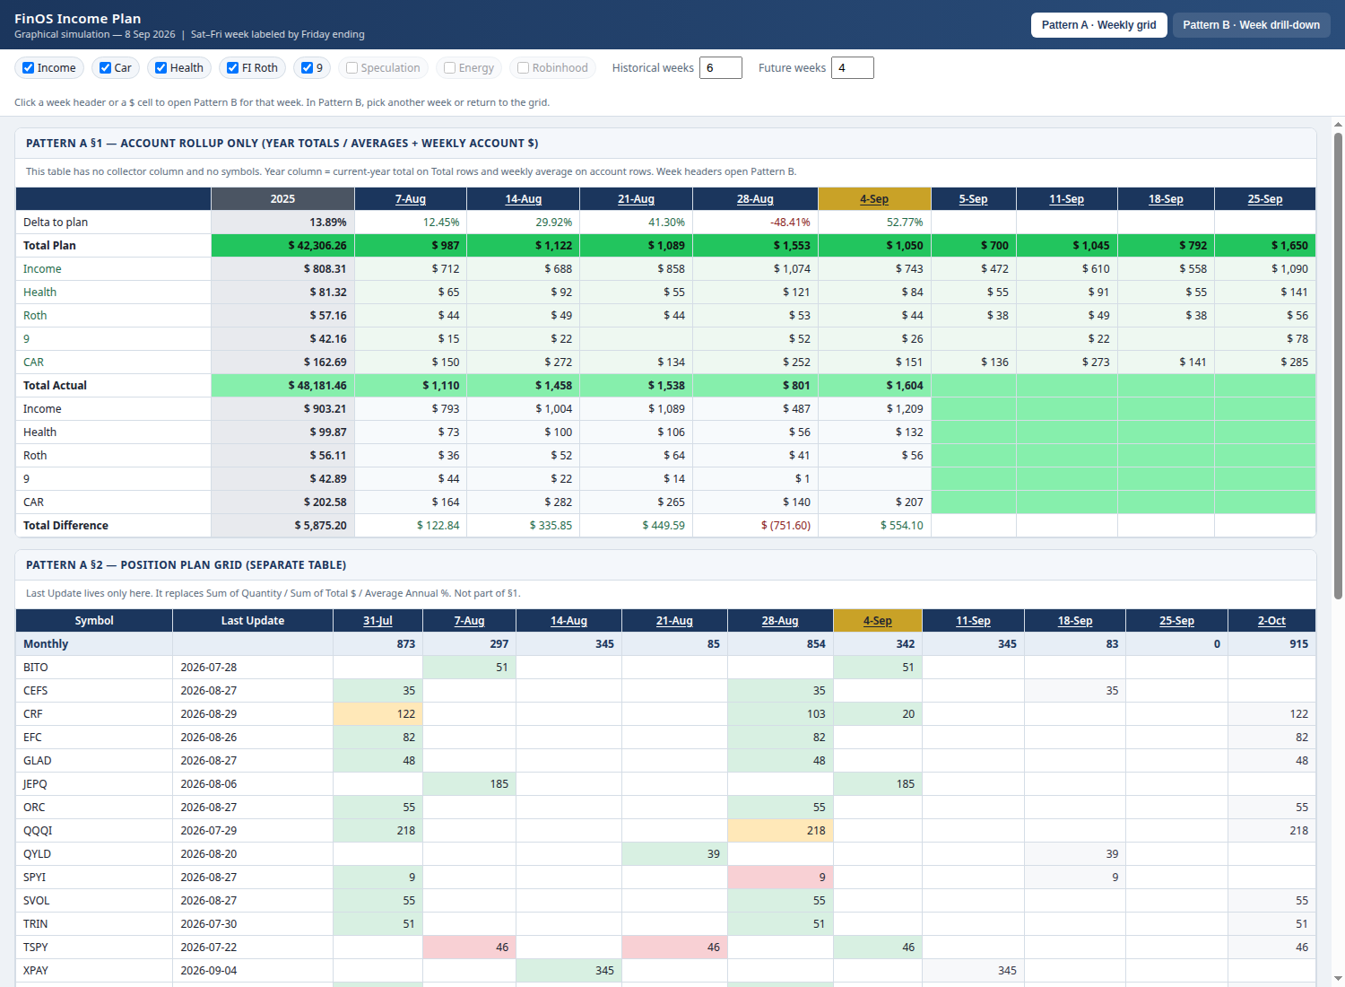
Figure 1. Visualization only. Table 1 year column and week columns match the live account rollup. Table 2 is a separate grid with Last Update.

4. Pattern A Table 2 — position plan grid ONLY
Separate table under Table 1. One row per position that has plan, declaration, or actual in the window for the selected accounts. Grouped Monthly / Quarterly / Weekly. Empty frequency is a ticket under Other — do not invent a group.
Frozen columns on Table 2 only (replaces the live-sheet Sum of Quantity, Sum of Total $, Average of Annual %):
1. Symbol (under the frequency header).
2. Last Update — last successful declaration-collector run date (YYYY-MM-DD). Blank if none. Never a failed run. Not the price collector.
3+. Week columns — Planned $ for that symbol in that week (default measure).
Monthly / quarterly names have $ only in their pay week. Weekly names have $ every week. Off-cycle empty cells are not red.
Window controls (page-level, both Pattern A tables): historical weeks default 6 (0–26); future weeks default 6 (0–26). The in-progress week is not a future week.
Cell states on Table 2: future plan (neutral); past actual ≈ plan (green); past variance (amber); past miss (red); not a pay week (empty, not red).

5. Plan amount lock (binding, both patterns)
Future pay dates use the current owner-set Plan $/share and the Plan pay date / Sat–Fri week.
After a pay date / week is in the past, freeze the Plan amount that was in effect for that pay date. Later Plan changes do not rewrite past weeks.
Example: Plan $0.15 in January, $0.17 in February. Closed January weeks stay at $0.15. Forward weeks use $0.17 until the next owner change.
Declarations, collector last_run, and actual payments never write Plan. Past grid columns read PlanHistory as-of that pay date. Future columns read the current open Plan. Shares = open lots in selected accounts as-of week-end for past weeks; current open lots for future weeks.

6. Pattern B — week drill-down
Opened from a Pattern A week header or week cell. Shows one Sat–Fri week.
Required: week Plan $, Actual $, variance; miss count; amount-exception count; position rows with frequency, Last Update, Plan $, Declaration $, Actual $, Variance; week strip to change weeks inside B; Back to Pattern A.
Plan $ in Pattern B is the frozen Plan for that week, not the current Plan if the week is closed.
Expected visualization — Pattern B:
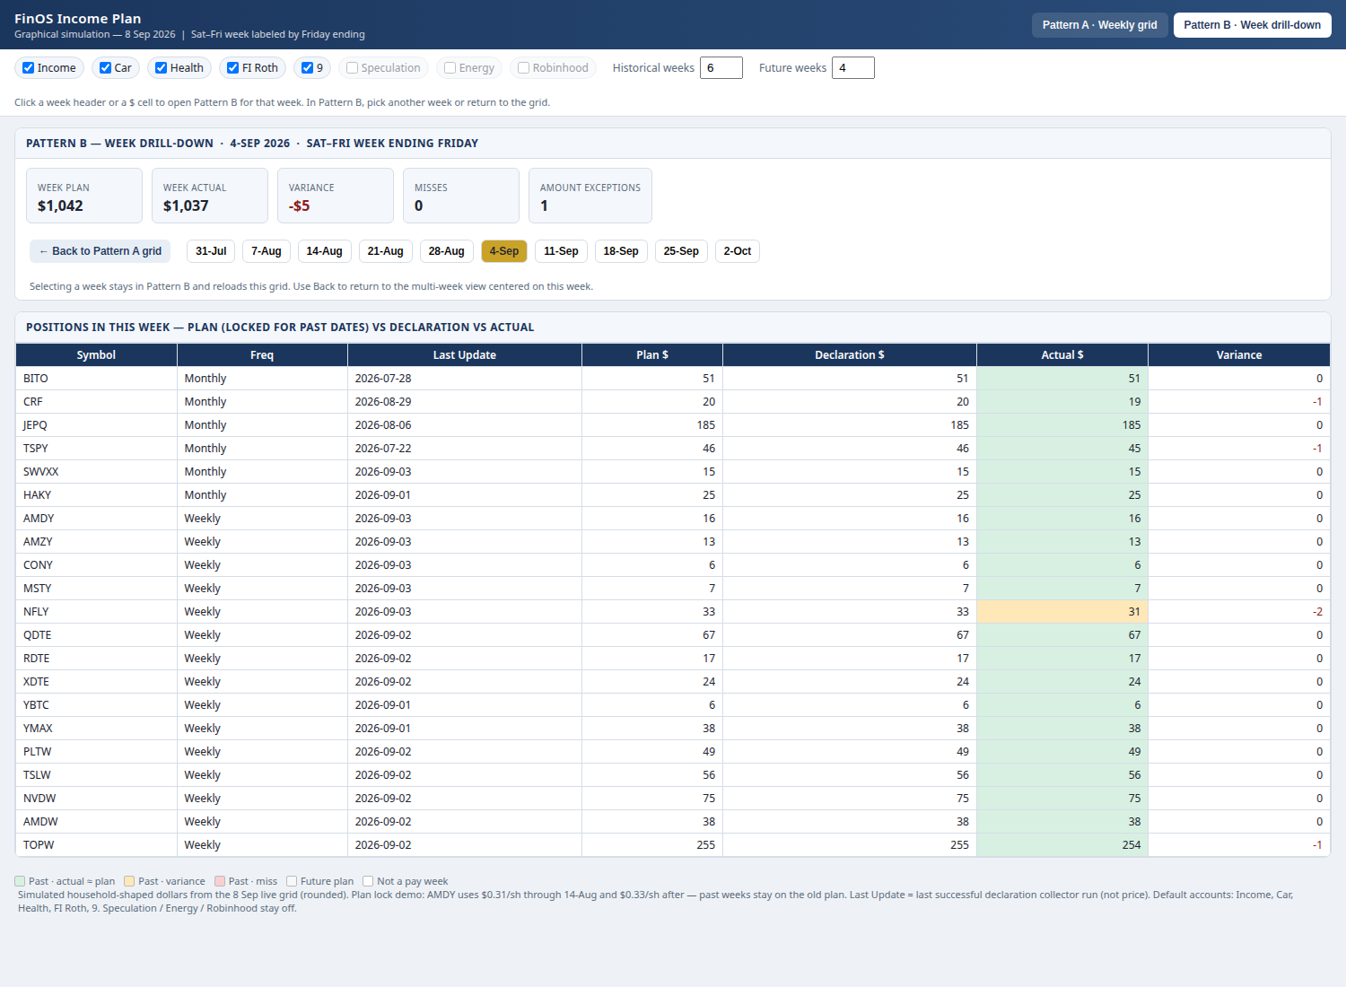
Figure 2. Visualization only. Week strip stays on Pattern B. Back returns to Pattern A.

7. What production must implement vs what the mock shows
Required in FinOS | Not required
Two Pattern A tables with the column split in §3 and §4 | Shipping or rendering the companion HTML
Pattern B week drill-down and A↔B navigation | CSS, fonts, chip style, or navy header from the mock
Plan lock, Sat–Fri week, blank future actuals | The mock’s rounded sample dollars
Last Update on Table 2 and Pattern B only | Last Update on Table 1
Account multi-select and week window integers | Exact 5-Sep extra column unless owner keeps that live-sheet quirk

8. Suggested enhancements (optional)
E1. Sticky frozen columns and week headers.
E2. Measure toggle on Table 2 only: Plan $ / Actual $ / Variance $. Table 1 always shows Plan, Actual, and Difference.
E3. Optional second line in a past Table 2 cell showing actual $.
E4. Stale-collector filter on Table 2.
E5. Export visible Table 2 window.
E6. Banner if Speculation / Energy / Robinhood are included.
E7. Do not port qty / YTD $ / annual % onto Income Plan.

9. Data sources
Plan $: Calculator PlanHistory + open lots in selected accounts.
Week placement: Plan pay date → Sat–Fri week; header = Friday ending.
Actual $: Activity Ledger YIELD / CASH. Income Plan shows cash received, not MAGI.
Last Update: last successful declaration collector timestamp per symbol.
Frequency: Position.payment_frequency.

10. Acceptance criteria
AC-IP-G01. Table 1 has no Last Update, symbol, or quantity column.
AC-IP-G02. Table 2 has Last Update and does not have Sum of Quantity / Sum of Total $ / Average Annual %.
AC-IP-G03. Car-only account selection changes both tables to Car dollars only.
AC-IP-G04. Historical=4 and Future=2 render the correct contiguous week set including the in-progress week rule.
AC-IP-G05. Plan change 0.15 → 0.17 leaves closed weeks at 0.15.
AC-IP-G06. Monthly payer $ only in pay week; weekly payer $ every week; off-cycle cells not red.
AC-IP-G07. Future Actual and Difference on Table 1 are blank, not zero.
AC-IP-G08. Week header on Table 1 or Table 2 opens Pattern B for that week.
AC-IP-G09. Pattern B week strip changes week; Back restores Pattern A with the same week selected.
AC-IP-G10. Last Update never shows a failed collector run.
AC-IP-G11. Default accounts exclude Speculation, Energy, Robinhood.
AC-IP-G12. Implementation may ignore the companion HTML file entirely and still pass these criteria.

11. Out of scope
ROC % and MAGI cliff math do not appear on these views. Holdings TVAL, Shopping Cart, and Dashboard cash burndown stay on their own views. Price collector is not Last Update.

12. Lock disposition
DRAFT FOR OWNER LOCK — revised 8 Sep 2026. Display addendum to the 13 Aug 2026 Income Plan architecture. Table 1 vs Table 2 split is mandatory. Companion HTML and Figures 1–2 are visualization only.
12. Golden harness (implementation gate)
Cursor and FinOS treat income_plan_display_golden_pack_2026-09-08.json as the oracle for this slice. Test symbols are WEEK1, MON1, QTR1, CASH1 only. Live household tickers are not fixtures.
G-IP-01 Table 1 column set is label, year summary, weeks — no Last Update.
G-IP-02 Table 2 frozen columns are symbol, last_update, weeks — no quantity, ytd_total, or annual_pct.
G-IP-03 WEEK1 100 Car shares: week ending 14-Aug 2026 Plan $ = 15.00 at locked 0.15; week ending 21-Aug 2026 Plan $ = 17.00 at current 0.17.
G-IP-04 MON1 has Plan $ only in its monthly pay week; other weeks empty and not red.
G-IP-05 Table 1 Actual and Difference for a future week are null, not zero.
G-IP-06 Car-only filter removes other account rows and non-Car lots from $.
G-IP-07 Week header opens Pattern B; Back restores Pattern A with that week selected.
G-IP-08 Failed collector run does not populate Last Update when there is no prior success.
G-IP-09 Default account set excludes Speculation, Energy, Robinhood.
G-IP-10 Production bundle does not ship the companion HTML as a runtime asset.
If the repo has a Golden Business Outcome Harness, register these ten ids there. Passing the harness is the slice exit. Visual match to Figures 1–2 is supporting evidence, not a pixel test.
13. Cursor handoff
Prompt file: Income_Plan_Cursor_Prompt_2026-09-08.md. Attach this Word doc, the 13 Aug Income Plan architecture, and the golden JSON. HTML attach is optional and visualization-only.
14. Lock disposition
DRAFT FOR OWNER LOCK — revised 8 Sep 2026 evening. Display addendum to the 13 Aug 2026 Income Plan architecture. Table 1 vs Table 2 split is mandatory. Companion HTML and Figures 1–2 are visualization only. Goldens G-IP-01..10 are the implementation gate.

