**List of technologies used are:**

1. Asp.net MVC 4
2. Linq to Sql
3. Sql Server 2008
4. WCF

**Design Patterns used are:**

Web Application part is coded in asp.net MVC. Dependendcy Injection is used for mailservice and pdfservice. SOA architecture is used to bring interoperability into app. Web application is consuming Wcf api in order to do operations like validatelogin, register user , search criminals.Service layer is talking to database layer along with Pdf and mail service to do background operations.

**Activity Diagram**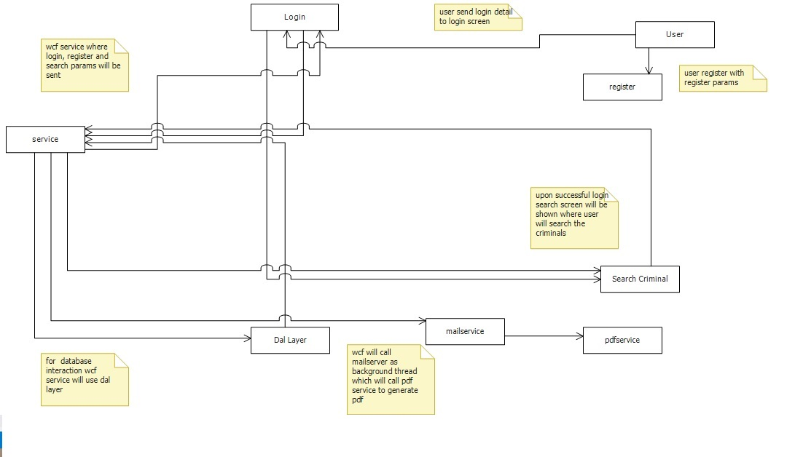

**Sequence Diagram**

