Technical Design Document For Stock App

TABLE OF CONTENTS
0 Preface 1
0.1 Purpose of this document 1
1 System Overview 2
1.1 System Characteristics 2
1.2 System Architecture 2
1.3 Infrastructure Services 4
2 System ScreeNs 5
3 Database Design 6
For database Sql server 2008 is used. It has four tables.Tables are User, UserStocks,Error, Stock.User table has all list of user along their credentials in the db. Userstock table has one to many relationship with user table.It can have many stock corresponding to particular user. Stock has list of stocks while Error table is used to store error records in db on exception in app. 6
3.1 Standards 7
3.2 Naming conventions 7
3.3 Programming Standards 7

0 Preface
0.1 Purpose of this document
- This document is a Technical Design Document document for Stock App project.In this document high level overview of stock app will be provided ,along that what architecture is used and what each screen do will also be provided.

System Overview
- This sytem is basically stock app which has basically two components. One is Web client and other is web service. Web client uses web service to show the data.Web client has login and register feature. User need to registger before they create their personalized stocks. Upon successful registration , they can login to the screen. As they login they will go straight to the dashboard where they can see their stock ticker.They can do to personalized stock link and there they can create personalized stocks. When they click on add button they will get list of stock matching the term which they type , then that stock get peristed in the db and will be visible on user dashboard as ticker. On dashboar stock along with the price gets shown. That price regulary get updated from the web service after every 10 seconds and its value vary b/w 1 to 1000

System Characteristics
- Show real time stock price after every 10 seconds
- the nature of the interface to the users of the system
- to be highly resilient or fault tolerant
- to be scaleable and easily maintainable in the future

System Architecture

Stock app has two component . One component is web service and other one is Web client.

Web Client

Web client is coded in Asp.net MVC4 with .net framework 4.0. Web client project is divided into many layers. Layers are given below

Stock.Web

Stock.Utilities

Stock.Dal

Stock.Web.Tests

Stock.Repository

Stock.Web is the main project i.e web application(asp.net MVC 4). Stock.Utilies has utility function to perform utility tasks such as password hash generation , encryption etc. Stock.Dal is basically linq to sql application .It has all ORM related stuffs. Stock.Repository has all objects to make call to dal layer, while Stock.Web.Tests has all unit testing and integration testing stuffs.

Design Patterns Used are:

Dependency Injection using ninject

Repository pattern (Stock.Repository)

Singleton pattern

Authentication

In Asp.net MVC authentication is done using asp.net Form authentication along custom membership provider. Password is stored as hashed along with its salt in database.

ORM

Linq to Sql Orm is used to interact with database

Web Service

Web Service is the other component which simulates updated prices of the stocks.It is coded in asp.net asmx web service and with 3.5 framework. It is exposed over Soap/get/post calls. It returns JSON content. It is exposed to make ajax calls from client.This web service has one method name GETDATA which return list of stocks along the updated prices. Prices value will always be b/w 1 to 1000.

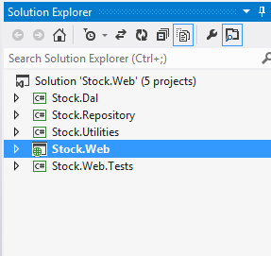

Above is the project structure diagram of stock web app.

Infrastructure Services
- Some of the infrastructure services are;
          - Security
          - Audit
          - Performance monitoring and reporting
          - Centralized Error Handling
          - Dependency management
          - Logging.

System ScreeNs

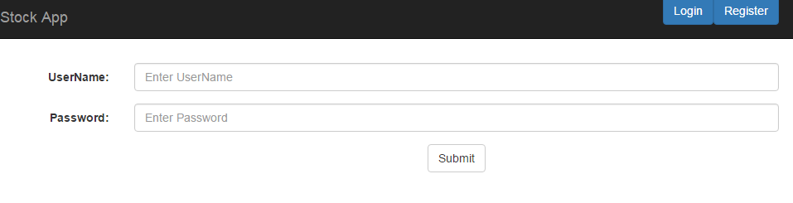
Above is Main screen and also the login screen for the app

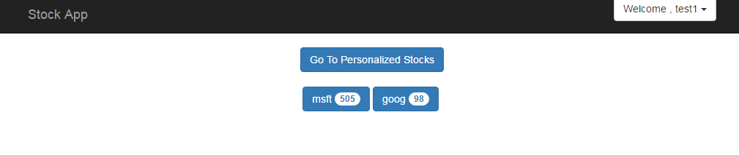

Above is dashboard screen when user login they will see list of stocks along their prices. Those prices are dynamically getting updated from the web service

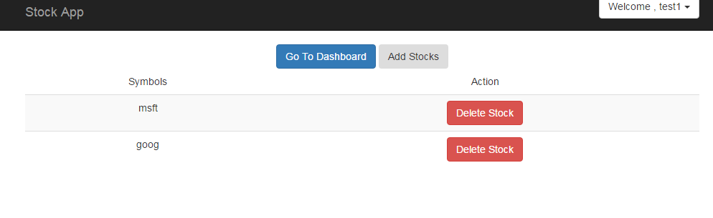
Above is the personalized stock screen for the user. Here user can add stocks to its personalized collection and those collections then get visible on dashboard as ticker with updated prices

Database Design

For database Sql server 2008 is used. It has four tables.Tables are User, UserStocks,Error, Stock.User table has all list of user along their credentials in the db. Userstock table has one to many relationship with user table.It can have many stock corresponding to particular user. Stock has list of stocks while Error table is used to store error records in db on exception in app.

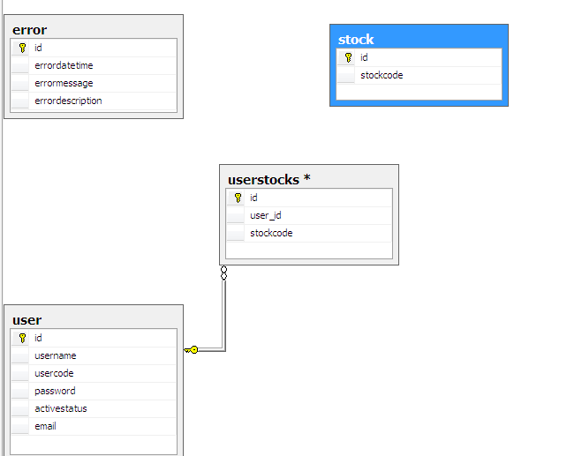

Above is database diagram of stock app database.

Standards

Naming conventions

Most of the program pascal naming convention is followed

Programming Standards

Throughout the program standard is tried to be maintained like proper commenting , coding , using proper indentation so that could look reasonable and proper

