# Material Summary: Data Acquisition

## 1. The Scientific Method

**1.1The Scientific Method Steps**

* Ask a question
* Do some research
* Form a hypothesis
* Test the hypothesis with an experiment
* Experiment works $⇒$ Analyze the data
* Experiment doesn't work $⇒$ Fix experiment
* Results align with hypothesis $⇒$ OK
* Results don't align with hypothesis $⇒$ new question, new hypothesis
* Communicate the results

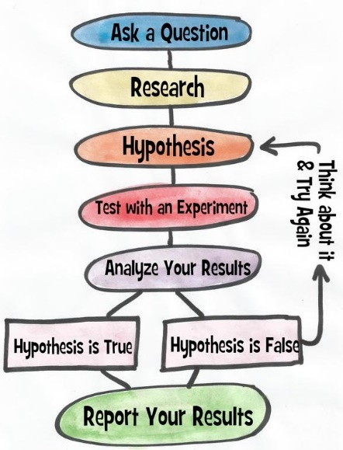

## Getting Data

* 1. **The Pandas Library**
* Provides a way to read and work with data
  + Table (DataFrame)
    - May have many dimensions
    - We usually call this a "dataset"
  + List (Series)
* One-dimensional
* Usually represents a column of a table
* 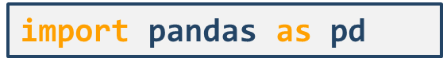Usage
* General requirements
  + Rows and columns are indexed, columns may have names
  + Each column has a fixed data type
    - Python will try to infer the best type according to the data
  1. **Data Sources**
* In order to work with the data, we need to represent it in tabular form
  + Sometimes our data is tabular – we just need to read it
  + In other cases, we need to create our tables
    - **Unstructured data:** data that doesn't have a **model**
      * There is some structure, it's just not very clear
      * Examples: Images, plain text, audio, web pages
* Most common sources
  + Tables in a text format such as .csv
  + Spreadsheets (such as Excel or Google Sheets)
  + Web services
  + Databases
  1. **Reading a Local File**
* Let's read the file accidents.csv
* Copy the file to a data folder
  + - Not required, just makes working with many data files easier
* Inspect the file (use a text editor or Excel) just to see what it contains
* read_csv() [***docs***](https://pandas.pydata.org/pandas-docs/stable/generated/pandas.read_csv.html)
* You'll see that all read_*() functions have a lot of optional arguments
* They make working with different formats easy, e.g.
  + - Instead of True and False, the table contains "Yes" and "No"
    - The actual table starts at line 30 of the file
    - There are blank / comment lines which should be skipped
    - There are no column names in the file
  1. **Exploring the Dataset**
* 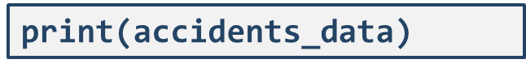In Python, we can print the variable
* Even better, in Jupyter, a cell outputs its last returned value
  + This will create a nicer output
* We can see that
  + Rows have numerical indices starting at 0 by default
  + Columns have names taken from the first line in the .csv file
* Column names:
* 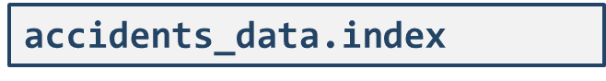Index values:



* Dimensions:
  + Format: (rows, columns)

**2.5 Reading Data from Other Files**

* The process is very similar
* Other text-based formats
  + pd.read_table() is the most general function
    - All others (read_csv(), read_fwf(), etc.) just apply some settings
  + If we come across a file, we can apply our own settings
    - The point is to match the format in the best possible way
    - Example: [*AutoMPG dataset*](http://archive.ics.uci.edu/ml/datasets/Auto+MPG)
* Excel
  + Read the green_tripdata_2015-09.xls file using pd.read_excel()
  + Explore the file dimensions

**2.6 Reading Data from Web Services**

* Web services work over the HTTP protocol and provide data in several formats
  + Most commonly used: JSON and XML
  + [*Some APIs to try*](https://github.com/toddmotto/public-apis)
* Example: [*OpenLibrary API*](https://openlibrary.org/)
  + We want information about books with ISBNs
    - Example: [*these 4 books*](https://openlibrary.org/api/books?bibkeys=ISBN:9780345354907,ISBN:0881847690,LCCN:2005041555,ISBN:0060957905&format=json)
    - We can put the URL directly, pandas will perform a GET request
  + Function: pd.read_json()
    - We can provide the parameter orient = "index" to arrange the dataset better
      * Books should be placed by rows, their properties – by columns
      * More details on this – next time
  + More complex queries require more pre-processing

**2.7 Reading Data from SQL**

* Relational databases store data in tables
  + Very similar to the datasets we use
* First, install a library to connect to databases
  + 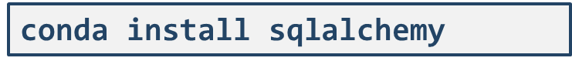From the command line:
* Then, import the library and connect to the database
  + Note: This is going to vary depending on your server settings



* + Perform a query

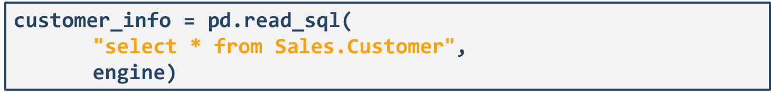

**2.8 Web Scraping**

* Another method for getting data
* Sometimes combined with **crawling**
  + Traversing a Web page structure recursively
* Basic procedure
  + Read a Web page as HTML
  + Use the HTML to obtain the data
    - A webpage is unstructured
    - We need to create and maintain the structure
    - We usually need more libraries to do that
* Examples
  + Get all job listings from a website
  + A screenshot of a computer

    Description automatically generatedGet user contact details from a Web page

## Using Multiple Sources

**3.1 Data Guidelines**

* Some queries will not be simple
  + E.g., scraping, dealing with "freeform" text, audio data, networks
  + We need to create a tabular structure from the raw data
    - How? We'll discuss this later in the course
* After we read the data, we have to ensure it's been read   
  without errors
  + A very simple first check: check the dimensions (dataframe.shape)  
    and show the first few rows (dataframe.head())
  + We may need to rename columns
  + We may need to perform different manipulations to ensure  
    the data is in a proper state
    - We'll do this in the next lectures

**3.2 Merging Many Data Sources**

* **Automate the process** as much as possible
  + From reading the raw data to getting the processed dataset
  + If the dataset changes or updates, you'll just re-run your code
* **Document the process**
* Create as few datasets as possible
  + I.e., merge many sources into one table if you can
    - We'll talk more about combining relations next time
* Ensure the different sources are compatible and consistent
  + If they aren't, process the raw data
    - Most common example: Mismatched IDs
* Make sure all column types are correct
  + Check: dataframe.dtypes
    - Example: str type for a numeric column