Run script from rdkit environment:
conda activate rdkit
1.qed_sa_script_filter_and_export_input.py (script to filter molecules that obtained from BiND by sa and qed ) to run this script fpscores.pkl.gz need to be in the folder
example of command:
(rdkit) C:\rdkit>python qed_sa_script_filter_and_export_input.py --input "C:\BiND_nicotinic_receptor_calculations\sample_7ekt_1000_include_test_pocket\gen" --output "C:\BiND_nicotinic_receptor_calculations\sample_7ekt_1000_include_test_pocket\gen"
Done.
2. docking script: batch_docking_Vina.py, files need to in folder receptor pds, receptor pdbqt, conf file, vina1.5.7.exe
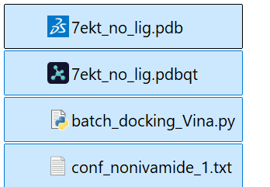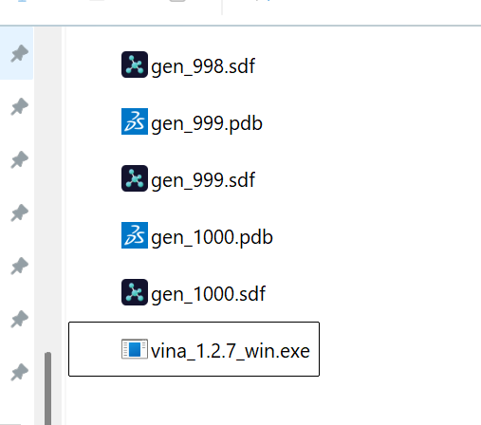
(rdkit) C:\rdkit>python batch_docking_Vina.py
Need to run it from folder where filtered molecules, or it will not find vina exe
Usage:
python dock_all_gen_pdb_vina.py "C:\path\to\folder_with_gen_pdb_and_vina_files"
example command:
python batch_docking_Vina.py "C:\BiND_nicotinic_receptor_calculations\sample_7ekt_1000_include_test_pocket\gen\filtered"
result in docking_runs folder
