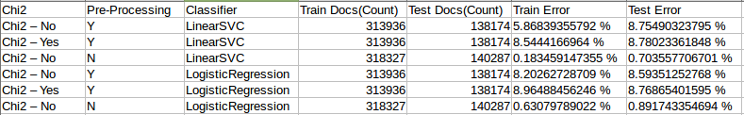
all the above didn't give us the boost in results

