- They used Multinomial Naive Bayes and LIBLINEAR (Logistic Regression) classifier.
- They tried with various features
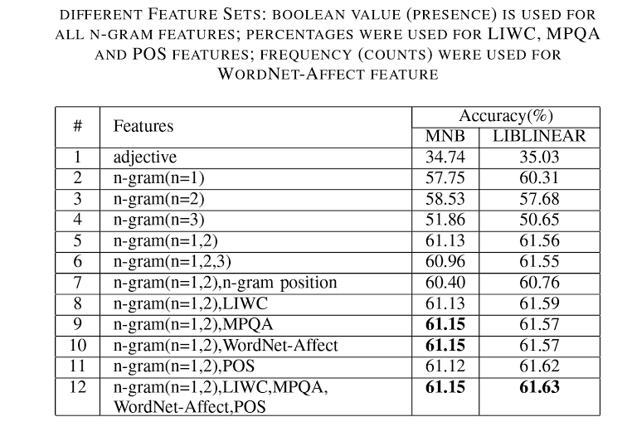
- Maximum result is, 62% accuracy
  - Features,
LIWC, MPQA word lists, Unigrams and Bigrams, Word net affect words(32 categories), number of words in each of POS category as features

  - With LogisticRegression(LIBLINEAR) classifier.

