Fig. 3

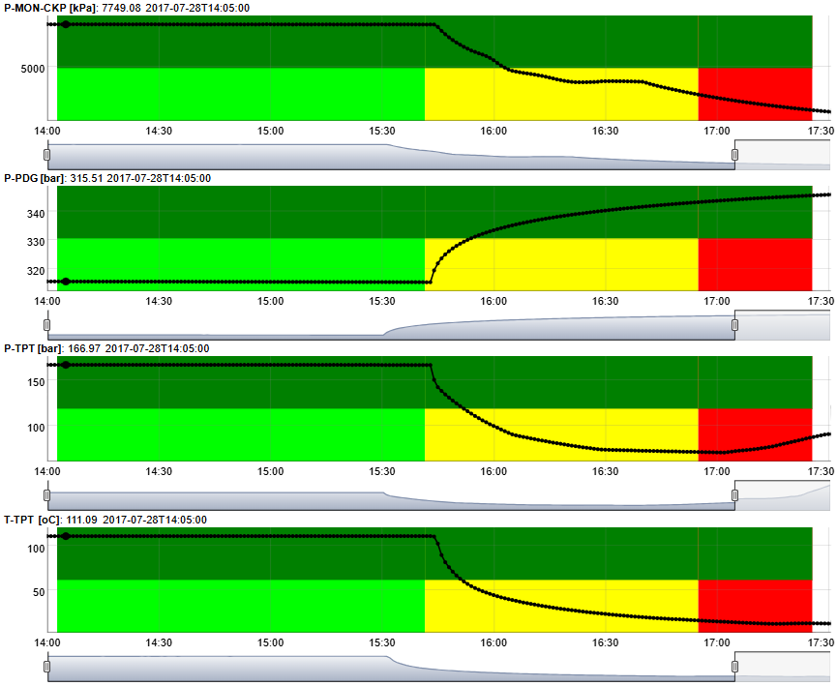

Example of a real Spurious Closure of DHSV instance in which pressure increase is observed in sensors located upstream of the DHSV (PDG) and pressure decreases are observed in sensors located downstream of the DHSV (TPT and MON-CKP). This example has 3 periods which were labeled with the Petrobras' Web Tool as follows: light green (1st period = Normal Operation): class label = 0; yellow (2nd period = Transient Condition): class label = 102; red (3rd period = Steady State): class label = 2; dark green (Open): state label = 0.

Fig. 4

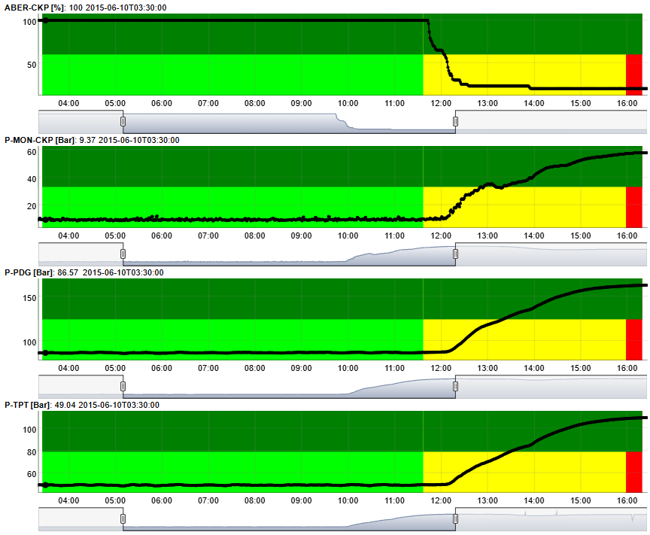

Example of a real Quick Restriction in PCK instance in which pressure increases are observed in sensors located in TPT, PDG, and MON-CKP. This example has 3 periods which were labeled with the Petrobras' Web Tool as follows: light green (1st period = Normal Operation): class label = 0; yellow (2nd period = Transient Condition): class label = 106; red (3rd period = Steady State): class label = 6; dark green (Open): state label = 0.

Fig. 5

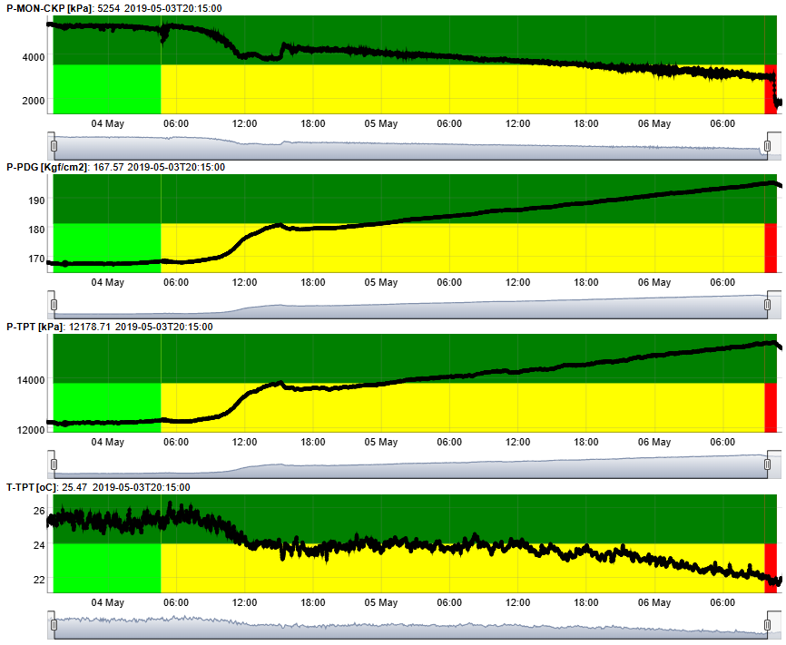

Example of a real Hydrate in Production Line instance in which pressure increases are observed in sensors located upstream of the production line (PDG and TPT) and pressure decrease is observed in sensor located downstream of the production line (MON-CKP). This example has 3 periods which were labeled with the Petrobras' Web Tool as follows: light green (1st period = Normal Operation): class label = 0; yellow (2nd period = Transient Condition): class label = 108; red (3rd period = Steady State): class label = 8; dark green (Open): state label = 0.

Fig. 6

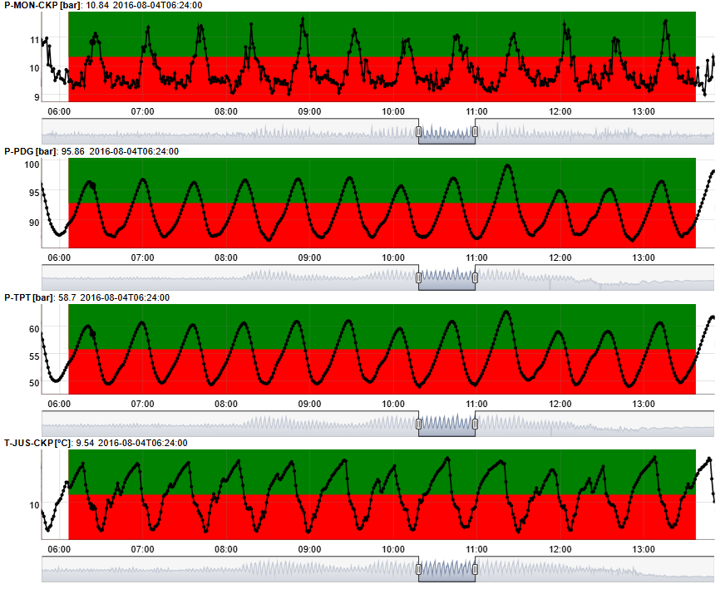

Example of a real Severe Slugging instance in which pressure oscillations with amplitudes above 10 bar are observed in sensors located in PDG and TPT. This example has 1 period which was labeled with the Petrobras' Web Tool as follows: red (1st period = Steady State): class label = 3; dark green (Open): state label = 0.

Fig. 7

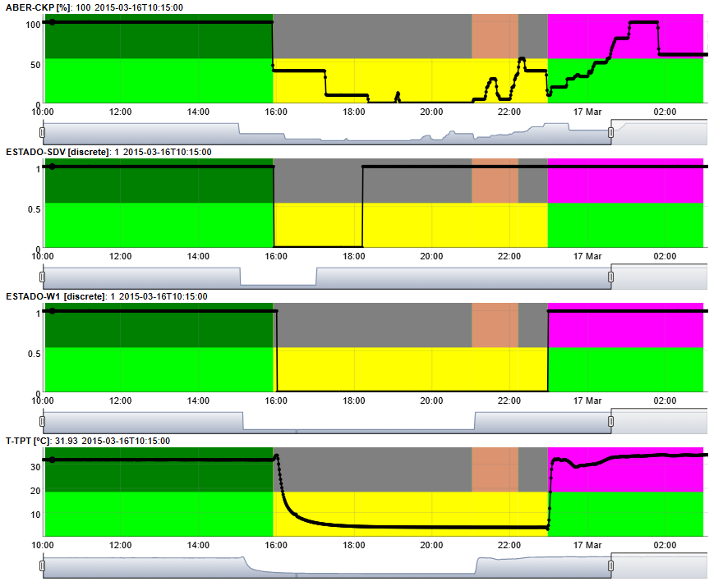

Example of a real Normal Operation instance in which depressurization has been carried out during a well shutdown, as shown by the opening of the PCK and SDV-P. This example has 1 period which was labeled with the Petrobras' Web Tool as follows: light green (1st period = Normal Operation): class label = 0; dark green (Open): state label = 0; gray (Shut-In): state label = 1; salmon (Depressurization): state label = 8; magenta (Restart): state label = 7.