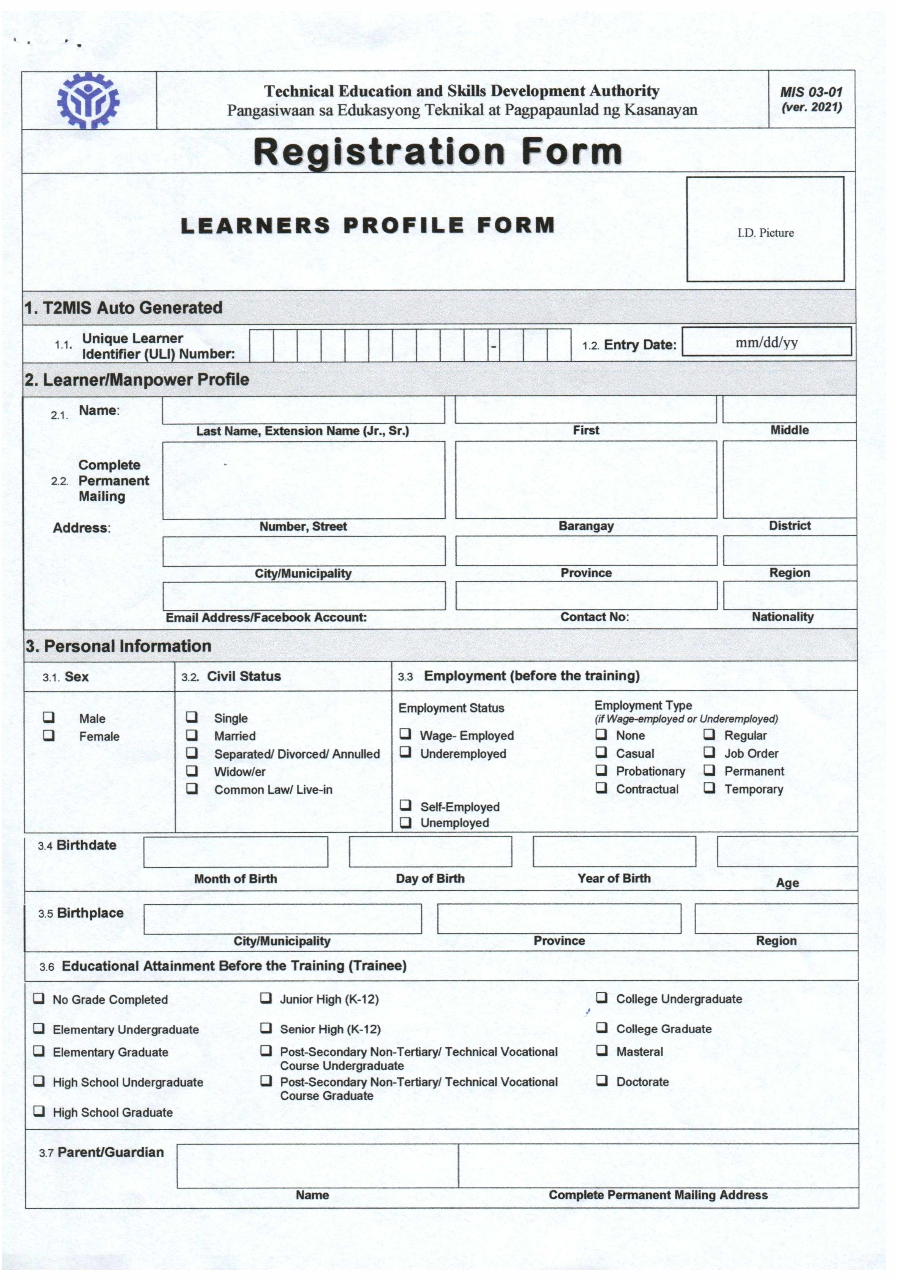
Middle Name
{educ13}
{educ11}
{address_parent}
{name_parent}
{educ12}
{educ10}
{educ9}
{educ8}
{educ7}
{region_birth}
{province_birth}
{city_birth}
{age}
{year_bday}
{day_bday}
Date of Birth
{emp2}
{emp1}
{single}
{date_now}
{uli_number}
{widow}
{married}
{male}
{last_name} {extension_name}
Active Email Address
{month_bday}
{educ6}
{educ5}
{educ4}
{educ3}
{educ2}
{educ1}
{female}
{livein}
{separated}
{empt8}
{empt7}
{empt6}
{empt5}
{empt4}
{empt3}
{empt2}
{empt1}
{emp4}
{emp3}
{nationality}
{contact_num}
{email}
{region}
{province}
{city}
{district}
{barangay}
{number_street}
{middle_name}
{first_name}
Active Email address
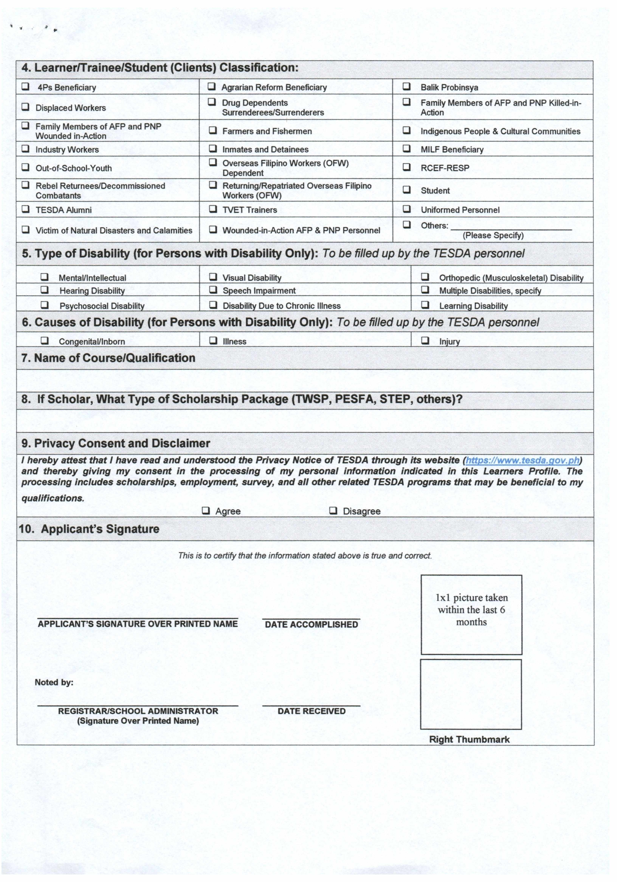
{others}
{consent_agree}
{date_now}
{first_name} {m_initial_name} {last_name} {extension_name}

j
{cause3}
{cause2}
{cause1}
{dis9}
{dis8}
{dis7}
{dis6}
{dis5}
{dis4}
{dis3}
{dis2}
{dis1}
{type_isko}
{classification}
{personnel}
{student}
{rcef}
{milf}
{indigenous}
{afp_pnp_killed}
{balik_probinsya}
{wounded}
{tvet}
{ofw_returning}
{ofw_dependent}
{inmate}
{farmer}
{drug}
{reform}
{victim}
{tesda_alumni}
{rebel}
{outofschoolyouth}
{industry_worker}
{afp_pnp}
{displaced_worker}
{4ps}
{consent_disagree}
{course}
CHRISTOPHER DC AQUILO

