BÀI THỰC HÀNH 1

1. Các tag định dạng cho text

This text is bold
This text is strong
This text is big
This text is emphasized
This text is italic
This text is small
This is _{subscript} and ^{superscript}
<html>
<body>
<p><b>This text is bold</b></p>
<p><strong>This text is strong</strong></p>
<p><big>This text is big</big></p>
<p><em>This text is emphasized</em></p>
<p><i>This text is italic</i></p>
<p><small>This text is small</small></p>
<p>This is<sub> subscript</sub> and <sup>superscript</sup></p>
</body>
</html>

This is
preformatted text.
It preserves both spaces
and line breaks.
The pre tag is good for displaying computer code:
for i = 1 to 10
print i
next i
html>
<body>

<pre>
This is
preformatted text.
It preserves both spaces
and line breaks.
</pre>

<p>The pre tag is good for displaying computer code:</p>

<pre>
for i = 1 to 10
print i
next i
</pre>
</body>
</html>

A blockquote quotation:
This is a long quotation. This is a long quotation. This is a long quotation. This is a long quotation. This is a long quotation.
The browser inserts line breaks and margins for a blockquote element.
<html>
<body>

A blockquote quotation:
<blockquote>
This is a long quotation. This is a long quotation. This is a long quotation. This is a long quotation. This is a long quotation.
</blockquote>
</body>
</html>

<p>
a dozen is
<del>twenty</del>
<ins>twelve</ins>
pieces
</p>

2. Link

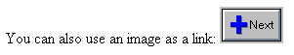
<html>
<body>
<p>
You can also use an image as a link:
<a href="lastpage.htm">
<img border="0" src="buttonnext.gif" width="65" height="38">
</a>
</p>

</body>
</html>

Last Page
If you set the target attribute of a link to "_blank", the link will open in a new window
<html>
<body>

<a href="lastpage.htm" target="_blank">Last Page</a>

<p>
If you set the target attribute of a link to "_blank",
the link will open in a new window.
</p>

</body>
</html>

Locked in a frame?
Click here!
<html>
<body>

<p>Locked in a frame?</p>

<a href="http://www.w3schools.com/"
target="_top">Click here!</a>

</body>
</html>

This is a mail link: Send Mail
<html>

<body>

<p>
This is a mail link:
<a href="mailto:someone@microsoft.com?subject=Hello%20again">
Send Mail</a>
</p>
</body>
</html>

This is another mailto link: Send mail!
<html>

<body>

<p>
This is another mailto link:
<a href="mailto:someone@microsoft.com?cc=someoneelse@microsoft.com&bcc=andsomeoneelse2@microsoft.com&subject=Summer%20Party&body=You%20are%20invited%20to%20a%20big%20summer%20party!">Send mail!</a>
</p>
</body>
</html>

3. Bảng (Table)
<table border="1">
<tr>
<td>100</td>
<td>200</td>
<td>300</td>
</tr>
<tr>
<td>400</td>
<td>500</td>
<td>600</td>
</tr>
</table>
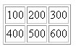

<table border="8">
<tr>
<td>First</td>
<td>Row</td>
</tr>
<tr>
<td>Second</td>
<td>Row</td>
</tr>
</table>
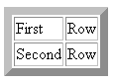

<table border="1">
<tr>
<th>First Name:</th>
<td>Bill Gates</td>
</tr>
<tr>
<th>Telephone:</th>
<td>555 77 854</td>
</tr>
<tr>
<th>Telephone:</th>
<td>555 77 855</td>
</tr>
</table>
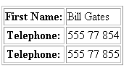

<html>
<body>

<h4>Cell that spans two columns:</h4>
<table border="1">
<tr>
<th>Name</th>
<th colspan="2">Telephone</th>
</tr>
<tr>
<td>Bill Gates</td>
<td>555 77 854</td>
<td>555 77 855</td>
</tr>
</table>

<h4>Cell that spans two rows:</h4>
<table border="1">
<tr>
<th>First Name:</th>
<td>Bill Gates</td>
</tr>
<tr>
<th rowspan="2">Telephone:</th>
<td>555 77 854</td>
</tr>
<tr>
<td>555 77 855</td>
</tr>
</table>

</body>
</html>
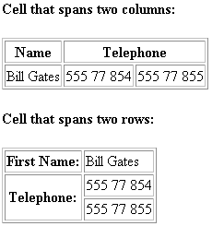

<table border="1"
cellpadding="10">
<tr>
<td>First</td>
<td>Row</td>
</tr>
<tr>
<td>Second</td>
<td>Row</td>
</tr>
</table>
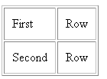

<html>
<body>

<h4>A background color:</h4>
<table border="1"
bgcolor="red">
<tr>
<td>First</td>
<td>Row</td>
</tr>
<tr>
<td>Second</td>
<td>Row</td>
</tr>
</table>

<h4>A background image:</h4>
<table border="1"
background="bgdesert.jpg">
<tr>
<td>First</td>
<td>Row</td>
</tr>
<tr>
<td>Second</td>
<td>Row</td>
</tr>
</table>

</body>
</html>
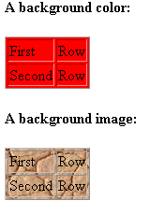

<html>
<body>

<h4>Cell backgrounds:</h4>
<table border="1">
<tr>
<td bgcolor="red">First</td>
<td>Row</td>
</tr>
<tr>
<td
background="bgdesert.jpg">
Second</td>
<td>Row</td>
</tr>
</table>

</body>
</html>

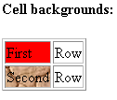

<html>
<body>

<table width="400" border="1">
<tr>
<th align="left">Money spent on....</th>
<th align="right">January</th>
<th align="right">February</th>
</tr>
<tr>
<td align="left">Clothes</td>
<td align="right">$241.10</td>
<td align="right">$50.20</td>
</tr>
<tr>
<td align="left">Make-Up</td>
<td align="right">$30.00</td>
<td align="right">$44.45</td>
</tr>
<tr>
<td align="left">Food</td>
<td align="right">$730.40</td>
<td align="right">$650.00</td>
</tr>
<tr>
<th align="left">Sum</th>
<th align="right">$1001.50</th>
<th align="right">$744.65</th>
</tr>
</table>

</body>
</html>

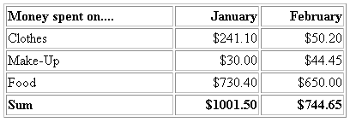

<html>
<body>

<p>
If you see no frames around the tables in these examples, your browser is too old, or does not support it.
</p>

<h4>With frame="border":</h4>
<table frame="border">
<tr>
<td>First</td>
<td>Row</td>
</tr>
<tr>
<td>Second</td>
<td>Row</td>
</tr>
</table>

<h4>With frame="box":</h4>
<table frame="box">
<tr>
<td>First</td>
<td>Row</td>
</tr>
<tr>
<td>Second</td>
<td>Row</td>
</tr>
</table>

<h4>With frame="void":</h4>
<table frame="void">
<tr>
<td>First</td>
<td>Row</td>
</tr>
<tr>
<td>Second</td>
<td>Row</td>
</tr>
</table>

<h4>With frame="above":</h4>
<table frame="above">
<tr>
<td>First</td>
<td>Row</td>
</tr>
<tr>
<td>Second</td>
<td>Row</td>
</tr>
</table>

<h4>With frame="below":</h4>
<table frame="below">
<tr>
<td>First</td>
<td>Row</td>
</tr>
<tr>
<td>Second</td>
<td>Row</td>
</tr>
</table>

<h4>With frame="hsides":</h4>
<table frame="hsides">
<tr>
<td>First</td>
<td>Row</td>
</tr>
<tr>
<td>Second</td>
<td>Row</td>
</tr>
</table>

<h4>With frame="vsides":</h4>
<table frame="vsides">
<tr>
<td>First</td>
<td>Row</td>
</tr>
<tr>
<td>Second</td>
<td>Row</td>
</tr>
</table>

<h4>With frame="lhs":</h4>
<table frame="lhs">
<tr>
<td>First</td>
<td>Row</td>
</tr>
<tr>
<td>Second</td>
<td>Row</td>
</tr>
</table>

<h4>With frame="rhs":</h4>
<table frame="rhs">
<tr>
<td>First</td>
<td>Row</td>
</tr>
<tr>
<td>Second</td>
<td>Row</td>
</tr>
</table>

</body>
</html>

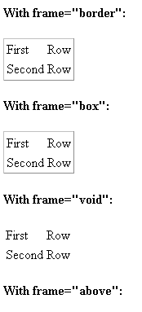

<table frame="hsides" border="3">
<tr>
<td>First row</td>
</tr>
</table>
<br />
<table frame="vsides" border="3">
<tr>
<td>First row</td>
</tr>
</table>
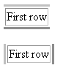

3. List

<html>
<body>

<h4>An Unordered List:</h4>
<ul>
<li>Coffee</li>
<li>Tea</li>
<li>Milk</li>
</ul>

</body>
</html>

An Unordered List:
- Coffee
- Tea
- Milk

<html>
<body>

<h4>An Ordered List:</h4>
<ol>
<li>Coffee</li>
<li>Tea</li>
<li>Milk</li>
</ol>

</body>
</html>

An Ordered List:
- Coffee
- Tea
- Milk

<h4>Roman numbers list:</h4>
<ol type="I">
<li>Apples</li>
<li>Bananas</li>
<li>Lemons</li>
<li>Oranges</li>
</ol>

Roman numbers list:
- Apples
- Bananas
- Lemons
- Oranges

<h4>Circle bullets list:</h4>
<ul type="circle">
<li>Apples</li>
<li>Bananas</li>
<li>Lemons</li>
<li>Oranges</li>
</ul>

Circle bullets list:
- Apples
- Bananas
- Lemons
- Oranges

<html>
<body>

<h4>A nested List:</h4>
<ul>
<li>Coffee</li>
<li>Tea
<ul>
<li>Black tea</li>
<li>Green tea</li>
</ul>
</li>
<li>Milk</li>
</ul>

</body>
</html>

A nested List:
- Coffee
- Tea
  - Black tea
  - Green tea
- Milk

<html>
<body>

<h4>A Definition List:</h4>
<dl>
<dt>Coffee</dt>
<dd>Black hot drink</dd>
<dt>Milk</dt>
<dd>White cold drink</dd>
</dl>

</body>
</html>

A Definition List:
Coffee
Black hot drink
Milk
White cold drink

4. Control in form

<html>
<body>

<form action="">
First name:
<input type="text" name="firstname">
<br>
Last name:
<input type="text" name="lastname">
</form>
</body>
</html>
Top of Form
First name: 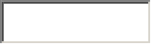
Last name:
Bottom of Form

<form action="">
Username:
<input type="text" name="user">
<br>
Password:
<input type="password" name="password">
</form>
<p>
Top of Form
Username:
Password:

<html>
<body>

<form action="">
I have a bike:
<input type="checkbox" name="vehicle" value="Bike">
<br />
I have a car:
<input type="checkbox" name="vehicle" value="Car">
<br />
I have an airplane:
<input type="checkbox" name="vehicle" value="Airplane">
</form>

</body>
</html>

Top of Form
I have a bike: 
I have a car:
I have an airplane:
Bottom of Form

<form action="">
Male:
<input type="radio" checked="checked"
name="Sex" value="male">
<br>
Female:
<input type="radio"
name="Sex" value="female">
</form>
Male: 
Female

<html>
<body>

<form action="">
<input type="button" value="Hello world!">
</form>

</body>
</html>

Top of Form
Bottom of Form

<fieldset>
<legend>
Health information:
</legend>
<form action="">
Height <input type="text" size="3">
Weight <input type="text" size="3">
</form>
</fieldset>
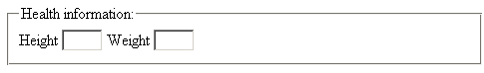

<form name="input" action="html_form_action.asp" method="get">

Type your first name:
<input type="text" name="FirstName" value="Mickey" size="20">
<br>Type your last name:
<input type="text" name="LastName" value="Mouse" size="20">
<br>
<input type="submit" value="Submit">

</form>
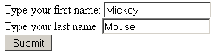

<html>
<body>
<form action="MAILTO:someone@w3schools.com" method="post" enctype="text/plain">

<h3>This form sends an e-mail to W3Schools.</h3>
Name:<br>
<input type="text" name="name"
value="yourname" size="20">
<br>
Mail:<br>
<input type="text" name="mail"
value="yourmail" size="20">
<br>
Comment:<br>
<input type="text" name="comment"
value="yourcomment" size="40">
<br><br>
<input type="submit" value="Send">
<input type="reset" value="Reset">

</form>
</body>
</html>
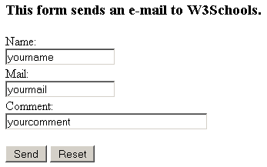

5. Images
<html>
<body>

<p>An image from another folder:</p>
<img src="/images/chrome.gif"
width="33" height="32">

<p>An image from W3Schools:</p>
<img src="http://www.w3schools.com/images/w3schools_green.jpg"
width="104" height="142">

</body>
</html>


BÀI TẬP:
Bài 1: Thiết kế 1 trang chủ để link các bài tập lại với nhau. Như giao diện sau:
+ Bài 1
+ Bài 2
+ Bài 3
+ Bài 4
- Các trang con có link để quay về trang chủ

Bài 2: Thiết kế 1 form đang ký người dùng như hình sau
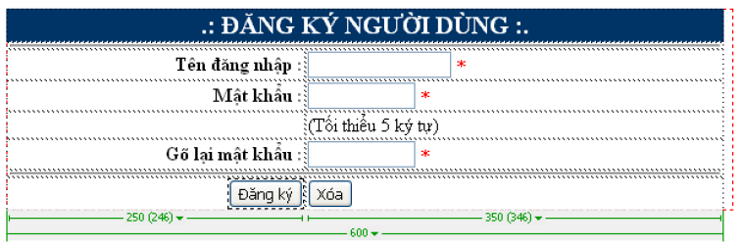
Bài 3: Thiết kế Form đăng ký người dùng như hình vẽ sau:

