Introduction

For this assignment, I had to use assembly language to program a Z80 microprocessor to turn a stepper motor, with an on/off control and a control for the direction of rotation. For this, I used the Merlin assembler, a very basic assembler program and a SAM board with a Z80 microprocessor. This program used a lot of my programming knowledge and also required me to learn a few new things.

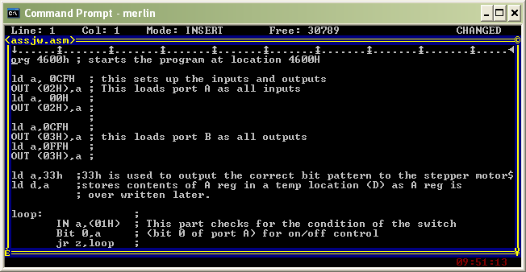
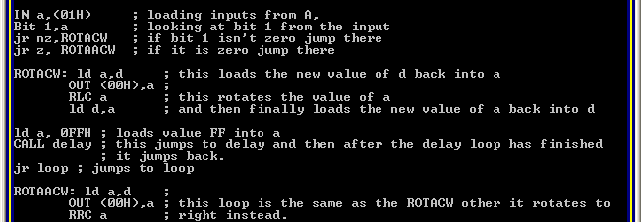
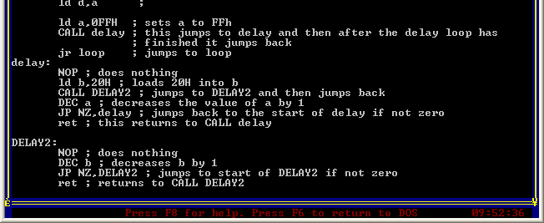

Conclusion

Overall, my project was very successful, although I was not able to get my stepper motor to turn at exactly the correct speed. I had got a roughly correct speed, however, had I had more time, it would have been possible to calculate the speed accurately by looking at the number of machine cycles it takes for each command in the delay and DELAY2 loops and therefore calculate the amount of time it takes for the loop to complete. This program was quite challenging to produce as it involved using several loops and (with a loop within a loop as well!). I also had to learn how to set up inputs and outputs, how to rotate values and how to tell the program to do nothing in order to slow the speed of the motor down. I thought the project was quite interesting and it was good to see a tangible application of assembly language.

Block Diagram
Switch Box
SAM board
LED box
Stepper motor board
5V DC
5V DC
Port A
Port B
5V DC

