|  |  |
| --- | --- |
|  | *Cost-Effective Food Monitoring System* |
| **Major:** | **Name:** |
| CS | Travis Wright |

**High-Level Diagram**

Android Smartphone app, allowing for easy adding of product using NFC tap of tag. Reusable temperature probe can be set to a specific item to monitor.

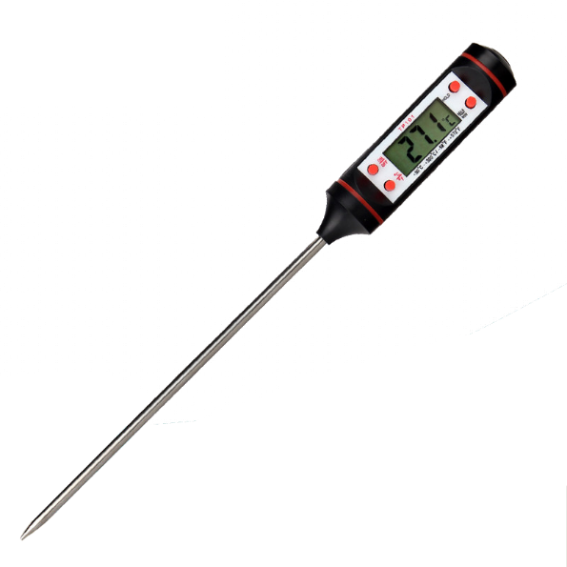

Item equipped with NFC tag as well as Bluetooth temperature probe, reporting temperature back to smartphone.

Item equipped with NFC tag, programmed with nutritional/expiration data.