**1．测试单元说明**

|  |  |  |  |  |
| --- | --- | --- | --- | --- |
| **单元模块** | **功能名称** | **输入** | **输出** | **目的** |
| 设置相关 | 添加联系人  (setting_01) | 在列表中选择联系人，并确认加入 | 在电话界面和短信显示根据数据库而产生的按钮 | 验证添加常用联系人是否正确，数据库读写是否正确。 |
| 添加常用短信  (setting_02) | 输入常用短信内容 | 在短信界面中，显示已经设置的常用短信 | 验证是否将设置的常用短信存入数据库 |
| 绑定网站账号  (setting_03) | 输入账号 | 下次显示已输入的账号 | 验证是否输入的账号已经被保存 |
| 设置GPS刷新频率  (setting_04) | 输入GPS刷新率 | 下次显示已输入的GPS刷新率 | 验证是否输入的GPS刷新率已经被保存 |
| 电话拨打 | 拨打常用电话  (phone_01) | 选择常用联系人 | 拨出相关人员电话 | 验证是否能拨电话，并且按钮相关信息设置正确 |
| 拨打临时电话  (phone_02) | 输入电话后自己拨打 | 拨出输入的电话 | 验证是否调用系统拨号功能成功 |
| 短信收发 | 发送短信  (message_01) | 选择相应联系人，选择相应已经存储好的短信内容 | 将该短信的发件人、发送时间和正文内容存入相应分类 | 验证分类存储功能是否正确，相关内容是否设置正确 |
| 接受短信  (message_02) | 点击“接受短信” | 弹出系统显示短信界面 | 验证是否能调用系统短信界面 |
| 照相照片 | 拍摄新照片  (camera_01) | 点击“我要拍新照片” | 弹出系统照相界面 | 验证照相功能是否正确 |
| 查看拍摄的照片  (camera _02) | 点击“我要看之前的照片” | 弹出相册界面 | 验证相册功能是否正确 |

**3.1测试单元模块1——设置相关**

填表日期：2014.4.10 编号： FC-01

|  |  |  |  |  |  |  |  |  |  |  |  |  |  |  |  |  |  |  |  |  |  |  |  |  |  |  |  |  |
| --- | --- | --- | --- | --- | --- | --- | --- | --- | --- | --- | --- | --- | --- | --- | --- | --- | --- | --- | --- | --- | --- | --- | --- | --- | --- | --- | --- | --- |
| 开发项目名称 | | | | | | ForGrandmon | | | | | | | 开发项目编号 | | | | 无 | | | | 第一责任人 | | | | | 冯哲 | | |
| 单元名称 | | | 设置相关 | | | | | | | 责任人 | | | 冯哲 | 单元所属子系统 | | | | | | | 无 | | | | 开发周期 | | |  |
| 代码测试检查：代码编译通过，且符合需求分析等文档要求 | | | | | | | | | | | | | | | | | | | | | | | | | | | | |
| 代码测试内容 | | | | | | | 测试人员 | | | | 测试结果 | | | | | | | | | | | | 备注 | | | | | |
| 路径测试 | | | | | | | 冯哲 | | | | 通过 | | | | | | | | | | | | 无 | | | | | |
| 声明测试 | | | | | | | 冯哲 | | | | 通过 | | | | | | | | | | | | 无 | | | | | |
| 循环测试 | | | | | | | 冯哲 | | | | 通过 | | | | | | | | | | | | 无 | | | | | |
| 边界测试 | | | | | | | 冯哲 | | | | 通过 | | | | | | | | | | | | 无 | | | | | |
| 接口测试 | | | | | | | 冯哲 | | | | 通过 | | | | | | | | | | | | 无 | | | | | |
| 界面测试 | | | | | | | 冯哲 | | | | 通过 | | | | | | | | | | | | 无 | | | | | |
| 数据确认测试 | | | | | | | 冯哲 | | | | 通过 | | | | | | | | | | | | 无 | | | | | |
| 代码走查 | | | | | | | 冯哲 | | | | 通过 | | | | | | | | | | | | 无 | | | | | |
| 功能测试：设置相关 | | | | | | | | | | | | | | | | | | | | | | | | | | | | |
| 序号 | 功能名称 | | | | | | | | 操作方法 | | | | | | | 结果 | | | | 建议 | | | | 测试人员 | | | 备注 | |
| 01 | 添加联系人  (setting_01) | | | | | | | | 1.打开此软件；  2.点击齿轮状按钮，进入设置界面；  3.点击“设置常用联系人”；  4.根据系统的提示信息继续进行操作完成添加功能。 | | | | | | | 在电话界面和短信界面中，可以看到新添加的人。 | | | | 无 | | | | 冯哲 | | |  | |
| 02 | 添加常用短信  (setting_02) | | | | | | | | 1.打开此软件；  2.点击齿轮状按钮，进入设置界面；  3.点击“设置常用短信”；  4.根据系统的提示信息继续进行操作完成添加功能。 | | | | | | | 在短信界面显示先前设置的相关短信内容 | | | | 建议有错误输入时候，显示提示 | | | | 冯哲 | | |  | |
| 03 | 绑定网站账号  (setting_03) | | | | | | | | 1.打开此软件；  2.点击齿轮状按钮，进入设置界面；  3.点击“绑定账号”；  4.在弹出的框中填入账号 | | | | | | | 以后任何时候打开该软件，都能显示已经存储的数据 | | | | 最好能把已经存入的数据锁定，若要修改，先弹出相关确认框 | | | | 冯哲 | | |  | |
| 04 | 设置GPS刷新频率  (setting_04) | | | | | | | | 1.打开此软件；  2.点击齿轮状按钮，进入设置界面；  3.点击“设定GPS刷新率”；  4.在弹出的选择列表中选择相应选项 | | | | | | | 以后任何时候打开该软件，都能显示已经存储的GPS数据 | | | | 把已经选定的数据显示 | | | | 冯哲 | | |  | |
| 测试结论 | | | | 系统单元模块基本满足测试要求，可按建议继续加深应用。 | | | | | | | | | | | | | | | | | | | | | | | | |
| 责任人 | | | | | 冯哲 | | | | | | | | | 项目第一责任人 | | | | | 傅雨东 | | | | | | | | | |
| 审核 | | | | | 傅雨东 | | | | | | | | | | | | | | | | | | | | | | | |
| 项目组 | | ForGrandmon开发小组 | | | | | | 测试组 | | | | ForGrandmon测试小组 | | | 总工办 | | | ForGrandmon开发小组 | | | | 总工程师 | | | | 傅雨东 | | |

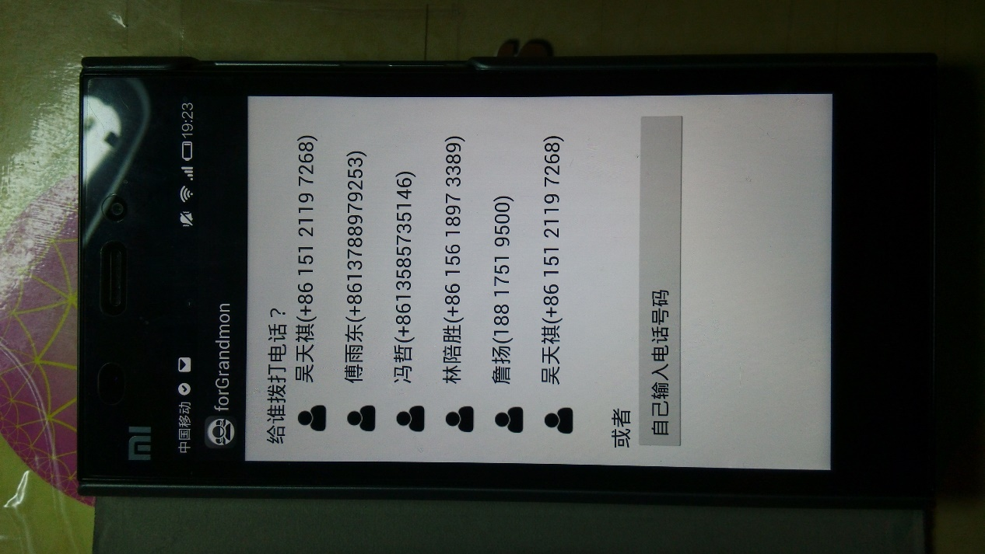

此时的常用联系人列表

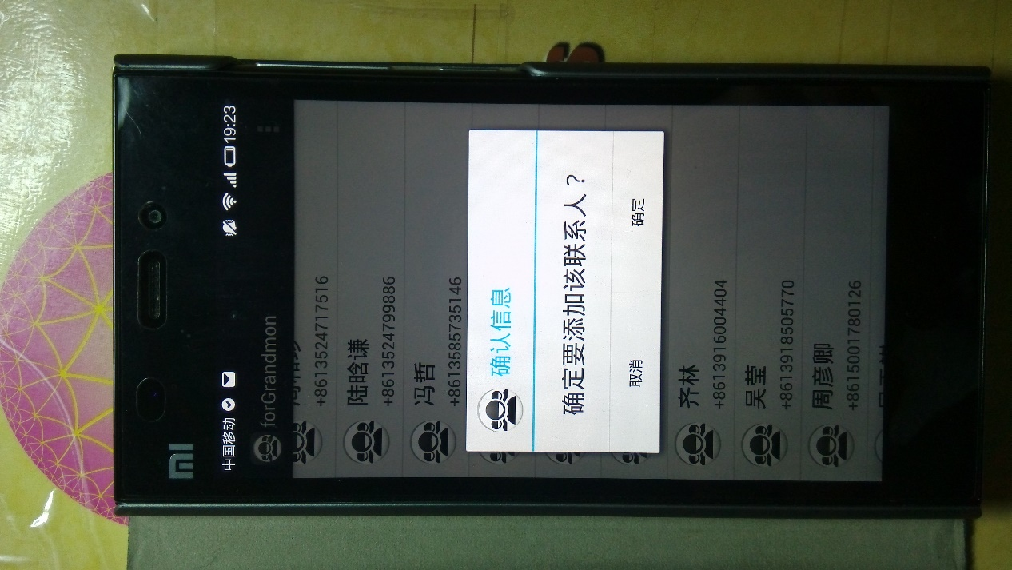

添加常用联系人

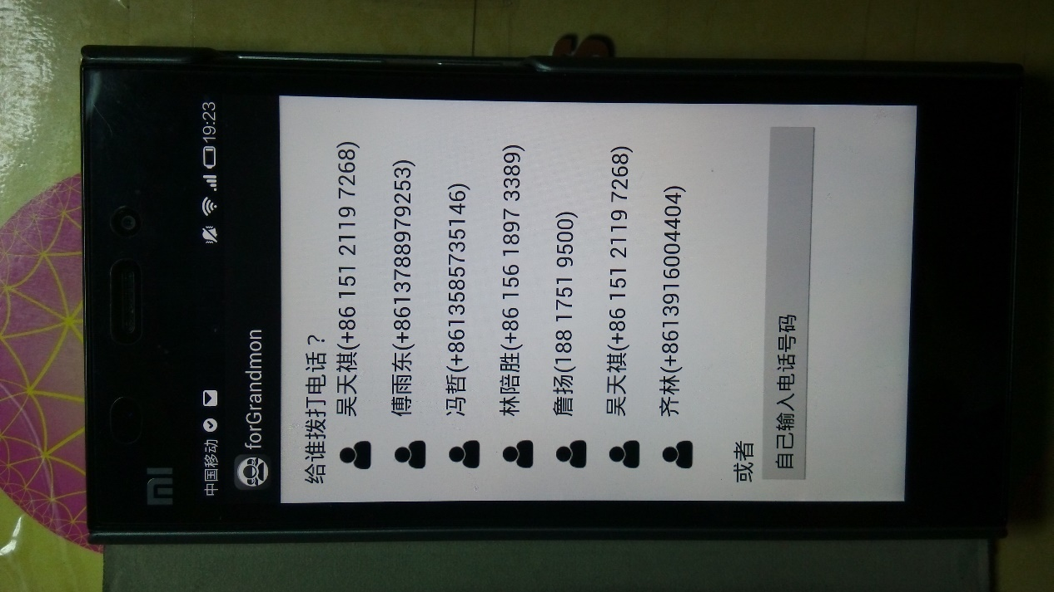

此时注意，已经添加了“齐林”联系人

测试01

<TO DO>

测试02图

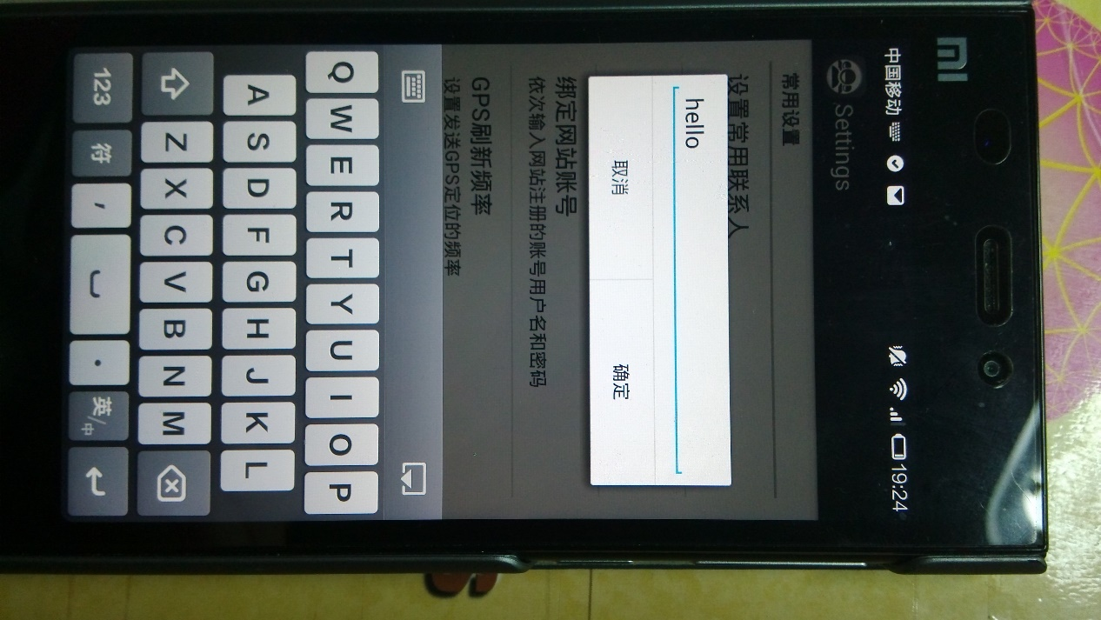

输入相关账号

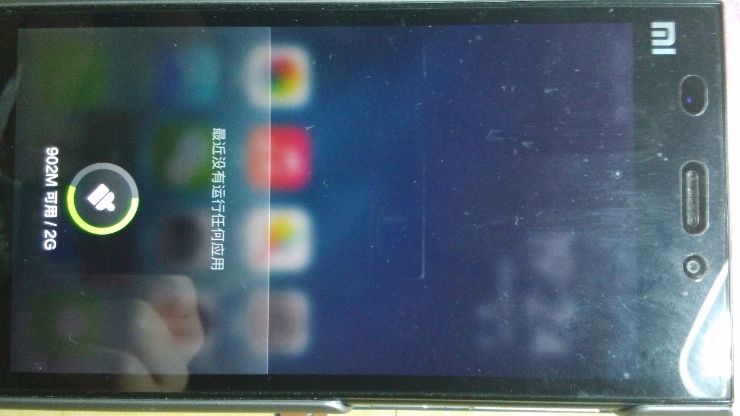

终止程序

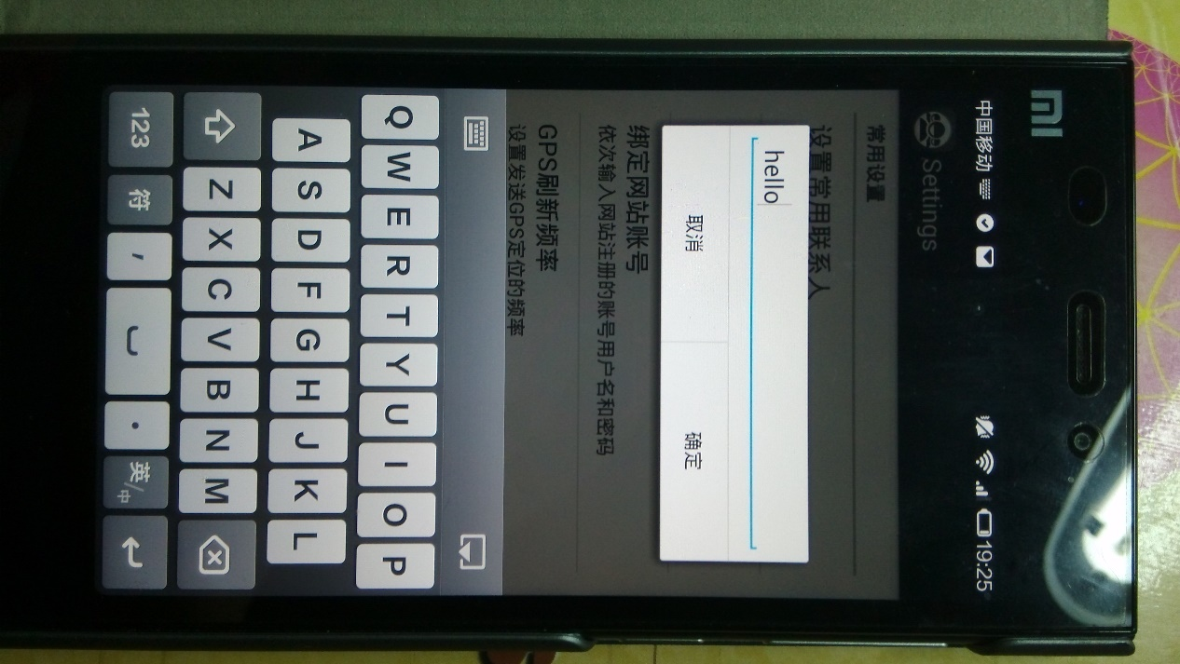

可见该内容依旧存在

测试03图

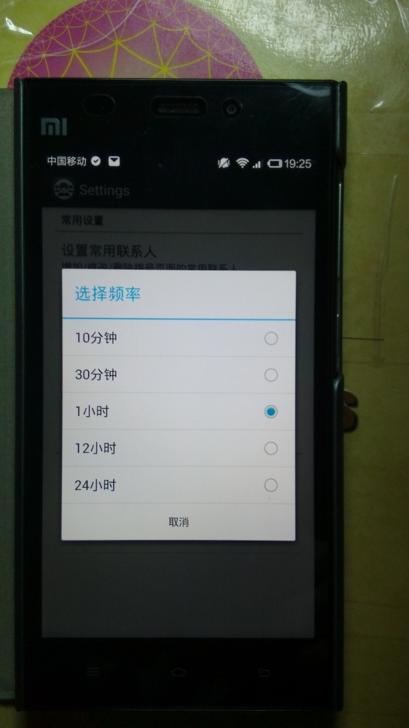

第一次设置内容

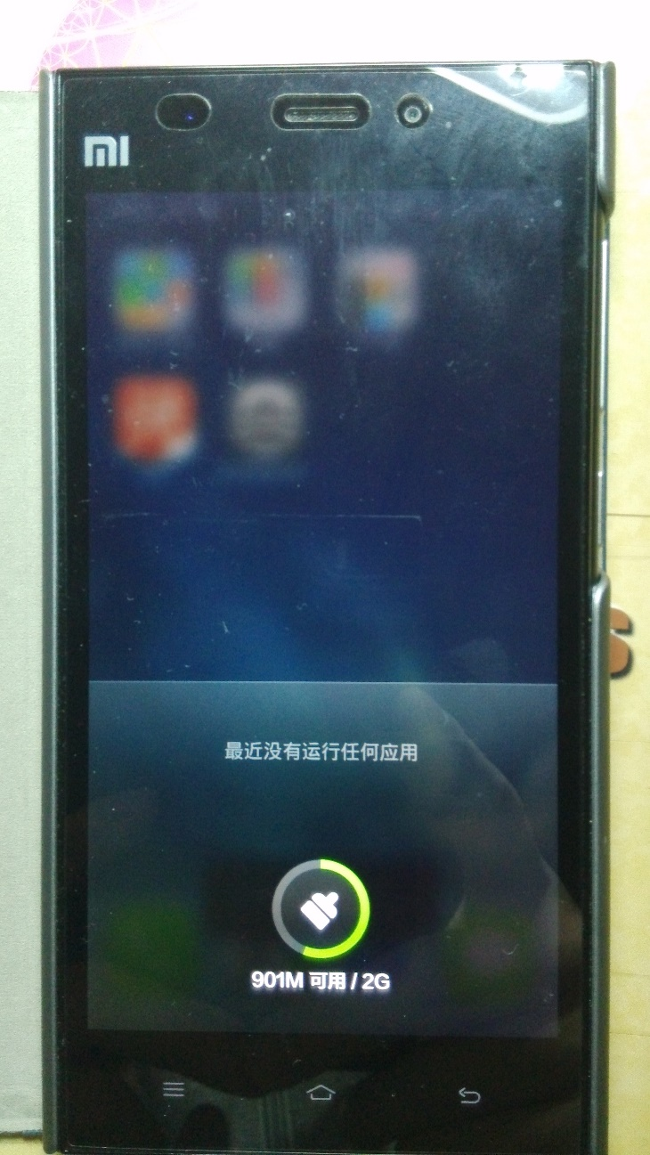

关闭程序

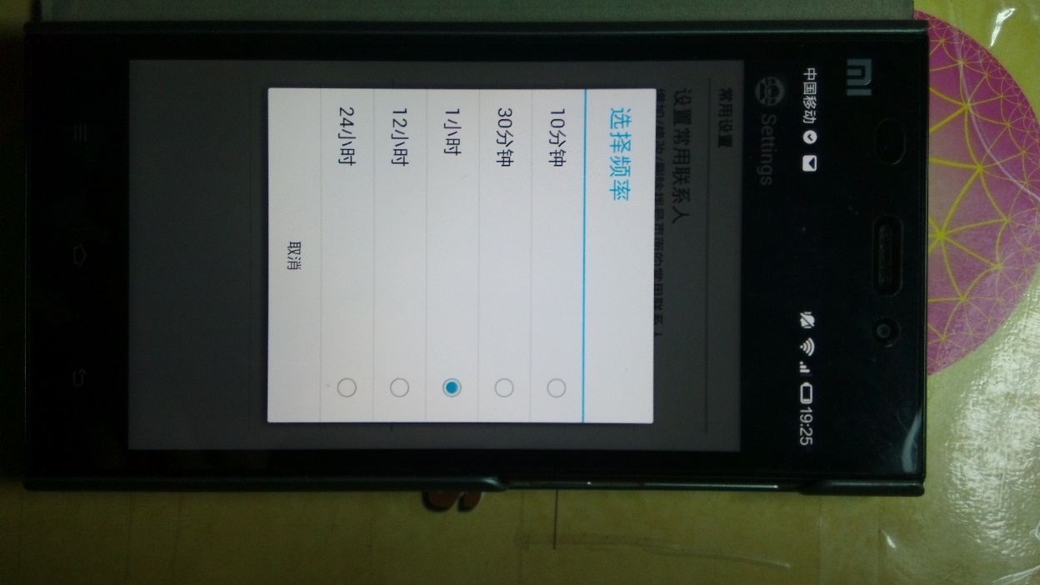

第二次打开还在

测试04图

**3.2测试单元模块2——电话拨打**

填表日期：2014.4.10 编号： FC-02

|  |  |  |  |  |  |  |  |  |  |  |  |  |  |  |  |  |  |  |  |  |  |  |  |  |  |  |  |  |
| --- | --- | --- | --- | --- | --- | --- | --- | --- | --- | --- | --- | --- | --- | --- | --- | --- | --- | --- | --- | --- | --- | --- | --- | --- | --- | --- | --- | --- |
| 开发项目名称 | | | | | | ForGrandmon | | | | | | | 开发项目编号 | | | | 无 | | | | 第一责任人 | | | | | 冯哲 | | |
| 单元名称 | | | 电话拨打 | | | | | | | 责任人 | | | 冯哲 | 单元所属子系统 | | | | | | | 无 | | | | 开发周期 | | |  |
| 代码测试检查：代码编译通过，且符合需求分析等文档要求 | | | | | | | | | | | | | | | | | | | | | | | | | | | | |
| 代码测试内容 | | | | | | | 测试人员 | | | | 测试结果 | | | | | | | | | | | | 备注 | | | | | |
| 路径测试 | | | | | | | 冯哲 | | | | 通过 | | | | | | | | | | | | 无 | | | | | |
| 声明测试 | | | | | | | 冯哲 | | | | 通过 | | | | | | | | | | | | 无 | | | | | |
| 循环测试 | | | | | | | 冯哲 | | | | 通过 | | | | | | | | | | | | 无 | | | | | |
| 边界测试 | | | | | | | 冯哲 | | | | 通过 | | | | | | | | | | | | 无 | | | | | |
| 接口测试 | | | | | | | 冯哲 | | | | 通过 | | | | | | | | | | | | 无 | | | | | |
| 界面测试 | | | | | | | 冯哲 | | | | 通过 | | | | | | | | | | | | 无 | | | | | |
| 数据确认测试 | | | | | | | 冯哲 | | | | 通过 | | | | | | | | | | | | 无 | | | | | |
| 代码走查 | | | | | | | 冯哲 | | | | 通过 | | | | | | | | | | | | 无 | | | | | |
| 功能测试：电话拨打 | | | | | | | | | | | | | | | | | | | | | | | | | | | | |
| 序号 | 功能名称 | | | | | | | | 操作方法 | | | | | | | 结果 | | | | 建议 | | | | 测试人员 | | | 备注 | |
| 01 | 拨打常用电话  (phone_01) | | | | | | | | 1.打开此软件；  2.点击电话按钮，进入电话界面；  3.点击某个人物按头像按钮；  4.等待电话拨出 | | | | | | | 电话成功拨出并接通 | | | | 无 | | | | 冯哲 | | |  | |
| 02 | 拨打临时电话  (phone_02) | | | | | | | | 1.打开此软件；  2.点击电话按钮，进入电话界面；  3.点击“自己输入电话号码”；  4.按照正常流程输入电话号码并拨出。 | | | | | | | 成功打开系统电话界面 | | | | 可以自己做个电话拨打界面，更加简单版本的。 | | | | 冯哲 | | |  | |
| 测试结论 | | | | 系统单元模块基本满足测试要求，可按建议继续加深应用。 | | | | | | | | | | | | | | | | | | | | | | | | |
| 责任人 | | | | | 冯哲 | | | | | | | | | 项目第一责任人 | | | | | 傅雨东 | | | | | | | | | |
| 审核 | | | | | 傅雨东 | | | | | | | | | | | | | | | | | | | | | | | |
| 项目组 | | ForGrandmon开发小组 | | | | | | 测试组 | | | | ForGrandmon测试小组 | | | 总工办 | | | ForGrandmon开发小组 | | | | 总工程师 | | | | 傅雨东 | | |

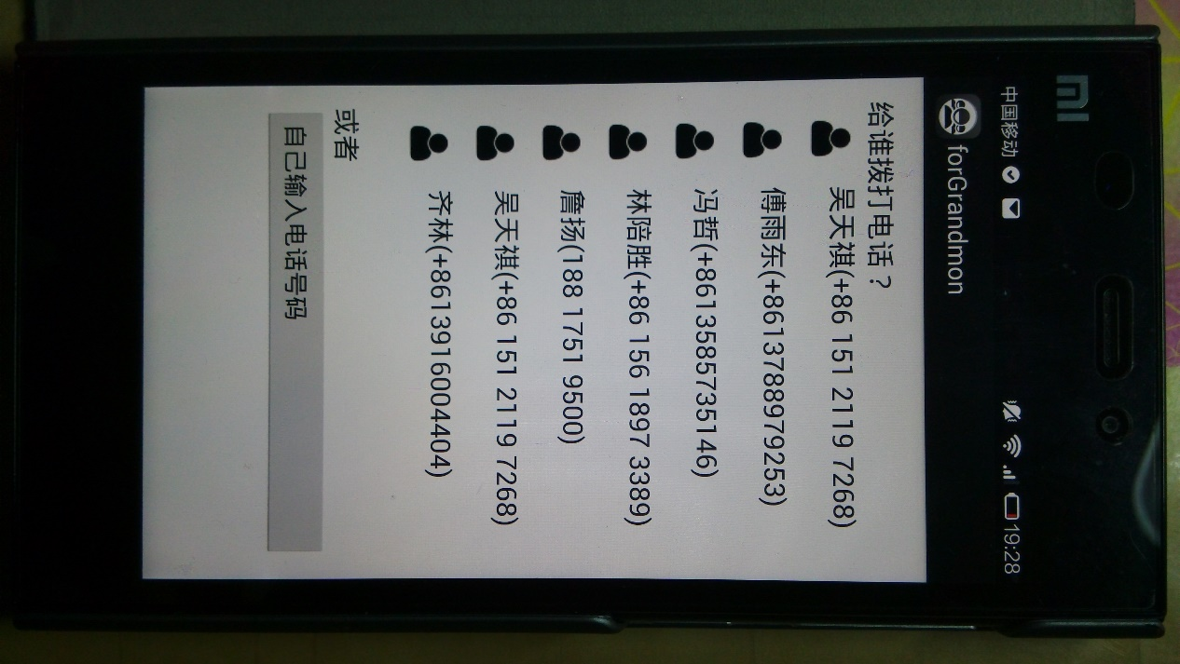

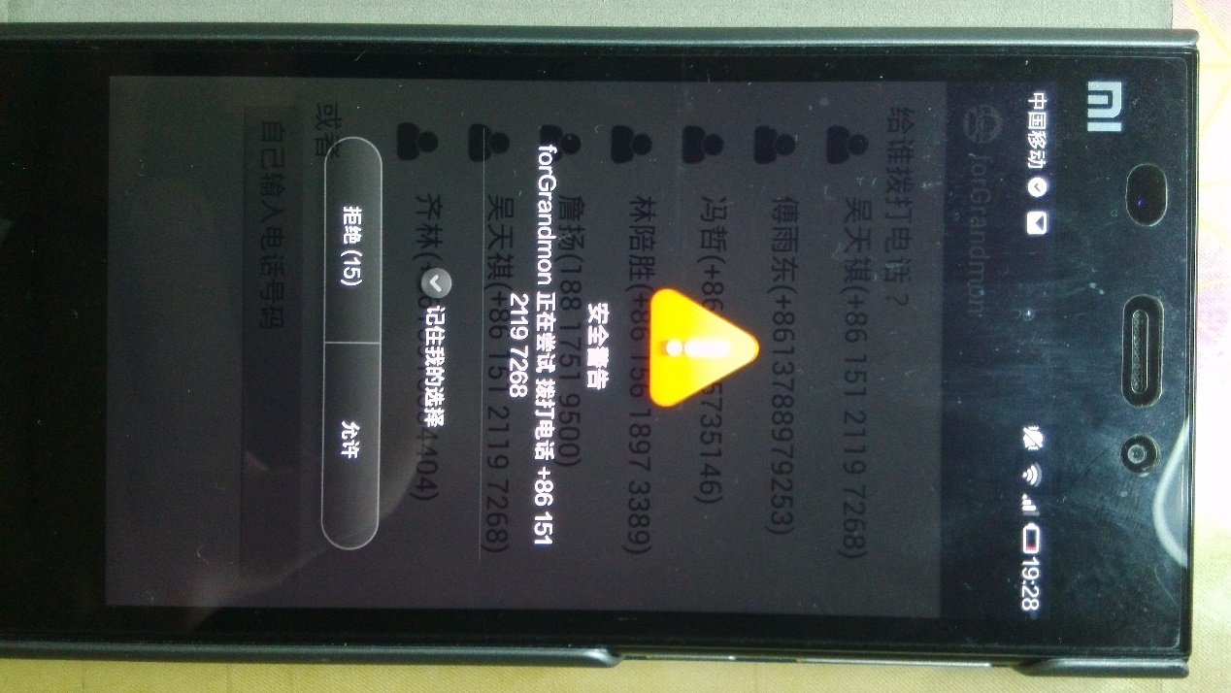

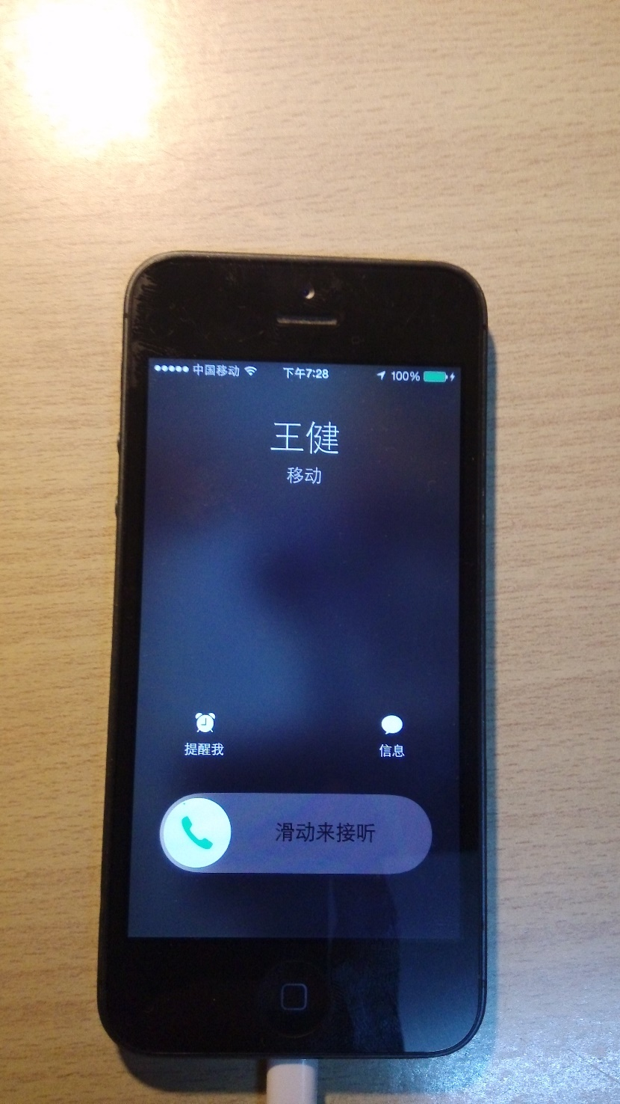

测试01

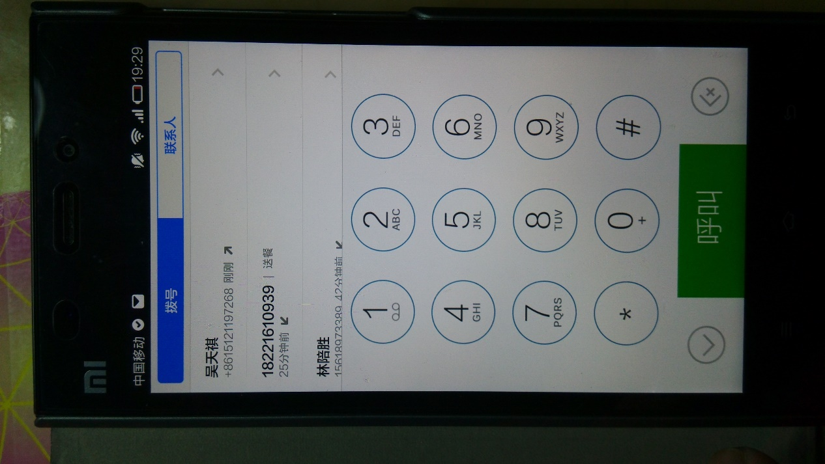

测试02

**3.3测试单元模块3——短信收发**

填表日期：2014.4.10 编号： FC-03

|  |  |  |  |  |  |  |  |  |  |  |  |  |  |  |  |  |  |  |  |  |  |  |  |  |  |  |  |  |
| --- | --- | --- | --- | --- | --- | --- | --- | --- | --- | --- | --- | --- | --- | --- | --- | --- | --- | --- | --- | --- | --- | --- | --- | --- | --- | --- | --- | --- |
| 开发项目名称 | | | | | | ForGrandmon | | | | | | | 开发项目编号 | | | | 无 | | | | 第一责任人 | | | | | 冯哲 | | |
| 单元名称 | | | 短信收发 | | | | | | | 责任人 | | | 冯哲 | 单元所属子系统 | | | | | | | 无 | | | | 开发周期 | | |  |
| 代码测试检查：代码编译通过，且符合需求分析等文档要求 | | | | | | | | | | | | | | | | | | | | | | | | | | | | |
| 代码测试内容 | | | | | | | 测试人员 | | | | 测试结果 | | | | | | | | | | | | 备注 | | | | | |
| 路径测试 | | | | | | | 冯哲 | | | | 通过 | | | | | | | | | | | | 无 | | | | | |
| 声明测试 | | | | | | | 冯哲 | | | | 通过 | | | | | | | | | | | | 无 | | | | | |
| 循环测试 | | | | | | | 冯哲 | | | | 通过 | | | | | | | | | | | | 无 | | | | | |
| 边界测试 | | | | | | | 冯哲 | | | | 通过 | | | | | | | | | | | | 无 | | | | | |
| 接口测试 | | | | | | | 冯哲 | | | | 通过 | | | | | | | | | | | | 无 | | | | | |
| 界面测试 | | | | | | | 冯哲 | | | | 通过 | | | | | | | | | | | | 无 | | | | | |
| 数据确认测试 | | | | | | | 冯哲 | | | | 通过 | | | | | | | | | | | | 无 | | | | | |
| 代码走查 | | | | | | | 冯哲 | | | | 通过 | | | | | | | | | | | | 无 | | | | | |
| 功能测试：电话拨打 | | | | | | | | | | | | | | | | | | | | | | | | | | | | |
| 序号 | 功能名称 | | | | | | | | 操作方法 | | | | | | | 结果 | | | | 建议 | | | | 测试人员 | | | 备注 | |
| 01 | 发送短信  (message_01) | | | | | | | | 1.打开此软件；  2.点击信封按钮，进入短信界面；  3.点击“我要发短信”按钮；  4．在后续弹出的界面中依次选择短信接收方和内容 | | | | | | | 短信成功发送 | | | | 无 | | | | 冯哲 | | |  | |
| 02 | 接受短信  (message_02) | | | | | | | | 1.打开此软件；  2.点击信封按钮，进入短信界面；  3.点击“我要收短信”按钮； | | | | | | | 成功打开系统短信箱界面 | | | | 做个自己的信箱，只显示选定来源的短信 | | | | 冯哲 | | |  | |
| 测试结论 | | | | 系统单元模块基本满足测试要求，可按建议继续加深应用。 | | | | | | | | | | | | | | | | | | | | | | | | |
| 责任人 | | | | | 冯哲 | | | | | | | | | 项目第一责任人 | | | | | 傅雨东 | | | | | | | | | |
| 审核 | | | | | 傅雨东 | | | | | | | | | | | | | | | | | | | | | | | |
| 项目组 | | ForGrandmon开发小组 | | | | | | 测试组 | | | | ForGrandmon测试小组 | | | 总工办 | | | ForGrandmon开发小组 | | | | 总工程师 | | | | 傅雨东 | | |

测试01

测试02

**3.4测试单元模块4——照相相册**

填表日期：2014.4.10 编号： FC-04

|  |  |  |  |  |  |  |  |  |  |  |  |  |  |  |  |  |  |  |  |  |  |  |  |  |  |  |  |  |
| --- | --- | --- | --- | --- | --- | --- | --- | --- | --- | --- | --- | --- | --- | --- | --- | --- | --- | --- | --- | --- | --- | --- | --- | --- | --- | --- | --- | --- |
| 开发项目名称 | | | | | | ForGrandmon | | | | | | | 开发项目编号 | | | | 无 | | | | 第一责任人 | | | | | 冯哲 | | |
| 单元名称 | | | 照相相册 | | | | | | | 责任人 | | | 冯哲 | 单元所属子系统 | | | | | | | 无 | | | | 开发周期 | | |  |
| 代码测试检查：代码编译通过，且符合需求分析等文档要求 | | | | | | | | | | | | | | | | | | | | | | | | | | | | |
| 代码测试内容 | | | | | | | 测试人员 | | | | 测试结果 | | | | | | | | | | | | 备注 | | | | | |
| 路径测试 | | | | | | | 冯哲 | | | | 通过 | | | | | | | | | | | | 无 | | | | | |
| 声明测试 | | | | | | | 冯哲 | | | | 通过 | | | | | | | | | | | | 无 | | | | | |
| 循环测试 | | | | | | | 冯哲 | | | | 通过 | | | | | | | | | | | | 无 | | | | | |
| 边界测试 | | | | | | | 冯哲 | | | | 通过 | | | | | | | | | | | | 无 | | | | | |
| 接口测试 | | | | | | | 冯哲 | | | | 通过 | | | | | | | | | | | | 无 | | | | | |
| 界面测试 | | | | | | | 冯哲 | | | | 通过 | | | | | | | | | | | | 无 | | | | | |
| 数据确认测试 | | | | | | | 冯哲 | | | | 通过 | | | | | | | | | | | | 无 | | | | | |
| 代码走查 | | | | | | | 冯哲 | | | | 通过 | | | | | | | | | | | | 无 | | | | | |
| 功能测试：电话拨打 | | | | | | | | | | | | | | | | | | | | | | | | | | | | |
| 序号 | 功能名称 | | | | | | | | 操作方法 | | | | | | | 结果 | | | | 建议 | | | | 测试人员 | | | 备注 | |
| 01 | 拍摄新照片  (camera_01) | | | | | | | | 1.打开此软件；  2.点击相机按钮，进入照相界面；  3.点击“我要照新照片； | | | | | | | 成功调用系统照相 | | | | 无 | | | | 冯哲 | | |  | |
| 02 | 查看拍摄的照片  (camera _02) | | | | | | | | 1.打开此软件；  2.点击相机按钮，进入相机界面；  3.点击“我要看之前的照片； | | | | | | | 成功调出系统相册 | | | | 无 | | | | 冯哲 | | |  | |
| 测试结论 | | | | 系统单元模块基本满足测试要求，可按建议继续加深应用。 | | | | | | | | | | | | | | | | | | | | | | | | |
| 责任人 | | | | | 冯哲 | | | | | | | | | 项目第一责任人 | | | | | 傅雨东 | | | | | | | | | |
| 审核 | | | | | 傅雨东 | | | | | | | | | | | | | | | | | | | | | | | |
| 项目组 | | ForGrandmon开发小组 | | | | | | 测试组 | | | | ForGrandmon测试小组 | | | 总工办 | | | ForGrandmon开发小组 | | | | 总工程师 | | | | 傅雨东 | | |

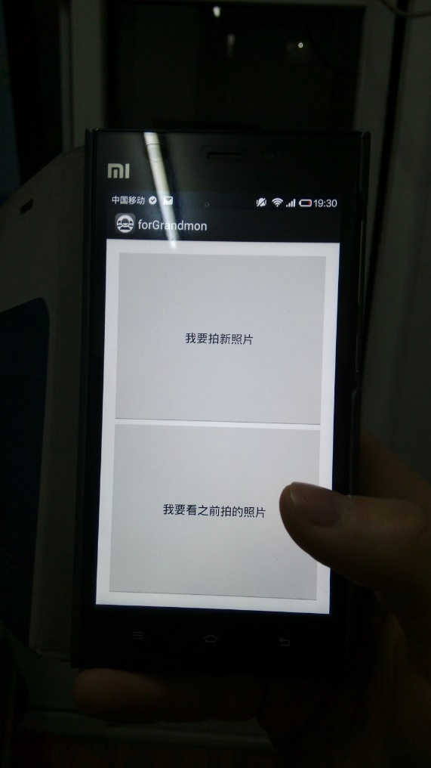

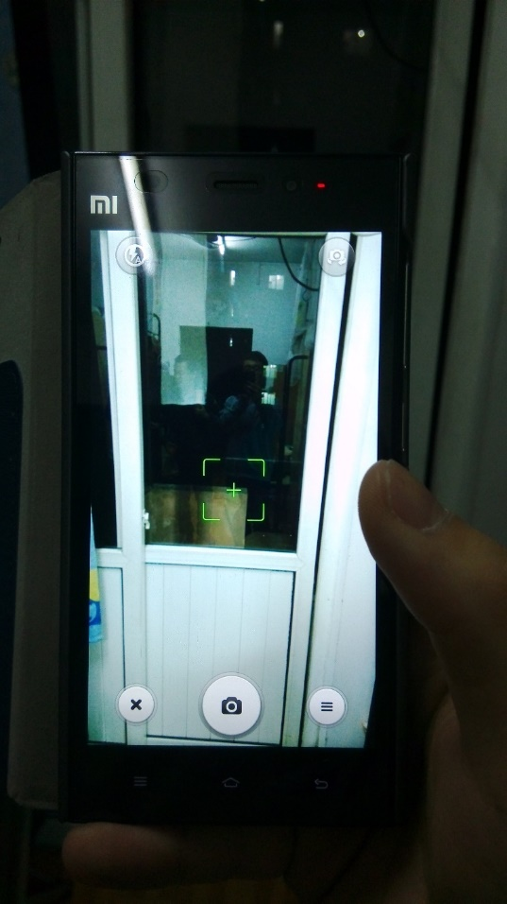

测试01

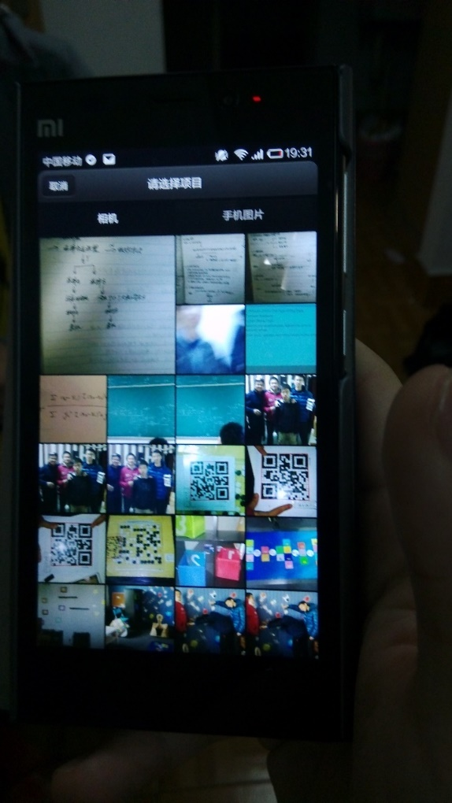

测试02