COSC603 Project 1

Name: Tao Qiu

Task 3:

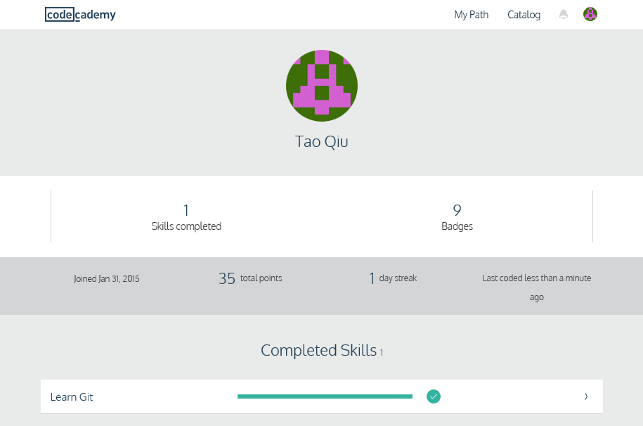

I have completed the training in Codecademy. The achievement is shown above. Basically, I feel this is a very good training course for me because I just have little knowledge about the Git. I have learn some basic operations and commands in Git such as creating new branch, deleting the branch, adding to new stage, unstaging, committing the branch, merging the branch with master, setting up the origin branch and merging the origin/master, pushing to and fetching from remote. In general, what I learn are all the Git commands. They are fast, easy to use, but I have to memorize them. In some complex situation, it is hard to find a good command to use, therefore I would rather to use a Git GUI to work on Github. I have downloaded and installed the GitHub Desktop on my computer.

Eventually, I figured out the EGit, rather than GitHub Desktop, is the best choice for me to connect Github, because the EGit directly work with Eclipse and integrated into the Eclipse. Why not just use EGit, so I have added the EGit plugin into Eclipse from the Eclipse marketplace. Even though there some issues after installation, I have solved them and was able to push my project “FileDangerCalculation” and a test program “HelloWorld” to the Github. I also did several updates and committed and pushed again. The Github worked well.