

**Nike Shoe Store Online System (NSSOS)**

**Report 3 – Software Requirement Specification**

– Da Nang, September 2024 –

**Table of Contents**

**I. Record of Changes** **4**

**II. Software Requirement Specification** **5**

1. Product Overview 5

2. User Requirements 6

2.1 Actors 6

2.2 Use Cases 7

2.2.1 Diagram(s) 7

2.2.2 Descriptions 9

UC_01: View homepage 11

UC-02: Register 12

UC-03: Change Password 14

UC-04: Forgot Password 16

UC-05: Verify account 18

UC-06: View profile 19

UC-07: View products 20

UC-08: Search products 22

UC-09: Evaluate & Comment 24

UC-10: Order a product 25

UC-11: Manage cart 27

UC-12: Add to cart 28

UC-13: Delete cart 30

UC-14: Chatbox 31

UC-15: Checkout 33

UC-16: Direct payment 35

UC-17: Pay by card/bank 36

UC-18: View Product Details 38

UC-19: Apply Discounts or Coupons 39

UC-20: Update Profile Information 41

UC-21: View Order History 43

UC-22: Proceed to Checkout 44

UC-23: Track Order 46

UC-24: Cancel Order 48

UC-25: Filter Products by Price Range 49

UC-26: Filter Products by Size 51

UC-27: Manage product 53

UC-28: Add products 55

UC-29: Delete products 56

UC-30: Edit products 58

UC-31: Invoice manager 59

UC-32: Order confirmation email 61

UC-33: View statistics 63

UC-34: Manage user 65

UC-35: View list of users 66

UC-36: View user information 68

UC-37: Manage Orders 70

UC-38: Manage Featured Products 71

UC-39: Manage Product Reviews 73

3. Functional Requirements 75

3.1 System Functional Overview 75

3.1.1 Screens Flow 75

3.1.2 Screen Descriptions 78

3.1.3 Screen Authorization 79

3.1.4 Non-Screen Functions 81

3.1.5 Entity Relationship Diagram 81

3.2 View Products 84

3.2.1 Product List 84

3.2.2 Product Details 85

3.3 Contact 87

3.3.1 Chat Box 87

3.3.2 Contact support 88

3.4 User Registration 90

3.5 Shopping Cart 91

3.6 Order Management 92

3.6.1 Order Placement 92

3.7 Product Reviews 94

3.8 Payment 95

3.9 User Dashboard 98

3.10 User Authentication 101

3.11 Product Management 103

3.12 Admin’s Dashboard 104

3.13 User Management 105

4. Non-Functional Requirements 107

4.1 External Interfaces 107

4.2 Quality Attributes 107

4.2.1 Usability 107

4.2.2 Reliability 107

4.2.3 Performance 107

4.2.4 Security 108

5. Requirement Appendix 108

5.1 Business Rules 108

5.2 Common Requirements 118

5.3 Application Messages List 119

# **I. Record of Changes**

| Date | A*  M, D | In charge | Change Description |
| --- | --- | --- | --- |
| 26/9 | AMD |  |  |
|  |  |  |  |
|  |  |  |  |
|  |  |  |  |
|  |  |  |  |
|  |  |  |  |
|  |  |  |  |
|  |  |  |  |
|  |  |  |  |
|  |  |  |  |
|  |  |  |  |
|  |  |  |  |
|  |  |  |  |

*A - Added M - Modified D - Deleted

# **II. Software Requirement Specification**

## **1. Product Overview**

For young and active individuals aged 16-35 who seek high-quality, stylish footwear, the Nike Online Shoe Store is an e-commerce platform that provides a seamless and personalized shopping experience. The website will offer access to Nike's full range of products, including exclusive releases, customizations, and user-specific recommendations. The system will track real-time inventory, customer preferences, and offer a convenient order history and return process. This platform will enhance customer satisfaction by saving customers as much time as possible, providing product availability notifications, and simplifying the shopping experience. Unlike other generic retail platforms, our product will deliver a brand-centered experience that reflects Nike’s innovation, community engagement, and commitment to sustainability.

The context diagram below illustrates the external entities and system interfaces :

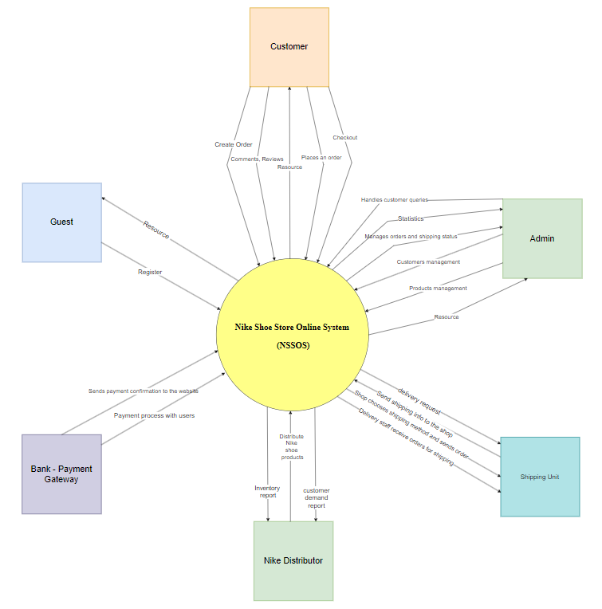

## **2. User Requirements**

### **2.1 Actors**

| **#** | **Actor** | **Description** |
| --- | --- | --- |
| 1 | Administrator | The Nike shoe manager stores all the website activities, like user interaction, purchases, customer visits, payments, ....etc |
| 2 | Customer | A person who logs into the system with the desire to buy shoes. Can confirm all functions such as viewing products, selecting products, paying, contact seller, evaluating |
| 3 | Guest | People can view the list and the information of shop on website without logging in |

### **2.2 Use Cases**

#### **2.2.1 Diagram(s)**

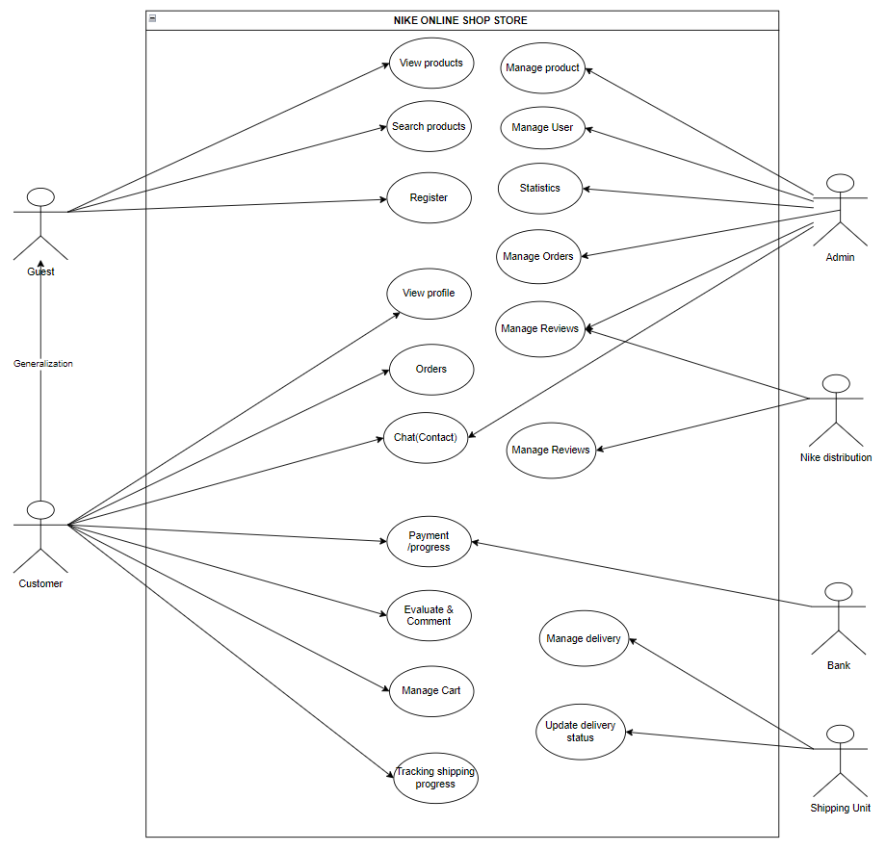

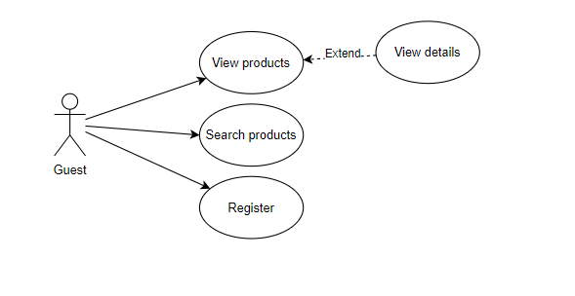

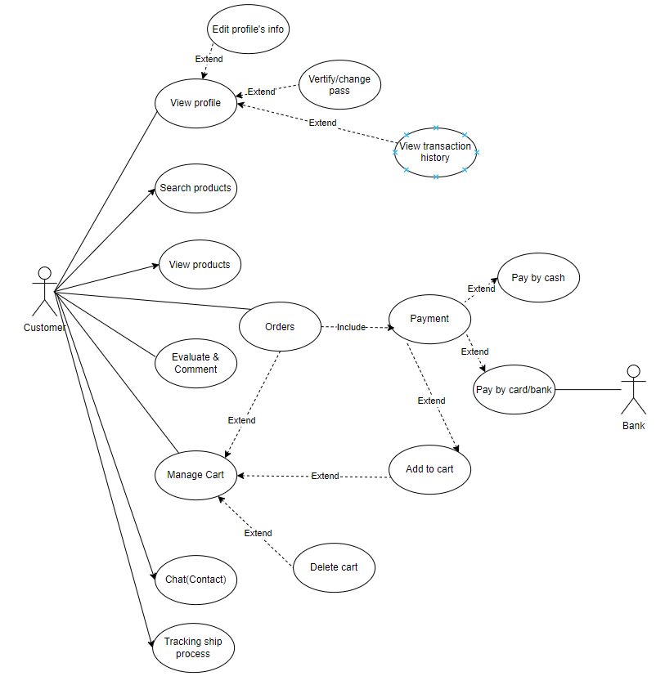

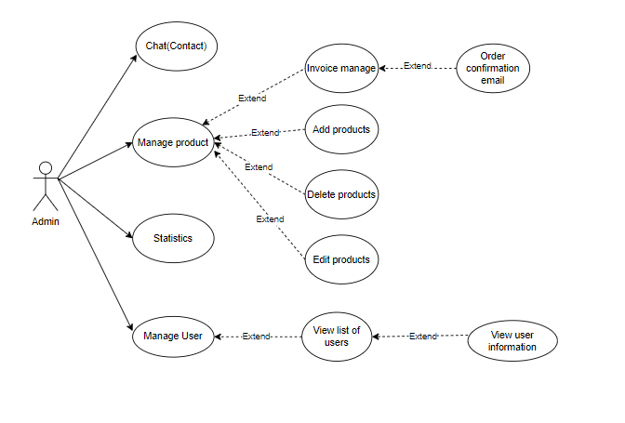

#### **2.2.2 Descriptions**

| **ID** | **Use Case** | **Actors** | **Use case descriptions** |
| --- | --- | --- | --- |
| 1 | View homepage | Guest, Customer, Admin | Allows anyone who wants to view the homepage of the system |
| 2 | Register an account | Guest | Allows a guest to create a new account in the system by providing required information (e.g., email, password, and personal details). |
| 3 | Change Password | Customer | Allows a customer to update their current password by providing their old password and a new password. |
| 4 | Forgot Password | Customer | Allows a customer to reset their password by requesting a password reset link or code, which is sent to their registered email. |
| 5 | Verify account | Customer | Allows a customer to verify their account by entering a verification code or link sent to their email or phone. |
| 6 | View profile | Customer | Allows a customer to view their personal profile information, including account details and settings. |
| 7 | View products | Guest / Customer | Allows a guest or customer to browse and view the list of products available in the system. |
| 8 | Search products | Guest / Customer | Allows a guest or customer to search for products using keywords, filters, or categories to find specific items in the system. |
| 9 | Evaluate & Comment | Customer | Allows a customer to leave a rating and comment on a product they have purchased or used. |
| 10 | Order a product | Customer | Allows a customer to place an order for selected products, specify quantity and delivery details, and complete the purchase through payment. |
| 11 | Manage cart | Customer | Allows a customer to add, remove, or adjust the quantity of products in their shopping cart before proceeding to checkout. |
| 12 | Add to cart | Customer | Allows a customer to add a selected product to their shopping cart for future purchases. |
| 13 | Delete cart | Customer | Allows a customer to remove items from their shopping cart, clearing it completely. |
| 14 | Chat with customer support | Customer | A customer can send and receive messages through a chat box interface for customer support or inquiries. |
| 15 | Proceed to checkout | Customer | Allows a customer to complete their purchase by providing payment information and confirming the transaction. |
| 16 | Direct payment | Customer | Allows a customer to make a payment immediately for their order without additional steps, such as entering payment details directly or using saved payment methods. |
| 17 | Pay by card/bank | Customer | Allows a customer to complete their purchase by entering credit/debit card details or bank account information for payment. |
| 18 | View Product Details | Customer | Allows customers to access and view detailed information about shoe products. |
| 19 | Apply Discounts or Coupons | Customer | Allows customers to apply discount codes or coupons to save money |
| 20 | Update Profile Information | Customer | Allows customers to modify their personal details and account settings, keep their information current, which is essential for billing, and shipping purposes |
| 21 | View Order History | Customer | Allows customers to access and review their past purchases, track orders, manage returns, reorder items easily |
| 22 | Proceed to Checkout | Customer | Allows customers to finalize their purchases, guides users through a structured process to confirm their order, enter payment information, complete the transaction |
| 23 | Track Order | Customer | Allows customers to monitor the status and location of their orders, enhances customer experience by real-time updates |
| 24 | Cancel Order | Customer | Allows customers to annul their orders |
| 25 | Filter Products by Price Range | Customer | Allows customers to narrow down their product search based on their budget |
| 26 | Filter Products by Size | Customer | Allows customers to narrow down their product search based on specific size requirements |
| 27 | Manage product | Admin | Allows admin to manage the product catalog, including adding, editing, and deleting. |
| 28 | Add products | Admin | Allows admin to add new products to the store. |
| 29 | Delete products | Admin | Allows admin to remove products from the store. |
| 30 | Edit products | Admin | Allows admin to modify the details of existing products. |
| 31 | Invoice manager | Admin | Allows admin to view and manage invoices for customer orders. |
| 32 | Order confirmation email | Admin | The system automatically sends an order confirmation email after a purchase is completed. |
| 33 | View statistics | Admin | Allows admin to view sales and customer data statistics. |
| 34 | Manage user | Admin | Allows admin to view and manage registered users. |
| 35 | View list of users | Admin | Allows admin to view a list of all users who have registered on the platform. |
| 36 | View user information | Admin | Allows admin to view specific details about a registered user. |
| 37 | Manage Orders | Admin | Allows users to oversee and control their orders, ability to view, modify, manage their orders, enhance their experience |
| 38 | Manage Featured Products | Admin | Allows admin to select and showcase specific products prominently on the website |
| 39 | Manage Product Reviews | Admin | Allows admin to oversee and interact with customer reviews for products |

##### **UC_01: View homepage**

| **Objective:** | This use case allows any user (guests, customers, or admin) to view the homepage of the Nike Shoe Store Online System. |
| --- | --- |
| **Actor:** | Any user (guest, customer, or admin). |
| **Trigger:** | User accesses the Nike Shoe Store Online System's URL or clicks the "Home" button from any page. |
| **Precondition:** | The system is online and accessible. |
| **Post-condition:** | The user views the homepage, which displays available categories (e.g., sports shoes, casual shoes), featured products, promotions, and the latest arrivals. |
| **Priority** | Medium |

**Activities Flow**

| **Step** | **Actor Action** | **System Response** |
| --- | --- | --- |
| 1 | User navigates to the homepage by accessing the URL or clicking "Home." | The system displays the homepage with categories, featured products, promotions, and latest arrivals. |
| 2 | Users can browse categories, featured products, or view promotions. | System allows further navigation, like clicking on a product or category to view more details. |

**Business Rules**

| **Step** | **BR Code** | **Description** |
| --- | --- | --- |
| 1 | BR-01 | Homepage Display Rules: The system will show categories, featured products, and promotions on the homepage. |
| 1 | BR-02 | Product Availability Rules: Only in-stock products will be shown in featured sections. |
| 1 | BR-03 | Responsiveness: The homepage will be responsive, adjusting to different screen sizes (mobile, tablet, desktop). |
| 2 | BR-04 | Product Click Rules: Clicking on any product will take the user to the product detail page. |

##### **UC-02: Register an account**

| **Objective:** | This use case allows a guest user to register for an account on the Nike Shoe Store Online System. |
| --- | --- |
| **Actor:** | Guest (unregistered user). |
| **Trigger:** | The guest clicks on the "Register" button or link on the homepage or login page. |
| **Precondition:** | The guest is not already registered in the system. |
| **Post-condition:** | A new user account is created successfully, and the user is logged in as a customer. |
| **Priority** | High |

**Activities Flow**

| **Step** | **Actor Action** | **System Response** |
| --- | --- | --- |
| 1 | The guest clicks the "Register" button or link. | The system displays the registration form with fields for name, email, password, and other required information. |
| 2 | The guest fills in the registration form and submits it. | The system validates the input data (e.g., email format, password strength). |
| 3 | If the input data is valid, the guest submits the form. | The system creates a new user account, stores the details in the database, and logs in the user as a customer. |
| 4 | System displays a confirmation message. | The user is redirected to the homepage or another relevant page, now logged in as a customer. |

**Business Rules**

| **Step** | **BR Code** | **Description** |
| --- | --- | --- |
| 1 | BR-05 | Registration Input Rules: The system must verify that all mandatory fields are filled out (e.g., name, email, password). |
| 2 | BR-06 | Email Uniqueness: The system checks that the provided email is not already registered (no duplicate accounts). |
| 3 | BR-07 | Password Strength: Password must meet security requirements (e.g., minimum 8 characters, include letters and numbers). |
| 4 | BR-08 | Account Creation: The system will store the new user account details in the Users table with the role "customer." |

##### **UC-03: Change Password**

| **Objective:** | This use case allows a registered user (customer or admin) to change their password. |
| --- | --- |
| **Actor:** | Customer  Admin |
| **Trigger:** | The user selects "Change Password" from their account settings. |
| **Precondition:** | The user is logged in successfully. |
| **Post-condition:** | The user's password is updated in the system. |
| **Priority** | Medium |

**Activities Flow**

| **Step** | **Actor Action** | **System Response** |
| --- | --- | --- |
| 1 | The user navigates to "Account Settings" and selects "Change Password." | The system displays the "Change Password" form, including fields for the current password, new password, and confirmation of the new password. |
| 2 | The user enters the current password, new password, and confirms the new password. | The system validates the entered information, ensuring the new password meets security requirements and matches the confirmation. |
| 3 | The user submits the form. | The system checks if the current password matches the one in the database. |
| 4 | If the current password is correct and the new password meets the criteria, the user’s password is updated. | The system updates the password in the database and displays a confirmation message. |
| 5 | The user is redirected to the account settings or homepage after successful password change. | The system logs the user out as a security measure, prompting them to log in again with the new password. |

**Business Rules**

| **Step** | **BR Code** | **Description** |
| --- | --- | --- |
| 1 | BR-09 | Password Strength: The new password must meet security requirements (e.g., minimum 8 characters, a mix of letters, numbers, and special characters). |
| 2 | BR-10 | Password Match: The system checks that the new password matches the confirmation password field. |
| 3 | BR-11 | Current Password Validation: The system verifies that the entered current password matches the one stored in the database. |
| 4 | BR-12 | Password Update: The system updates the password in the database if all validations pass. |

##### **UC-04: Forgot Password**

| **Objective:** | This use case allows a registered user (customer or admin) to recover their account by resetting the password if they have forgotten it. |
| --- | --- |
| **Actor:** | Customer  Admin |
| **Trigger:** | The user clicks on the "Forgot Password" link on the login page. |
| **Precondition:** | The user has a registered account in the system with a valid email address. |
| **Post-condition:** | The user’s password is reset successfully, and a new temporary password or reset link is sent to their email. |
| **Priority** | Medium |

**Activities Flow**

| **Step** | **Actor Action** | **System Response** |
| --- | --- | --- |
| 1 | The user clicks on the "Forgot Password" link on the login page. | The system displays a form asking for the registered email address. |
| 2 | The user enters their registered email and submits the form. | The system verifies that the email is associated with a registered account. |
| 3 | If the email is valid, the system generates a password reset link or temporary password and sends it to the provided email. | The system displays a confirmation message indicating that the reset instructions have been sent to the user’s email. |
| 4 | The user follows the link in the email to reset their password or uses the temporary password to log in. | The system prompts the user to enter a new password if they use the reset link. |
| 5 | The user enters the new password and confirms it. | The system validates the new password based on strength requirements and updates the password in the database. |
| 6 | After successfully resetting the password, the user can log in with the new password. | The system confirms the password change and redirects the user to the login page. |

**Business Rules**

| **Step** | **BR Code** | **Description** |
| --- | --- | --- |
| 1 | BR-13 | Email Validation: The system checks that the email provided exists in the database and is associated with a registered account. |
| 2 | BR-14 | Reset Link Generation: The system generates a secure password reset link or temporary password and emails it to the user. |
| 3 | BR-15 | Password Strength: The new password must meet security requirements (e.g., minimum 8 characters, mix of letters, numbers, and special characters). |
| 4 | BR-16 | Password Update: The system updates the user's password in the database after a successful reset. |

##### **UC-05: Verify account**

| **Objective:** | This use case allows a newly registered user (customer) to verify their account after registration. |
| --- | --- |
| **Actor:** | Customer |
| **Trigger:** | The system sends a verification email with a unique verification link after successful registration, or the user manually requests account verification. |
| **Precondition:** | The user has registered an account but has not yet verified it. |
| **Post-condition:** | The user’s account is verified, enabling full access to the system (e.g., purchasing products, accessing order history). |
| **Priority** | Medium |

**Activities Flow**

| **Step** | **Actor Action** | **System Response** |
| --- | --- | --- |
| 1 | After registering, the user checks their email inbox for the verification email. | The system sends an email with a unique verification link to the user's registered email address. |
| 2 | The user clicks the verification link in the email. | The system validates the verification token and verifies the user’s account. |
| 3 | If the token is valid, the user is notified that their account is successfully verified. | The system updates the user’s account status in the database to "verified." |
| 4 | The user is redirected to the homepage or a relevant page, now logged in as a verified customer. | The system grants full access to the user’s account features. |

**Business Rules**

| **Step** | **BR Code** | **Description** |
| --- | --- | --- |
| 1 | BR-17 | Verification Email Rules: The system sends a unique verification link to the registered email after successful account creation. |
| 2 | BR-18 | Link Expiration: The verification link must be valid for a limited time (e.g., 24 hours). |
| 3 | BR-19 | Token Validation: The system ensures that the token in the verification link is valid and matches the one stored in the database. |
| 4 | BR-20 | Account Status Update: After successful verification, the system changes the user’s status to "verified." |

##### **UC-06: View profile**

| **Objective:** | This use case allows a logged-in user (customer or admin) to view their profile information. |
| --- | --- |
| **Actor:** | Customer  Admin |
| **Trigger:** | The user clicks on the "Profile" or "My Account" link in the navigation bar or user settings. |
| **Precondition:** | The user is logged in successfully. |
| **Priority** | Medium |
| **Post-condition:** | The user’s profile details are displayed on the screen, allowing them to view their personal information (e.g., name, email, contact information, and past orders). |

**Activities Flow**

| **Step** | **Actor Action** | **System Response** |
| --- | --- | --- |
| 1 | The user clicks the "Profile" or "My Account" link. | The system retrieves the user’s profile information from the database. |
| 2 | The system displays the user’s profile, including name, email, contact details, and account settings. | The user can review their profile information and past orders. |
| 3 | The user can choose to update their profile information by clicking on "Edit Profile." | The system provides an option to edit profile details or change password. |

**Business Rules**

| **Step** | **BR Code** | **Description** |
| --- | --- | --- |
| 1 | BR-21 | User Authentication: The user must be logged in to access their profile page. |
| 2 | BR-22 | Data Display Rules: The system must display accurate and up-to-date information from the Users table. |
| 3 | BR-23 | Security Rules: Sensitive information, such as the password, must not be visible. |

##### **UC-07: View products**

| **Objective:** | This use case allows any user (guest, customer, or admin) to view a list of products available in the Nike Shoe Store Online System. |
| --- | --- |
| **Actor:** | Guest  Customer  Admin |
| **Trigger:** | The user selects a category, uses a search feature, or navigates to the product listing page from the homepage or menu. |
| **Precondition:** | Products are available in the database. |
| **Post-condition:** | A list of products is displayed, and the user can view detailed information for each product or add products to the shopping cart (for customers). |
| **Priority** | High |

**Activities Flow**

| **Step** | **Actor Action** | **System Response** |
| --- | --- | --- |
| 1 | The system displays a list of products, showing brief details (e.g., name, image, price, short description). | The user can scroll through the list and select a product for more detailed information. |
| 2 | The user clicks on a specific product to view more details. | The system displays the product detail page. |

**Business Rules**

| **Step** | **BR Code** | **Description** |
| --- | --- | --- |
| 1 | BR-24 | Product Availability Rules: Only products that are currently in stock are shown to the user. |
| 2 | BR-25 | Category Display Rules: The system filters the product list by the selected category or search term. |
| 3 | BR-26 | Product Information Display: The system must display relevant product details like name, image, price, and availability status. |
| 4 | BR-27 | User Role Rules: Guests can only view products, while customers can add products to their shopping cart. Admins can view and manage products. |

##### **UC-08: Search products**

| **Objective:** | This use case allows users (guest, customer, or admin) to search for products based on keywords. |
| --- | --- |
| **Actor:** | Guest  Customer  Admin |
| **Trigger:** | The user clicks on the search bar. |
| **Precondition:** | Products matching the search criteria are available in the database. |
| **Priority** | High |
| **Post-condition:** | The system displays a list of products matching the search query, and the user can view product details or add products to the cart (for customers). |

**Activities Flow**

| **Step** | **Actor Action** | **System Response** |
| --- | --- | --- |
| 1 | The user enters a keyword into the search bar and clicks the search button. | The system retrieves products from the database that match the keyword in product name, description, or other fields. |
| 2 | The system displays a list of products that match the search query. | The user can browse the results and select a product to view detailed information. |
| 3 | The user clicks on a product for more information. | The system displays the product detail page. |

**Business Rules**

| **Step** | **BR Code** | **Description** |
| --- | --- | --- |
| 1 | BR-28 | Keyword Matching Rules: The system must search for products based on the entered keyword, checking the product name, description, categories, and other relevant fields. |
| 2 | BR-29 | Search Accuracy Rules: The search must ignore case sensitivity and handle partial matches (e.g., searching for "run" should match products with "running"). |
| 3 | BR-30 | Product Display Rules: The system must display relevant product details, such as name, image, price, and short description for each matching product. |
| 4 | BR-31 | User Role Rules: Guests can only search and view products, while customers can add products to their cart. Admins can search and manage products. |

##### **UC-09: Evaluate & Comment**

| **Objective:** | This use case allows a logged-in customer to evaluate a product by providing a rating and comment, helping future customers make informed purchase decisions. |
| --- | --- |
| **Actor:** | Customer |
| **Trigger:** | The user clicks the "Leave a Review" or "Rate and Comment" button on the product detail page. |
| **Precondition:** | The user is logged in as a customer.  The user has purchased the product they are reviewing. |
| **Post-condition:** | The user's rating and comment are saved, and the system displays the updated reviews on the product page. |
| **Priority** | Medium |

**Activities Flow**

| **Step** | **Actor Action** | **System Response** |
| --- | --- | --- |
| 1 | The user navigates to the product detail page and clicks on "Leave a Review" or "Rate and Comment." | The system displays a form for entering a rating (e.g., 1–5 stars) and comment. |
| 2 | The user fills out the rating and comment form and submits it. | The system validates the input and saves the rating and comment in the database. |
| 3 | The system updates the product’s overall rating based on all customer reviews. | The updated rating and new comment are displayed on the product detail page. |

**Business Rules**

| **Step** | **BR Code** | **Description** |
| --- | --- | --- |
| 1 | BR-32 | User Authentication: Only logged-in customers who have purchased the product can leave a review. |
| 2 | BR-33 | Review Form: The system must allow the user to rate the product (e.g., 1–5 stars) and leave a written comment. |
| 3 | BR-34 | Input Validation: The system must ensure that the rating is within the allowed range and the comment text is not empty or too long. |
| 4 | BR-35 | Product Rating Update: The system must calculate the updated average rating for the product after each new review. |
| 5 | BR-36 | Display Rules: The system must show the updated product rating and the latest customer comments on the product detail page. |

##### **UC-10: Order a product**

| **Objective:** | This use case allows a logged-in customer to place an order for a product in the Nike Shoe Store Online System. |
| --- | --- |
| **Actor:** | Customer |
| **Trigger:** | The user adds products to their shopping cart and clicks the "Proceed to Checkout" button. |
| **Precondition:** | The user is logged in as a customer.  The user has at least one product in their shopping cart. |
| **Post-condition:** | The order is successfully placed, and the customer receives an order confirmation. |
| **Priority** | High |

**Activities Flow**

| **Step** | **Actor Action** | **System Response** |
| --- | --- | --- |
| 1 | After the user clicks on the "Checkout" button in the shopping cart. | The system displays the checkout page, summarizing the order details (product(s), quantity, total price). |
| 2 | The user provides shipping and payment information and reviews the order. | The system validates the information and calculates the total cost, including shipping and taxes. |
| 3 | The user submits the order. | The system processes the order and generates an order ID. |
| 4 | The system confirms the order placement. | The user receives an order confirmation email with the order details and estimated delivery information. |

**Business Rules**

| **Step** | **BR Code** | **Description** |
| --- | --- | --- |
| 1 | BR-37 | User Authentication: Only logged-in customers can place an order. |
| 1 | BR-38 | Shopping Cart Validation: The system must ensure that the cart contains valid products before proceeding to checkout. |
| 2 | BR-39 | Payment and Shipping Information: The user must provide valid shipping and payment details to complete the order. |
| 3 | BR-40 | Order Processing: The system must validate stock availability before placing the order. |
| 4 | BR-41 | Confirmation: The system must send an order confirmation email to the user after successful order placement. |

##### **UC-11: Manage cart**

| **Objective:** | This use case allows a logged-in customer to add, update, or remove products in their shopping cart. |
| --- | --- |
| **Actor:** | Customer |
| **Trigger:** | The user interacts with the shopping cart by adding items, updating quantities, or removing items. |
| **Precondition:** | The user is logged in as a customer.  The user has at least one product in their cart or is in the process of adding a product. |
| **Post-condition:** | The shopping cart is updated based on the user's actions, reflecting the current items and quantities. |
| **Priority** | High |

**Activities Flow**

| **Step** | **Actor Action** | **System Response** |
| --- | --- | --- |
| 1 | The user adds a product to the cart from the product detail page. | The system confirms the addition and updates the cart count. |
| 2 | The user views the cart by clicking on the "Cart" icon. | The system displays the cart summary with product details, quantities, and total price. |
| 3 | The user updates the quantity of a product or removes a product from the cart. | The system recalculates the total price and updates the cart accordingly. |
| 4 | The user clicks "Proceed to Checkout." | The system redirects the user to the checkout page with the current cart items. |

**Business Rules**

| **Step** | **BR Code** | **Description** |
| --- | --- | --- |
| 1 | BR-42 | Cart Management: Users can add multiple products to the cart, and the system must ensure stock availability at the time of adding. |
| 2 | BR-43 | Cart Summary Display: The system must display accurate product details, including name, price, quantity, and total price. |
| 3 | BR-44 | Quantity Update Rules: The system must allow users to update quantities and recalculate the total price. |
| 4 | BR-45 | Item Removal: The system must allow users to remove items from the cart, updating the cart summary accordingly. |
| 5 | BR-46 | Proceed to Checkout: The system must verify that the cart is not empty before allowing checkout. |

##### **UC-12: Add to cart**

| **Objective:** | This use case allows a logged-in customer to add a product to their shopping cart. |
| --- | --- |
| **Actor:** | Customer |
| **Trigger:** | The user clicks the "Add to Cart" button on the product detail page. |
| **Precondition:** | The user is logged in as a customer.  The product is available in stock. |
| **Post-condition:** | The product is added to the shopping cart, and the user receives a confirmation. |
| **Priority** | High |

**Activities Flow**

| **Step** | **Actor Action** | **System Response** |
| --- | --- | --- |
| 1 | The user selects the desired product and clicks the "Add to Cart" button. | The system checks the stock availability for the selected product. |
| 2 | If the product is available, the system adds the product to the user's shopping cart. | The system updates the cart count and displays a confirmation message (e.g., "Product successfully added to your cart"). |
| 3 | The user can view the cart or continue shopping. | The system allows the user to either navigate to the cart or stay on the product page. |

**Business Rules**

| **Step** | **BR Code** | **Description** |
| --- | --- | --- |
| 1 | BR-47 | User Authentication: Only logged-in customers can add products to their cart. |
| 1 | BR-48 | Stock Availability: The system must check for product availability before adding it to the cart. |
| 2 | BR-49 | Cart Update: If the product is already in the cart, the system should increase the quantity instead of adding a new entry. |
| 2 | BR-50 | Confirmation: The system must display a confirmation message once the product is added to the cart. |
| 3 | BR-51 | Navigation Options: The user should have the option to view the cart or continue shopping seamlessly. |

##### **UC-13: Delete cart**

| **Objective:** | This use case allows a logged-in customer to delete the items they choose from their shopping cart. |
| --- | --- |
| **Actor:** | Customer |
| **Trigger:** | The user clicks the "Delete" button in the shopping cart interface. |
| **Precondition:** | The user is logged in as a customer.  The user has items in their shopping cart. |
| **Post-condition:** | The items have been removed from the shopping cart. |
| **Priority** | High |

**Activities Flow**

| **Step** | **Actor Action** | **System Response** |
| --- | --- | --- |
| 1 | The user navigates to the shopping cart and clicks the "Delete Cart" or "Empty Cart" button. | The system displays a confirmation pop-up asking if the user is sure they want to delete all items from the cart. |
| 2 | The user confirms the deletion. | The system removes all items from the shopping cart. |
| 3 | The system updates the cart display. | The user sees an empty cart with a message indicating that the cart is empty. |

**Business Rules**

| **Step** | **BR Code** | **Description** |
| --- | --- | --- |
| 1 | BR-52 | User Authentication: Only logged-in customers can delete items from their cart. |
| 2 | BR-53 | Confirmation Requirement: The system must prompt the user for confirmation before deleting the cart. |
| 3 | BR-54 | Cart Deletion: The system must remove all items from the cart upon user confirmation. |
| 4 | BR-55 | Display Update: The system must update the cart display to reflect the deletion and show an appropriate message. |

##### **UC-14: Chat with customer supports(chatbox)**

| **Objective:** | This use case allows customers to communicate with customer support in real-time through a chat box feature on the website. |
| --- | --- |
| **Actor:** | Customer  Customer Support Representative |
| **Trigger:** | The user clicks on the chat icon/button to open the chat box. |
| **Precondition:** | The user is logged in as a customer (optional, depending on whether guests can use the chat feature). |
| **Post-condition:** | The customer receives assistance, and the chat session is recorded for future reference. |
| **Priority** | High |

**Activities Flow**

| **Step** | **Actor Action** | **System Response** |
| --- | --- | --- |
| 1 | The user clicks on the chat icon/button. | The system opens the chat box interface for user interaction. |
| 2 | The user types a message and sends it. | The system displays the user's message in the chat box and sends it to the customer support team. |
| 3 | The customer support representative replies to the user’s message. | The system displays the representative's response in the chat box. |
| 4 | The user and representative continue the conversation. | The system maintains the chat session, allowing both parties to exchange messages in real-time. |
| 5 | The user clicks on "End Chat" or closes the chatbox. | The system logs the chat session and displays a summary of the conversation if needed. |

**Business Rules**

| **Step** | **BR Code** | **Description** |
| --- | --- | --- |
| 1 | BR-56 | Chat Availability: The chatbox should be available during customer support hours. |
| 2 | BR-57 | User Authentication: Customers must be logged in to initiate a chat (optional). |
| 3 | BR-58 | Message Format: The system must support basic text messaging and display timestamps for messages. |
| 4 | BR-59 | Response Time: Customer support representatives must respond to user inquiries within a specified timeframe (e.g., 2 minutes). |
| 5 | BR-60 | Session Logging: The system must log all chat sessions for future reference and quality assurance. |

##### **UC-15: Proceed to checkout**

| **Objective:** | This use case allows a logged-in customer to review their cart, enter shipping information, and complete the purchase of selected products. |
| --- | --- |
| **Actor:** | Customer |
| **Trigger:** | The user clicks the "Checkout" button in the shopping cart. |
| **Precondition:** | The user is logged in as a customer.  The user has at least one item in their shopping cart. |
| **Post-condition:** | The order is successfully created, and the user is directed to the payment page or receives an order confirmation. |
| **Priority** | Medium |

**Activities Flow**

| **Step** | **Actor Action** | **System Response** |
| --- | --- | --- |
| 1 | The user clicks the "Checkout" button. | The system displays the cart summary with selected items, quantities, and total price. |
| 2 | The user reviews the cart details and confirms the items. | The system prompts the user to enter shipping information (address, delivery options). |
| 3 | The user enters their shipping information and selects a delivery option. | The system validates the entered information for completeness and correctness. |
| 4 | The user clicks "Proceed to Payment." | The system redirects the user to the payment page with a summary of the order details and shipping information. |
| 5 | The user completes the payment process. | The system processes the payment and displays an order confirmation message upon success. |

**Business Rules**

| **Step** | **BR Code** | **Description** |
| --- | --- | --- |
| 1 | BR-65 | Cart Summary: The system must display an accurate summary of items in the cart, including total price and applicable taxes. |
| 2 | BR-66 | Shipping Information: The system must prompt the user to enter complete shipping details before proceeding. |
| 3 | BR-67 | Validation: The system must validate the shipping information for accuracy before proceeding to payment. |
| 4 | BR-68 | Payment Redirection: The system must redirect the user to the payment page after confirming the shipping details. |
| 5 | BR-69 | Order Confirmation: The system must provide immediate confirmation of the order after payment is processed, including an order summary and confirmation email. |

##### **UC-16: Direct payment**

| **Objective:** | This use case allows a customer to make a direct payment for their selected products without going through the traditional checkout process. |
| --- | --- |
| **Actor:** | Customer |
| **Trigger:** | The user selects the "Direct Payment" option on the product detail page or shopping cart. |
| **Precondition:** | The user is logged in as a customer.  The user has selected at least one product to purchase. |
| **Post-condition:** | The payment is successfully processed, and the customer receives a confirmation of the transaction and an order summary. |
| **Priority** | High |

**Activities Flow**

| **Step** | **Actor Action** | **System Response** |
| --- | --- | --- |
| 1 | The user clicks on the "Direct Payment" button for a selected product. | The system displays the payment options and product details for review. |
| 2 | The user selects a payment method and enters the required payment information. | The system validates the payment information for accuracy. |
| 3 | The user submits the payment information. | The system processes the payment through the selected payment gateway. |
| 4 | The system confirms the payment status. | If successful, the system displays a confirmation message and sends an order confirmation email. If it fails, it displays an error message. |

**Business Rules**

| **Step** | **BR Code** | **Description** |
| --- | --- | --- |
| 1 | BR-70 | Direct Payment Option: The system must allow customers to make direct payments for products without a full checkout process. |
| 2 | BR-71 | Payment Options: The system must present multiple payment methods for the user to choose from. |
| 3 | BR-72 | Payment Information Validation: The system must validate the entered payment details before processing the payment. |
| 4 | BR-73 | Payment Processing: The system must securely process payment information through a trusted payment gateway. |
| 5 | BR-74 | Confirmation: The system must provide immediate feedback on the payment status and send an order confirmation email upon successful payment. |

##### **UC-17: Pay by card/bank**

| **Objective:** | This use case allows customers to complete their purchases using a credit/debit card or bank transfer as the payment method. |
| --- | --- |
| **Actor:** | Customer |
| **Trigger:** | The user selects "Pay by Card/Bank" on the payment page during checkout. |
| **Precondition:** | The user is logged in as a customer.  The user has selected products in their cart and is ready to check out. |
| **Post-condition:** | The payment is successfully processed using the selected card or bank method, and the customer receives a confirmation of the transaction. |
| **Priority** | High |

**Activities Flow**

| **Step** | **Actor Action** | **System Response** |
| --- | --- | --- |
| 1 | The user selects "Pay by Card/Bank" as the payment method. | The system displays the payment form for card details or bank information entry. |
| 2 | The user enters their card/bank details and billing information. | The system validates the entered information for accuracy and completeness. |
| 3 | The user submits the payment information. | The system processes the payment through the selected payment gateway or banking system. |
| 4 | The system confirms the payment status. | If successful, the system displays a confirmation message and sends an order confirmation email. If it fails, it displays an error message. |

**Business Rules**

| **Step** | **BR Code** | **Description** |
| --- | --- | --- |
| 1 | BR-75 | Payment Method Selection: The system must allow customers to choose between card or bank payment options. |
| 2 | BR-76 | Required Fields: The system must require specific fields for card/bank information (e.g., card number, expiration date, CVV, bank account number). |
| 3 | BR-77 | Payment Information Validation: The system must validate the entered payment details before processing the payment. |
| 4 | BR-78 | Secure Processing: The system must securely process card/bank information through a trusted payment gateway. |
| 5 | BR-79 | Confirmation: The system must provide immediate feedback on the payment status and send an order confirmation email upon successful payment. |

##### **UC-18: View Product Details**

| **Objective:** | This use case allows customers to view detailed information about a specific product, including its features, price, images, and customer reviews. |
| --- | --- |
| **Actor:** | Customer |
| **Trigger:** | The user clicks on a product from the product listing page. |
| **Precondition:** | The user is on the product listing page and has selected a product to view. |
| **Post-condition:** | The user is presented with a detailed view of the selected product. |
| **Priority** | High |

**Activities Flow**

| **Step** | **Actor Action** | **System Response** |
| --- | --- | --- |
| 1 | After the user clicks on a product image or name. | The system retrieves and displays the product details, including images, description, price, available sizes/colors, and reviews. |
| 2 | The user scrolls through the product details. | The system allows the user to view all available information without any restrictions. |
| 3 | The user can select size/color options (if applicable). | The system updates the price and availability based on the selected options. |
| 4 | The user reads customer reviews and ratings. | The system displays all relevant reviews associated with the product. |
| 5 | The user clicks "Add to Cart" or "Direct Payment." | The system processes the request and adds the product to the cart or initiates the payment process. |

**Business Rules**

| **Step** | **BR Code** | **Description** |
| --- | --- | --- |
| 1 | BR-80 | Product Information: The system must display comprehensive product details, including images, descriptions, specifications, and prices. |
| 2 | BR-81 | Options Availability: The system must display available size/color options and adjust pricing accordingly. |
| 3 | BR-82 | Review Display: The system must show customer reviews and ratings for the product, if available. |
| 4 | BR-83 | Navigation: The system must allow the user to navigate back to the product listing page easily. |

##### **UC-19: Apply Discounts or Coupons**

| **Objective:** | This use case allows customers to apply discount codes or coupons to their orders to receive price reductions before finalizing their purchase. |
| --- | --- |
| **Actor:** | Customer |
| **Trigger:** | The user clicks on the "Apply Discount" button during the checkout process. |
| **Precondition:** | The user is logged in as a customer.  The user has items in their shopping cart and is at the checkout page. |
| **Post-condition:** | The discount is applied to the order total, and the user sees the updated price. |
| **Priority** | Low |

**Activities Flow**

| **Step** | **Actor Action** | **System Response** |
| --- | --- | --- |
| 1 | The user clicks on the "Apply Discount" button. | The system displays a field to enter the discount code or coupon. |
| 2 | The user enters a valid discount code and submits it. | The system validates the discount code for authenticity and applicability. |
| 3 | If valid, the system calculates the new total price. | The system updates the order total, displaying the applied discount and the new total amount. |
| 4 | The user reviews the updated total and proceeds to payment. | The system allows the user to continue with the checkout process with the new total. |
| 5 | If the discount code is invalid, the system displays an error message. | The user has the option to re-enter a different code or proceed without a discount. |

**Business Rules**

| **Step** | **BR Code** | **Description** |
| --- | --- | --- |
| 1 | BR-84 | Valid Codes: The system must accept only valid discount codes that meet predefined conditions (e.g., expiration date, minimum purchase amount). |
| 2 | BR-85 | Discount Calculation: The system must correctly calculate the discount and adjust the order total accordingly. |
| 3 | BR-86 | Feedback: The system must provide immediate feedback on the discount application status (success or failure). |
| 4 | BR-87 | Clear Display: The system must clearly display the original price, applied discount, and new total price for transparency. |

##### **UC-20: Update Profile Information**

| **Objective:** | This use case allows customers to update their personal information, including name, email address, phone number, and shipping address in their profile. |
| --- | --- |
| **Actor:** | Customer |
| **Trigger:** | The user navigates to the "Profile" section and selects "Update Profile Information." |
| **Precondition:** | The user is logged in as a customer. |
| **Post-condition:** | The user's profile information is successfully updated in the system. |
| **Priority** | Low |

**Activities Flow**

| **Step** | **Actor Action** | **System Response** |
| --- | --- | --- |
| 1 | The user clicks on "Update Profile Information." | The system displays the current profile information in editable fields. |
| 2 | The user modifies the necessary fields (e.g., name, email, phone number, address). | The system enables the save option for the user to confirm changes. |
| 3 | The user clicks the "Save Changes" button. | The system validates the input for accuracy (e.g., valid email format, required fields). |
| 4 | If valid, the system updates the user's profile information in the database. | The system displays a confirmation message ("Profile updated successfully."). |
| 5 | If there are validation errors, the system displays appropriate error messages. | The user is prompted to correct any issues before saving again. |

**Business Rules**

| **Step** | **BR Code** | **Description** |
| --- | --- | --- |
| 1 | BR-88 | Editable Fields: The system must allow users to edit specific fields in their profile, such as name, email, phone number, and address. |
| 2 | BR-89 | Validation: The system must validate user input for correctness, including format checks for email and required fields. |
| 3 | BR-90 | Save Confirmation: The system must confirm successful updates to the user and display the updated information. |
| 4 | BR-91 | Error Messaging: The system must provide clear error messages for any validation issues encountered during the update process. |

##### **UC-21: View Order History**

| **Objective:** | This use case allows customers to view their past orders, including details such as order date, items purchased, total amount, and order status. |
| --- | --- |
| **Actor:** | Customer |
| **Trigger:** | The user navigates to the "Order History" section of their account. |
| **Precondition:** | The user is logged in as a customer. |
| **Post-condition:** | The user can view a list of their previous orders along with relevant details. |
| **Priority** | Medium |

**Activities Flow**

| **Step** | **Actor Action** | **System Response** |
| --- | --- | --- |
| 1 | The user clicks on the "Order History" link in their account menu. | The system retrieves the user's past orders from the database. |
| 2 | The system displays a list of previous orders with summary information (e.g., order date, total amount, status). | The user can scroll through the list to view all orders. |
| 3 | The user clicks on a specific order for more details. | The system displays detailed information about the selected order, including items purchased, shipping information, and payment details. |
| 4 | The user can navigate back to the order list. | The system returns the user to the order history summary page. |

**Business Rules**

| **Step** | **BR Code** | **Description** |
| --- | --- | --- |
| 1 | BR-92 | Order Retrieval: The system must retrieve and display all orders associated with the logged-in user. |
| 2 | BR-93 | Summary Display: The system must show a summary for each order, including date, total amount, and status (e.g., shipped, pending, canceled). |
| 3 | BR-94 | Detailed View: The system must allow users to view detailed information about each order when selected. |
| 4 | BR-95 | Navigation: The system must allow easy navigation back to the order history list from the detailed view. |

##### **UC-22: Proceed to Checkout**

| **Objective:** | This use case allows customers to review their selected items and complete the purchase process by entering shipping and payment information. |
| --- | --- |
| **Actor:** | Customer |
| **Trigger:** | The user clicks on the "Proceed to Checkout" button from the shopping cart page. |
| **Precondition:** | The user is logged in as a customer.  The user has items in their shopping cart. |
| **Post-condition:** | The user is directed to the checkout page to complete the purchase. |
| **Priority** | Medium |

**Activities Flow**

| **Step** | **Actor Action** | **System Response** |
| --- | --- | --- |
| 1 | The user clicks the "Proceed to Checkout" button. | The system validates the items in the cart (e.g., availability, total price). |
| 2 | The system displays the checkout page with a summary of the cart items. | The user reviews the order summary, including item details, quantities, and total price. |
| 3 | The user enters or confirms shipping information (address, delivery options). | The system validates the shipping information for completeness and correctness. |
| 4 | The user selects a payment method (e.g., credit card, PayPal, etc.). | The system displays the relevant fields to enter payment information based on the selected method. |
| 5 | The user reviews all entered information and clicks "Complete Purchase." | The system processes the payment and updates the order status. If successful, the user receives a confirmation message and order number. |
| 6 | If there are any errors (e.g., invalid shipping address, payment failure), the system displays error messages. | The user is prompted to correct any issues before attempting to proceed again. |

**Business Rules**

| **Step** | **BR Code** | **Description** |
| --- | --- | --- |
| 1 | BR-96 | Cart Validation: The system must check the availability and pricing of items in the cart before proceeding to checkout. |
| 2 | BR-97 | Order Summary: The system must display a clear summary of the order, including items, quantities, prices, and total amount. |
| 3 | BR-98 | Shipping Information: The system must require complete and valid shipping details before processing the order. |
| 4 | BR-99 | Payment Method Selection: The system must provide multiple payment options and display the corresponding input fields based on the user’s selection. |
| 5 | BR-100 | Error Handling: The system must provide clear and immediate feedback for any errors encountered during the checkout process. |

##### **UC-23: Track Order**

| **Objective:** | This use case allows customers to track the status and location of their orders after purchase. |
| --- | --- |
| **Actor:** | Customer |
| **Trigger:** | The user clicks on the "Track Order" link in their account or from the order confirmation email. |
| **Precondition:** | The user is logged in as a customer.  The user has previously placed at least one order. |
| **Post-condition:** | The user is presented with the current status and tracking information for the selected order. |
| **Priority** | High |

**Activities Flow**

| **Step** | **Actor Action** | **System Response** |
| --- | --- | --- |
| 1 | The user navigates to the "Track Order" section. | The system prompts the user to enter the order number or select from a list of past orders. |
| 2 | The user enters the order number or selects an order to track. | The system retrieves the order details from the database, including current status and tracking information. |
| 3 | The system displays the tracking information, including shipping status, estimated delivery date, and carrier information. | The user can view the location of the package and any updates related to the shipment. |
| 4 | The user can navigate back to their account or view other orders. | The system allows the user to return to the previous menu or view more details about other orders if desired. |

**Business Rules**

| **Step** | **BR Code** | **Description** |
| --- | --- | --- |
| 1 | BR-101 | Order Retrieval: The system must retrieve and display order tracking information associated with the logged-in user. |
| 2 | BR-102 | Tracking Details: The system must provide comprehensive tracking details, including the current status, carrier, and estimated delivery date. |
| 3 | BR-103 | Error Handling: The system must provide feedback if the order number is invalid or if tracking information is unavailable. |
| 4 | BR-104 | Navigation: The system must allow users to navigate easily back to their account or order history after viewing tracking details. |

##### **UC-24: Cancel Order**

| **Objective:** | This use case allows customers to cancel their orders before they are shipped. |
| --- | --- |
| **Actor:** | Customer |
| **Trigger:** | The user clicks on the "Cancel Order" button from the order details page. |
| **Precondition:** | The user is logged in as a customer.  The user has at least one order that is eligible for cancellation (i.e., not yet shipped). |
| **Post-condition:** | The order is successfully canceled, and the user receives confirmation. |
| **Priority** | Medium |

**Activities Flow**

| **Step** | **Actor Action** | **System Response** |
| --- | --- | --- |
| 1 | The user navigates to their order history and selects the order to cancel. | The system displays the order details along with the "Cancel Order" option. |
| 2 | The user clicks the "Cancel Order" button. | The system displays a confirmation pop-up asking the user to confirm the cancellation. |
| 3 | The user confirms the cancellation. | The system processes the cancellation request. |
| 4 | If successful, the system updates the order status to "Canceled" and initiates a refund process (if applicable). | The system displays a confirmation message ("Your order has been canceled successfully.") and updates the order history. |
| 5 | If there are any issues (e.g., the order cannot be canceled), the system displays an error message. | The user is informed of the cancellation failure and any necessary next steps. |

**Business Rules**

| **Step** | **BR Code** | **Description** |
| --- | --- | --- |
| 1 | BR-105 | Cancellation Eligibility: The system must allow cancellation only for orders that have not yet been shipped. |
| 2 | BR-106 | Confirmation Required: The system must require confirmation from the user before proceeding with the cancellation. |
| 3 | BR-107 | Refund Process: The system must initiate a refund process if the payment has already been processed. |
| 4 | BR-108 | Notification: The system must notify the user of the cancellation status (successful or failure). |

##### **UC-25: Filter Products by Price Range**

| **Objective:** | This use case allows customers to filter the list of products based on a specified price range, helping them find products that fit their budget. |
| --- | --- |
| **Actor:** | Customer |
| **Trigger:** | The user selects a price range using the filter options on the product listing page. |
| **Precondition:** | The user is on the product listing page. |
| **Post-condition:** | The system displays a filtered list of products that fall within the specified price range. |
| **Priority** | Medium |

**Activities Flow**

| **Step** | **Actor Action** | **System Response** |
| --- | --- | --- |
| 1 | After the user navigates to the product listing page. | The system displays the available products along with filter options. |
| 2 | The user selects a minimum and maximum price from the price range filter. | The system validates the input values for correctness. |
| 3 | The user clicks the "Apply Filters" button. | The system retrieves and displays products that fall within the specified price range. |
| 4 | The user can view the filtered list of products, including relevant details (e.g., name, price, image). | The system updates the product listing to show only the items within the selected price range. |
| 5 | The user can adjust the filters or clear them to view all products again. | The system refreshes the product listing based on the new filter criteria. |

**Business Rules**

| **Step** | **BR Code** | **Description** |
| --- | --- | --- |
| 1 | BR-109 | Price Range Validation: The system must validate the minimum and maximum price inputs to ensure they are numeric and the minimum is less than or equal to the maximum. |
| 2 | BR-110 | Filter Application: The system must retrieve and display only those products whose prices fall within the specified range. |
| 3 | BR-111 | Dynamic Update: The system must dynamically update the product listing based on the selected filter criteria without requiring a page refresh. |
| 4 | BR-112 | Clear Filters: The system must provide an option to clear filters and reset the product listing to show all available products. |

##### **UC-26: Filter Products by Size**

| **Objective:** | This use case allows customers to filter the list of products based on selected sizes, helping them find products that fit their needs. |
| --- | --- |
| **Actor:** | Customer |
| **Trigger:** | The user selects one or more sizes from the size filter options on the product listing page. |
| **Precondition:** | The user is on the product listing page. |
| **Post-condition:** | The system displays a filtered list of products that match the selected sizes. |
| **Priority** | Medium |

**Activities Flow**

| **Step** | **Actor Action** | **System Response** |
| --- | --- | --- |
| 1 | After the user navigates to the product listing page. | The system displays the available products along with filter options, including size. |
| 2 | The user selects one or more sizes from the size filter options. | The system validates the selected sizes to ensure they are available for the products. |
| 3 | The user clicks the "Apply Filters" button. | The system retrieves and displays products that are available in the selected sizes. |
| 4 | The user can view the filtered list of products, including relevant details (e.g., name, price, image). | The system updates the product listing to show only the items in the selected sizes. |
| 5 | The user can adjust the size filters or clear them to view all products again. | The system refreshes the product listing based on the new filter criteria. |

**Business Rules**

| **Step** | **BR Code** | **Description** |
| --- | --- | --- |
| 1 | BR-113 | Size Validation: The system must validate the selected sizes to ensure they are valid options available for the products. |
| 2 | BR-114 | Filter Application: The system must retrieve and display only those products that are available in the selected sizes. |
| 3 | BR-115 | Dynamic Update: The system must dynamically update the product listing based on the selected filter criteria without requiring a page refresh. |
| 4 | BR-116 | Clear Filters: The system must provide an option to clear size filters and reset the product listing to show all available products. |

##### **UC-27: Manage product**

| **Objective:** | This use case allows the system administrator to manage product listings, including adding, editing, and deleting products from the inventory. |
| --- | --- |
| **Actor:** | Admin(System Administrator) |
| **Trigger:** | The user navigates to the "Manage Products" section in the admin dashboard. |
| **Precondition:** | Admin is logged in a system. |
| **Post-condition:** | The system reflects any changes made to the product listings (additions, edits, or deletions). |
| **Priority** | High |

**Activities Flow**

| **Step** | **Actor Action** | **System Response** |
| --- | --- | --- |
| 1 | The administrator navigates to the "Manage Products" section. | The system displays the current list of products with options to add, edit, or delete products. |
| 2 | The administrator chooses to add a new product. | The system displays a form for entering product details (name, description, price, size, image, etc.). |
| 3 | The administrator fills out the product form and submits it. | The system validates the input and, if successful, adds the new product to the inventory. |
| 4 | The administrator chooses to edit an existing product. | The system displays the selected product's details in a form for editing. |
| 5 | The administrator makes changes to the product and submits the form. | The system validates the input and updates the product information in the inventory. |
| 6 | The administrator chooses to delete a product. | The system displays a confirmation pop-up asking the administrator to confirm the deletion. |
| 7 | The administrator confirms the deletion. | The system processes the deletion request and removes the product from the inventory. |
| 8 | The administrator can return to the product listing or manage other products. | The system updates the product list to reflect any changes made and allows further actions. |

**Business Rules**

| **Step** | **BR Code** | **Description** |
| --- | --- | --- |
| 1 | BR-117 | Product Management Access: The system must allow only logged-in administrators to access the "Manage Products" section. |
| 2 | BR-118 | Input Validation: The system must validate product details (e.g., name, price, size) when adding or editing products. |
| 3 | BR-119 | Unique Product ID: The system must ensure each product has a unique identifier. |
| 4 | BR-120 | Confirmation for Deletion: The system must require confirmation before deleting a product to prevent accidental removal. |
| 5 | BR-121 | Notification of Changes: The system must notify the administrator of successful additions, edits, or deletions. |

##### **UC-28: Add products**

| **Objective:** | This use case allows the system administrator to add new products to the inventory, ensuring the product details are correctly input and validated. |
| --- | --- |
| **Actor:** | Admin(System Administrator) |
| **Trigger:** | The user selects the "Add Product" option in the "Manage Products" section of the admin dashboard. |
| **Precondition:** | Admin is logged in a system. |
| **Post-condition:** | The new product is successfully added to the inventory and is available for customers to view and purchase. |
| **Priority** | High |

**Activities Flow**

| **Step** | **Actor Action** | **System Response** |
| --- | --- | --- |
| 1 | The administrator navigates to the "Manage Products" section. | The system displays the current list of products along with the option to add a new product. |
| 2 | The administrator clicks on the "Add Product" button. | The system displays a form for entering new product details (name, description, price, size, image, etc.). |
| 3 | The administrator fills out the product details in the form. | The system validates the input fields for correctness (e.g., required fields, valid price format). |
| 4 | The administrator submits the product form. | If validation is successful, the system adds the new product to the inventory and displays a success message. |
| 5 | The administrator can choose to add another product or return to the product listing. | The system allows navigation back to the product listing or a reset of the form for adding additional products. |

**Business Rules**

| **Step** | **BR Code** | **Description** |
| --- | --- | --- |
| 1 | BR-122 | Admin Access: The system must allow only logged-in administrators to add new products. |
| 2 | BR-123 | Input Validation: The system must validate all input fields for required information and correct formatting. |
| 3 | BR-124 | Unique Product Identification: The system must ensure that each new product has a unique identifier (SKU or ID). |
| 4 | BR-125 | Successful Addition Notification: The system must notify the administrator of successful product addition. |

##### **UC-29: Delete products**

| **Objective:** | This use case allows the system administrator to delete existing products from the inventory. |
| --- | --- |
| **Actor:** | Admin(System Administrator) |
| **Trigger:** | The user selects the "Delete" option for a specific product in the "Manage Products" section of the admin dashboard. |
| **Precondition:** | Admin is logged in a system.  The product to be deleted exists in the inventory. |
| **Post-condition:** | The specified product is successfully deleted from the inventory. |
| **Priority** | High |

**Activities Flow**

| **Step** | **Actor Action** | **System Response** |
| --- | --- | --- |
| 1 | The administrator navigates to the "Manage Products" section. | The system displays the current list of products with options to delete each product. |
| 2 | The administrator clicks the "Delete" option for a specific product. | The system displays a confirmation pop-up asking the administrator to confirm the deletion. |
| 3 | The administrator confirms the deletion. | The system processes the deletion request and removes the product from the inventory. |
| 4 | The system updates the product list to reflect the deletion. | The system displays a success message confirming that the product has been deleted. |
| 5 | The administrator can continue managing other products or return to the product listing. | The system allows navigation back to the product listing or performing other management actions. |

**Business Rules**

| **Step** | **BR Code** | **Description** |
| --- | --- | --- |
| 1 | BR-126 | Admin Access: The system must allow only logged-in administrators to delete products. |
| 2 | BR-127 | Confirmation Required: The system must require confirmation before proceeding with product deletion to prevent accidental removal. |
| 3 | BR-128 | Successful Deletion Notification: The system must notify the administrator of successful product deletion. |
| 4 | BR-129 | Referential Integrity: The system must ensure that the product being deleted is not associated with existing orders or transactions. |

##### **UC-30: Edit products**

| **Objective:** | This use case allows the system administrator to edit the details of existing products in the inventory. |
| --- | --- |
| **Actor:** | Admin(System Administrator) |
| **Trigger:** | The user selects the "Edit" option for a specific product in the "Manage Products" section of the admin dashboard. |
| **Precondition:** | Admin is logged in a system.  The product to be edited exists in the inventory. |
| **Post-condition:** | The specified product details are successfully updated in the inventory. |
| **Priority** | High |

**Activities Flow**

| **Step** | **Actor Action** | **System Response** |
| --- | --- | --- |
| 1 | The administrator navigates to the "Manage Products" section. | The system displays the current list of products with options to edit each product. |
| 2 | The administrator clicks the "Edit" option for a specific product. | The system displays the product details in an editable form. |
| 3 | The administrator modifies the product details (e.g., name, description, price, size, image). | The system validates the modified input fields for correctness. |
| 4 | The administrator submits the edited product form. | If validation is successful, the system updates the product details in the inventory. |
| 5 | The system displays a success message confirming that the product has been updated. | The product listing is refreshed to show the updated product details. |
| 6 | The administrator can choose to edit another product or return to the product listing. | The system allows navigation back to the product listing or resets the form for further edits. |

**Business Rules**

| **Step** | **BR Code** | **Description** |
| --- | --- | --- |
| 1 | BR-130 | Admin Access: The system must allow only logged-in administrators to edit product details. |
| 2 | BR-131 | Input Validation: The system must validate all modified input fields for required information and correct formatting. |
| 3 | BR-132 | Successful Update Notification: The system must notify the administrator of successful product updates. |
| 4 | BR-133 | Unique Product Identification: The system must ensure that the edited product retains a unique identifier. |

##### **UC-31:** Invoice manager

| **Objective:** | This use case allows the system administrator to manage invoices for orders placed within the system, including viewing, generating, and deleting invoices. |
| --- | --- |
| **Actor:** | Admin(System Administrator) |
| **Trigger:** | The user selects the "Invoice Manager" option from the admin dashboard. |
| **Precondition:** | Admin is logged in a system.  There are existing orders with associated invoices in the system. |
| **Post-condition:** | The administrator can view, generate, or delete invoices, with the system reflecting any changes made. |
| **Priority** | Medium |
| **Priority** | High |

**Activities Flow**

| **Step** | **Actor Action** | **System Response** |
| --- | --- | --- |
| 1 | The administrator navigates to the "Invoice Manager" section. | The system displays a list of all existing invoices, including order details and status. |
| 2 | The administrator selects an invoice to view. | The system displays the detailed information of the selected invoice (items purchased, customer details, total amount, etc.). |
| 3 | The administrator chooses to generate a new invoice for an order. | The system prompts the administrator to select an order for which an invoice needs to be created. |
| 4 | The administrator selects the order and submits the request. | The system generates a new invoice based on the selected order details and displays a success message. |
| 5 | The administrator can choose to delete an existing invoice. | The system displays a confirmation pop-up asking for confirmation to delete the selected invoice. |
| 6 | The administrator confirms the deletion. | The system processes the deletion request and removes the invoice from the system. |
| 7 | The system updates the invoice list to reflect any changes made. | The system displays an updated list of invoices and relevant messages confirming actions taken. |

**Business Rules**

| **Step** | **BR Code** | **Description** |
| --- | --- | --- |
| 1 | BR-134 | Admin Access: The system must allow only logged-in administrators to access the Invoice Manager. |
| 2 | BR-135 | Invoice Generation: The system must create invoices based on completed orders only. |
| 3 | BR-136 | Successful Action Notification: The system must notify the administrator of successful invoice generation or deletion. |
| 4 | BR-137 | Referential Integrity: The system must ensure that invoices can only be deleted if they are not associated with any ongoing transactions. |

##### **UC-32: Order confirmation email**

| **Objective:** | This use case allows the system to send an order confirmation email to the customer after a successful purchase, ensuring that the customer receives important details about their order. |
| --- | --- |
| **Actor:** | System (automated process) |
| **Trigger:** | The customer completes a purchase and the order is successfully processed. |
| **Precondition:** | The customer has successfully placed an order and provided a valid email address. |
| **Post-condition:** | The customer receives an email confirming their order details. |
| **Priority** | Should have |
| **Priority** | Medium |

**Activities Flow**

| **Step** | **Actor Action** | **System Response** |
| --- | --- | --- |
| 1 | Customer places an order. | The system processes the order and updates the order status. |
| 2 | System triggers email sending. | The system generates an order confirmation email with the order details (items purchased, total amount, delivery address, etc.). |
| 3 | System sends the email. | The system sends the confirmation email to the customer's provided email address. |
| 4 | Customer receives the email. | The customer checks their inbox and finds the order confirmation email. |
| 5 | Customers can refer to the email for order details. | The email includes instructions for tracking the order and customer service contact information. |

**Business Rules**

| **Step** | **BR Code** | **Description** |
| --- | --- | --- |
| 1 | BR-138 | Valid Email Required: The system must ensure that the customer provides a valid email address during checkout. |
| 2 | BR-139 | Email Format: The system must validate the format of the email address before sending the confirmation email. |
| 3 | BR-140 | Successful Email Notification: The system must log the successful sending of the email for record-keeping. |
| 4 | BR-141 | Email Content: The confirmation email must include order details, estimated delivery time, and customer service contact information. |

##### **UC-33: View statistics**

| **Objective:** | This use case allows the system administrator to view various statistics related to sales, customer behavior, and inventory, providing insights for decision-making and strategic planning. |
| --- | --- |
| **Actor:** | Admin(System Administrator) |
| **Trigger:** | The user selects the "View Statistics" option from the admin dashboard. |
| **Precondition:** | Admin is logged in a system. |
| **Post-condition:** | The system displays relevant statistics and data visualizations. |
| **Priority** | High |

**Activities Flow**

| **Step** | **Actor Action** | **System Response** |
| --- | --- | --- |
| 1 | The administrator navigates to the "View Statistics" section. | The system loads and displays the available statistics categories (e.g., sales, inventory, customer engagement). |
| 2 | The administrator selects a specific statistics category. | The system retrieves and displays relevant data, such as total sales, number of orders, and product performance metrics. |
| 3 | The administrator can filter the statistics by date range or product category. | The system updates the displayed statistics based on the selected filters. |
| 4 | The administrator can choose to export the statistics as a report. | The system prepares the report and prompts the administrator to download it in a specified format (e.g., PDF, CSV). |
| 5 | The administrator reviews the statistics and makes strategic decisions. | The system provides insights and trends based on the displayed data, supporting informed decision-making. |

**Business Rules**

| **Step** | **BR Code** | **Description** |
| --- | --- | --- |
| 1 | BR-142 | Admin Access: The system must allow only logged-in administrators to view statistics. |
| 2 | BR-143 | Data Accuracy: The statistics displayed must reflect the most recent and accurate data available in the system. |
| 3 | BR-144 | Export Options: The system must provide options to export statistics in various formats (e.g., PDF, CSV). |
| 4 | BR-145 | Historical Data: The system must retain historical statistics for a specified period to support trend analysis. |

##### **UC-34: Manage user**

| **Objective:** | This use case allows the system administrator to manage user accounts, including viewing, editing, and deleting user information, to maintain an organized user base. |
| --- | --- |
| **Actor:** | Admin(System Administrator) |
| **Trigger:** | The user selects the "Manage User" option from the admin dashboard. |
| **Precondition:** | Admin is logged in a system.  There are existing user accounts in the system. |
| **Post-condition:** | The administrator can view, edit, or delete user accounts, reflecting any changes made in the system. |
| **Priority** | High |

**Activities Flow**

| **Step** | **Actor Action** | **System Response** |
| --- | --- | --- |
| 1 | The administrator navigates to the "Manage User" section. | The system displays a list of existing users with options to view, edit, or delete each user. |
| 2 | The administrator selects a user to view their details. | The system displays detailed information about the selected user (e.g., username, email, roles, and account status). |
| 3 | The administrator can edit the user's information. | The system prompts the administrator to update the relevant fields (e.g., role, email, status). |
| 4 | The administrator submits the changes. | The system validates the input and updates the user information in the database. |
| 5 | The administrator can choose to delete a user account. | The system displays a confirmation pop-up asking for confirmation to delete the selected user. |
| 6 | The administrator confirms the deletion. | The system processes the deletion request and removes the user from the system. |
| 7 | The system updates the user list to reflect any changes made. | The system displays an updated list of users, confirming actions taken with relevant messages. |

**Business Rules**

| **Step** | **BR Code** | **Description** |
| --- | --- | --- |
| 1 | BR-146 | Admin Access: The system must allow only logged-in administrators to manage user accounts. |
| 2 | BR-147 | Input Validation: The system must validate all modified input fields for required information and correct formatting. |
| 3 | BR-148 | Successful Action Notification: The system must notify the administrator of successful updates or deletions of user accounts. |
| 4 | BR-149 | Referential Integrity: The system must ensure that user accounts can only be deleted if they are not associated with any active transactions. |

##### **UC-35: View list of users**

| **Objective:** | This use case allows the system administrator to view a comprehensive list of all registered users within the system, enabling efficient user management and monitoring. |
| --- | --- |
| **Actor:** | Admin(System Administrator) |
| **Trigger:** | The user selects the "View List of Users" option from the admin dashboard. |
| **Precondition:** | Admin is logged in a system.  There are existing user accounts in the system. |
| **Post-condition:** | The system displays a list of registered users with relevant details. |
| **Priority** | Low |

**Activities Flow**

| **Step** | **Actor Action** | **System Response** |
| --- | --- | --- |
| 1 | The administrator navigates to the "View List of Users" section. | The system loads and displays a list of all registered users, including basic details such as username, email, role, and account status. |
| 2 | The administrator can scroll through the user list or search for a specific user. | The system provides search functionality and pagination to facilitate easy navigation through the user list. |
| 3 | The administrator selects a user from the list to view more details. | The system displays detailed information about the selected user, including registration date, last login, and any associated orders. |
| 4 | The administrator can choose to filter the list based on roles or account status. | The system updates the user list according to the selected filters and displays the filtered results. |
| 5 | The administrator can return to the main dashboard or select another action. | The system navigates back to the previous menu or performs the selected action. |

**Business Rules**

| **Step** | **BR Code** | **Description** |
| --- | --- | --- |
| 1 | BR-150 | Admin Access: The system must allow only logged-in administrators to view the list of users. |
| 2 | BR-151 | Data Privacy: The system must ensure that sensitive user information is not displayed without appropriate authorization. |
| 3 | BR-152 | Sorting and Filtering: The system must provide options to sort and filter the user list by various criteria (e.g., role, status, registration date). |
| 4 | BR-153 | Search Functionality: The system must allow administrators to search for specific users by username or email address. |

##### **UC-36: View user information**

| **Objective:** | This use case allows the system administrator to view detailed information about a specific user, facilitating effective user management and support. |
| --- | --- |
| **Actor:** | Admin(System Administrator) |
| **Trigger:** | The administrator selects a user from the "View List of Users" section. |
| **Precondition:** | Admin is logged in a system.  There are existing user accounts in the system. |
| **Post-condition:** | The system displays comprehensive information about the selected user. |
| **Priority** | Medium |

**Activities Flow**

| **Step** | **Actor Action** | **System Response** |
| --- | --- | --- |
| 1 | The administrator selects a user from the list. | The system retrieves and displays detailed information about the selected user. |
| 2 | The administrator reviews the user's information. | The system shows relevant details such as username, email, registration date, last login, role, and order history. |
| 3 | The administrator can edit user information if needed. | The system allows the administrator to update relevant fields (e.g., role, status) and prompts for confirmation of changes. |
| 4 | The administrator can view the user's order history. | The system displays a summary of the user's past orders, including order dates, statuses, and total amounts. |
| 5 | The administrator can return to the user list or dashboard. | The system navigates back to the previous menu or main dashboard. |

**Business Rules**

| **Step** | **BR Code** | **Description** |
| --- | --- | --- |
| 1 | BR-154 | Admin Access: The system must allow only logged-in administrators to view user information. |
| 2 | BR-155 | Data Privacy: The system must ensure that sensitive user information is only visible to authorized personnel. |
| 3 | BR-156 | Information Accuracy: The system must display the most current and accurate information about the user. |
| 4 | BR-157 | Audit Trail: The system must log any changes made to user information for accountability. |

##### **UC-37: Manage Orders**

| **Objective:** | This use case allows the system administrator to manage customer orders, including viewing, updating, and canceling orders to ensure smooth order processing. |
| --- | --- |
| **Actor:** | Admin(System Administrator) |
| **Trigger:** | The user selects the "Manage Orders" option from the admin dashboard. |
| **Precondition:** | Admin is logged in a system.  There are existing orders in the system. |
| **Post-condition:** | The administrator can view, update, or cancel orders, reflecting any changes made in the system. |
| **Priority** | High |

**Activities Flow**

| **Step** | **Actor Action** | **System Response** |
| --- | --- | --- |
| 1 | The administrator navigates to the "Manage Orders" section. | The system displays a list of all existing orders, including order IDs, customer names, statuses, and total amounts. |
| 2 | The administrator selects an order to view its details. | The system retrieves and displays detailed information about the selected order, including items ordered, quantities, shipping details, and order status. |
| 3 | The administrator can update the order status (e.g., processing, shipped, canceled). | The system prompts the administrator to confirm the status change and updates the order status accordingly. |
| 4 | The administrator can cancel an order if applicable. | The system displays a confirmation pop-up to confirm the cancellation request. |
| 5 | The administrator confirms the cancellation. | The system processes the cancellation and updates the order status to "Canceled," notifying the customer if required. |
| 6 | The administrator can return to the order list or main dashboard. | The system navigates back to the previous menu or main dashboard, reflecting any changes made. |

**Business Rules**

| **Step** | **BR Code** | **Description** |
| --- | --- | --- |
| 1 | BR-158 | Admin Access: The system must allow only logged-in administrators to manage orders. |
| 2 | BR-159 | Order Status Updates: The system must validate that the order status can only be updated based on its current state (e.g., an order cannot be canceled if it is already shipped). |
| 3 | BR-160 | Customer Notification: The system must notify the customer of any changes to their order status (e.g., cancellation or shipping). |
| 4 | BR-161 | Order History: The system must retain a history of all orders and their status changes for auditing purposes. |

##### **UC-38: Manage Featured Products**

| **Objective:** | This use case allows the system administrator to manage the featured products on the homepage, enabling effective promotion and visibility of select items. |
| --- | --- |
| **Actor:** | Admin(System Administrator) |
| **Trigger:** | The user selects the "Manage Featured Products" option from the admin dashboard. |
| **Precondition:** | Admin is logged in a system.  There are existing products available in the system. |
| **Post-condition:** | The administrator can add, remove, or update featured products, which are reflected on the homepage. |
| **Priority** | High |

**Activities Flow**

| **Step** | **Actor Action** | **System Response** |
| --- | --- | --- |
| 1 | The administrator navigates to the "Manage Featured Products" section. | The system displays a list of currently featured products along with options to add or remove products. |
| 2 | The administrator can select a product to feature or unfeature. | The system shows the details of the selected product, including images, descriptions, and current status (featured or not). |
| 3 | The administrator can add a new product to the featured list. | The system provides a search feature to find products and an option to select a product to feature. |
| 4 | The administrator confirms the selection of a product to feature. | The system adds the selected product to the featured list and updates the homepage display accordingly. |
| 5 | The administrator can remove a product from the featured list. | The system displays a confirmation pop-up to confirm the removal of the product from the featured section. |
| 6 | The administrator confirms the removal of the product. | The system processes the removal request and updates the featured products list accordingly. |
| 7 | The administrator can return to the main dashboard or view product listings. | The system navigates back to the previous menu or main dashboard, reflecting any changes made. |

**Business Rules**

| **Step** | **BR Code** | **Description** |
| --- | --- | --- |
| 1 | BR-162 | Admin Access: The system must allow only logged-in administrators to manage featured products. |
| 2 | BR-163 | Featured Product Limit: The system may impose a limit on the number of featured products displayed on the homepage. |
| 3 | BR-164 | Visibility Updates: Changes to featured products must be reflected on the homepage immediately after the update. |
| 4 | BR-165 | Product Availability: Only active products can be featured; inactive products should not be selectable for featuring. |

##### **UC-39: Manage Product Reviews**

| **Objective:** | This use case allows the system administrator to manage customer reviews for products, including viewing, approving, rejecting, or deleting reviews to maintain quality and relevance. |
| --- | --- |
| **Actor:** | Admin(System Administrator) |
| **Trigger:** | The user selects the "Manage Product Reviews" option from the admin dashboard. |
| **Precondition:** | Admin is logged in a system.  There are existing reviews for products in the system. |
| **Post-condition:** | The administrator can view, approve, reject, or delete reviews, with changes reflected in the system. |
| **Priority** | High |

**Activities Flow**

| **Step** | **Actor Action** | **System Response** |
| --- | --- | --- |
| 1 | The administrator navigates to the "Manage Product Reviews" section. | The system displays a list of all product reviews, including reviewer names, ratings, comments, and status (pending, approved, rejected). |
| 2 | The administrator selects a review to view its details. | The system shows detailed information about the selected review, including product details and the reviewer's comments. |
| 3 | The administrator can approve a pending review. | The system prompts the administrator for confirmation to approve the review and updates the review status to "approved" upon confirmation. |
| 4 | The administrator can reject a review. | The system prompts the administrator to provide a reason for the rejection and updates the review status to "rejected." |
| 5 | The administrator can delete a review if necessary. | The system displays a confirmation pop-up to confirm the deletion request. |
| 6 | The administrator confirms the deletion of the review. | The system processes the deletion request and removes the review from the list. |
| 7 | The administrator can return to the review list or main dashboard. | The system navigates back to the previous menu or main dashboard, reflecting any changes made. |

**Business Rules**

| **Step** | **BR Code** | **Description** |
| --- | --- | --- |
| 1 | BR-166 | Admin Access: The system must allow only logged-in administrators to manage product reviews. |
| 2 | BR-167 | Review Approval: All reviews must be approved by the administrator before being displayed publicly on the product page. |
| 3 | BR-168 | Reason for Rejection: The system must require a reason for rejecting a review, which may be stored for future reference. |
| 4 | BR-169 | Audit Trail: The system must maintain a record of all actions taken on reviews (approve, reject, delete) for accountability. |

## **3. Functional Requirements**

### **3.1 System Functional Overview**

#### **3.1.1 Screens Flow**

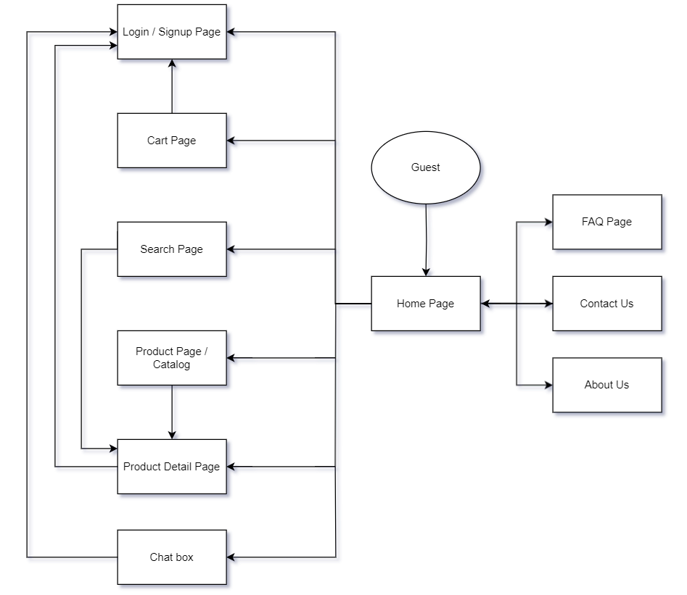

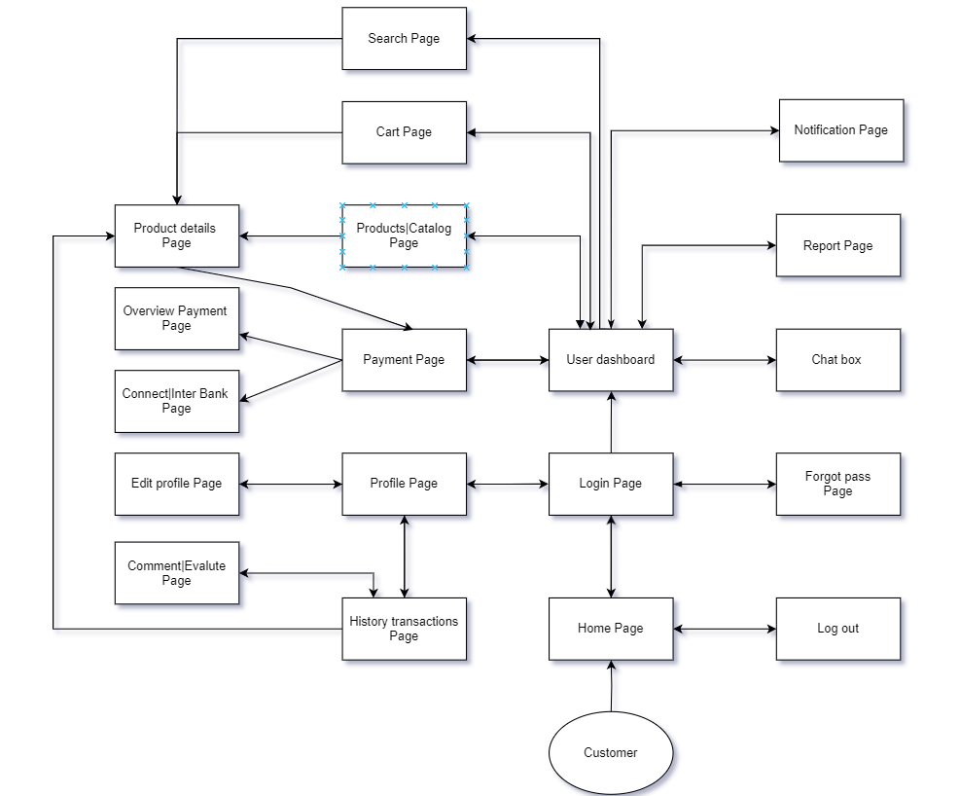

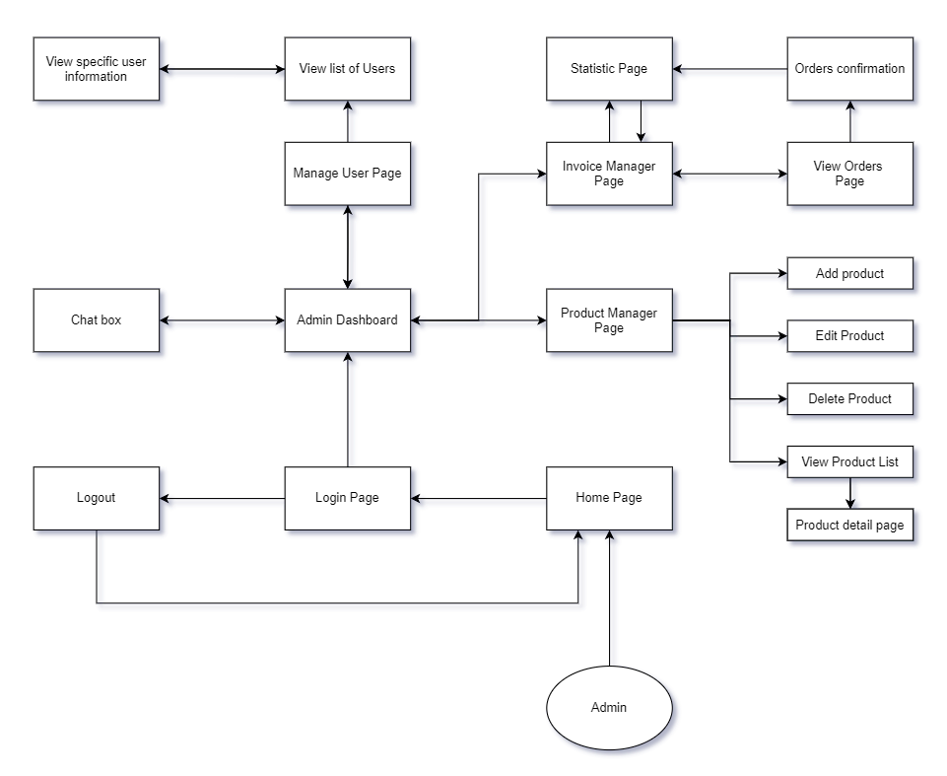

#### **3.1.2 Screen Descriptions**

| **#** | **Feature** | **Screen** | **Description** |
| --- | --- | --- | --- |
| 1 | Register account | Login/Sign up page | Display the form for guests to enter the necessary information to register |
| 2 | Log in | Login/Sign up page | Display login form for the user to enter account and password to log in |
| 3 | Forgot password | Forgot password page | Send OTP to the user's email to change the password |
| 4 | Change profile | Edit profile page | Display the form for the user to change personal information and user account password |
| 5 | View history transaction | History transactions page | Display the transaction list as a table |
| 6 | Evaluate transaction | Comment/Evaluate page | Display the form for users to comment and interactive rating for users to rate |
| 7 | Chatbox | Chatbox | Users can communicate with each other and with tutors |
| 8 | Report issue | Report page | Users can report any problems or bugs encountered within the system |
| 9 | Contact support | Contact us | User can fill out a contact form, providing details of their issue |
| 10 | Classify each product category | Product page/Catalog | View a list of categories as a menu |
| 11 | View product details | Product detail page | View detailed product information |
| 12 | Review the product in the cart | Cart page | All products the user has selected to add to the cart will be intuitively displayed in a table format. |
| 13 | Easy for users to access | User dashboard | Display a dashboard that has all the functions of the user |
| 14 | Searching | Search page | Display a search bar to make it easier for users to find the products they want |
| 15 | Receive notifications | Notification page | Users receive important notifications such as products ordered, invoices paid, information about new products |
| 16 | Payment | Payment page | Display information about the invoice and payment methods such as cash or bank transfer |
| 17 | Verify payment | Overview payment page | Display full information about paid invoices so users can confirm |
| 18 | Easy for admin to access | Admin dashboard | Display a dashboard that has all the functions of admin |
| 19 | Manage product | Product manager page | Display a list of products in a table format, the admin can add, delete, edit, and review existing products |
| 20 | Manage user | Manage user page | Displays a list of information of users currently accessing the system. |
| 21 | Manage order | Invoice manager page | Displays a list of bills that the user has paid. |
| 22 | Revenue statistics | Statistics page | Make sales statistics for admin to review |

#### **3.1.3 Screen Authorization**

| **Screen** | **Admin** | **Customer** | **Guest** |
| --- | --- | --- | --- |
| Login Page | X | X | X |
| Register |  | X | X |
| Forgot Password Page |  | X | X |
| Change Password | X | X |  |
| Home Page | X | X | X |
| Profile Page |  | X |  |
| Edit Profile Page |  | X |  |
| Payment Page |  | X |  |
| Search Page |  | X | X |
| Cart Page |  | X | X |
| Product Page | X | X | X |
| Product Detail Page | X | X | X |
| Chatbox |  | X | X |
| Contact us |  | X | X |
| About us | X | X | X |
| FAQs Page | X | X | X |
| User Dashboard |  | X |  |
| Overview Payment Page |  | X |  |
| Connect/Interbank Page |  | X |  |
| History Transactions Page |  | X |  |
| Comment/Evaluate Page |  | X |  |
| Report Page |  | X |  |
| Notification Page |  | X |  |
| Admin Dashboard | X |  |  |
| Product Manager Page | X |  |  |
| Invoice Manager Page | X |  |  |
| Statistic Page | X |  |  |
| View Order Page | X |  |  |
| Manage User Page | X |  |  |
| View Product Details | X | X | X |
| Apply Discounts or Coupons |  | X | X |
| Update Profile Information |  | X |  |
| View Order History |  | X |  |
| Proceed to Checkout |  | X |  |
| Track Order |  | X |  |
| Cancel Order |  | X |  |
| Filter Products by Price Range | X | X | X |
| Filter Products by Size | X | X | X |
| Manage Orders | X |  |  |
| Manage Featured Products | X |  |  |
| Manage Product Reviews | X |  |  |

#### **3.1.4 Non-Screen Functions**

| **#** | **Feature** | **System Function** | **Description** |
| --- | --- | --- | --- |
| 1 | Inventory Management | Update Inventory | The system automatically updates the inventory when a purchase is made to reflect available stock. |
| 2 | Payment Processing | Process Payment | The system processes payments securely through integrated payment gateways. |
| 3 | Order Management | Track Orders | The system tracks orders from creation to delivery, updating order status in real time. |
| 4 | User Authentication | Verify Login | The system verifies user login credentials against the database before allowing access to personal accounts. |
| 5 | Notification System | Send Alerts | The system sends email or SMS notifications to users regarding their order status or promotional offers. |
| 6 | Custom interface | Custom interface language | The system allows users to change the interface language to suit |

#### **3.1.5 Entity Relationship Diagram**

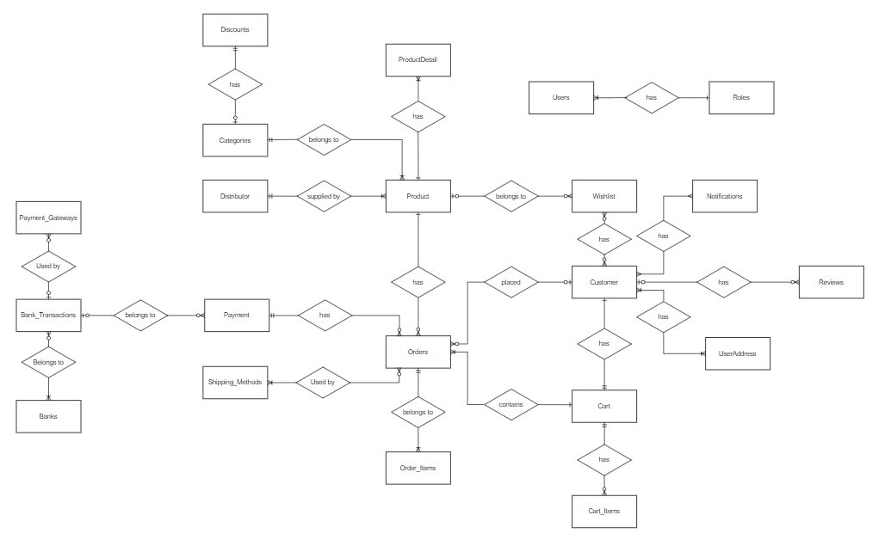

**Entities Description**

| **#** | **Entity** | **Description** |
| --- | --- | --- |
| 1 | Product | Represents the individual Nike items for sale (e.g., shoes, apparel, accessories), including attributes like product name, price, and stock status. |
| 2 | ProductDetail | Contains additional information related to the products such as descriptions, sizes, materials, colors, and specifications. |
| 3 | Customer | Stores information about customers, including personal details, contact information, and their purchase history. |
| 4 | Order | Represents customer purchases and contains details like the order date, status, and total amount. It also links to both the customer and individual items within the order (via Order_Items). |
| 5 | Order_Items | Holds information on individual products within an order, including product IDs, quantities, and unit prices. |
| 6 | Cart | Tracks items that a customer intends to purchase, functioning as a temporary holding area before an order is placed. |
| 7 | Cart_Items | Records specific items in the customer's shopping cart, including the product details and quantities. |
| 8 | Categories | Represents the various classifications of products, such as footwear, clothing, and accessories. Products belong to one or more categories. |
| 9 | Discount | Manages promotions, coupon codes, or discounts that can be applied to products, affecting their prices. |
| 10 | Distributor | Represents the suppliers or distributors that provide products to the online store, detailing the relationship between the products and their suppliers. |
| 11 | Users | Refers to all users of the system, including both customers and administrative staff. Each user has associated roles. |
| 12 | Roles | Defines the different roles within the system (e.g., customer, admin), determining the permissions and access levels for each user. |
| 13 | Wishlist | A list of products that a customer has saved for future purchase but has not yet added to their cart. |
| 14 | Notifications | Stores notifications sent to users, such as order updates, product announcements, or discounts. |
| 15 | Reviews | Contains customer reviews of products, including text reviews and star ratings. |
| 16 | UserAddress | Stores one or more addresses for each customer, used for billing and shipping purposes. |
| 17 | Shipping Methods | Represents the different shipping options available to customers, such as standard shipping, express delivery, or international shipping. |
| 18 | Payment | Manages the payment details for orders, including the total payment amount, status, and the payment method used. |
| 19 | Payment_Gateways | Represents external services (like Stripe or PayPal) used to process customer payments securely. |
| 20 | Banks | Stores bank details used for processing payments and customer transactions. |
| 21 | Bank_Transactions | Tracks financial transactions made via banks during the payment process, linking payments to specific bank accounts. |

### **3.2 View Products**

#### **3.2.1 Product List**

### 

| **#** | **Component** | **Comp. Type** | **Editable** | **Mandatory** | **Default Value** | **Description** |
| --- | --- | --- | --- | --- | --- | --- |
| 1 | Product Listing Screen | Label | No | N/A. | N/A. | This field displays text: “ Products List” |
| 2 | Products table: Display information about Products. | | | | | |
| Table Name | Label | No | N/A. | N/A. |  |
| Search Box | Text Box | No | N/A. | N/A. | Allows users to search for shoes by name, model, or type. |
| Category Filter | Slider | No | N/A. | N/A. | Allows users to filter shoes based on price range |
| Sort By | Compo Box | No | N/A. | N/A. | Provides options to sort by popularity, price or newest arrivals. |
| Product Grid/List | Data Table | No | N/A | N/A | Displays shoes with name, image, price and current availability status. |
| 4 | Add to Cart | Button | N/A. | N/A. | N/A. | Add selected shoes to the shopping cart |
| 5 | View Details | Button | N/A. | N/A. | N/A. | Redirects the user to the detailed product page for more information. |

#### **3.2.2 Product Details**

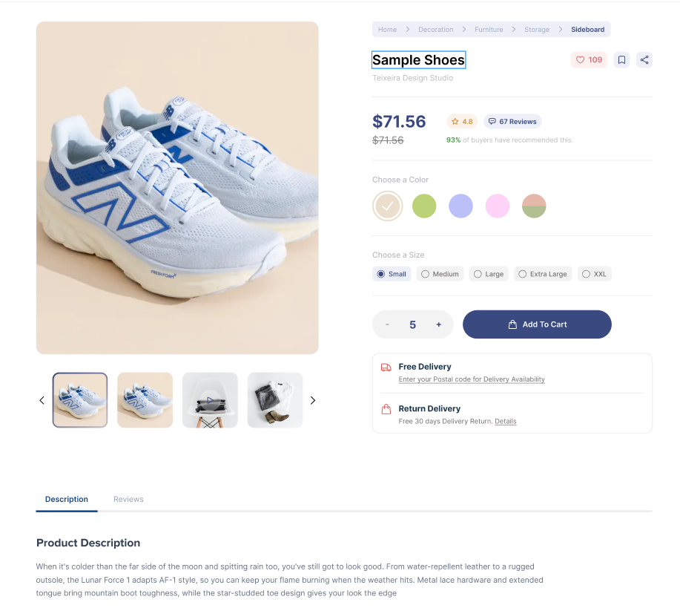

#### 

| **#** | **Component** | **Comp. Type** | **Editable** | **Mandatory** | **Default Value** | **Description** |
| --- | --- | --- | --- | --- | --- | --- |
| 1 | Products Image | Image | No | N/A. | N/A. | Display the shoe image |
| 2 | Products table: Display information about Products. | | | | | |
| Product Name | Label | No | N/A. | N/A. | Display name of product |
| Price | Label | No | N/A. | N/A. | Displays the price of the shoe |
| Description | Text Area | No | N/A. | N/A. | A detailed description of the shoe |
| Available Sizes | Combo Box | No | N/A. | N/A. | Shows available shoe sizes |
| Available Colors | Combo Box | No | N/A | N/A | Shows available shoe colors |
| 4 | Reviews | Data Table | N/A. | N/A. | N/A. | Lists review from other customers. |
| 5 | Add to Cart | Button | N/A. | N/A. | N/A. | Adds the shoe to the shopping cart |
| 6 | Submit review | Button | No | N/A | N/A | Allows the user to submit a review |

### **3.3 Contact**

#### **3.3.1 Chat Box**

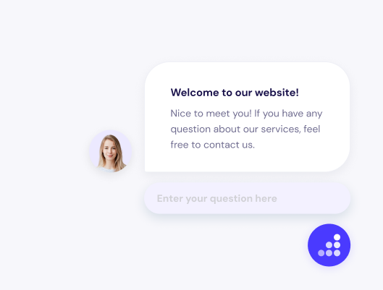

#### 

| **#** | **Component** | **Comp. Type** | **Editable** | **Mandatory** | **Default Value** | **Description** |
| --- | --- | --- | --- | --- | --- | --- |
| 1 | Chat Input | Text Box | No | N/A. | N/A. | Allows the user to type and send message to tutor |
| 2 | Send button | Button | No | N/A | N/A | Sends the typed message to the chat system |

#### **3.3.2 Contact support**

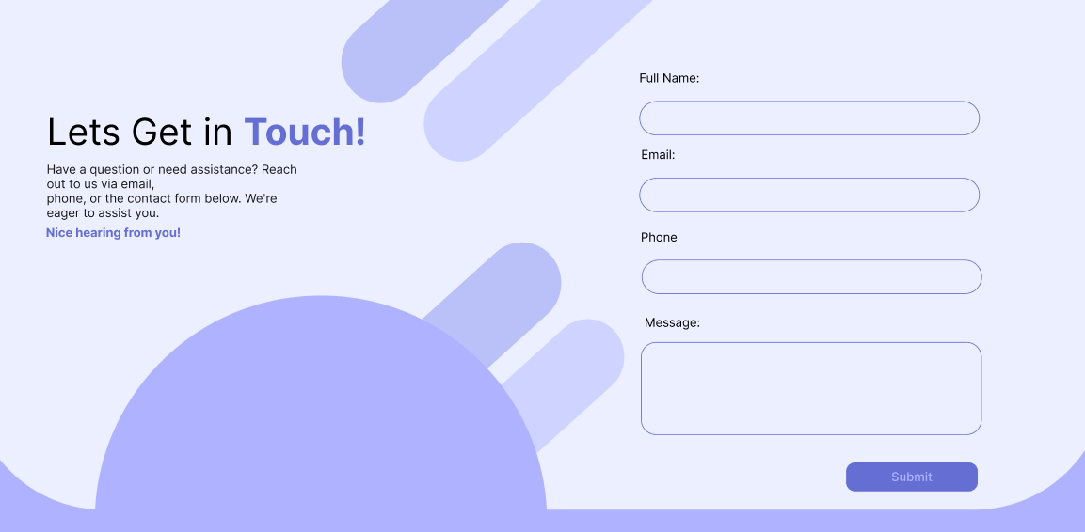

| **#** | **Component** | **Comp. Type** | **Editable** | **Mandatory** | **Default Value** | **Description** |
| --- | --- | --- | --- | --- | --- | --- |
| 1 |  | Image | No | N/A. | N/A. | Display the shoe image |
| 2 | Products table: Display information about Products. | | | | | |
|  |  | No | N/A. | N/A. | Display name of product |
|  |  | No | N/A. | N/A. | Displays the price of the shoe |
|  |  | No | N/A. | N/A. | A detailed description of the shoe |
|  | Combo Box | No | N/A. | N/A. | Shows available shoe sizes |
|  | Combo Box | No | N/A | N/A | Shows available shoe colors |
| 4 |  | Data Table | N/A. | N/A. | N/A. | Lists review from other customers. |
| 5 |  | Button | N/A. | N/A. | N/A. | Adds the shoe to the shopping cart |
| 6 |  | Button | No | N/A | N/A | Allows the user to submit a review |

### **3.4 User Registration**

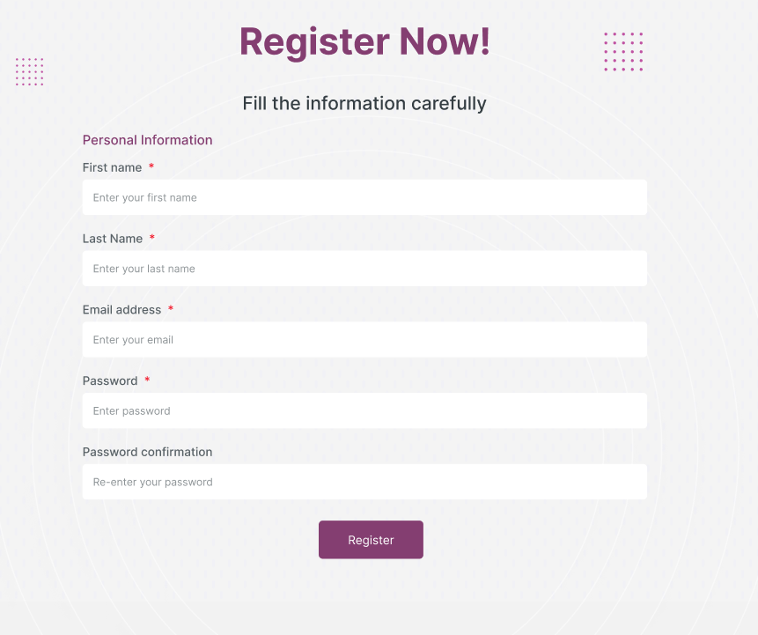

#### 

| **#** | **Component** | **Comp. Type** | **Editable** | **Mandatory** | **Default Value** | **Description** |
| --- | --- | --- | --- | --- | --- | --- |
| 2 | Register table: Form to fill the information | | | | | |
| First Name | Text Box | No | N/A. | N/A. | User’s first name |
| Last name | Text Box | No | N/A. | N/A. | User’s last name |
| Email | Text Box | No | N/A. | N/A. | User’s email address |
| Password | Password Box | No | N/A. | N/A. | User’s password |
| Confirm Password | Password Box | No | N/A | N/A | User re-enters password to confirm it. |
|  | Register | Button | N/A. | N/A. | N/A. | Submits the registration form. |

### **3.5 Shopping Cart**

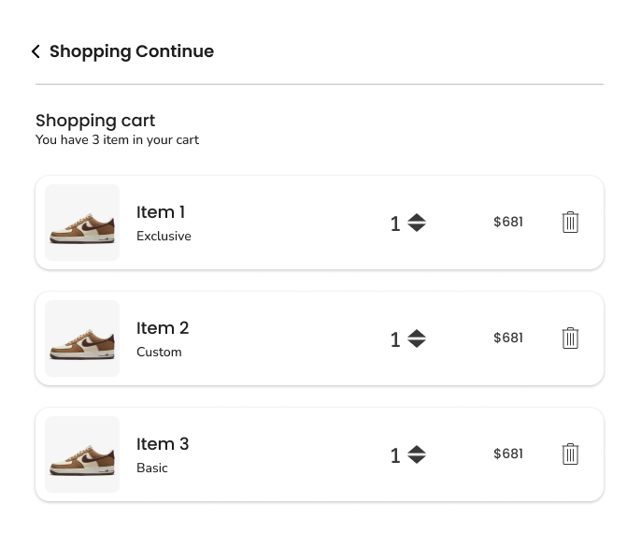

#### 

| **#** | **Component** | **Comp. Type** | **Editable** | **Mandatory** | **Default Value** | **Description** |
| --- | --- | --- | --- | --- | --- | --- |
| 1 | Cart Items | Data Table | No | N/A. | N/A. | List of items in the cart (name, quantity, price) |
| 2 | Quantity | Spinner | N/A. | N/A. | N/A. | Allows the user to adjust the quantity of each item. |
| 3 | Remove | Button | N/A. | N/A. | N/A. | Removes an item form the cart. |
| 4 | Total Price | Label | No | N/A | N/A | Displays the total price of all items. |
| 5 | Checkout | Button | No | N/A | N/A | Proceed to checkout |

### **3.6 Order Management**

#### **3.6.1 Order Placement**

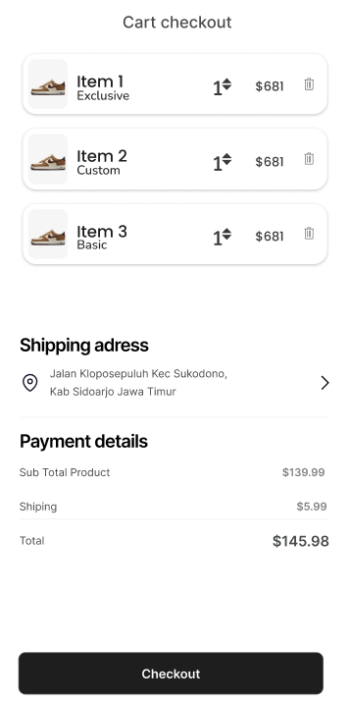

#### 

| **#** | **Component** | **Comp. Type** | **Editable** | **Mandatory** | **Default Value** | **Description** |
| --- | --- | --- | --- | --- | --- | --- |
| 1 | Shipping Address | Text Box | No | N/A. | N/A. | Display the user’s delivery address. |
| 2 | Shipping Method | Combo Box | N/A. | N/A. | N/A. | Dropdown to select a shipping option (e.g., standard, express) |
| 3 | Payment Method | Combo Box | N/A. | N/A. | N/A. | Dropdown to select a payment option (e.g., credit card, PayPal). |
| 4 | Order Summary | Data Table | No | N/A | N/A | Displays a list of product in the order (name, quantity, price) |
| 5 | Total Price | Label | No | N/A | N/A | Total cost of the order including shipping. |
| 6 | Place Order | Button | No | N/A | N/A | Confirm and submit the order |
| 7 | Back to Cart | Button | No | N/A | N/A | Return the user to the cart for any modifications. |

#### 

### **3.7 Product Reviews**

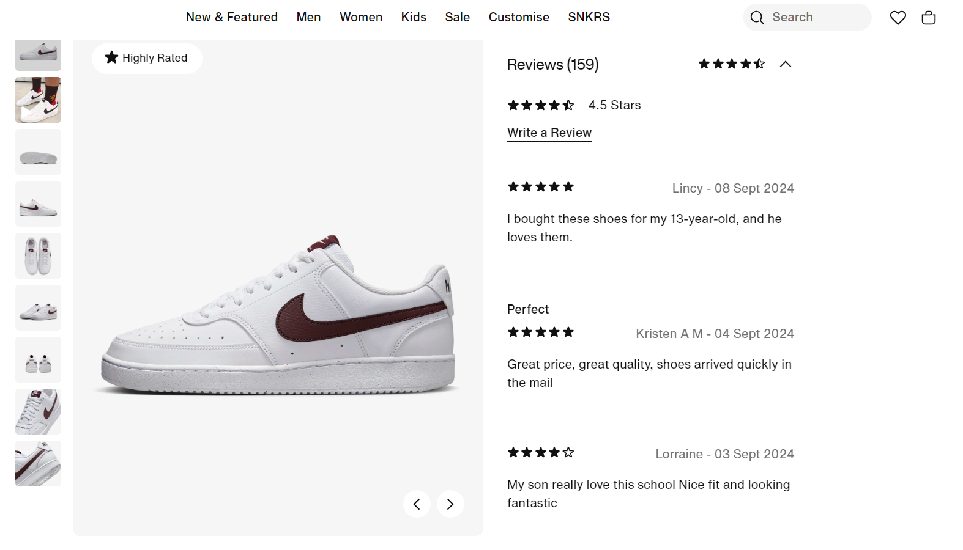

#### 

| **#** | **Component** | **Comp. Type** | **Editable** | **Mandatory** | **Default Value** | **Description** |
| --- | --- | --- | --- | --- | --- | --- |
| 1 | Rating | Combo Box | No | N/A. | N/A. | Dropdown for rating the product (1 - 5 stars) |
| 2 | Review | Text Area | N/A. | N/A. | N/A. | Input field for submitting the text review. |
| 3 | Submit | Button | N/A. | N/A. | N/A. | Submit the review |

### **3.8 Payment**

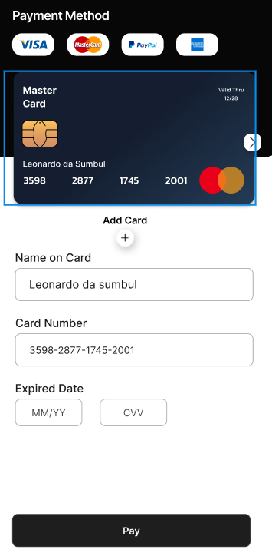

| **#** | **Component** | **Comp. Type** | **Editable** | **Mandatory** | **Default Value** | **Description** |
| --- | --- | --- | --- | --- | --- | --- |
| 1 | Order Summary | Display Only | No | N/A. | N/A. | A summary of items in the cart, including product names, quantities and total cost. |
| 2 | Payment Method | Dropdown | N/A. | N/A. | N/A. | A selection of payment options (e.g.,Credit/Debit Card, PayPal, Apple Pay,..) |
| 3 | Cardholder Name | Text Input | N/A. | N/A. | N/A. | The name of the person to whom the card is issued |
| 4 | Card Number | Text Input | No | N/A | N/A | The 16 digit numbers on the credit/debit card. |
| 5 | Expiration Date | Dropdowns | No | N/A | N/A | Dropdowns for selecting the card’s expiration month and year. |
| 6 | CVV | Text Input | No | N/A | N/A | The 3 or 4 digit security code on the back of the card. |
| 7 | Billing Address | Text Area | No | N/A | N/A | The address associated with the payment method |
| 8 | Street Address | Text Input | No | N/A | N/A | The street address for billing. |
| 9 | City | Text input | No | N/A | N/A | The city for the billing address. |
| 10 | State/Province | Dropdown | No | N/A | N/A | The state or province for the billing address. |
| 11 | Postal Code | Text Input | No | N/A | N/A | The postal code for the billing address. |
| 12 | Country | Dropdown | No | N/A | N/A | The country for billing address. |
| 13 | Total Amount | Display Only | No | N/A | N/A | The total amount to be changed, including taxes and shipping. |
| 14 | Terms and Conditions | Check Box | No | N/A | N/A | A checkbox for users to agree to the terms and conditions. |
| 15 | Submit Payment | Button | No | N/A | N/A | A button to confirm and submit the payment. |

#### 

### **3.9 User Dashboard**

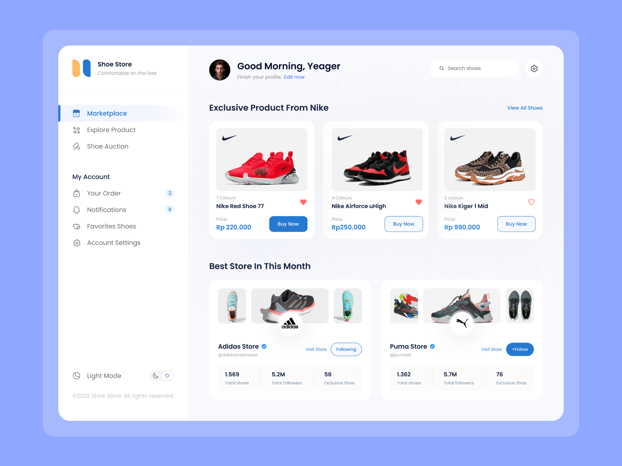

#### 

| **#** | **Component** | **Comp. Type** | **Editable** | **Mandatory** | **Default Value** | **Description** |
| --- | --- | --- | --- | --- | --- | --- |
| 1 | User Name | Display Only | No | N/A. | N/A. | The user’s chosen username display prominently. |
| 2 | Profile Picture | Image Upload | N/A. | N/A. | N/A. | The user’s profile image, allowing for personalization. |
| 3 | Account Creation Date | Display Only | N/A. | N/A. | N/A. | The date when the user’s account was created. |
| 4 | Order History | Link/List | No | N/A | N/A | A list of past orders with links to view details. |
| 5 | Order Numbers | Display Only | No | N/A | N/A | The unique identifier for each order in the order history. |
| 6 | Order Status | Display Only | No | N/A | N/A | The current status of the order(e.g., Shipped, Delivered). |
| 7 | Track Shipments | Button/Link | No | N/A | N/A | A link or button to view tracking information for current orders. |
| 8 | Edit Profile | Button/Link | No | N/A | N/A | A button to edit personal information such as name and address. |
| 9 | Email address | Text Input | No | N/A | N/A | The user’s registered email address, editable in profile settings. |
| 10 | Phone Number | Text input | No | N/A | N/A | The user’s contact number, editable in profile settings. |
| 11 | Payment Method | Link/List | No | N/A | N/A | A section to manage saved payment methods (add,edit,remove) |
| 12 | WishList | Link/List | No | N/A | N/A | A link to view saved items, allowing users to manage their wishlist. |
| 13 | Personalized | Display Area | No | N/A | N/A | A section displaying recommended products based on user activity. |
| 14 | Customer Support | Link/Button | No | N/A | N/A | Quick access to customer support options(FAQs, Contact Us). |
| 15 | Logout | Button | No | N/A | N/A | A button to securely log out of the user account. |

### **3.10 User Authentication**

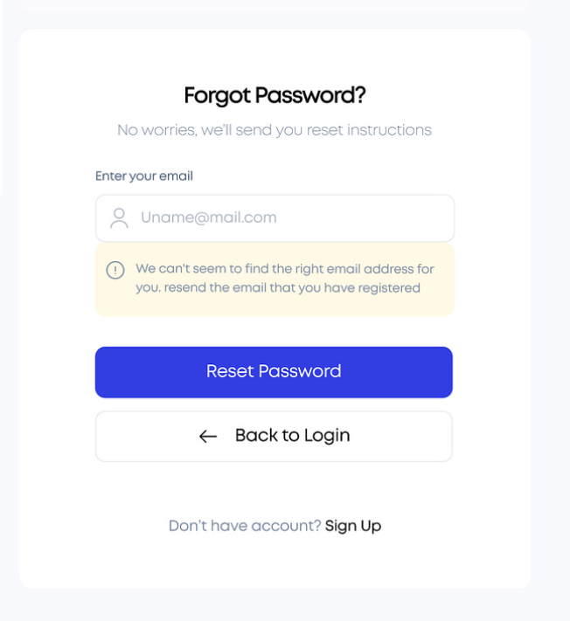

#### 

| **#** | **Component** | **Comp. Type** | **Editable** | **Mandatory** | **Default Value** | **Description** |
| --- | --- | --- | --- | --- | --- | --- |
| 1 | Email | Text Box | No | N/A. | N/A. | Input for the user’s registered email address |
| 2 | Send Reset Link | Button | N/A. | N/A. | N/A. | Send a password reset link to the provided email address. |
| 3 | Back to Login | Button | N/A. | N/A. | N/A. | Redirects the user back to the login page. |

### **3.11 Product Management**

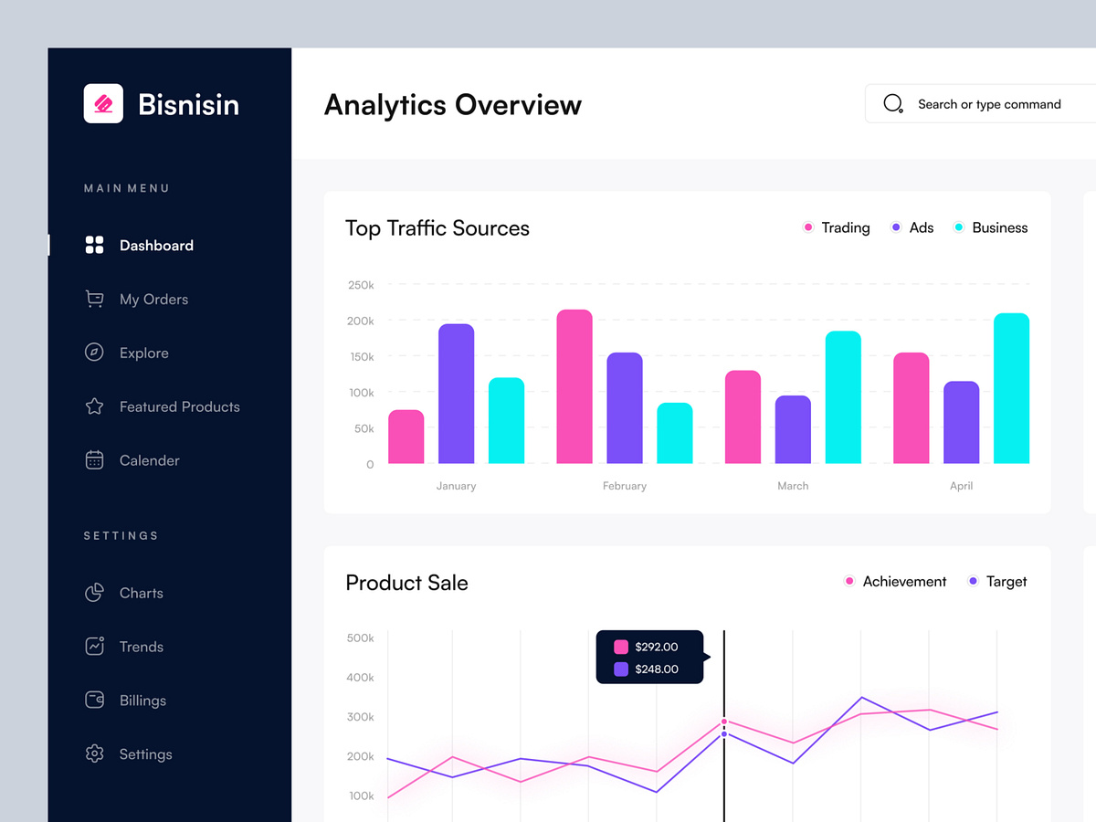

#### 

| **#** | **Component** | **Comp. Type** | **Editable** | **Mandatory** | **Default Value** | **Description** |
| --- | --- | --- | --- | --- | --- | --- |
| 1 | Product | Image | No | N/A. | N/A. | Display the shoe image. |
| 2 | Product Name | Label | N/A. | N/A. | N/A. | Name of the product. |
| 3 | Price | Label | N/A. | N/A. | N/A. | Display the price of the shoe. |
| 4 | Description | Text Area | No | N/A | N/A | A detailed description of the shoe. |
| 5 | Available Sizes | Combo Box | No | N/A | N/A | Shows available shoe sizes. |
| 6 | Available Colors | Combo Box | No | N/A | N/A | Shows available shoe colors. |
| 7 | Submit | Button | No | N/A | N/A | A button to submit the product details (for adding or editing). |
| 8 | Delete | Button | No | N/A | N/A | A button to remove the product from the database. |

### **3.12 Admin’s Dashboard**

### 

### **3.13 User Management**

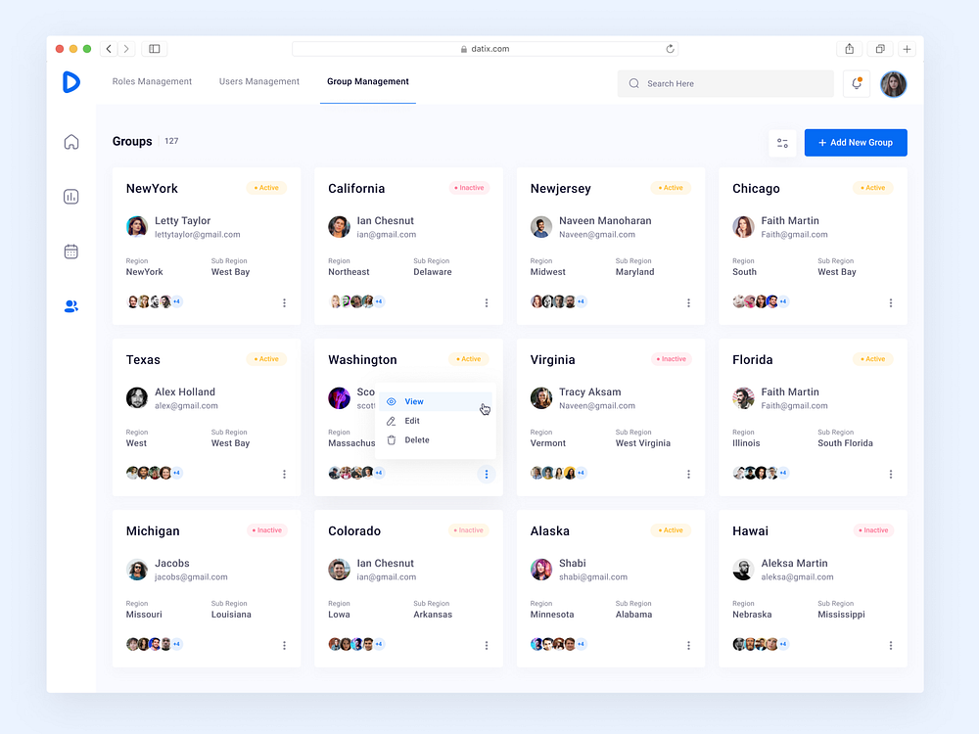

#### 

| **#** | **Component** | **Comp. Type** | **Editable** | **Mandatory** | **Default Value** | **Description** |
| --- | --- | --- | --- | --- | --- | --- |
| 1 | View | Button | No | N/A. | N/A. | Display profile of user |
| 2 | Edit | Button | N/A. | N/A. | N/A. | Update information for users.(e.g.,Decentralization) |
| 3 | Delete | Button | N/A. | N/A. | N/A. | Remove user from system. |

## **4. Non-Functional Requirements**

### **4.1 External Interfaces**

This section ensures that the web shoe application communicates effectively with users, external hardware, and software systems.

* User Interface: The web application must provide a responsive and intuitive user interface that adapts seamlessly to different devices (desktops, tablets, and smartphones).
* Payment Gateway: The system must integrate with payment gateways (e.g., PayPal, Bank) to securely process transactions.
* Shipping: Must connect with logistics providers for real-time shipping rates and tracking updates.
* User Authentication: Integration with third-party authentication services (e.g., Google, Facebook) for secure user login.
* Analytics Integration: The application should interface with web analytics tools (e.g., Google Analytics) to track user behavior and application performance.

### **4.2 Quality Attributes**

#### **4.2.1 Usability**

* Training Time: New users should be able to complete a purchase within 5 minutes of first use, while experienced users should complete it in under 2 minutes.
* Task Time: Users should be able to search for a specific shoe in less than 10 seconds.

#### **4.2.2 Reliability**

* Availability: The application must be available 99.9% of the time over a month, allowing for scheduled maintenance.
* Mean Time Between Failures (MTBF): The system should aim for an MTBF of 1,000 hours.
* Mean Time To Repair (MTTR): The maximum allowable downtime after a failure is 1 hour.
* Accuracy: The system must ensure that order confirmations and shipping details are 99.5% accurate.
* Maximum Bugs or Defect Rate: The application should maintain a defect rate of no more than 5 bugs per thousand lines of code (bugs/KLOC).
* Bugs Categorization:
* Critical Bugs: Complete loss of transaction data or inability to make purchases.
* Significant Bugs: Issues that prevent users from completing their purchases.
* Minor Bugs: Minor UI glitches that do not hinder functionality.

#### **4.2.3 Performance**

* Response Time:
* Average transaction response time should be less than 2 seconds.
* Maximum response time should not exceed 4 seconds during peak load.
* Throughput: The system should support at least 100 transactions per second without performance degradation.
* Capacity: The application must handle up to 10,000 concurrent users without issues.
* Resource Utilization:
* Memory usage should not exceed 80% during peak operations.
* Disk I/O should be optimized to handle high read/write operations efficiently.
* Page Load Time: Web pages should load in under 3 seconds on average, even with images and multimedia content.

#### **4.2.4 Security**

* Data Protection: All sensitive data (e.g., credit card information, personal details) must be stored securely and encrypted.
* User Authentication: Support multi-factor authentication (MFA) for both users and admin to enhance security.

**4.2.5 Compatibility**

* Cross-Platform Support: The application should be compatible with various operating systems (Windows, macOS, Linux) and devices (smartphones, tablets)
* API Compatibility: Ensure that any external APIs are versioned to maintain compatibility with the web application during updates.

## **5. Requirement Appendix**

### **5.1 Business Rules**

| ID | Rule Definition |
| --- | --- |
| BR-01 | Homepage Display Rules: The system will show categories, featured products, and promotions on the homepage. |
| BR-02 | Product Availability Rules: Only in-stock products will be shown in featured sections. |
| BR-03 | Responsiveness: The homepage will be responsive, adjusting to different screen sizes (mobile, tablet, desktop). |
| BR-04 | Product Click Rules: Clicking on any product will take the user to the product detail page. |
| BR-05 | Registration Input Rules: The system must verify that all mandatory fields are filled out (e.g., name, email, password). |
| BR-06 | Email Uniqueness: The system checks that the provided email is not already registered (no duplicate accounts). |
| BR-07 | Password Strength: Password must meet security requirements (e.g., minimum 8 characters, include letters and numbers). |
| BR-08 | Account Creation: The system will store the new user account details in the Users table with the role "customer." |
| BR-09 | Password Strength: The new password must meet security requirements (e.g., minimum 8 characters, a mix of letters, numbers, and special characters). |
| BR-10 | Password Match: The system checks that the new password matches the confirmation password field. |
| BR-11 | Current Password Validation: The system verifies that the entered current password matches the one stored in the database. |
| BR-12 | Password Update: The system updates the password in the database if all validations pass. |
| BR-13 | Email Validation: The system checks that the email provided exists in the database and is associated with a registered account. |
| BR-14 | Reset Link Generation: The system generates a secure password reset link or temporary password and emails it to the user. |
| BR-15 | Password Strength: The new password must meet security requirements (e.g., minimum 8 characters, mix of letters, numbers, and special characters). |
| BR-16 | Password Update: The system updates the user's password in the database after a successful reset. |
| BR-17 | Verification Email Rules: The system sends a unique verification link to the registered email after successful account creation. |
| BR-18 | Link Expiration: The verification link must be valid for a limited time (e.g., 24 hours). |
| BR-19 | Token Validation: The system ensures that the token in the verification link is valid and matches the one stored in the database. |
| BR-20 | Account Status Update: After successful verification, the system changes the user’s status to "verified." |
| BR-21 | User Authentication: The user must be logged in to access their profile page. |
| BR-22 | Data Display Rules: The system must display accurate and up-to-date information from the Users table. |
| BR-23 | Security Rules: Sensitive information, such as the password, must not be visible. |
| BR-24 | Product Availability Rules: Only products that are currently in stock are shown to the user. |
| BR-25 | Category Display Rules: The system filters the product list by the selected category or search term. |
| BR-26 | Product Information Display: The system must display relevant product details like name, image, price, and availability status. |
| BR-27 | User Role Rules: Guests can only view products, while customers can add products to their shopping cart. Admins can view and manage products. |
| BR-28 | Keyword Matching Rules: The system must search for products based on the entered keyword, checking the product name, description, categories, and other relevant fields. |
| BR-29 | Search Accuracy Rules: The search must ignore case sensitivity and handle partial matches (e.g., searching for "run" should match products with "running"). |
| BR-30 | Product Display Rules: The system must display relevant product details, such as name, image, price, and short description for each matching product. |
| BR-31 | User Role Rules: Guests can only search and view products, while customers can add products to their cart. Admins can search and manage products. |
| BR-32 | User Authentication: Only logged-in customers who have purchased the product can leave a review. |
| BR-33 | Review Form: The system must allow the user to rate the product (e.g., 1–5 stars) and leave a written comment. |
| BR-34 | Input Validation: The system must ensure that the rating is within the allowed range and the comment text is not empty or too long. |
| BR-35 | Product Rating Update: The system must calculate the updated average rating for the product after each new review. |
| BR-36 | Display Rules: The system must show the updated product rating and the latest customer comments on the product detail page. |
| BR-37 | User Authentication: Only logged-in customers can place an order. |
| BR-38 | Shopping Cart Validation: The system must ensure that the cart contains valid products before proceeding to checkout. |
| BR-39 | Payment and Shipping Information: The user must provide valid shipping and payment details to complete the order. |
| BR-40 | Order Processing: The system must validate stock availability before placing the order. |
| BR-41 | Confirmation: The system must send an order confirmation email to the user after successful order placement. |
| BR-42 | Cart Management: Users can add multiple products to the cart, and the system must ensure stock availability at the time of adding. |
| BR-43 | Cart Summary Display: The system must display accurate product details, including name, price, quantity, and total price. |
| BR-44 | Quantity Update Rules: The system must allow users to update quantities and recalculate the total price. |
| BR-45 | Item Removal: The system must allow users to remove items from the cart, updating the cart summary accordingly. |
| BR-46 | Proceed to Checkout: The system must verify that the cart is not empty before allowing checkout. |
| BR-47 | User Authentication: Only logged-in customers can add products to their cart. |
| BR-48 | Stock Availability: The system must check for product availability before adding it to the cart. |
| BR-49 | Cart Update: If the product is already in the cart, the system should increase the quantity instead of adding a new entry. |
| BR-50 | Confirmation: The system must display a confirmation message once the product is added to the cart. |
| BR-51 | Navigation Options: The user should have the option to view the cart or continue shopping seamlessly. |
| BR-52 | User Authentication: Only logged-in customers can delete items from their cart. |
| BR-53 | Confirmation Requirement: The system must prompt the user for confirmation before deleting the cart. |
| BR-54 | Cart Deletion: The system must remove all items from the cart upon user confirmation. |
| BR-55 | Display Update: The system must update the cart display to reflect the deletion and show an appropriate message. |
| BR-56 | Chat Availability: The chatbox should be available during customer support hours. |
| BR-57 | User Authentication: Customers must be logged in to initiate a chat (optional). |
| BR-58 | Message Format: The system must support basic text messaging and display timestamps for messages. |
| BR-59 | Response Time: Customer support representatives must respond to user inquiries within a specified timeframe (e.g., 2 minutes). |
| BR-60 | Session Logging: The system must log all chat sessions for future reference and quality assurance. |
| BR-61 | Payment Options: The system must offer multiple payment methods for customers to choose from. |
| BR-62 | Payment Information Validation: The system must validate the entered payment details before processing the payment. |
| BR-63 | Payment Processing: The system must securely process payment information through a trusted payment gateway. |
| BR-64 | Confirmation: The system must provide immediate feedback on the payment status and send an order confirmation email upon successful payment. |
| BR-65 | Cart Summary: The system must display an accurate summary of items in the cart, including total price and applicable taxes. |
| BR-66 | Shipping Information: The system must prompt the user to enter complete shipping details before proceeding. |
| BR-67 | Validation: The system must validate the shipping information for accuracy before proceeding to payment. |
| BR-68 | Payment Redirection: The system must redirect the user to the payment page after confirming the shipping details. |
| BR-69 | Order Confirmation: The system must provide immediate confirmation of the order after payment is processed, including an order summary and confirmation email. |
| BR-70 | Direct Payment Option: The system must allow customers to make direct payments for products without a full checkout process. |
| BR-71 | Payment Options: The system must present multiple payment methods for the user to choose from. |
| BR-72 | Payment Information Validation: The system must validate the entered payment details before processing the payment. |
| BR-73 | Payment Processing: The system must securely process payment information through a trusted payment gateway. |
| BR-74 | Confirmation: The system must provide immediate feedback on the payment status and send an order confirmation email upon successful payment. |
| BR-75 | Payment Method Selection: The system must allow customers to choose between card or bank payment options. |
| BR-76 | Required Fields: The system must require specific fields for card/bank information (e.g., card number, expiration date, CVV, bank account number). |
| BR-77 | Payment Information Validation: The system must validate the entered payment details before processing the payment. |
| BR-78 | Secure Processing: The system must securely process card/bank information through a trusted payment gateway. |
| BR-79 | Confirmation: The system must provide immediate feedback on the payment status and send an order confirmation email upon successful payment. |
| BR-80 | Product Information: The system must display comprehensive product details, including images, descriptions, specifications, and prices. |
| BR-81 | Options Availability: The system must display available size/color options and adjust pricing accordingly. |
| BR-82 | Review Display: The system must show customer reviews and ratings for the product, if available. |
| BR-83 | Navigation: The system must allow the user to navigate back to the product listing page easily. |
| BR-84 | Valid Codes: The system must accept only valid discount codes that meet predefined conditions (e.g., expiration date, minimum purchase amount). |
| BR-85 | Discount Calculation: The system must correctly calculate the discount and adjust the order total accordingly. |
| BR-86 | Feedback: The system must provide immediate feedback on the discount application status (success or failure). |
| BR-87 | Clear Display: The system must clearly display the original price, applied discount, and new total price for transparency. |
| BR-88 | Editable Fields: The system must allow users to edit specific fields in their profile, such as name, email, phone number, and address. |
| BR-89 | Validation: The system must validate user input for correctness, including format checks for email and required fields. |
| BR-90 | Save Confirmation: The system must confirm successful updates to the user and display the updated information. |
| BR-91 | Error Messaging: The system must provide clear error messages for any validation issues encountered during the update process. |
| BR-92 | Order Retrieval: The system must retrieve and display all orders associated with the logged-in user. |
| BR-93 | Summary Display: The system must show a summary for each order, including date, total amount, and status (e.g., shipped, pending, canceled). |
| BR-94 | Detailed View: The system must allow users to view detailed information about each order when selected. |
| BR-95 | Navigation: The system must allow easy navigation back to the order history list from the detailed view. |
| BR-96 | Cart Validation: The system must check the availability and pricing of items in the cart before proceeding to checkout. |
| BR-97 | Order Summary: The system must display a clear summary of the order, including items, quantities, prices, and total amount. |
| BR-98 | Shipping Information: The system must require complete and valid shipping details before processing the order. |
| BR-99 | Payment Method Selection: The system must provide multiple payment options and display the corresponding input fields based on the user’s selection. |
| BR-100 | Error Handling: The system must provide clear and immediate feedback for any errors encountered during the checkout process. |
| BR-101 | Order Retrieval: The system must retrieve and display order tracking information associated with the logged-in user. |
| BR-102 | Tracking Details: The system must provide comprehensive tracking details, including the current status, carrier, and estimated delivery date. |
| BR-103 | Error Handling: The system must provide feedback if the order number is invalid or if tracking information is unavailable. |
| BR-104 | Navigation: The system must allow users to navigate easily back to their account or order history after viewing tracking details. |
| BR-105 | Cancellation Eligibility: The system must allow cancellation only for orders that have not yet been shipped. |
| BR-106 | Confirmation Required: The system must require confirmation from the user before proceeding with the cancellation. |
| BR-107 | Refund Process: The system must initiate a refund process if the payment has already been processed. |
| BR-108 | Notification: The system must notify the user of the cancellation status (successful or failure). |
| BR-109 | Price Range Validation: The system must validate the minimum and maximum price inputs to ensure they are numeric and the minimum is less than or equal to the maximum. |
| BR-110 | Filter Application: The system must retrieve and display only those products whose prices fall within the specified range. |
| BR-111 | Dynamic Update: The system must dynamically update the product listing based on the selected filter criteria without requiring a page refresh. |
| BR-112 | Clear Filters: The system must provide an option to clear filters and reset the product listing to show all available products. |
| BR-113 | Size Validation: The system must validate the selected sizes to ensure they are valid options available for the products. |
| BR-114 | Filter Application: The system must retrieve and display only those products that are available in the selected sizes. |
| BR-115 | Dynamic Update: The system must dynamically update the product listing based on the selected filter criteria without requiring a page refresh. |
| BR-116 | Clear Filters: The system must provide an option to clear size filters and reset the product listing to show all available products. |
| BR-117 | Product Management Access: The system must allow only logged-in administrators to access the "Manage Products" section. |
| BR-118 | Input Validation: The system must validate product details (e.g., name, price, size) when adding or editing products. |
| BR-119 | Unique Product ID: The system must ensure each product has a unique identifier. |
| BR-120 | Confirmation for Deletion: The system must require confirmation before deleting a product to prevent accidental removal. |
| BR-121 | Notification of Changes: The system must notify the administrator of successful additions, edits, or deletions. |
| BR-122 | Admin Access: The system must allow only logged-in administrators to add new products. |
| BR-123 | Input Validation: The system must validate all input fields for required information and correct formatting. |
| BR-124 | Unique Product Identification: The system must ensure that each new product has a unique identifier (SKU or ID). |
| BR-125 | Successful Addition Notification: The system must notify the administrator of successful product addition. |
| BR-126 | Admin Access: The system must allow only logged-in administrators to delete products. |
| BR-127 | Confirmation Required: The system must require confirmation before proceeding with product deletion to prevent accidental removal. |
| BR-128 | Successful Deletion Notification: The system must notify the administrator of successful product deletion. |
| BR-129 | Referential Integrity: The system must ensure that the product being deleted is not associated with existing orders or transactions. |
| BR-130 | Admin Access: The system must allow only logged-in administrators to edit product details. |
| BR-131 | Input Validation: The system must validate all modified input fields for required information and correct formatting. |
| BR-132 | Successful Update Notification: The system must notify the administrator of successful product updates. |
| BR-133 | Unique Product Identification: The system must ensure that the edited product retains a unique identifier. |
| BR-134 | Admin Access: The system must allow only logged-in administrators to access the Invoice Manager. |
| BR-135 | Invoice Generation: The system must create invoices based on completed orders only. |
| BR-136 | Successful Action Notification: The system must notify the administrator of successful invoice generation or deletion. |
| BR-137 | Referential Integrity: The system must ensure that invoices can only be deleted if they are not associated with any ongoing transactions. |
| BR-138 | Valid Email Required: The system must ensure that the customer provides a valid email address during checkout. |
| BR-139 | Email Format: The system must validate the format of the email address before sending the confirmation email. |
| BR-140 | Successful Email Notification: The system must log the successful sending of the email for record-keeping. |
| BR-141 | Email Content: The confirmation email must include order details, estimated delivery time, and customer service contact information. |
| BR-142 | Admin Access: The system must allow only logged-in administrators to view statistics. |
| BR-143 | Data Accuracy: The statistics displayed must reflect the most recent and accurate data available in the system. |
| BR-144 | Export Options: The system must provide options to export statistics in various formats (e.g., PDF, CSV). |
| BR-145 | Historical Data: The system must retain historical statistics for a specified period to support trend analysis. |
| BR-146 | Admin Access: The system must allow only logged-in administrators to manage user accounts. |
| BR-147 | Input Validation: The system must validate all modified input fields for required information and correct formatting. |
| BR-148 | Successful Action Notification: The system must notify the administrator of successful updates or deletions of user accounts. |
| BR-149 | Referential Integrity: The system must ensure that user accounts can only be deleted if they are not associated with any active transactions. |
| BR-150 | Admin Access: The system must allow only logged-in administrators to view the list of users. |
| BR-151 | Data Privacy: The system must ensure that sensitive user information is not displayed without appropriate authorization. |
| BR-152 | Sorting and Filtering: The system must provide options to sort and filter the user list by various criteria (e.g., role, status, registration date). |
| BR-153 | Search Functionality: The system must allow administrators to search for specific users by username or email address. |
| BR-154 | Admin Access: The system must allow only logged-in administrators to view user information. |
| BR-155 | Data Privacy: The system must ensure that sensitive user information is only visible to authorized personnel. |
| BR-156 | Information Accuracy: The system must display the most current and accurate information about the user. |
| BR-157 | Audit Trail: The system must log any changes made to user information for accountability. |
| BR-158 | Admin Access: The system must allow only logged-in administrators to manage orders. |
| BR-159 | Order Status Updates: The system must validate that the order status can only be updated based on its current state (e.g., an order cannot be canceled if it is already shipped). |
| BR-160 | Customer Notification: The system must notify the customer of any changes to their order status (e.g., cancellation or shipping). |
| BR-161 | Order History: The system must retain a history of all orders and their status changes for auditing purposes. |
| BR-162 | Admin Access: The system must allow only logged-in administrators to manage featured products. |
| BR-163 | Featured Product Limit: The system may impose a limit on the number of featured products displayed on the homepage. |
| BR-164 | Visibility Updates: Changes to featured products must be reflected on the homepage immediately after the update. |
| BR-165 | Product Availability: Only active products can be featured; inactive products should not be selectable for featuring. |
| BR-166 | Admin Access: The system must allow only logged-in administrators to manage product reviews. |
| BR-167 | Review Approval: All reviews must be approved by the administrator before being displayed publicly on the product page. |
| BR-168 | Reason for Rejection: The system must require a reason for rejecting a review, which may be stored for future reference. |
| BR-169 | Audit Trail: The system must maintain a record of all actions taken on reviews (approve, reject, delete) for accountability. |

### **5.2 Common Requirements**

**User Authentication and Authorization**

* The system must require users to register with an email address and password.
* Registered users must authenticate themselves to access their account and cart information.
* Different user roles (e.g., customer, administrator) must have varying levels of access and permissions.

**Responsive Design**

* The system must be accessible on both desktop and mobile devices.
* The design should automatically adjust to fit various screen sizes without loss of functionality.

**System Availability**

* The platform should be operational 99.9% of the time, with minimal downtime for maintenance.
* Maintenance periods should be communicated to users at least 24 hours in advance.

**Data Encryption**

* All sensitive user data (e.g., passwords, payment details) must be encrypted in transit and at rest using industry-standard encryption protocols.
* Communications between the client and server should use HTTPS.

**Performance**

* The platform should respond to user interactions within 2 seconds.
* The system should be able to handle at least 1000 concurrent users during peak hours without noticeable performance degradation.

**Backup and Recovery**

* The system must perform daily backups of all customer data, orders, and product information.
* In case of a system failure, the platform should be restored within 2 hours from the most recent backup.

**Error Handling**

* The system must gracefully handle any errors that occur, such as payment failures or invalid user inputs.
* Users should be notified with appropriate messages in case of issues, guiding them to resolve the problem (e.g., incorrect payment details, out-of-stock products).

### **5.3 Application Messages List**

| **#** | **Message code** | **Message Type** | **Context** | **Content** |
| --- | --- | --- | --- | --- |
| 1 | MSG01 | In line | There is not any search result | *No search results.* |
| 2 | MSG02 | In red, under the text box | Input-required fields are empty | *The * field is required.* |
| 3 | MSG03 | Toast message | Updating asset(s) information successfully | *Update asset(s) successfully.* |
| 4 | MSG04 | Toast message | Adding new asset successfully | *Add assets successfully.* |
| 5 | MSG05 | Toast message | Confirming email of asset hand-over is sent successfully | *A confirmation email has been sent to {email_address}.* |
| 6 | MSG06 | Toast message | Resetting asset information successfully | *Return asset(s) successfully.* |
| 7 | MSG07 | Toast message | Deleting asset information successfully | *Delete asset(s) successfully.* |
| 8 | MSG08 | In red, under the text box | Input value length > max length | *Exceed max length of {max_length}.* |
| 9 | MSG09 | In line | Username or password is not correct when clicking sign-in | *Incorrect username or password. Please check again.* |
| 10 | MSG10 | In line | Database connection error | Database connection error. |

### 