Performance Test Report

Date | Mar 18, 2024, 4:06:16 PM
Project | Test_BTTruyen
Scenario | scenario1
Comment
Notes

Summary
Results summary
Name | 16:05 - 18 Mar 2024 | Project | Test_BTTruyen
Description |  | Scenario | scenario1
Status | Passed | Load Policy | • The population Pop1 is ramp up from 4 users adding 6 users every 2.0 minutes.
Start date | Mar 18, 2024, 4:06:16 PM | Load Policy
End date | Mar 18, 2024, 4:08:43 PM | Stop Policy | • Population Pop1: immediate.
Duration | 00:02:27 | Stop Policy | • Population Pop1: immediate.
Termination reason | Execution policy | Filters | None
LG Hosts | l​o​c​a​l​h​o​s​t​:​7​1​0​0​ | Debug | Disabled
Statistics Summary
Total pages | 112 |  | Average pages/s | 0.8
Total requests | 292 |  | Average requests/s | 2.0
Total users launched | 4 |  | Average Request response time | 2.46 s
Total iterations completed | 0 |  | Average Page response time | 3.33 s
Total throughput | 1.47 MB |  | Average throughput | 0.08 Mb/s
Total request errors | 40 |  | Error rate | 13.7 %
Total action errors | 0 |  | Alerts total duration | 99.8 %

= No SLA | = Passed | = Warning | = Failed

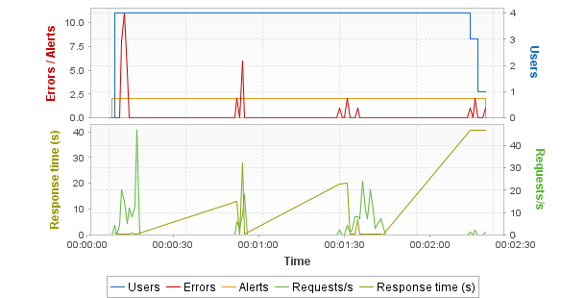
Hot spots
Top 5 errors
User Path | Parent | Page | Count
Test_Web_recording | Actions | /ptracking | 4
Test_Web_recording | Actions | /youtubei/v1/log_event | 4
Test_Web_recording | Actions | /embed/lzU5qCUGhtQ | 4
Test_Web_recording | Actions | /Upload02/MemberImage/20240207/...e1b-0c15afd9c821.jpg | 4
Test_Web_recording | Actions | /Home/getListLastedCmt | 4
Top 5 alerts
Sev. | Alert | Duration % | Occurrences
 | Controller/OS Memory Used >= 80.0% | 99.8 | 1
 | LG localhost:7100/OS Memory Used >= 80.0% | 99.8 | 1
First critical alerts
No alerts
Top 5 average response time (Pages)
User Path | Parent | Page | Duration
Test_Web_recording | Actions | /youtubei/v1/log_event | 41.6
Test_Web_recording | Actions | /ptracking | 40.9
Test_Web_recording | Actions | /embed/lzU5qCUGhtQ | 1.24
Test_Web_recording | Actions | /g/collect | 0.893
Test_Web_recording | Actions | / | 0.819
Top 5 maximum response time (Pages)
User Path | Parent | Page | Duration
Test_Web_recording | Actions | /ptracking | 44.4
Test_Web_recording | Actions | /youtubei/v1/log_event | 42.4
Test_Web_recording | Actions | /embed/lzU5qCUGhtQ | 1.27
Test_Web_recording | Actions | /g/collect | 0.989
Test_Web_recording | login | /youtubei/v1/next | 0.986
Errors
Request errors
Error Type | Count | Description
404 | 20 | Not Found - The server has not found anything matching the Request-URI.
NL-NETWORK-01 | 16 | Miscellaneous I/O error when connecting to the server.
411 | 4 | Length Required - The server refuses to accept the request without a defined Content-Length.
Total | 40 | Total error count.
Action errors
No errors
Alerts
 | Element | Critical | Warning | Monitored
 | Controller | 0 | 1 | 4
 | LG localhost:7100 | 0 | 1 | 4
General statistics
Min | Avg | Max | Count | Err | % of Err | SLA Profile
All User Paths
130.9 | 134 | 138 | 4 | 4 | 100 | -
All pages
0.098 | 3.33 | 44.4 | 112 | 20 | 17.9 | -
All requests
0.032 | 2.46 | 44.3 | 292 | 40 | 13.7 | -
Transaction statistics
Min | Avg | Max | Count | Err | % of Err | Perc 50 | Perc 95 | Perc 99 | Std Dev | Avg-90% | SLA Profile
All Transactions
- | - | - | - | 0 | - | - | - | - | - | - | -

Scenario
Summary
Name | 16:05 - 18 Mar 2024 | Project | Test_BTTruyen
Description |  | Scenario | scenario1
Status | Passed | Load Policy | • The population Pop1 is ramp up from 4 users adding 6 users every 2.0 minutes.
Start date | Mar 18, 2024, 4:06:16 PM | Load Policy
End date | Mar 18, 2024, 4:08:43 PM | Stop Policy | • Population Pop1: immediate.
Duration | 00:02:27 | Stop Policy | • Population Pop1: immediate.
Termination reason | Execution policy | Filters | None
LG Hosts | l​o​c​a​l​h​o​s​t​:​7​1​0​0​ | Debug | Disabled
Populations
Pop1
User Path | Percentage | WAN Emulation | Signal strength | Bandwidth ↑ | Latency ↑ | Packet loss % ↑ | Bandwidth ↓ | Latency ↓ | Packet loss % ↓ | Browser | Handle cookies | Connections | Handle cache
Test_Web_recording | 100.0% | Unlimited |  | Unlimited | 0ms | 0% | Unlimited | 0ms | 0% | Recorded one | Yes | 6 | Returning user
User Paths
Name | Description | On failed assertion | On error | Think time | Thinktime range
Test_Web_recording |  | Do nothing | Do nothing | From pages | 0%
Rendezvous
Enabled | Name | Policy | Value | Timeout
Empty list

Execution context
Name | 16:05 - 18 Mar 2024 |  | Project | Test_BTTruyen
Description |  |  | Scenario | scenario1
Status | Passed |  | Load Policy | • The population Pop1 is ramp up from 4 users adding 6 users every 2.0 minutes.
Start date | Mar 18, 2024, 4:06:16 PM |  | Load Policy
End date | Mar 18, 2024, 4:08:43 PM |  | Stop Policy | • Population Pop1: immediate.
Duration | 00:02:27 |  | Stop Policy | • Population Pop1: immediate.
Termination reason | Execution policy |  | Filters | None
LG Hosts | l​o​c​a​l​h​o​s​t​:​7​1​0​0​ |  | Debug | Disabled
NeoLoad version |  | 2023.4.1;build=20240214-48
Graphs granularity |  | Standard
Application proxy
Name | Description
test | Automatically detect settings
Zone application proxies
Zone | Name | Description
Empty list
Constant variables
Name | Value | Description
Empty list
User Paths settings
Test_Web_recording
Error policy: | Do nothing
Assertion policy: | Do nothing
Thinktime policy: | defined in pages
Pacing: | No pacing

Servers
Servers
Host | Port | HTTP/2 ready | HTTP/2 used
baotangtruyen10.com | 443 | Yes | Yes
img.baotangtruyenvip.com | 443 | No | No
rr8---sn-42u-nbosr.googlevideo.com | 443 | No | No
analytics.google.com | 443 | Yes | Yes
www.phtracker.com | 443 | Yes | Yes
www.gstatic.com | 443 | Yes | Yes
functional.events.data.microsoft.com | 443 | Yes | Yes
services.bingapis.com | 443 | Yes | Yes
nav-edge.smartscreen.microsoft.com | 443 | Yes | Yes
www.youtube.com | 443 | Yes | Yes
www.google.com | 443 | Yes | Yes
jnn-pa.googleapis.com | 443 | Yes | Yes

Populations
Graphs
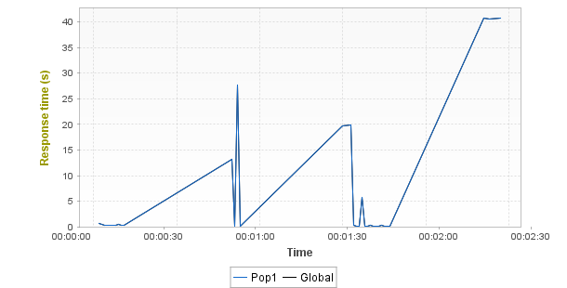
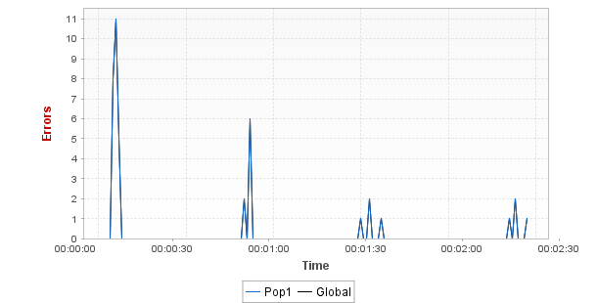
Statistics
Population | Total requests | Average requests/s | Avg. Page res. time | Error rate
Pop1 | 292 (100%) | 2.0 | 3.33s (0%) | 13.7% (0%)
Global | 292 (100%) | 2.0 | 3.33s | 13.7%

User Paths
User Paths
Min | Avg | Max | Count | Err | % of Err | SLA Profile
Test_Web_recording
130.9 | 134 | 138 | 4 | 4 | 100 | -

Transactions
Shared Containers
Min | Avg | Max | Count | Err | % of Err | Perc 50 | Perc 95 | Perc 99 | Std Dev | Avg-90% | SLA Profile
Empty list
Test_Web_recording
Min | Avg | Max | Count | Err | % of Err | Perc 50 | Perc 95 | Perc 99 | Std Dev | Avg-90% | SLA Profile
Test_Web_recording
130.9 | 134 | 138 | 4 | 4 | 100 | - | - | - | - | - | -
Init
0 | 0 | 0 | 4 | 0 | 0 | - | - | - | - | - | -
Actions
- | - | - | - | 0 | - | - | - | - | - | - | -
login
- | - | - | - | 0 | - | - | - | - | - | - | -
find
- | - | - | - | 0 | - | - | - | - | - | - | -
follow
- | - | - | - | 0 | - | - | - | - | - | - | -
dsf
- | - | - | - | 0 | - | - | - | - | - | - | -
dsfollow
- | - | - | - | 0 | - | - | - | - | - | - | -
unfollow
- | - | - | - | 0 | - | - | - | - | - | - | -
logout
- | - | - | - | 0 | - | - | - | - | - | - | -
End
0 | 0 | 0 | 4 | 0 | 0 | - | - | - | - | - | -

Push messages
Shared Containers
Min | Avg | Max | Count | Err | % of Err | SLA Profile
Empty list
Test_Web_recording
Min | Avg | Max | Count | Err | % of Err | SLA Profile
Empty list

Pages
Shared Containers
Min | Avg | Max | Count | Err | % of Err | SLA Profile
Empty list
Test_Web_recording
Min | Avg | Max | Count | Err | % of Err | SLA Profile
Test_Web_recording
130.9 | 134 | 138 | 4 | 4 | 100 | -
Actions
- | - | - | - | 0 | - | -
/crx/info/a
0.674 | 0.674 | 0.674 | 4 | 0 | 0 | -
/undersideautosuggest/api/v1/service/autosuggest
0.399 | 0.399 | 0.4 | 4 | 0 | 0 | -
/
0.806 | 0.819 | 0.825 | 4 | 0 | 0 | -
/Home/getListFollowByUser
0.121 | 0.127 | 0.134 | 4 | 0 | 0 | -
/Home/getListLastedCmt
0.098 | 0.114 | 0.128 | 4 | 4 | 100 | -
/Upload02/MemberImage/20240207/p...e1b-0c15afd9c821.jpg
0.142 | 0.17 | 0.187 | 4 | 4 | 100 | -
/embed/lzU5qCUGhtQ
1.18 | 1.24 | 1.27 | 4 | 4 | 100 | -
/api/browser/edge/navigate/3
0.617 | 0.63 | 0.647 | 4 | 0 | 0 | -
/youtubei/v1/player
0.336 | 0.409 | 0.464 | 4 | 0 | 0 | -
/g/collect
0.826 | 0.893 | 0.989 | 4 | 0 | 0 | -
/api/stats/qoe
0.128 | 0.157 | 0.183 | 4 | 0 | 0 | -
/youtubei/v1/next
0.509 | 0.572 | 0.686 | 4 | 0 | 0 | -
/youtubei/v1/log_event
39.9 | 41.6 | 42.4 | 4 | 4 | 100 | -
/youtubei/v1/log_event_1
0.258 | 0.338 | 0.516 | 4 | 0 | 0 | -
/api/stats/playback
0.148 | 0.181 | 0.23 | 4 | 0 | 0 | -
/ptracking
39.5 | 40.9 | 44.4 | 4 | 4 | 100 | -
/youtubei/v1/log_event_2
0.116 | 0.172 | 0.24 | 4 | 0 | 0 | -
login
- | - | - | - | 0 | - | -
/api/stats/atr
0.134 | 0.185 | 0.264 | 4 | 0 | 0 | -
/dang-nhap
0.153 | 0.21 | 0.274 | 4 | 0 | 0 | -
/youtubei/v1/log_event
0.132 | 0.141 | 0.155 | 4 | 0 | 0 | -
/g/collect
0.39 | 0.425 | 0.472 | 4 | 0 | 0 | -
/g/collect_1
0.112 | 0.169 | 0.316 | 4 | 0 | 0 | -
/api/browser/edge/navigate/3
0.117 | 0.129 | 0.135 | 4 | 0 | 0 | -
/embed/lzU5qCUGhtQ
0.649 | 0.759 | 0.864 | 4 | 0 | 0 | -
/youtubei/v1/player
0.475 | 0.532 | 0.622 | 4 | 0 | 0 | -
/recaptcha/api2/anchor
0.247 | 0.351 | 0.464 | 4 | 0 | 0 | -
/api/stats/qoe
0.118 | 0.144 | 0.165 | 4 | 0 | 0 | -
/youtubei/v1/next
0.623 | 0.76 | 0.986 | 4 | 0 | 0 | -

SLA per User Path
Shared Containers
SLA | Value | Severity
Empty list
Test_Web_recording
SLA | Value | Severity
Test_Web_recording
Actions
/crx/info/a
/undersideautosuggest/api/v1/service/autosuggest
/
/Home/getListFollowByUser
/Home/getListLastedCmt
/Upload02/MemberImage/20240207/p...e1b-0c15afd9c821.jpg
/embed/lzU5qCUGhtQ
/api/browser/edge/navigate/3
/youtubei/v1/player
/g/collect
/api/stats/qoe
/youtubei/v1/next
/youtubei/v1/log_event
/youtubei/v1/log_event_1
/api/stats/playback
/ptracking
/youtubei/v1/log_event_2
login
/api/stats/atr
/dang-nhap
/youtubei/v1/log_event
/g/collect
/g/collect_1
/api/browser/edge/navigate/3
/embed/lzU5qCUGhtQ
/youtubei/v1/player
/recaptcha/api2/anchor
/api/stats/qoe
/youtubei/v1/next

Media Contents
Test_Web_recording
Count | Errors | Bitrate | Played Time | Lag Duration | Lag Ratio | Fill Buffer Duration
Empty list

Monitors
Controller
Performance Counters
Min | Avg | Max | Med | Avg-90% | Std Dev
Controller/User Load
0 | 3.87 | 4 | 4 | 3.99 | 0.6
Controller/Throughput
0 | 0.08 | 1.59 | 0 | 0.024 | 0.265
Controller/Alerts
0 | 0 | 0 | 0 | 0 | -
Controller/Critical Alerts
0 | 0 | 0 | 0 | 0 | -
Controller/Warning Alerts
0 | 0 | 0 | 0 | 0 | -
Controller/CPU Load
0 | 1.93 | 8 | 2 | 1.84 | 1.36
Controller/JVM Memory Used
23 | 25.3 | 28 | 25 | 25.3 | 1.18
Controller/OS Memory Used
87 | 87.8 | 88 | 88 | 87.8 | 0.431
Controller/Thread Count
605 | 622.1 | 630 | 620 | 622 | 5
Controller/Connected
1 | 1 | 1 | 1 | 1 | 0
Controller/Total Disconnections
0 | 0 | 0 | 0 | 0 | 0
Controller/Total Reconnections
0 | 0 | 0 | 0 | 0 | 0
Controller/Network/Segments sent/sec.
0 | 5,631 | 10,620 | 6,948 | 5,658 | 3,526
Controller/Network/Segments retransmitted/sec.
0 | 0 | 0 | 0 | 0 | 0
Controller/Network/eth2 (Realtek Gaming GbE Family Contr...gabits received/sec.
0 | 0 | 0 | 0 | 0 | -
Controller/Network/eth2 (Realtek Gaming GbE Family Contr...)/Megabits sent/sec.
0 | 0 | 0 | 0 | 0 | -
Controller/Network/eth0 (Bluetooth Device (Personal Area...gabits received/sec.
0 | 0 | 0 | 0 | 0 | -
Controller/Network/eth0 (Bluetooth Device (Personal Area...)/Megabits sent/sec.
0 | 0 | 0 | 0 | 0 | -
Controller/Network/wlan3 (MediaTek Wi-Fi 6 MT7921 Wirele...gabits received/sec.
0 | 0.123 | 2.06 | 0.012 | 0.053 | 0.337
Controller/Network/wlan3 (MediaTek Wi-Fi 6 MT7921 Wirele...)/Megabits sent/sec.
0.006 | 0.054 | 0.765 | 0.018 | 0.036 | 0.1
Controller/NeoLoad Web/Megabits received/sec.
0 | 0 | 0 | 0 | 0 | 0
Controller/NeoLoad Web/Megabits sent/sec.
0 | 0.009 | 0.056 | 0.009 | 0.008 | 0.008
Controller/Default zone/User Load
0 | 3.87 | 4 | 4 | 3.99 | 0.6
Controller/Default zone/Pop1/User Load
0 | 3.87 | 4 | 4 | 3.99 | 0.6
Controller/Default zone/Pop1/Test_Web_recording/User Load
0 | 3.87 | 4 | 4 | 3.99 | 0.6
LG localhost:7100
Performance Counters
Min | Avg | Max | Med | Avg-90% | Std Dev
LG localhost:7100/CPU Load
0 | 1.91 | 8 | 2 | 1.83 | 1.34
LG localhost:7100/JVM Memory Used
2 | 4.3 | 5 | 4 | 4.32 | 0.554
LG localhost:7100/OS Memory Used
87 | 87.8 | 88 | 88 | 87.8 | 0.431
LG localhost:7100/Throughput
0 | 0.08 | 1.59 | 0 | 0.024 | 0.265
LG localhost:7100/User Load
0 | 3.87 | 4 | 4 | 3.99 | 0.6
LG localhost:7100/Thread Count
43 | 80.8 | 87 | 80 | 81.1 | 4.82
LG localhost:7100/Http client/Thread Pool used
0.1 | 0.167 | 0.195 | 0.165 | 0.167 | 0.016
LG localhost:7100/Http client/Task Pool used
0 | 0 | 0 | 0 | 0 | 0
LG localhost:7100/Controller Connection/Disconnections
0 | 0 | 0 | 0 | 0 | -
LG localhost:7100/Controller Connection/Reconnections
0 | 0 | 0 | 0 | 0 | -
LG localhost:7100/Controller Connection/Ping Duration (ms)
1 | 1.73 | 2 | 2 | 1.75 | 0.448
LG localhost:7100/Network/Segments sent/sec.
0 | 43.5 | 4,039 | 0 | 0 | 384.4
LG localhost:7100/Network/Segments retransmitted/sec.
0 | 0 | 0 | 0 | 0 | 0
LG localhost:7100/Network/eth2 (Realtek Gaming GbE Famil...gabits received/sec.
0 | 0 | 0 | 0 | 0 | -
LG localhost:7100/Network/eth2 (Realtek Gaming GbE Famil...)/Megabits sent/sec.
0 | 0 | 0 | 0 | 0 | -
LG localhost:7100/Network/eth0 (Bluetooth Device (Person...gabits received/sec.
0 | 0 | 0 | 0 | 0 | -
LG localhost:7100/Network/eth0 (Bluetooth Device (Person...)/Megabits sent/sec.
0 | 0 | 0 | 0 | 0 | -
LG localhost:7100/Network/wlan3 (MediaTek Wi-Fi 6 MT7921...gabits received/sec.
0 | 0.122 | 2.04 | 0.012 | 0.053 | 0.336
LG localhost:7100/Network/wlan3 (MediaTek Wi-Fi 6 MT7921...)/Megabits sent/sec.
0.006 | 0.054 | 0.765 | 0.018 | 0.036 | 0.1

Alerts
Controller
Alerts
Sev. | Alert | Occurrences | First Occurrence | Duration %
 | Controller/OS Memory Used >= 80.0% | 1 | 00:00:00.121 | 99.8
Too high amount of OS memory used
LG localhost:7100
Alerts
Sev. | Alert | Occurrences | First Occurrence | Duration %
 | LG localhost:7100/OS Memory Used >= 80.0% | 1 | 00:00:00.121 | 99.8
Too high amount of OS memory used

Main graphs
Average page response time

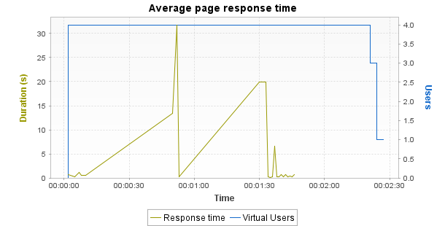

Min | Average | Max
0.161 | 3.328 | 31.764

Notes: Displays the average response time, in seconds, of all pages during the test.
Average request response time

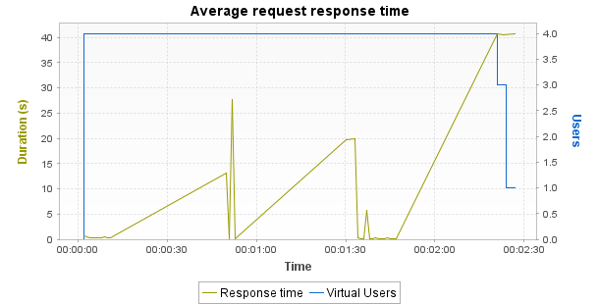

Min | Average | Max
0.051 | 2.458 | 40.778

Notes: Displays the average response time, in seconds, of all requests during the test.
Average response time (Transactions)

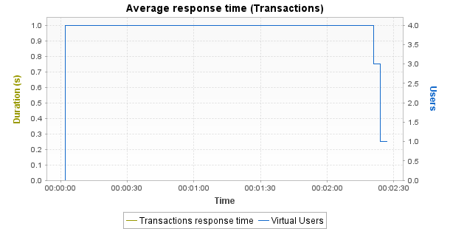

Min | Average | Max | Median | Avg-90% | Std. Dev.
0 | 0 | 0 | 0 | 0 | 0

Notes: Displays the average response time, in seconds, of all Transactions during the test.
Requests per second

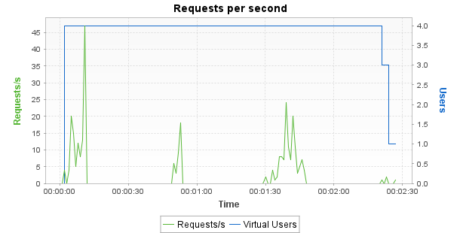

Min | Average | Max
0 | 2 | 47

Notes: Displays the number of requests per second.
Errors

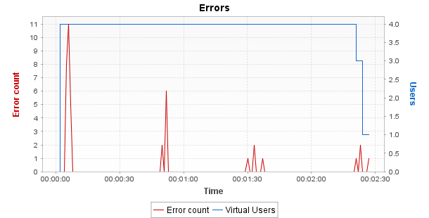

Min | Average | Max
0 | 0.3 | 11

Notes: Displays the number of errors per sampling interval.
Throughput

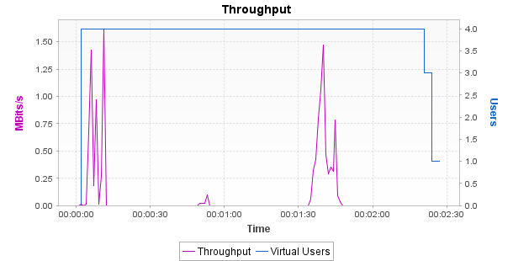

Min | Average | Max
0 | 0.08 | 1.62

Notes: Displays the number of megabits of data per second returned by the server.
Response time against load

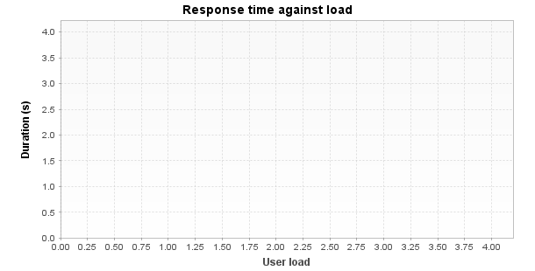

Min | Average | Max
4.022 | 4.022 | 4.022

Notes: Displays the average response time, in seconds, of all pages according to the number of simultaneous Virtual Users.
Top 10 First Alerts

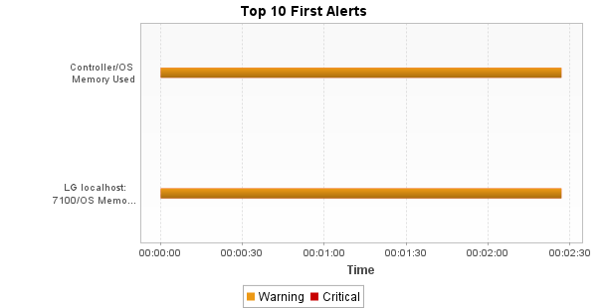
Notes: Displays the list of alerts on the monitored counters during the test.

