**CLASS DIAGRAM**

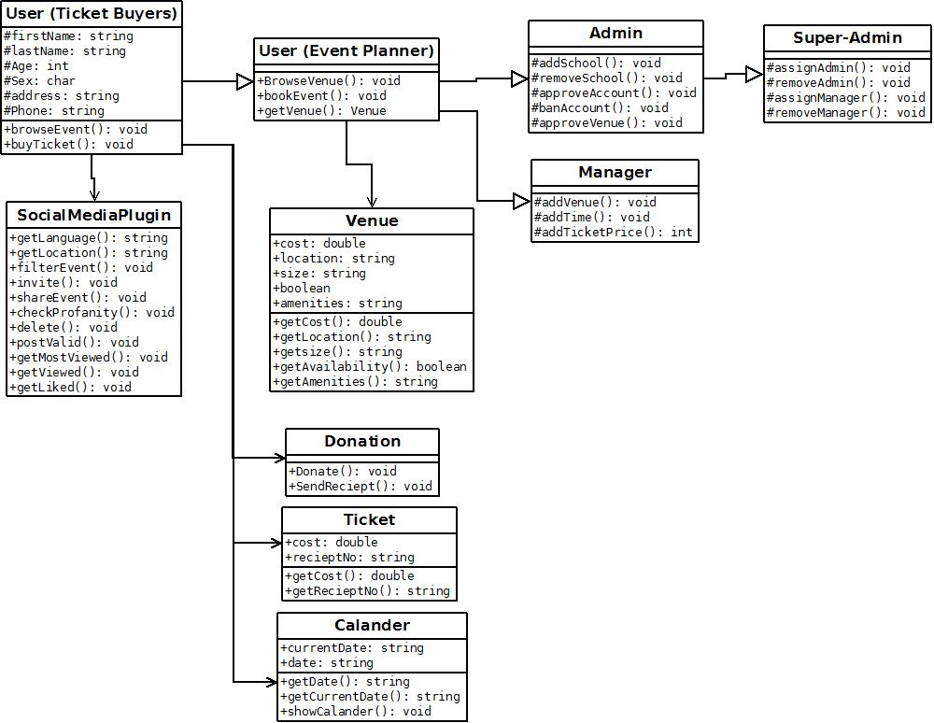

**HIGH LEVEL ARCHITECTURE**

