Progress Report
Increment 2
trAIner the AI game

Scope and Purpose: The implementation of artificial intelligence technology on a Java based application. The trAIner is an AI robot which accomplishes the given task via running in background genetic algorithm. In the field, the AI is being trained on simple maps and after a while the complexity of the maps increases which challenges both the AI and the user. As the complexity of the game is being increased, there would be a necessity to use the AI itself to finish the challenge.

Accomplished From First Increment
- moving elements (enemies)
- the AI object
- building block objects (bricks)
- side panel
- elements (bricks)
- enemy objects (laser etc)
- back-end
- behavior of the obstacles
- parts of genetic algorithm (mutation, fitness of genes)

Progress During the Second Increment
- Loading and saving of maps
- Implemented AI genetic algorithm
- Bottom Panel
- Top Panel
- Right Panel
- Side Bar
- Ability to Pause/Load Game
- Ability to Increase/Decrease speed
- Created 9 new Map Elements

Further Tasks:
- Create an Empty Default Map
- Create Maps with different levels of difficulty
- Implement Dragging and Dropping for the Map Builder
- Improve the AI Algorithm
- Implement JUnit tests
- Test the game and fix the issues

As the project is moving towards it's final stage, the work becomes more detail-oriented, and time-consuming. Yet we can already see the Land!

screenshot_01 shows the current view of the UI from a Single Player Mode

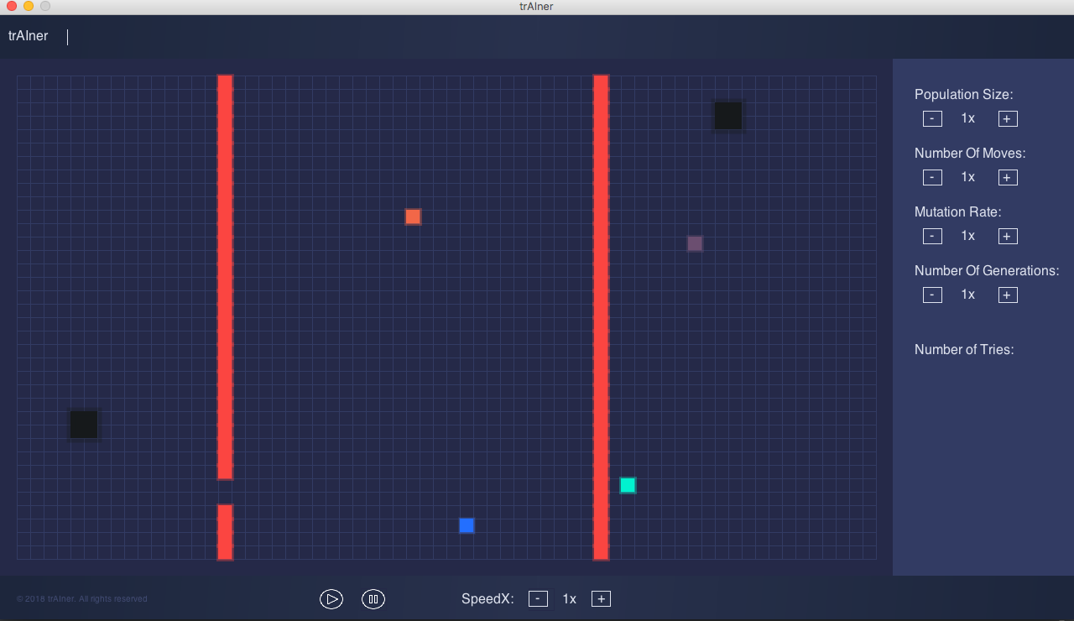
screenshot_02 shows the save & load functionality
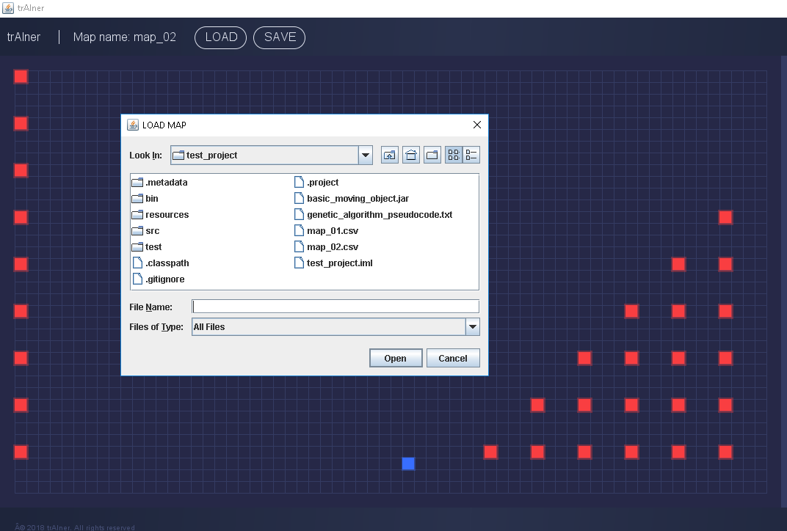

screenshot_03 shows an AI population searching for an optimal path towards finish. Just like we do.
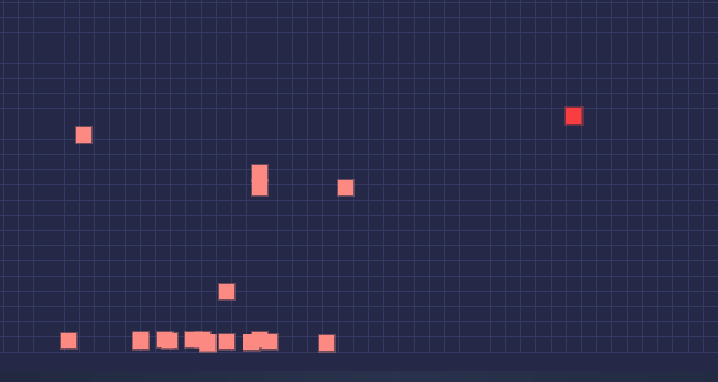

Date: 13.12.2018

