Progress Report
Increment 3
trAIner the AI game

Date: 2019-01-03

Scope and Purpose: The implementation of artificial intelligence technology on a Java based application. The trAIner is an AI robot which accomplishes the given task via running in background genetic algorithm. In the field, the AI is being trained on simple maps and after a while the complexity of the maps increases which challenges both the AI and the user. As the complexity of the game is being increased, there would be a necessity to use the AI itself to finish the challenge.

Accomplished during the First Increment
- moving elements (enemies)
- the AI object
- building block objects (bricks)
- side panel
- elements (bricks)
- enemy objects (laser etc)
- back-end
- behavior of the obstacles
- parts of genetic algorithm (mutation, fitness of genes)

Accomplished during the Second Increment
- Loading and saving of maps
- Implemented basic AI genetic algorithm
- Bottom Panel
- Top Panel
- Right Panel
- Side Bar
- Ability to Pause/Load Game
- Ability to Increase/Decrease speed
- Created 9 new Map Elements

Accomplished during the Third Increment
- Further improved genetic algorithm
- Map elements can be placed on map in 'building mode'
- Creation of an empty map
- Enemies can bounce off of walls
- Creation of some 'Challenge Maps'

Further Tasks:
- Improve the AI Algorithm
- Implement JUnit tests
- Implementation of a Preview button in 'building mode'
- Test the game and fix the issues

As the project is moving towards it's final stage, the work becomes more detail-oriented, and time-consuming. Yet we can already see the Land!

screenshot_ai_game_mode shows an AI population searching for an optimal path towards finish.
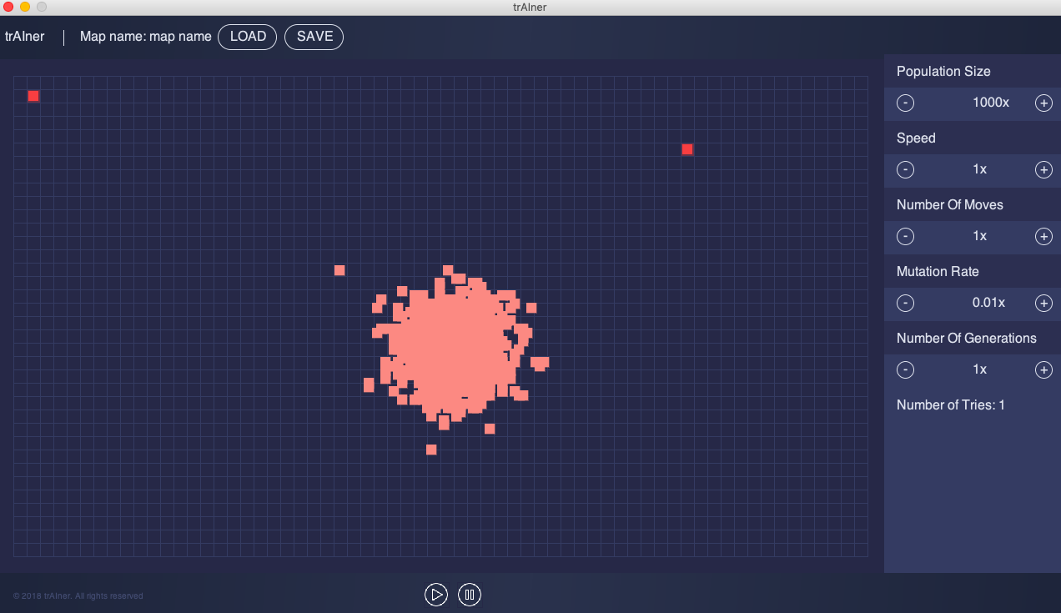

screenshot_normal_map shows the current view of the UI from a Single Player Mode:

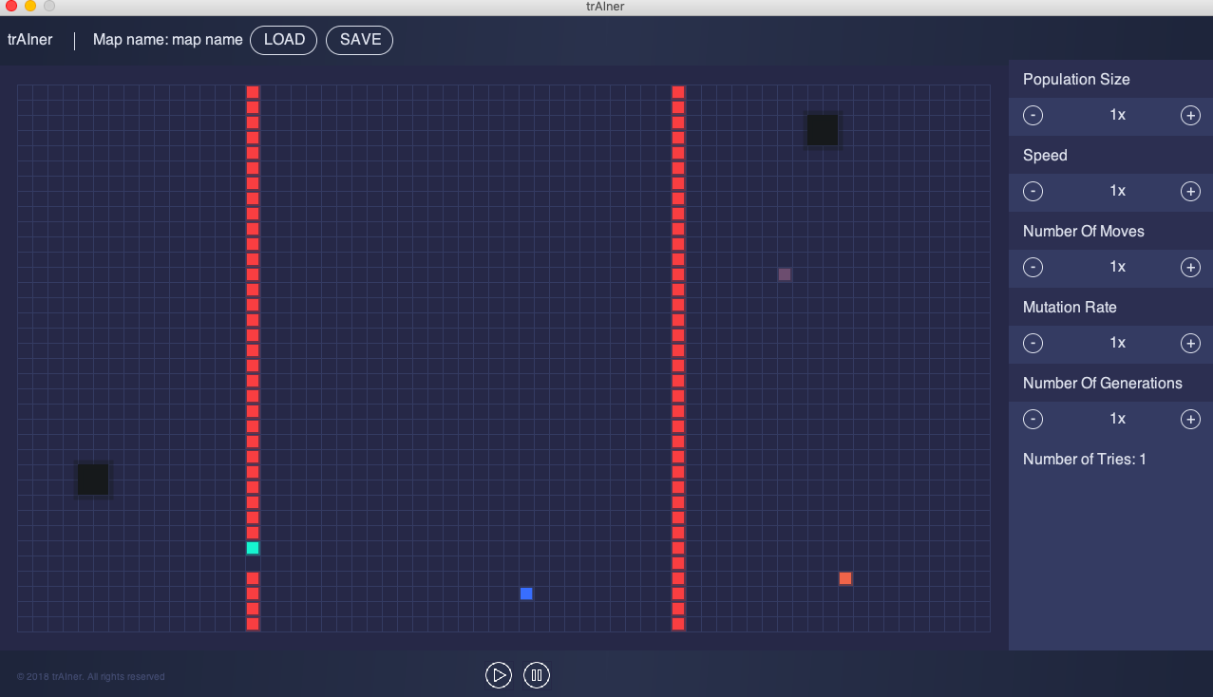
screenshot_map_madness_build_mode shows the building mode with some randomly placed plasma-balls and enemies:
