Progress Report

trAIner the AI game

Scope and Purpose :: The implementation of artificial intelligence technology on a Java based application. The trAIner is an AI robot which accomplishes the given task via running in background genetic algorithm. In the field, the AI is being trained on simple maps and after a while the complexity of the maps increases which challenges both the AI and the user. As the complexity of the game is being increased, there would be a necessity to use the AI itself to finish the challenge.

Progress :: To date, the trAIner application launches a grid with:
- game field
  - moving elements (enemies)
  - the AI object
  - building block objects (bricks)
- side panel
  - drag and drop elements (bricks)
  - enemy objects (laser etc)
- backend
  - behaviour of the obstacles
  - parts of genetic algorithm (mutation, fitness of genes)

The trAIner development team with its progressive approach is being able to implement the above mentioned features in the application and it looks for further challenges and additional tasks to accomplish.

Additional Work :: Tasks to completed in the coming weeks
- Loading and saving of maps
- Drag and drop elements functionality
- The backend AI genetic algorithm
- Bottom and top panel

Till date implementation::

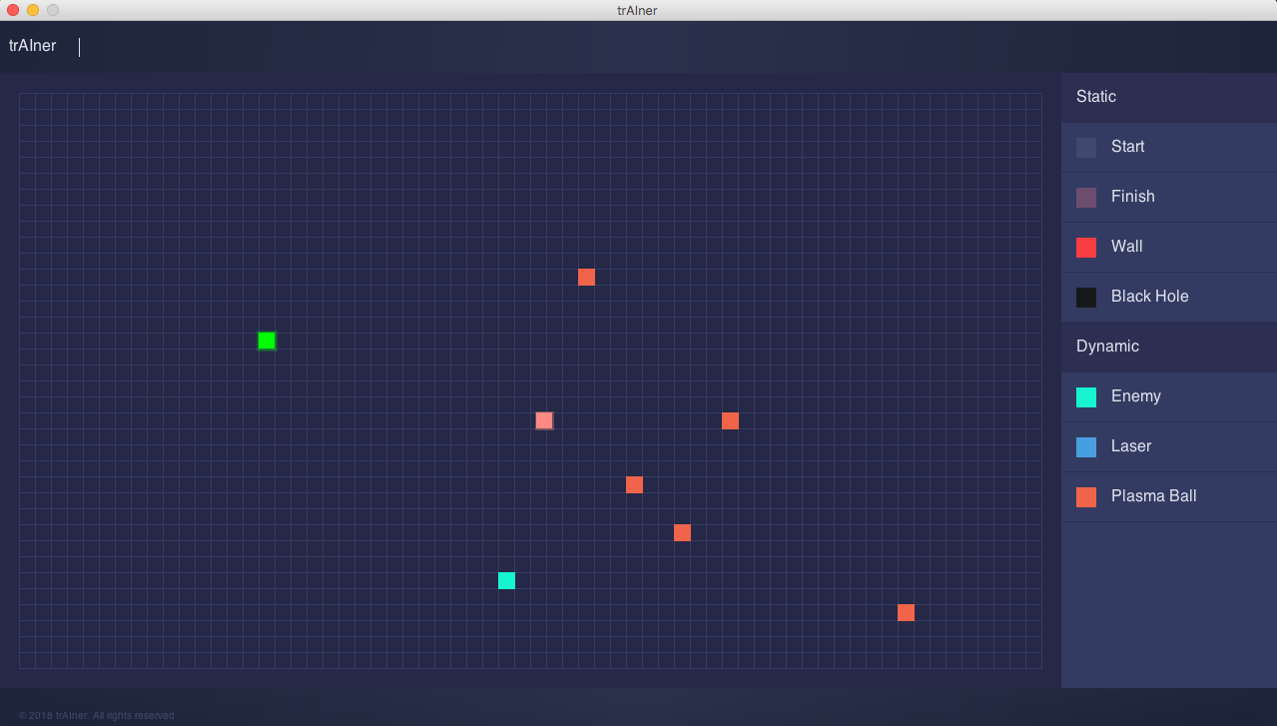

Date: 19.11.2018

